English – Stage 1 – Unit 22
Contents
Unit overview and instructions for use 3
Teacher notes 4
Outcomes and content – Component A 5
Outcomes and content – Component B 7
Week 1 10
Component A teaching and learning 10
Component B teaching and learning 11
Lesson 1: Introducing Peggy and circular narrative 13
Lesson 2: Compound sentences 15
Lesson 3: Verbs, commas, and complex sentences 17
Lesson 4: Circular narrative and character 19
Lesson 5: Puppet retell 22
Week 2 25
Component A teaching and learning 25
Component B teaching and learning 26
Lesson 6: Planning 27
Lesson 7: Super Animal Adventures begin 29
Lesson 8: Super Animal Adventures continue 30
Lesson 9: Finish, edit, publish 31
Lesson 10: Big book of Super Animal Adventures 33
Resource 1: Circular narrative 34
Resource 2: Narrative mountain 35
Resource 3: Clines 36
Resource 4: FANBOYS mnemonic 38
Resource 5: Subordinating conjunctions 39
Resource 6: Sentence frames 40
Resource 7: Types of verbs (teacher resource) 42
Resource 8: Puppets 43
Resource 9: Author hot seat questions 47
References 48

Unit overview and instructions for use
This two-week unit is comprised of Component A and Component B. Connecting learning across both components is encouraged.
Teaching and learning | Component A | Component B
Suggested duration | 60 minutes | 45 minutes
Explicit teaching focus areas | - Phonic knowledge  - Reading fluency  - Reading comprehension  - Spelling  - Handwriting | - Oral language and communication  - Vocabulary  - Reading comprehension  - Creating written texts  - Understanding and responding to literature
To prepare for teaching and learning: | - Refer to Outcomes and content – Component A, K-2 – Instructional sequence – grapheme–phoneme correspondences [PDF 825 KB], and the teaching advice documents (hyperlinked in Component A teaching and learning table).  - Based on student needs identified through ongoing assessment data, plan and document how you will sequence teaching and learning in whole class and targeted teaching groups across the two-week cycle. | - Familiarise yourself with Outcomes and content – Component B, Textual concepts information and videos, English Textual Concepts and Learning Processes (2016), and the teaching and learning sequence.  - Based on student needs identified through ongoing assessment data, determine how you will support students in whole class and targeted teaching groups across the two-week cycle as required.
English K–10 Syllabus © 2022 NSW Education Standards Authority (NESA) for and on behalf of the Crown in right of the State of New South Wales.

Teacher notes
- Narrative is defined as ‘an account of events or related experiences which may be fictional or non-fictional' (NESA Glossary). A narrative is usually structured in such a way as to invite responder involvement through recounting challenges and characters’ attitudes towards them and moving towards resolution – English Textual Concepts (2016).
- Understanding of narrative can be supported through watching the department’s video: Narrative (3:51).
- While narrative is the mentor concept for the conceptual component of this unit, the supporting concept of character can be explored using the mentor text Peggy by Anna Walker.
- If time permits, providing time for students to create scenes and puppets for Lesson 5 would enhance student engagement.
- Reflect on student learning and engagement in activities and record differentiation and adjustments within the unit to inform future teaching and learning. One way of doing this could be to add comments to the digital file.
- Content points are linked to the National Literacy Learning Progression version (3).
- The supporting texts listed in this unit are suggested alternative texts only. They can be replaced with any text with a similar circular narrative structure.
Levels and indicators sourced from National Literacy Learning Progression © Australian Curriculum, Assessment and Reporting Authority (ACARA), accessed 18 August 2022 and was not modified. See references for more information.

Outcomes and content – Component A
The table below outlines the focus outcomes and content. Content is linked to the National Literacy Learning Progression version (3).
Focus area and outcome | Content points and National Literacy Learning Progression
Phonic knowledge  EN1-PHOKW-01 – uses initial and extended phonics, including vowel digraphs, trigraphs to decode and encode words when reading and creating texts | - blend and decode 2-syllable words with taught vowel graphs, digraphs, trigraphs, and quadgraphs, including graphemes for r-controlled vowels and diphthongs and apply this when reading texts (PKW6, PKW7)  - decode 2-syllable base words with common double consonants when reading texts (PKW7)
Reading fluency  EN1-REFLU-01 – sustains reading unseen texts with automaticity and prosody and self-corrects errors | - self-correct when fluency and/or meaning is interrupted
Reading comprehension  EN1-RECOM-01 – comprehends independently read texts that require sustained reading by activating background and word knowledge, connecting and understanding sentences and whole text, and monitoring for meaning | - register a break in comprehension when reading (UnT5)  - recount relevant ideas from texts in the form of a written, visual, or oral summary (UnT6)
Spelling  EN1-SPELL-01 – applies phonological, orthographic and morphological generalisations and strategies when spelling words in a range of writing contexts | - segment multisyllabic words into syllables and phonemes as a strategy for spelling (SpG5)  - explain when to use double consonants to spell 2-syllable base words and apply this when spelling (SpG6)  - use extended phonic code for taught consonant phonemes  - use spelling conventions when adding tense-marking suffixes (SpG9)
Handwriting  EN1-HANDW-01 – uses a legible, fluent and automatic handwriting style, and digital technology, including word-processing applications, when creating texts | - form all letters with consistent size and slope in NSW Foundation Style from memory (HwK5)  - position all letters correctly on the line with appropriate spacing between words (HwK5)

Outcomes and content – Component B
The table below outlines the focus outcomes and content. Content is linked to the National Literacy Learning Progression version (3).
Focus area and outcome | Content points and National Literacy Learning Progression
Oral language and communication  EN1-OLC-01 – communicates effectively by using interpersonal conventions and language to extend and elaborate ideas for social and learning interactions. | - organise key ideas in logical sequence  - recount narratives with key components (Spk3)  - adapt a narrative for a particular audience
Vocabulary  EN1-VOCAB-01 – understands and effectively uses Tier 1, taught Tier 2 and Tier 3 vocabulary to extend and elaborate ideas | - use taught morphemic knowledge to create word families
Reading comprehension  EN1-RECOM-01 – comprehends independently read texts that require sustained reading by activating background and word knowledge, connecting and understanding sentences and whole text, and monitoring for meaning | - know the meaning and purpose of coordinating and subordinating conjunctions and identify them in a complex sentence  - use knowledge of text structure, type of text, author, and forms of writing to predict and confirm meaning (UnT6)  - make text-to-self, text-to-text or text-to-world connections when reading (UnT6)  - recount relevant ideas from texts in the form of a written, visual or oral summary (UnT6)  - interpret patterns in texts to enhance understanding
Creating written texts  EN1-CWT-01 – plans, creates and revises texts written for different purposes, including paragraphs, using knowledge of vocabulary, text features and sentence structure | - write texts that describe, explain, give an opinion, recount an event, tell a story (CrT7)  - use a logical order to sequence ideas and events in sentences across a text (GrA4)  - use action, saying, relating, and sensing verbs to add detail and precision to writing (GrA2, GrA5)  - use a combination of simple and compound sentences to engage the reader when creating written texts (CrT6, GrA4)  - use commas to separate ideas, lists and/or dependent clauses in a sentence (PuN4, PuN6)  - use a variety of planning strategies and tools for creating texts  - experiment with writing complex sentences which include a clause for the main message and dependent clause to elaborate or modify the message (GrA5)
Understanding and responding to literature  EN1-UARL-01 – understands and responds to literature by creating texts using similar structures, intentional language choices and features appropriate to audience and purpose | - identify patterns in narratives that set up expectation and aid prediction of actions and attitudes  - create and re-create narratives using understanding of narrative features (CrT5)

Week 1

Component A teaching and learning
The table below can be used to plan and document lessons that address Component A outcomes and content. Both the detailed example [DOC 529KB] of a two-week teaching and learning cycle and brief example [DOC 66KB] may support you in your planning.
Focus Areas | Lesson 1 | Lesson 2 | Lesson 3 | Lesson 4 | Lesson 5
Phonic knowledge
15 minutes
Spelling and Handwriting
15 minutes
Reading comprehension and Reading fluency
30 minutes

Component B teaching and learning
The following teaching and learning sequence has been designed to address Component B outcomes and content. Adapt the sequence as required to best meet the needs of your students.

Learning intention and success criteria
Learning intentions and success criteria are best co-constructed with students.

Learning intention
Students are learning to respond to circular narrative picture books and use a variety of sentences, conjunctions, and commas when writing.

Success criteria
Students can:
- identify how characters are represented in illustrations and written text
- identify patterns in narratives
- write compound sentences using coordinating conjunctions
- identify past tense verbs and list using commas
- write complex sentences using subordinating conjunctions
- identify subject and verb in sentences
- recount a narrative using puppets

Resources
- Walker A (2014) Peggy: A Brave Chicken on a Big Adventure, Houghton Mifflin Harcourt. ISBN: 9780544259003
- Sendak M (2012) Where the Wild Things Are, Harper Trophy. ISBN: 9780064431781
- Fox M (1991) Koala Lou (Lofts P, illus.), Picture Puffin. ISBN: 9780140540635
- Resource 1: Circular narrative – enlarged copy for teacher use and individual copies for student use
- Resource 2: Narrative mountain
- Resource 3: Clines (digital or individual copies of the student cline; enlarged copies of the sample and student clines)
- Resource 4: FANBOYS mnemonic
- Resource 5: Subordinating conjunctions
- Resource 6: Sentence frames – enlarged copy for teacher use and individual copies for student use
- Resource 7: Types of verbs (teacher resource)
- Resource 8: Puppets – copies for each group; craft sticks, tape
- Clines
- 5 sticky notes for each student
- Digital technology and apps (optional)
- Large sticky notes with ideas
- Large coloured circles or large paper plates for each student

Lesson 1: Introducing Peggy and circular narrative
- Display the front cover of Peggy. Explain that this text is a narrative. Review the concept of narrative and revisit key terminology, for example, character, setting, orientation, series of events, conclusion.
- Show the dedication and title page. Students share their wonderings about the main character, the ‘feathered friends’, the setting, and the character with the camera.
- Display the back cover with the text hidden. Students complete a ‘quick draw’ of 3 to 4 images that show a prediction of the sequence of events. Students describe their predictions based on their understanding of narrative text structure.
- Read Peggy.
- Compare student predictions with the story. How were they the same? How were they different?
- Display an enlarged version of Resource 1: Circular narrative. Discuss the structure of the circular narrative. Note that:
- the narrative always ends where it begins
- the character’s traits change from the beginning to the end of the story because of their experiences within the series of events.
- Outline that the story settings help frame the narrative structure with a home-away-home pattern. Display the word ‘home’ at the front of the classroom and the word ‘away’ at the back. To reinforce an understanding of circular structure, retell the key events of Peggy. Students start at ‘home’ and move around the room in a circular direction, miming the key events in the narrative until they return to the ‘home’ position.
- Display and compare Resource 2: Narrative mountain with the enlarged version of Resource 1: Circular narrative. Compare the 2 narrative structures, noting the similarities and differences. Make text-to-text connections by comparing the structure of a familiar linear narrative with a circular narrative. For example, compare the linear narrative structure of Koala Lou with the circular narrative structure of Peggy.
- Use Resource 1: Circular narrative to discuss and then brainstorm and record Peggy’s feelings at different stages, including:
- at the beginning of the text (orientation/home): for example, safe, cosy, happy
- when the big wind came and blew her off the trampoline and into the city (events/away sector), for example, scared, hurt, curious
- when she ’watched, hopped, jumped, twirled, and tasted’ (events/away sector), for example, brave, adventurous
- when she missed her home and saw a sunflower (events/away sector), for example, sad, confused, homesick
- when she followed the pigeons back to her home (conclusion/home sector), for example, happy, safe.
- Discuss how and why Peggy’s feelings changed and how she became more adventurous because of her experiences.
- Display and discuss Resource 3: Clines. Explain that a cline sequences words to show change.
- Provide students with the blank Resource 3: Clines or a digital version. Students complete the cline using the brainstormed list of words to show the progression of Peggy’s feelings and how they changed.
Too hard? Complete the cline using emojis to represent Peggy’s feelings.
Too easy? Complete a cline based on a character from a book of choice.
- As a class, students share their ordering of the feeling words, giving reasons for the placement within the sequence.
Stage 1 Assessment task 1 – Observations from this lesson allow students to demonstrate achievement towards the following syllabus outcome and content points:
EN1-RECOM-01 – comprehends independently read texts that require sustained reading by activating background and word knowledge, connecting and understanding sentences and whole text, and monitoring for meaning
- use knowledge of text structure, type of text, author, and forms of writing to predict and confirm meaning
- make text-to-self, text-to-text or text-to-world connections when reading.

Lesson 2: Compound sentences
- Read text from Peggy that demonstrates a range of sentence structures, variability of sentence length, and sentence beginnings. For example, ‘She watched the sky grow darker as clouds rolled by. The wind was cold. A flock of birds flew quietly overhead.’
- Discuss how authors use a variety of sentences to engage the reader.
- Display the simple sentence: ‘Peggy missed her home’. Identify and discuss the sentence features.
- Display Resource 4: FANBOYS mnemonic and review coordinating conjunctions. Display the compound sentence: ‘Peggy hopped out of the train, but the sunflower was gone’. Highlight that a compound sentence comprises 2 or more independent clauses that are joined by a conjunction. Deconstruct the example sentence by underlining the independent clauses and circling the conjunction.
Compound sentence: A sentence comprised of 2 or more independent clauses joined by a coordinating conjunction.
- Explicitly teach that each clause is a complete idea with a subject plus a verb and that each clause can be a simple sentence. The conjunction shows the relationship between what would have been 2 independent ideas. In this sentence, the coordinating conjunction ‘but’ is showing contrast.
- Display compound sentences from Peggy. For example:
- ‘The sunflower sat down, so Peggy sat down too.’
- ‘She tried asking for directions, but people found it hard to understand her.’
- Share the pen to deconstruct the sentences by underlining the independent clauses and circling the conjunctions.
- Display the double page of Peggy where the pages are divided into boxes showing Peggy’s daily routine.
- Display and review Resource 4: FANBOYS mnemonic. Identify the coordinating conjunctions used in Step 6.
- Model orally creating a compound sentence about Peggy by combining 2 simple sentences with a conjunction. For example: Peggy ate her breakfast near the window. She could watch the pigeons fly away. The compound sentence becomes ‘Peggy ate her breakfast near the window so she could watch the pigeons fly away.’
- Students say a simple sentence that describes an action from the double page. For example, ‘Peggy liked playing on the trampoline’. Ask another student to add a conjunction and another simple sentence to create a compound sentence. For example, ‘Peggy liked playing on the trampoline, so she practised every day’. Discuss how this has added a relationship between ideas and interest to the writing.
- Students write a simple sentence about their daily routine, for example, ‘I eat toast for my breakfast’. Student A reads their sentence to a partner, and Student B, nominates a conjunction and a simple sentence to add more meaning. For example, ‘but my dad eats cereal.’ Students swap roles and repeat the process to create additional compound sentences.
- Students deconstruct their compound sentences by underlining the clauses and circling the coordinating conjunction. Students share and describe their sentences with the class.
Too hard? Facilitate use of text-to-speech technology or audio recording to produce the text.
Too easy? Students add prepositional phrases to their compound sentences to indicate the setting. For example, ‘I eat breakfast in the kitchen and I clean my teeth in the bathroom.’

Lesson 3: Verbs, commas, and complex sentences
- Display the page in Peggy that has the sentence, ‘Peggy watched, hopped, jumped, twirled, and tasted.’ Read the text and note the use of the comma to separate the list of action verbs.
- Discuss the change of tense (from present tense to past tense) when the suffix -ed is added to the base word. (Refer to Outcomes and content – Component A – Spelling if relevant). Explain that narrative texts are mostly written in past tense. Identify and list the past tense verbs in Peggy. Focus on the verbs that follow the past tense spelling pattern of adding -ed. For example, watched – watch. Draw attention to the spelling pattern of doubling the consonant if it is preceded by a vowel when adding -ed. For example, hop – hopped.
- Display a list of irregular past tense verbs, for example, saw, found, ate, drew, wrote, ran, fought. Ask students to identify the regular present tense of the verb.
- Students play a variation of the game, Simon Says, where a present tense action is provided and students write the past tense verb on mini whiteboards. Students can then circle the past tense morpheme -ed if added, underline the letter that is doubled and the -ed if it follows the short vowel spelling pattern, and circle the entire word if it is an irregular past tense verb. For example, if Simon Says ‘watch’, students write ‘watched’. Students will then circle the past tense morpheme since it follows the -ed pattern. Students flip and show their mini whiteboards to share their responses.
- Review the previous day’s learning related to authors using a variety of sentence types to add interest for the reader. Revise complex sentences and subordinating conjunctions. For additional reference, display Resource 5: Subordinating conjunctions.
- Display Resource 6: Sentence frames. Read the complex sentence in the frame and review the use of commas to separate dependant clauses. Identify the dependent clause and the placement of the comma. Discuss how the subordinating conjunction has been used at the beginning of the sentence. Explain that when the subordinating conjunction is used between clauses, a comma is not used.
- To support understanding, model drawing an illustration to match the dependent and independent clauses in the clause boxes in the sentence frames.
- Co-construct success criteria for writing complex sentences with the correct structure and punctuation.
- To innovate on the text, introduce a new character, Super Peggy. Ask students to imagine a super-hen who has superpowers. Students write Super Peggy complex sentences using Resource 6: Sentence frames. For example, Once Super Peggy learnt to talk, she could tell jokes to the pigeons. Students draw pictures illustrating each of the clauses in their sentence. For support, refer to Resource 5: Subordinating conjunctions.
Too hard? Provide sentence starters with a limited number of subordinating conjunctions.
Too easy? Write a combination of compound and complex sentences to further explore Super Peggy’s superpowers.
- As a class, students share and discuss their sentences against the co-constructed success criteria.
Stage 1 Assessment task 2 – Observations/work samples from this lesson allow students to demonstrate achievement towards the following syllabus outcomes and content points:
EN1-VOCAB-01 – understands and effectively uses Tier 1, taught Tier 2 and Tier 3 vocabulary to extend and elaborate ideas
- use taught morphemic knowledge to create word families.
EN1-RECOM-01 – comprehends independently read texts that require sustained reading by activating background and word knowledge, connecting and understanding sentences and whole text, and monitoring for meaning
- know the meaning and purpose of coordinating and subordinating conjunctions and identify them in a complex sentence.
EN1-CWT-01 – plans, creates and revises texts written for different purposes, including paragraphs, using knowledge of vocabulary, text features and sentence structure
- use commas to separate ideas, lists and/or dependent clauses in a sentence
- experiment with writing complex sentences which include a clause for the main message and dependent clause to elaborate or modify the message.

Lesson 4: Circular narrative and character
- Display Where the Wild Things Are. Look at the front and back cover of the book. Ask students: What is happening? What can we tell about the characters from the front and back cover?
- Read Where the Wild Things Are.
- Students identify the structure of the narrative. Display Resource 1: Circular narrative and identify the home-away-home structure that was also used in Peggy. Recall that:
- the narrative always ends where it begins
- the character’s traits change from the beginning to the end of the story because of their experiences within the series of events.
- Model how to check and clarify the meaning of new words or phrases. For example, ‘mischief’, ‘private’, ’gnashed’, ‘wild rumpus’, ‘his ceiling hung with vines and the walls became the world all around’.
- Display the double page where Max meets the wild things. Read the sentence:
‘And when he came to the place where the wild things are
they roared their terrible roars and gnashed their terrible teeth
and rolled their terrible eyes and showed their terrible claws.’
- Revise and identify the subject and verb within each clause. Consider how the author has used line and page breaks instead of commas to separate sentences and clauses.
Subject: The word or words in a clause that convey who or what the clause is about. For example, in the sentence ‘The girl threw the ball’, ‘the girl’ is the subject.
- Display and identify the subject and the verb in a variety of clauses within different sentence types. For example:
- But the wild things cried, ‘Oh please don’t go– (Subject: ‘the wild things’; Saying verb: ‘cried’)
- we’ll eat you up– (Subject: ‘we’; Action verbs: ‘will eat you up’)
- we love you so!’ (Subject: ‘we’; Sensing verb: ‘love’).
- Create a four-column table with the headings action verbs, saying verbs, relating verbs, and sensing verbs. Ask students to define each type of verb. Identify verbs in Where the Wild Things Are and list them in correct columns. For teacher reference, see Resource 7: Types of verbs.
- Display the 3 double pages of the wild rumpus. Students focus on the illustrations and identify additional verbs that the characters display. For example, hung, screamed, danced, climbed. Write these verbs in the correct column on the table.
- To innovate on the text, support students to visualise themselves in the wild rumpus. Ask students what they would look like, what their actions would be, and how they would feel.
- Students act out the wild rumpus. Say ‘freeze’ to stop the action. Select students by tapping on the shoulder to explain their character, actions, and feelings.
- Students draw the wild rumpus including themselves, the wild things, and Max. Students label their drawing with verbs or verb phrases to describe the scene.
- Students write a paragraph about their actions and feelings using a combination of sentences to engage the reader.
- Review the structure of Where the Wild Things Are with Resource 1: Circular narrative and confirm that the narrative has ended where it began.
- Students close their eyes and imagine that they are sailing back home with Max. Students listen as the remainder of the text is read.
- Discuss students’ feelings as they realise that they are back home safely. Compare these feelings to how Max felt at the beginning of the narrative.
- Discuss how Max’s character traits have changed from the beginning to the end of the narrative.

Lesson 5: Puppet retell
Note: Teacher preparation for this lesson:
- large sticky notes
- all resources from previous lessons
- scenes and stick puppet resources (Resource 8: Puppets)
- digital technology and apps (optional), for example, Canva, Clips, Puppet Pals.
- Explain that students will be recounting the story of Where the Wild Things Are by performing a puppet play in small groups.
- Model planning the recount of Where the Wild Things Are. Write the word ‘home’ in one quadrant of a large, coloured paper circle or large paper plate. Write key ideas for the recount on the large sticky notes:
- where Max began
- 3 key events
- a final event.
Add the sticky notes around the edge of the circle starting at the home position.
- Show how ideas can be changed by replacing one sticky note with another, or by moving the sticky notes around to create a logical sequence.
- Display and discuss a simple checklist of criteria for writing an oral recount plan for the puppet play. For example, the recount must include:
- a logical order of events/circular narrative structure
- a combination of simple, compound, and complex sentences to engage the audience
- action, saying, relating, and sensing verbs to add detail.
- Model writing a sentence for each sticky note. Refer to the simple checklist of criteria and the teacher’s circular narrative plan. For example:
- Home – Max wore his wolf suit at home and made mischief.
- Event – Max was sent to bed.
- Event – He sailed to the land where the wild things are.
- Event –They had a wild rumpus and they made him king.
- Home – After Max sailed back home, he felt happy.
- Model creating an oral recount by expanding on sentences in the circular narrative plan.
- Explain that students are going to recount Where the Wild Thing Are using puppets and their own circular narrative plan and sentences.
- Distribute 5 sticky notes and a circle/paper plate to each small group. On the sticky notes, students collaboratively develop a five-step circular narrative plan, writing ideas for where Max began (note 1), key events (notes 2, 3, 4), and conclusion (note 5). Students arrange the sticky notes in logical order around the edge of the circle.
- In small groups, students write a series of sentences to elaborate on each idea referring to the simple checklist of criteria.
- In small groups, students orally recount the key ideas using their sentences as a guide.
- Provide each group with Resource 8: Puppets and background scenes, craft sticks, and tape.
- Students use their puppets and background scenes to practise their recount of Where the Wild Things Are.
- Groups record and/or present their puppet show to the class.
Stage 1 Assessment task 3 – Observations and work samples from this lesson allow students to demonstrate achievement towards the following syllabus outcomes and content points:
EN1-OLC-01 – communicates effectively by using interpersonal conventions and language to extend and elaborate ideas for social and learning interactions
- recount narratives with key components
- adapt a narrative for a particular audience.
EN1-RECOM-01 – comprehends independently read texts that require sustained reading by activating background and word knowledge, connecting and understanding sentences and whole text, and monitoring for meaning
- recount relevant ideas from texts in the form of a written, visual or oral summary
- interpret patterns in texts to enhance understanding.
EN1-CWT-01 – plans, creates and revises texts written for different purposes, including paragraphs, using knowledge of vocabulary, text features and sentence structure
- use action, saying, relating and sensing verbs to add detail and precision to writing
- use a variety of planning strategies and tools for creating texts.

Week 2

Component A teaching and learning
The table below can be used to plan and document lessons that address Component A outcomes and content. Both the detailed example [DOC 529KB] of a two-week teaching and learning cycle and brief example [DOC 66KB] may support you in your planning.
Focus Areas | Lesson 6 | Lesson 7 | Lesson 8 | Lesson 9 | Lesson 10
Phonic knowledge
15 minutes
Spelling and Handwriting
15 minutes
Reading comprehension and Reading fluency
30 minutes

Component B teaching and learning
The following teaching and learning sequence has been designed to address Component B outcomes and content. Adapt the sequence as required to best meet the needs of your students.

Learning intention and success criteria
Learning intentions and success criteria are best co-constructed with students.

Learning intention
Students are learning to create narratives that use a circular structure, intentional language choices, and illustrations to represent characters and ideas.

Success criteria
Students can:
- use tools to plan writing
- write a paragraph to introduce characters and setting using a variety of sentences
- organise ideas in logical sequence
- provide and apply effective feedback
- represent characters using illustrations and text
- respond to questions about the narrative.

Resources
- Walker A (2014) Peggy: A Brave Chicken on a Big Adventure, Houghton Mifflin Harcourt. ISBN: 9780544259003
- Sendak M (2012) Where the Wild Things Are, Harper Trophy. ISBN: 9780064431781
- Resource 1: Circular narrative
- Resource 9: Author hot seat questions
- 5 sticky notes for each student
- Large coloured circles or large paper plates for each student

Lesson 6: Planning
- Revisit Peggy to review the structural features of a circular narrative, including the orientation (home), series of events including challenges (away), conclusion (home). Use Resource 1: Circular narrative for support. Review how character traits change from the beginning to the end of the story.
- Recall the text innovation involving Super Peggy and her actions from Lesson 3. Explain that students will write a circular narrative to create a class big book, Super Animal Adventures, involving characters with superpowers.
- Students visualise what Super Peggy would look like and what she would do. For example, she would have a cape on her back and she would use superpowers to help others.
- Students draw their visualisation of Super Peggy, adding details to show her actions.
- Students identify Super Peggy verbs and label their drawing.
- Students share their Super Peggy drawings with the class.
- Students use the Think-Pair-Share strategy to discuss criteria for writing a circular narrative. Record student responses.
- Co-construct success criteria for writing the circular narrative and the simple checklist of criteria from Lesson 5. For example, write at least one complex sentence using subordinating conjunctions, and include simple and compound sentences in writing.
- As a class, brainstorm ideas for Super Animal Adventures. Encourage creative, original ideas and list them on an anchor chart under the headings:
- characters/superpower
- where the adventure starts and ends
- settings
- events/challenges.
- Model creating a circular narrative plan using the anchor chart and steps 4 and 5 from Lesson 5. Write ideas onto sticky notes and place on the circular narrative plan. Review how ideas can be changed by replacing one sticky note with another or moving the sticky notes around to create a logical sequence.
- Distribute a paper plate or a large, coloured circle and 5 sticky notes to each student. Students write a circular narrative plan for their Super Animal Adventure.
Too hard? Students draw and label their ideas on sticky notes.
- Students share their plan with a partner as a draft oral narrative. Students take turns to ask clarifying questions on the ideas and events within the narrative and provide feedback based on the co-constructed success criteria.
- Students apply feedback to their circular narrative plan.

Lesson 7: Super Animal Adventures begin
- Display pages from Peggy to identify and revise:
- the correct use of punctuation
- how a variety of sentences engage the reader
- the purpose of coordinating and subordinating conjunctions
- the circular narrative structure.
- Display teacher’s circular narrative plan from Lesson 6 and model visualising by drawing a super animal character and setting.
- Students draw and label their super animal characters and the setting.
Paragraph: A group of sentences, starting with a topic sentence, followed by other sentences that elaborate on the topic, and include details that support a specific point or topic.
- Review paragraph structure. Model writing the first paragraph of the Super Animal Adventure that introduces the character and setting using the teacher modelled circular narrative plan and drawing.
- Students write the orientation of their narrative using their circular narrative plan and drawing.
Too hard? Facilitate use of text-to-speech technology or audio recording to produce the text.
Too easy? Students edit their writing to include more complex vocabulary and punctuation, including character dialogue.
- Students share their writing with a partner who provides feedback using the TAG feedback proforma and the co-constructed success criteria.
- Students review their writing and apply feedback.

Lesson 8: Super Animal Adventures continue
- Read a section of Peggy out of order and discuss the importance of organising a sequence of events in logical order. For example, ‘The pigeons knew the way back to the yard’, ‘She tried asking for directions, but people found it hard to understand her’, ‘One blustery day, a big gust of wind swept down through the clouds, scooping up leaves, twigs and Peggy’.
- Review text from Peggy that demonstrates a range of sentence structures, variability of sentence length, and sentence beginnings. For example, ‘She watched the sky grow darker as clouds rolled by. The wind was cold. A flock of birds flew quietly overhead. It was the pigeons’. Discuss how the variety of sentences can engage the reader.
- Model writing the next paragraph for students’ Super Animal Adventure that includes a range of sentences. Explain that each paragraph must contain a new event. Discuss how the paragraphs build towards a challenge for the character.
- Students write the series of events in logical order using paragraphs.
Too hard? Facilitate use of text-to-speech technology or audio recording to produce the text.
Too easy? Students edit their writing to include more complex vocabulary and punctuation, including character dialogue.
- Students share their writing with a partner and provide feedback using the TAG feedback proforma and the co-constructed success criteria.
- Students review their writing and apply feedback.

Lesson 9: Finish, edit, publish
- Review your circular narrative plan and modelled writing. Discuss that the purpose of the conclusion is to:
- resolve the challenge
- return the character home
- show a change in character traits.
- Model writing the conclusion of Super Animal Adventure focusing on a range of sentence structures, variability of sentence length, and sentence beginnings.
- Read your modelled narrative from the beginning, pausing to check for text cohesion.
- Students write the conclusion of their Super Animal Adventure.
Too hard? Facilitate use of text-to-speech technology or audio recording to produce the text.
Too easy? Students edit their writing to include more complex vocabulary and punctuation, including character dialogue.
- Students self-assess their narrative by reviewing the purpose of the conclusion and editing their writing.
- Students read their narrative from the beginning, using a strategy to slow down the reading and check for accuracy. For example, place a dot above each word when it is read aloud.
- Students review and edit their writing, checking for text cohesion.
- Students read their narrative to a partner who provides feedback using the co-constructed success criteria from Lesson 6.
- Provide time for students to review and apply feedback to their writing.
- Students publish their narrative for the class big book.
Stage 1 Assessment task 4 – Observations and work samples from this lesson allow students to demonstrate achievement towards the following syllabus outcomes and content points:
EN1-OLC-01 – communicates effectively by using interpersonal conventions and language to extend and elaborate ideas for social and learning interactions
- organise key ideas in logical sequence.
EN1-RECOM-01 – comprehends independently read texts that require sustained reading by activating background and word knowledge, connecting and understanding sentences and whole text, and monitoring for meaning
- write texts that describe, explain, give an opinion, recount an event, tell a story
- use a logical order to sequence ideas and events in sentences across a text
- use a combination of simple and compound sentences to engage the reader when creating written texts.
EN1-UARL-01 – understands and responds to literature by creating texts using similar structures, intentional language choices and features appropriate to audience and purpose
- create and re-create narratives using understanding of narrative features
- identify patterns in narratives that set up expectation and aid prediction of actions and attitudes.

Lesson 10: Big book of Super Animal Adventures
- Revise how authors make intentional choices about colours and images to represent their ideas. Encourage students to consider size, angle, and colour choice to match their Super Animal Adventure theme. Students finish publishing their narrative.
- Model the Author hot seat activity: a student reads their narrative to the class, then peers ask questions about their decisions as an author. See Resource 9: Author hot seat questions for a possible scaffold.
- As a class or in small groups, students present their Super Animal Adventure and participate in Author hot seat.
Too hard? Students use Resource 9: Author hot seat questions as prompts.
Too easy? Students assume the character of their super animal in the hot seat activity.
- Collate the narratives and bind together to create a class big book for students to enjoy.

Resource 1: Circular narrative
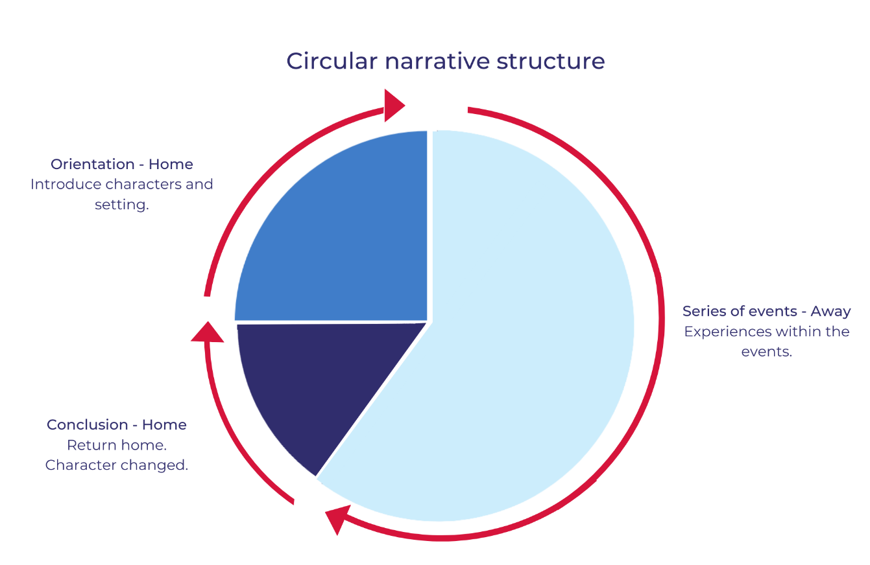

Resource 2: Narrative mountain
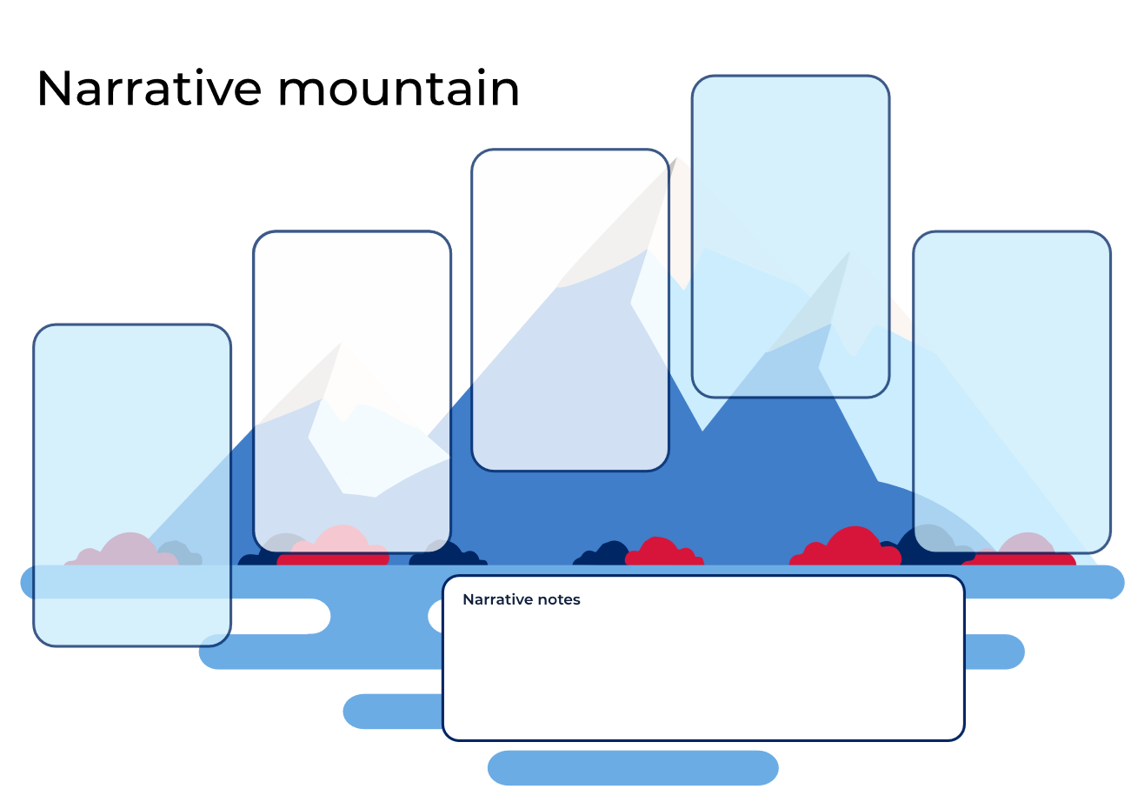

Resource 3: Clines
Example cline:
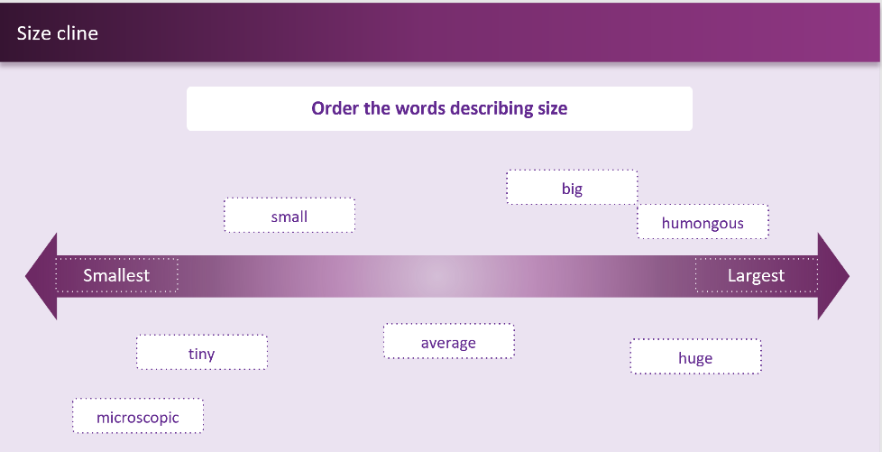

Student cline:
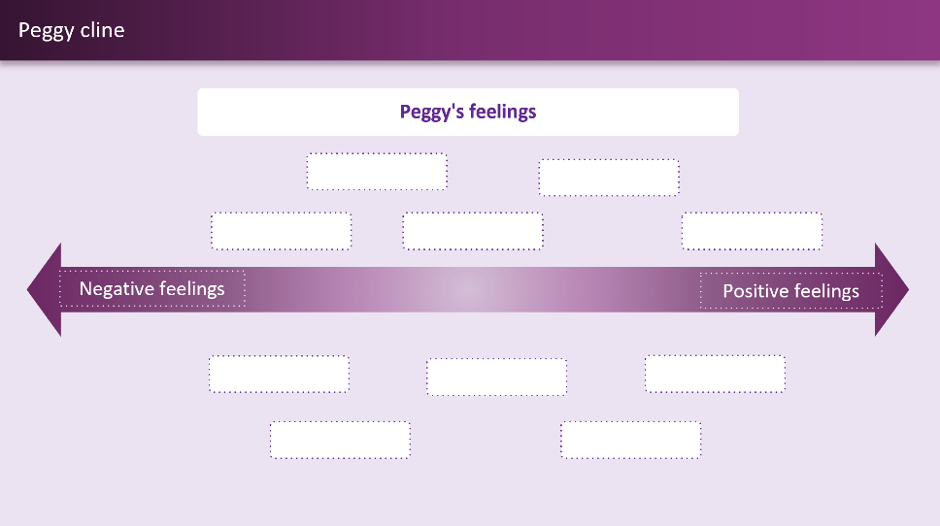

Resource 4: FANBOYS mnemonic
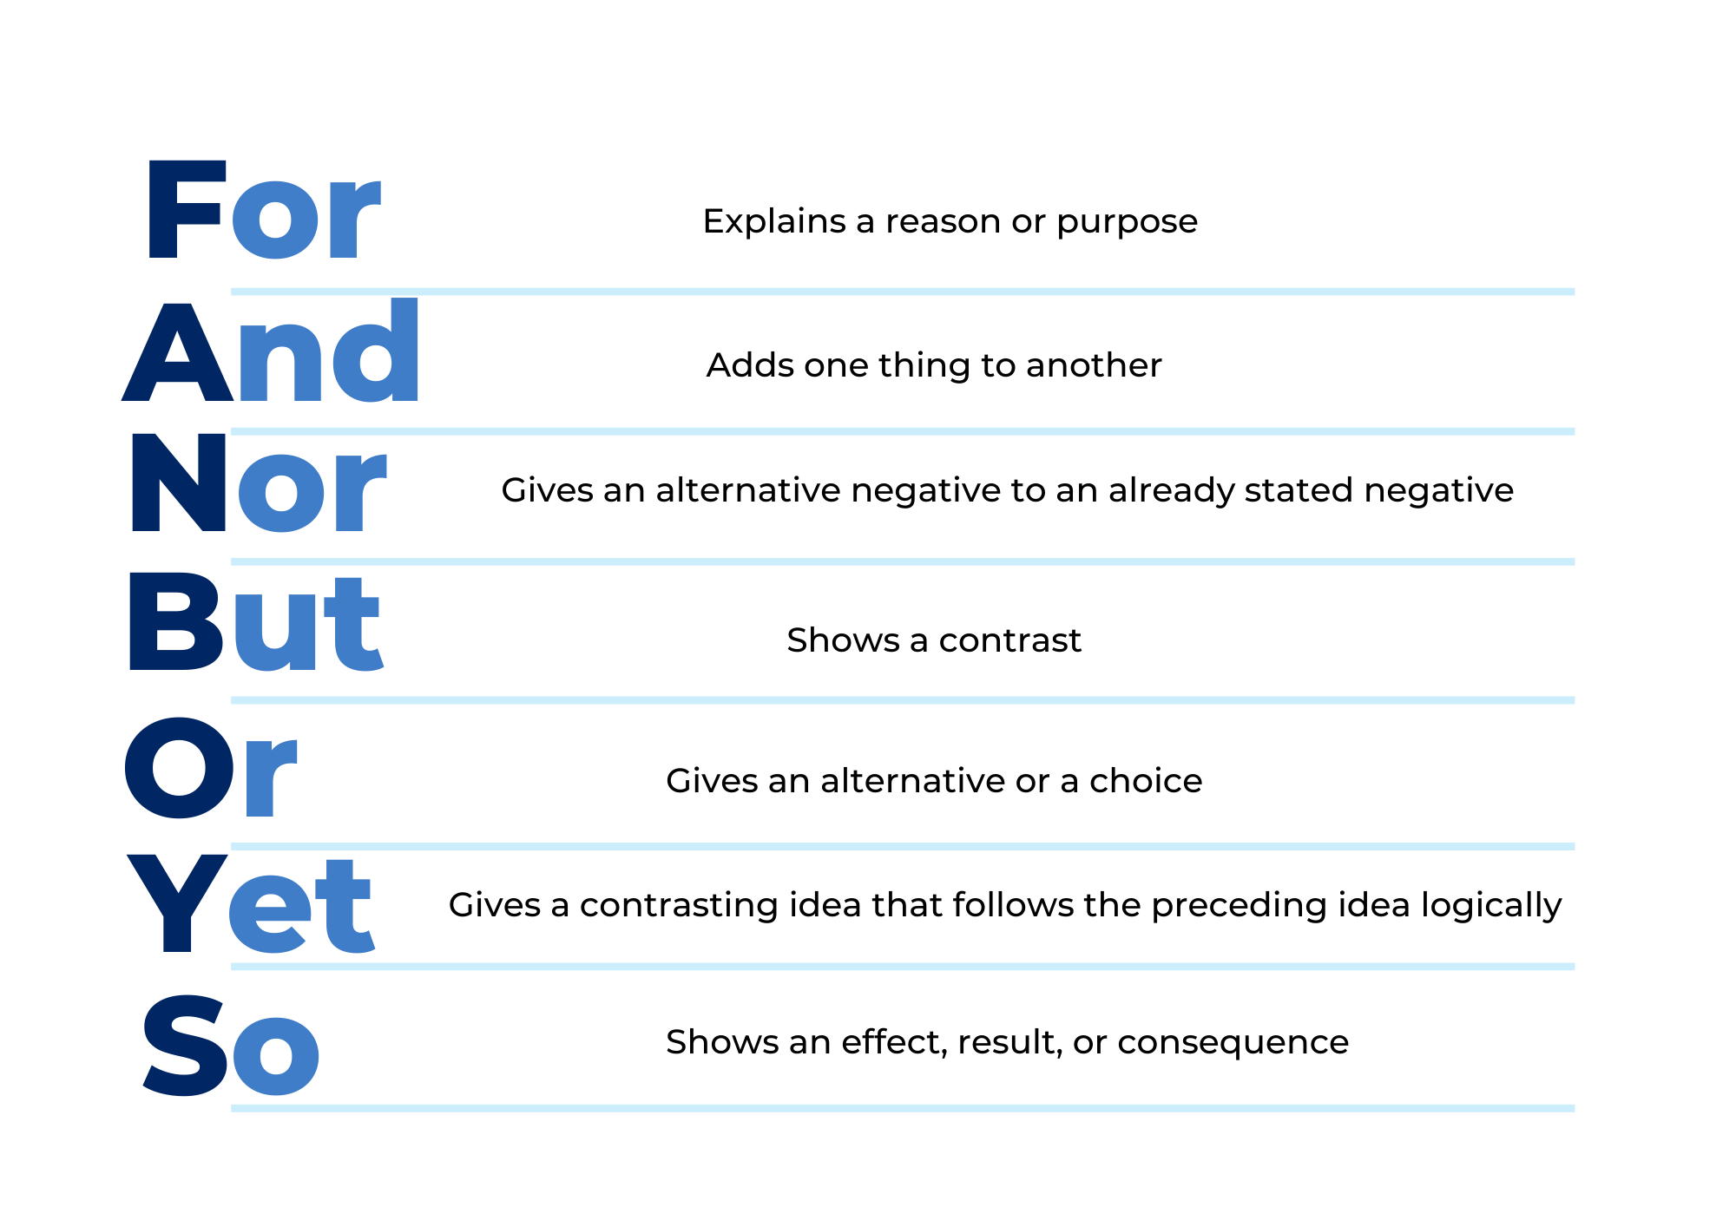

Resource 5: Subordinating conjunctions
after  although  as  because  before  if  once  so that | than  that  unless  where  when  which  while

Resource 6: Sentence frames
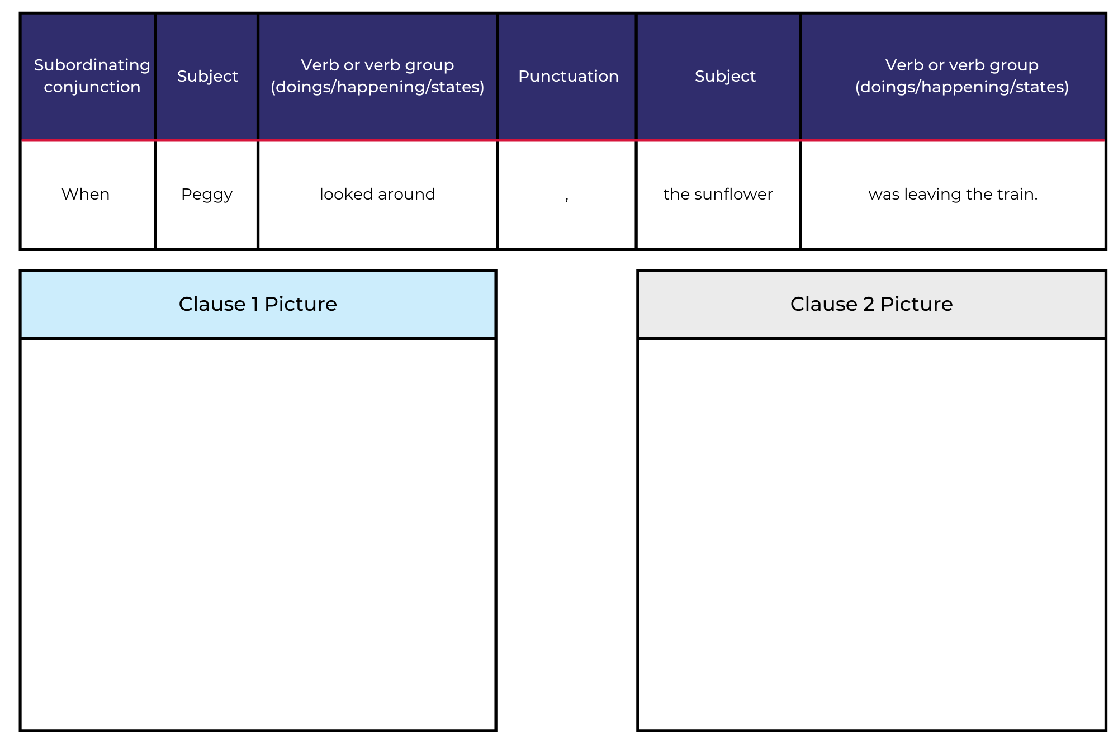
Write Super Peggy sentences in the frame.
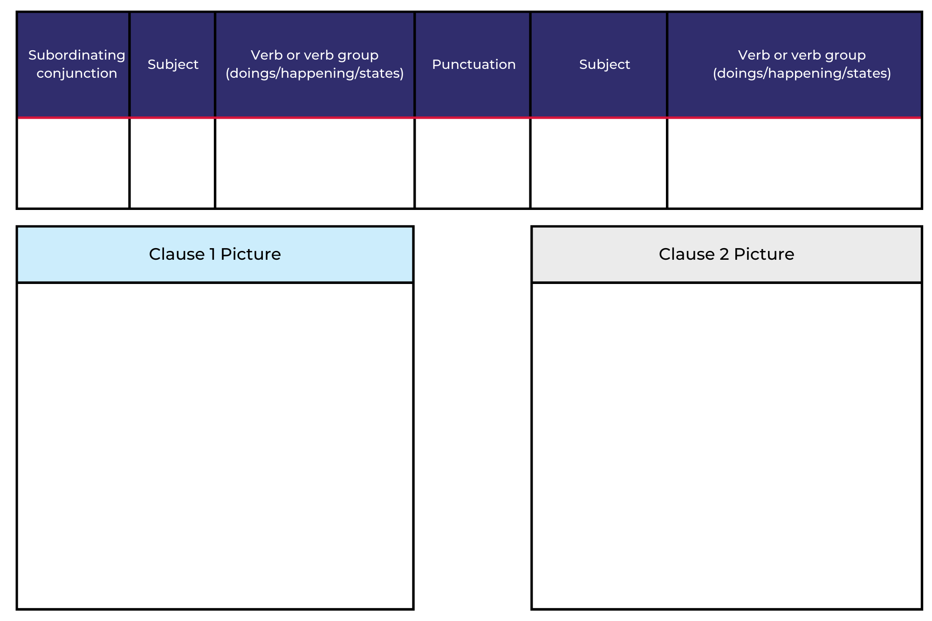

Resource 7: Types of verbs (teacher resource)
Type | Verbs from ‘Where the Wild Things Are’ | Other verbs
action | wore, made, sent, eating, grew, hung, tumbled, sailed, roared, gnashed, rolled, showed, tamed, staring, blinking, let, smelled, gave, eat, stepped, waved, found, waiting | skip, dance, swim, run
saying | called, said, cried | talk, say, whisper, shout, speak
sensing | frightened, wanted, loved | think, dream, hear, feel
relating | was, became, are, be, were | is, am

Resource 8: Puppets
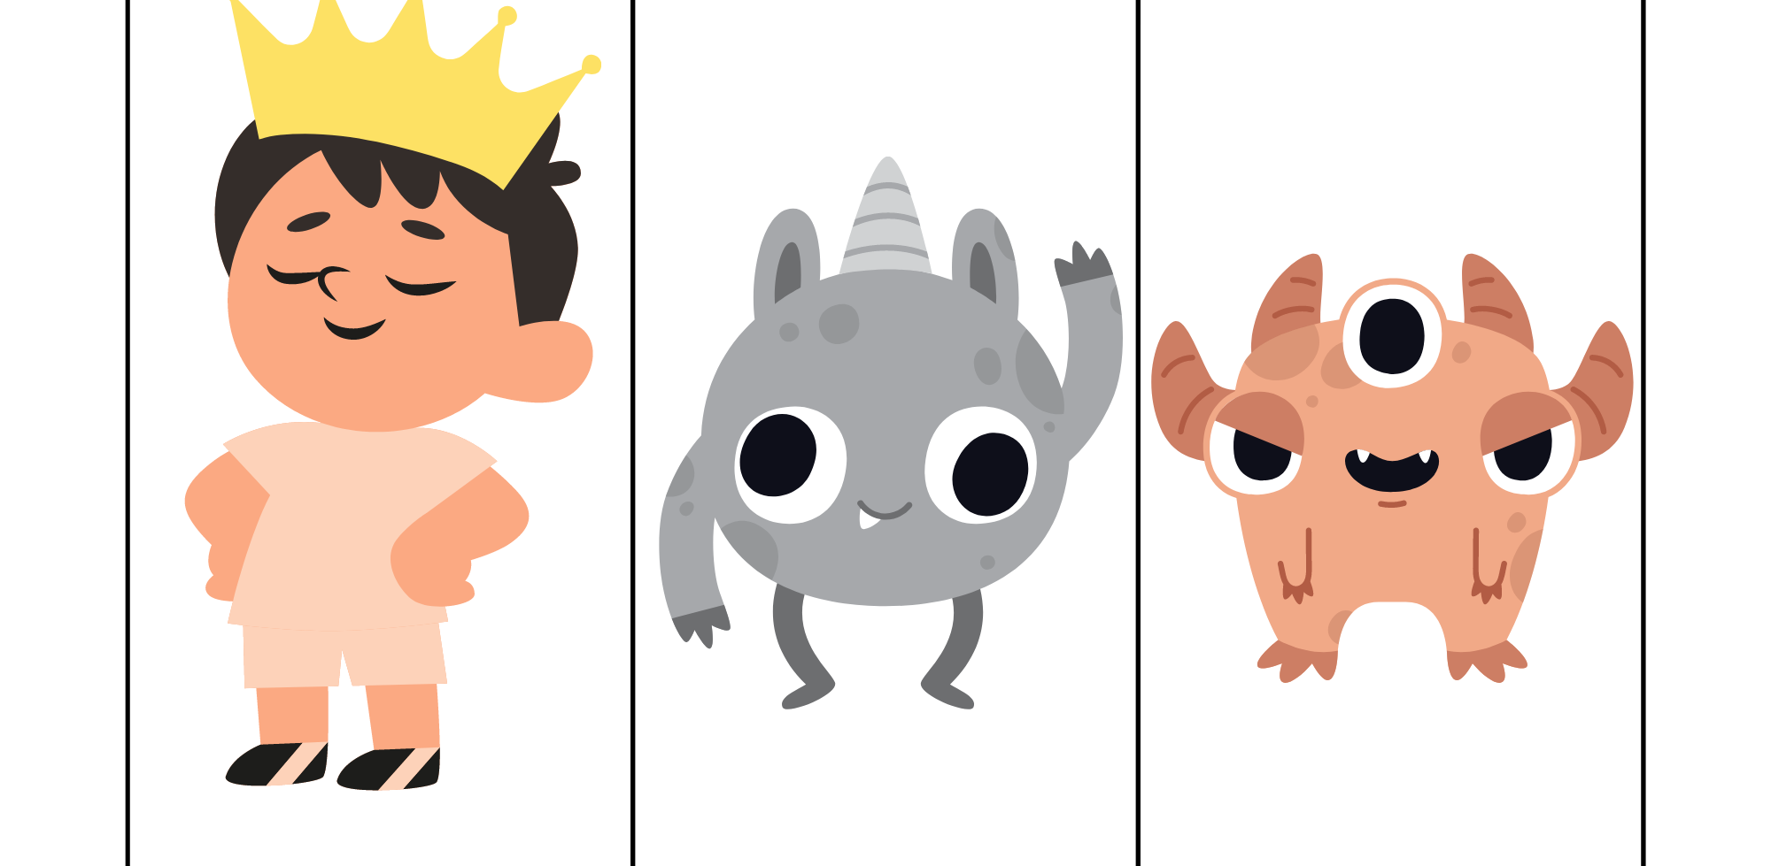
Images sourced from Canva and used in accordance with the Canva Content License Agreement.
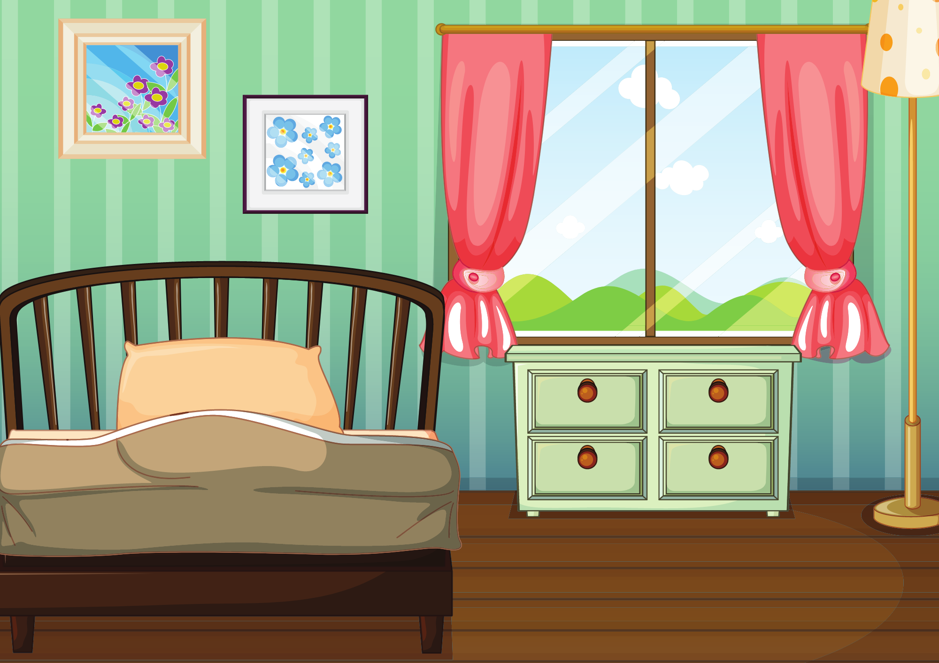
“An Empty Bedroom” by blueringmedia is sourced from Canva and used in accordance with the Canva Content License Agreement.
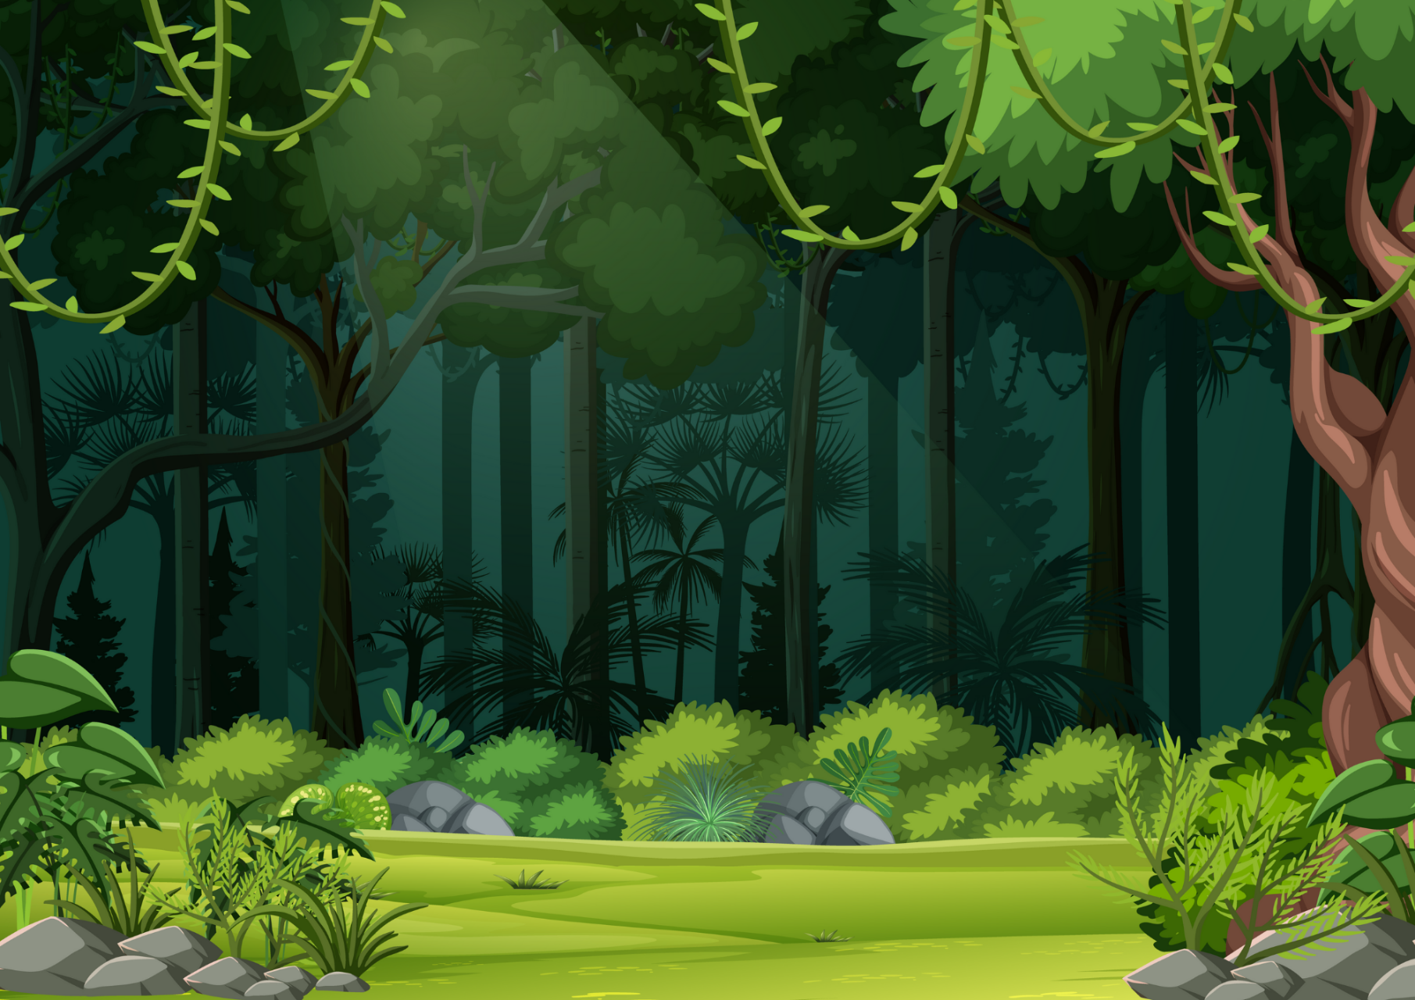
“Nature forest landscape background” by blueringmedia sourced from Canva and used in accordance with the Canva Content License Agreement.

“Empty nature beach ocean” by Matthew Cole and “Boat” by blueringmedia sourced from Canva and used in accordance with the Canva Content License Agreement.

Resource 9: Author hot seat questions
Imagine if your adventure had a different setting. What can you see? | How does your Super Animal feel when they are away from home?
Imagine if your character had a different superpower. What would it be? | What other adventures has your character been on?
We have been looking at circular narratives. How did your Super Animal change from the beginning of the story to the end of the story? | What was your favourite part of the adventure? Tell me why.

References
Links to third-party material and websites
Please note that the provided (reading/viewing material/list/links/texts) are a suggestion only and implies no endorsement, by the New South Wales Department of Education, of any author, publisher, or book title. School principals and teachers are best placed to assess the suitability of resources that would complement the curriculum and reflect the needs and interests of their students.
If you use the links provided in this document to access a third-party's website, you acknowledge that the terms of use, including licence terms set out on the third-party's website apply to the use which may be made of the materials on that third-party website or where permitted by the Copyright Act 1968 (Cth). The department accepts no responsibility for content on third-party websites.
Except as otherwise noted, all material is © State of New South Wales (Department of Education), 2021 and licensed under the Creative Commons Attribution 4.0 International License. All other material (third-party material) is used with permission or under licence. Where the copyright owner of third-party material has not licensed their material under a Creative Commons or similar licence, you should contact them directly for permission to reuse their material.
English K–10 Syllabus © 2022 NSW Education Standards Authority (NESA) for and on behalf of the Crown in right of the State of New South Wales.
© 2021 NSW Education Standards Authority. This document contains NSW Curriculum and syllabus content. The NSW Curriculum is developed by the NSW Education Standards Authority. This content is prepared by NESA for and on behalf of the Crown in right of the State of New South Wales. The material is protected by Crown copyright.
Please refer to the NESA Copyright Disclaimer for more information.
NESA holds the only official and up-to-date versions of the NSW Curriculum and syllabus documents. Please visit the NSW Education Standards Authority (NESA) website and the NSW Curriculum website.
National Literacy Learning Progression © Australian Curriculum, Assessment and Reporting Authority (ACARA) 2010 to present, unless otherwise indicated. This material was downloaded from the Australian Curriculum website (National Literacy Learning Progression) (accessed 18 August 2022) and was not modified. The material is licensed under CC BY 4.0. Version updates are tracked in the ‘Curriculum version history’ section on the 'About the Australian Curriculum' page of the Australian Curriculum website.
ACARA does not endorse any product that uses the Australian Curriculum or make any representations as to the quality of such products. Any product that uses material published on this website should not be taken to be affiliated with ACARA or have the sponsorship or approval of ACARA. It is up to each person to make their own assessment of the product, taking into account matters including, but not limited to, the version number and the degree to which the materials align with the content descriptions and achievement standards (where relevant). Where there is a claim of alignment, it is important to check that the materials align with the content descriptions and achievement standards (endorsed by all education Ministers), not the elaborations (examples provided by ACARA).
ETA (English Teachers Association) and NSW Department of Education (2016) Narrative, English Textual Concepts website, accessed 18 August 2022.
ETA (English Teachers Association) and NSW Department of Education (2016) The Textual Concepts and Processes resource, English Textual Concepts website, accessed 18 August 2022.
Fox M (1991) Koala Lou (Lofts P, illus.), Picture Puffin, Australia (original work published 1988).
Sendak M (2012) Where the Wild Things Are, Harper Trophy, New York (original work published 1963).
Walker A (2014) Peggy: A Brave Chicken on a Big Adventure, Houghton Mifflin Harcourt, Boston.

