Concepts of music

Teaching resources

Stage 5

Table of contents
Concepts of music 1
Teaching resources 1
Stage 5 1
Table of contents 2
Duration resources 7
The concepts of music 8
Duration 8
Pitch 8
Tone colour 8
Structure 8
Texture 8
Dynamics and expressive techniques 8
Duration 9
Definitions 9
Beat 9
Rhythm 9
Time Signature 9
Tempo 9
Note Values 9
Syncopation 9
Ostinato 9
Anacrusis 9
Multimetre 9
Duration match up 10
Note values 11
Musical numeracy activity 11
Exercise 1 11
Exercise 2 11
Dotted notes 12
Triplets 13
Rhythm sheet 14
Time signatures 15
Simple time 15
Compound time 15
Multimetre 16
Musical numeracy activity 16
Simple and compound time exercises 18
Simple time 18
Exercise 1 18
Exercise 2 18
Compound time 20
Exercise 1 20
Exercise 2 20
Rhythm homework sheet 22
Rhythmic dictations 24
Tempo 26
Listening - answers 26
Syncopation 27
Syncopation using rests 27
Syncopation using ties 27
Syncopation using accents 27
Listening activity 28
Duration — what am I listening for? 30
Listening activity 30
Listening activity - answers 32
Duration 34
Listening — Paragraph response 34
Steps 34
Pitch resources 35
Pitch definitions 36
Tonality 36
Melody 36
Harmony 36
Shape 36
Contour 36
Range 36
Register 36
Rate of harmonic change 36
Pitch— what am I listening for? 37
Listening activity 37
Pitch paragraph response 39
‘All is Found’ by Alan Menken 39
Class performance recording 39
Note naming 39
Treble clef 40
Note names 40
Bass clef 41
Note names 41
Scales 44
Major scales 44
C major 44
G major 44
F major 44
Minor scales 44
A natural minor scale 45
E natural minor scale 45
D natural minor scale 45
A harmonic minor 45
E harmonic minor 45
D harmonic minor 46
Chromatic scales 46
C chromatic 46
Extension 47
Melodic minor scales 47
A melodic minor scale 47
E melodic minor scale 47
D melodic minor scale 47
Scale composition 48
Steps 48
Example 48
Tone and semitone scale composition 49
Steps 49
Example 50
Key signatures 51
Major or minor melodies? 52
Listening activity 52
Major and minor key signatures 53
Activity 53
Activity — answers 55
Writing a melody and chords 56
Steps 56
Tips 58
Scale degrees and triads 60
Scale degrees 60
Triads 61
Activity 61
Answers 62
Intervals 63
Activity 63
Exercise 1 63
Exercise 2 63
Homework 64
Answers 65
Exercise 1 65
Exercise 2 65
Exercise 3 65
The pentatonic scale 66
Performance 66
Listening 66
Composition 67
Structure resources 68
Structure 69
Forms 69
Binary form 69
Ternary form 69
Rondo form 69
Theme and variations 69
Through composed 69
Strophic form 69
Verse/chorus form 69
Structure composition activity 70
Composition/performance/listening 70
Steps 70
Graphic notation grid 72
Section 72
Graphic notation grid 75
Structure examples 76
Through form 76
Binary form 76
Ternary form 77
Rondo form 77
Strophic form 79
‘Amazing Grace’ by John Newton 79
Theme and variations form 80
Listening 80
Activity 80
Extension 82
Composition/performance 82
Answers 83
Verse chorus form 85
Intro 85
Verse 85
Pre-chorus 85
Chorus 85
Bridge 85
Solo/instrumental 85
Outro 86
Activity — listening 86
Tone colour resources 87
Tone colour — what am I listening for? 88
Activity — listening 88
Timbre words 89
Activity — listening answers 90
Instrument match up 91
Activity 91
Who am I? 92
Activity 92
Woodwind 92
Brass 93
Strings 93
Tuned percussion 94
Untuned percussion 94
Tone colour research task 95
Texture resources 96
Texture 97
What am I listening for? 97
Activity — listening 97
Texture listening example 99
Listening 99
Activity 99
Dynamics and expressive techniques resources 100
Dynamics and expressive techniques 101
Dynamics 101
Expressive techniques 102
Dynamics and expressive techniques 103
Listening 103
Activity 103
Activity — listening answers 103
Match up activity 105
Dynamics and expressive techniques 105
Revision 105
Image references 107

Duration resources

The concepts of music

Duration
The speed of a piece of music as well as the lengths of sound and organisation of notes and rests.

Pitch
The highness and lowness of sound and their combinations.

Tone colour
The instruments, voices and performing media used in a piece of music as well as describing the quality of the sound using adjectives.

Structure
The order of sections and ideas in a piece of music.

Texture
The layers of sound.

Dynamics and expressive techniques
Dynamics refers to the volume (loudness/softness) of sound. Expressive techniques refer to the manipulation of other concepts for expressive or stylistic purposes.

Duration

Definitions

Beat
The consistent pulse of a piece of music.

Rhythm
Long and short sounds organised into patterns.

Time Signature
How many beats and what type of beats are in each bar.

Tempo
The speed of a piece of music.

Note Values
The length of individual notes and rests described as short or long.

Syncopation
When a rhythm is played or accented off the beat

Ostinato
A short, repeated rhythmic or melodic pattern.

Anacrusis
When the first and last bar of a piece of music add up to one whole bar. It is also known as a ‘pick up’.

Multimetre
When the time signatures change throughout a piece of music.

Duration match up
Draw a line to match the duration word to its definition or colour code them with textas or pencils.

Duration | Definition
Tempo | When the first and last bar of a piece of music add up to one whole bar. It is also known as a ‘pick up’.
Multimetre | The consistent pulse of a piece of music.
Beat | Long and short sounds organised into patterns.
Ostinato | How many beats and what type of beats are in each bar.
Backbeat | The speed of a piece of music.
Syncopation | The length of individual notes and rests described as short or long.
Rhythm | When a rhythm is played or accented off the beat.
Time signature | An accent placed on beats two and four.
Note values | A short, repeated rhythmic or melodic pattern.
Anacrusis | When the time signatures change throughout a piece of music.

Note values
Note name | Note | Rest name | Rest | Value
semibreve |  | semibreve rest |  | four beats
minim |  | minim rest |  | two beats
crotchet |  | crotchet rest |  | one beat
quaver |  | quaver rest |  | ½ beat
semiquaver |  | semiquaver rest |  | ¼ beat

Musical numeracy activity
Complete the exercises below.

Exercise 1
Draw the note value and rest that corresponds to the values given below:

- two beats ________________________________
- four beats ________________________________
- ¼ beat ________________________________
- one beat ________________________________
- ½ beat ________________________________

Exercise 2
Name the following symbols and write down how many beats they go for. The first one has been done for you.
Note | Name | value
 | semiquaver | ¼ beat
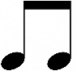
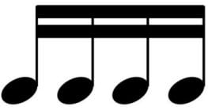

Exercise 3
Add the following note values together. The first one has been done for you.
Activity | Notes | Total
A) | + + = | 7 beats
B) | + + + =
C) | + + + + + =
D) | + + + + + =
E) | + + + + + =

Dotted notes
A dot next to a note adds half the value of the original note. For example:
Note name | Note | Value
dotted minim | 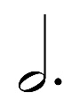 | 3 beats
dotted crotchet | 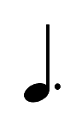 | 1 ½ beats
dotted quaver | 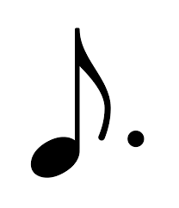 | ¾ beat

Extension
Note name | Note | Value
dotted semibreve |  | 6 beats
dotted semiquaver |  | 3/8 beat

Triplets
A triplet is three notes performed in the time of two. For example:
Note name | Note | Value
quaver triplet | 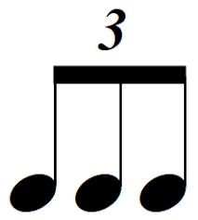 | one beat
crotchet triplet | 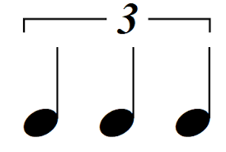 | two beats
semiquaver triplet | 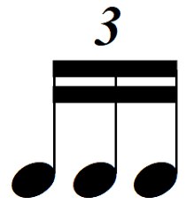 | ½ beat

Rhythm sheet
Perform the following rhythms in pairs or small groups using percussion instruments or bucket drums.
Phrase | Score
1
2
3
4
5
6
7
8
9
10

Time signatures
A time signature tells us how many beats and what type of beats per bar. It consists of two numbers written on top of one another at the beginning of a piece of music.
The top number tells us how many beats are in each bar. For example, four.
The bottom number tells us what type of beats are in each bar. For example, crotchet beats. The time signature below stands for 4 crotchet beats per bar.
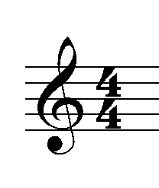
When the bottom number is a 2 they are minim beats.
When the bottom number is a 4 they are crotchet beats.
When the bottom number is an 8 they are quaver beats.
When the bottom number is a 16 they are semiquaver beats.

Simple time
Simple time is based on whole beats like crotchets or minims. For example, the following time signatures are examples of simple time:
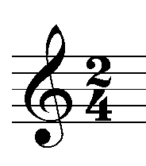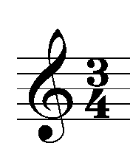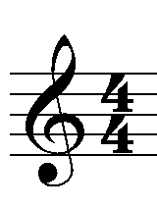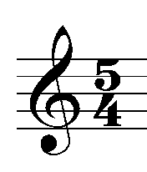

Compound time
Compound time is based on dotted beats such as dotted crotchets and will sound like there are three fast pulses within in each main beat. The following time signatures are examples of compound time:
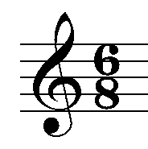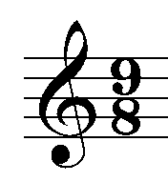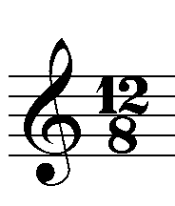

Multimetre
Multimetre is when a piece of music changes time signatures throughout the piece. This creates rhythmic interest in a piece of music. For example, the time signature may change from 4/4 to 5/4 to ¾.
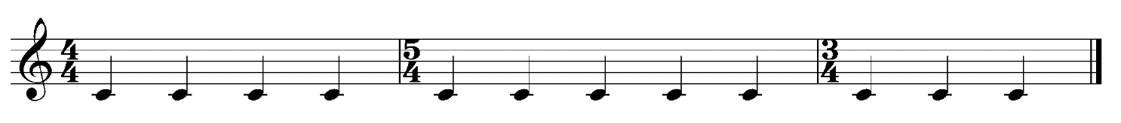

Musical numeracy activity

Exercise 1
Give the definition for the following time signatures:
- …………………………………………………………………………
- …………………………………………………………………………
- …………………………………………………………………………
- …………………………………………………………………………
- …………………………………………………………………………
- 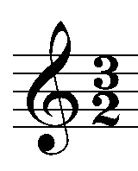 …………………………………………………………………………

Exercise 2
Add notes to make up the correct number of beats per bar:

Exercise 3
Add bar lines to the following rhythms:

Exercise 4
Add a time signature to the following rhythms:

Simple and compound time exercises

Simple time

Exercise 1
Clap the following rhythms in simple time.

Exercise 2
Add bar lines to the following rhythms in simple time.

Exercise 3
Add a simple time signature to the following rhythmic patterns.

Exercise 4
Complete each bar of simple time by adding rests.
- 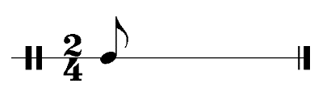

Compound time

Exercise 1
Clap the following rhythms in compound time.

Exercise 2
Add bar lines to the following rhythms in compound time.
- 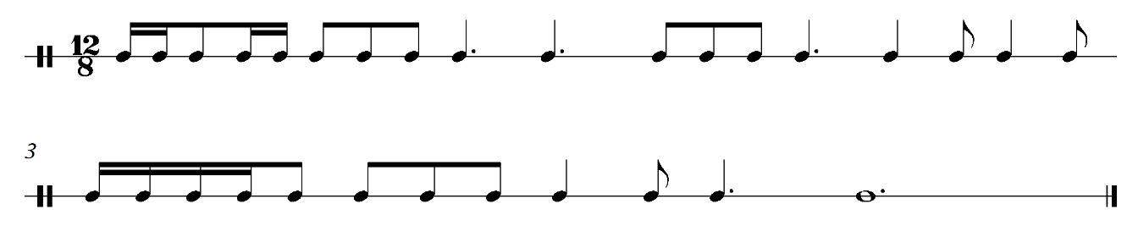

Exercise 3
Add a compound time signature to the following rhythmic patterns.

Exercise 4
Complete each bar of compound time by adding rests.
- 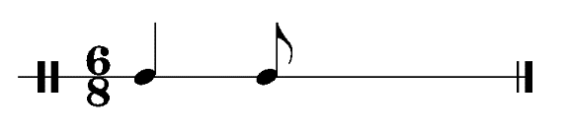
- 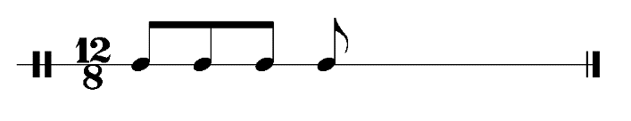

Rhythm homework sheet
Name the notes in the table below and write how many beats they go for.

Note | Note name and duration
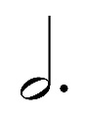
Add the note values together in the table below.

Number | Notes | Answer
A) | + + + 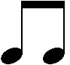 =
B) | + + 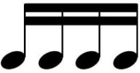 + + + =
C) | + + + + + + =
D) | + + + + + + =
E) | + + + + + =
What is a time signature? ……………………………………………………………………………………………………………………………………………………………………………………………………………………

For the following time signatures, state the number and type of beats per bar:
- 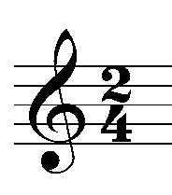 …………………………………………………………………………
- 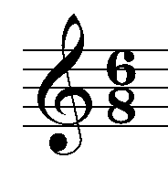 …………………………………………………………………………
- 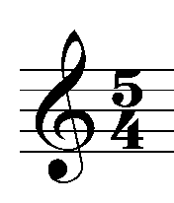 …………………………………………………………………………
- 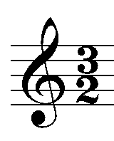 …………………………………………………………………………

Add bar lines to the following rhythms:

Rhythmic dictations
Clap the following rhythms three or more times. Students are to write the rhythm in their books or on manuscript. This can be used as a starter activity for each lesson.

Number | Rhythm
1
2
3
4
5
6
7
8
9
10
11
12
13
14
15
16
17
18
19
20

Tempo
Tempo is the speed of a piece of music. The following Italian terms are commonly used to describe the tempo of a piece of music:
- Largo – slowly (40 – 60 bpm)
- Adagio – at ease (66 – 76 bpm)
- Andante – at an easy walking pace (76 – 108 bpm)
- Moderato – at a moderate speed (108 – 120 bpm)
- Allegro – fast and lively (120 – 156 bpm)
- Vivace – very fast (156 – 176 bpm)
- Presto – very fast (168 – 200 bpm)

Listening - answers
Listen to excerpts below and determine the tempo.
- ‘Can’t Stop The Feeling’ by Justin Timberlake (00:03:59) (date accessed 27/10/2020) (moderato/allegro)
- ‘Sleeping on My Dreams’ by Jacob Collier (00:04:18) (date accessed 27/10/2020) (moderato)
- ‘Symphony No. 9’ by Dvorak (00:03:04) audio(date accessed 28/10/2020) (allegro)
- ‘Requiem’ by Mozart (00:08:53) audio (date accessed 28/10/2020) (largo)
- ‘Hey Jude’ by The Beatles (00:07:05) audio (date accessed 28/10/2020) (andante)
- ‘Back in Black’ by AC/DC (00:04:14) audio (date accessed 28/10/2020) (andante)
- ‘Summertime’ by Gershwin (00:05:06) audio (date accessed 28/10/2020) (adagio)
- ‘The Incredibles’ by Giacchino (00:08:00) audio (date accessed 28/10/2020) audio (presto)

Syncopation
Syncopation is when a rhythm is played off the beat. There are three types of syncopation. Syncopation using rests, syncopation using ties and syncopation using accents. Listen to each excerpt and clap the rhythm through as a class. You may even like to mark where the beat falls with sticks above the music.

Syncopation using rests
This is when rests are placed ………………………………………………………… and notes are placed …………………………………………………………………………………………

For example: ‘Billie Jean’ by Michael Jackson (00:00:00 – 00:00:46) audio (bass and synthesizer part) (date accessed 30/10/2020)

Syncopation using ties
A tie is a line that joins two notes of the same pitch together. Instead of playing them separately, you play them as one note. Syncopation using ties is when the ties are placed ………………………………………………………

For example: ‘The Simpsons’ theme song by Danny Elfman (00:00:08 – 00:00:23) (date accessed 30/10/2020)

Syncopation using accents
An accent is an arrow placed above or below a note which means that you need to play
it stronger than the other notes. Syncopation using accents is when accents are placed
………………………………………………………
For example: ‘Dance of the Young Maidens’ from ‘The Rite of Spring’ by Stravinsky (00:00:00 – 00:00:11) audio (date accessed 30/10/2020)

Listening activity

Listen to each example and identify which types of syncopation are used:

- ‘Flight of the Bumblebee’ by Rimsky-Korsakov (00:03:25) audio (date accessed 30/10/2020)
- ‘Skyfall’ by Adele (00:04:49) audio (date accessed 30/10/2020)
- ‘Demons’ by Imagine Dragons (00:03:56) audio (date accessed 30/10/2020)
- ‘Superstition’ by Stevie Wonder (00:04:27) audio (date accessed 30/10/2020)
- ‘Crazy in Love’ by Beyonce (00:04:35) audio (date accessed 30/10/2020)
- ‘To The Pirates Cave’ from Pirates of the Caribbean by Klaus Bedelt (00:03:30) audio (date accessed 30/10/2020)
- ‘Count Bubba’ by Gordon Goodwin’s Big Phat Band (00:07:33) audio (date accessed 30/10/2020)
- ‘Ode to Joy’ by Beethoven (00:12:57) audio (date accessed 10/11/2020)

Example | No syncopation | Syncopation using rests | Syncopation using ties | Syncopation using accents
1
2
3
4
5
6
7
8

Listening activity — answers

Syncopation using rests
This is when rests are placed on the beat and notes are placed off the beat.

Syncopation using ties
A tie is a line that joins two notes of the same pitch together. Instead of playing them separately, you play them as one note. Syncopation using ties is when the ties are placed over the beat.

Syncopation using accents
An accent is an arrow placed above or below a note which means that you need to play
it stronger than the other notes. Syncopation using accents is when accents are placed
off the beat.
Listen to each example and identify which types of syncopation are used:
Example | No syncopation | Syncopation using rests | Syncopation using ties | Syncopation using accents
1 | X
2 |  |  | X
3 |  |  | X
4 |  | X
5 |  | X
6 |  |  |  | X
7 |  |  |  | X
8 | X

Duration — what am I listening for?
There are many elements within the concept of duration to listen for when you are analysing a piece of music. Students are to discuss and define the following elements with the concept of duration and write them down in their books:
- beat – is the beat strong or weak? Definite or indefinite?
- time signature – what is the time signature? Does it contain multimetre?
- note values – listen to the note values of each individual instrument. Are they long or short? Could you identify them in more detail? For example, quavers, crotchets, minims.
- syncopation – identify if any syncopation is used and the type of syncopation used. For example, accents, rests or ties.
- bar lengths – are the bar lengths regular or does it contain multimetre?
- tempo – identify the tempo using Italian terms.

Listening activity
Listen to one minute of the following excerpts and identify the duration elements contained within each piece on the following page. The final two excerpts can be the students own choice.
- ‘Under the Sea’ from ‘The Little Mermaid’ by Alan Menken (00:03:15) audio (date accessed 30/10/2020)
- ‘Watermelon Sugar’ by Harry Styles (00:02:53) audio (date accessed 30/10/2020)
- ‘Russian Rag’ by Elena Kats-Chernin (00:04:29) audio (date accessed 30/10/2020)
- ‘Mission Impossible Theme’ by Lalo Schifrin (00:03:27) audio (date accessed 30/10/2020)

Piece | Beat | Time signature | Note values | Syncopation | Bar lengths | Tempo
‘Under the Sea’ from ‘The Little Mermaid’ by Alan Menken
‘Watermelon Sugar’ by Harry Styles
‘Russian Rag’ by Elena Kats-Chernin
‘Mission Impossible Theme’ by Lalo Schifrin
Title
Title

Listening activity - answers
Piece | Beat | Time signature | Note values | Syncopation | Bar lengths | Tempo
‘Under the Sea’ from ‘The Little Mermaid’ by Alan Menken | strong and definite | 4/4 | short note values used including quavers and semiquavers | yes using rests and accents | regular | moderato
‘Watermelon Sugar’ by Harry Styles | strong and definite | 4/4 | a combination of note values are used from semiquavers to semibreves | yes using rests and accents | regular | andante/moderato
‘Russian Rag’ by Elena Kats-Chernin | weak and indefinite due to rubato | 4/4 | mainly short to medium note values including quavers to minims | Yes using ties | regular however they sound irregular at times due to the use of rubato | Andante/moderato  The tempo changes throughout due to the use of rubato
‘Mission Impossible Theme’ by Lalo Schifrin | strong and definite but indefinite in the very first section due to the trill. | 5/4 and then changes to 4/4 | a combination of note values are used from short quavers and crotchets to longer semibreves in the main melody | yes using rests, accents and ties | irregular due to multimetre | presto
Title
Title

Duration

Listening — Paragraph response
‘Watermelon Sugar’ by Harry Styles (00:02:53) audio (date accessed 30/10/2020)

Steps
- Identify the structure of the first two sections (or more)
- The first paragraph should contain duration elements that are common to the whole excerpt. For example, time signature, tempo, bar lengths and beat.
- The following paragraphs should outline the note values and rhythmic devices used for each individual instrument in each section. For example, crotchets, quavers and syncopation.
- Other musical observations may be included if they relate to or support the duration element.
- Students are to write the following model response in their books (done as a class.)

Verse 1
The verse begins in 4/4 time at a moderato tempo. It contains regular bar lengths and the beat is strong and definite due to the accent placed on beat 1 by all instruments and the chords changing once per bar.
The note values sung by the male vocalist include mainly short note values such as semiquavers thorough to minims and uses syncopation using rests and ties. The electric guitar plays a 1 bar syncopated repeated rhythm using chords. The note values are very short and include mainly semiquavers. The synthesizer plays chords on beat 1 of each bar using semibreves.

Prechorus
The note values of the vocals change and become longer in duration by using more minims at the ends of phrases. The synthesizer and guitar remain the same, however, a bass is added which rhythmically doubles the synthesizer by playing semibreves on the beat to outline the chord progression.

Pitch resources

Pitch definitions

Tonality
Whether a piece is in a major or minor key.

Melody
The tune of a piece of music.

Harmony
The chords (two or more notes combined) that provide the pitch accompaniment to the melody. It can be described as consonant (nice sounding) or dissonant (clashing sounding).

Shape
Whether the notes of an instrument are moving in steps or leaps.

Contour
Whether the notes of an instrument are either ascending, descending or a combination.

Range
The distance between the lowest and highest notes heard. For example, small, medium or wide.

Register
Whether an instrument is playing in its low, middle or high register.

Rate of harmonic change
How often the chords change. For example, once per bar, twice per bar.

Pitch— what am I listening for?
There are many elements within the concept of pitch to listen for when you are analysing a piece of music. Students are to discuss and define the following elements with the concept of pitch and write them down in their books.
- Tonality – is the piece in a major or minor key?
- Melody – which instrument provides the main melody in the piece?
- Shape – do the notes of the melody move in steps or leaps or a combination?
- Contour – are the notes of the melody ascending or descending or a combination?
- Range – describe whether the notes of the melody use a small, medium or wide range of notes.
- Register – describe if the main melodic instrument is using its low, middle or high register.
- Harmony – are the chords used consonant or dissonant?

Listening activity
Listen to the following excerpts and identify the pitch elements contained within each piece. For the first excerpt, students are to use their own recording that they took on their phone of the class performance.
Students are to complete another two excerpts of their own choice for homework.

Piece | Tonality | Melody | Shape | Contour | Range | Register | Harmony
‘All is Found’ class performance
‘Zebra’ (00:03:59) accessed 11/11/2020 by The John Butler Trio’
Eine Kleine Nachtmusik - Mozart (00:05:47) accessed 11/11/2020 by Mozart
‘Dead Silence’ (00:02:59) accessed 11/11/2020 by Nathan Sharp

Pitch paragraph response

‘All is Found’ by Alan Menken

Class performance recording
- Identify the structure of the first two sections (or more)
- The first sentence should outline the tonality of the piece and then the pitch elements of each individual instrument should be described under section headings. For example, shape, contour, range, register, harmony, rate of harmonic change.
- Other musical observations may be included if they relate to or support the pitch element.
- Students are to write the following model response in their books (done as a class.)

The model response below is a suggestion only. Your own class performance and therefore analysis, will vary depending on your arrangement.

Intro
The tonality of this piece is minor which is outlined by the piano chords at the beginning of the excerpt. The main pitch instrument is the piano which is playing broken chords which move in small leaps using an ascending contour. It is playing in its middle register, using a small range of notes. The harmony is consonant, and the rate of harmonic change is once to twice per bar.

Verse 1
The vocals then enter providing the melody, whilst the piano provides harmonic accompaniment. The vocals use a combination of steps and leaps using both an ascending and descending contour. The vocals are singing in their low to middle register and use a small range of notes. The melody is legato and flowing.
The piano continues to play chords, although a bass note is now added which extends the piano range to medium. The harmony remains consonant and the rate of harmonic change also stays the same.

Verse 2
Verse 2 sees the introduction of the backing vocals which now provide a harmony to the lead vocals. Both vocal parts use mainly steps and some small leaps in both an ascending and descending direction. The range of notes used is small and they use their low to middle register. The piano and lead vocals continue the same musical material as heard in verse 1. All vocal parts are sung legato. The harmonic features remain the same as the previous sections.

Note naming
The five lines in music are called a staff or stave.

Treble clef

Note names
Lines
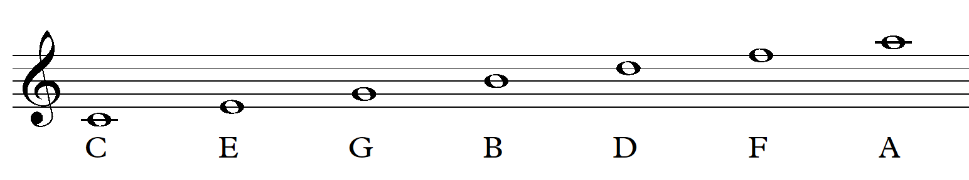
Spaces
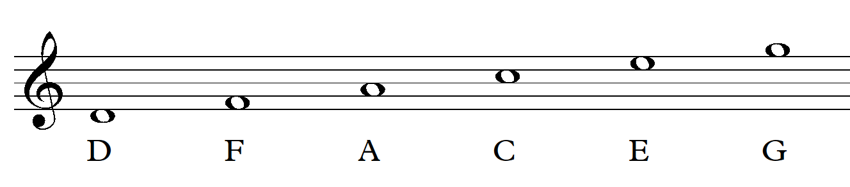

Can you think of a creative reverse acronym for each of the above letter names? For example:
Lines: Cats Eat Grass Because Dogs Fly Away
Spaces: Don’t Forget A Chocolate Egg Greg!
Lines: ………………………………………………………………………………………………
Spaces: ……………………………………………………………………………………………

Exercise 1
Draw a line of treble clefs:

Exercise 2
Name these notes:
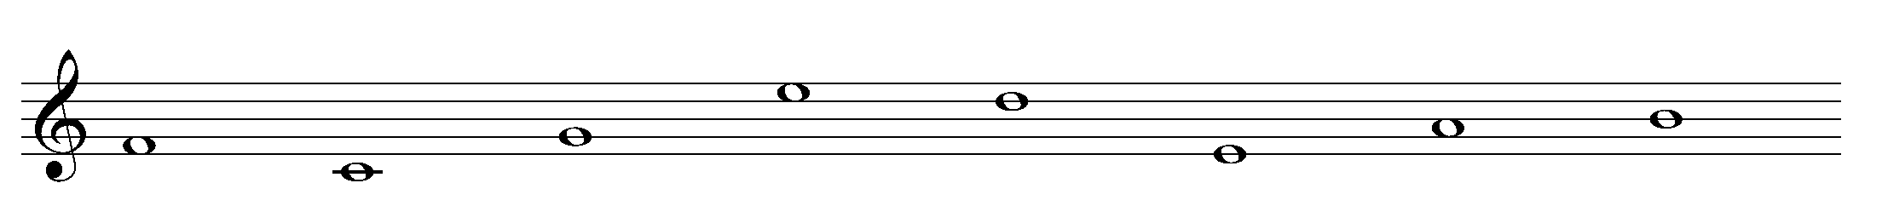

Exercise 3
Draw these notes as crotchets: F (line), middle C, G (line) E (space) D (line) C (space)

Exercise 4
Create a four to seven letter word using note names (A, B, C, D, E, F, G). You can repeat letters if needed. Draw the notes of that word on the stave using quavers:

Bass clef

Note names
Lines
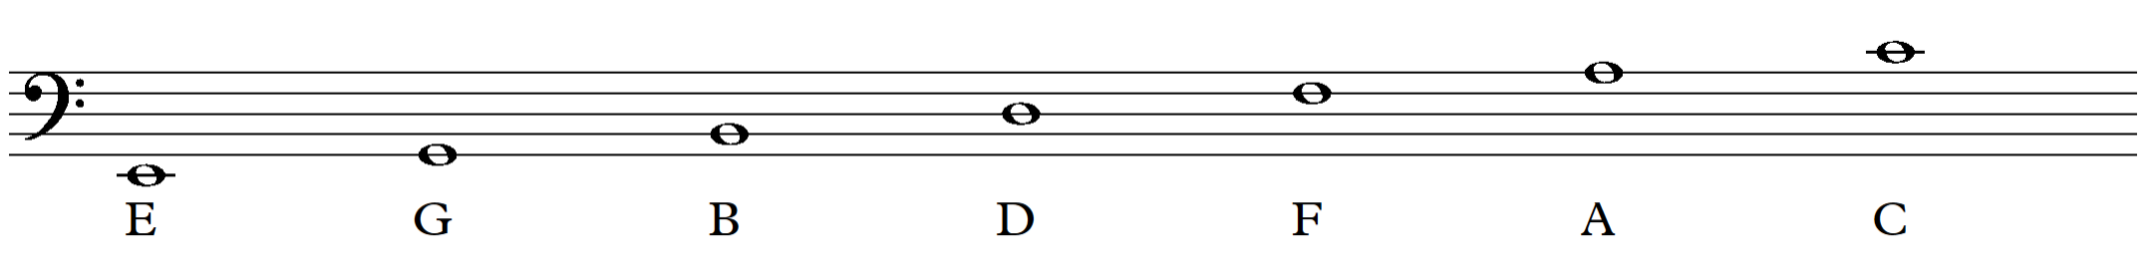
Spaces
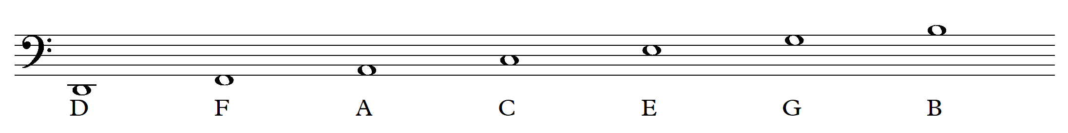

Can you think of a creative reverse acronym for each of the above letter names? For example:
Lines: Every Good Boy Deserves Fish And Chips
Spaces: Ducks Fly And Chicken Eggs Go Bad
Lines: ………………………………………………………………………………………………
Spaces: ……………………………………………………………………………………………

Exercise 1
Draw a line of bass clefs:

Exercise 2
Name these notes:
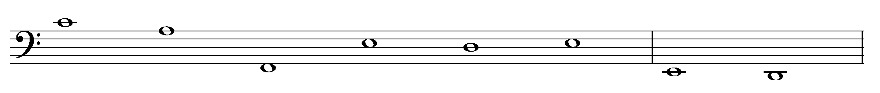

Exercise 3
Draw these notes as minims: F (space), D (line), B (space), Middle C, A (line), G (line)

Exercise 4
Create a four to seven letter word using note names (A, B, C, D, E, F, G). You can repeat letters if needed. Draw the notes of that word on the stave using semibreves:

Scales
A scale is a pattern of ascending and descending notes which move in small steps known as tones and semitones.
A tone is a whole step. For example, from C to D.
A semitone is a half-step. For example, from C to C#.

Major scales
A major scale is made up of the following pattern:
T, T, S, T, T, T, S.
Play through the following major scales on your own instrument or virtual keyboard, and label the tones and semitones.

C major
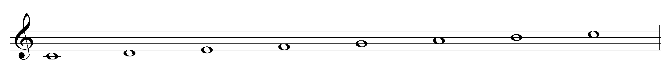

G major
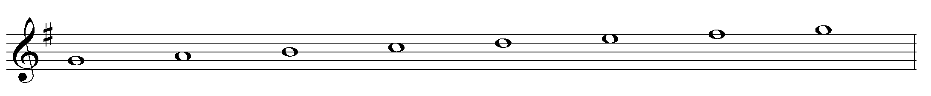

F major
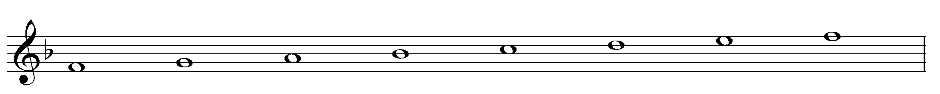

Minor scales
There are three types of minor scales: the natural minor scale, the harmonic minor scale and the melodic minor scale. A minor scale is made up of the following pattern:
T, S, T, T, S, T, T.
The pattern above is for the natural minor scale which only uses the key signature.
Play through the following natural minor scales on your own instrument or virtual keyboard and label the tones and semitones.

A natural minor scale
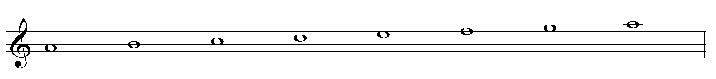

E natural minor scale
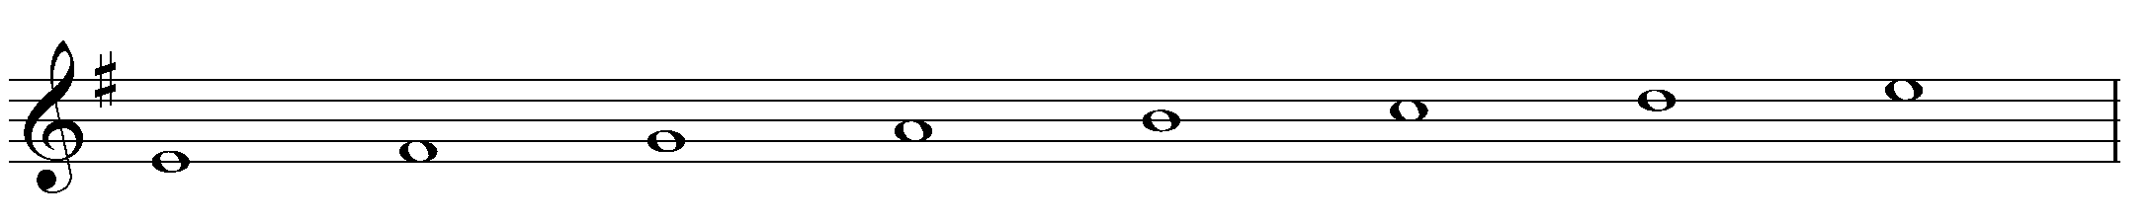

D natural minor scale
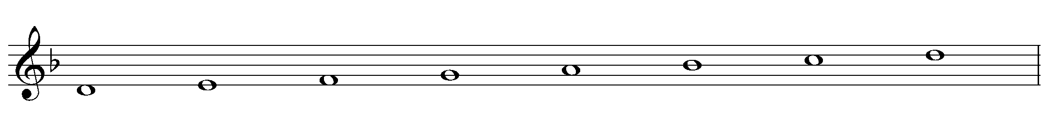
A harmonic minor scale uses the same pattern however, the 7th note of the scale is raised by a semitone and is written as an accidental. Play through the following harmonic minor scales on your instrument or keyboard. How do they sound different from the natural minor scales?

A harmonic minor
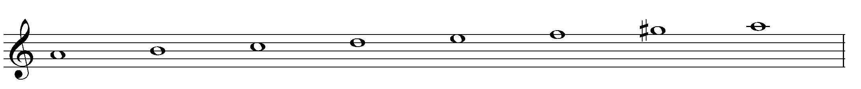

E harmonic minor
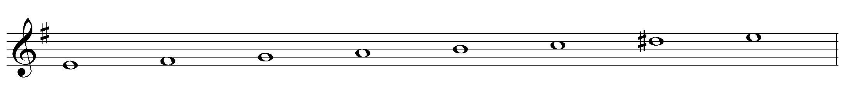

D harmonic minor
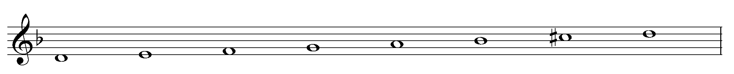

Chromatic scales
The chromatic scale is made up entirely of semitones. Play through the C chromatic scale and listen to how it sounds.

C chromatic
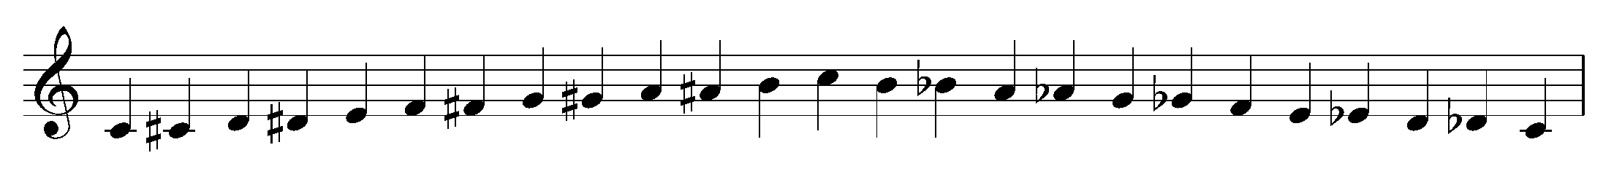

Extension

Melodic minor scales
A melodic minor scale uses the same pattern as the natural minor scale, however on the way up the scale, the 6th and 7th notes are raised. On the way down the 6th and 7th return to their normal notes and you play the key signature only. Play through the following melodic minor scales on your instrument or keyboard. How would you distinguish them from the other types of minor scales?

A melodic minor scale

E melodic minor scale
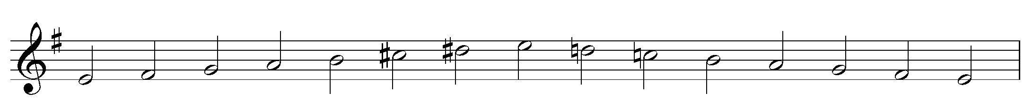

D melodic minor scale
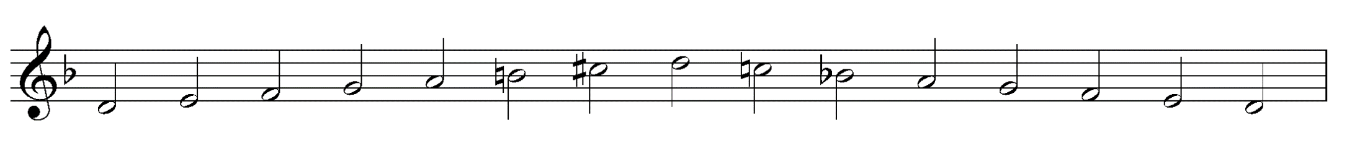

Scale composition
For this activity you will need:
- your instrument or a keyboard
- manuscript, a rubber and a pencil or
- digital notation software such as Musescore, Noteflight or Sibelius.

Steps
- Choose your favourite scale from the scales we have learnt so far.
- Choose to compose either a 4 bar, 8 bar or 12 bar composition.
- Write the clef you are going to use at the very start of the manuscript. For example, treble or bass clef.
- Write down the time signature of 4/4 after the clef on the first line only.
- Create a rhythm first - write out an interesting rhythm using only crotchets, quavers and minims. Clap through this rhythm to see if it flows and is interesting. You may also use rests if you wish. Adjust the rhythm if you need to.
- Using your instrument, experiment with playing notes to this rhythm using your chosen scale to see which sound best. You must start and end your composition on the first note of your chosen scale. For example, if you are using A harmonic minor scale you must start and end the piece on an A.
- Write out the notes on the stave.
- Check that each bar adds up to four counts and that the stems are going in the correct direction. Add a double bar line at the end to show that the piece is finished. Add a title if you wish.
- Extension - add articulation and dynamics.
- Perform and record your composition on your phone or device for submission.

Example
G major scale is used. 4/4 time.
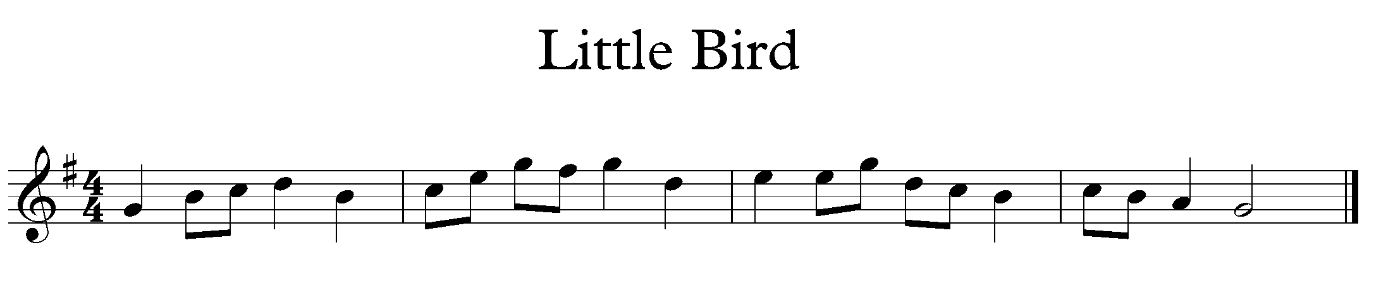

Tone and semitone scale composition

Steps
- Using your random objects, place them in a random order that is different to the major and minor scale pattern. For example:
S, T, T, S, T, T, T.
- You are now going to use this pattern to create your very own scale. Choose a note to start on and write out the notes using the pattern of tones and semitones you have created. You may need to use accidentals to do this. Write the tone and semitone pattern underneath your scale.
For example: starting on E
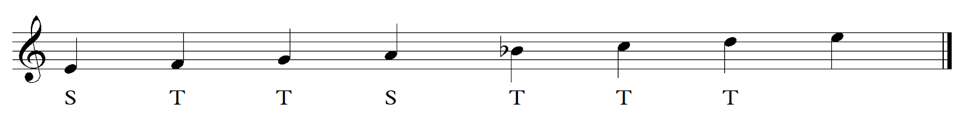

- Perform this scale on your instrument and listen to the sound carefully. Can you use a word to describe the mood or feeling of this scale? Does it sound eerie? Sweet? Abrasive? Think of a word to describe the sound of your scale and write it down.
- Now using this word as inspiration, write a four to eight bar composition using your scale. Remember you must start and end on the first note of your scale. You may use any combination of note values and any time signature you like.
- Use your instrument to experiment and improvise as to which notes and rhythms will work best. Start with the rhythm first if you need to.
- Add a title to reflect the mood word chosen and a tempo marking at the beginning of your piece. For example, Allegro.
- Perform your composition to the class.

Example
This scale sounds mysterious.
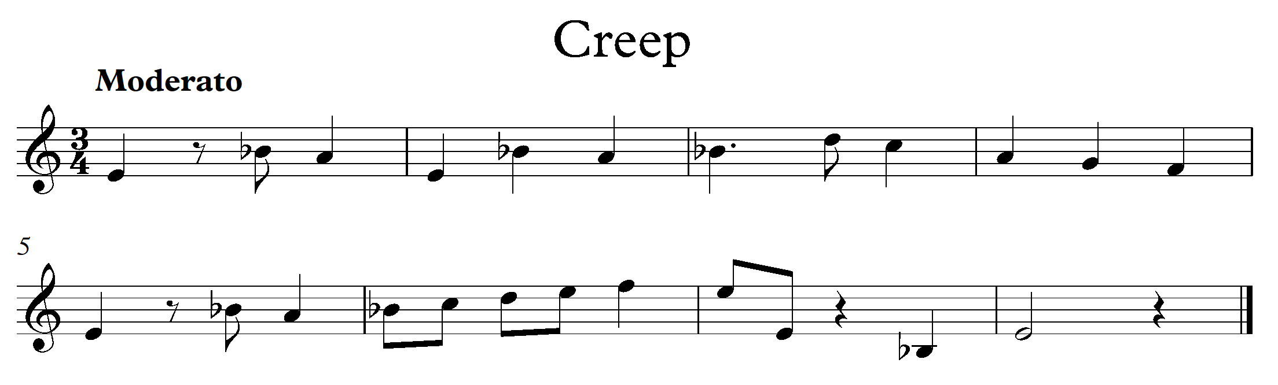

Key signatures
A key signature tells us how many sharps or flats are in a piece of music. A key signature can contain up to seven sharps or flats.
The order of sharps is:
F#, C#, G#, D#, A#, E#, B#.
The order of flats is:
Bb, Eb, Ab, Db, Gb, Cb, Fb.
For example: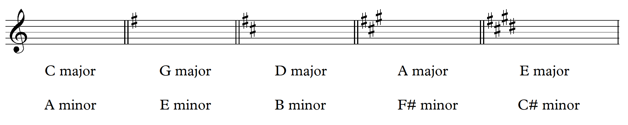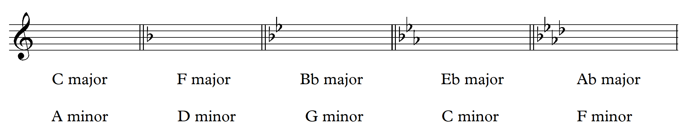

Major or minor melodies?

Listening activity
The teacher will perform the following melodies on an instrument. The students are to write down in their books whether the melody they hear is major or minor.
Number | Melody | Answer
1. | 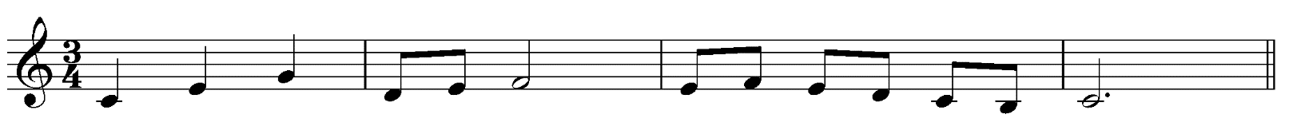 | major
2. |  | major
3. |  | minor
4. | 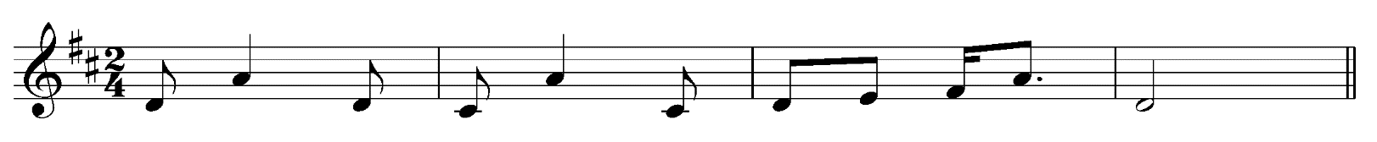 | major
5. | 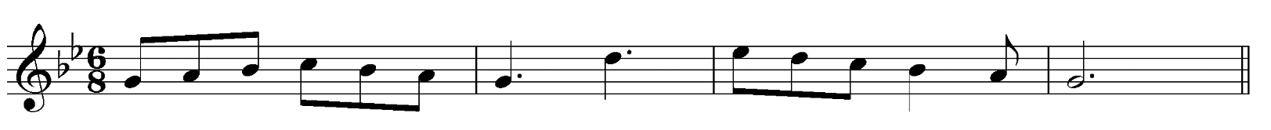 | minor
6. |  | minor
7. |  | major
8. |  | minor
9. | 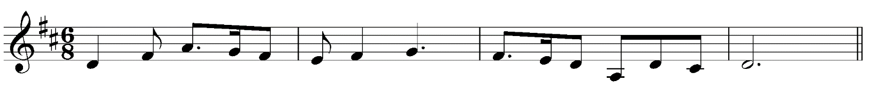 | major
10. |  | major

Major and minor key signatures

Activity
Identify the following major key signatures used in these melodies:
Number | Melody | Answer
1. | 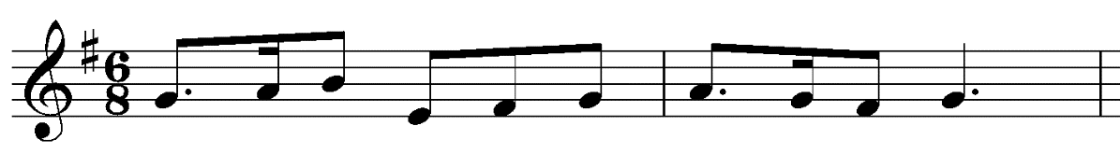
2. | 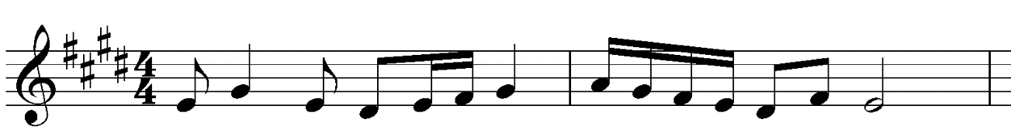
3. | 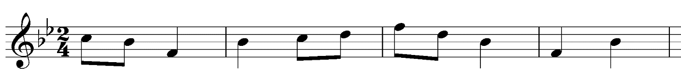
4. | 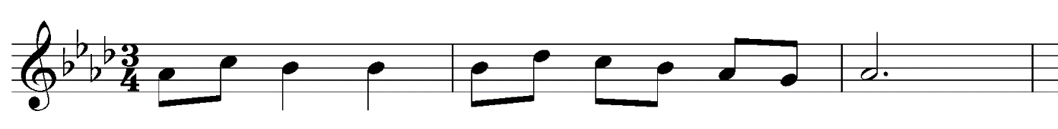
5. | 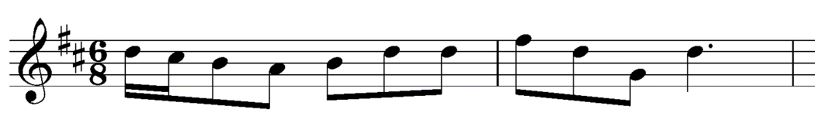
6. | 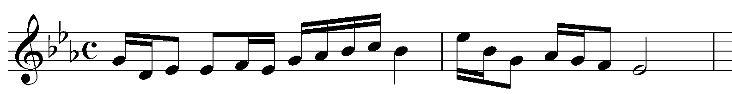
7. | 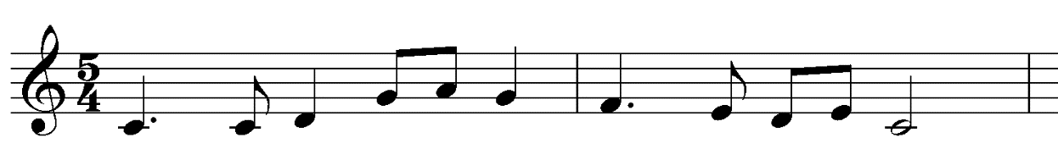
8. | 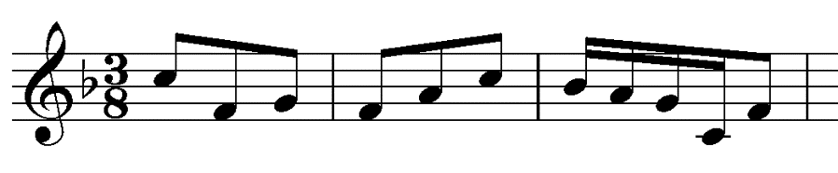

Identify the following minor key signatures used in these melodies:
Number | Melody | Answer
1. | 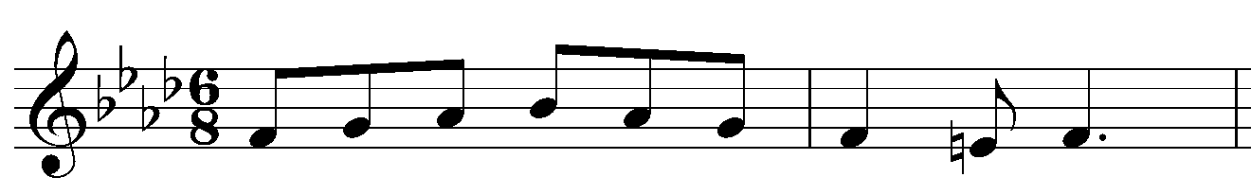
2. | 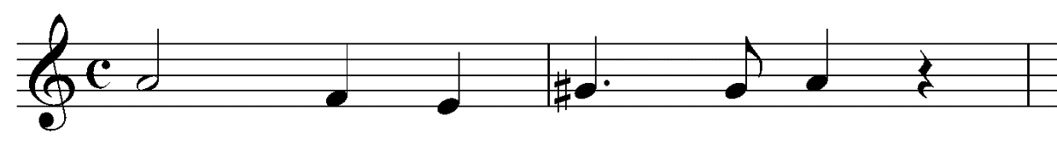
3. | 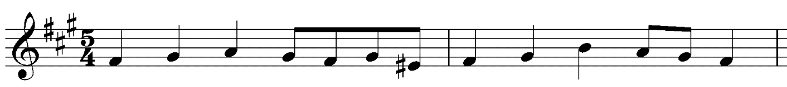
4. | 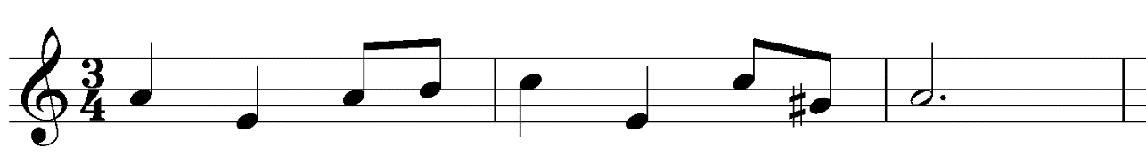
5. | 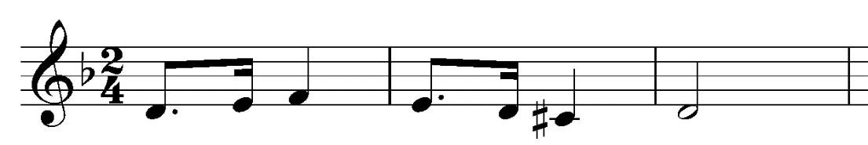
6. | 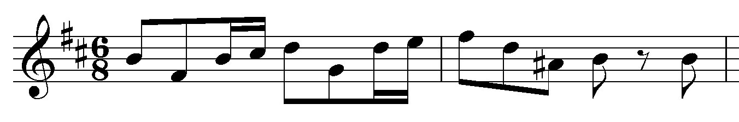
7. | 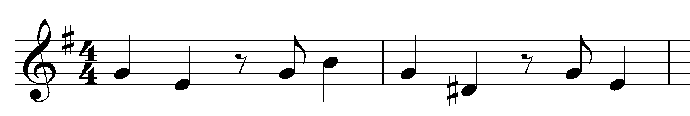
8. | 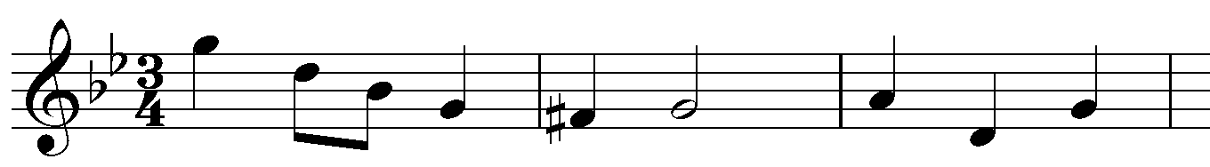

Activity — answers

Major key signatures
- G major
- E major
- Bb major
- Ab major
- D major
- Eb major
- C major
- F major

Minor key signatures
- F minor
- A minor
- F# minor
- A minor
- D minor
- B minor
- E minor
- G minor

Writing a melody and chords
Students are to write an eight-bar melody and chord progression for their chosen instrument.
What you will need:
- key signature sheet
- your instrument
- a keyboard, guitar, ukulele or virtual keyboard
- a digital notation program such as Musescore, Sibelius or Noteflight or
- manuscript, a rubber and pencil.

Steps
- Choose a key signature and scale that they want to work with.
- Set up your score with the following:
  - divide each line of manuscript into four bars (eight bars total)
  - draw a treble clef or bass clef at the start of each line depending on what instrument you are writing for. For example, if you are writing for flute you would use treble clef. If you were writing for bass guitar you would write bass clef.
  - write the key signature after the clef on each line.
  - write the time signature of 4/4 after the key signature on the first line only.
  - write a double bar line at the end of the piece.

For example: (in D minor)
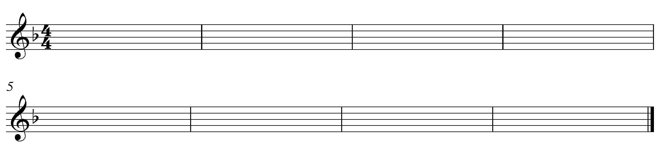

- Next, you will create a chord progression using a digital program called AutoChords. Click on the link autochords. (date accessed 11/11/2020) It will look like this:

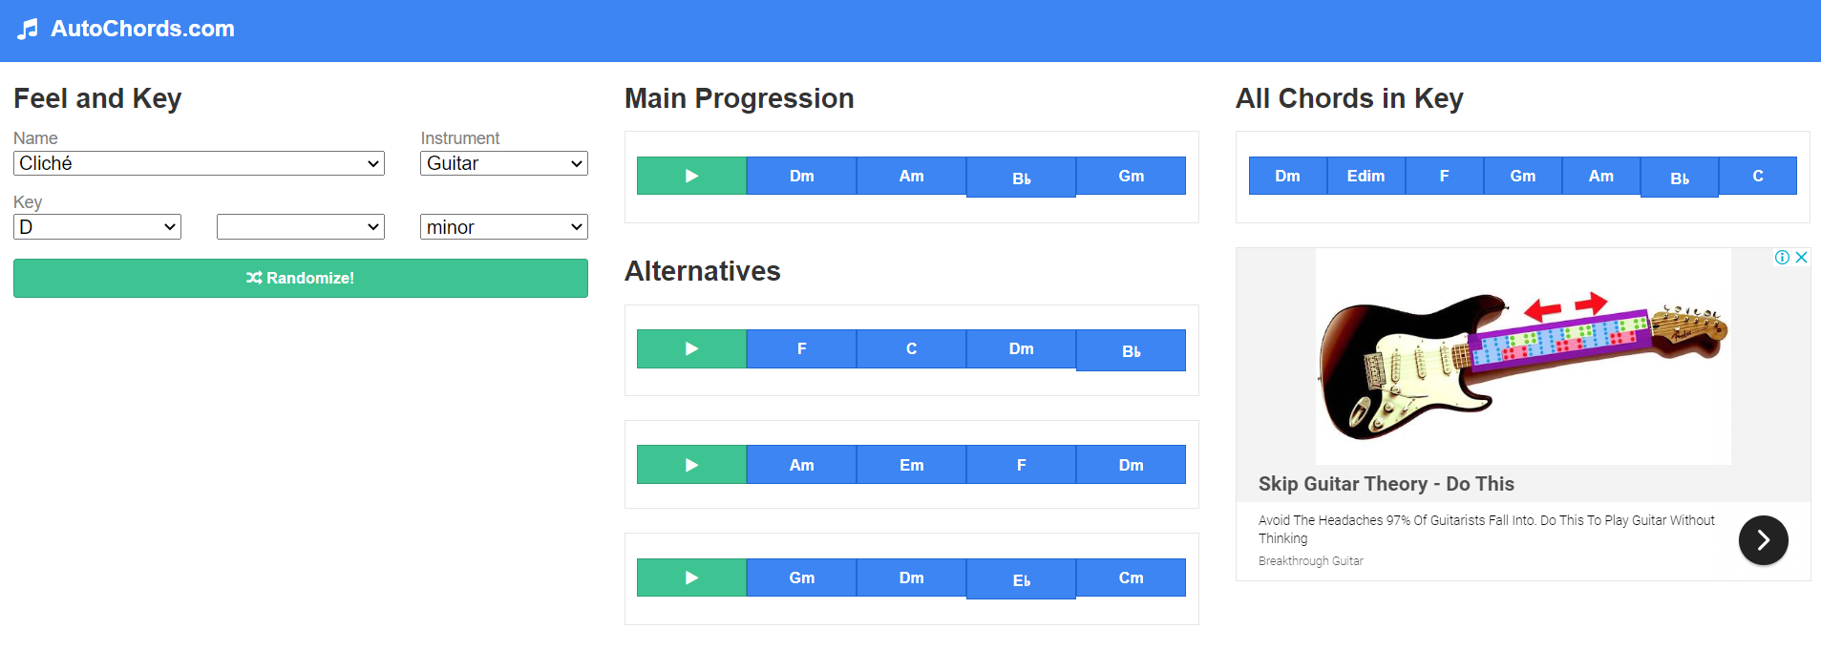
- Next, you need to choose what type of chord progression you wish to create. Follow the steps below:
  - choose the key signature you have already chosen by clicking on the box titled ‘key’ and then select if you are using a ‘major’ or ‘minor’ key.
  - choose the instrument you would like to hear the chords played on. The screen example shows the instrument selected as ‘guitar.’
  - choose a name for the type of sounds or ‘feel’ you want the chords to sound like. The screen example shows the name as ‘cliché.’
  - Autohords will then create a four bar chord progression for you under the title ‘main progression’ as well as some alternative options underneath it. You can listen to each progression by pressing the ‘play’ arrow next to each progression. Listen to each option and choose the chord progression you like best.

- Write the chord progression you have chosen above each bar on your score. You will need to repeat the progression for bars five to eight. For example:

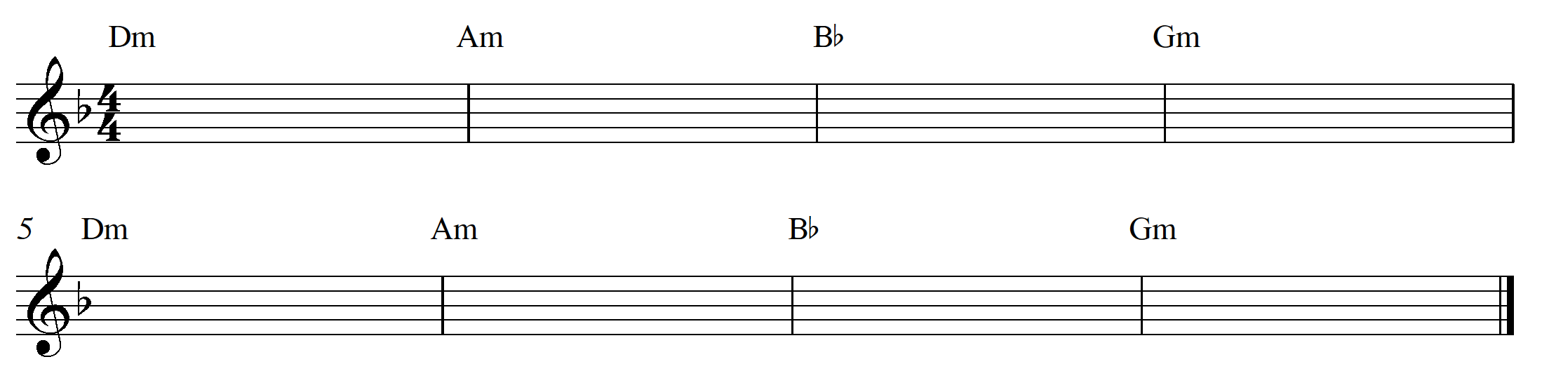

- If you can, play each of these chords on your keyboard/ukulele/guitar and listen to how they sound.
- Next, it’s time to write a melody to go with the chords. First, write out the notes of the scale you are using on a piece of paper. For example, I am using D minor so I am going to write out the notes of the D harmonic minor scale. For example:

D, E, F, G, A, Bb, C#, D.
- Next you are going to use these notes to write the melody. There are two ways you can approach this. Choose the option that works best for you:

  - record the chord progression on a device and experiment by improvising over the top of it using the scale of the key signature you have chosen. Write down any ideas or notes that ‘work’ with your chords. You can then use these, adapt and extend your ideas further.
  - create a rhythm first, and then experiment using the notes of the scale you have chosen to work with. Keep in mind it is useful to base your choices around the notes in each chord. If you are unsure of what the notes are in each chord, hover your mouse over the chord in AutoChords and it will tell you which notes are in that particular chord. You will need to play the melody along with the audio on your notation program or pre-recorded it on a device to check that the notes work well with the chords.
  - Using the notes that the chords are based on, simply start writing some notes on the stave to see what they sound like. You can adjust your musical decisions as you go.

- Name your piece.
- Extension – add dynamics and articulation.
- Perform your melody on your instrument with the chords providing accompaniment on a device. Or, if you are unable to play the melody, perform the chord progression and have the melody played on a device or by another class member or teacher.

Tips
- make sure you start your piece on the first note of your scale
- you can use whatever rhythms you like, but if you’re not sure, stick to crotchets, quavers, minims, semibreves and don’t forget some rests!
- if you have created the melody through improvisation by singing or on an instrument and you aren’t sure how to write down the rhythm you have created, that’s ok – give it a go anyway, even if it’s not quite right. Your teacher will be able to assist you.

Example:
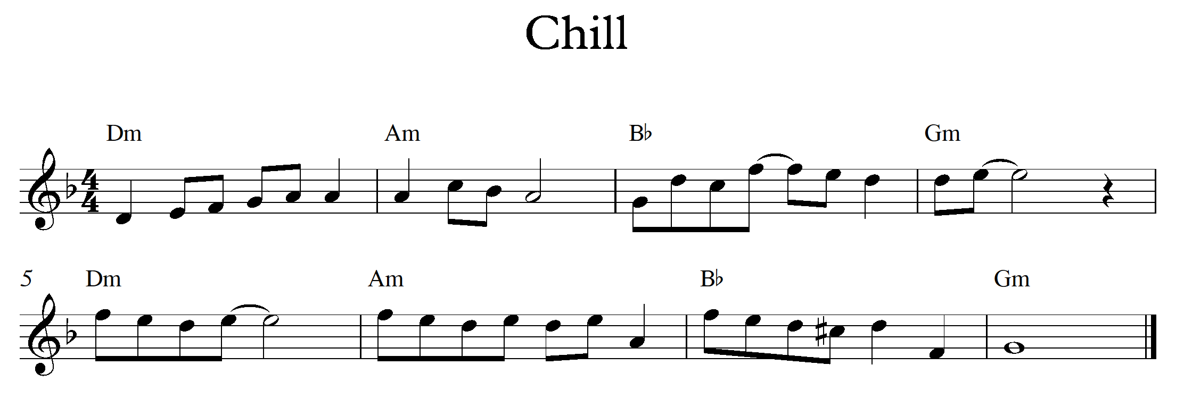

Scale degrees and triads

Scale degrees
Watch the following video on scale degrees: scale degree video (00:00:00-00:01:12) date accessed 11/11/2020.
Each note of a scale is given a number and a name (otherwise known as a scale degree).
For example: C major
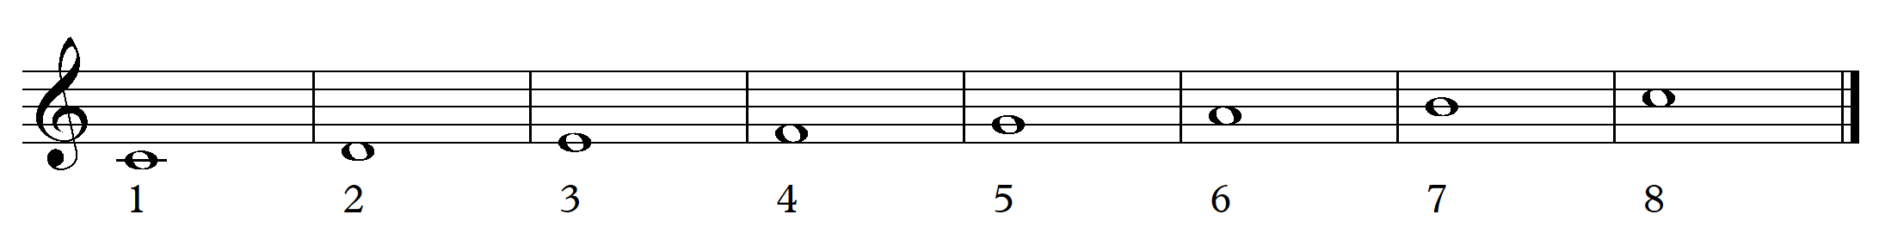
1 = tonic
2 = supertonic
3 = mediant
4 = subdominant
5 = dominant
6 = submediant
7 = leading note
8 = tonic

Triads
A triad is made up of three notes. When constructing a major or minor triad, you must use the first, third and fifth degrees of the scale.
For example:
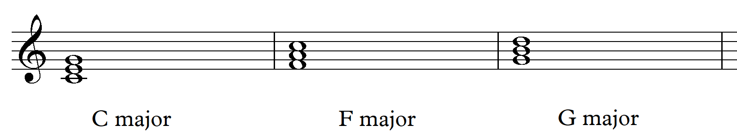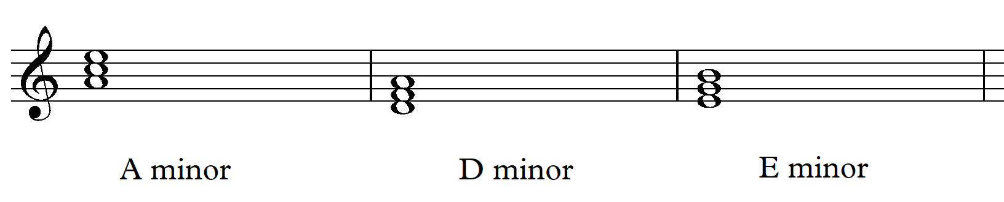

Activity

Exercise 1
Identify the following major triads:

Exercise 2
Identify the following minor triads: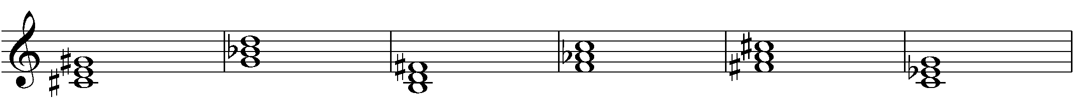

Exercise 3
Write down the following triads: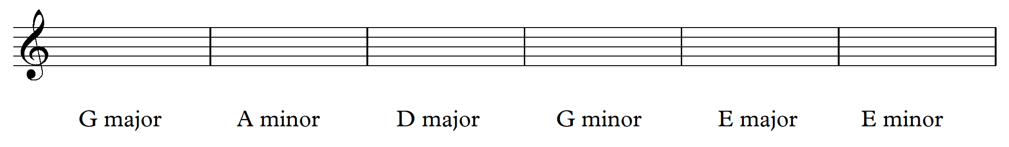

Answers

Exercise 1
- F major
- Bb major
- D major
- Eb major
- C major
- F major

Exercise 2
- C# minor
- G minor
- B minor
- F minor
- F# minor
- C minor

Exercise 3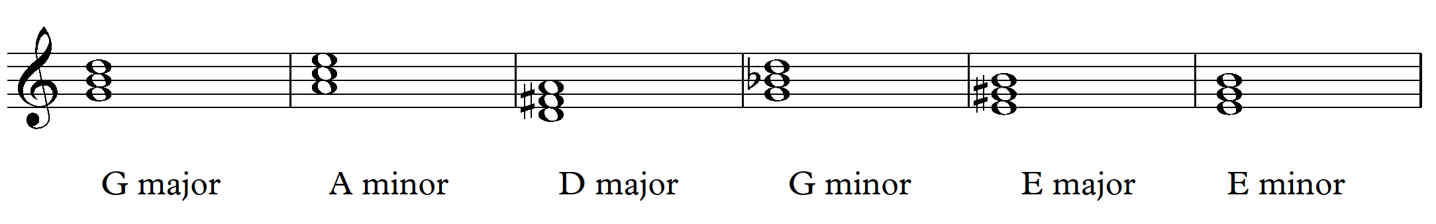

Intervals
An interval is the distance between two notes. Watch the Intervals (00:06:27) date accessed 11/11/2020 video to learn about how intervals are formed. Below is a list of common intervals found in music. Listen and sing through these intervals together as a class:
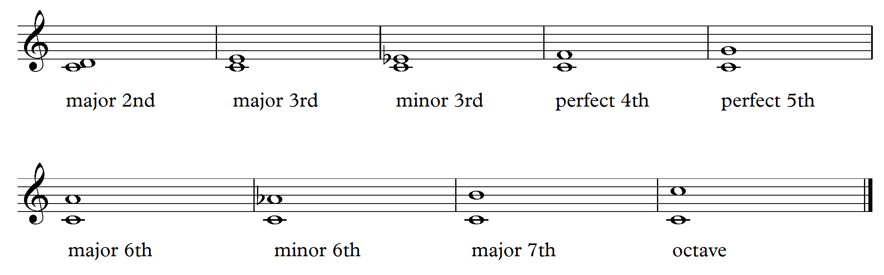

Activity

Exercise 1
Label the following intervals. Remember to look carefully at the starting note and check your key signature.
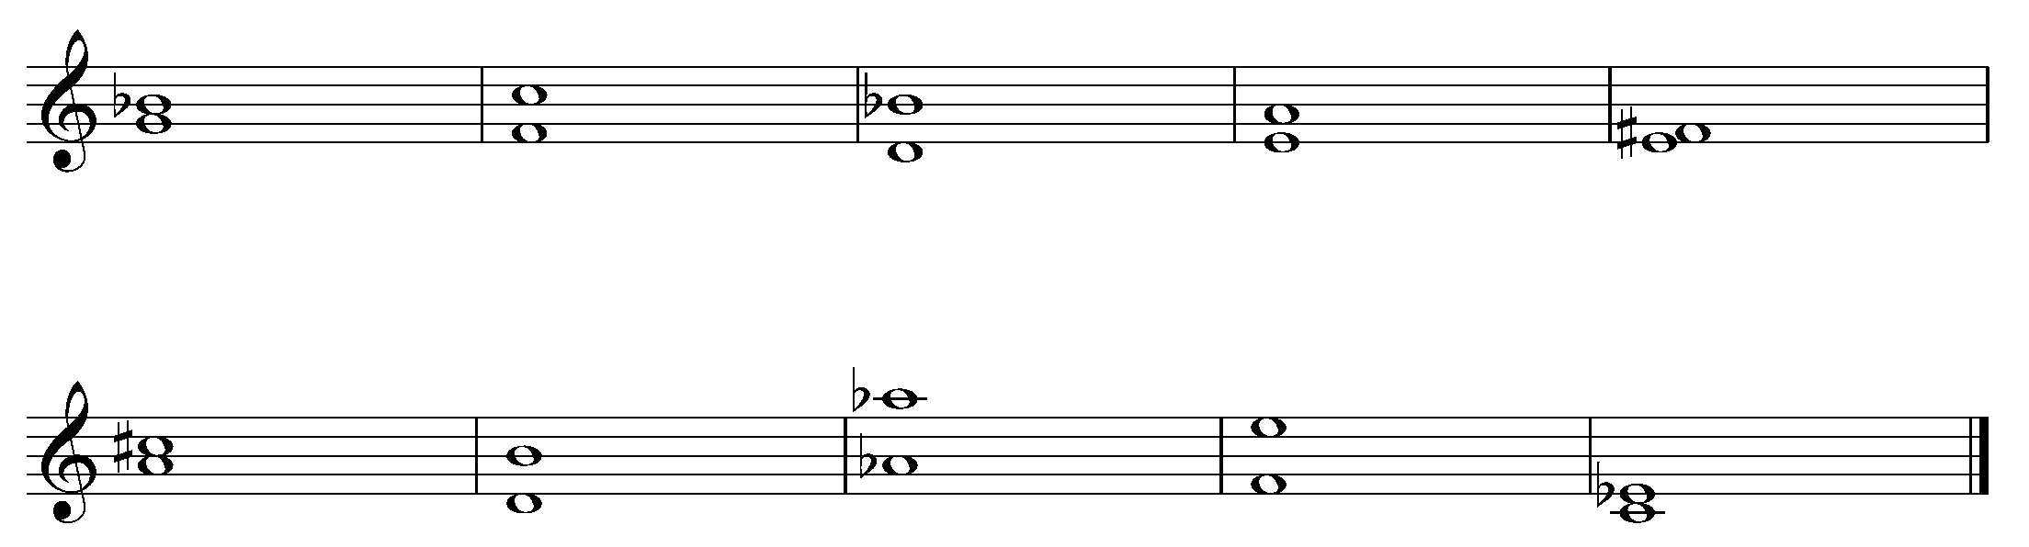

Exercise 2
Write the following intervals using the starting note given:
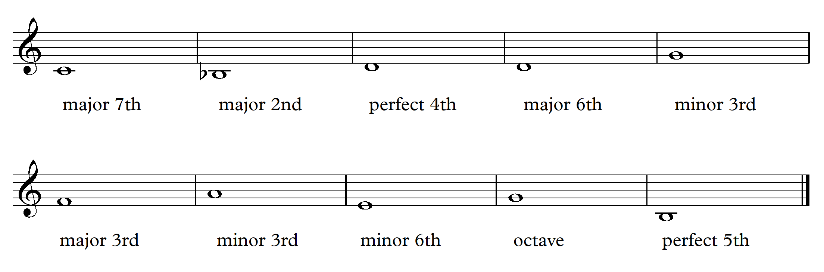

Exercise 3
Listen to the following intervals played by your teacher. In your books, write down what the interval is. There are eight intervals in total.

Homework
Listening
Students are to select five songs of their choice and identify the first interval used by the main melody (this may be the vocals or another instrument) For each song, write down the following in your books:
- name of the song and artist
- youtube link
- name of the interval used by the main melody
- identify the section of the song you identified the interval in. For example: the first two notes of the vocals in verse, or the first two notes of the synthesizer in the intro etc.

Answers

Exercise 1
- minor 3rd
- perfect 5th
- minor 6th
- perfect 4th
- major 2nd
- major 3rd
- major 6th
- octave
- major 7th
- minor 3rd

Exercise 2
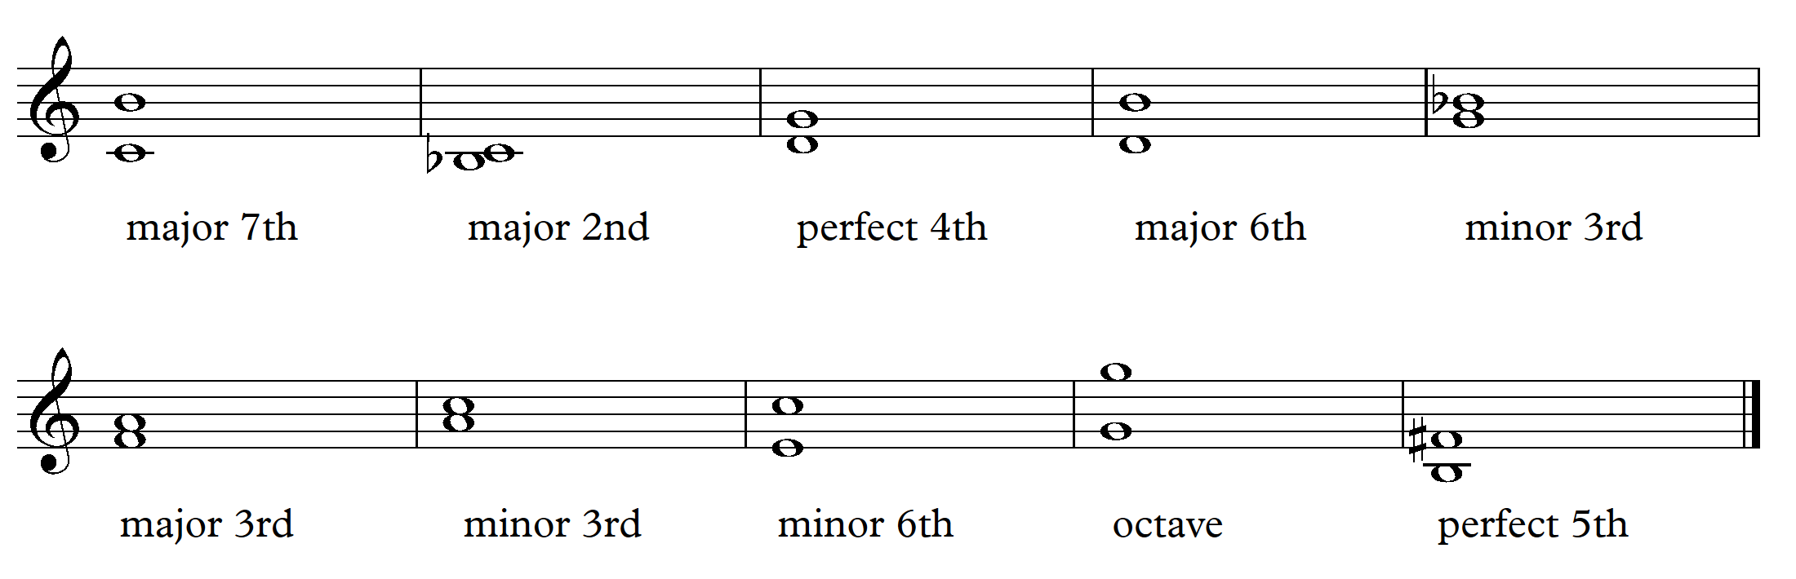

Exercise 3
- major 3rd
- octave
- perfect 4th
- minor 3rd
- major 6th
- perfect 5th
- major 3rd
- major 7th

The pentatonic scale

Performance
Perform the first verse and chorus of ‘Shake It Off’ by Taylor Swift on either your voice or instrument by using the audio and score links below:
‘Shake It Off’ (00:04:01) by Taylor Swift (date accessed 11/11/2020) audio
‘Shake it Off’ by Taylor Swift (date accessed 11/11/2020) score
Then, discuss and answer the following questions:
- What key is this piece in? (look at the key signature)
- Look at the notes carefully. What are the note names used in the piece? For example, C, D.
- How many notes/pitches are used in total and what are they?
That’s right! ‘Shake It Off’ only uses five pitches. This is called the pentatonic scale.
The pentatonic scale is a scale made up of five pitches. The 1st, 2nd, 3rd, 5th and 6th note of the major scale.
In C, the pentatonic scale is written below. Play through this scale on your instrument or keyboard.
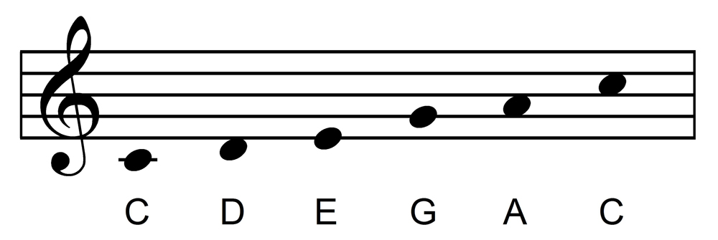
Watch this clip of Bobby McFerrin who demonstrates how cool the pentatonic scale really is: Power of the Pentatonic Scale (00:03:04) date accessed 11/11/2020

Listening
- Listen to these two pieces which use the pentatonic scale:
  - ‘The Cup Song’ from ‘Pitch perfect’ by A.P Carter (00:04:21) (date accessed 11/11/2020)
  - ‘Sing’ by the Pentatonix (00:04:19) (date accessed 11/11/2020)
Choose either ‘The Cup Song’ or ‘Sing’ and answer the following questions in your book:
  - What is the tonality of this piece?
  - What is the time signature of this piece?
  - What is the tempo of this piece?
  - What are the instruments used in the piece?
  - What types of note values are used by the melody? (voice)
  - Is syncopation used in this piece? If so, which instrument and in what section?
  - What is the contour of the main melody (vocals)?
  - Does the melody use steps or leaps?
  - What is the range and register of the vocals?
  - Outline the structure of the song. For example, intro, verse 1, pre chorus, chorus.

Composition
Using the digital software program Chrome Music Lab (date accessed 11/11/20), compose a short pentatonic composition. Check out the following two examples of pieces that use the pentatonic scale in chrome music lab for inspiration:
Example one (date accessed 11/11/2020) Example two (date accessed 11/11/2020)

Steps
- Visit the Chrome Music Lab website. (date accessed 11/11/2020)
- Then click on ‘song maker’. (top left of screen)
- This will take you to a composition grid. Experiment by clicking the boxes and choosing different instruments which are located at the bottom of the screen. Remember for a pentatonic composition you can only use five pitches. The five pitches (colours) which you should be using are red, yellow, orange, dark green and blue.
- Once you have finished your composition, save it and send the link to your teacher.

Structure resources

Structure
Structure can be described as the form of a piece of music and how it is put together in different sections.

Forms
The forms of structure below are most commonly used in music.
Binary form – refers to a composition with two main sections, called A and B. Section A is followed by section B which is made up of different musical material. Sometimes these sections are marked by repeat signs.
Ternary form – has three sections. A, B and then a return to section A. The B section uses contrasting musical material. Sometimes there will be modifications or additions to the concepts of music in section A when it returns.
Rondo form – has many sections. It starts with the main theme in section A, followed by a number of new sections. The form is A B A C A.
Theme and variations – The main theme is usually a distinctive melody which is then changed and adapted in subsequent sections through the concepts of music. Theme and variations was widely used in the classical period.
Through composed – a piece which is continuous with just one main section. It doesn’t repeat any sections but develops the one idea continuously.
Strophic form – is a form where there are several verses, each with different words but the same musical accompaniment. Hymns and blues pieces follow strophic form.
Verse/chorus form – is a structure used in popular music. It may contain sections such as verse, prechorus, chorus, bridge, intro, outro or solo.

Structure composition activity

Composition/performance/listening
In this activity, students will create short compositions in small groups which will then be put together to demonstrate the following forms:
- through form
- binary form
- ternary form
- rondo form.

Steps
- In small groups of four to five, students are to create an eight bar composition (A) that consists of the following:
  - eight bars in length
  - uses a 3/4, 4/4 or 6/8 time signature
  - uses a pentatonic scale
  - a melody
  - harmonic/rhythmic accompaniment
- Students are to perform their composition to the class and record it on their phones or other digital device.
- Students are then to repeat the process above creating a (B) section which must address the following:
  - eight bars in length
  - uses a pentatonic scale
  - the texture must change (for example become thicker or thinner)
- Students are to perform and record their performance on their phones or devices.
- Students repeat the same process for a (C) section but this section must only contain rhythmic instruments, percussion or body percussion.
- Students are then to use these three sections of musical material to create through form, binary form, ternary form and rondo form. Play through each of these structures.
- Students are then to perform to the class one of these structures and record the performance on their phones. The class is to identify which structure each group have performed.
- Distribute the graphic notation grid. In groups, students must notate each section of the composition using graphic notation grids. They may choose to do this using graphic notation, traditional notation or a combination of both. Examples are provided.
- Homework: Students are to analyse one of their compositions according to pitch and duration using the audio and score they have created.

Graphic notation grid

Section

Instrument | Bar 1 | Bar 2 | Bar 3 | Bar 4 | Bar 5 | Bar 6 | Bar 7 | Bar 8
Instrument
Instrument
Instrument
Instrument
Instrument

Samples
Traditional notation and graphic notation example:
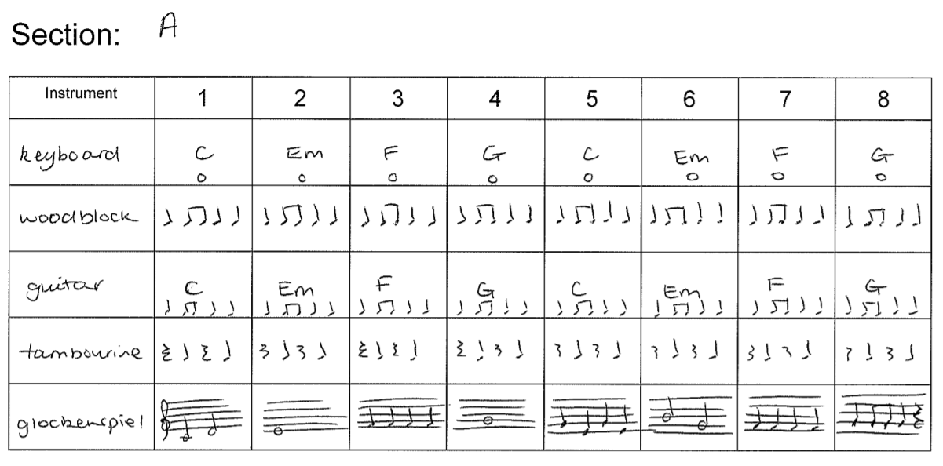

Graphic notation sample:
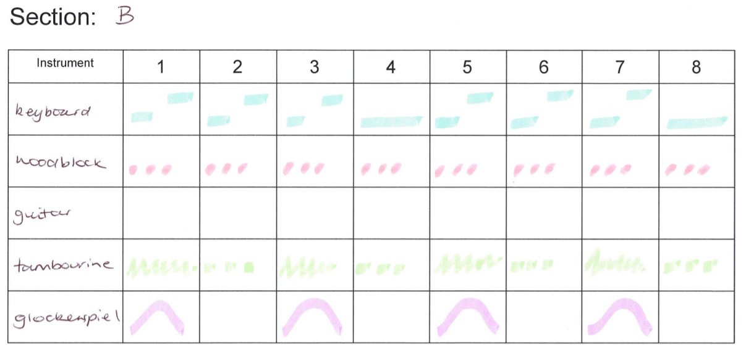

Graphic notation grid
Section A
Instrument | Bar 1 | Bar 2 | Bar 3 | Bar 4 | Bar 5 | Bar 6 | Bar 7 | Bar 8
Instrument
Instrument
Instrument
Instrument
Instrument
Section B
Instrument | Bar 1 | Bar 2 | Bar 3 | Bar 4 | Bar 5 | Bar 6 | Bar 7 | Bar 8
Instrument
Instrument
Instrument
Instrument
Instrument
Section C
Instrument | Bar 1 | Bar 2 | Bar 3 | Bar 4 | Bar 5 | Bar 6 | Bar 7 | Bar 8
Instrument
Instrument
Instrument
Instrument
Instrument

Structure examples

Through form
Through form is a work that that typically contains one melodic idea that is continuously developed with little contrasting musical material and can be labelled as ‘A.’ It is usually associated with vocal music but exists within all instrumental forms.
Your first section of your group composition is an example of through form.

Binary form
A piece in Binary form contains two sections. The first section ‘A’ is followed by section ‘B’. Section B is made up of contrasting musical material that is different to section A. Sometimes these sections are marked with a repeat sign.
Perform or listen to the ‘Minuet’ below and label sections ‘A’ and ‘B’ on the score. How were you able to tell where section ‘B’ began?
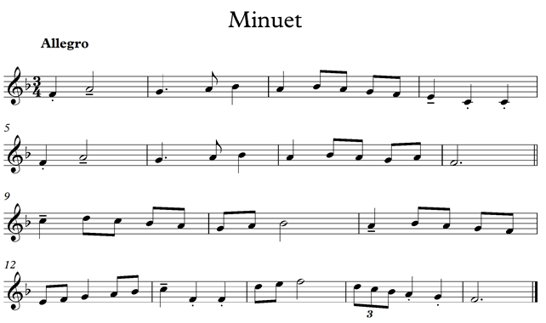

Ternary form
A piece designed in ternary form is made up of three sections: ‘A B A’.
‘A’ uses the same musical material and ‘B’ presents contrasting musical material to section ‘A’.
Perform or listen to ‘Jazz It Up’ below and label sections ‘A’ and ‘B’ on the score. How were you able to tell where section ‘B’ began?
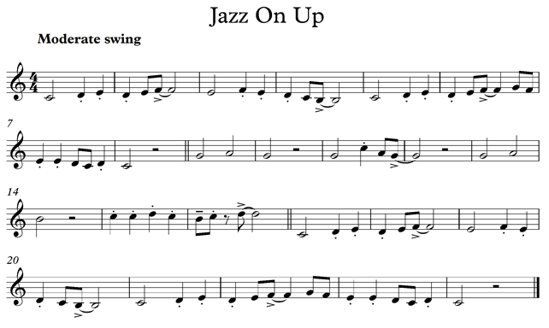

Rondo form
Rondo form consists of one section ‘A’ that reoccurs throughout the piece in alternation with other themes. It can take on a number of forms including A B A C A or A B A C A B A.
Perform or listen to ‘Threes and Twos’ below and label sections ‘A’ and ‘B’ and ‘C’ on the score.

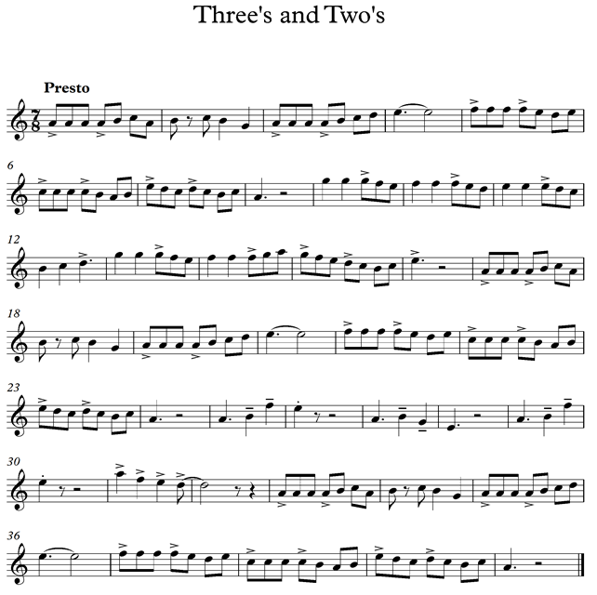

Strophic form
Strophic form is a vocal form in which the same music is repeated for each stanza or verse. Most traditional church hymns are in strophic form.

‘Amazing Grace’ by John Newton
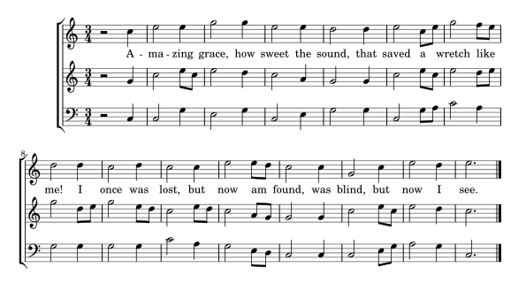Amazing Grace (date accessed 6/11/20)

Verse 2
‘Twas grace that taught my heart to fear, and grace my fears relieved;
How precious did that grace appear the hour I first believed!

Verse 3
Thro’ many dangers, toils and snares I have already come;
‘Tis grace hath brought me safe thus far, and grace will lead me home.

Verse 4
When we’ve been there ten thousand years, bright shining as the sun;
We’ve no less days to sing God’s praise than when er first begun.

Theme and variations form
The form theme and variations was widely used in the classical period. In this form a musical idea – the theme – is repeated over and over and is changed each time. Each variation is approximately the same length as the theme.
Changes of melody, rhythm, harmony, accompaniment, dynamics or tone colour may be used to give a variation its own identity. For example, the melody could be presented by another instrument, repeated in a minor key or be heard together with a new melody.

Listening

Activity
- Listen to ‘The Trout Quintet’ movement IV by Schubert (00:00:00 – 00:05:02) (date accessed 11/11/2020) and identify the musical characteristics of the theme according to the following table:

Theme (00:00:00 – 00:01:11)
Instruments and their roles | Tonality | Texture | Dynamic | Note lengths | Extras
Instrument

- Now listen to each of the four variations based on this theme and compare the musical characteristics between each and the original theme:

Variation 1 (00:01:11 – 00:02:05)
Instruments and their roles | Tonality | Texture | Dynamic | Note lengths | Extras
Instrument

Variation 2 (00:02:05 – 00:03:00)
Instruments and their roles | Tonality | Texture | Dynamic | Note lengths | Extras
Instrument

Variation 3 (00:03:01 – 00:03:58)
Instruments and their roles | Tonality | Texture | Dynamic | Note lengths | Extras
Instrument

Variation 4 (00:03:59 – 00:05:02)
Instruments and their roles | Tonality | Texture | Dynamic | Note lengths | Extras
Instrument

Extension

Composition/performance

Steps
- Working either individually or in small groups, students are to create their own ‘variation’ of Schubert’s ‘Trout Quintet’ theme by manipulating the concepts of music to create their own version. Students may choose to do this by ear, or refer to the score which can be found here: ‘The Trout Quintet’ by Schubert (date accessed 11/11/2020) score.
- Perform and record on a device.
- When complete, students are to write two paragraphs as to how they adapted the concepts of music in their own variation.

Answers

Theme (00:00:00 – 00:01:11)
Instruments and their roles | Tonality | Texture | Dynamic | Note lengths | Extras
violin (melody)  Viola, cello and double bass harmonic accompaniment | major | thin | piano | short to medium | light articulation

Variation 1 (00:01:11 – 00:02:05)
Instruments and their roles | Tonality | Texture | Dynamic | Note lengths | Extras
piano (melody)  violin, viola, cello and double bass harmonic accompaniment | major | moderately thick | mezzo forte | very short note lengths including triplets | ornamentation of melody

Variation 2 (00:02:05 – 00:03:00)
Instruments and their roles | Tonality | Texture | Dynamic | Note lengths | Extras
viola (melody) piano, violin, cello and double bass harmonic accompaniment | major | moderately thick | mezzo forte | combination of note lengths with very short notes in the violin and busier rhythms in accompanying parts | call and response between the viola and piano

Variation 3 (00:03:01 – 00:03:58)
Instruments and their roles | Tonality | Texture | Dynamic | Note lengths | Extras
cello and double bass melody  violin, viola and piano harmonic accompaniment | major | thick | forte | combination of note lengths with very short note values in the piano | rhythmically very busy and complex

Variation 4 (00:03:59 – 00:05:02)
Instruments and their roles | Tonality | Texture | Dynamic | Note lengths | Extras
violin (melody) piano, viola, cello and double bass harmonic accompaniment | minor then modulates to major | very thick | fortissimo | short | use of accents  the melody is new however the chord progression remains the same as the theme

Verse chorus form
Verse chorus form is a structure most commonly used in popular music. It consists of several repeated sections. These sections may include:

Intro
Otherwise known as the introduction, the intro establishes the melodic, harmonic and rhythmic material related to the verse and/or chorus of the piece. It is usually only instrumental.

Verse
The verse is one of the main sections of the song where the vocals will enter. The verse will be repeated several times throughout a song. Each verse will contain the same harmonic progression and melody but use different lyrics.

Pre-chorus
The pre-chorus functions to connect the verse to the chorus, typically using subdominant chords or other transitional harmonies.

Chorus
The chorus is repeated throughout the song using the same harmonic foundation and lyrics. It is almost always of greater musical and emotional intensity than the verse. It also often contains a ‘hookline’ which is when the title of the song is used in the chorus.

Bridge
The bridge is a transitional section towards the end of the song which provides contrast through its new musical material.

Solo/instrumental
The solo section is designed to showcase an instrumentalist and usually uses harmonic accompaniment taken from the verse or chorus.

Outro
The outro is the last section of the song. It often uses chords from the chorus or verse and the vocalist may improvise or ‘ad lib’.

Activity — listening
- Listen to ‘Everybody Rise’ by Amy Shark (00:00:00 – 00:03:10) (date accessed 11/11/2020) and identify the sections used in the piece and how many bars are in each section.
- Homework – complete the same activity using a pop piece of your choice.

Activity — listening answers
‘Everybody Rise’ by Amy Shark (00:00:00 – 00:03:10) (date accessed 11/11/2020)
- Intro – 4 bars
- Verse 1 – 8 bars
- Prechorus – 4 bars
- Verse 2 – 4 bars
- Prechorus – 4 bars
- Chorus – 16 bars
- Bridge – 8 bars
- Instrumental – 4 ½ bars (uses multimetre - 4 x 4/4 time plus 1 x bar 2/4 time)
- Chorus – 16 bars
- Outro – 4 bars.

Tone colour resources

Tone colour — what am I listening for?
When analysing tone colour in a piece of music, you need to identify:
- performing media – What instruments/voices/sounds are being used for each section and what are they playing?
- timbre – Use an adjective to describe the sound quality of each instrument in each section of the music.
- roles – What are the roles of each individual instrument?
- melodic
- harmonic accompaniment
- rhythmic accompaniment.

Activity — listening
Listen to ‘Everyone’s Waiting’ by Missy Higgins (00:00:00-00:00:56) (date accessed 11/11/2020) and discuss the use of tone colour in the intro and verse.

Timbre words
To describe the sound quality of each instrument, you may find the words below helpful.
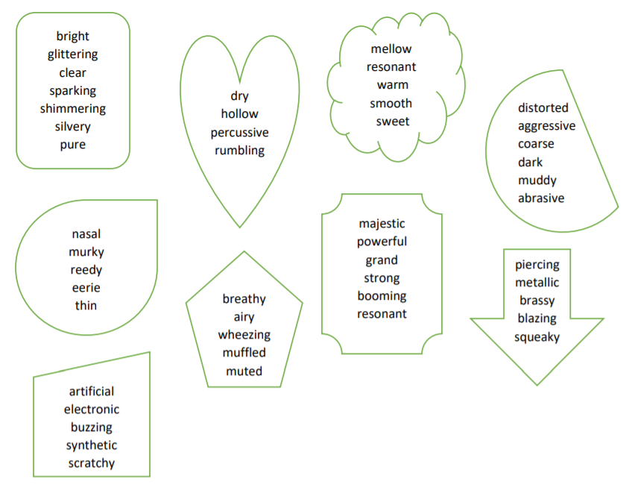

Activity — listening answers
Listen to ‘Everyone’s Waiting’ by Missy Higgins (00:00:00-00:00:56) (date accessed 11/11/2020) and discuss the use of tone colour in the intro and verse.

Model response
In the intro the piece begins with a female lead vocalist accompanied by a group of backing vocalists. The lead vocalist provides the melodic role using a smooth and raspy timbre, whilst the backing vocalists provide the harmonic accompaniment by singing chords that at times work in rhythmic unison with the lead vocalist. They use a mellow and warm timbre. An electric guitar can be heard faintly playing a drone, using an effects pedal providing harmonic accompaniment. The timbre of the guitar is haunting and ringing.
In verse 1, the lead vocals and electric guitar continue to provide their respective melodic roles whilst an acoustic guitar enters strumming in a rhythmic pattern providing both harmonic and rhythmic accompaniment. The timbre of the acoustic guitar is twangy and bright, whilst the vocal and electric guitar timbre remains the same as the intro. Halfway through verse 1 the bass guitar is added providing harmonic accompaniment using a powerful, rich and resonant timbre.

Instrument match up

Activity
Match up the following instruments with their instrument family.
Instruments | Instruments | Instruments | Instruments | Instruments
clarinet | cowbell | saxophone | bass clarinet | bassoon
french horn | trombone | guiro | harp | double bass
timpani | glockenspiel | flute | xylophone | triangle
violin | viola | guitar | cello | piccolo
drumkit | tambourine | woodblock | snare drum | bass drum
oboe | trumpet | tuba | cymbals | bass guitar

Instrument families | Instrument families
Woodwind | Strings
Brass | Percussion

Who am I?

Activity
Label the following instruments using the names of the instruments provided.

Woodwind
Flute, oboe, clarinet, bassoon, bass clarinet, piccolo, alto saxophone, soprano saxophone, tenor saxophone, baritone saxophone.
Instrument picture | Instrument picture | Instrument picture | Instrument picture | Instrument picture
1.  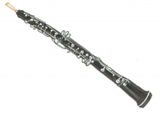 | 2. 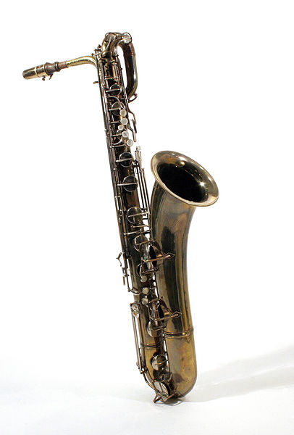 | 3.  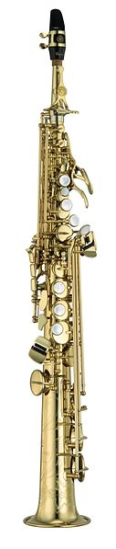 | 4.  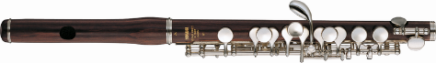 | 5.  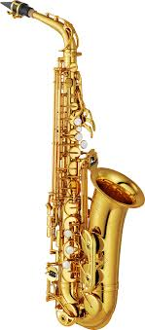
6.  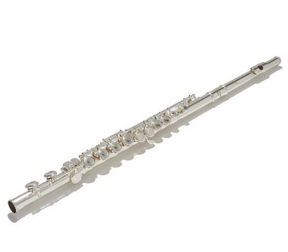 | 7.  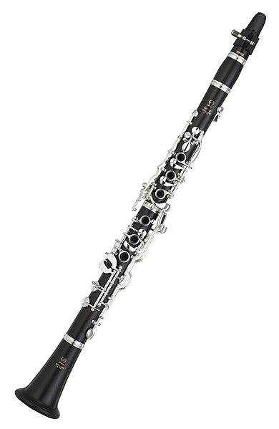 | 8.  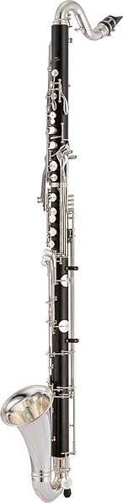 | 9.  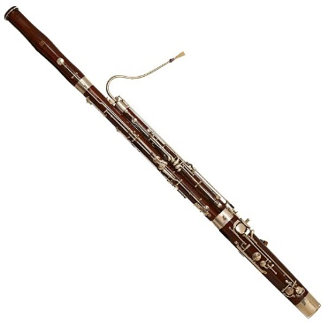 | 10.  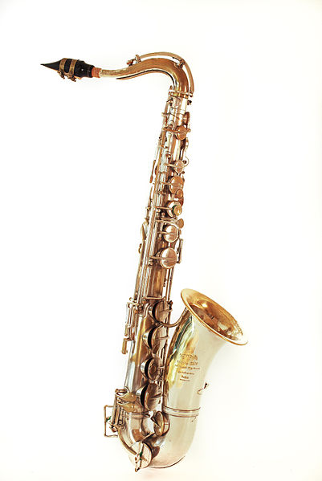

Brass
Trumpet, trombone, french horn, tuba.
Instrument picture | Instrument picture | Instrument picture | Instrument picture
1.  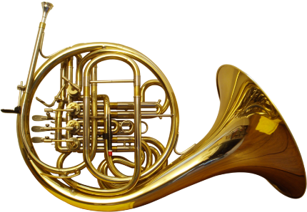 | 2.  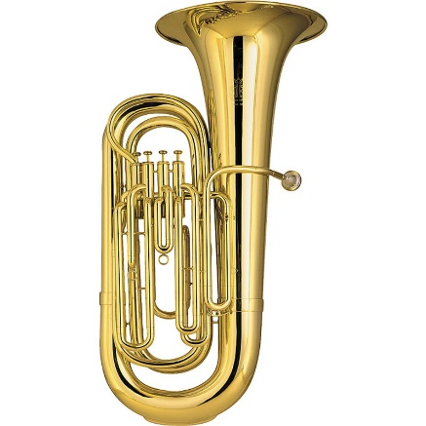 | 3.  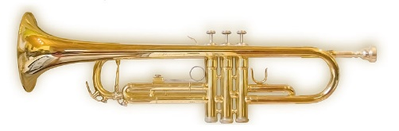 | 4.  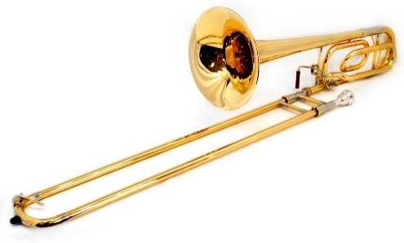

Strings
Double bass, cello, viola, violin, harp.
Instrument picture | Instrument picture | Instrument picture | Instrument picture | Instrument picture
1.  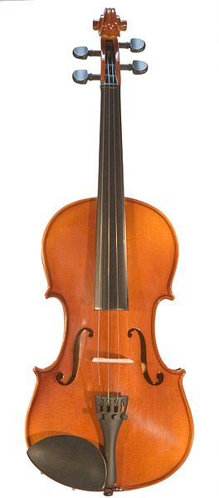 | 2.  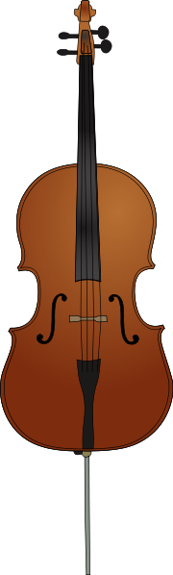 | 3.  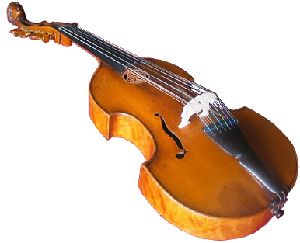 | 4.  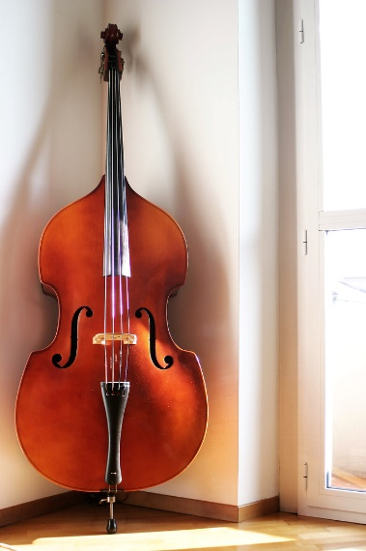 | 5.  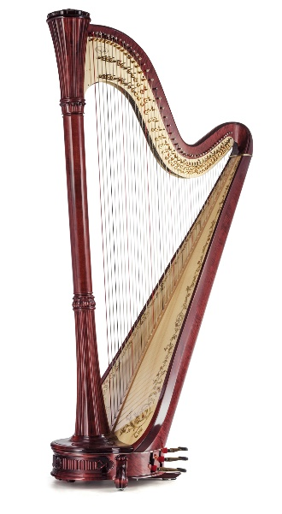

Tuned percussion
Vibraphone, xylophone, marimba, glockenspiel, timpani.
Instrument picture | Instrument picture | Instrument picture | Instrument picture | Instrument picture
1. 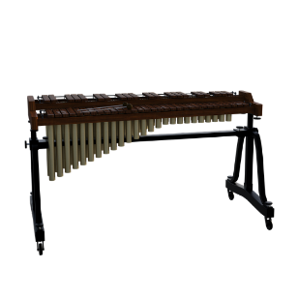 | 2. 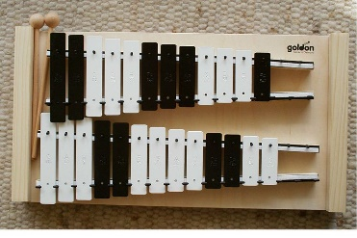 | 3.  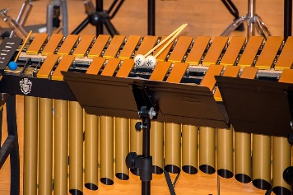 | 4.  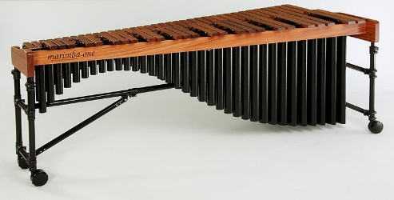 | 5.  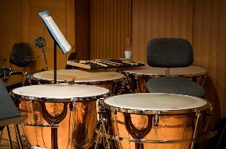

Untuned percussion
Bongos, maracas, cymbal, guiro, tambourine, cowbell, claves, woodblock, snare drum, triangle, bass drum, bells.
Instrument picture | Instrument picture | Instrument picture | Instrument picture
1.  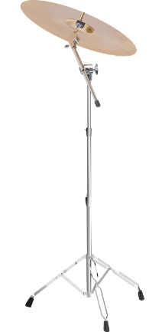 | 2.  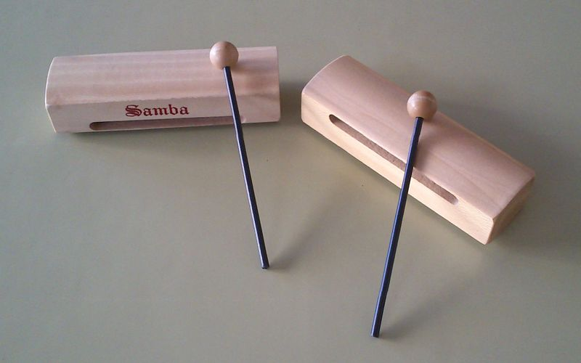 | 3.  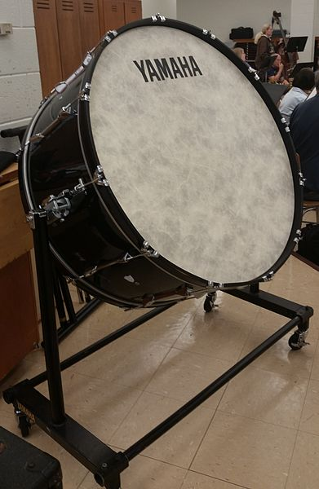 | 4.  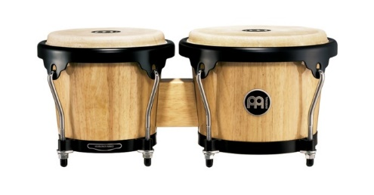
5.  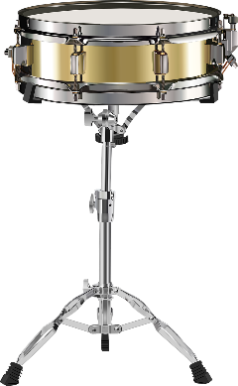 | 6.  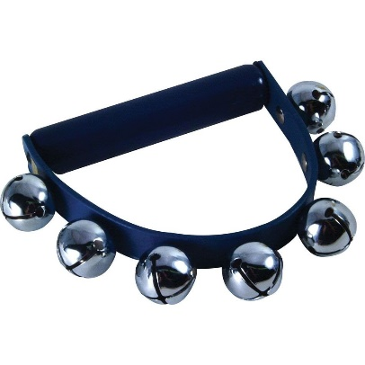 | 7.  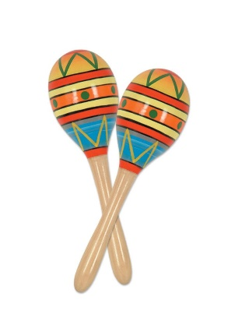 | 8.  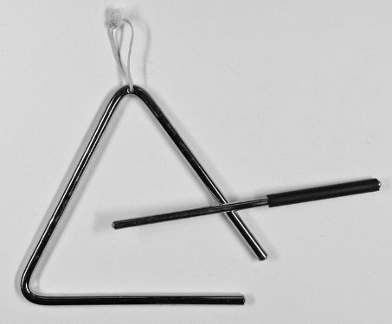
9.  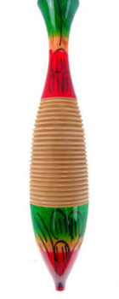 | 10.  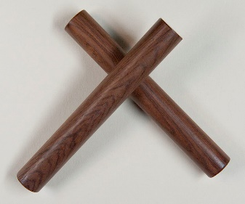 | 11.  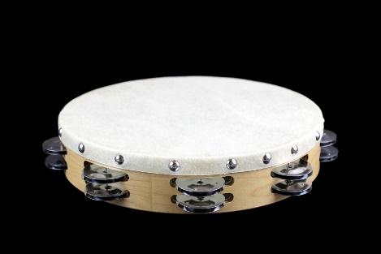 | 12.  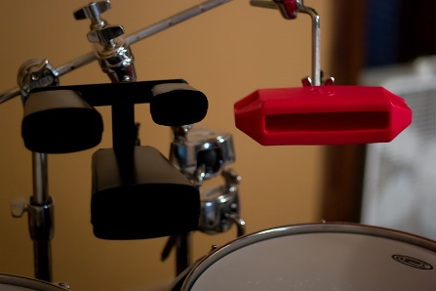

Tone colour research task
Research your main instrument and answer the following questions in your book:
- Instrument:
- Provide a picture or photo of your instrument with the different parts of your instrument labelled. For example: mouthpiece, strings, bell, keys.
- Describe in one paragraph how sound is produced on your instrument.
- Provide two paragraphs on the history of your instrument. For example, when and where was it invented? What type of music does it perform?
- Provide a youtube clip of your favourite song that is performed on your instrument.
- Write one paragraph about why you like this particular song which is specific to your chosen instrument. For example, ‘I like how this piece showcases the expressive upper register and sparkling timbre of the flute.’
- Write one paragraph about what you like about playing your instrument and why.

Texture resources

Texture

What am I listening for?
Texture refers to how many layers of sound you can hear and what those layers are doing. When analysing texture, you need to listen for the following elements:
- thick or thin? Is the texture thick or thin in each section and why? Does the texture change between sections and how? For example, addition and subtraction of instruments, dynamic changes, complexity of rhythm.
- what is the phonic?
- monophonic – one melody
- homophonic – one melody with harmonic accompaniment
- polyphonic – two or more melodies with or without harmonic accompaniment

Activity — listening
Below is a texture analysis close passage of ‘That Green Gentleman’ by Panic at the Disco (00:00:00 – 00:03:12) (date accessed 11/11/2020). Complete the close reading passage below using the word bank provided.

Word bank
backing vocalists, riff, lead, thicker, rhythmic, thickens, thick, harmonic, accompaniment, four, rhythmic, polyphonic, drumkit, instruments, riff, organ, thickens, monophonic, thin, addition, electric guitar, bass, melody, acoustic guitar, thickens, high-hat, vocals, homophonic, chords, countermelody.

Texture response

‘That Green Gentleman’ by Panic at the Disco
The texture starts …………………………………………………… and ………………………with the ……………………………………………………… strumming chords. ……………… beats later the ………………………… is added playing crotchets as a lead into the ……………………………… and ……………………………… being added in bar three. The texture is now …………………………………………… and ……………………… with the electric guitar playing a ……………………….
The …………………………………… are then added in bar five as well as the …………… and tubular bells. This dramatically ……………………………… the texture, however it remains …………………………………… with the vocals providing the ……………………. During the prechorus, an ………………………… is added playing sustained ………………… for four beats, which also …………………………………… the texture.
During the chorus, two ……………………………………………… are added singing harmonies in ……………………………unison with the ……………………… vocals. The texture remains moderately …………………………… throughout all verses, prechoruses and choruses.
During the last chorus the texture changes to …………………………………………… as a second vocal part is added singing a ……………………………………… over the top of the main vocals. The instruments continue to provide the ………………………………………… and ………………………………… accompaniment, and again the texture slightly …………………………………….
The outro is …………………………………… with the lead guitar playing a melodic ………… and the remaining instruments provide the ………………………………
The texture changes are mainly sudden due to the ………………………………… of ………………………………………

Texture response — answers

‘That Green Gentleman’ by Panic at the Disco
The texture starts monophonic and thin with the acoustic guitar strumming chords. Four beats later the high-hat is added playing crotchets as a lead into the electric guitar and bass being added in bar three. The texture is now thicker and homophonic with the electric guitar playing a riff.
The vocals are then added in bar five as well as the drumkit and tubular bells. This dramatically thickens the texture, however it remains homophonic with the vocals providing the melody. During the prechorus, an organ is added playing sustained chords for four beats, which also thickens the texture.
During the chorus, two backing vocalists are added singing harmonies in rhythmic unison with the lead vocals. The texture remains moderately thick throughout all verses, prechoruses and choruses.
During the last chorus the texture changes to polyphonic as a second vocal part is added singing a countermelody over the top of the main vocals. The instruments continue to provide the harmonic and rhythmic accompaniment, and again the texture slightly thickens.
The outro is homophonic with the lead guitar playing a melodic riff and the remaining instruments provide the accompaniment.
The texture changes are mainly sudden due to the addition of instruments.

Texture listening example

Listening

Activity
Analyse the texture of the following excerpt as a class:
‘Baru’ by Saltwater Band (00:00:00 – 00:01:18) (date accessed 11/11/2020)
Remember to discuss:
- thick/thin
- monophonic/homophonic/polyphonic.

Model Response

Section 1
The texture starts homophonic with the male vocals providing the melody, the didgeridoo providing a drone as harmonic accompaniment and the clapping sticks playing steady crotchets on the beat as rhythmic accompaniment. The texture here is moderately thick with three layers of sound. The end of the excerpt is characterized by the tapping sticks and didgeridoo abruptly stopping whilst the male vocals continue singing the melody. This dramatically thins the texture and it is now monophonic.

Section 2
The section sees the addition of the drumkit, bass, electric guitar and keyboard with the didgeridoo also present playing in 4/4 time at an allegro tempo. The keyboard provides a melodic riff, whilst the electric guitar and didgeridoo provide harmonic accompaniment. The drumkit and clapping sticks provides rhythmic accompaniment. The texture here is thick and homophonic.

Section 3
The lead male vocals enter which are harmonised by the backing vocals. The texture remains homophonic as the male vocals now provide the melody over the existing accompaniment, however, the didgeridoo is omitted. This thickens the texture even further with many layers of sound.

Dynamics and expressive techniques resources

Dynamics and expressive techniques

Dynamics
Dynamics are the louds and softs used in a piece of music. We use a variety of symbols and Italian terms to describe dynamics in music.
Italian word | Symbol in music | Meaning
pianissimo | pp | very soft
piano | p | soft
mezzo piano | mp | moderately soft
mezzo forte | mf | moderately loud
forte | f | loud
fortissimo | ff | very loud
To show gradual changes in music, the terms and symbols are used in the table below.
Italian word | Symbol in music | Meaning
crescendo |  | gradually getting louder
decrescendo |  | gradually getting softer

Expressive techniques
Expressive techniques are the elements found within a piece of music that contribute to musical expression and style. These can include:

Articulation
Name | Symbol in music | Meaning
legato – this may include using slurs | 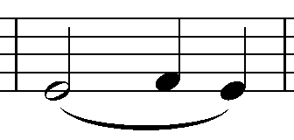 | smooth and well connected
staccato | 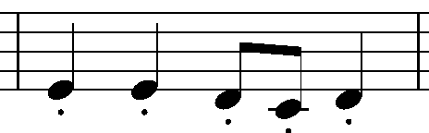 | short and detached
accent | 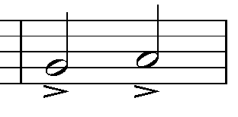 | emphasise the note

Techniques
Name | Meaning
vibrato | to slightly shake or vibrate the sound
glissando | a rapid succession of notes played in a sliding motion
pizzicato | to pluck the strings
pedal | an electronic device often used to change the timbre of guitars. For example, distortion pedal.
muting | this can be used on a brass or string instrument using a mute which quietens the sound and changes the timbre or can also be produced by using the fingers or hand to dampen the sound on a string instrument.
melisma | when you sing a single syllable of text whilst moving between several different notes in succession.

Dynamics and expressive techniques

Listening

Activity
Listen to the following examples and circle which dynamics and expressive techniques you can hear in each excerpt:
- ‘Where?’ by Kate Miller-Heidke (00:00:00 – 00:02:32) (date accessed 11/11/2020)
- ‘Eliza Aria’ by Elena Kats-Chernin (00:00:00 – 00:01:31) (date accessed 9/11/2020)
- ‘Ocean’ by John Butler (00:00:00 – 00:03:01) (date accessed 11/11/2020)
Piece | Dynamics | Expressive techniques | Other
‘Where’ by Kate Miller- Heidke | pp, p, mp, mf, f, ff  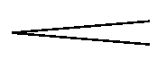 | Legato, staccato, accent, vibrato, glissando, pizzicato  Pedal, muting, melisma
‘Eliza Aria’ by Elena Kats-Chernin | pp, p, mp, mf, f, ff | Legato, staccato, accent, vibrato, glissando, pizzicato  Pedal, muting, melisma
‘Ocean’ by John Butler | pp, p, mp, mf, f, ff | Legato, staccato, accent, vibrato, glissando, pizzicato  Pedal, muting, melisma
Own choice | pp, p, mp, mf, f, ff | Legato, staccato, accent, vibrato, glissando, pizzicato  Pedal, muting, melisma

Activity — listening answers
Listen to the following examples and circle which dynamics and expressive techniques you can hear:
Piece | Dynamics | Expressive techniques | other
‘Where’ by Kate Miller- Heidke | Pp, p, mp, mf, f, ff  both cresc. and decresc. used | Legato, staccato, accent, vibrato, glissando, pizzicato  Pedal, muting, melisma | rubato
‘Eliza Aria’ by Elena Kats-Chernin | pp, p, mp, mf, f, ff  both cresc. and decresc. used | Legato, staccato, accent, vibrato, glissando, pizzicato  Pedal, muting, melisma | arco
‘Ocean’ by John Butler | pp, p, mp, mf, f, ff  both cresc. and decresc. used | Legato, staccato, accent, vibrato, glissando, pizzicato  Pedal, muting, melisma | slides, hammer on and off, strumming and picking, muting, tapping, tremolo, bends
own choice: | pp, p, mp, mf, f, ff | Legato, staccato, accent, vibrato, glissando, pizzicato  Pedal, muting, melisma

Match up activity

Dynamics and expressive techniques

Revision
Name | Symbol | Definition
pianissimo | pp | very soft
piano | p | soft
mezzo piano | mp | moderately soft
mezzo forte | mf | moderately loud
forte | f | loud
mezzo forte | mf | moderately loud
forte | f | loud
fortissimo | ff | very loud
crescendo |  | gradually getting louder
decrescendo |  | gradually getting softer
legato – this may include using slurs | 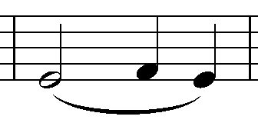 | smooth and well connected
staccato | 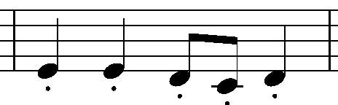 | short and detached
accent | 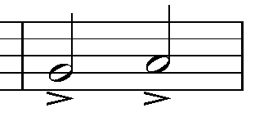 | emphasise the note

Name | Definition
vibrato | to slightly shake or vibrate the sound
glissando | a rapid succession of notes played in a sliding motion
pizzicato | to pluck the strings
pedal | an electronic device often used to change the timbre of guitars. For example, distortion pedal
muting | this can be used on a brass or string instrument using a mute which quietens the sound and changes the timbre or can also be produced by using the fingers or hand to dampen the sound on a string instrument
melisma | when you sing a single syllable of text whilst moving between several different notes in succession

Image references
- oboe woodwind picture 1 (date accessed 9/11/2020)
- baritone saxophone woodwind picture 2 (date accessed 9/11/2020)
- soprano saxophone woodwind picture 3 (date accessed 9/11/2020)
- piccolo picture woodwind picture 4 (date accessed 9/11/20)
- alto saxophone picture 5 (date accessed 9/11/2020)
- flute woodwind picture 6 (date accessed 9/11/2020)
- clarinet woodwind picture 7 (date accessed 9/11/2020)
- bass clarinet woodwind picture 8 (date accessed 9/11/2020)
- bassoon woodwind picture 9 (date accessed 9/11/2020)
- tenor saxophone woodwind picture 10 (date accessed 9/11/2020)
- french horn brass instrument picture 1 (date accessed 9/11/2020)
- tuba brass instrument picture 2 (date accessed 9/11/2020)
- trumpet brass picture 3 (date accessed 9/11/2020)
- trombone brass picture 4 (date accessed 9/11/2020)
- violin string picture 1 (date accessed 9/11/2020)
- cello string picture 2 (date accessed 9/11/2020)
- viola string picture 3 (date accessed 9/11/2020)
- double bass string picture 4 (date accessed 9/11/2020)
- harp string picture 5 (date accessed 9/11/2020)
- xylophone tuned percussion picture 1 (date accessed 9/11/20)
- glockenspiel tuned percussion picture 2 (date accessed 9/11/2020)
- vibraphone tuned percussion picture 3 (date accessed 9/11/2020)
- marimba tuned percussion picture 4 (date accessed 9/11/2020)
- timpani tuned percussion picture 5 (date accessed 9/11/2020)
- cymbal untuned percussion picture 1 (date accessed 9/11/2020)
- woodblock untuned percussion picture 2 (date accessed 9/11/2020)
- bass drum untuned percussion picture 3 (date accessed 9/11/2020)
- bongos untuned percussion picture 4 (date accessed 9/11/2020)
- snare drum untuned percussion picture 5 (date accessed 9/11/2020)
- bells untuned percussion picture 6 (date accessed 9/11/2020)
- maracas untuned percussion picture 7 (date accessed 9/11/2020)
- triangle untuned percussion picture 8 (date accessed 9/11/2020)
- guiro untuned percussion picture 9 (date accessed 9/11/2020)
- claves untuned percussion picture 10 (ate accessed 9/11/2020)
- tambourine untuned percussion picture 11 (date accessed 9/11/2020)
- cowbell untuned percussion picture 12 (date accessed 9/11/2020)

