Music 2 HSC

Music of the last 25 years

‘Death in Sidmouth’ by Jim Coyle

Table of contents
Music 2 HSC 1
Music of the last 25 years 1
‘Death in Sidmouth’ by Jim Coyle 1
Table of contents 2
Music 2 HSC Resource 3
‘Death in Sidmouth’ by Jim Coyle 3
‘Death in Sidmouth’ 4
By Jim Coyle 4
Synopsis 4
Movement four: ‘November’ 5
Literacy activity 6
Performance and composition 6
Musicology and aural 7
Composition 11
Extension activity 12
Answers 13
Literacy activity 13
Performance and composition 14
Musicology and aural 15

Music 2 HSC Resource

‘Death in Sidmouth’ by Jim Coyle
This education resource has been prepared for students studying the NSW Higher School Certificate Music 2 course as part of the mandatory topic ‘Music of the Last 25 Years’. It is comprised of a movement taken from Australian composer Jim Coyle’s dramatic song cycle titled ‘Death in Sidmouth’. This resource contains a variety of listening, performance, composition and literacy activities suitable for study. Scores, worksheets and answers for the teacher are also included.
‘Death at Sidmouth’ by Jim Coyle is a dramatic song cycle for bass-baritone voice and string quartet written in five movements. Each movement is chronologically represented as a different month of the year.
The activities contained within the resource provide students with the opportunity to explore cross curricular literacy content through the integration of the poem ‘November’ by British poet Thomas Hood, which is used as the lyric content for this work. Class performance is encouraged through a classroom arrangement, to develop performance and score reading skills, and to further explore the compositional devices utilised. Students are then required to demonstrate their understanding of these devices through completion of the composition activities provided. A complete listening guide according to the concepts of music is included for score study, in addition to guided listening activities to develop critical listening skills. Extension activities are also included.

‘Death in Sidmouth’

By Jim Coyle
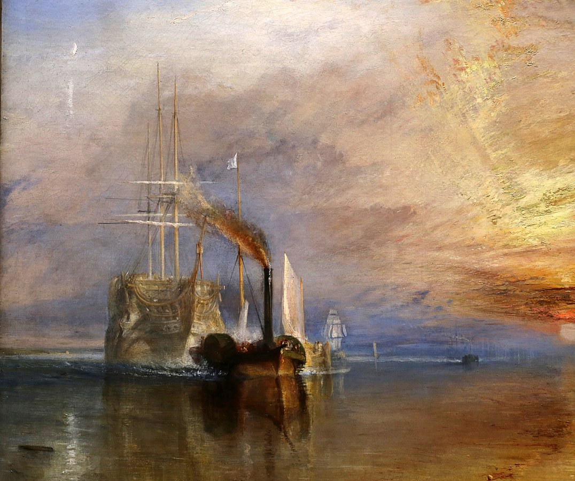
'The Fighting Temeraire’ by John Turner (date accessed 05/02/2021)
Jim Coyle is an Australian composer of operas, concertos, choral and orchestral works as well as pieces for solo instrument and chamber music. He has written for some of Australia's finest musicians but is also passionate about creating new music for young musicians, school ensembles and children. Jim also lectures in Music Education at the Sydney Conservatorium of Music and holds a PhD in composition from Sydney University. Jim regularly delivers composition masterclasses and professional learning for music teachers, and is also a community choir director.
‘Death at Sidmouth’ by Jim Coyle is a dramatic song cycle for bass-baritone voice and string quartet written in five movements. Each movement is chronologically represented as a different month of the year. Much of its lyric content is taken from poems by famous British composers such as Alford, Keats, Hood and Swinburne.
Text source from Jim Coyle website (date accessed 16/12/2020)

Synopsis
It is August 1947 and Harold Lancebury (‘Pallas’ to his pupils) has just completed nearly forty years as Music Master at Holt’s, an expensive English boarding school. He retires to a small hotel in the seaside resort of Sidmouth full of fond reminiscence. As autumn progresses, however, his world darkens as loneliness, purposelessness and despair overcome him.
‘Death in Sidmouth’ is rich in allusion and imagery and mines a deep vein of very English sensibility. Ghosts are here, the friendly and the hostile, in the music with its echoes of Elgar, Vaughan Williams and Britten, and in the text with its quotations from the Romantic poets and its indebtedness to folk ballad and to The Book of Common Prayer. Despite its profound Englishness, 'Death in Sidmouth’ is principally concerned with a universal theme – the fear of abandonment as we grow old.
‘Death in Sidmouth’ was composed in 2018 and is a research output of the University of Sydney.
Text source from Jim Coyle website (date accessed 16/12/2020)

Movement four: ‘November’
The five songs in this song cycle each relate to events in five consecutive months. As the light and warmth disappear from the natural world during this time, so they also disappear from the Lancebury’s life. Like everyone else in the world, Lancebury needs to feel useful and appreciated and needs human interaction. It is in this movement that his lonely and depressing situation becomes very apparent to him.
The previous movement (‘October’) is set to part of the text of Keats’ ‘Ode to Autumn’ and deals with the abundance of the earth and sea. Lancebury is delighted by the plenty (he is someone who enjoys food) but realises that he is feasting alone.
In the following movement (‘December’) the poetry is from ‘The Garden of Proserpine’ by Swinburn and is concerned with death and oblivion. The music has resignation and calm, but Lancebury’s solitary, quiet and lonely death can be nothing but tragic.
In between, the ‘November’ movement is one of harsh realisation. The weather on the English coast in November can be extremely unpleasant and there is a great deal of darkness. This bleak world (and dirty weather) is reflected in the music, as is Lancebury’s gathering pessimism.
Text source from Jim Coyle website (date accessed 16/12/2020)

Literacy activity
The text for the opening of ‘November’ by Jim Coyle was taken from a poem written in 1844 by British poet Thomas Hood. Read the poem by following the link below and answer the following questions in your workbook.
‘November’ by Thomas Hood (date accessed 15/12/2020)
- What is the first thing you notice about this poem?
- Describe the tone or mood of the poem. How is this achieved?
- Identify the rhyme scheme used in this poem. Do you notice any patterns? Additional help in identifying rhyme schemes can be found here: ‘How do I identify the rhyme scheme?’ (date accessed 08/02/2021)
- What other literary techniques can you identify?

Performance and composition
- Perform the classroom arrangement of the first section of ‘November’ by Jim Coyle by using the classroom arrangement score provided. Please note there is a C, Bb and Eb version available if you have mixed instrumentation.
- Following the performance, answer the following question is your book and discuss as a class:
  - Describe the mood of the music. How do you think this is represented in the musical material? Give two specific examples.
  - How many layers of sound can you hear? What are their roles? Describe their musical material.
  - The harmonic accompaniment is derived from repeated rhythmic ostinatos. How many ostinatos can you identify in the excerpt? Play these through as a class, focusing on the use of articulation.
Example one (bars 322-324)
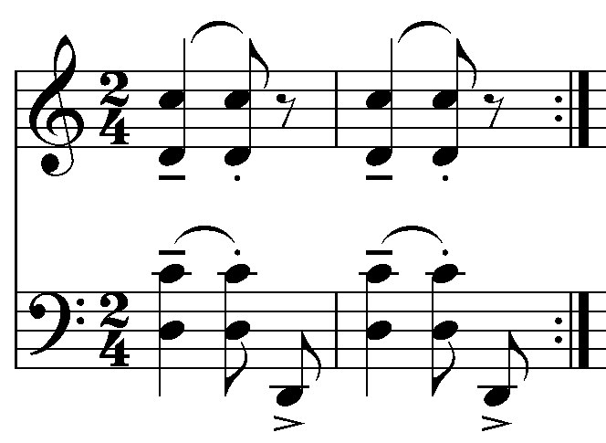
Example two (bars 342-343)
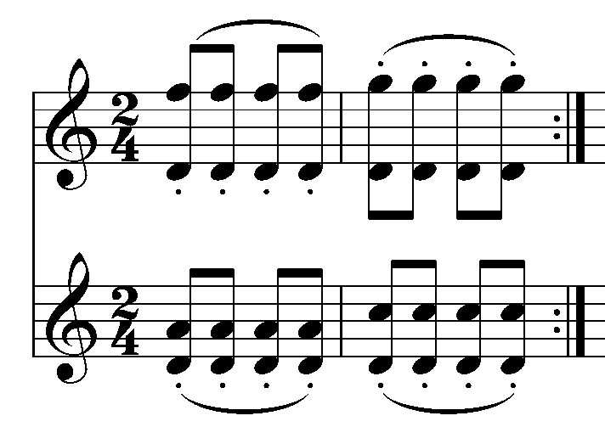
Example three (bars 362-363) This rhythmic ostinato is found later in the piece.
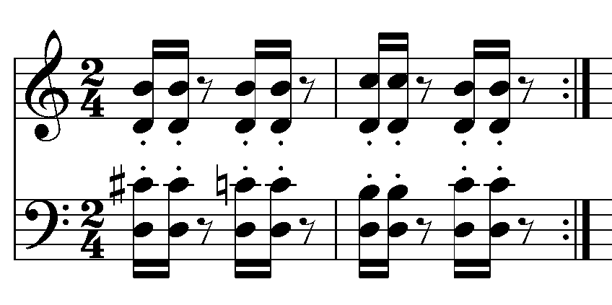
- Experiment with each rhythmic ostinato above by altering the articulation. How does this change the musical outcome?
- In pairs, compose your own two bar rhythmic ostinato that also features harmony and articulation. Perform your ostinato to the class.

Musicology and aural
Listen to ‘November’ by Jim Coyle (date accessed 15/12/2020) whilst following the score provided and answer the questions below.
- Describe the use of pitch used in this piece. Elements to consider include:
  - tonality
  - the type of harmony used
  - intervals
  - the contour of the melodic material
- How does the musical material create tension? Please provide specific examples in your answer.
- In this piece the strings use a variety of techniques which have an impact on the timbre and expression. In the table below is a list of the techniques used in this movement and how they are notated. You are required to:
  - identify where this technique is used on the score by providing a bar number
  - explain how the performer produces each technique
  - listen to the recording of each technique. Describe the timbre created and how this impacts on the expression.

Technique | Name | Bar | Explanation | Timbre
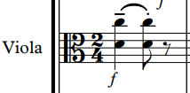 | double stopping
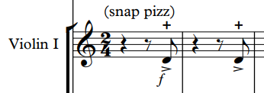 | snap pizzicato
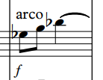 | arco

Listening guide
Concepts | Musical features
Structure | - Through composed.  - Irregular phrasing is implemented due to the narrative. Phrasing is often between five and nine bars long.
Duration | - 2/4 time signature, regular bar lengths, moderate tempo.  - Repeated rhythmic cells are developed and used to provide unity. For example, the repeated rhythms played by the strings in bars 322-333. These also provide propulsion and momentum to the piece.  - The notes values used are mainly short from semiquavers through to minims.  - Syncopation is used in the opening repeated rhythm (bars 322 – 334) with an accent placed on the last quaver of each bar and highlighted by the violin II part. This creates uncertainty of beat one which creates tension. Further rhythmic interest is achieved in the polyrhythm of the crotchet triplet against the quavers in bars 339-341.  - Rhythmic unison is heavily featured in bars 396-405 in the string parts.
Pitch | - The tonality is mostly based on D Locrian mode with use of chromatic harmony which creates dissonance. (bars 329-335)  - There is a consistent use of wide intervals in both the vocal and accompaniment parts of mainly minor 7ths, major and minor 6ths and diminished 5ths which contributes to the tension in the piece. (bars 329-333). Major 2nds can also be seen in the B section in bars 391-394.  - The melodic contour is very angular and regularly contains large leaps such as minor 7ths and octaves.  - The range of all instruments is wide. The vocals span almost two octaves, whilst the strings individually also play across two to two and a half octaves.  - Irregular phrasing is implemented due to the narrative. Phrasing is often between five and nine bars long.  - The rate of harmonic change also varies due to the irregularity of the phrasing from anywhere between 1 to 5 bars.
Tone Colour | - The bass baritone voice provides the melody using a strong, bellowing timbre.  - The string quartet provides the harmonic and rhythmic accompaniment using a scratchy and sometimes abrasive timbre due to the string techniques incorporated throughout.  - Techniques include snap pizzicato and the use of open strings which results in a raw, earthy sound.
Texture | - Homophonic texture is used throughout with the vocals providing the melody and the string quartet providing the harmonic and rhythmic accompaniment using repeated ostinatos. (bars 322-323)  - The texture is predominantly thick with the accompanying parts playing harmonic rhythms throughout. The second half of the piece is more varied in texture due to frequent omissions of instrumental parts and rests interspersed between the prose which makes the texture thinner. (bars 375 – 389)  - The violin I often imitates the vocal line or plays small fills in between the vocal line. For example, a fill is seen in bars 334 - 335 and imitation is observed in bars 340-341.  - Thinning of the texture can also be heard through the decrescendo from bar 350.  - Use of staggered entries can be seen in bars 391 – 395 which gradually thickens the texture.
Dynamics and expressive techniques | - Interest is created through the varied articulation in all parts and the incorporation of string techniques such as double stopping, snap pizzicato and arco. These techniques are used to create a raw, edgy sound which reflects the narrative. Exaggerated vibrato is used in the vocal part to reflect the style and mood of the piece.  - The dynamics are extensive ranging from pianississimo to fortissimo. The opening of the piece begins at forte and slowly diminishes across the section to mezzo piano at bar 337, and pianissimo at bar 354. An explosive fortissimo is then interjected combined with snap pizzicato, accents in the string parts and exclamatory language used in the ‘November’ motif in the vocal part from bar 355. The second half of the piece features quieter moments with a thinner texture and more sparse voicing in the string parts. Loud moments are interjected using dynamics of forte and fortissimo at bars 371, 381, 399 and 419.  - The piece ends in a unified pianississimo which is lightly bowed with staccato articulation.

Additional Listening
These are links to the other movements in the entire song cycle of ‘Death in Sidmouth’ for further reference.
‘August’ mv 1 by Jim Coyle (date accessed 18/12/2020)
‘September’ mv 2 by Jim Coyle (date accessed 18/12/2020)
‘October’ mv 3 by Jim Coyle (date accessed 18/12/2020)
‘November’ mv 4 by Jim Coyle (date accessed 18/12/2020)
‘December’ mv 5 by Jim Coyle (date accessed 18/12/2020)

Composition
Using a notation program such as Sibelius, Finale, Musescore or Flat, you will compose your own short piece for string quartet and voice in through form.
Sibelius (date accessed 15/12/2020)
Finale (date accessed 15/12/2020)
Musescore (date accessed 15/12/2020)
Flat (date accessed 15/12/2020)
You may like to initially experiment with the following steps using instruments first and then notate in the software program later.

Steps
- Select a poem of your choice which will become the lyric content for your work. This can be a poem that is pre-existing, or you can write your own poem if you wish. Make sure that it is not too long.
- Identify the mood of the poem.
- Brainstorm musical elements or features that you could use to achieve this mood within your composition. For example, Jim Coyle has used the following to create a mood of tension and despair:
  - use of D Locrian mode
  - dissonance
  - chromatic harmony
  - string expressive techniques that create a raw, edgy sound
  - angular melodic writing including large leaps
  - wide voicing in the strings parts utilising clashing intervals such as major 7ths.
- Create a new project in one of the software platforms listed above for string quartet and voice.
- Write a rhythmic ostinato for the cello and viola. You may wish to use the one you wrote in the previous activity or you may write a new one. Start with the rhythm first which reflects the mood of the piece, and then work to build the harmony. Keep in mind the musical elements you brainstormed in question three and make sure your musical decisions reflect the mood.
- Experiment with this ostinato by altering the pitch or articulations until you come up with approximately 8 to 16 bars of harmonic accompaniment that you are happy with.
- Revisit the lyrics you wish to use for your composition. Improvise or experiment with creating a melody with these lyrics that will fit with the accompaniment. Start with one motif for the first phrase and develop the motif further in the consecutive phrases. Adjust any of the harmonic accompaniment as required. Don’t forget to write the lyrics underneath the melody.
- Repeat step five if you need to create more accompaniment material until you have included all the lyrics you wish to use.
- Consider how to utilise your violin parts. This could include:
  - accentuating rhythms with additional notes
  - imitating the vocal line or providing fills in breaks
  - adding an additional harmony to the rhythmic ostinato
  - pairing them in sections to create a contrasting harmonic pattern
  - using expressive or extended techniques to achieve a unique timbre
- When you have finished, consider how interest or contrast is created in your composition. Is it too repetitive? How could you manipulate the concepts of music to achieve this? Then consider unity. What are the unifying musical features? Does the melody meander, or does it have some form of structure? Make adjustments as needed.
- Add dynamics, articulation and expressive terms where appropriate.
- Name your piece and present it to the class.

Extension activity
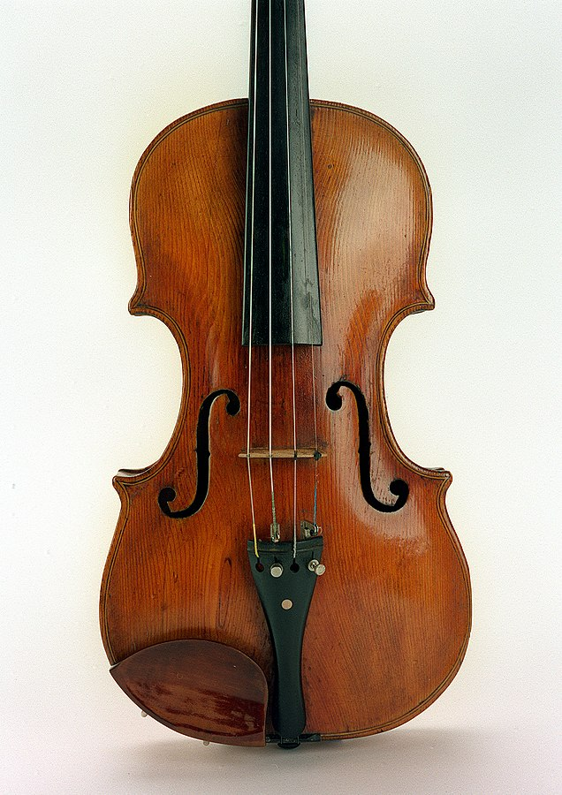
Image source wikimedia (date accessed 18/12/2020)
Image source wikimedia (date accessed 18/12/2020)
There are multiple string techniques used in ‘Death in Sidmouth’ by Jim Coyle which contribute to the musical expression through tone colour and articulation. These techniques influenced the complex and nuanced bowing found in ‘November’ by Jim Coyle.
- Research some additional string techniques (no less than five) and provide the following:
  - notation for the technique
  - name for the technique
  - method of playing
  - timbre produced
Examples may include sultando, ricochet, sul ponticello, spiccato. You may wish to watch the following video as a starting point:
String techniques – London Symphony Orchestra (date accessed 18/12/2020)

Answers

Literacy activity
- What is the first thing you notice about this poem?
  - The repetition of the word ‘no’ and then how it is used in the final statement ‘November!’.
- Describe the tone or mood of the poem. How is this achieved?
  - The tone of the poem is one of frustration and despair. This is achieved through the use of anaphora with the repetition of the word ‘no’. It is also achieved through two examples of exclamatory language. For example, ‘No sun – no moon!’ and ‘November!’
- Identify the rhyme scheme used in this poem. Do you notice any patterns? Additional help in identifying rhyme schemes can be found here: ‘How do I identify the rhyme scheme?’
  - Stanza one: A, A, B, C, C, B
  - Stanza two: D, D, D, E, F
  - Stanza three: F, G, F, H, G
- What other literary techniques can you identify?
  - Anaphora – the repetition of a word at the beginning of multiple lines or sentences used to create dramatic significance. For example - ‘no’.
- Use of the hyphen – the pace of the poem is established through the repetitive use of the hyphen.
  - Exclamatory language – this emphasises the tone at both the start and end of the poem. For example, ‘No sun – no moon!’ and ‘November!’.
  - Hyperbole – an exaggerated metaphor. For example, ‘no sky, no road, no street.’
  - Alliteration – when the first letter of multiple words is repeated. For example, shade/shine, butterflies/bees, fruits/flowers.

Performance and composition
Perform the classroom arrangement of the first section of ‘November’ by Jim Coyle by using the classroom arrangement score provided. Please note there is a C, Bb and Eb version available if you have mixed instrumentation.
Following the performance, answer the following question is your book and discuss as a class:
- Describe the mood of the music. How do you think this is represented in the musical material? Give two specific examples.
  - The mood is of anguish, frustration, negativity and despair. Suggested answers as to how this is represented in the musical material may include:
  - The lyric content with repetition of the word ‘no’.
  - The lower registers portrayed in the strings, producing a dark timbre and raw edgy sound through the use of open strings.
  - The dissonance used in the harmony.

- How many layers of sound can you hear? What are their roles? Describe their musical material.
  - There are five layers of sound:
  - Melody – provides the melody. The melody is angular and mostly made up of wide leaps. The phrases vary in length from five to eight bars.
  - Part 1 – provides harmonic accompaniment and at times imitates or provides fills in the rests of part 1.
  - Part 2 – provides harmonic accompaniment and is highly syncopated. It uses rhythmic ostinato and wide voicing in the accompanying ostinato.
  - Part 3 – provides harmonic accompaniment through a rhythmic ostinato. Wide intervals are utilised in the voicing of the harmony. The simple rhythms used help to maintain the beat and define the metre.
  - Bass line – similar to part three, however, being the bass line, it defines the tonal centre of D in partnership with part three.
- The harmonic accompaniment is derived from repeated rhythmic ostinatos. How many ostinatos can you identify in the excerpt?
  - There are two rhythmic ostinatos used in this particular excerpt which are outlined in the resource material above.

Musicology and aural
Listen to ‘November’ by Jim Coyle (date accessed 15/12/2020) whilst following the score provided and answer the questions below.
- Describe the use of pitch in this piece. Elements to consider include:
  - Tonality — it sounds somewhat atonal but is based on the D Locrian scale with a clear tonal centre of D maintained throughout.
  - The type of harmony used — chromatic harmony is utilised.
  - Intervals — wide intervals are used in both the accompaniment voicing and the vocal line. This is partly due to the double stopping in the string parts where intervals such as major and minor 6ths, major 7ths and diminished 5ths are incorporated throughout. Large leaps using these intervals are also found in the vocal part.
  - The contour of the melodic material — the contour of the vocal part is very angular and both ascends and descends. It moves mainly in leaps with some step wise material. The opening of each phrase often starts with a large intervallic leap.
- How does the musical material create tension? Please provide specific examples in your answer. Suggested answers may include:
  - Dissonance due to the use of a modal tonality combined with chromatic harmony throughout.
  - Wide intervals used in all parts as both melody and harmony create a sense of unease and contribute to the dissonance.
  - The angular melodic contour due to wide leaps in the vocals creates a sense of unease or tension.
  - Uneven phrases feel somewhat unsettling and unresolved.
  - The sound of ‘no’ is exaggerated by the use of accent and a higher pitch in most of the phrases presented.
  - The raw, edgy timbre provided by the strings due to the use of open strings in the double stopping.
  - The booming and powerful timbre provided by the vocals throughout contributes to the harshness of the atmosphere or mood.
  - The propulsion and momentum created by the string ostinato rhythms in combination with the accented and short articulation creates tension.
  - The syncopation in the opening accompaniment through the use of accent is unexpected and alludes to uncertainty of beat placement therefore creating tension.
  - The use of snap pizzicato results in a percussive and harsh timbre contributing to the tension.
  - The sudden changes in dynamics from piano to forte or fortissimo creates an element of surprise.
- In this piece the strings use a variety of techniques which have an impact on the timbre and expression. In the table below is a list of the techniques used in this movement and how they are notated. You are required to:
  - identify where this technique is used on the score by providing a bar number
  - explain how the performer produces each technique
  - listen to the recording of each technique. Describe the timbre created and how this impacts on the expression.
Technique | Name | Bar | Explanation | Timbre
 | double stopping | 1 | When two notes are played at once simultaneously. In this case using open strings. | Raw and edgy due to the open strings. This contributes to the dark and suspenseful expression communicated in this movement.
 | snap pizzicato | 1 | Pluck the string away from the fingerboard with sufficient force to cause it to snap back and strike the fingerboard creating a snapping sound in addition to the pitch itself. | Percussive and abrasive which contributes to the tension and element of the unexpected revealed in this movement.
 | arco | 7 | To play with the bow. | This technique typically produces a warm and bright timbre depending on the register it is played in.

The concepts of music checklist

Duration
- Tempo – Adagio/Lento/Moderato/Allegro?
- Tempo – changes/constant?
- Time signature – constant/multimeter?
- Rhythm is strict/rigid/free/indefinite?
- Syncopation/polyrhythms/cross rhythms?
- Ostinato/backbeat/anacrusis?
- Accelerando/ritardando/rubato?
- Note values – long/short/dotted?
- Repeated rhythms?
- Beat – strong/indefinite?
- Bar lengths – regular/irregular?

Pitch
- Tonality – major/minor/modal/atonal/pentatonic?
- Modulations/key changes?
- Rate of harmonic change?
- Arpeggios/triads/drone?
- Scales used – major/minor/chromatic/blues/mode?
- Harmony – consonant/dissonant?
- Melody – moves in steps/leaps?
- Melodic contour – ascending/descending?
- Range/intervals?
- Phrase lengths
- Imitation/repetition/ostinato/sequence?
- Ornamentation/improvisation?
- Counter melody/call and response/canon?
- Cadences – perfect/plagal/imperfect/interrupted?
- Tone clusters

Structure
- Binary/ternary/rondo
- Theme and variations
- Through composed
- Strophic form
- Verse/chorus form
- 12 bar blues form
- How can you tell when a new section begins?
- Identify the number of bars in each section.
- Macro (whole song) and micro (phrases) structure

Texture
- Thin/thick?
- Monophonic/homophonic/polyphonic?
- Roles of the instruments – melodic/harmonic/rhythmic?
- How many layers of sound are there?
- Changes in texture – sudden/gradual?
- Unison/doubling/imitation?
- Call and response/canon?
- Motion – similar/contrary?

Tone colour
- Performing media
- Aerophones/chordophones/membranophones/idiophones?
- Electronic sounds
- Range – narrow/medium/wide?
- Register – low/middle/high?
- Description of sound – use adjectives to describe the timbre.
- Role of each instrument
- Tone colour changes during the excerpt
- Describe the overall mood/atmosphere

Dynamics and expressive techniques
- Dynamics
- Sudden/gradual dynamic changes?
- Articulation — legato/tenuto/staccato/accents?
- Vibrato/tremolo/glissando/pizzicato?
- Muting/strumming/picking/pedals?
- Drum roll/distortion/amplification?
- Double stopping/note bending/multiphonics?
- Falsetto/scat/melisma?

