Extension Music

Composition

Table of contents
Extension Music 1
Composition 1
Table of contents 2
Course requirements – NESA 2
Assessment and examination information 3
Performances and submitted works 3
Course requirements 4
What do I have to do? 4
What do I need to create for submission? 4
The compositions 5
Extension music composition marking criteria 6
The composition portfolio 7
What do I need to include in the composition portfolio? 7
Composition portfolio template 8
Composition scaffold 10
Composition scaffold sample 11
Compositional devices 12
Rhythmic and melodic devices 12
Rhythmic devices 13
Melodic devices 14
Harmonic devices 15
Instrument specific notation 17
Italian expressive terms 18
Composition self-reflection 21
Composition timeline and submission dates 22
Composition checklist – final edit 23
Additional resources 25

Course requirements – NESA
Teachers and students should refer to the Stage 6 Music Extension Syllabus and supporting documents as outlined on the NESA website. The following resources in this booklet are provided for student distribution and use in the classroom.

Assessment and examination information
- Performance band descriptions for Music Extension
- Assessment and reporting in Music Extension
- Music Extension Stage 6 (2009): HSC practical tasks and submitted work marking guidelines (PDF, 8 pages, 249 KB)

Performances and submitted works
- HSC performance and submitted works requirements for Music Extension
- Rules and processes for practical and performance HSC exams including information for supervising teachers.

Stage 6 Music Extension Syllabus © NSW Education Standards Authority (NESA) for and on behalf of the Crown in right of the State of New South Wales, 2003.

Course requirements

What do I have to do?
Students in Music Extension will develop a deeper understanding of the characteristics of musical styles, periods and/or genres through their specialisation in composition. In addition, students will extend their musical understanding through a more detailed study of the relationships between the musical concepts of duration, pitch, dynamics and expressive techniques, tone colour, texture and structure.
The Extension course of study is intended as a refinement and sophistication of the skills within the learning experiences of composition, which should be demonstrated as follows:
- establishing a convincing personal musical style
- sophisticated and constructive critical appraisals of own compositions and the compositions of others
- refining the skill of analysing the works of other composers through the use of musical concepts
- ensemble direction in the performance of own compositions
- discussion of ideas that have led to the development of a composition
- compiling a composition portfolio.

What do I need to create for submission?
- Students will need to complete two contrasting pieces or movements for submission to NESA and must include a score and recording of each piece. The maximum combined time for both compositions should be no longer than 6 minutes.
- Students will be required to compile a composition portfolio as part of the process of preparing a submitted work. The portfolio forms part of the internal HSC assessment mark but is not externally assessed.
Information sourced from the Stage 6 Music Extension Syllabus © NSW Education Standards Authority (NESA) for and on behalf of the Crown in right of the State of New South Wales, 2003.

The compositions
For the purpose of the Higher School Certificate examination, the term ‘composition’ applies to original works. The composition should be of a musically substantial nature and should reflect an understanding of the stylistic features of the topic that it represents. It should show evidence of a personal interpretation and not be merely imitative writing.
The marking of submitted compositions is based on both the written scores and the recordings. The recordings are used as a guide to the intentions of the composer, and therefore the technical quality will not be taken into consideration. All details necessary to realise the scores must be included on the submitted manuscript. Traditional and non-traditional notation is acceptable. If non-traditional notation is used, a key should accompany the score. Page numbers, bar numbers and all performance directions are to be included on each work, and instruments/voices should be labelled on each page.
Candidates will be assessed on how well they demonstrate:
- understanding of musical concepts and the relationships between them
- stylistic understanding
- knowledge of score conventions and performance directions
- ability to establish and sustain a musical idea
- a sense of personal compositional style.
Any style or genre of music may be considered by students for their own compositions however, consideration needs to be given as to how successfully students can meet the marking criteria within the style selected. Each composition or movement is marked out of 25.

Extension music composition marking criteria
Criteria | Marks
- Composes a highly coherent work demonstrating sophisticated stylistic understanding through the use of highly developed compositional techniques, the sustained development and refinement of musical ideas, and the establishment of a personal compositional style.  - Demonstrates a sophisticated understanding of the concepts of music and their relationships within the work.  - Demonstrates an outstanding knowledge and application of scoring conventions in the expression and communication of musical ideas. | 21 – 25
- Composes a coherent work demonstrating stylistic understanding through the accomplished use of compositional techniques, the development and refinement of musical ideas, and evidence of a personal compositional style.  - Demonstrates an extensive understanding of the concepts of music and their relationships within the work.  - Demonstrates a successful application of scoring conventions in the expression and communication of musical ideas. | 16 – 20
- Composes a work demonstrating stylistic understanding through the use of compositional techniques, the development and refinement of musical ideas, and the emergence of a personal compositional style.  - Demonstrates a sound understanding of the concepts of music and their relationships within the work.  - Demonstrates an understanding of scoring conventions in the expression and communication of musical ideas. | 11 – 15
- Composes a work demonstrating stylistic understanding through the use of appropriate compositional techniques.  - Demonstrates an understanding of the concepts of music and their relationships within the work.  - Demonstrates an understanding of scoring conventions in the expression of musical ideas. | 6 – 10
- Composes a work demonstrating stylistic understanding but compositional techniques are inconsistent with the chosen style.  - Demonstrates some understanding of the concepts of music and their relationships within the work.  - Demonstrates limited understanding of scoring conventions in the expression of musical ideas. | 1 – 5

Stage 6 Music Extension Syllabus © NSW Education Standards Authority (NESA) for and on behalf of the Crown in right of the State of New South Wales, 2003.

The composition portfolio
A composition portfolio is to be developed as a record of the compositional process for composition and may be used as part of school-based assessment. Schools will use the composition portfolio as evidence of student progress and authorship of student work as it develops over time. The composition portfolio is not part of the external examination mark. This portfolio may be requested by NESA to validate authorship of the composition.

What do I need to include in the composition portfolio?
The composition portfolio is for students to document everything about their composition process. It can be in either a digital format (such as an online document, PowerPoint or webpage) or hard copy format such as a large visual arts diary or booklet. If using an online tool, students must ensure their work is backed up regularly, and the content should not be posted on a public facing website. It is important that HSC submittable works are protected and if using a webpage, it needs to be password protected. It is advised that digital diaries must also be saved as PDF files that can be provided to NESA if requested.
Your composition portfolio should contain the following:
- the decision making process
- background listening, musicological observations and performance within the style
- development of compositional skills
- performance considerations
- draft compositions including annotations written on the score
- analysis of your composition at every stage
- suggestions for ways to enhance the composition.
NESA composition portfolio - additional information.

Composition portfolio template
The following table contains suggested headings for a composition portfolio.
Heading | Additional information
First ideas | Students are to brainstorm any first ideas they have in regards to what type of composition they wish to write. This may include instrumentation, style, musical features or inspiration drawn from a stimulus.
Listening | Students are to research performers or composers who write or perform in the style selected or use similar instrumentation. Students are required to select a range of works (at least three) that they find appealing or are interested in. Complete a condensed concept analysis (this can be in dot points) for each piece.
Musical features to consider | Students are to compile a list of musical features that they find interesting derived from the listening activity. This is a list of features they might like to include in their own composition. This may include for example, interesting rhythmic or melodic devices, a creative use of structure, or unusual expressive techniques.
Musicology | Students are to research the genre and historical and cultural context of the style they wish to write in and provide an overview with relevant information.
Stylistic musical characteristics | Create a list of musical characteristics that are typical of the style. These should be derived from listening and research, with consideration given to all concepts.
Decision making | Students are to consolidate their initial ideas and make some decisions in regards to:  - instrumentation  - style  - if the compositions are going to be two separate works, or two movements of a larger work.  Students must document their decision process as to why they have made these choices.
Composition scaffold | Students are to map out their initial ideas in regards to the structure of the piece/s and any musical features that would support or enhance the structure. A sample composition scaffold is provided.
Instrument performance considerations | Students are to research each instrument they plan to use and document the following:  - General capabilities – this may include technical considerations. Can the instrument/voice perform fast passages? Can the sound be sustained? Can it play harmony? What is its typical role within your selected style?  - Range and register – which register is most powerful? Which register is difficult for the performer to achieve specific dynamics?  - Dynamics and expressive techniques – this may include extended techniques. How does the instrument execute different articulations? Can it play all dynamics in all registers with ease? How does this change the timbre?  - Special considerations – are there any cultural considerations regarding the instruments you have chosen? Who will perform your composition for the recording? (if needed).
Experimentation – draft 1 | Students are to begin experimenting with creating musical material as a basis of their first ‘draft.’ Once initial experimentation is complete, students are to notate their process and ideas and paste it in their portfolio.
Reflection – draft 1 | Students are to annotate their first draft and reflect on their composition thus far. Some guiding questions may include:  - What worked well or was musically successful?  - What isn’t quite working and why? How can you resolve this next time?
Experimentation and development – draft 2 | Students are to continue experimenting and developing their initial ideas from draft 1. Continue documentation of process and ideas and paste the draft into the portfolio.
Reflection – draft 2 | Students are to annotate their draft and reflect on their composition thus far as above. Students will continue the draft and reflection process for each time they work on their composition. Students are expected to produce multiple drafts and reflections as the composition evolves and develops.
Rehearsal reflection | Students are to write a reflection on the rehearsal process (if performing to be recorded). Questions may include:  - What worked well?  - What didn’t work well and why?  - What changes need to be made so that the composition is musically successful?
Recording reflection | After recording the composition, students are to edit their score accordingly and write a reflection on the recording process.
Final score and reflection | Students are to paste in their final score and reflection of their composition. A composition checklist is provided for the final edit.

Composition scaffold

Composition scaffold sample
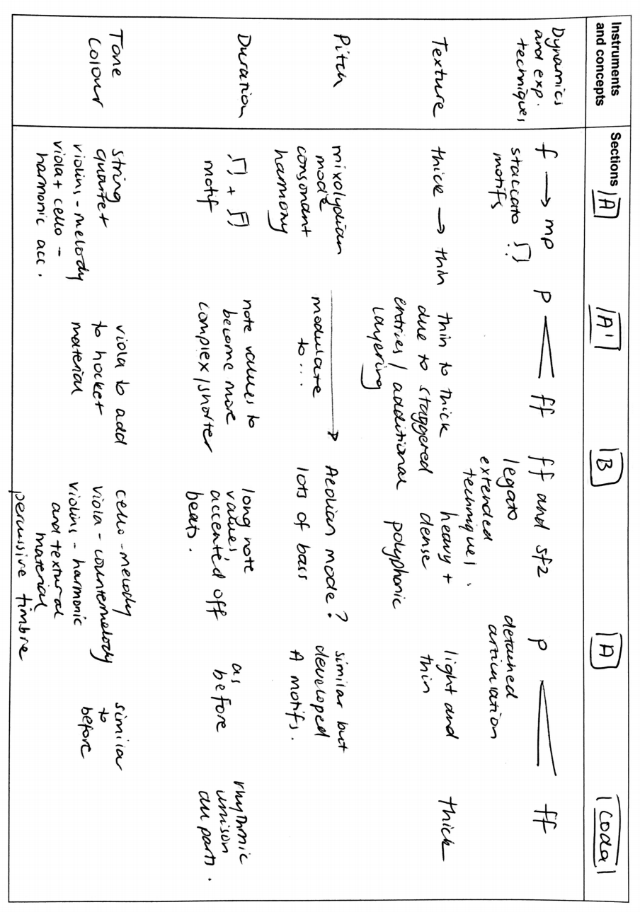

Compositional devices

Rhythmic and melodic devices
Name | Definition | Example
Motif | A short melody or figure. | 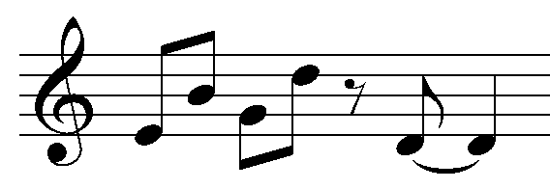
Retrograde | The motif played backwards. | 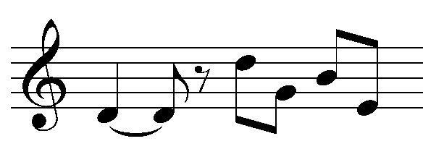
Fragmentation | Using only part of the motif. | 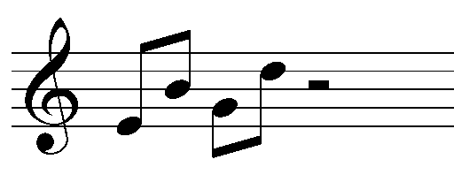
Interpolation | Adding new material into the middle of a motif. | 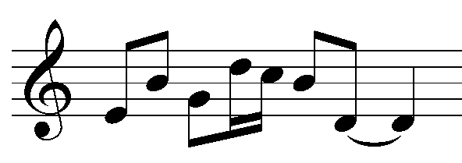
Extension | Adding new material to the start or end of a motif. | 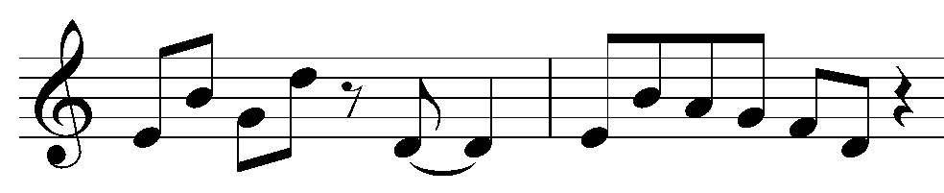
Repetition | Repeating the motif or parts of the motif. | 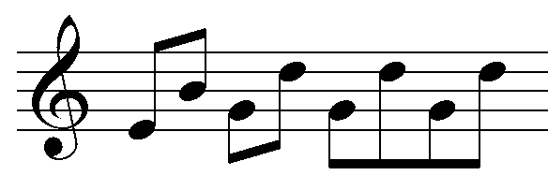
Ostinato | A repeated phrase or rhythm. | 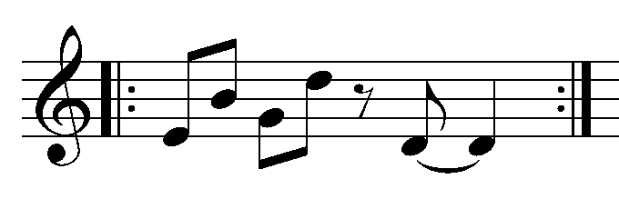
Unison | The same part played by at least two instruments or voices. | 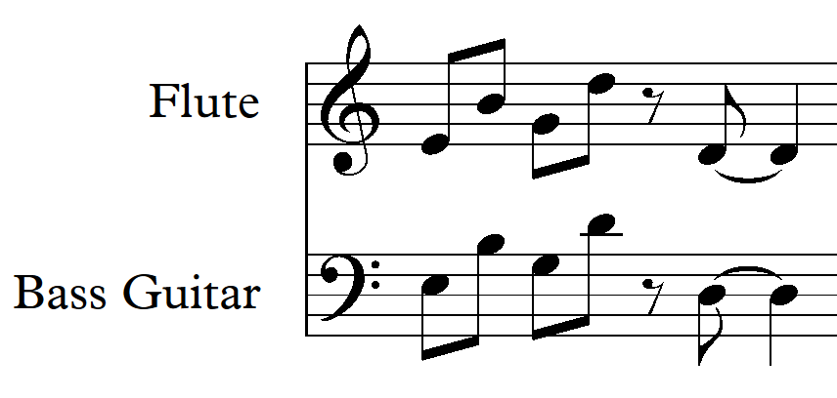
Call and response | A succession of two distinct phrases usually played by different instruments, where the second phrase is heard as a direct commentary on or response to the first. | 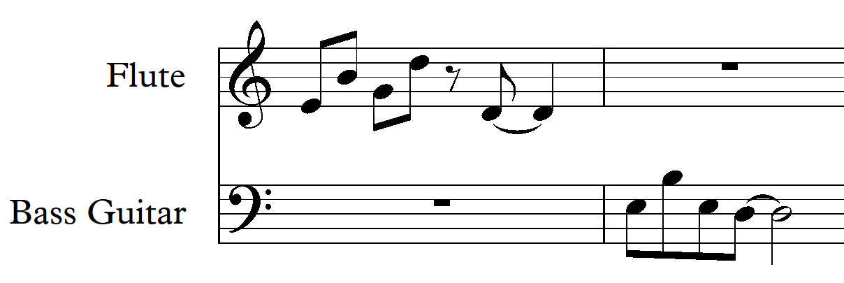

Rhythmic devices
Name | Definition | Example
Motif | A short melody or figure.
Augmentation | Increasing the note lengths of a motif. | 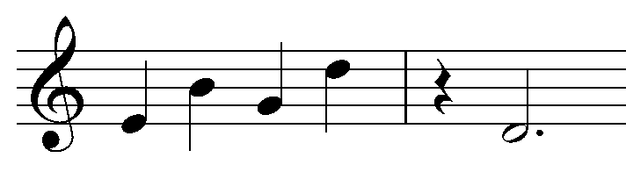
Diminution | Decreasing the note lengths of a motif. | 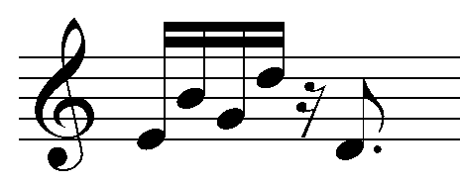
Rhythmic alteration | Same pitch, different rhythm. | 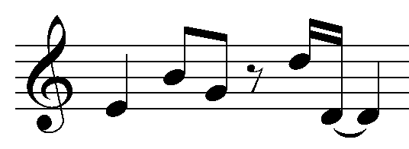
Hemiola | Superimposing two notes in the time of three, or three notes in the time of two. | 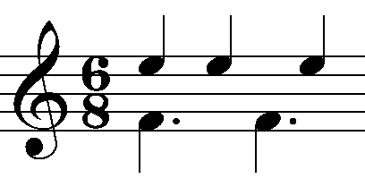
Syncopation | When a rhythm is played ‘off the beat’. | 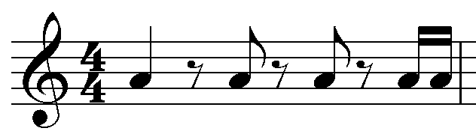
Polyrhythm | Two or more contrasting rhythms played at once. | 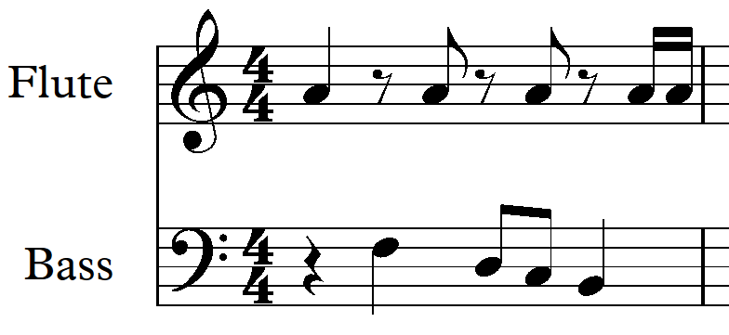
Cross rhythm | Two rhythms which use or give the impression of using two different time signatures against one another. | 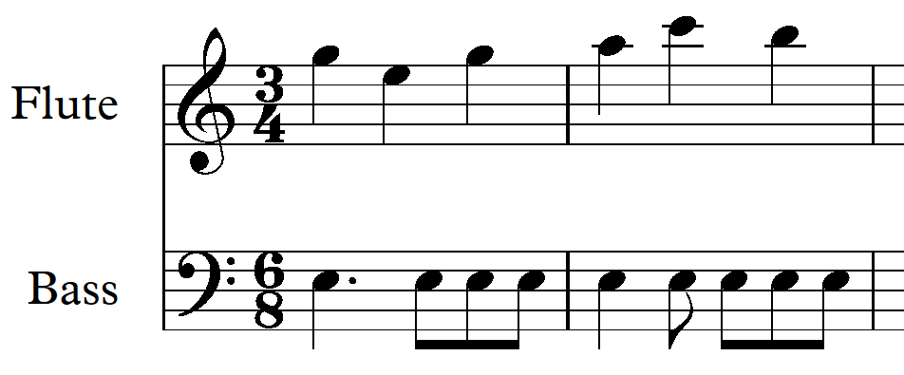
Additive rhythm | Grouping of irregular note values (for example quavers grouped in 2’s and 3’s) to create irregular metre. | 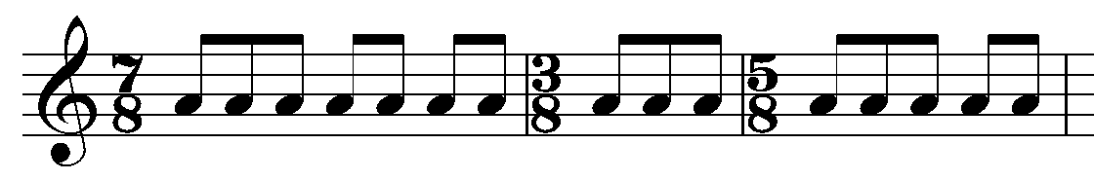
Irrational rhythm | Using bracketed notes to divide note values into a beat or beats. For example 5:4. | 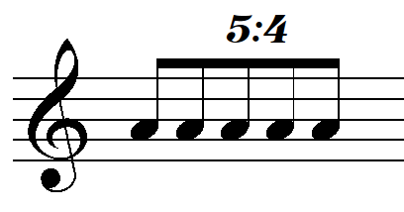
Multimetre | The use of changing time signatures throughout a piece. | 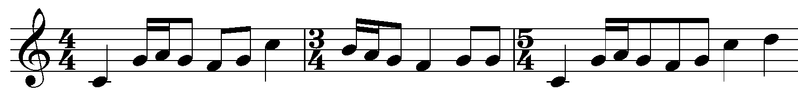

Melodic devices
Name | Definition | Example
Motif | A short melody or figure.
Interval expansion (augmentation) | Making the intervals between consecutive notes wider. | 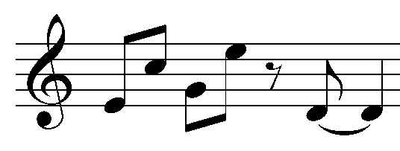
Interval contraction (diminution) | Making the intervals between consecutive notes shorter. | 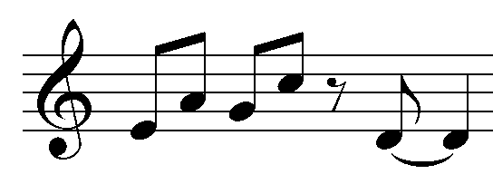
Pitch displacement | Same rhythm different pitch. | 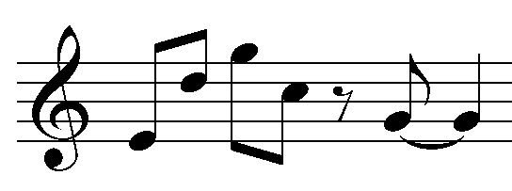
Inversion | Changing the direction of the intervals in the motif. | 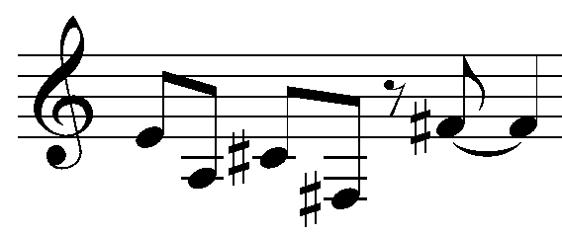
Sequence | The restatement of a motif at a higher or lower pitch. | 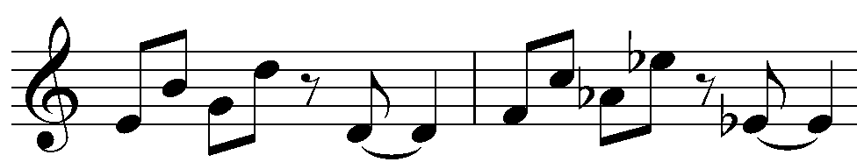
Imitation | The repetition of a motif by another instrumental part. The imitation may be slightly varied. | 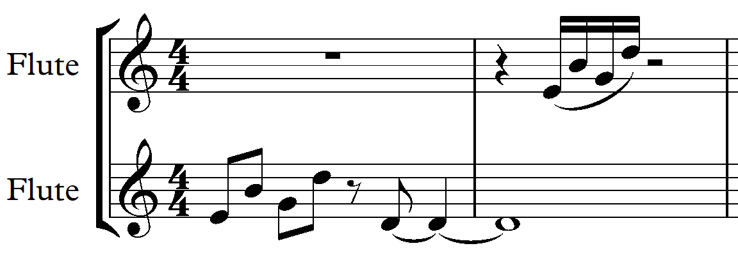
Transposition | Changing the pitch of the motif but keeping the intervals between the consecutive notes the same. | 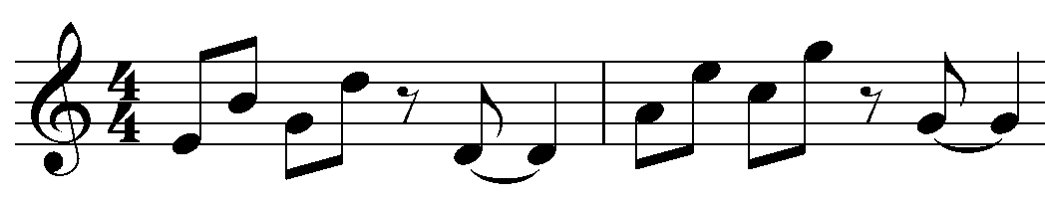
Round or canon | A piece of music where the instruments/voices sing or play the music starting at different times. | 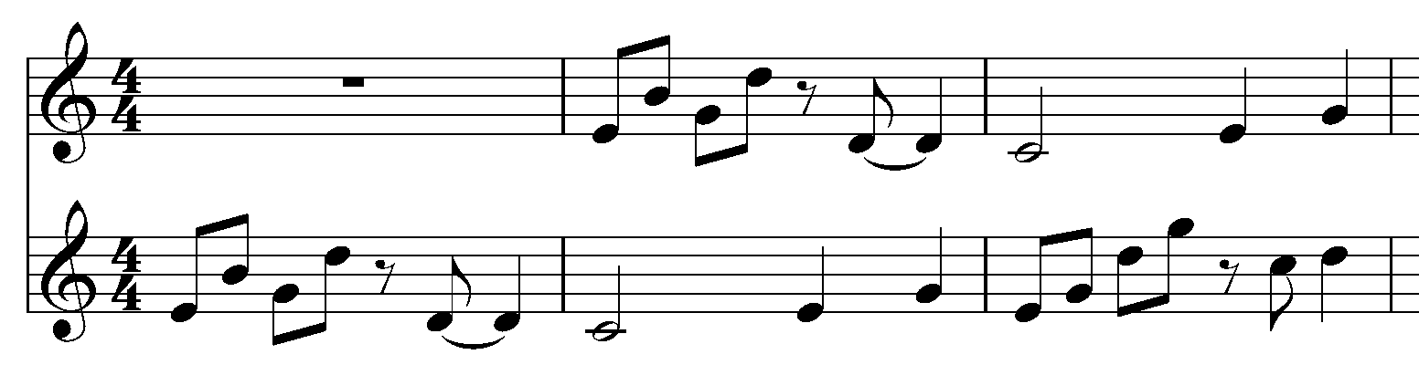
Countermelody | Another melody of secondary importance to the first played at the same time. | 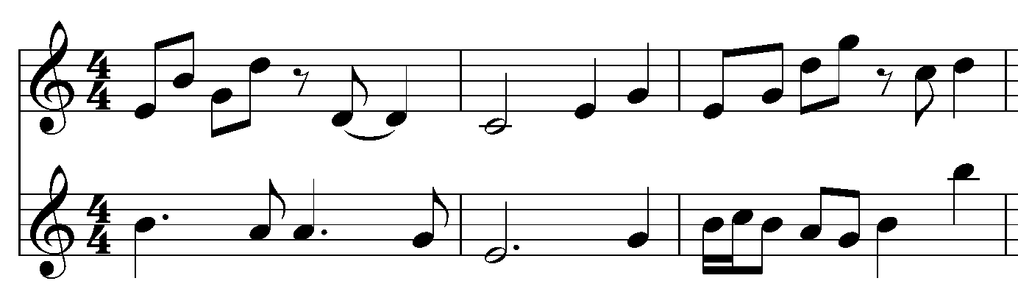
Passing notes | A passing note is a non-chord tone which you use to move to a chord tone. | 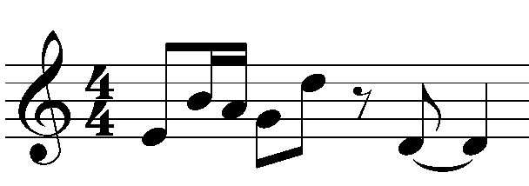
Dovetailing | When phrases are connected by overlapping the end of one phrase with the beginning of the next. | 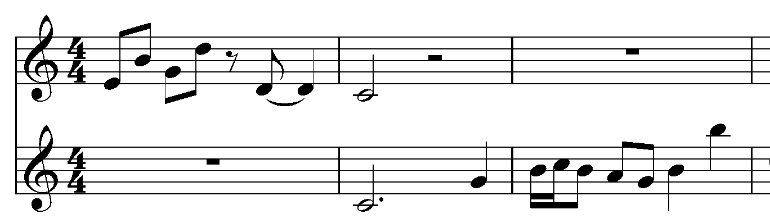
Hocketing | A single melody is shared between two (or occasionally more) voices such that alternately one voice sounds whilst the other rests. | 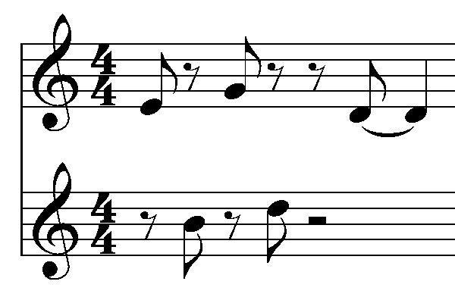

Harmonic devices
Name | Definition | Example
Pedal point | A low sustained note played under a moving chord progression. | 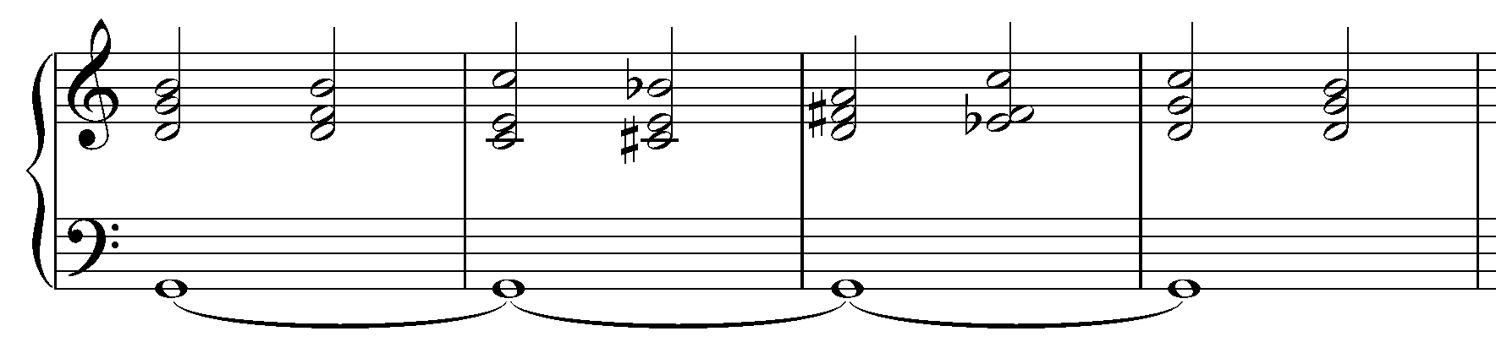
Figured bass | The numbers underneath the bass part to indicate the harpsichord player which chords to play in the left hand (used in Baroque music). | 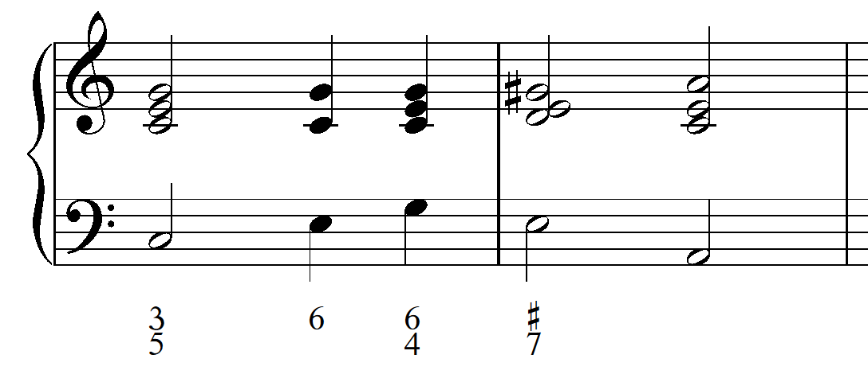
Basso continuo | The bass line (used in Baroque music). | 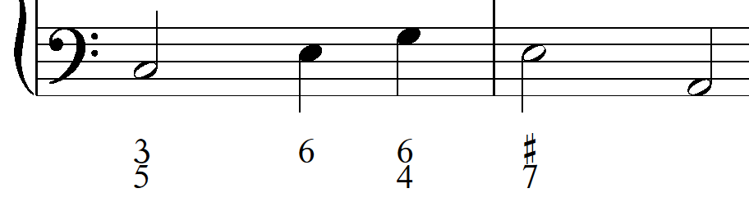
Alberti bass | A broken chord or arpeggiated accompaniment. | 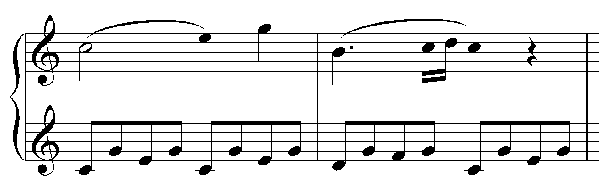
Parallel motion | Motion in the same direction, keeping the same interval between them. | 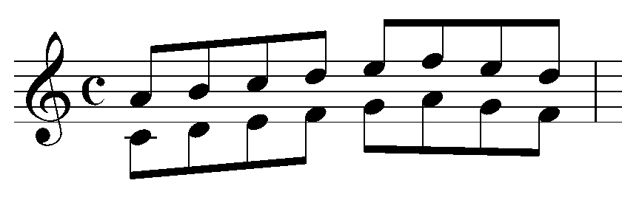
Contrary motion | Motion in opposite directions. | 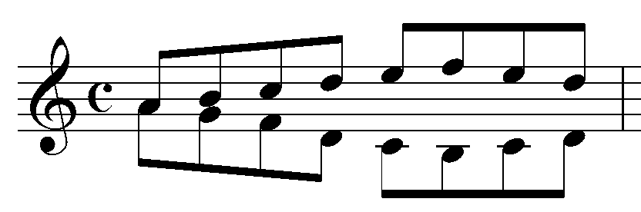
Similar motion | Motion in the same direction, but the interval between them changes. | 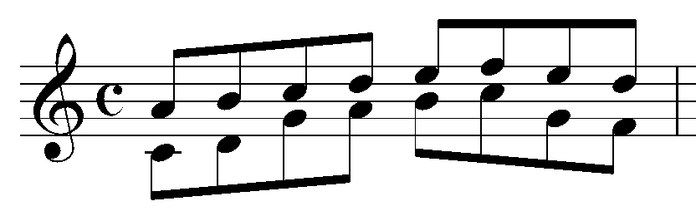
Oblique motion | Motion of one melodic line while the other remains at the same pitch. | 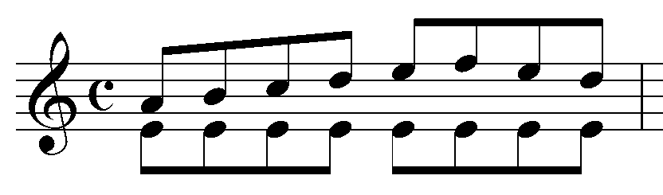
Suspension | When a note from a chord is held whilst the other notes of the chord change to a new harmony. The resulting dissonance persists until the suspended note resolves by stepwise motion into a new consonant harmony. | 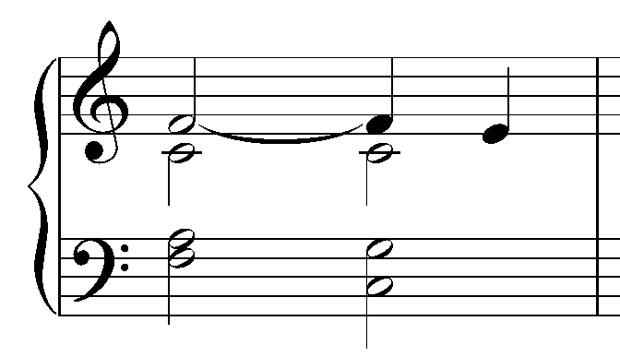
Extended chords | Chords that are used up of more than three notes. For example, 7th chords. | 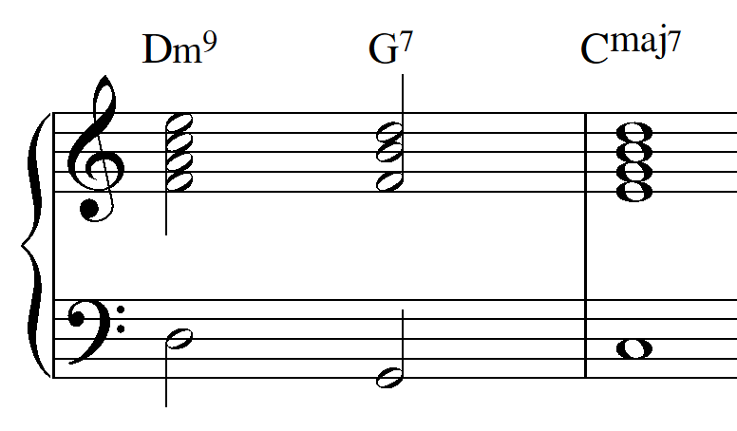
Cadence | A progression of two chords at the end of a phrase. | 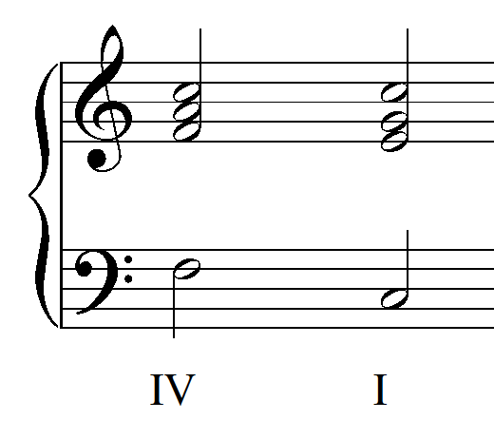
Tone cluster | A group of several adjacent notes played together to create dissonance. | 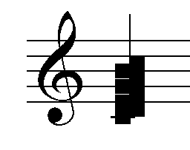
Modulation | When a piece of music changes from one key signature to another. | 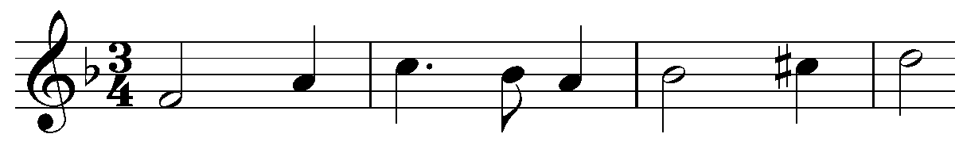

Instrument specific notation
Instrument specific information including notation of expressive and extended techniques.
Instrument family | Resource
Strings | Violin, viola, cello, double bass and harp (date accessed 3/5/2021)
Woodwind | Flutes, oboes, clarinets and bassoons (date accessed 3/5/2021)
Brass | Trumpets, horns, trombones, tubas (date accessed 3/5/2021)
Percussion | Timpani, drums, mallets, cymbals and metal, bells (date accessed 3/5/2021)
Drumkit | Drumkit (date accessed 3/5/2021)
Piano | Piano (date accessed 3/5/2021)
Voice | Glossary of vocal terminology 1 (date accessed 3/5/2021)  Glossary of vocal terminology 2 (PDF) (date accessed 3/5/2021)
Guitar | Guitar symbols and meanings (date accessed 3/5/2021)  Bass guitar notation guide (PDF) (date accessed 3/5/2021)  Electric guitar notation guide (PDF) (date accessed 3/5/2021)

Italian expressive terms
Use this list to select Italian expressive terms to add to your final composition where appropriate.
Italian term | Definition
affettuoso | with feeling, emotion
agitato | agitated
allargando | gradually becoming broader
a niente | fade to nothing
animato | animated
apassionata | full of emotion
assai | very
ben marcato | well marked
brilliante | brilliantly
bruscamente | harsh and rough
cantabile | in a singing style
con amore | with love
con anima | with feeling
con spirito | with spirit
con fuoco | with fire
con moto | with movement
decisio | decisively
delicato | delicately
dolce | sweetly
dolente | sadly
expressione | expressively
feroce | fiercely
giocoso | merry
grave | slow and solemn
grazioso | gracefully
l’istesso tempo | at the same tempo
lamentoso | mournfully
larghetto | rather broadly
legato | smooth and well connected
leggiero | lightly
ma non troppo | but not too much
maestoso | majestically
mancando | dying away
marcato | marked
meno | less
meno mosso | less speed
misterioso | mysteriously
molto | very
morendo | dying away
non troppo | not too much
passionato | passionately
perdendosi | fading away
pesate | heavily
piu | more
piu mosso | more speed
poco | a little
poco a poco | little by little
quasi | almost
risoluto | with resolution
rubato | freedom of time
scherzando | playfully
semplice | simple
sempre | always
senza | without
sforzando | a strong accent
smorzando | dying away
sostenuto | sustained
stringendo | pressing on faster
subito | suddenly
teneramente | tenderly
tranquillo | calmly
tutti | together
vivace | lively and spirited
vivo | lively and spirited

Composition self-reflection
Circle or highlight the words that describe your composition thus far. You may like to elaborate on these in your composition portfolio and brainstorm ways in which you can improve your composition further.
My composition demonstrates/is:
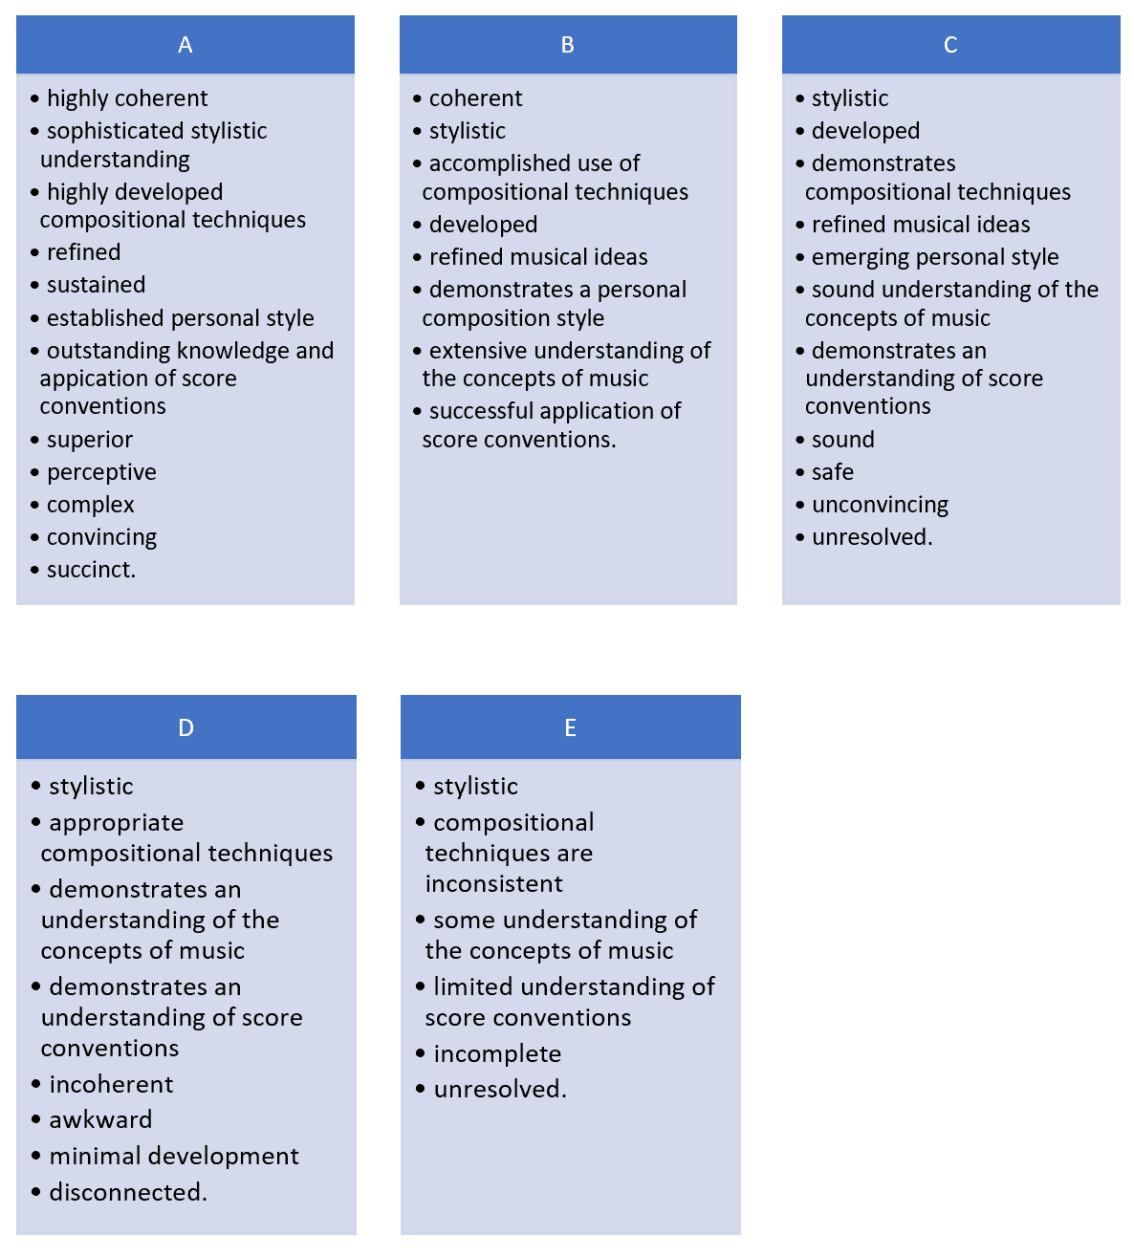

Composition timeline and submission dates
This is a suggested timeline of the composition process for Term 3.
Date | Task
Term 3, Week 1 | Compositions must be completed and submitted to your teacher for a final check.
Term 3, Week 2 | Organise rehearsals for your composition recording and distribute parts.
Term 3, Week 3 | Record your composition.
Term 3, Week 4 | The edited composition audio file will be completed and returned to you. Make final adjustments to your score based on the recording.
Term 3, Week 6 | All compositions must be finalised and submitted to your teacher for a final check.
Term 3, Week 8 | All compositions and portfolios must be submitted in accordance with the NESA date provided. Your teacher will then send your composition to NESA for external marking.

Composition checklist – final edit
Checklist | Done
I have shown the individual parts to people that play my chosen instruments/voices to double check it is all actually playable.
My composition has an appropriate title and my student number is located at the top right of every page.
Each page of my score is numbered.
My instruments are in the correct score order.
My score is written as a transposing score.
Performance notes are included for any performance directions requiring a brief explanation.
A tempo marking (in Italian) is written at the beginning of the score as well as a metronome marking. Any tempo changes are indicated throughout with a new metronome marking and Italian term.
I have expressive markings (in Italian or English depending on genre) added to my score to describe the mood of individual sections. They are written using italics.
Every instrument has articulation and specific instrumental/vocal techniques such as pedaling included.
Every instrument has clear dynamic indications throughout the entire piece. All of my dynamics are written using bold italics and they are evenly spaced in all parts so they aren’t touching notes or bar lines.
The dynamics include cresc and decresc shaping within the phrases where appropriate.
All of my rhythms and rests adhere to correct rhythmic groupings.
I have marked the sections of my piece with rehearsal markings. For example: verse, chorus or A, B, C.
My composition has bar numbers.
My slurs and ties are correctly inputted as slurs and ties.
The instruments are clearly labelled down the side of my score on page 1, and an abbreviation for each instrument is included on each additional page.
The spacing between staves is balanced between pages and staves do not interfere with each other, allowing for enough room for dynamics and expressive terms and techniques so there are no clashes.
The range for each instrument is adhered to.
All accents, articulations, ornamentation and score markings are spaced evenly above/below each instrument part, so all parts look cohesive in their presentation.
My composition audio recording is within the time limit specified.
The instrument specific techniques are written correctly. For example, bowing, pedaling, glissando.
If using vocals, the lyrics are clearly written underneath each vocal line.
My composition portfolio is complete and a final score and reflection is included in the portfolio as the final entry.
Once you have ticked all of these boxes you have successfully completed your composition. Congratulations!

Additional resources
- Stage 6 Music Extension Syllabus © NSW Education Standards Authority (NESA) for and on behalf of the Crown in right of the State of New South Wales, 2003.
- Performance band descriptions for Music Extension © NSW Education Standards Authority (NESA) for and on behalf of the Crown in right of the State of New South Wales, 2021.
- Assessment and reporting in Music Extension © NSW Education Standards Authority (NESA) for and on behalf of the Crown in right of the State of New South Wales, 2020.
- Music Extension Stage 6 (2009): HSC practical tasks and submitted work marking guidelines (PDF, 8 pages, 249 KB) © NSW Education Standards Authority (NESA) for and on behalf of the Crown in right of the State of New South Wales, 2009.
- HSC performance and submitted works requirements for Music Extension © NSW Education Standards Authority (NESA) for and on behalf of the Crown in right of the State of New South Wales, 2009.
- Rules and processes for practical and performance HSC exams including information for supervising teachers © NSW Education Standards Authority (NESA) for and on behalf of the Crown in right of the State of New South Wales, 2021.
- NESA composition portfolio additional information © NSW Education Standards Authority (NESA) for and on behalf of the Crown in right of the State of New South Wales, 1999.
- Elizabeth Jigalin – How to begin your HSC composition (date accessed 3/5/2021)
- HSC Music Composition Portfolios (06:22) (date accessed 3/5/2021)
- Ten ways you can impress your composition examiners (date accessed 3/5/2021)

