Stage 6 Music 1 preliminary course

Music for small ensembles

Resource booklet

Table of contents
Stage 6 Music 1 preliminary course 1
Music for small ensembles 1
Resource booklet 1
Table of contents 2
The concepts of music 4
Duration 4
Pitch 4
Structure 5
Texture 5
Tone colour 5
Dynamics and expressive techniques 6
Medieval music 7
Musicology 7
Performance 7
‘Saltarello’ (traditional) 7
Aural and musicology 8
Performance 8
Medieval dance rhythm activity 8
Composition and performance 9
Extension 9
Answers 10
Performance 10
Aural and musicology 10
Klezmer music 12
What is Klezmer music? 12
Performance 12
Musicology 12
Performance and aural 12
Aural and composition 13
Answers 14
Instrument cards 14
Musicology 15
Performance and aural 15
Aural and composition 15
Classical music 17
‘Eine Kleine Nachtmusik’ by Mozart 17
Performance 17
Musicology 17
Composition, performance and aural 19
Extension 20
Answers 21
Performance 21
Musicology 21
Music of the 20th century 24
Neoclassicism 24
Aural and musicology 24
Performance 24
Composition and performance 25
Composition technique cards 27
Composition graphic score template 28
Musicology and literacy – homework 29
‘The Soldier’s Tale’ by Stravinsky (1918) 29
Aural, musicology and literacy 30
Additional resources 30
Answers 31
Aural and musicology 31
Musicology and literacy – homework 32
Aural and musicology 33
Jazz 34
Minor blues 34
Musicology 34
A short history of jazz ensembles 34
Performance 35
‘Mr P.C’ by John Coltrane (1960) 35
Composition – improvisation 36
Additional resources 36
Extension 37
Composition, aural, performance and musicology – arranging 37
Answers 39
Composition, aural, performance and musicology – arranging 39
Musical Theatre 42
‘In the Heights’ by Lin-Manuel Miranda 42
Option one – sing and play 42
Performance 42
Composition 43
Aural and musicology 43
Option two – rhythms and grooves 44
Performance and musicology 44
Composition 44
Aural and musicology 45
Answers 46
Option one – sing and play 46
Option two – rhythms and grooves 47
Ensemble communication skills 50
Funk fusion 50
Composition 50
Activity – ‘Pass the rhythm’ 50
Performance, aural and musicology 50
Additional resources 51
Answers 52
Composition 52

The concepts of music

Duration
- Tempo – Adagio/Lento/Moderato/Allegro?
- Tempo – changes/constant?
- Time signature – constant/multimeter?
- Rhythm is strict/rigid/free/indefinite?
- Syncopation/polyrhythms/cross rhythms?
- Ostinato/backbeat/anacrusis?
- Accelerando/ritardando/rubato?
- Note values – long/short/dotted?
- Repeated rhythms?
- Beat – strong/indefinite?
- Bar lengths – regular/irregular?

Pitch
- Tonality – major/minor/modal/atonal/pentatonic?
- Modulations/key changes?
- Rate of harmonic change?
- Arpeggios/triads/drone?
- Scales used – major/minor/chromatic/blues/mode?
- Harmony – consonant/dissonant?
- Melody – moves in steps/leaps?
- Melodic contour – ascending/descending?
- Range/intervals?
- Phrase lengths
- Imitation/repetition/ostinato/sequence?
- Ornamentation/improvisation?
- Counter melody/call and response/canon?
- Cadences – perfect/plagal/imperfect/interrupted?
- Tone clusters

Structure
- Binary/ternary/rondo
- Theme and variations
- Through composed
- Strophic form
- Verse/chorus form
- 12 bar blues form
- How can you tell when a new section begins?
- Number of bars in each section
- Macro (whole song) and micro (phrases) structure

Texture
- Thin/thick?
- Monophonic/homophonic/polyphonic?
- Roles of the instruments – melodic/harmonic/rhythmic?
- How many layers of sound are there?
- Changes in texture – sudden/gradual?
- Unison/doubling/imitation?
- Call and response/canon?
- Motion – similar/contrary?

Tone colour
- Performing media
- Aerophones/chordophones/membranophones/idiophones?
- Electronic sounds
- Range – narrow/medium/wide?
- Register – low/middle/high?
- Description of sound – adjectives to describe the timbre
- Role of each instrument
- Tone colour changes during the excerpt
- Describe the overall mood/atmosphere

Dynamics and expressive techniques
- Dynamics
- Sudden/gradual dynamic changes?
- Articulation — legato/tenuto/staccato/accents?
- Vibrato/tremolo/glissando/pizzicato?
- Muting/strumming/picking/pedals?
- Drum roll/distortion/amplification?
- Double stopping/note bending/multiphonics?
- Falsetto/scat/melisma?

Medieval music
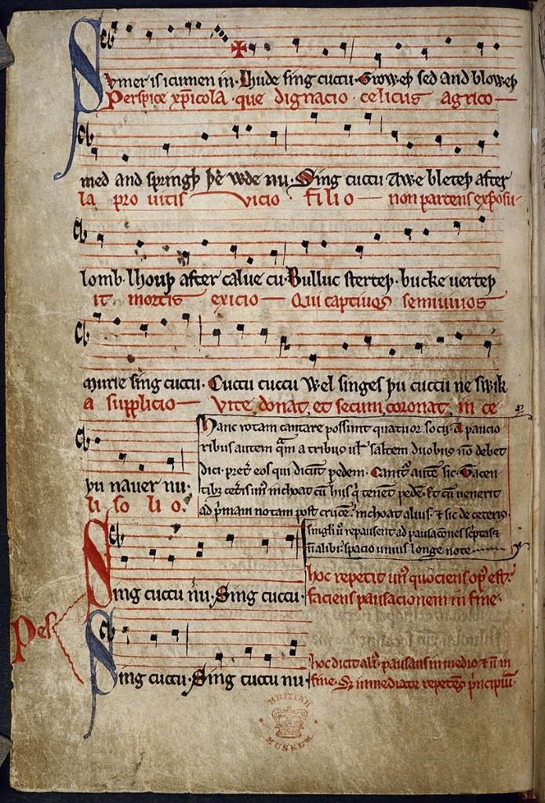
Image sourced from Wikimedia (date accessed 12/02/2021)

Musicology
Complete the ‘Medieval Madness’ Kahoot quiz as a class to learn about the instruments used in the medieval period. Kahoot quiz – ‘Medieval Madness’

Performance

‘Saltarello’ (traditional)
A ‘Saltarello’ is a medieval dance which originated from Italy. It is commonly known as an estampie which is a medieval musical form and a popular dance from the 13th and 14th century. This piece was discovered in the manuscript Add MS2 9987 which is now held in the British library. The form of an estampie consists of a succession of repeated sections – aa, bb, cc, dd.
- Students are to perform ‘Saltarello’ in groups of three to five using the score provided in the score booklet. Students may wish to perform all or part of the piece. There are three parts to be distributed:
  - melody
  - harmonic accompaniment
  - rhythmic accompaniment.
- Discussion – What were some of the musical features of this piece? Identify and label these on the score provided.

Aural and musicology
- Students are to watch and listen to the performance of ‘Saltarello’ by the Voices of Music ensemble and discuss and answer the following questions in their workbook:
‘Saltarello’ (0:00:00 – 00:03:35) (audio file)
  - Identify the instruments used in this small ensemble. What are their roles within the ensemble?
  - What is the name of the technique that the vielle and recorder are using when they play the same melody together?
  - This piece is performed without a conductor. How does the ensemble work together to communicate the music?
  - Describe the use of tone colour and texture in the A section (00:00:00 – 00:00:34) of the piece. Refer to the concepts of music worksheet for ideas.

Performance

Medieval dance rhythm activity
- Identify the rhythmic cells contained within the A section of the score of ‘Saltarello’. How many different rhythms can you identify?
- There are only four different rhythms. Clap each one through as a class.

Rhythm 1
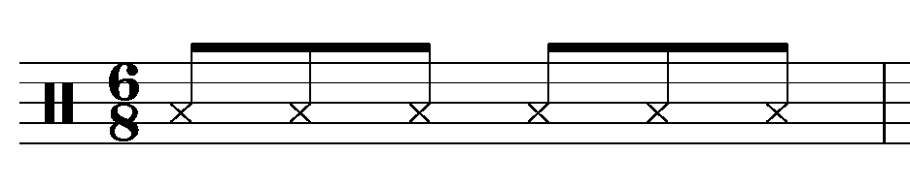
Rhythm 2
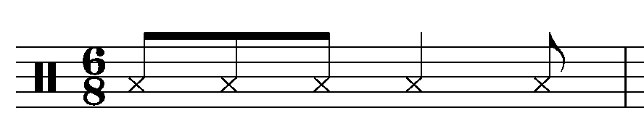
Rhythm 3
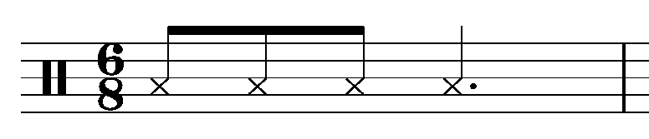
Rhythm 4
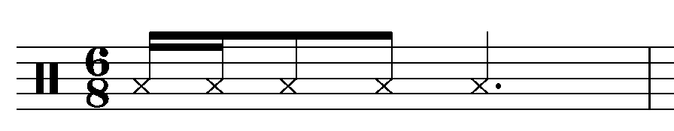
- Divide into four groups. Each group is to create a body percussion pattern for each rhythm. The underlying pulse could be presented using the feet, whilst the rhythms themselves are clapped or you may like to use the ideas found in the following body percussion videos:
  - body percussion video 1 (00:00:00 – 00:05:56)
  - body percussion video 2 (00:00:00 – 00:00:57)
- Each group is to teach their body percussion rhythm to the rest of the class.
- Perform the A section of ‘Saltarello’ as a class using the body percussion.

Composition and performance
Compose your own eight bar melody for a ‘Saltarello’ using at least two of the four rhythms provided in the previous activity. The two bar codettas from the original ‘Saltarello’ are then to be added for each repeat. The melody must include:
- eight bars in treble clef with an extra two bars added for each repeat
- 6/8 time signature
- C major key signature
- use of at least two of the dance rhythms provided
- use of mainly steps with some small leaps.
Digital notation software can be utilised to write your composition, or you may wish to use manuscript. Notation software available includes:
- Sibelius
- Finale
- Flat
- Musescore.
Perform your melody to the class when complete.

Extension
Using the compositions created above, students are to choose up to four melodies created by their peers. Through experimentation, combine these four melodies (for example: A, B, C, D), to create a complete ‘Saltarello’ score. Arrange the piece for your class to include melody, harmonic accompaniment and rhythmic accompaniment. Perform as a class.

Answers

Performance
Discussion – 6/8 time signature, open 5th accompaniment largely based on a drone, dance like rhythms, fast tempo, A, B, C, D structure, repeated sections and codettas, use of mainly steps and small leaps in the melody, homophonic texture, fast tempo.

Aural and musicology
- Students are to watch and listen to the performance of ‘Saltarello’ by the ‘Voices of Music’ ensemble and discuss and answer the following questions in their workbook: ‘Saltarello’ (0:00:00 – 00:03:35) (audio file)
  - Identify the instruments used in this small ensemble. What are their roles within the ensemble?
- Recorder and vielle (melody), harp and lute (harmonic accompaniment), tambourine (rhythmic accompaniment).
  - What is the name of the technique that the vielle and recorder are using when they play the same melody together?
- Doubling or unison.
  - This piece is performed without a conductor. How does the ensemble work together to communicate the music?
- watching each other
- listening to ensure balance within the ensemble
- physically engaging with the metre (temporal cueing)
- intensive listening and responding to unify the musical intention of the ensemble in their execution of the style in relation to dynamics and shaping of the phrases.
- accentuating the metre through nuance and accent
  - Describe the use of tone colour and texture in the A section of the piece. ‘Saltarello’ (00:00:00 – 00:00:34) Refer to the concepts of music worksheet for ideas.
- The opening of the piece begins with just the tambourine providing a rhythmic pulse in 6/8. It plays using a hollow tone colour, which is contrasted with the bright bells of the tambourine on the downbeat of every second bar. The texture here is thin.
- The lute providing the harmonic accompaniment then enters playing open 5th chords in a drone like manner, plucking the strings using quavers which accentuates the underlying rhythmic pulse. This is then immediately echoed by the harp which imitates the lute accompaniment. Both of these instruments use a sweet, resonant tone colour. The texture here is thicker due to the multiple layers playing.
- The recorder and vielle then enter performing the melody in unison an octave apart. The recorder has a wooden, thin tone which is juxtaposed against the warm, earthy tone of the vielle. The texture here is now moderately thick and homophonic, with the recorder and vielle playing the melody, the harp and lute providing harmonic accompaniment, and the tambourine providing rhythmic accompaniment.

Klezmer music
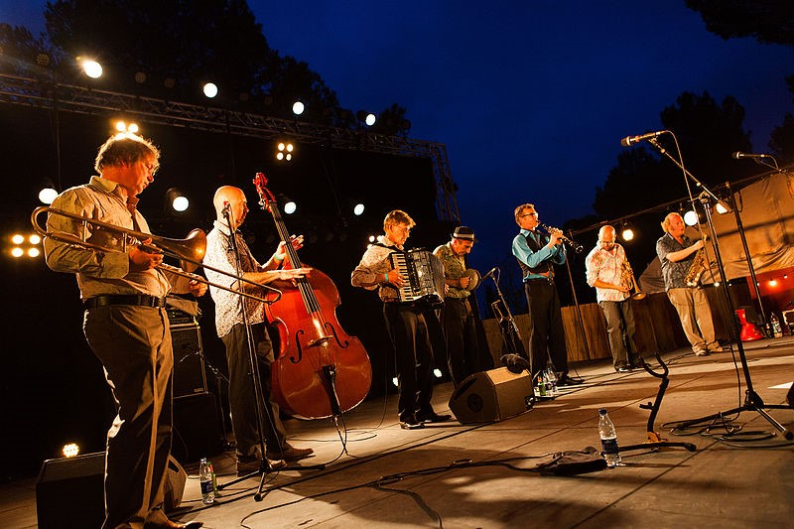
Image sourced from wikimedia (date accessed 16/02/2021)

What is Klezmer music?

Performance
Klezmer music is a style of folk instrumental music that draws upon the traditions of Ashkenazi Judaism and Eastern European folk traditions. It is usually played at social functions such as weddings. Klezmer music uses interesting scales and modes such as the Phrygian dominant scale as seen below. Perform or sing this scale on your instrument.
E Phrygian dominant scale:
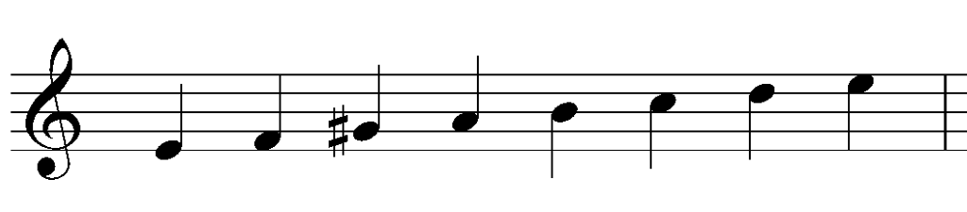

Musicology
Watch the 'Klezmer BBC documentary' (00:00:00-00:04:10) and write down three important points about Klezmer music in your work book. Discuss as a class.

Performance and aural
Perform ‘Hava Nagila’ (traditional) on classroom instruments in small groups or as a class. Please note the melody must be doubled. The audio and score are provided below.
- ‘Hava Nagila’ (00:00:00 – 00:03:17)
- ‘Hava Nagila’ score
- ‘Hava Nagila’ guitar chords and lyrics

Discussion: what are some of the musical features of this genre?

Aural and composition
- Listen to ‘Hava Nagila’ (00:00:00 – 00:03:17). What do you notice about the melody being played by the two instruments? Are they identical? Discuss.
- Listen to the following pieces and you will also notice that the melody is doubled but with slight variations to the melody. This is called heterophonic texture. Write down ways in which the melodies have been slightly altered in the following listening pieces:
  - ‘Ob Ebra do Dunava Live in Vilnius’ (00:00:10 – 00:00:38) by the Barcelona Gipsy Balkan Orchestra
  - ‘Hava Nagila’ (00:00:57 – 00:01:45) by the Moscow Klezmer Band
  - ‘Ze Dos Kleydl Tateshi’ (00:00:00 – 00:00:45) by the Budapest Klezmer Band
- Using some of the techniques discussed above, compose a new version of ‘Hava Nagila’ that uses some or all of these techniques in the treatment of the melodic material. Perform to the class and record your composition on your phone.
- Discussion: How did each group modify the melodic material?
- Listen back to your performance and answer the following questions:
  - What compositional techniques did you use to alter the melody in your arrangement of ‘Hava Nagila’?
  - Describe the small ensemble that your group consisted of. What role did each instrument play and what was the tone colour of each instrument?
  - During the performance, which instrument/musician was the ‘leader’? How did they demonstrate this? Is this typical of Klezmer music?
  - What types of texture did your group utilise in the performance and how? Give examples according to the sections of your arrangement.
- Extension – Listen to ‘Yiddish Music’ (00:00:00 – 00:03:02) by the Moscow Klezmer Band. Write a paragraph response as to how the melodic material is treated in the excerpt. For example, who plays the melody and when? How is it presented? Are there any compositional techniques and features of how the melody is treated?

Answers

Instrument cards
`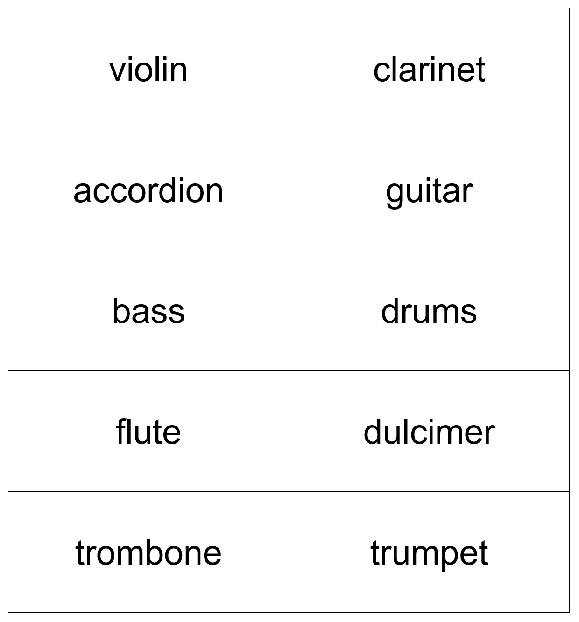

Musicology
Watch the ‘Klezmer BBC documentary’ (00:00:00 – 00:04:10) and write down three important points about Klezmer music in your work book. Discuss as a class.
Answers may include:
- Klezmer refers to anything that has come from East European Jewish music as played by Yiddish speaking people.
- The clarinet and violin are predominantly used in Klezmer music as they imitate the human voice.
- Klezmer music now has all kinds of instruments and there are a wide range of Klezmer musical styles.
- Klezmer provided a focus for people to immerse themselves in a culture.

Performance and aural
Discussion: what are some of the musical features of this genre?
Answers may include:
- use of modal melodies or eastern scales
- a combination of textures including monophonic, homophonic, polyphonic and heterophonic textures
- use of doubling or unison of the melody often played by clarinet or violin
- frequent tempo changes that usually start slow and accelerando
- V – I chord progression
- small ensembles typically consisting of a combination of the following: clarinet, violin, bass, drums, accordion, guitar and dulcimer
- ornamentation of the melody.

Aural and composition
- Listen to 'Have Nagila' (00:03:17). What do you notice about the melody being played by the two instruments? Are they identical? Discuss.
- No, the melody is not completely identical. The melody is played by the clarinet at the beginning of the excerpt and is then doubled or played in unison with the violin. Slight differences between the parts include slides, harmonisation in some parts of the melody, ornamentation and part independence particularly at the end of the excerpt where additional notes are added by the violin.
- Listen to the following pieces and you will also notice that the melody is doubled but with slight variations. This is called heterophonic texture. Write down ways in which the melodies have been slightly altered in the following listening pieces:
  - ‘Ob Ebra do Dunava Live in Vilnius’ (00:00:10 – 00:00:38) by the Barcelona Gipsy Balkan Orchestra.
- Clarinet and accordion doubling, fragmentation, ornamentation.
  - ‘Hava Nagila’ (00:00:57 – 00:01:45) by the Moscow Klezmer Band.
- Violin, clarinet and trumpet use doubling/unison, harmonisation, trills, slides, added notes and octaves.
  - ‘Ze Dos Kleydl Tateshi’ (00:00:00 – 00:00:45) by the Budapest Klezmer Band.
- Accordion and voice use extensive elaboration of melody, ornamentation and some doubling/unison.
- Extension – Listen to ‘Yiddish Music’ (00:00:00 – 00:03:02) by the Moscow Klezmer Band and write a paragraph response as to how the melodic material is treated in the excerpt. For example, who plays the melody and when? How is it presented? Are there any compositional techniques and features of how the melody is treated?
Answers may include:
- The melody at the beginning is played by the accordion using a monophonic texture.
- The clarinet then enters playing melodic gestures whilst the accordion continues to play melodic phrases creating a polyphonic texture.
- The melody is then reiterated in the accordion part as the piece increases in tempo. This melody is then passed to the clarinet resulting in a homophonic texture.
- The melody is then passed again to the violin which doubles the accordion and is then passed back to the clarinet again in a call and response fashion which continues throughout the section.
- The melody is then presented by the trumpet and harmonised in some sections by the violin before being played in unison again by the accordion and violin.
- Call and response continues between the violin and clarinet.
- The final melody is then played in unison by the clarinet, trumpet, accordion and violin.
- Additional ornaments and slides are added to embellish the melody throughout by all instruments.

Classical music
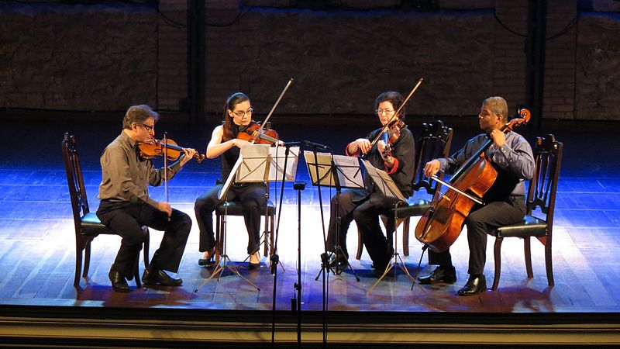
Image sourced from Wikimedia (date accessed 17/02/2021)

‘Eine Kleine Nachtmusik’ by Mozart
The classical period saw the development of chamber music, which is a music written for a small ensemble designed for an intimate setting in a home or palace, rather than for the concert hall. The most popular type of chamber music in the classical period is the string quartet. The string quartet consists of two violins, a viola and a cello. Mozart, Haydn and Beethoven wrote some significant pieces for string quartet.
‘Eine Kleine Nachtmusik’ (Serenade No. 13 for strings in G major) by W.A Mozart was originally written as a chamber piece for a string octet, but it is often performed by string ensembles or string quartets.

Performance
Perform the classroom arrangement of ‘Eine Kleine Nachtmusik’ movement 1 – ‘Allegro’ provided in the scores resource booklet. Audio with a moving score is also provided below for reference.
- Eine Kleine Nachtmusik by Mozart movement 1 audio (00:00:00 – 00:04:21)
- Eine Kleine Nachtmusik by Mozart movement 1 with score (00:00:00 – 00:06:02)
Discussion: what are the roles of each instrument? Discuss any interesting observations.

Musicology
- Create a texture graph using the table below. Using two different colours, colour in which bars each instrument plays the melody and harmonic accompaniment.
Part | Bar 1 | Bar 2 | Bar 3 | Bar 4
Part 1
Part 2
Part 3
Part 4

Part | Bar 5 | Bar 6 | Bar 7 | Bar 8
Part 1
Part 2
Part 3
Part 4

Part | Bar 9 | Bar 10 | Bar 11 | Bar 12
Part 1
Part 2
Part 3
Part 4

Part | Bar 13 | Bar 14 | Bar 15 | Bar 16
Part 1
Part 2
Part 3
Part 4

Part | Bar 17 | Bar 18
Part 1
Part 2
Part 3
Part 4

- Label within the corresponding bars, the following musical features of each instrumental part:
- Mannheim rocket
- unison
- harmonic rhythm
- pedal point
- broken chord
- Define each of these terms in your workbook.

Composition, performance and aural
- Compose your own four bar Mannheim rocket theme for a single melodic line. You must notate your theme using either traditional or graphic notation and it must contain the following features:
- four bars in length
- any notes or rhythms may be used
- use one chord of your choice in each bar
- rapidly ascend as a broken chord or arpeggio.
- Perform your Mannheim rocket to the class and record your performance.
- Compare your Mannheim rocket theme to Mozart’s Mannheim rocket theme used in the string quartet version of ‘Eine Kleine Nachtmusik.’ Discuss the use of duration and pitch in your response. You may do this in columns using dot points, or you may wish to write a paragraph response. Refer to the concepts of music checklist at the beginning of the booklet resource.
- Eine Kleine Nachtmusik by Mozart movement 1 audio (00:00:00 – 00:04:21)
For example:
Mannheim rocket theme | Duration | Pitch
Mozart version
My version

Extension
- Performance and composition – perform ‘Eine Kleine Nachtmusik’ in a different style. For example, as a rock or jazz version.
- Composition – extend your Mannheim rocket theme by adding an eight bar melody and chords to the theme. You may wish to do this using digital software notation, or record your melody on your phone using voice memos.
- Musicology and aural – comparative analysis. Analyse the musical differences between the Mannheim rocket theme of another version of ‘Eine Kleine Nachtmusik’, and the original string quartet version. You may choose one from the list below or you may research one of your own. Please refer to the relevant concepts of music in your response.
- ‘Eine Kleine Nachtmusik’ rock version (00:00:00 – 00:00:07)
- ‘Eine Kleine Nachtmusik’ jazz version (0:00:00 – 00:00:37)
- ‘Eine Kleine Nachtmusik’ latin version (00:00:00 – 00:00:10)
- ‘Eine Kleine Nachtmusik’ electronic dubstep version (00:00:00 – 00:00:37).

Additional resources
Full analysis of ‘Eine Kleine’ Nachtmusik’ mv 1 – ‘Allegro (00:00:00 – 00:16:34).

Answers

Performance
Discussion: what are the roles of each instrument?
- Part 1 performs the melody whilst parts 2,3 and 4 provide harmonic accompaniment with part 4 providing the bass line.

Musicology
- Create a texture graph using the table below. Using two different colours, colour in which bars each instrument plays the following roles:
- melody
- harmonic accompaniment.
The suggested answer is found on the next page. Please note the melody is red and the harmonic accompaniment is blue.

Part | Bar 1 | Bar 2 | Bar 3 | Bar 4
Part 1 | Mannheim rocket
Part 2 | unison
Part 3 | broken chord
Part 4

Part | Bar 5 | Bar 6 | Bar 7 | Bar 8
Part 1
Part 2 | harmonic rhythm
Part 3 | harmonic rhythm
Part 4 | pedal point

Part | Bar 9 | Bar 10 | Bar 11 | Bar 12
Part 1
Part 2
Part 3
Part 4

Part | Bar 13 | Bar 14 | Bar 15 | Bar 16
Part 1
Part 2
Part 3
Part 4

Part | Bar 17 | Bar 18
Part 1
Part 2
Part 3
Part 4

- Label within the corresponding bars, the following musical features of each instrumental part:
Answers are labelled in the table above.
- Mannheim rocket
- Unison
- Harmonic rhythm
- Pedal point
- Broken chord
- Define each of these terms in your workbook.
- Mannheim rocket – a rapidly ascending broken chord melodic passage used in a theme.
- unison – two or more instruments/voices playing the same melody or rhythm.
- harmonic rhythm – the rhythmic pattern of a harmonic progression in a musical passage.
- pedal point – a long sustained note at a constant pitch which is held as the other parts move.
- broken chord – when the notes of a chord are played individually in succession.

Music of the 20th century

Neoclassicism
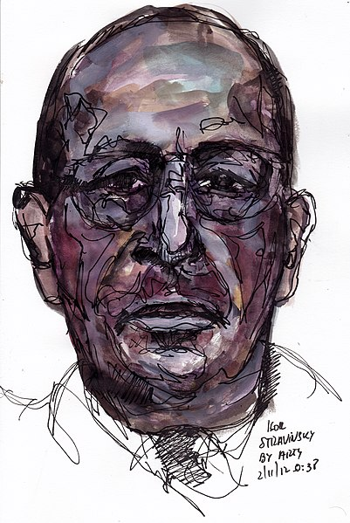
Image sourced by Wikimedia (date accessed 19/2/2021)

Aural and musicology
- Watch and listen to the video ‘Airs by a Stream’ from ‘The Soldier’s Tale’ by Stravinsky. (00:00:00 – 00:02:32) and answer the following questions in your book:
  - Using the table below, list the instruments used in the piece, the general pitch of the instrument (high or low) and a tone colour word to describe the sound.

Instrument | Pitch | Tone colour
  - What do you notice about how the instruments are grouped?
  - Why do you think Stravinsky has chosen to do this?

Performance
- Using instruments, students are to individually play the pitch pattern below ascending and descending as a scale. Discuss the scale as a class. For example, what does it sound similar to? What are the intervals? Does anyone know which scale or mode it is?
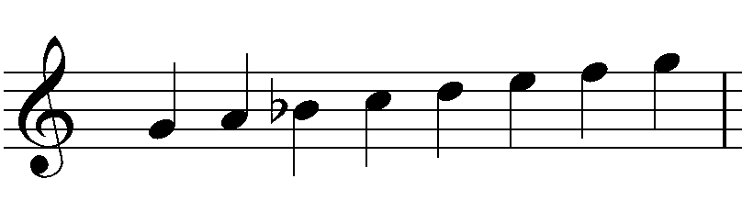
This is G Dorian mode. Composers of the 20th century (especially neo-classicists like Stravinsky) liked to use modes in their compositions for their distinctive sound qualities and harmonic possibilities.
- Each student is to remain on their own instrument playing G Dorian mode repeatedly. Percussionists are to freely improvise based on the mood or atmosphere of the G Dorian mode. Walking around the room (if they’re able), each student is to find a partner to pair with by playing the mode with each member of the class. They must choose their partner based on how well the sound of the two instruments goes together. Students must listen carefully to the tone colour and pitch of each instrument playing the mode together to determine the best possible musical outcome. Once they have agreed on a partner, they must sit down to indicate that they are paired.

Composition and performance
- In the above pairs, students are presented with a set of cards (a template is provided on the next page) with the following compositional techniques written on each card:
- imitate
- interplay
- call and response
- rhythmic unison
- ‘running rhythms’
- polyphonic texture
- accents
- interject.
- In pairs, students are to compose a short composition (about 1 minute in length) using at least four of the techniques on the cards as well as the G Dorian mode in any style they wish. Consideration must be given to the roles of each instrument and the structure of the piece. Students may like to experiment through improvising, or they may like to brainstorm some ideas to begin with. Some guiding questions may include:
- what mood do you want your composition to have?
- what tempo would best fit this mood?
- what dynamic do you imagine the piece would begin with?
- what dynamic or intensity do you imagine the ending would have?
- how are you going to get from point A (the beginning) to point B (the ending)?
- can you create a motif, melody or riff that will form the main content of your composition?
- can you create a rhythm that might form part of the accompaniment or melody?
- how are you going to combine the instruments or interact with one another?
- how will you incorporate the compositional techniques provided on the cards?
- Rehearse your composition, and when ready, perform it to the class and record it on your phone or tablet.
- Notate your composition using a graphic score. A template is provided over the page for reference and you may need to use your recording for reference.
- Extension – after listening to the class’ performances, combine the groups to form quartets. This should be based on the style of each composition, with similar styles to be grouped together. Students are to combine their compositions to form two sections. Then, they are to rearrange their piece for all four performers. Modifications may be needed to the compositions for musical success. Perform to the class.

Composition technique cards
These cards are to be used for the composition activity above. Copy and cut out the words below to make one set of cards for each pair of students:
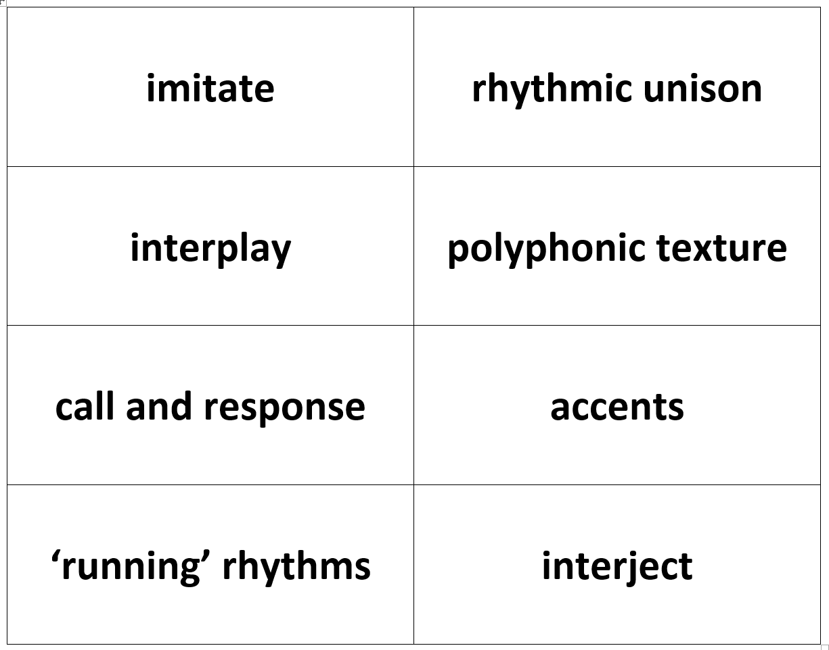

Composition graphic score template

Musicology and literacy – homework

‘The Soldier’s Tale’ by Stravinsky (1918)
The piece you listened to at the start of the lesson was taken from Igor Stravinsky’s piece ‘The Soldier’s Tale’. This piece is a theatrical work containing eleven pieces, to be performed by three actors taking on the roles of the Narrator, the Devil and the Soldier, one dancer, and accompanied by a septet of instruments including clarinet, bassoon, cornet, trombone, violin, double bass and percussion.
Read The Soldier’s Tale’ musicology research on the context of this work and answer the questions below.

Questions
- What was the immediate need for Stravinsky to write a new piece?
- Was it successful in achieving his goal?
- What is the general story of ‘The Soldier’s Tale?
- There are eleven musical numbers in the piece. Stravinsky insisted that jazz had influenced how he conceived the piece. What might have indicated this?
- The premiere of the piece took place in 1918 in Switzerland and it was well received. However, following the premiere, what event took place that hindered any future performances in the immediate future?

Aural, musicology and literacy
Listen to The Devils Dance’ by Stravinsky (00:00:00 – 00:00:41) which is taken from ‘The Soldier’s Tale’ by Stravinsky.
Complete the following cloze passage using the compositional techniques cards. Some of the words are used more than once. This cloze passage is based on the use of tone colour and texture in the above excerpt.
The opening of the work begins with the higher pitch instruments such as cornet and clarinet playing short note values using __________________________, followed by the bassoon and drum playing _______________________________ using a descending scalic pattern in a ___________________________________ fashion. The texture here is thick and homophonic with the main motifs harmonised and played by all instruments.
The call and response continues back and forth between the instruments before ___________________________ is seen in the string parts. _________________ and __________________ is then identified through the very fast scalic passages played by the clarinet and bassoon. Short motifs and themes are often repeated in ___________________________ and then ___________________ by additional flourishes and melodies creating a thick __________________________________.
At the end of the excerpt, the strings and drum play in _________________________ until the clarinet _________________ with ________________________________ at the beginning of the next section.

Additional resources
‘The Soldier’s Tale’ by Stravinsky (00:00:00 – 00:57:39) full audio with score

Answers

Aural and musicology
- Watch and listen to the video ‘Airs by a Stream’ from ‘The Soldier’s Tale’ by Stravinsky. (00:00:00 – 00:02:32) and answer the following questions in your book:
  - Using the table below, list the instruments used in the piece, the general pitch of the instrument (high or low) and a tone colour word to describe the sound.

Instrument | Pitch | Tone colour
violin | high | scratchy
double bass | low | warm
trombone | low | resonant
bassoon | low | woody
clarinet | high | bright
cornet | high | warm
percussion | NA | NA
  - What do you notice about how the instruments are grouped?
- The instruments are grouped in pairs according to their instrument family with consideration given to the pitch of the instrument. For example, one high pitched and one low pitched.
  - Why do you think Stravinsky has chosen to do this?
- Pairing them in instrument families allows for unity within each pairing and balance within the entire ensemble according to pitch. The combination of all instrument families allows Stravinsky to explore a range of tone colour possibilities and instrument combinations.

Musicology and literacy – homework

‘The Soldier’s Tale’ by Stravinsky (1918)
The piece you listened to at the start of the lesson was taken from Igor Stravinsky’s piece ‘The Soldier’s Tale’. This piece is a theatrical work containing eleven pieces, to be performed by three actors taking on the roles of the Narrator, the Devil and the Soldier, one dancer, and accompanied by a septet of instruments including clarinet, bassoon, cornet, trombone, violin, double bass and percussion.
Read the ‘The Soldier’s Tale’ musicology research on the context of this work and answer the questions below:

Questions:
- What was the immediate need for Stravinsky to write a new piece?
  - Stravinsky was broke and needed money.
- Was it successful in achieving his goal?
  - No.
- What is the general story of ‘The Soldier’s Tale?
  - It is the tale of a soldier who makes a trade with the Devil: his fiddle for a magic book. The soldier then plays a card game with the Devil to win back his fiddle with success. He then marries a princess and prepares to live happily ever after, but his relationship with the Devil is not over yet.
- There are eleven musical numbers in the piece. Stravinsky insisted that jazz had influenced how he conceived the piece. What might have indicated this?
  - The names of the pieces reflect the time and context of the work as jazz became popular at the beginning of the 20th century. The pieces names like ‘Ragtime’ indicate a jazz influence, and the musical rhythms, syncopation and accents may also be derived from the jazz scores that Stravinsky referred to.
- The premiere of the piece took place in 1918 in Switzerland and it was well received. However, following the premiere, what event took place that hindered any future performances in the immediate future?
  - The international flu epidemic resulted in the actors, stage hands and musicians becoming ill. The Swiss government ordered the closure of every public performance venue due to the pandemic.

Aural and musicology
Listen to ‘The Devils Dance’ by Stravinsky (00:00:00 – 00:00:41) which is taken from ‘The Soldier’s Tale’ by Stravinsky.

Complete the following cloze passage using the compositional techniques cards. Some of the words are used more than once. This cloze passage is based on the use of tone colour and texture in the above excerpt.
The opening of the work begins with the higher pitch instruments such as cornet and clarinet playing short note values using accents, followed by the bassoon and drum playing ‘running’ rhythms using a descending scalic pattern in a call and response fashion. The texture here is thick and homophonic with the main motifs harmonised and played by all instruments.
The call and response continues back and forth between the instruments before rhythmic unison is seen in the string parts. Imitation and interplay is then identified through the very fast scalic passages played by the clarinet and bassoon. Short motifs and themes are often repeated in unison and then interjected by additional flourishes and melodies creating a thick polyphonic texture.
At the end of the excerpt, the strings and drum play in rhythmic unison until the clarinet interjects with ‘running rhythms’ at the beginning of the next section.

Jazz
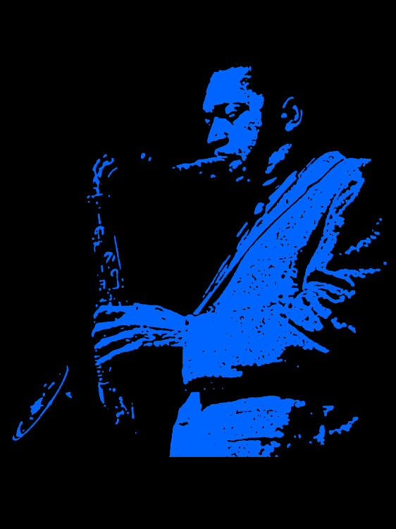
Image sourced from Flickr (date accessed 21/02/2021)

Minor blues

Musicology
As a class, brainstorm anything that you know about jazz music. This may include musical features, instruments, artists or genres.

A short history of jazz ensembles
When jazz music evolved in the early 20th century, the large ensembles of the 1920’s to 1940’s such as big bands and jazz orchestras, performed for a wide audience. They provided entertainment in dance halls and theatres, and it was the main form of popular music of the time. With the rise of be-bop and the end of the swing era after the war, jazz lost it’s ‘popular music’ cachet and became known as ‘music for musicians.’ This saw a return to smaller ensembles from the 1940’s onwards. These small ensembles or ‘jazz combos’ were anything from trios to quintets, and usually consisted of a rhythm section (bass, drums, piano or electric guitar) and a lead player such as a saxophone or brass player.

Performance

‘Mr P.C’ by John Coltrane (1960)
Students will learn how to play the minor blues chart ‘Mr P.C’ by John Coltrane and improvise using the C blues scale.
- ‘Mr P.C’ by John Coltrane lead sheet score
- ‘Mr P.C’ by John Coltrane performed by Chad L.B Trio (00:00:00 – 00:04:45)
Steps:
- Students are to sit in seats in a circle, with their instrument and music score (lead sheet) in front of them.
- Identify which students are going to be the ‘rhythm section’. (This will include the drums, bass, percussion, guitar and piano players). The remainder of the instruments will be our ‘lead players’ or ‘frontline’.
- Discuss the chord structure as being a typical ‘minor blues’ consisting of 12 bars using the chord pattern outlined below. Students may wish to label these roman numerals on their score.
Example: minor blues chord progression
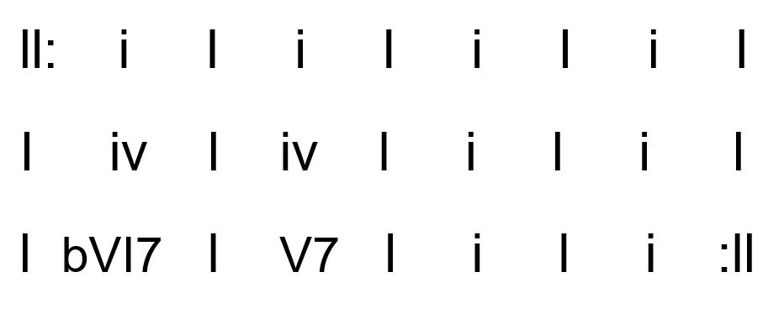
- The rhythm section members are to play through the chords as provided on the score. What they play will depend on their abilities. Drummers are to maintain a swing feel. Bass players may like to play a walking bass line or just the tonic of each chord, guitars and pianists are to comp on each chord in a swing style. (Comping means to play chords using a rhythmic pattern in an improvisational style). Additional scores and recordings for the rhythm section can be found online if needed. The frontline players are to follow along with the score whilst listening to the chord changes.
- The frontline instruments are to perform the melody over the chord changes by either reading the score, listening to the audio, or the teacher performing the melody in chunks whilst the frontline repeat it back. Repeat until the frontline instruments are fluent, and perform the melody with the rhythm section.

Composition – improvisation
Students will now learn how to improvise over the chord changes using ‘call and response’ or ‘trading’.
Steps:
- Still seated in a circle, the rhythm section are to play the 12 bar minor blues chord progression repeatedly. Each student in the circle takes a turn at improvising a four bar rhythm using just the first note of the C Blues sale as outlined below. Improvisation should continue around the circle continually and also include the rhythm section players. Students are encouraged to listen to each other’s ideas and respond to them in their own improvisation.
C Blues scale:
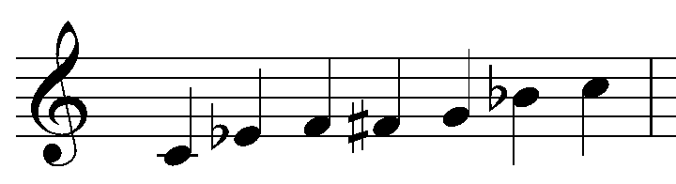
- Once every one has had a turn, repeat the same activity but now use the first two notes of the C blues scale. Continue until all the notes of the scale are used in the improvisation.
- To conclude this activity, perform the ‘head’ (the melody with chords and accompaniment) and follow it with a round of improvisation with four bars from each student followed by the head again.
For example: head, improvisation, head.

Additional resources
The following videos may be helpful for students undertaking the improvisation process and ensemble playing:
- How to trade solos in jazz (00:00:00 – 00:03:31)
- Developing improvisation games in jazz (00:00:00 – 00:05:22)
- Connecting the bass and the drums in a rhythm section (00:00:00 – 00:03:49)
- Learning how to comp on guitar and piano (00:00:00 – 00:00:04:36)
- C minor blues backing track medium swing (00:00:00 – 00:05:04)

Extension
For students who wish to be extended in improvisation, try the following modes over the changes in ‘Mr P.C’ by John Coltrane.
Minor blues bar | Chord | Mode to use for improvisation | Mode notation
Bars 1 – 4 | Cm | C dorian | 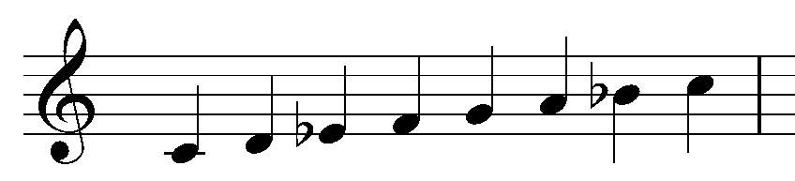
Bars 5 – 6 | Fm | F dorian | 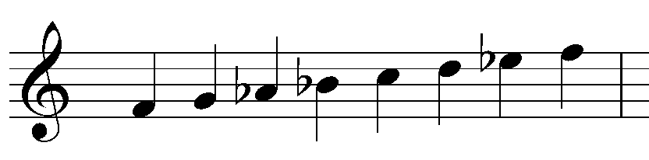
Bars 7 – 8 | Cm | C dorian
Bar 9 | Ab7 | Ab mixolydian | 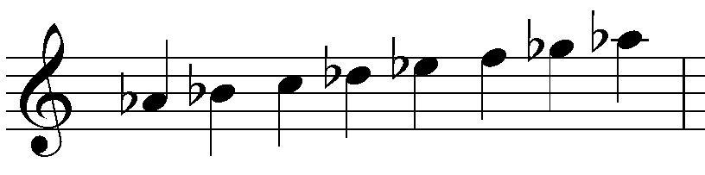
Bar 10 | G7 | G mixolydian | 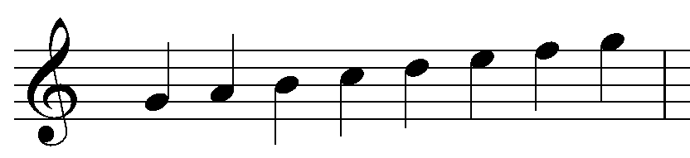
Bars 11 – 12 | Cm | C dorian

Composition, aural, performance and musicology – arranging
- Listen to ‘Mr P.C’ by the Chad L.B Trio (00:00:00 – 00:04:45) and write down the structure of the arrangement including using the words ‘head’ and ‘solo’, and the role of each instrument in the table below within each section:
Structure | Tone colour –– instrument and role
- Create your own class or small ensemble arrangement of ‘Mr P.C’ by John Coltrane which should include repetition of the head, and solos which include ‘trading.’ Write down your arrangement according to structure and tone colour in the table below:
Structure | Tone colour –– instrument and role
- Perform your arrangement and record it on your phone or device.
- Homework – write a comparative analysis between your own version of ‘Mr P.C’ by John Coltrane and the above version by the Chad L.B Trio up until the end of the first solo. Please refer to the concepts of structure, duration and dynamics and expressive techniques in your response. You may like to complete this in a table, or you may like to write it as a paragraph response.

Answers

Composition, aural, performance and musicology – arranging
- Listen to ‘Mr P.C’ by the Chad L.B Trio (00:00:00 – 00:04:45) and write down the structure of the arrangement including using the words ‘head’ and ‘solo’, and the role of each instrument in the table below within each section:
Structure | Tone colour –– instrument and role
Intro | double bass – harmonic accompaniment  drums – rhythmic accompaniment
Head x 2 | tenor saxophone – melody  double bass – harmonic accompaniment  drums – rhythmic accompaniment
Solo | tenor saxophone – melody  double bass – harmonic accompaniment  drums – rhythmic accompaniment
Solo | drums – rhythmic solo  tenor saxophone – harmonic accompaniment through fills
Head x 2 | tenor saxophone – melody  double bass – harmonic accompaniment  drums – rhythmic accompaniment
Outro | tenor saxophone – melody  double bass – harmonic accompaniment  drums – rhythmic accompaniment
- Homework – write a comparative analysis between your own version of ‘Mr P.C’ by John Coltrane and the above version by the Chad L.B Trio up until the end of the first solo. Please refer to the concepts of structure, duration and dynamics and expressive techniques in your response. You may like to complete this in a table, or you may like to write it as a paragraph response.

Sample answers
Intro
The time signature is cut common time and the tempo is Allegro with regular bar lengths and a strong beat. The intro begins with the double bass playing a repeated two bar riff/bass line using a grace note pick up and double stopping to form open 5ths at a mezzo piano dynamic. The note values are syncopated and use mainly short notes including dotted crotchets, quavers and crotchets with a variety of articulation including longer held notes contrasted with some staccato notes.
The drums enter half way through the third time the riff is played with a drum roll on the snare drum which uses a gradual crescendo from piano to mezzo piano before establishing a Latin feel similar to a mambo groove for the remainder of the intro. It plays a repeated rhythmic pattern using the bass drum, ride cymbal and cross stick on the snare drum at a mezzo forte dynamic. The note values are very short and consist of crotchets and quavers with the bass drum doubling the hits of the double bass and the snare drum using syncopated accents. Polyrhythms by all instruments are seen throughout the excerpt.
Head
The tenor sax plays the melody of the head at a mezzo forte dynamic using mainly short notes including crotchets, quavers and minims with a variety of syncopation. The melodic rhythm is repeated for phrases one and two, with the final phrase varying its rhythm. The articulation here uses both staccatos and accents to exaggerate the syncopation as well as a ‘scoop’ into notes in bar two and six, and a ‘fall’ on the last note of the head. Unison ‘hits’ of the melody are played by all members of the ensemble in bars three and four and seven and eight, as well as in the last two bars of the final head where the snare drum doubles the melodic rhythm.
The bass and drums continue with the same rhythmic material as found in the intro. There is little dynamic variation of the head other than a slight crescendo at the very end of the last head as it transitions into the solo.
Solo
This section sees a change in the rhythmic feel with the groove now being established by the drums and bass as a fast swing feel. The dynamic here is now forte, and all instruments play much shorter note values consisting of crochets, quavers and semiquavers. Syncopation using accents remains in both the tenor sax and drums parts whilst the double bass plays a walking bass line using almost exclusively crotchets with some rhythmic alterations through unison ‘hits’ with the bass drum. Both the drums and double bass play some repeated rhythmic patterns with a variety of variations in the snare part to emphasise certain hits, or respond or imitate the saxophone improvisation. As the solo continues, the tenor sax rhythmic material becomes incredibly sophisticated and complex with very short note values such as demisemiquavers played in rapid succession which is emulated by the drums.

Musical Theatre

‘In the Heights’ by Lin-Manuel Miranda
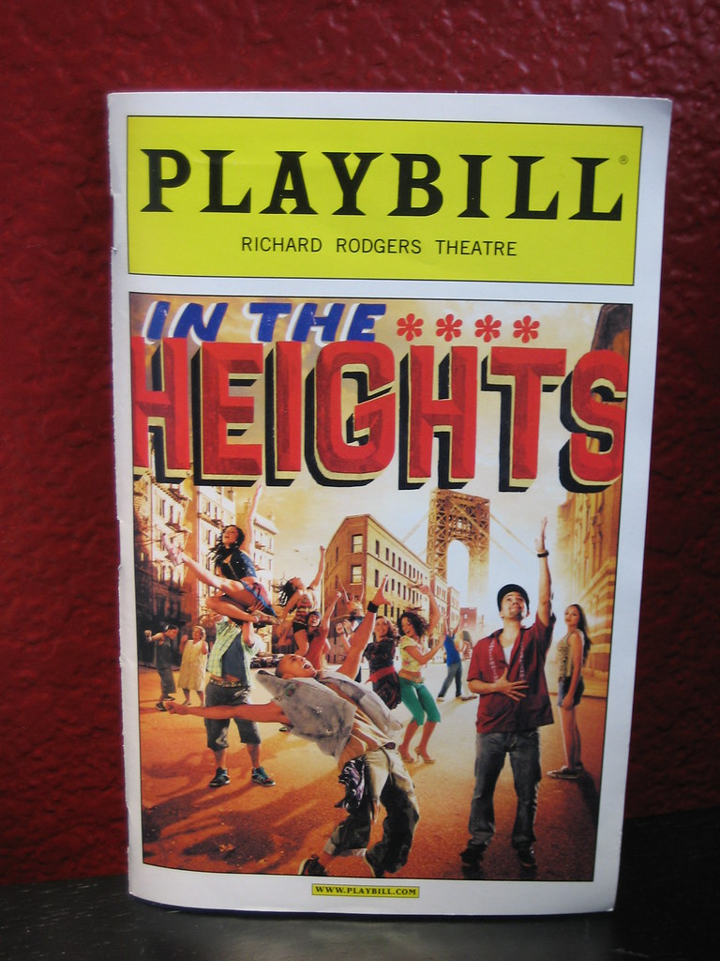
Image sourced from Flickr (date accessed 23/02/2021)
‘In the Heights’ was written by Lin-Manuel Miranda and debuted on Broadway in 2008. It tells the story of a vibrant Latin American community in the New York suburb of Washington Heights. Its music is distinctively drawn from pop music culture, combining the rhythms of salsa, soul and hip hop whilst maintaining the typical musical theatre ballads and punchy opening and closing numbers. The pit orchestra for ‘In the Heights’ is a very small ensemble consisting of just nine musicians. Smaller ensembles of five to ten are now more commonly used in musicals compared to the larger pit orchestras of musicals written in the mid to late 20th century. The development of electronic sound sources such as synthesizers and pre-recorded sounds, and the influence of pop music culture has found its place in modern musicals, resulting in a stripped back pit orchestra now commonly used in musical theatre. Examples of musicals which use a small ensemble include: ‘Come From Away’, ‘Hamilton’, ‘Little Shop of Horrors’, ‘Waitress’ and ‘Six’. A detailed synopsis and additional information of ‘In the Heights’ can be found in the ‘In the Heights’ program notes and ‘In the Heights’ trailer (00:00:00 – 00:02:22).
Additional resource: Lin-Manuel Miranda composer interview about ‘In the Heights’
There are two options for classroom activities for this unit. Students may choose which activities they would like to do using either option one or option two.

Option one – sing and play

Performance
- Starter Activity – complete some of the vocal warm up activities contained within the following video: Musical Theatre vocal warm up exercises (00:00:00 – 00:03:56)
- Perform a section or more of ’Breathe’ by Lin-Manuel Miranda from ‘In the Heights’ in small groups and record your own performance on your phone or device.
  - ‘Breathe’ by Miranda score
  - ‘Breathe’ by Miranda audio (00:00:00 – 00:04:04)
  - ‘Breathe’ by Miranda lyrics
Discussion: What are the lyrics about? What is the main emotion that Nina is expressing?

Composition
Think of a time or situation when you felt similar emotions as Nina did in ‘Breathe’. Using the same chord progression as ‘Breathe’ (or a section of it), compose your own melody and lyrics to be sung over the chord progression. You may like to create a ‘mood board’ to brainstorm your ideas and feelings. This task can be done in small groups or as an individual using the ‘Breathe’ backing track (00:00:00 – 00:01:20). Perform to the class and record on your phone or device.

Aural and musicology
Using either your original composition or your original ‘Breathe’ performance, compare one of these recordings to the original recording ‘Breathe’ by Miranda (00:00:00 – 00:01:18) according to the concepts of structure, tone colour, dynamics and expressive techniques and texture.
Concept | Original ‘Breathe’ | Own version
Structure
Tone colour
Dynamics and expressive techniques
Texture

Option two – rhythms and grooves

Performance and musicology
- Read the information and write down three to five points of the roles of the instruments in the Latin music ensemble.
The musical score for ‘In the Heights’ uses a range of Latin grooves, and the small ensemble used is typical of the style. Latin music is made for dancing, and the music is anchored by the rhythm of the claves. The other instruments typical of a modern Latin ensemble include a variety of percussion such as timbales, congas, bongos, maracas, guiro and agogo bell as well as melodic and harmonic instruments such as bass guitar, guitar, piano, trumpet or trombone and voice.
The role of the percussion is central to the groove. Every percussion instrument has its own short rhythmic ostinato which is repeated throughout, and these rhythms interlock and hocket to form a complex rhythmic tapestry. Each part is of the same importance to establish and maintain the groove, and must work together to ensure the parts are unified. Latin music contains many polyrhythms, however there are also moments of complete rhythmic unison when all instruments play unison ‘hits’ to signify the beginning or end of a section. There is little room for improvisation, except for perhaps a timbale solo.
- ‘The Club’ is one of the Latin tracks found in ‘In the Heights’ and features a cascara rhythm or groove. Perform the ‘Cascara Rhythms’ groove found in the score booklet resource as a class or in small groups.
Extension: Try performing along with the track ‘The Club’ by Miranda (00:00:00 – 00:01:18) which features in ‘In the Heights.’

Additional resources:
Conga hand positions
Latin Rhythms by Victor Lopez

Composition
- Latin music contains many dance rhythms and grooves that define the feel of the style. Below is the basic rhythm for a samba. This rhythm would typically be played by the claves and drum side stick. Clap through the rhythm as a class:
The samba rhythm
- Compose additional rhythmic parts for your percussion instruments to create a samba groove. Your samba rhythm must contain the following:
  - bass drum should stress beat 1 and 3
  - usually played at a fast tempo
  - should have the feeling of a 2/4 pulse
  - the syncopation should not alter the two bar phrases
  - only use crotchets and quavers and crotchet and quaver rests to create your rhythmic patterns.
- Students are to notate their part on the stave using traditional notation on either manuscript or using digital notation software.
- Perform to the class and record on phones or devices.
Discussion: What were the challenges you faced in composing for your instruments? How did you overcome them? Did you play together successfully as an ensemble? Why/why not?

Aural and musicology
The following excerpt from ‘In the Heights’ is to be used for this activity:
‘The Club’ by Lin-Manuel Miranda (00:00:00 – 00:01:18)
- The teacher will provide three sheets of A3 paper and write one concept of music at the top of each sheet including tone colour, texture and duration. The sheets are then to be placed as ‘concept stations’ around the room. Concepts of music checklist sheets may be provided if needed at each station.
- Each student is to choose a concept station to start with and sit at that desk with a pen.
- The excerpt will then be played by the teacher and the students have two playings to write down their musical observations according to that particular concept in dot points.
- Once finished, the class then rotate and move to a different ‘concept station’. The excerpt gets twice played again, and the students record their observations on the corresponding concept sheet. Students are encouraged to read the previous students’ responses first and either add more detail to a point previously given or contribute another musical observation.
- Once all students have contributed to each concept sheet, each student is to share with the class, the observations from each concept sheet. Discuss.

Answers

Option one – sing and play

Performance
Discussion: What are the lyrics about? What is the main emotion that Nina is expressing?
Nina has returned to her home town after dropping out of college and is really embarrassed and disappointed in herself that she has let her family and community down. She feels they were all counting on her to succeed and had high expectations of her success. Nina feels nervous and anxious and is telling herself to ‘just breathe.’

Aural and musicology
Using either your original composition or your original ‘Breathe’ performance, compare one of these recording to the original recording ‘Breathe’ by Miranda (00:00:00 – 00:01:18) according to the concepts of structure, tone colour, dynamics and expressive techniques and texture.
Concept | Original ‘Breathe’ | Own version
Structure | Verse/Chorus form  - Intro – 8 bars  - Chorus – 18 bars  - Verse 1 – 16 bars  - Pre-chorus – 16 bars  - Chorus – 16 bars  The phrase structure generally consists of 8 bar phrases.
Tone colour | Instrument/role/timbre  - acoustic guitar – harmonic accompaniment – bright and clear  - flute – melody in the intro – airy and sweet  - shaker – rhythmic accompaniment – dry  - male voice (solo) – melody – warm  - electric bass – harmonic accompaniment – mellow  - piano – harmonic accompaniment – bright  - female voice (solo) – melody – resonant  - trumpet (muted) – harmonic accompaniment – buzzing  - vocal chorus – melody in the chorus and harmonic accompaniment – warm and resonant
Dynamics and expressive techniques | - The intro is mainly mezzo piano due to the thin texture.  - The chorus’ are mezzo forte due to the addition of the male and female vocals.  - The verse and pre-chorus is mezzo piano due to the thinner texture with the male vocals omitted.  - The intro is played legato by all instruments with vibrato used by the flute.  - In the chorus, the guitar and bass pluck the strings using a mixture of legato and detached articulations. The voice sings in Spanish using vibrato, melisma and ornamentation of the melody.  - In the verse and pre-chorus the female vocals continue to use melisma and vibrato.  - In the final chorus the trumpet uses a mute.
Texture | - In the intro the texture is thin and homophonic with the flute providing the melody and the guitar and piano providing harmonic accompaniment.  - In the chorus the male vocals provide the melody with the chorus male vocals, guitar and female vocals providing the harmonic accompaniment. The texture here is moderately thin.  - The verse and pre-chorus are thinner but remain homophonic with the female vocals providing the melody and the remaining instruments providing harmonic and rhythmic accompaniment. The texture gradually gets thicker here as more instruments like the trumpet are added.  - The chorus is moderately thick as the staggered entries of instruments emerge throughout the section. The male chorus vocals provide the melody and the female vocals sing a countermelody which serves as accompaniment.

Option two – rhythms and grooves

Aural and musicology
The following excerpt from ‘In the Heights’ is to be used for this activity:
‘The Club’ by Lin-Manuel Miranda (00:00:00 – 00:01:18)
Suggested answers:

Tone Colour
- Trumpet and trombone create a blazing and powerful tone colour. Their role is melodic and harmonic.
- Bass guitar provides the harmonic accompaniment with a booming tone colour.
- Piano provides harmonic accompaniment through the use of montuno piano ostinatos using a bright and tinny tone colour.
- Male vocals provide the melody using a nasal tone colour.
- Female vocals provide melodic fragments using a warm tone colour.
- Percussion: this includes the use of timbales, congas, bongos, claves and agogo bells which overall provide rhythmic accompaniment and a percussive, dry tone colour.

Texture
- The intro is very thick with the trumpets and trombones providing the melodic material with the percussion and rhythm section providing harmonic and rhythmic accompaniment.
- The horn section plays in rhythmic or melodic unison. The texture here is homophonic with the trumpet and trombones sharing the melodic content using call and response.
- The rhythm section consists of a full Latin percussion section with timbales, congas, bongos, claves, and agogo bells providing rhythmic accompaniment as well as the bass and piano playing the bass line and harmonic accompaniment.
- The verse begins with a slightly thinner homophonic texture as the horns are omitted, however it still remains moderately thick due to the many layers of percussion. The piano plays a two bar montuno piano ostinato as harmonic accompaniment which outlines the chord progression.
- The male vocals provide the melody with interjections from the female vocals. The end of the first verse section briefly becomes monophonic due to the ‘sprechstimme’ used by the vocal chorus as all instruments play a unified rhythmic ‘hit.’
- The second half of the verse becomes slightly thicker due to the addition of the horns providing backing figures over the harmonic and rhythmic accompaniment, as the vocals continue to provide the harmonic accompaniment. The end of this section again becomes briefly monophonic as before.
- Middle 8 – This section uses a homophonic texture and is very thick due to all instruments playing at the dynamic of forte, however the vocals are omitted. The trumpets and trombones playing a four bar phrase which is repeated. The rhythmic and harmonic accompaniment is provided by the remaining instruments with the piano now comping chords in a repeated rhythmic pattern.

Duration
(Answers may include rhythmic transcriptions)
- The tempo is Allegro, the time signature is 2/2 and the beat is strong and regular due to the percussion rhythms placing an emphasis on beats 1 and 3.
- In the intro, the brass performs the melody using 4 bar phrases in a repeated rhythmic pattern. The note values used are most short, accented and syncopated, consisting mainly of crotchets and quavers placed off the beat.
- The percussion instruments play a variety of repeated ostinato polyrhythms consisting of short note values such as crotchets and quavers to establish the Latin groove which also contains a lot of syncopation.
- The bass and percussion often play unison ‘hits’ with the percussion section at the end of phrases or sections. The bass also plays a moving bass line which is highly syncopated using note values such as crotchets and minims tied over the beat to outline the chord progression.
- The verse begins with the entry of the male vocals which use highly syncopated short note values such as quavers and crotchets. This is interjected by the female vocals which use more legato in the rhythmic execution with longer, tied note values such as minims and semibreves.
- The accompaniment instruments in the verse consist of the percussion section which continue similar rhythmic patterns to the intro using repeated rhythmic ostinatos and polyrhythms. The piano plays a repeated two bar montuno piano ostinato in octaves using syncopated crotchets. The bass plays a highly syncopated bass line using ties and long note values such as minims.
- The middle 8 sees the percussion section continue as above, but the horns now play a syncopated melody in rhythmic unison using quavers and crotchets.
- Accents are regularly used throughout in all parts to emphasise the syncopation and unison ‘hits’ played by the ensemble.

Ensemble communication skills

Funk fusion
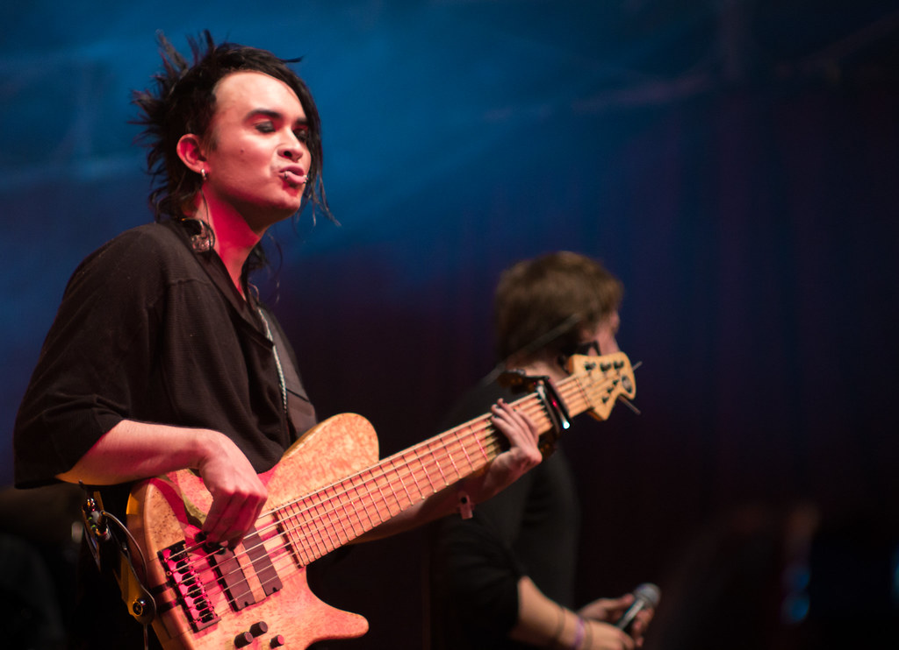
Image sourced from Flickr (date accessed 02/03/2021)

Composition

Activity – ‘Pass the rhythm’
As a class, stand in a circle. One person begins by clapping a very short rhythm to another person in the circle by making eye contact with them. (Pass the rhythm). That student is then to clap a different rhythm to another person in the circle by making eye contact with them. If someone misses their turn, they must sit down and are ‘out’. Once you get to a handful of players, you can have two people within the circle clap ‘pass the rhythm’, until you are left with two players who are both the winners.
Discussion: What type of communication did you notice when the rhythm was passed to you? What type of communication did you use when you had to ‘pass the rhythm?’

Performance, aural and musicology
- In small groups, perform any song (or part of a song) of your choice. Record your performance on your phone or device as a video.
- Watch back your performance. How did your ensemble communicate with each other? Was it effective? Why/why not? How important is effective communication in a small ensemble performance?
- Brainstorm as a class some ways in which a small ensemble can interact and communicate to ensure a successful musical performance.
- Watch the following performance of ‘Coffee Break is Over’ by Dirty Loops. (00:00:00 – 00:03:15) and observe the ensemble communication techniques that they use in their performance.
- Rehearse your group performance again and experiment with integrating some of the ensemble communication techniques discussed above. Record your performance on your phone and answer the following questions:
  - List the ensemble communication techniques your group used throughout the performance.
  - Do you think the ensemble communication skills you used made the performance more successful? Why/Why not?
  - How did the ensemble communication unify and support the musical intent of the performance? Refer to some of the concepts of music in your response.
- Research a small ensemble piece of your choice and list the ways in which your chosen example uses ensemble communication skills. Write your observations in your book.

Additional resources
Advanced musicology research in ensemble communication

Answers

Composition

Activity
Discussion: What type of communication did you notice when the rhythm was passed to you? What type of communication did you use when you had to ‘pass the rhythm?’ Answers may include:
- eye contact
- physical cueing
- gestures

Performance, aural and musicology
- As a class, brainstorm some ways in which a small ensemble can interact and communicate to ensure a successful musical performance. Answers may include:
  - eye contact
  - temporal cueing
  - physical gestures
  - synchronisation of rhythm through auditory awareness
  - counting a song in
  - focused listening to respond to other members and how they explore the concepts. For example, dynamic build ups/climax.
  - ‘cut offs’ with hands or instruments to signify the end of a song or section.
- Watch the following performance of ‘Coffee Break is Over’ by Dirty Loops. (00:00:00 – 00:03:15) and observe the ensemble communication techniques that they use in their performance.
Answers may include:
  - looking at each other (visual communication)
  - cueing
  - listening to ensure rhythmic precision and unity
  - synchronisation of rhythm
  - gestures
  - common understanding of musical intent to guide physical interaction and presentation. For example, mood, climax, dynamics.

Disclaimer
Please note that the recommended music software/programs referenced in this booklet are a suggestion only and implies no endorsement by the New South Wales Department of Education, of any software developer or company.

