Connotation, imagery and symbol in the arts
Creative arts Early Stage 1 learning sequence
Learning sequence description
In Lesson 1 students explore the symbolic role of images in communicating understandings about Australia’s environment and culture. In Lesson 2 they investigate selected pop art in visual arts and examine the imagery and hidden meanings within. Students identify and interpret these hidden meanings across the creative arts. This is then used to examine mass production and advertising through the stimulus of a music study of nursery rhymes.

Syllabus outcomes and content
Music
MUES1.1 - participates in simple speech, singing, playing and moving activities, demonstrating an awareness of musical concepts.
  - performs simple speech rhymes and songs maintaining a sense of beat and rhythm based on nursery rhymes
  - moves to music maintaining a constant beat
  - performs music using body percussion, percussion instruments and self-made sound sources
  - explores simple aspects of musical concepts in their singing, playing and moving activities.

MUES1.4 - listens to and responds to music.
  - listens to music and responds by moving to the beat, doing simple actions when different sections are played
  - responds to music through movement.

Visual arts

VAES1.1 - makes simple pictures and other kinds of artworks about things and experiences.
- investigates relationships in their artmaking, including people who are important to them such as parents, grandparents, brothers and sisters, friends, and others in their local area
- talks about significant features and relationships within their artworks.
VAES1.2 - experiments with a range of media in selected forms.
- explores the qualities of different drawing media and tools such as graphite (‘lead’) and colour pencils, fibre tip pens, crayons, brushes and sticks in drawing
- recognises how qualities such as colour and shape can assist them to depict various things
- explores the qualities of paint, recognising qualities such as transparency and opacity and uses brushes and other tools
- uses scissors to cut regular and irregular shapes from papers and cardboards and assembles these in a variety of ways by overlapping, repeating, layering patterns, gluing, and sticking.
VAES1.3 - recognises some of the qualities of different artworks and begins to realise that artists make artworks.
- identifies different colours, shapes, textures and other things of interest in artworks
- recognises and identifies some of the things depicted in artworks and responds to these through associations
- talks about pictures and other artworks they have seen, noting what they are about and who made them.
VAES1.4 - communicates their ideas about pictures and other kinds of artworks.
- describes and responds to what artworks are about
- identifies features in the works that are significant to them and makes links with their experience
- talks about the artist who made the work and suggests that the artist has similar feelings to the things they represent in their artworks.
NSW Creative Arts K-6 Syllabus © 2006 NSW Education Standards Authority (NESA) for and on behalf of the Crown in right of the State of New South Wales.

Lesson 1 – how do artists help us to understand their works through images and hidden meanings?
Students are learning to:
- explore the use of symbols within artworks to communicate meaning and expression of self
- think about different techniques and forms that artists use to tell their story and share their thoughts
- create artworks for different purposes.
Item | Learning experience | Differentiation strategies and/or adjustments | Resources
1.1 | Begin with a discussion of Aboriginal culture in Australia and the importance of reflecting on the original owners of the land in your community. Highlight that Aboriginal peoples have looked after this land for a long time and we all have the responsibility to continue this practice.  Use process of a form of symbolic abstract painting video (which was also used in the previous learning sequence). Go outside to a special place within your school or local environment. Where possible take a plastic surface, some cardboard, a paver or alternatively find some concrete or into a tiled or paved area. Take some water in a container and a paintbrush for each student.  Ask the students to look around at their immediate environment in silence. Ask them to identify something that they perceive as important about their environment – either natural or man-made.  Ask the students to create artworks to reflect a symbol of something in this environment that is important to them. Once it has vanished, repeat with another symbolic image. Discuss that artworks don’t always need to be permanent but that they do represent a meaning to the artist, and when permanent can be used to keep that meaning for audiences to consider.  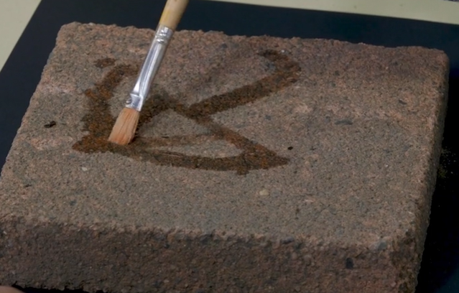  Explore this further by examining the work ‘Centrepoint Tower’ by Aboriginal artist Esme Timbery from the collection at the Art Gallery of NSW. Timbery is a Bidjigal artist whose family were shell workers from the Aboriginal mission community of La Perouse in Sydney. La Perouse women artists have been working with and earning an income from shell work for generations, with one of the earliest reports from the late 1800s.  Ask the students to look at this work and think about how it was created and what it symbolises. Discuss the meaning of the shells as traditional materials and a technique used by the artist. Ask students to think about why they would be placed on a man-made structure like Centrepoint Tower. Consider the meaning of the work in terms of a mixture of traditional methods, natural and man-made and the importance of Aboriginal culture.  Students should then think again about their natural environment and consider some materials they could gather to create a different form of temporary artwork. Emphasise that they should not take from nature such as shells from the beach permanently.  The student should then create a temporary artwork that reflects their local environment and photograph it. For example, leaves, sticks, dirt, shells, seaweed, pebbles or grass to represent the landscape. In the example below these are placed on a piece of paper without gluing and then replaced back into the environment they came from.  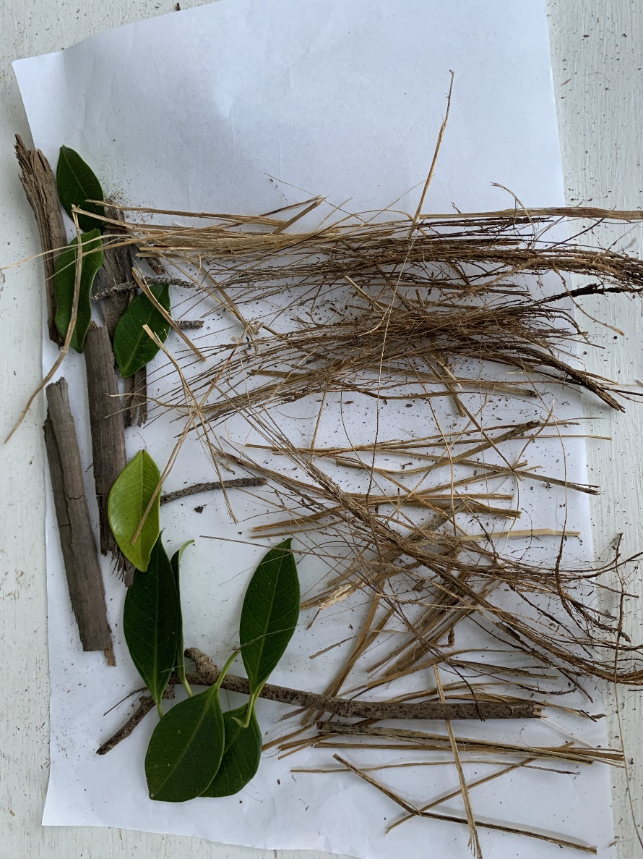  Ask the student to write or record their artist intent statement to accompany the work including a title and what it means to them as an artist. This may also be conducted through an interview. | Where equipment is unavailable, draw symbolic images on paper or in the air.  Photographs of aspects of the local environment may be used as a substitute for making them using local materials. | Student workbook including image of ‘Centrepoint Tower’ by Esme Timbery  Demonstration video (1:07):  Process of a form of symbolic abstract painting  Paintbrush  Container of water  Paver, plastic lid or cardboard  Locally sourced materials such as leaves, grass or dirt
1.2 | Examine a different perspective presented by an artist about the Australian landscape through the artwork ‘Triple fronted’ by Howard Arkley from the Art Gallery of NSW. Arkley’s work is all about suburban streets and houses in Australia and transforming them into the extraordinary. He loved decorating magazines and advertising.  Arkley’s style is known as pop art. This is because he took something ordinary, like this house and transformed it with unusual and bright colours to make it more ‘popular’ or ‘pop’ culture. Works like ‘Triple fronted’ were reflecting on how so many houses in suburbs all look the same. This one is clearly different through its use of colours.  Ask the students to draw their house (or apartment block) using a pencil, ruler and straight lines in their student workbook. They should then go over their drawing with a black pencil, marker or texta. The students should then transform their house using different colours, not the colours that would be expected or that are really there, to make it a pop art style. Students may choose to use textas, crayons or paints to give this bright effect. The difficulty most students will find with this task is selecting colours that wouldn’t normally be used. For example, in the sample below the student would not compromise on the colour of the sun but was able to colour a full sky orange.  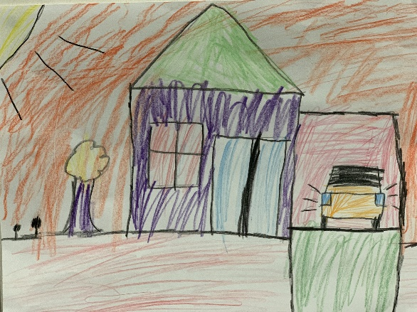  If students are lacking confidence to draw their home, they may use the outline provided below (and at the end of their student workbook). This is for emergency use only to ensure that all artworks reflect the uniqueness of the artist’s house. | Stencil provided in workbook can be used as an alternative to drawing the house. | Student workbook with image or link to artwork ‘Triple fronted’ by Howard Arkley from the Art Gallery of NSW  Black texta, artline pen or marker  Coloured textas, paints or crayons.
1.3 | Opportunity for monitoring student learning  Student temporary artwork to reflect their interpretation of their environment – presentation  Students create an artwork to reflect their local environment using locally sourced materials. These artworks are temporary and represent something important to the student in their environment. Students should explain the meaning their artwork has to them and must recognise that as an artist their work can be temporary by returning it to its original location.  What to look for:  - Does the student represent an aspect of their surroundings through locally sourced materials?  - Is the student able to discuss the meaning of their work through the artist intent statement? This should include a title for their work and an explanation of its meaning to them.  - Did the student return materials used to the environment and thus recognise that as an artist their artwork can be temporary? |  | Student workbook or artwork

Lesson 2 – how the arts have helped us think differently about society and the things we have?
Students are learning to:
- identify the ways in which artists make us think differently about things we think are ordinary in our society
- identify the role of the ways in which artists connote meaning for an audience
- Use techniques to stimulate our interest and thought
- explore and understand a variety of musical concepts through nursery rhymes
- identify the ways in which the arts such as nursery rhymes have helped us make meaning of our culture throughout history.
Item | Learning experience | Differentiation strategies and/or adjustments | Resources
2.1 | Show the students the artwork by Andy Warhol which is often used to represent pop art ‘Campbell’s Soup Cans’. Ask the students to discuss what they notice about the work. Are the cans all the same? Why might they be the so similar and yet different?  Discuss the meaning described by the artist that this was a product he ate repeatedly, and it is mass-produced. He was also trying to show the image of a supermarket shelf which has rows of the same mass-produced product lining it, but he has some fun and shows slight differences.  Discuss with the students how Warhol’s hidden meaning here was that art did not always have to be completely original. Are mass produced artworks even art then?  Ask the students to think about what items they notice or look at in rows in the supermarket. How could these be made into artworks?  Ask the students to draw a tin of soup like Warhol’s 'Campbell’s Soup Can’ by drawing a cylinder. Start by creating the oval on the top and then the lines for the sides using as much of the page as possible. Uniformity is not necessary amongst the tin shapes. Go over the shape with a black marker or pencil.  Ask the students to draw a line and a circle through the middle of the can which will connect the artworks together to create that mass-produced feel and give that additional meaning to the work when displayed as a class.  Ask the students to then create their own soup flavour to go into the tin. For example, pizza soup or marshmallow soup. This artwork should reveal their favourite food through the flavour of the soup. They should then colour and label their soup appropriately to connote their flavour of choice.  Once complete, display the soup cans on the wall in the style of a mass production supermarket shelf like in Warhol’s work.  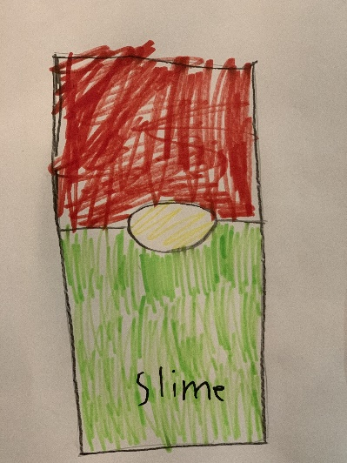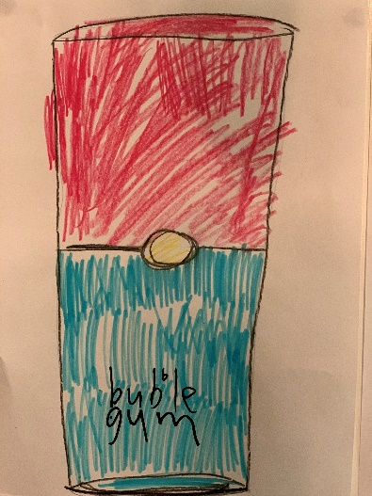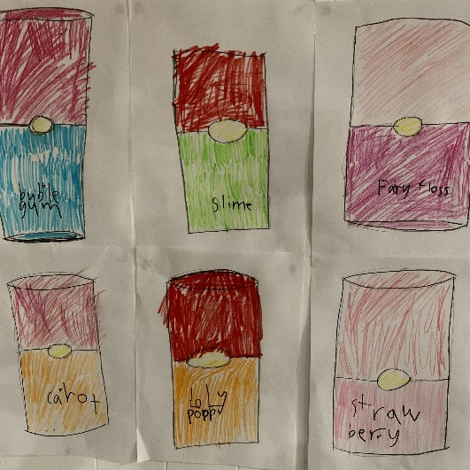  A plain blank outline has been included below for differentiation purposes only. The process of allowing the students to draw their own shapes is an important part of their artistic learning.  Show the students the image of Heinz’s new ‘Ketchup puzzle’ which has 570 pieces to match their 570 products. Is this a tribute to Warhol’s style? | If a cylinder is too difficult to draw, the students should draw a rectangle instead.  A plain blank outline has been included below for differentiation purposes only. The process of allowing the students to draw their own shapes is an important part of their artistic learning and should be encouraged where possible. | Student workbook  Image of ‘Campbell’s Soup Cans’ by Andy Warhol  Black pencil, artline pen or texta  Coloured pencils
2.2 | Reflect on the process of making soup from a can. Think of the requirements you would need such as a wooden spoon and a saucepan. What sound would they make when hit together? Suggest other items that could make similar sounds in your environment.  Experiment with available items that make sounds like the kitchen items of a wooden spoon and saucepan. Clap some rhythms and ask the children to play them back on their ‘instrument’. After a few rounds of echoing the rhythms, ask the students to make up (improvise) their own rhythms in response. Explain that musicians call this ‘call and response’. Try this a few different rhythms.  Ask the students to stir an imaginary bowl of ‘porridge’ and listen to the song ‘Pease Pudding Hot’. They should then sing the song with you. Discuss how this song was originally used as an early advertisement for a soup like food known as ‘Pease Pudding’. This was originally a porridge that later became a much thicker pudding. It was an item that was considered ‘mass produced’ for the time and was sold in the market by a person calling out its name and then became a song. Discuss how this was an early form of advertising. How has this process changed?  Watch and participate in the music lesson about ‘Pease Pudding’ (18 minutes). After watching the video, discuss what they learnt. Also remind students that throughout history nursery rhymes have had hidden meanings such as advertising, delivering messages or telling a story.  Ask the students to create their own ‘pea’ pudding artwork which can represent all their favourite ingredients. What would go into it? Contents can be peas or whatever you think would be a much better pudding. Students can create an imaginary bowl or use the image provided in the student workbook to create their ‘pudding’ using collage and drawing techniques. Icons or logos may be used to stand for that item or an image may be used instead.  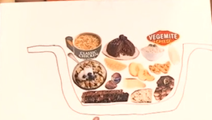 | Explore some clapping games and other nursery rhymes that you can sing. They are an excellent way to keep the beat and sing a song.  Examine the meanings of different nursery rhymes. They often have much more to tell than is apparent on the surface. Other nursery rhymes are included in previous learning sequences. | Student workbook or piece of paper  Household or school equipment that can be used to make a sound like a saucepan or wooden spoon  Magazine cuttings or empty food packaging, glue, scissors and coloured pencils  Link to YouTube of the song ‘Pease Pudding Hot’  Link to music lesson about ‘Pease Pudding’ (18 minutes)
2.3 | Opportunity for monitoring student learning  Exit slip – class presentation, written response or teacher interview  Students should use one of the visual artworks they have created in response to learning about connotation, imagery and symbols in creative arts as stimulus. With the assistance of that artwork, they should reveal either to the class, in writing or individually to the teacher, some information about their learning.  Students should explain one thing that they better understand now about how artists create meaning for an audience through their work.  Students should then explain one thing they are still puzzled about or would like to find out more about. The attached proforma may be of assistance in this process.  What to look for:  - Does the student identify that artists use images, logos or symbols to represent their ideas?  - Has the student shown this understanding in their artworks by representing their ideas visually?  - Does their understanding of the concept covered require further assistance? |  | Student artworks  Student workbook  Exit slip template in this document

Reflection and evaluation
These simple questions may help you reflect on your students’ learning and plan for next steps.
What worked well and why?
What didn’t work and why?
What might I do differently next time?
What are the next steps for student learning based on the evidence gathered?
Outline of a bowl for creating pudding artworks.

Outline of an apartment for differentiation purposes only. Preference is for students to create their own drawing first.
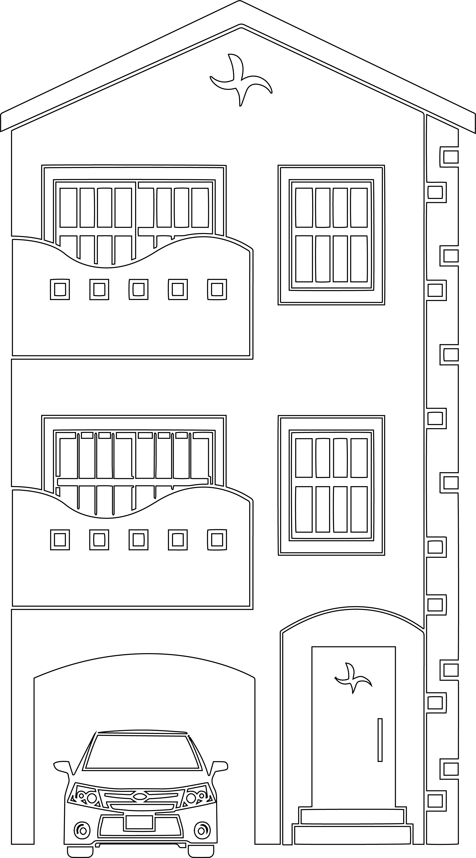

Outline of a house for differentiation purposes only. Preference is for students to create their own drawing first.

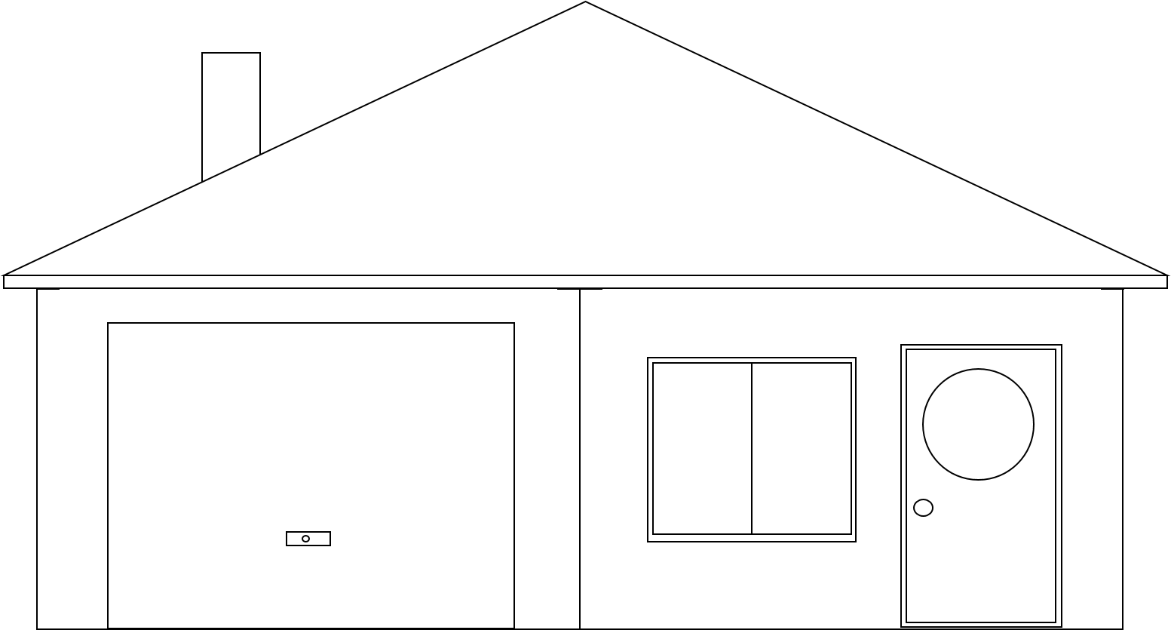
Outline of a soup can for differentiation purposes only. Preference is for students to create their own drawing first.
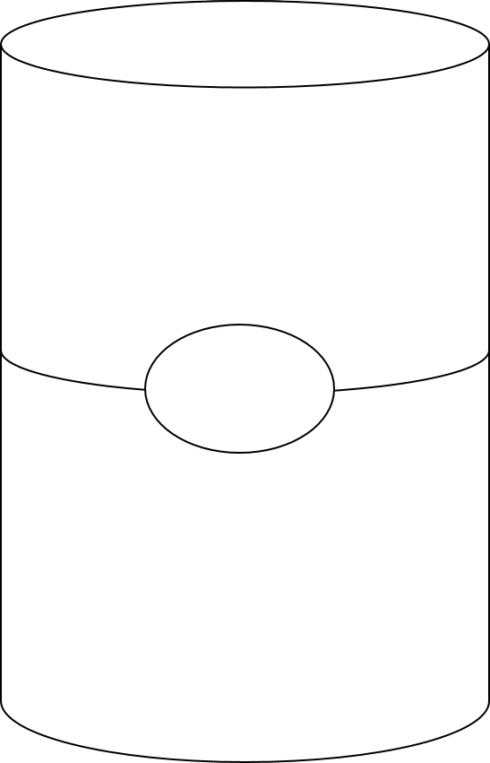

Sample exit slip
Student name: ____________________________________________________ Date: _____________________________________

I know artists share ideas by using _______________________________________________________________________________

____________________________________________________________________________________________________________

____________________________________________________________________________________________________________

One thing I wonder ____________________________________________________________________________________________

____________________________________________________________________________________________________________

____________________________________________________________________________________________________________

