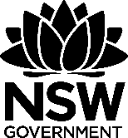 Waste as art – precious water
This document references Creative Arts K-6 Syllabus © NSW Education Standards Authority (NESA) for and on behalf of the Crown in right of the State of New South Wales, 2006. The illustrations used in this document are copyright © Cara MacLeod, 2011.
The precious water teaching resource Kit, funded by the NSW Environmental Trust, is a generic version of resources developed by Woollahra Municipal Council for their Environmental Schools Sculpture Prize (2010). This resource should be used in conjunction with ‘A guide to implementing waste as art and environmental art projects in schools’.
The NSW Environmental Trust welcomes the use of these resources within the restraints imposed by the Copyright Act 1968 (Commonwealth). Provided acknowledgement is made of the source, Australian school staff, community groups and council staff are permitted to copy this material freely for the purpose of teaching students in schools or communicating with parents and others in the community.

Table of contents
Lesson 1 – fragile forms 2
Lesson 2 – transformed landscapes 5
Lesson 3 – caring for our creeks 8
Lesson 4 – plastics washed ashore 11
Lesson 5 – lets collaborate 13
Lesson 6 – appreciating artworks 15

Lesson 1 – fragile forms
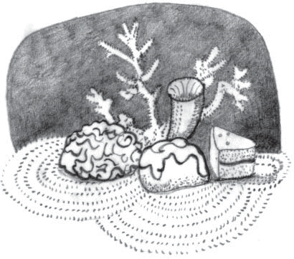

Lesson overview
After viewing examples of coral reefs, students sketch a form of coral and then develop a mixed media relief collage. Students experiment with simple techniques by crumpling, folding, modelling and gluing paper onto a solid cardboard base to make a three-dimensional artwork about coral. Students are introduced to the artwork Sweet Barrier Reef, by Ken and Julia Yonetani. This sculptural installation from white sugar highlights the fragility of the natural environment.

Lesson outcomes
VAES1.2, VAS2.2, VAS3.2, VAES1.4, VAS1.4, VAS2.4, VAS3.4

Cross curriculum links
Science and Technology (Values and attitudes, Knowledge and understanding), HSIE (Geography)

You will need
- photos of the Great Barrier Reef;
- newspaper, cardboard, drawing paper, tissue paper, scrap paper of varying thickness;
- drawing pencils;
- watered down PVA craft glue;
- watercolour paints or coloured chalk and

Activities

Introduction
Show students different photos of the Great Barrier Reef on a smartboard. Create a class discussion around the different types of coral communities and some of the facts about the reef that make it precious and unique. Ask students to consider some of the differences between the corals in the photos and to consider how the corals might feel to touch.
Ask students to consider some of the current environmental threats to the reef from human actions. Threats include, coral bleaching from global warming, increased algal blooms from chemical runoff into the ocean, increased species extinctions and changes to existing reef ecosystems. Stimulate a class discussion by asking students to consider the outcome for the Great Barrier reef if we do nothing to address the current threats already discussed. Establish with students that art can be used to draw attention to environmental problems by informing the public of issues through visual and creative means.

Artist case study
Show students images of Sweet Barrier Reef by Ken and Julia Yonetani, which can be downloaded from the Sweet Barrier Reef artist resource booklet. Discuss with the class what the artworks are made from, how the artworks were made and the message conveyed in the artwork. Ask the class to consider the effectiveness of this artwork and if it has been successful in communicating the intended message of the degradation of the reef environment in Australia.

Drawing activity
Ask students to sketch some of the different shapes and textures that interested them in the photos of the Great Barrier Reef shown to the class. Students could consider which style, shape or colour of coral interests them the most.

Sculptural artmaking
Ask students then model and shape newsprint by scrunching, crumpling, folding, layering, wrapping, tearing, cutting and twisting to resemble various forms of coral. When experimenting with these different methods students might crumple the paper into a ball, fold it to create regular pleats like a fan or a book, or wring it to create irregular lines and folds. Students may wish to open out their paper again to see the kinds of patterns and textures they have created. Students can explore surface texture and tactile qualities further by using these methods with different types of paper. They will achieve varied results depending on the type of paper they use, for example, very soft tissue to represent soft coral or very stiff paper to represent hard coral.
After experimenting with ways to manipulate and shape paper, students create a three-dimensional artwork about coral by adding thin paper dipped into diluted glue onto a base of stiff cardboard. Ask the class to think about the elements or qualities they want to represent, such as dots and lines, rounded forms or even patterns of waves or currents in water and the environmental message they can convey through their work. To do this, first slightly dampen the paper and base with diluted glue, then lightly attach it to the board. Students can then play with the paper to sculpt it by pulling out separate forms and modelling different surface textures based on the images they have seen on coral reefs. Have the photographs visible to students as they sculpt. The paper should dry quite quickly, allowing students to colour their work by painting or rubbing coloured chalk into the crumpled surfaces. They could also consider using colour to show the difference between a healthy or bleached reef.

Lesson 2 – transformed landscapes
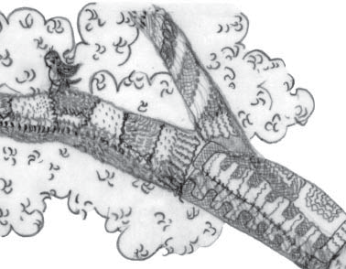

Lesson overview
Through discussion students are encouraged to describe some sculpture media and techniques. As well as to appreciate the location of large-scale artworks which are about the environment and installed outdoors. Appreciation of different site-specific art projects, Wrapped Coast and I Heart Kings Cross will give the class some insight into different art practices and questions are designed to provoke student discussion about environmental perspectives and attitudes to coastal and urban environments. In practical activities, each student will make three-dimensional artworks using mixed media. They will experiment with simple sculpture techniques.

Lesson outcomes
VAES1.2, VAS1.2, VAS2.2, VAS3.2, VASES1.3, VAS1.3, VAS2.3, VAS3.3

Cross curriculum links
Science and Technology (Values and attitudes, Knowledge and understanding), HSIE (Geography)

You will need
- a copy of Wrapped Coast Kaldor Arts Projects education kit;
- found natural objects to wrap and transform such as fallen twigs, discarded household items or rubbish;
- fabric such as calico, cotton or hessian and
- wool, string, cotton twine, shoelaces or rope.

Activities
Artist case study one
Introduce students to Christo and Jean-Claude’s large scale installation Wrapped Coast by showing images from the Kaldor Arts Projects education kit. Ask your students;
- Where is art displayed usually and how does this artwork differ?
- What environmental message are the artists trying to communicate?
- How does this artwork make you feel? Is the artwork beautiful, impressive and powerful in its message? Does the landscape look enclosed, trapped, suffocating and damaged?
- What environmental problems might an installation of this size cause? Is it damaging to the ecosystem it sits within or a waste of resources?

Artist case study two
There are other approaches to wrapping the environment. Sydney based artists collective Reef Knot created an installation artwork made from knitted materials in Sydney in 2009. Show students examples of their guerrilla knitting and ask students the following questions;
- How would you feel about wrapping up a living thing like a tree? How long do you think it might survive under this kind of wrapping?
- Is the texture rough or smooth? What materials and techniques were used?
- Do you like the idea of covering an object to make it colourful, mysterious, simplified or abstract?
- What messages could be communicated through this kind of art?

Sculptural artmaking
Building on the discussions of both the Wrapped Coast and I Heart Kings Cross projects, students select a found or discarded object to transform. Students wrap their chosen item with recycled fabric in a way that transforms the object and encourage them to experiment with different wrapping methods such as layering and folding. When students are happy with their work, students should tie it together carefully with string or wool to secure the covering. Younger students may need additional support with this part of the activity.
Finally consider if wrapping an object can reveal the underlying form by unifying or simplifying the surface. Can other people still recognize the original form of the object? Does the way the object has been wrapped, or the material that has been used, convey any environmental messages? What is the environmental impact of your sculpture? Have you used recycled materials that could be re-used if you took the sculpture apart?
Display the finished wrapped objects. Students could find a suitable location in the classroom, library, office or grounds to display their sculptures. Consider if the artworks would be better displayed as a group, or separately. Why? This could be documented in photographs.

Extension
Christo and Jeanne-Claude made scale models, drawings and photographs to plan and document their projects. Students could sketch their own wrapped object to show the underlying 3D form. Working in the style of Christo and Jeanne-Claude or Reef Knot, students could create a small maquette or model for a large-scale project they would like to realise in a particular place in the school buildings or grounds that responds to the theme of protecting and conserving our precious water sources and environments.
Students could carefully wrap a large object in the classroom such as a piano, chair or fan, then the whole class could sketch this using techniques such as continuous line, perspective and shading- using pencil or charcoal on A3 paper, or white pastel pencil on black paper.

Lesson 3 – caring for our creeks
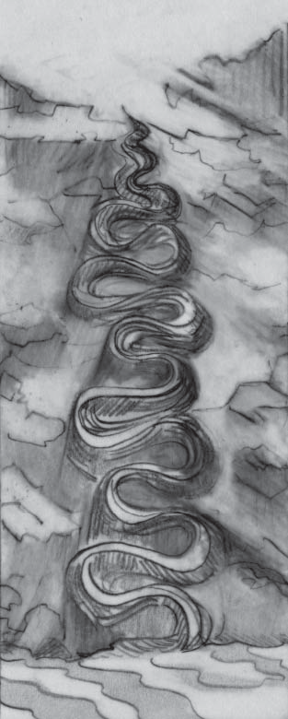

Lesson overview
In this lesson students explore artworks by Robert Smithson and Andy Goldsworthy, who use natural materials to create sculptures and installations in and about the environment. In practical activities, students observe a local creek or water body, and collect objects or record textures, shapes and sounds that interest them. Students experiment with basic ceramic tools and techniques, to explore elements of art such as line, texture and form in a 3D clay tile representing aspects of a creek in their local area.
Responsible use of natural materials should also be emphasised through discussions about only taking imprints and rubbings from natural objects, and only collecting natural objects that have already fallen to the ground.

Lesson outcomes
VAES1.1, VAS1.1, VAS2.1, VAS3.1, VAES1.3, VAS1.3, VAS2.3, VAS3.3

Cross curriculum links
HSIE (Geography)

You will need
- images of Spiral jetty (1970) by Robert Smithson;
- Time magazine article featuring Andy Goldsworthy’s river art works;
- air drying paper clay;
- ceramic modelling tools including a wire cutting tool and sponges;
- sketching equipment including paper, pencils and clipboards (if working outside);
- reused clean takeaway or butter containers to store spare clay, slurry, tools and damp sponges in and
- found objects such as seed pods, pine cones, sticks and shells.

Activities

Artist case study one
The installation of artworks into the landscape, sometimes known as land art or earth works emerged in the 1970’s when artists including Robert Smithson created large scale installations or changes to the earth’s surface. To make Spiral Jetty, Smithson used earth-moving equipment to extend a rock and dirt spiral, 460m long, into Great Salt Lake, Utah which was then left to change and erode under natural conditions. In this case, the artist was interested in the impact of human activity on different environments. He chose this lake because it had been used as an industrial site before and was already affected by salinisation. Show the class evidence of the changes over time in the photographs of the artwork, including effects of a drought and salinisation. When the water level rose in 2001, Spiral Jetty disappeared under the lake’s surface, but later re-emerged, covered in pink and white salt.

Artist case study two
Andy Goldsworthy is a British sculptor, photographer and environmentalist. He creates both temporary and permanent sculptures which are made in harmony with nature. Goldsworthy uses the organic elements he finds in specific locations to highlight the natural beauty of the place and works methodically with the rhythms of nature. For example, in 1998 he carried out an installation whereby he first dug clay out of a river bed, kneaded it into shape and let it dry out until it was sticky and easy to model. Goldsworthy then constructed a river shape out of the river clay by adding it onto the adjacent rock wall with his hands. The sculpture later dried and cracked in the sun and eventually fell slowly back into the river. The artist worked with changing weather conditions, but unexpected changes are all part of his process, further examples of Andy Goldsworthy’s work can be found here.

Discussion
Discuss each of these projects using images, YouTube links and the link to the artist interview from Time. Ask students how they would describe the lines, colours and shapes? What are they reminiscent of? How long do students think each artwork took to make? And finally, why might the artists have made each work? Some people question the environmental impact of land art installation projects. Ask students to consider if it would be acceptable to make changes to the environment for the sake of art? For example, would it be okay to do this to a creek in the local area? Why or why not? Ask older students to compare the approaches by Smithson and Goldsworthy and discuss the aspects of each artwork they prefer?

Ceramic artmaking
In this activity students will each make a small tile shape ceramic impression of a natural form. This activity can be conducted in the classroom or outside near a stream or creek. Each student will need a small slab of air drying paper clay approximately 10 x 20cm and 2cm thick as well as wooden ceramic tools to make patterns with. Preparing an example clay tile to show students how to build up forms by adding clay, using tools or how to imprint or inscribe lines and textures to represent water using different found objects may be helpful.
In the classroom, show students images or short YouTube clips of local creeks or waterways of relevance. As a class study the natural shapes, lines and textures and ask students to sketch some of the shapes and textures they would like to use in their own artworks. Students develop their own creative representation of a local creek or waterway by drawing into or cutting away from their clay slab. Students explore ways to develop their work by rolling, pinching and imprinting into their clay with different tools and natural materials and developing the surface qualities of texture, line, shape and form. They could also experiment by joining small additional pieces of clay by scratching the surfaces to join with a bamboo skewer or a fork and wiggling and pressing pieces firmly together. A small amount of slurry (watered down clay) can be dabbed on with a finger or sponge to help stick parts together. Small damp sponges can be used to keep fingers and tools damp and clean. Students should initial their work before their clay dries.
Alternatively, students could observe local creeks during a class excursion. Take a bag with clip boards, pencils and paper for sketches and rubbings of bark, leaves, or patterns. Cleaned plastic takeaway or butter containers could be used to hold each student’s slab of clay. The class could collect found objects such as pods, branches, sticks, leaves or seed pods that have already fallen to the ground during the excursion to make some impressions of interesting textures. While visiting a local creek, discuss what inspires students about the natural area for example patterns or sounds? Ask the class, are there special features such as rocks or plants that they want to express in their tile? Have patterns or imprints already formed in the creek bed? Is there evidence of any human impact like pollution and litter?
Clay needs to be of an even thickness and allowed to dry slowly to avoid warping and cracking. Dry finished artworks somewhere out of the way- a window sill or the top of a cupboard. Sit finished artworks on newspaper to dry and loosely cover with plastic sheet or bags and turn them over the next day or later in the day so that they can dry evenly top and bottom.

Lesson 4 – plastics washed ashore
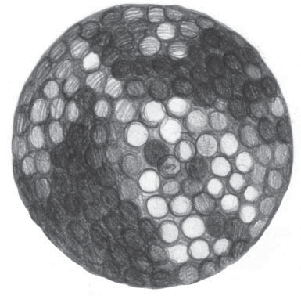

Lesson overview
Students consider the work of Australian artists John Dahlsen and Jane Gillings, who makes sculptures from discarded plastics. Such artworks demonstrate how artists can express a strong commitment to cleaning our environment by recycling in creative ways. In this lesson students will learn how they can reuse and recycle their own art materials to create a sculptural artwork.

Lesson outcomes
VAES1.2, VAS1.2, VAS2.2, VAS3.2, VASES1.4, VAS1.4, VAS2.4, VAS3.4

Cross curriculum links
Science and Technology (Values and attitudes, Knowledge and understanding)

You will need
- examples of John Dahlsen’s artworks and sculptures made by artist Jane Gillings all created from discarded plastics;
- introductory YouTube clips such as plastics in the oceans and how marine animals are affected by plastics
- discarded plastic items such as coloured plastics, water bottles, coloured plastic bags, milk bottle rings, rope and fishing line, polystyrene and driftwood, bottle caps, straws, plastic take away containers and
- wire, string, craft glue, hot glue gun, scissors and pliers.

Activities

Artist case study and introduction
Introduce students to the impacts of plastics on marine ecosystems by showing YouTube clips such as plastics in the oceans and how marine animals are affected by plastics. Show students examples of John Dahlsen’s artworks and Jane Gillings sculptures created from discarded plastics. Begin a class discussion based around the following questions. How long do you think it might take to collect all the materials needed to make artworks from plastics? What messages do the artworks made by Dahlsen and Gillings communicate to their audience? Consider the use of line, colour and shape by both artists, what techniques have been used by these artists? Ask students to reflect on their own feelings about the art created by both artists and the environmental impacts of plastics.

Sculptural artmaking
To collect enough plastic materials to create sculptures ask the class to collect and bring to school all plastics they can find over a week. Class clean ups of school grounds could also produce enough materials. Wash and dry all collected plastic items. Separate all plastics into categories, categories could be based on size and colour, for example, blue plastic caps and rings or large clear plastics such as milk bottles or water bottles.
Students can either make an animal or robot based on some of the artworks of Jane Gillings or something more abstract will be suitable for older students based on the artworks of John Dahlsen. Ask students to discuss or draw ideas before selecting plastic materials to create a sculpture. A simple animal head or shape could be made by using a milk bottle or water bottle for a body or face, many examples are available online for inspiration. Once students have their shape or animal in mind they can select plastic the plastic materials they will need to build their sculpture. Plastics can easily be joined by using a hot glue gun however try to use craft glue, wire or string where possible to avoid using a hot glue gun. Younger students may need a teacher to cut and glue plastics together for them.

Lesson 5 – let’s collaborate
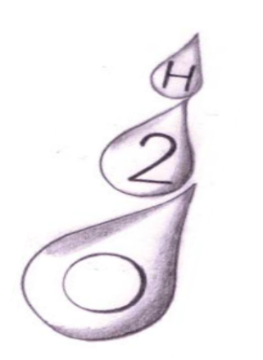

Lesson overview
Students discuss the process of collaboration and consider how and why people make large-scale art projects with teams of helpers and volunteers. Students make individual clay slab tiles in the shape of a water drop and represent their ideas about water conservation to contribute to a group installation. Students decorate their tile to represent qualities of water, using surface decoration of flowing lines, dot patterns and swirling textures, and a carefully inscribed water saving message for their school community.

Lesson outcomes
VAES1.1, VAS1.1, VAS2.1, VAS3.1, VAES1.3, VAS1.3, VAS2.3, VAS3.3

Cross curriculum links
Science and Technology (Knowledge and understanding)

You will need
- images of some of the large scale installation artworks that have been already studied in this unit, such as Wrapped Coast or other works by Christo and Jeanne-Claude available on the Kaldor Public Art Projects webpage;
- air drying paper clay, each student will need a pre-cut slab of clay about 12 x 18 cm and 2cm thick, store clay in clean takeaway or butter containers to prevent it from drying out and
- ceramic modelling tools, bamboo skewers, wire cutting tool and sponges.

Activities

Introduction
Explain the process of collaboration to the class, artists and people who care for the environment can work together to create a large-scale project that would not be possible to make alone. Discuss the work of Christo and Jeanne-Claude and aspects of the project including planning, time scales and the installation process. Wrapped coast involved many volunteers to help clean up sites, builders to construct aspects of the work and rock climbers to abseil down the cliff face and roll out kilometres of fabric and rope. Consider environmental projects such as Clean Up Australia Day or Earth Hour. How can these collaborations help us make a difference to our environment? Ask the class to consider what kind of collaboration could be developed to save and conserve water? Discuss different water saving strategies with the class.

Sculptural artmaking
Explain to students that the class will be making a collaborative artwork based on the idea of saving water. Each student will create a large water drop shape from their 12 x 18 x 2cm slab of clay but cutting away from the slab and working the slab into shape. Next students work directly onto the surface of the clay water drop to develop a design to express their own water saving message. Students could lightly stamp dots or patterns into the surface of the clay, adding coils or small pieces of clay onto the surface with slurry (watered down clay) to develop an interesting surface texture. Students may even wish to incorporate plastics and recycled materials to further add colour and texture.
If inscribing in the clay surface, keep the design light and only go one third of the way into the slab. Remember to use cross hatching and a little bit of slurry to join cracks or to press pieces of clay or other materials firmly together.
Finally, the class will need to decide on a suitable location to display all the dried clay water drops together. The class installation could be photographed and students could work on writing individual responses. Other students or teachers could be surveyed to gauge responses and the effectiveness of the installation.

Lesson 6 – appreciating artworks
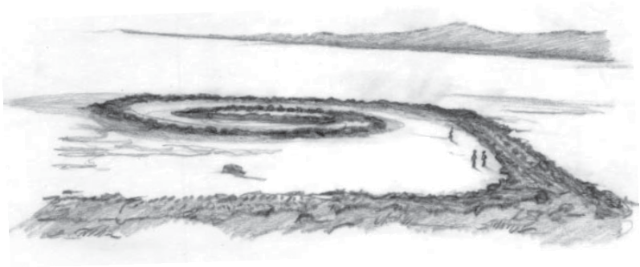

Lesson overview
In this lesson students increase their understanding of exhibitions and art prizes by exploring recent and local examples which highlight sustainability in art. Students are given guidelines for writing an artist’s statement.

Lesson outcomes
VAES1.4, VAS1.4, VAS2.4, VAS3.4

Cross curriculum links
English
You will need
- examples of past winners of the Woollahra Municipal Council Environmental Schools Sculpture Prize;
- access to the Woollahra Municipal Council entry information page for the Environmental Schools Sculpture Prize and
- to have created at least one artwork from this unit of work to be used in this activity.

Activities

Discussion
Show students the Woollahra Municipal Council Environmental Schools Sculpture prize page, show the class examples of previous winners. Next show students the Woollahra Municipal Council Schools Sculpture Prize current entry information page. Discuss with the class how most art prizes often have a theme. The them that has been the subject of this unit of work is precious water. Ask the class to consider which of the artworks they have created either individually or as a group they would be happy submitting into an art competition. Once they have selected an artwork, students create an artist statement of less than 100 words for their work by answering the following questions:
- What is the environmental message your artwork communicates to an audience?
- How does your artwork relate to the theme of precious water?
- What reused or recycled materials was your artwork constructed from?
- How were these materials sourced?

