Collect resources
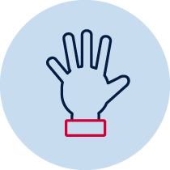 Hands on
Write
Create/make
Draw
Observe/find
Reflection
Collaborate
Brainstorm/think
Discuss
Play game/resource

Creative arts workbook ES1
Name:
Class:

Overview
You will learn about the role of character in the creative arts. Character is the way people are represented in a narrative or story. Characters can help to create meaning in songs and artworks.

Resources

Lesson 1
- An adult to help read the instructions
- A nursery rhyme you know or someone in your household knows
- The words to ‘This Old Man’ (included below)
- 2 spoons
- Paper and pencil
- Any random objects in your house.

Lesson 2
- An adult to help read the instructions
- Paper (or use the paper provided)
- Paints
- Bottle tops of varying sizes
- Water in a container
- A paintbrush
- An outside area with concrete, pavers or bricks
- Coloured pencils (or paints).

Lesson 1
Character in a song
Resources
- A nursery rhyme you know or someone in your household knows
- The words to ‘This Old Man’ (included below)
- 2 spoons
- Paper and pencil
- Any random objects in your house.

Warm up (sing a song)
Sing a song you know and keep the beat.

Understanding character (learn a nursery rhyme)
Who is your song about?
With someone in your household, think of another nursery rhyme. Read and mime the story. Does it tell a story or is it mainly focussed on the characters in the nursery rhyme? Who are the main characters and what do we learn about them through the nursery rhyme?
Sing or perform it together.

Learn a new song
Learn to sing ’This Old Man’ whilst keeping the beat, using these words:
This old man, he played one,
He played knick-knack on my thumb;
With a knick-knack paddywhack,
Give the dog a bone,
This old man came rolling home.
This old man, he played two,
He played knick-knack on my shoe;
With a knick-knack paddywhack,
Give the dog a bone,
This old man came rolling home.
This old man, he played three,
He played knick-knack on my knee;
With a knick-knack paddywhack,
Give the dog a bone,
This old man came rolling home.
This old man, he played four,
He played knick-knack on my door;
With a knick-knack paddywhack,
Give the dog a bone,
This old man came rolling home.
This old man, he played five,
He played knick-knack on my hive;
With a knick-knack paddywhack,
Give the dog a bone,
This old man came rolling home.
This old man, he played six,
He played knick-knack on my sticks;
With a knick-knack paddywhack,
Give the dog a bone,
This old man came rolling home.
This old man, he played seven,
He played knick-knack up in heaven;
With a knick-knack paddywhack,
Give the dog a bone,
This old man came rolling home.
This old man, he played eight,
He played knick-knack on my gate;
With a knick-knack paddywhack,
Give the dog a bone,
This old man came rolling home.
This old man, he played nine,
He played knick-knack on my spine;
With a knick-knack paddywhack,
Give the dog a bone,
This old man came rolling home.
This old man, he played ten,
He played knick-knack once again;
With a knick-knack paddywhack,
Give the dog a bone,
This old man came rolling home.
Explore some actions using mime and movement initially to help learn the song. For example, imagine the way that you would move if you were holding a shoe or knick- knacking on the door and so on. Freeze in each pose like you are a photograph.

What does the song mean?
Discuss with someone in your household what does this nursery rhyme mean? ‘Knick knacks’ are small trinkets or ‘knick-knacking’ also means tapping out a rhythm using spoons. A whack means to hit something once, hard and forcefully.

Practice your numbers

Revise writing and saying the numbers 1 to 10.

Collect objects that represent each number. Collect 2 spoons to start with.

Make some music
Use two spoons together to ‘knick-knack’ to the beat of the song. This can be as simple as hitting spoons (or even sticks) together. There are many tricky ways of playing spoons together. This is called ‘knick-knacking’.
A repeated pattern is also called an ostinato. Can you play a pattern that repeats for this song using the spoons to ‘knick-knack’. For example, saying ‘Knick knack paddy whack’ over and over again as an ostinato then use this rhythm with the spoons. Attempt to play this whilst singing the song.

Change the music
Discuss rhyming words. What are they? Practice some rhyming words for each of the numbers 1 to 10. For example, 1 and sun, 2 and glue and so on. Most songs have a rhyming word at the end of each line. See if you can find new rhyming words for example, one and drum, two and glue, three and tree, four and drawer, five and chive, six and Netflix, seven and Kevin, eight and mate, nine all the time, ten and pen.

More singing and moving
If possible, find a comfortable space to watch the footage of ‘This Old Man’ and participate in the activities within the video.

Reflection
Think about some of your newly learnt songs. Play instruments along with the songs. Sing different songs with rhyming words as well.

Activity 2
During this activity you will explore character in visual artworks.
Resources
Art equipment: paper, paints, bottle tops of various sizes.

Revise a song
Revise ‘This Old Man’. Sing it or say it with a household member or friend if you can. Practice keeping the beat through body percussion or using spoons or other instruments.
Discuss who this nursery rhyme is about. What did the character do? What do we know about how he travelled?
Do some art
Make an artwork using different bottle tops. Put paint on the bottle top and press it on to paper. You can press it down the same number of times as each number in ‘This old man’. Use the next blank page. The example included here might help you get started:
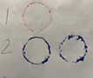
Blank page for your number printmaking:

Think of a character and make some more art
Use some water in a container and a paintbrush. Go outside onto some concrete or into a tiled or paved area. Create artworks to reflect a symbol to represent a character that is important to you. For example, an image of your pet or a favourite person. Once it has vanished, repeat with something or someone different. Repeat this again with a symbol of a journey or a trip you have been on.
Take some photos before each artwork disappears if you want to remember them.
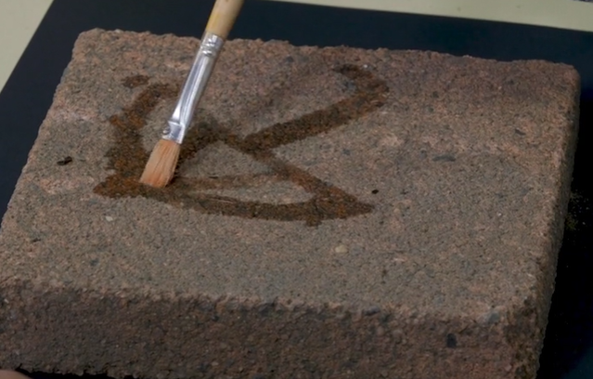
Investigate some art
Your teacher may have included an image of the Aboriginal artwork ‘Minyma Tjuta Tjukurpa’ (‘Seven Sisters Creation Story’) from the collection of the Art Gallery of NSW. It is sometimes referred to as ‘dancing across country’ and was painted by Pitjantjatjara artist Wingu Tingima in 2007.
Wingu Tingima painted this story about seven sisters travelling and then dancing in her country.
Talk like an artist
Talk about the colours, shapes and patterns used in the artwork. Describe the mood of the painting. You may notice that although there are no portraits of people it is about characters and is shown through symbols, colours and shapes.
Be an artist
Use ‘dancing across country’ as an inspiration to create a portrait of your family or friends. This may be a painting or a drawing. Think carefully about your use of colour. Use colours and shapes that express their feelings or that remind you of the place in which these people are from. Just as in ‘dancing across country’ these people may be dancing and celebrating or doing their favourite activities. Use the following blank page or some other paper or materials for your artwork.
An example might look like this or be completely different the choice is yours:
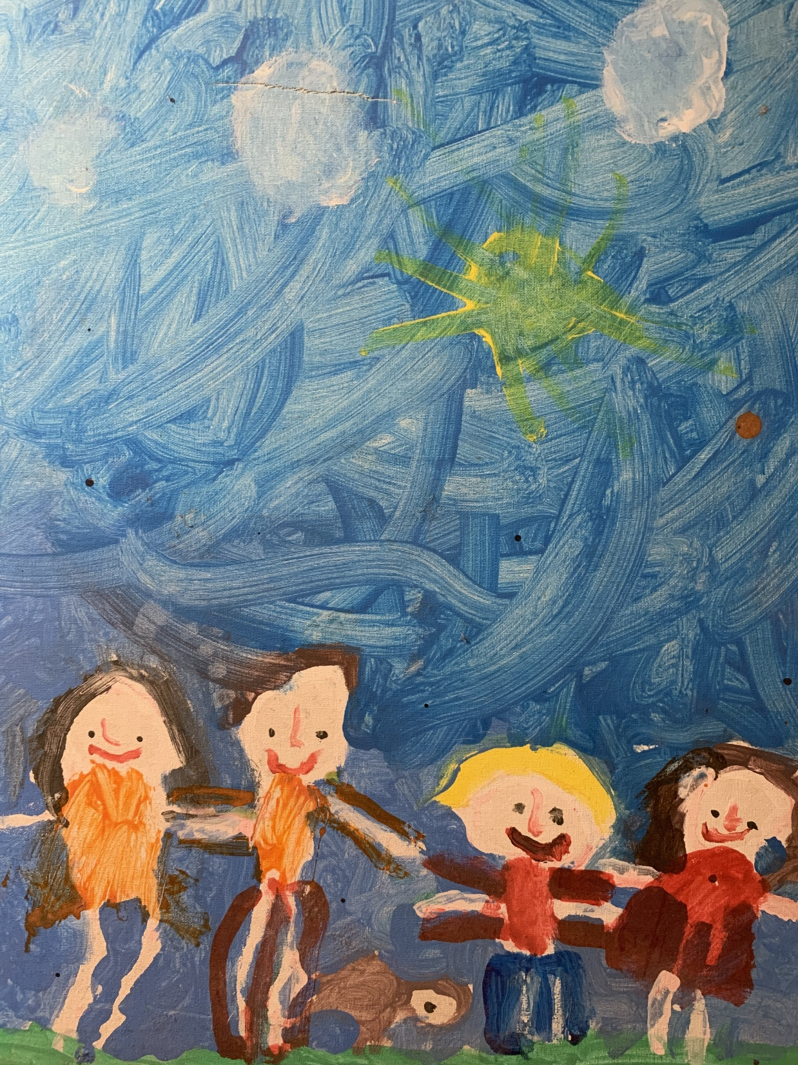
Blank page for your family or friends portrait

Write like an artist
Write a sentence or tell someone something about your artwork. This is called an artist statement! When you visit an art gallery you may see artist statements on the wall. What is it about? You may like to tell your sentence to an adult and they can help you write it down.
________________________________________________________________________
________________________________________________________________________
________________________________________________________________________

