Creative arts workbook S1
Name:
Class:

Overview
You will learn about the role of character in helping us learn more about the creative arts. Character is the way people are represented in a narrative or story. Characters can help to create meaning in songs and artworks.

Resources

Lesson 1
- A nursery rhyme you know or someone in your household knows
- The words to ‘Little Miss Muffett’ (included below)
- Paper, a thick texta and pencil

Lesson 2
- Art equipment: Paints, paper (preferably thick or cardboard and coloured), a paintbrush
- The poem ‘Metamorphosis’ (see below)
- The artwork: ‘Wanka’ (‘Spider’) by Harry Tjutjuna [This artwork is referred to with thanks to the Art Gallery of NSW. Please note that this artwork will need to be prepared for students in a non-digital environment for their student workbook and inserted below.]

Lesson 1
Character in a song
Resources
- A nursery rhyme you know or someone in your household knows
- The words to ‘Little Miss Muffett’ (included below)
- Paper, a thick texta and pencil

Warm up (sing a song)
Sing a song you know and keep the beat. If you know ‘Incy Wincy Spider’ sing that song and do the actions as well before you practise keeping the beat.

Understanding character (learn a nursery rhyme)
Who is your song about?
With someone in your household, think of another nursery rhyme. Read and mime the story. Does it tell a story or is it mainly focussed on the characters in the nursery rhyme? Who are the main characters and what do we learn about them through the nursery rhyme?
Sing or perform it together.
Move like a spider
Move around the room like a spider. Start by being a slow old spider, then a young small and very fast spider, then a jumping spider. Change the mood of the spider to grumpy or happy and so on.

Learn a new song
Learn to sing 'Little Miss Muffett’ whilst keeping the beat, using these words:
Little Miss Muffet
Sat on a tuffet,
Eating her curds and whey;
Along came a spider,
Who sat down beside her,
And frightened Miss Muffet away
You might notice that there are 3 beats in each bar in this piece because you can hear a strong, weak, weak, strong, weak, weak feel as you keep the beat.
Explore some actions using mime and movement initially to work out the lyrics and then to support the singing of the song. For example, imagine the way that you would move if you were eating your breakfast or if you saw a spider. Freeze in each pose like you are a photograph.
Experiment with the music
Try different tempos or speeds when singing the song. Start slow (‘lento’) then fast (‘allegro’) whilst keeping the beat. Then combine the two tempos with an ‘accelerando’ (getting faster) in the middle when Miss Muffett finds the spider.
How does this effect the way that we think about that character?

What does the song mean?
Discuss what the nursery rhyme is about and who is it about? Who is the main character? What do we know about them?
Little Miss Muffett was a girl named Patience, who was Dr Muffett's stepdaughter. He was an English entomologist in 16th century England. The lyrics probably tell the story of an incident when Patience ran away from her breakfast, being frightened by a spider from Dr. Muffett's collection. Discuss what an entomologist does (An entomologist studies insects).
Why are songs important?
Reflect on the role nursery rhymes and songs in general throughout history have taught us about characters. Does anyone in your household know any songs about particular characters? How does the music help to tell their story?

Follow the melody
Start by using your fingers to point or your hands to follow the melody. Draw the melodic contour (the shape of the melody) on the next page a bit like a line map. Do this while you sing the song ‘Little Miss Muffett’.
Start up high when the notes are high and make the line go low as the melody does. A bit like a zig zag that you can see in the picture below:
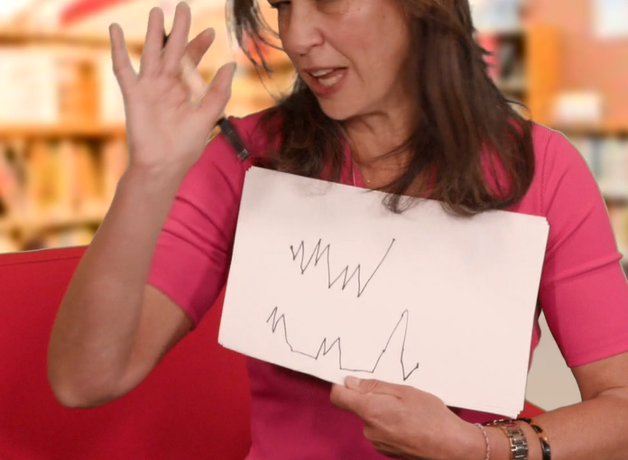

This page is blank for your melodic contour line drawing:

Create an artwork

Create an artwork based upon the melodic contour drawing that you made of ‘Little Miss Muffett’s’ melodic contour on the last page. This should be a line drawing and can be realistic or abstract (not real). It may feature a spider web or anything else it reminds you of. These examples may inspire your artworks based on the melodic contour drawings:
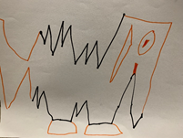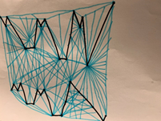

Lesson 2
During this activity you will explore character in visual artworks.
Resources
Art equipment: Paints, paper (preferably thick or cardboard and coloured), a paintbrush.
The poem ‘Metamorphosis’ (see below)
The artwork: ‘Wanka’ (‘Spider’) by Harry Tjutjuna
[This artwork is referred to with thanks to the Art Gallery of NSW. Please note that this artwork will need to be prepared for students in a non-digital environment for their student workbook and inserted below.]

Revise a song
Revise ‘Little Miss Muffett’. Sing it or say it with a household member. Keep the beat and try different tempos.
Think about bugs
What insects do you have in your house or at school? What do they do in a day? Do you think they’re disgusting or beautiful? Which ones do you like or dislike? Why do some people think of them differently?
Read and perform a poem
Read through ‘Metamorphosis’ by Jackie Hosking, illustrated by Matt Ottley.
[Copyright: The School Magazine, Orbit, Issue 10, 2019]
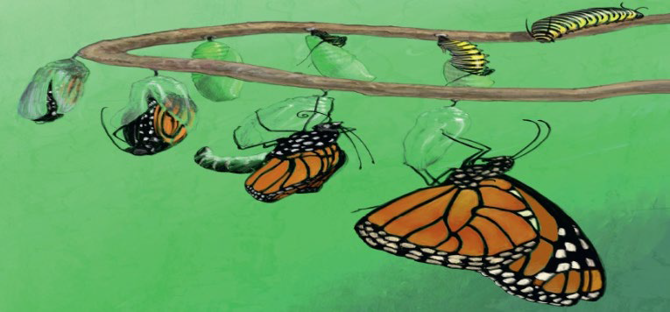
‘I wrapped myself inside myself
And gave myself a kiss
Caterpillar
Butterfly
Metamorphosis.’
Recite the poem and use movement to show the changes in the butterfly.

Do some art
Create an artwork inspired by figurative painting.
Cover some coloured paper in paint or use the next blank page. Scratch out the paint with the end of the paintbrush to represent a character either a spider or a butterfly or another creature or person in the environment.
Make sure you think about the body of a spider and identify its main body parts. This is called figurative painting. It can be of animals or people.
Remember to focus on shapes of the figure and not perfect lines here.
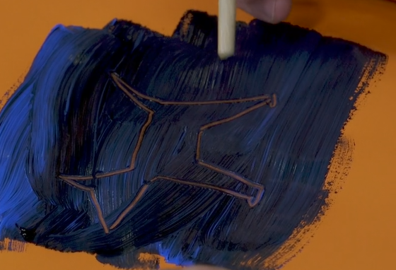
Blank page for your figurative scratch painting:

What are powerful characters?

Reflect on the character of Miss Muffett in the nursery rhyme ‘Little Miss Muffett’. Think about the power the spider has over her. She is so frightened of it she runs away. What does this tell us about her character?
Look at some art
Investigate the Aboriginal artwork ‘Wanka’ (‘Spider’) by Pitjantjatjara artist Harry Tjutjuna from the collection at the Art Gallery of NSW. Your teacher will have included the artwork for you.
Harry has painted this artwork about ‘Wati Wanka (Spider Man)’ who is a powerful and clever man. Harry is a Ngankari, a traditional healer or doctor and this is his story, a kind of self-portrait.
Talk like an artist
Can you find the spider and eggs in the artwork? What shapes, lines and colours has he used?
Think about your own art
Think of an animal or insect that you think is clever or powerful. Why do you think that? Think about some popular superheroes. What characteristics do they have?

Be an artist

Draw, paint or build your own superhero who has healing abilities. This might be the animal or insect you thought of before, or it may be a person. You can present your artwork however you would like and use whatever materials you have available. For example, you may choose to present it as a painting, a drawing, a sculpture, or through printmaking, Lego, textiles, fabrics and so on. It is up to you!

There is some blank paper included below if you want to draw it there. You may also like to include a photograph for you teacher.

Blank page for your superhero art

Write like an artist
Write a sentence or tell someone an artist intent statement. Include what your artwork is about as though it was a sign next to your work in an art gallery. You should write about your superhero character and how you made your artwork. You may like to tell your sentences to an adult, and they can help you write them down.
________________________________________________________________________
________________________________________________________________________
________________________________________________________________________
________________________________________________________________________
________________________________________________________________________

