How does character help us to learn more about art and music?
Creative arts Stage 1 learning sequence 2
Description
A focus is placed on the concept of character to help students analyse musical concepts as presented in nursery rhymes. Emphasis is placed on how character is reinforced in musical concepts beyond just an exploration of the lyrics. In visual artworks character in the form of figurative painting is explored and fictitious super-heroes form the basis of this exploration.

Syllabus outcomes and content
VAS1.1 - makes artworks in a particular way about experiences of real and imaginary things.
- investigates stories and the features of fantasy and imaginative characters derived from their experience, imaginings, artworks, cartoons, illustrated books and other books, videos/films, and video games
VAS1.2 - uses the forms to make artworks according to varying requirements.
- thinks about how they can interpret the teacher’s or others’ requirements for artmaking
- experiments with the properties of different drawing and paint media and tools

VAS1.3 - realises what artists do, who they are and what they make.
- identifies particular qualities in artworks such as the way the subject matter is represented and the use of particular techniques and the effects these have in the artist’s work and on viewers.
VAS1.4 - begins to interpret the meaning of artworks, acknowledging the roles of artist and audience.
- recognises that artists explore the world in particular ways in how they approach their artmaking and in the artworks they make.
MUS1.1 - sings, plays and moves to a range of music, demonstrating an awareness of musical concepts.
- sings songs developing a sense of beat, pitch, tone colour and structure
- moves to music maintaining a constant beat, identifying structure, identifying changes in pitch

MUS1.3 - uses symbol systems to represent sounds.
- devises symbols to represent sounds, explores simple notational systems such as graphic notation and uses them to record their work
- begins to use simple representations leading to the understanding of graphic notation.

MUS1.4 - responds to a range of music, expressing likes and dislikes and the reasons for these choices.
- identifies simple musical features of the music that is performed and listened to, eg the tempo, pitch, structure, dynamics, tone colour.

DRAS1.2 - conveys story, depicts events and expresses feelings by using the elements of drama and the expressive skills of movement and voice.
- creates and adapts stories for enactment
Creative Arts K-6 © (2006) NSW Education Standards Authority (NESA) for and on behalf of the Crown in right of the State of New South Wales.

Lesson 1 – musical characters
Students are learning to:
Explore and understand a variety of musical concepts through nursery rhymes.
Sing a variety of musical compositions with both lyrics and without to discover the music concepts that composers and performers use.
Identify the role of character in the creative arts to evoke meaning for an audience.
Item | Learning experience | Differentiation strategies and/or adjustments | Resources
1.1 | Start with a warm-up song such as some familiar nursery rhymes. Select a nursery rhyme from this list or others as known: ‘Baa, Baa, Black Sheep’, ‘Itsy Bitsy Spider’, ‘Little Miss Muffett’, ‘Humpty Dumpty’. Read the nursery rhyme and mime the actions on the spot (non-locomotor).  Sing the song ‘Insy Winsy (Bitsy) Spider’. Start by doing the finger play then change this to movement. Move around the room like a spider. Start by being a slow old spider, then a young small and very fast spider, then a jumping spider. Change the mood of the spider to grumpy or happy and so on.  Learn to sing ‘Little Miss Muffett’. Keep the beat on knees using spider fingers. Move this to one accent slapping knees and then gentle spider touches on the remaining 2 pulses in each beat (strong, weak, weak, strong, weak, weak).  Experiment with different tempos accompanying this song. Slow (‘lento’) then fast (‘allegro’) whilst keeping the beat. Then combine the two tempos with an ‘accelerando’ (getting faster) in the middle when Miss Muffett finds the spider. Highlight how music can explore a character and changing musical concepts (such as changing the tempo) can effect the way that we think about that character.  Move hands up and down to indicate the direction of the pitch contour (the melody). Identify the patterns, steps and jumps in the pitch. Highlight that the melodic contour has many patterns, steps and leaps.  Discuss rhyming words. What are they? What rhyming words are used in ‘Little Miss Muffett’? Identify and explain any unfamiliar words within the nursery rhyme.  Discuss what the nursery rhyme is about. Researching nursery rhymes often shows very complex and unexpected stories. Who is it about? Who is the main character? What do we know about them?  Most research indicates that Little Miss Muffett was a girl named Patience, who was Dr Muffett's stepdaughter. He was an English entomologist in 16th century England. The lyrics probably tell the story of an incident when Patience ran away from her breakfast, being frightened by a spider from Dr. Muffett's collection. Discuss what an entomologist does.  Reflect on the role nursery rhymes and songs in general throughout history have taught us about character. Think of songs about different characters and what role musical concepts have in reinforcing this. For example, how would our perception of Queen Elizabeth II change if ‘God Save the Queen’ became a rap piece? | Pause and replay the video. Watch and participate with your child.  Try some of the songs and activities within the film with other nursery rhymes or songs that are known.  Play instruments along with the songs in the video.  Explore different songs with rhyming words or even consider changing the lyrics of ‘Little Miss Muffett’ to reflect different objects and rhyming words. This may include a new character in place of Miss Muffett. | Student workbook  Nursery rhymes:  ‘Baa, Baa, Black Sheep’  ‘Itsy Bitsy Spider’  ‘Little Miss Muffett’  ‘Humpty Dumpty’  Song recording:  ‘Insy Winsy (Bitsy) Spider’  ‘Little Miss Muffett’
1.2 | Watch the lesson footage of ‘Little Miss Muffett’ especially designed for students from Early Stage 1 and Stage 1 in NSW and participate in the activities in the video. Discuss what has been learnt.  Create the melodic contour line map with assistance of the footage then practise humming ‘Little Miss Muffett’. Reflect on the quote by Paul Klee that ‘A line is a dot that went for a walk’ and discuss what this line map looks like.  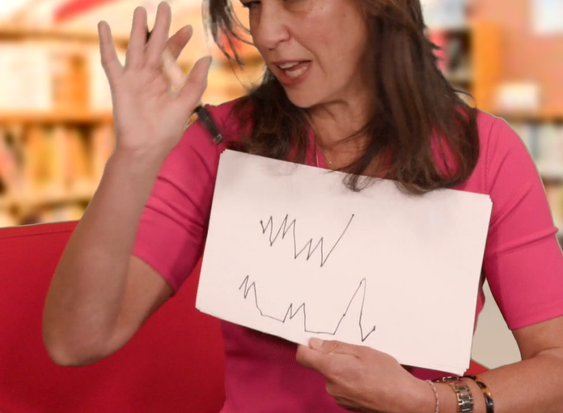  Create an artwork based upon the melodic contour drawing that was made during the video. This should be a line drawing and can be realistic or abstract. It may feature a spider web or anything else it reminds the students of. These examples may inspire the artworks:  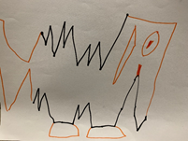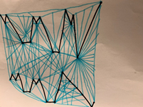 | If unable to view the lesson footage reinforce the previously learnt musical concepts and materials relating to this nursery rhyme.  Create a line graph to reflect the melodic contour of ‘Little Miss Muffett’ as shown for the students to follow. | Student workbook  Lesson footage of ‘Little Miss Muffett’  Art supplies:  Paper and a texta or pencils
1.3 | Opportunity for monitoring student learning  Melodic contour mapping – Teacher observation or collection of student work  Students listen to then sing ‘Little Miss Muffett’ and represent the melodic contour using their hands to follow the flow of the melody or draw a line map as a form of graphic notation to represent the pitch.  What to look for:  - Is the student able to identify or discuss the features of the melody in the musical composition?  - Does the student accurately move up and down according to the pitch contour or direction of the notes in the melody?  - Is the student able to represent the melody through lines moving up and down according to the direction of the pitch? |  | Student workbook  Artwork presented as appropriate.

Lesson 2 – strength of character in visual artworks
Students are learning to:
- Reflect on character and meaning within their own and others’ artworks
- Explore the use of symbols, line, shapes and colours in artworks
- Create artworks for different purposes to reinforce their perception of character
Item | Learning experience | Differentiation strategies and/or adjustments | Resources
2.1 | Revise ‘Little Miss Muffett’. Sing it or say it with a household member or peer. Ask the students to reflect on what insects they have in their house or at school. What do they do in a day? This might be considered disgusting by some such as a fly or it could be considered beautiful by others like a butterfly. Why do we perceive them differently?  Reflect on the poem ‘Metamorphosis’ by Jackie Hosking, illustrated by Matt Ottley. Does this change our perception of butterflies? Recite the poem and use movement to reflect the meaning of the words.  [Copyright: The School Magazine, Orbit, Issue 10, 2019]  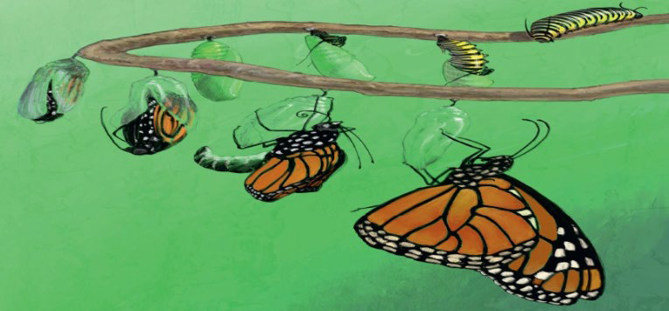  Use this video to help you create an artwork inspired by figurative painting through covering some coloured paper in paint and scratching out the paint to represent a character either a spider or a butterfly or another creature or person in the environment.  Scratch out a spider or butterfly on your painted page with the reverse end of the paintbrush. Make sure you think about the body of a spider and identify its main body parts. Figurative painting can be of animals or people. Remember to focus on shapes of the figure and not perfect lines for this technique.  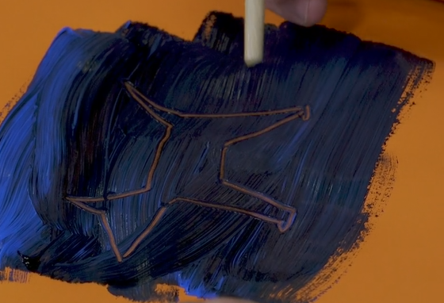 | Act out and move to reflect the life cycle of a butterfly and other animals or insects.  Draw a picture of a spider instead of scratching it out.  Scratch out the entire scene of ‘Little Miss Muffett’ including all characters. Include Dr Muffett (her stepfather) in the scene as well if desired.  Create other figurative painting artwork using this scratching technique as shown in the video provided.  Consider other animals such as the demonstrated dog in your artwork. Look at some of the artwork of Reg Mombassa for inspiration. | Student workbook  Film footage of figurative painting  Art supplies:  Paints, paper (preferably thick or cardboard and coloured), paintbrush  ‘Metamorphosis’ poem by Jackie Hosking.  [Copyright: The School Magazine, Orbit, Issue 10, 2019]  ‘I wrapped myself inside myself  And gave myself a kiss  Caterpillar  Butterfly  Metamorphosis.’
2.2 | Reflect on the character of Miss Muffett in the nursery rhyme ‘Little Miss Muffett’. Discuss the power the spider has over her. She is so frightened of it she runs away. What does this tell us about her character in this song?  Investigate the Aboriginal artwork ‘Wanka’ (‘Spider’) by Pitjantjatjara artist Harry Tjutjuna from the collection at the Art Gallery of NSW. He is now a renowned artist from Australia’s Southern desert region. He has painted this artwork about ‘Wati Wanka (Spider Man)’ who is a powerful and clever man. Harry is a Ngankari, a traditional healer or doctor and this is his story, a kind of self-portrait.  Find the spider and eggs in the artwork. Identify and discuss the colours, shapes and lines, particularly around the spider’s legs. Think of another animal or insect that could be perceived as clever and powerful. This will very amongst individual students. What effect do they have on the student and why?  Discuss popular superheroes and their characteristics. Draw, paint or build own superheroes who have healing abilities using either the animal or insect identified earlier or a person. The presentation of this can be however the students would like and use whatever materials they have available. For example, students may choose to present it as a painting, a drawing, a sculpture, through printmaking or textiles and fabrics and so on.  The artwork must include an artist intent statement to indicate what it is about. This statement must include information about the character that has been created and details about how the work was created. | Ensure students have access to the artwork described.  Reflect on popular superheroes including those in comics. Describe and draw these.  Consider a variety of materials and artmaking processes as appropriate for students. | Student workbook  Artwork:  ‘Wanka’ (‘Spider’) by Harry Tjutjuna  This artwork is referred to with thanks to the Art Gallery of NSW. Please note that this artwork with need to be prepared for students in a non-digital environment for their student workbook.
2.3 | Opportunity for monitoring student learning  Super character art – Presentation  Students draw, paint or build their own superhero who has healing abilities. The presentation of this can be however the students would like and use whatever materials they have available. For example. Students may choose to present it as a painting, a drawing, a sculpture, through printmaking or textiles and fabrics and so on.  The artwork must include an artist intent statement to indicate what it is about. This statement must include information about the character that has been created and details about how the work was created.  What to look for:  - reflect on character and meaning within their own and others’ artworks  - use symbols, line, shapes and colours in artworks to enhance meaning  - create artworks for different purposes and to reflect different characters and emotions |  | Student workbook  Art supplies:  As individually selected

Reflection and evaluation
These simple questions may help you reflect on your students’ learning and plan for next steps.
What worked well and why?
What didn’t work and why?
What might I do differently next time?
What are the next steps for student learning based on the evidence gathered?

