Connotation, imagery and symbol in the arts
Creative arts Stage 1 learning sequence
In Lesson 1 students explore the symbolic role of images in communicating understandings about Australian and global environments and cultures. In Lesson 2 they investigate selected visual artworks and musical compositions to examine the imagery and hidden meanings within. Students will then identify and interpret these hidden meanings across the creative arts, particularly through connecting music and visual arts.

Syllabus outcomes and content
VAS1.1 - makes artworks in a particular way about experiences of real and imaginary things.
- investigates details of objects, places and spaces and other living things
- talks about significant features and relationships within their artworks, referring to such things as size, scale, proportion, colour.
VAS1.2 - uses the forms to make artworks according to varying requirements.
- thinks about how they can interpret the teacher’s or others’ requirements for artmaking
- experiments with the properties of different drawing and paint media and tools
VAS1.3 - realises what artists do, who they are and what they make.
- identifies particular qualities in artworks such as the way the subject matter is represented and the use of particular techniques and the effects these have in the artist’s work and on viewers.
VAS1.4 - begins to interpret the meaning of artworks, acknowledging the roles of artist and audience.
- recognises that artists explore the world in particular ways in how they approach their artmaking and in the artworks they make.
MUS1.1 - sings, plays and moves to a range of music, demonstrating an awareness of musical concepts.
- moves to music maintaining a constant beat, identifying structure, identifying changes in pitch
MUS1.2 Explores, creates, selects and organises sound in simple structures.
- explores ways of making different sounds on instruments or sound sources
- creates simple musical compositions, with a sense of spontaneity, that are variations on known material and material that is new.
MUS1.4 - responds to a range of music, expressing likes and dislikes and the reasons for these choices.
- identifies simple musical features of the music that is performed and listened to, eg the tempo, pitch, structure, dynamics, tone colour.
Creative Arts K-6 © (2006) NSW Education Standards Authority (NESA) for and on behalf of the Crown in right of the State of New South Wales.
Lesson 1 – How do artists help us to understand their works through images and hidden meanings?
Students are learning to:
- explore the use of symbols within artworks to communicate meaning and expression of self
- think about different techniques and forms that artists use to tell their story and share their thoughts
- make and explain their own use of symbols in artworks
- create artworks for different purposes.

Item | Learning experience | Differentiation strategies and/or adjustments | Resources
1.1 | Begin with a discussion of Aboriginal culture in Australia and the importance of reflecting on the original owners of the land in your community. Highlight that Aboriginal peoples have looked after this land for a long time and we all have the responsibility to continue this practice.  Use this video as a guide to the process of a form of symbolic abstract painting (which was also used in the previous learning sequence). Go outside to a special place within your school or local environment. Where possible take a plastic surface, some cardboard, a paver or alternatively find a concrete, tiled or paved area. Take some water in a container and a paintbrush for each student.  Ask the students to look around at their immediate environment in silence. Ask them to identify something that they perceive as important about their environment – either natural or man-made.  Ask the students to create artworks to reflect a symbol of something in this environment that is important to them. Once it has vanished, repeat with another symbolic image. Discuss that artworks don’t always need to be permanent but that they do represent a meaning to the artist, and when permanent can be used to keep that meaning for audiences to consider.  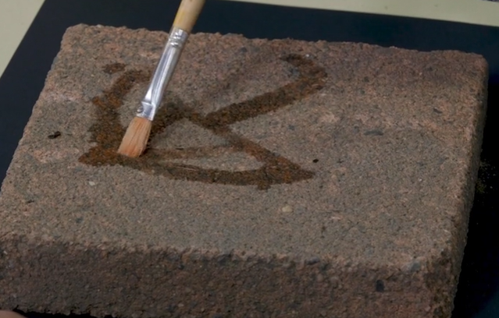  Explore this further by examining the work ‘Centrepoint Tower’ by Aboriginal artist Esme Timbery from the collection at the Art Gallery of NSW. Timbery is a Bidjigal artist whose family were shell workers from the Aboriginal mission community of La Perouse in Sydney. La Perouse women artists have been working with and earning an income from shell work for generations, with one of the earliest reports from the late 1800s.  Ask the students to look at this work and think about how this work was created and what it symbolises. Discuss the meaning of the shells as traditional materials and a technique used by the artist and to think about why they would be placed on a man-made structure like Centrepoint Tower. Consider the meaning of the work in terms of a mixture of traditional methods, natural and man-made and the importance of Aboriginal culture.  Students should then think again about their environment and consider an item that symbolises Australia to them. Emphasise that they should not take from nature such as shells from the beach permanently – it must be returned once the work is complete.  The students should then create a symbolic sculpture artwork and photograph it. For example, this may include leaves, shells or flowers and may also include cultural aspects of symbolic importance to their community to represent an aspect of their Australia. In the example below, a sculpture was created about a classic Australian symbol, the gum leaf. This footage of the process of creating a symbolic sculpture may be used to support this process.  In this example paper clay was used. This can either be purchased or handmade. Airdry clay is also a good alternative which can be easily handmade. In the absence of either alternative, using playdough, dough or blutak without painting is a viable option. The planning and making process is the most important component.  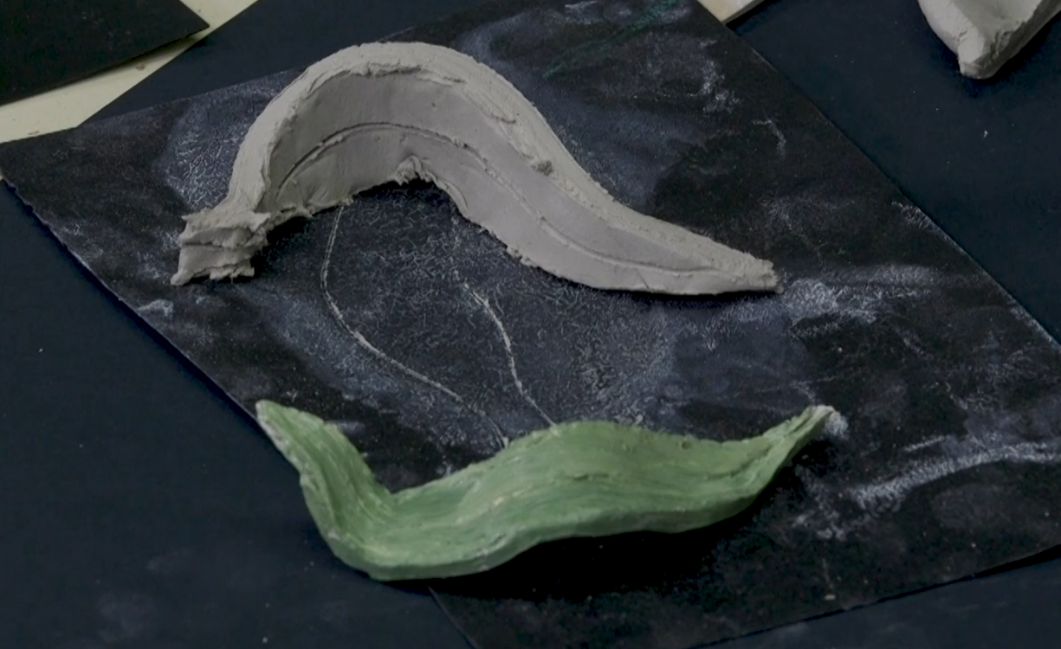 | Where equipment is unavailable, draw symbolic images on paper or in the air.  If sculpting equipment is unavailable for symbolic sculptures, consider other alternatives such as drawing or painting.  Consider creating sculptures inspired by Timbery’s work. | Student workbook including image of ‘Centrepoint Tower’ by Esme Timbery  Demonstration video:  Process of a form of symbolic abstract painting  Paintbrush  Container of water  Paver, plastic lid or cardboard  Demonstration video:  Process of creating a symbolic sculpture  Paper clay, airdrying clay, playdough, dough or blutak  Paints of different colours
1.2 | Discuss with the students how artists represent ideas and meanings of their world through their works. Link this directly to the work they previously did in exploring their own symbolic works. Point out that artists have been doing this throughout history. Identify some works that exemplify this by exploring and discussing some of the following works. This is a curated and small sample of what is available. Many of these artworks have been re-released from the archive sets from the Art Gallery of NSW:  Bailed up – Tom Roberts (includes ‘kids tour’ audio file) - Australia’s rugged bush, heat and bushrangers.  Fire’s on – Arthur Streeton – Australia's heat and sunlight.  Tram kaleidoscope – Frank Hinder – modernist Sydney transportation  Compare Keswick Siding with Bus terminus – both by Jeffrey Smart - two unified but different images of suburban landscapes and transportation  The camp - Sidney Nolan - imagery and implied meaning around the division of this artwork.  Swimming before school - Ian Abdulla – Aboriginal people’s sense of community on the fringe of farmed land.  The doors - Edouard Vuillard – mysterious meaning of this room and the corner character. What mood is implied?  Nine elements - Joe Tilson – connection between words, images and symbols.  Drinka Pinta Milka – Derek Boshier – links milk, chocolate and symbolically suggests drowning in advertising.  Ask the students to complete the table included in their workbooks to indicate their understanding and interpretation of the meaning of the selected works. This table is also included below with some sample answers. Remove any works you do not wish to use and supply the students with any answers you think will guide them. | There are multiple alternatives of artwork with imagery and symbolism. Explore others if desired.  If written tasks are not ideal, discuss artworks rather than completing written tasks. | Student workbooks with some of the images below included where possible (you will need to include these yourself):  Bailed up – Tom Roberts  Fire’s on – Arthur Streeton  Tram kaleidoscope – Frank Hinder  Compare Keswick Siding with Bus terminus’– both by Jeffrey Smart  The camp - Sidney Nolan  Swimming before school - Ian Abdulla  The doors - Edouard Vuillard  Nine elements - Joe Tilson  Drinka Pinta Milka – Derek Boshie
1.3 | Opportunity for monitoring student learning  Student created temporary symbolic art - teacher observation or student work sample  Students draw a symbol of something important to them about their environment using water, a paver or equivalent and a paintbrush.  What to look for:  - Is the student able to represent an aspect of their surroundings through a symbol?  - Is the student able to discuss the meaning of their work?  - Was the student able to engage in this technique and able to accept its temporary nature?  Student art appreciation activity – collection of student work  Students complete some aspects of a table to gain their understanding of the way artists can make meaning through their works.  What to look for:  - Is the student able to identify or discuss the features of an artwork?  - Does the student accurately identify techniques used by the artist to create meaning?  - Is the student able to explain what the artist is trying to represent through their artwork? |  | Student workbook  Artwork presented as appropriate.

Lesson 2 – How have the arts helped us make meaning of the things we see and hear?
Students are learning to:
- identify the ways in which artists make us think differently about things we think are ordinary in our society
- identify the role of the ways in which artists connote meaning for an audience
- techniques that artists use to stimulate our interest and thought
- explore and understand a variety of musical concepts through listening to and participating in music
- identify the ways in which the arts such as nursery rhymes have helped us make meaning of our culture throughout history.

Item | Learning experience | Differentiation strategies and/or adjustments | Resources
2.1 | Composers often use music to tell a story. There are several ways that this can be done either through words or through the way the instruments sound (their ‘tone colour’) and the music they play. Listen to each piece (or a section of it) and complete some aspects of the table below which is also in the student workbook. Remove or add to the table for the pieces you listen to.  Start by listening to ‘My Island Home’ by the Aboriginal Warumpi Band. What is the meaning the singer is trying to portray through his song? Listen to the introduction with the watery sounds and the folk style instruments throughout. These connote a deep connection to Country. Identify the different feel around 02:40 when the tempo speeds up and the music sounds much brighter and the dynamics get louder as the singer implies he is getting home (portraying happiness).  Heinrich Biber made the violin sound like animals in his ‘Sonata Representativa’, composed in 1669. Listen and compare the violin imitations with the real animal sounds. How does the composer make the instruments sound like each animal?  00:00 Introduction  01:11 Nightingale  02:14 Cuckoo  02:54 Frogs  04:16 Chicken, Rooster  04:54 Quail  05:54 Cat  Explore the ‘Flight of the Bumblebee’ which is a piece for orchestra by Rimsky-Korsakov. Ask the students to move around the beat with the tempo, following their own path just like a bee. Discuss with the students how it sounds just like a bee flying. Explain that the composer has achieved this meaning through increasing in speed (or tempo).  Listen to a sample of Australian composer James Ledger’s ‘Indian Pacific’. This piece sounds like the journey of this famous Australian iconic train across the country. Identify through moving to the beat and then discuss how Ledger has achieved this through repetitive rhythms that sound just like a train driving (pushing) along a track with a countryside view out the window.  There are many other examples of this type of music (called programme music). Listen to the familiar ‘Spring’ from the ‘Four Seasons’ by Vivaldi. In this movement (or section) there are three specific aspects of spring that the composer is attempting to ‘picture’. Play the following excerpts and ask the students what they think Vivaldi was trying to imitate:  00:32-01:05 birds  01:12-01:27 a running stream  01:42-02:07 a thunderstorm.  Ask the students to think of one sound in their environment that is of interest to them and which instrument or available item they could use to imitate that sound. For example, a whistle for a bird, a glass like the wind, hitting something strongly with their hands like a storm, a paint brush on a table like sand or water, a book slamming like thunder, tissue coming out of a box like brushing your hair, clicking a ring pull like a frog and so on.  Ask the students to either play, record or write about (in their student workbooks) the sound they have chosen and what it represents.  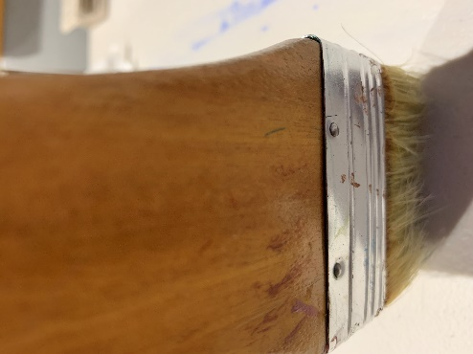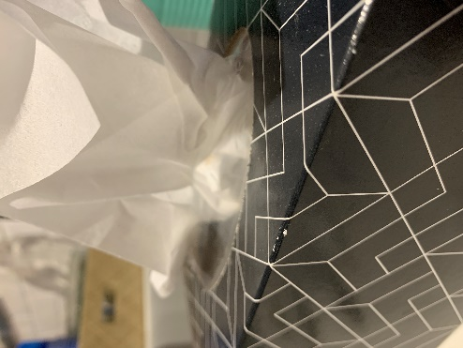 | Substitute other pieces or songs as known.  Discuss rather than write responses.  Compose an entire piece such as a soundscape using the sound samples created. Put them together as a class composition or individually. | Student workbooks  Audio samples:  ‘My Island Home’ by the Aboriginal Warumpi Band.  Biber’s ‘Sonata Representativa’  Comparison animal sounds:  Nightingale  Cuckoo  Frogs  Chicken, Rooster  Quail  Cat  James Ledger’s ‘Indian Pacific’  ‘My Island Home’ by the Aboriginal Warumpi Band.  Vivaldi’s ‘Spring’ from the ‘Four Seasons’  Rimsky-Korakov's ‘Flight of the Bumblebee’  A variety of items or instruments (if available)
2.2 | Point out to the students that often artworks are inspired by pieces of music. Sometimes musicians get meaning from artworks and other times artists construct works based upon what they hear in a composition. This can be a way that both artists and musicians imply meaning through their works.  Discuss with the students one such example of this in ‘Broadway Boogie-Woogie’ by Piet Mondrian. Explain how this work is an image of the New York city grid pattern. It was inspired by a jazz style of the day called boogie woogie music. One such example is Tommy Dorsey’s ‘Boogie Woogie.’ Ask the students to listen to the work and identify key features of the music that can be identified in Mondrian’s work. For example, the bright lights (cars) in the pattern, the repetition of the grid (like the traffic and the grid of New York city) and the large shapes (car horns) are just like the trumpet bursts and the repetitive rhythms of the music.  Listen to a section of Beethoven’s ‘Symphony Number 6’ (‘Pastorale’). Focus particularly on Movement 2 which evokes a running brook. Discuss the musical features which imply this. For examples, repetitive and lilting rhythms, soft dynamics (piano) and a gentle mood and instrumental tone colours such as the flute to imply birds and so on.  Play the music again and ask the students to paint or draw a picture which evokes the meaning of the music. They should consider which colours to use, such as pastels and water colours.  The students should carefully consider the appropriate content such as a countryside, a stream, birds, trees and so on. Decide as a class whether to sketch first and paint later. Make part of the process about appropriate methods for setting up, behaving appropriately and cleaning when painting.  It is also important to discuss and determine the success criteria. For example, artistic techniques and forms, use of landscape view, colours and so on. Does the work convey the ‘sound’ of Beethoven’s work and the implied meaning, including the gentility of a stream in the countryside?  After the completion of this artwork, the students should discuss their work and describe the features of the work to either the teacher or peers.  As a conclusion to this unit, the students should complete an exit slip a sample of which is included at the end of this document and in the student workbook. | Substitute Beethoven’s ‘Symphony No. 6’ for another preferred piece.  Draw the country scene rather than painting it.  Create artworks for other movements in Beethoven’s work. | Student workbook including a copy of the image of ‘Broadway Boogie-Woogie’ by Piet Mondrian  Audio sample of Tommy Dorsey’s ‘Boogie Woogie’  Audio sample of Beethoven’s ‘Symphony Number 6’ (‘Pastorale’) focusing particularly on Movement 2  Art paper and paintbrushes of a variety of tip sizes  Watercolour paints, pencils or paints in pastel colours
2.3 | Opportunity for monitoring student learning  Beethoven inspired artwork– presentation  Students paint or draw a picture which evokes the meaning of the music of the 2nd movement of Beethoven’s ‘Symphony No. 6’ (‘Pastorale’). They should consider which colours to use, such as pastels and water colours. The students should carefully consider the appropriate content such as a countryside, a stream, birds, trees and so on.  What to look for:  - use symbols, line, shapes and colours in artworks to enhance meaning  - use of landscape view and other appropriate artistic techniques such as pastel colours  - inclusion of a stream and other symbols implying a country scene  - student describes the features of their work and the implied meaning as evoked from Beethoven’s work  - create artworks that revoke appropriate gentle mood and feel for the scene. |  | Student workbook  Artworks completed by students

Reflection and evaluation
These simple questions may help you reflect on your students’ learning and plan for next steps.
What worked well and why?
What didn’t work and why?
What might I do differently next time?
What are the next steps for student learning based on the evidence gathered?

Table for discussing and answering questions about artworks as indicated in Lesson 1.2:

Artwork title and artist | What is its hidden meaning about culture or country? | How does it tell us that?
‘Bailed up’ – Tom Roberts | Australia’s rugged bush, heat and bushrangers. | The use of colours and images.
‘Fire’s on’ – Arthur Streeton | Australia’s heat and bright sun. | The use of colours, images and implied textures.
‘Tram kaleidoscope’ – Frank Hinder | Modern Sydney city transportation. | The use of shapes, compact forms, cubist shapes, lines, repetition and pattern.
‘Keswick Siding’ with ‘Bus terminus’ – Jeffrey Smart | Two unified but different images of suburban landscapes and transportation. | The use of the same shapes and lines yet different colours and subject matter.
‘The camp’ - Sidney Nolan | Contrasting calm of police before the arrival of the bushranger. | The use of a dividing line between the two scenes with different colours and moods.
‘Swimming before school’ - Ian Abdulla | Aboriginal people’s sense of community on the fringe of farmed land. | The selection of people, water and the carefully shaped land.
‘The doors’ - Edouard Vuillard | Character in the corner, hidden. | The use of muted tones and the use of space, with dominance of the room but not the character.
‘Nine elements’ - Joe Tilson | Each image has a symbol to represent something. | The symbol represents something and is very bold and enlarged.
‘Drinka Pinta Milka’ – Derek Boshier | Links milk, chocolate and symbolically suggests drowning in advertising | The choice of colour pouring down with the line of people and pops of colour leading the eye.

Table for guiding discussion and answers to Lesson 2.1 as above.

Title of piece and composer | Musical concepts used and what do they mean?
‘My Island Home’ by the Warumpi Band. | Introduction with the watery sounds and the folk style instruments throughout. These connote a deep connection to Country.  Identify the different feel around 02:40 as the singer implies he is getting home (portraying happiness).  Tempo speeds up, the music sounds much brighter and the dynamics get louder like a home arrival.
‘Sonata Representativa’ by Heinrich Biber | Violin tone colour and sounds are like animals he is portraying.
‘Flight of the Bumblebee’ by Sergei Rachmaninoff. | Violin is high and shrill which sounds just like a bee flying.  Increasing speed (or tempo) as the bees flight gets faster.
‘Indian Pacific’ by James Ledger | Repetitive rhythms sound just like a train driving (pushing) along a track with countryside view out the window.
‘Spring’ from the ‘Four Seasons’ by Antonio Vivaldi. | Instrumental tone colours sound like aspects of spring.  Dynamics get louder to connote a storm.  High pitches like birds and so on.

Sample exit slip
Student name: ____________________________________________________ Date: _____________________________________

One thing I now know better about the way artists share meaning through their artworks _____________________________________

____________________________________________________________________________________________________________

____________________________________________________________________________________________________________

One thing I am still puzzled about _________________________________________________________________________________

____________________________________________________________________________________________________________

____________________________________________________________________________________________________________

