Creative arts – learning sequence

Resource considerations
This lesson sequence allows for continuity of student learning and could be adapted to fit in with your existing teaching and learning program. Students will be supported to meet outcomes from a Key Learning Area. Each task has a duration of 30 minutes and could be used in conjunction with your framework, designed using the K-6 template. This lesson sequence uses a balance of synchronous and asynchronous learning strategies. The tasks provide options for students with and without technology. They can be used with any online platform. Suggestions about how your school will plan students’ learning from home and ways to communicate with students can be found through the Learning at home, school planning page. Assessment strategies are included to ensure evidence of learning is monitored and collected.

Stage 1 learning sequence
Outcomes
VAS1.1 Makes artworks in a particular way about experiences of real and imaginary things.
VAS1.4 Begins to interpret the meaning of artworks, acknowledging the roles of artist and audience.
MUS1.1 Sings, plays and moves to a range of music, demonstrating an awareness of musical concepts.
MUS1.4 Responds to a range of music, expressing likes and dislikes and the reasons for these choices.
DRAS1.1 Takes on roles in drama to explore familiar and imagined situations.
DRAS1.2 Conveys story, depicts events and expresses feelings by using the elements of drama and the expressive skills of movement and voice.
DAS1.2 Explores and selects movement using the elements of dance to express ideas, feelings or moods.
Learning sequence overview – students explore the role of narrative in the creative arts to evoke meaning in artworks in visual arts, dance and drama.
Key concepts – narrative, perspective, point of view, character, artists, audiences, artworks
Key language – narrative, tempo, dynamics, colour, line, perspective, tone colour (timbre), instruments, role-play, mime, composition, artist intent, interpretation, textiles
Key inquiry question – How does artist intent change the narrative of an artwork for an audience?
Aim of lesson sequence
- Students will learn about the role of narrative in the creative arts to create meaning for an audience.
- A variety of musical compositions with both lyrics and without will be explored to discover the techniques that composers and performers use to enhance the meaning of a narrative.
- Techniques used in artwork to evoke a narrative will be explored.
- Role-play and mime combined with locomotor and non-locomotor movement are used to develop understanding of narrative in nursery rhymes.
- Students will create their own artworks to demonstrate their understanding of a musical composition’s intention and the ways in which meaning can vary between audience members.
Teacher notes
- Narrative in the creative arts and English are interconnected. The links between them will enhance understanding of the concept of narrative in both Key Learning Areas.
- Students should be provided with the opportunity to engage in interpreting narrative through available compositions in music, literary works and visual artworks.
- Encourage the students to continue to develop their knowledge and skills of each artform using appropriate language and techniques in the relevant artform such as tempo, dynamics, mime, movement, expression, line and colour.
- Students should interpret narrative through creating their own artworks in response to a musical stimulus. These should be accompanied by student written artist intent statements to assist in creating meaning for their audience.

Activities
Narrative in song
  - Digital: Learn to sing the song ‘Issunboshi' from Vocal Ease MORE (Module 1). Use this animated score as a guide. Pause and play to assist you to learn the song. The lyrics are also included at the end of this document. Practice keeping the beat with the animated score and following the moving score.
What features of the music let you know that it is Japanese? (the instruments and the overall sound). How does this reinforce the meaning of the narrative? Use these instrument guides to explore the instrumental tone colours (timbres) of the Japanese instruments the Koto, Shamisen and the Shakuhachi. Think of three adjectives to describe the sound of each of the instruments below. Write these down and add to the class online digital platform.
Koto:
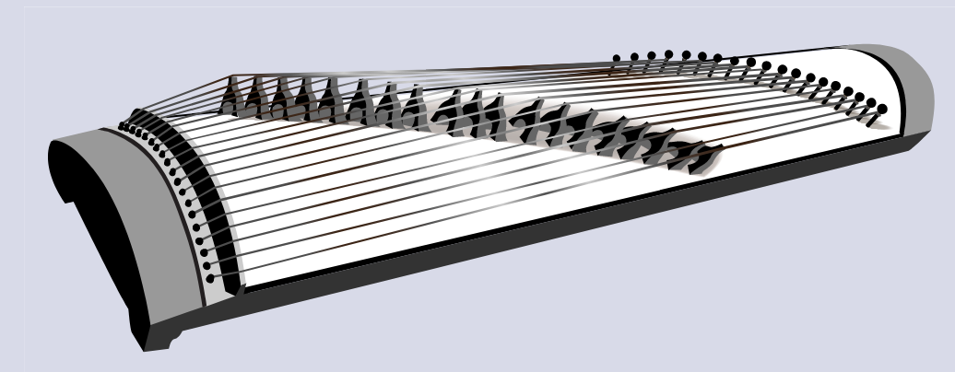
Shamisen:
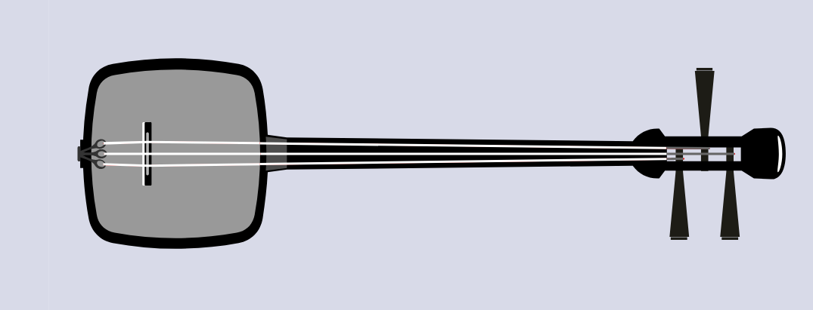
Shakuhachi
The piece is also based on the E pentatonic scale. This scale is typically found in traditional Japanese music. If appropriate and depending upon availability, students could play this scale. Alternatively they could listen to scale and follow along the notes:
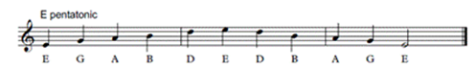

Read through the story of ‘Issunboshi’ (‘The Inch Boy’) by Junko Murimoto. What is happening in the story? What other texts or narratives do we know that have similar stories to ‘Issunboshi’ (such as ‘Thumbelina’)? Reflect on these stories and the similarities of narrative.
Discuss other songs which tell a story. Family members, caregivers and friends may be aware of songs that they know which tell a story or create a narrative. What role does the music have in supporting this narrative? Add these songs to a list in the class digital platform. Also include a sentence to describe how the music helps to tell the story. Add access information to the digital student resource.
b. Non-digital: Practice singing a song learnt in class or that is known to students and their family or friends. For example, the students may choose to sing ‘Mr Clicketty Cane’, ‘Everything is Awesome’ or ‘The Duck Song’, keeping the beat whilst singing the song.
Learn the nursery rhyme ‘Sing a Song of Sixpence’ or any alternative that is potentially more familiar. It also has a melody which students or their families may be aware of:
Sing a song of sixpence a pocket full of rye,
Four and twenty blackbirds baked in a pie,
When the pie was opened the birds began to sing,
Oh wasn't that a dainty dish to set before the king?
The king was in his counting house counting out his money,
The queen was in the parlour eating bread and honey,
The maid was in the garden hanging out the clothes,
When down came a blackbird and pecked off her nose!

What is happening in the story of the nursery rhyme? With household members, role-play the story of the nursery rhyme.
In a nursery rhyme such as ‘Sing a Song of Sixpence’ the conclusion of the story in the nursery rhyme is not pleasant. Does the music reflect this event (no)? Why would this have been done? How do we know? What could the composer have done to reinforce the meaning of the narrative? Explore musical concepts such as changing the dynamics (volume) or changing the pitch (perhaps making it descend at the end) or tempo (slowing it down to reinforce the meaning in parts). These concepts will relate to both sung or spoken versions of the rhyme. Write a response in the student workbook.
Are there other texts that have been read that reflect a story? For example, another nursery rhyme such as ‘Humpty Dumpty’. Discuss other songs which tell a story. Family members, caregivers and friends may be aware of songs that they know that tell a story or create a narrative. What role does the music have in supporting this narrative?
Add these songs to a list in the student workbook. Also include a sentence to describe how the music does or does not assist to tell the story.
- Narrative in drama and dance
  - Digital: Select a nursery rhyme from this list or others as known – :
‘Baa, Baa, Black Sheep’
‘Itsy Bitsy Spider’
‘Little Bo Peep’
‘Star Light, Star Bright’
‘Old Mother Hubbard’
‘Little Miss Muffet’
‘Humpty Dumpty’
‘Rock-a-bye Baby’
‘A Sailor Went to Sea Sea Sea’
‘Hey Diddle Diddle’
‘Here We Go Round the Mulberry Bush’
Working with a household member or alone, read the nursery rhyme and mime the actions on the spot (non-locomotor). What is the rhyme about? Does it make sense? Does it tell a story? Write responses in the class digital platform including the name of the rhyme and what it is about.
Repeat reading the rhyme and then have the students begin by making themselves as small as possible to represent a seed in the ground. As they read the rhyme, begin to grow into a tree with long, wide branches. Take the whole poem to fully expand into the adult tree and then slowly blow in the wind. Read the poem a second time and now the students take the entirety of the poem to melt down to the ground like a puddle.
Say the nursery rhyme again, this time in an exaggerated manner or with a silly voice. Ask the students to recite it a third time with some movement around the room (non-locomotor) as a character or thing from the rhyme depicting what is happening in the narrative. For example, in ‘Little Miss Muffet’ being the girl or spider, sitting on a seat eating cereal, then being scared or startled or in ‘Humpty Dumpty’ being the wall, king, horse, soldier or egg, then falling, lying down or trying to put the egg back together. Think about not only facial expressions and tone of voice, but also the way that the selected character would move including movement dynamics such as whether they would be light or heavy. Freeze in a pose and have someone in the household take a photo (or have students take a selfie) and post on the class digital platform.
How does this assist in developing meaning of the narrative of the rhyme? Does changing role or expression change the meaning of the nursery rhyme? Does it change the point of view of the characters in the rhyme?
  - Non-digital: Select a nursery rhyme from this list or others as known: ‘Baa, Baa, Black Sheep’, ‘Itsy Bitsy Spider’, ‘Little Bo Peep’, ‘Old Mother Hubbard’, ‘Little Miss Muffet’, ‘Humpty Dumpty’, ‘A Sailor Went to Sea Sea Sea’, ‘Hey Diddle Diddle’, ‘Here We Go Round the Mulberry Bush’.
Working with a household member or alone, read the nursery rhyme and mime the actions on the spot (non-locomotor). What is the rhyme about? Does it make sense? Does it tell a story? Written responses should be put in the student workbook including the name of the rhyme and what it is about.
Repeat reading the rhyme and then have the students begin by making themselves as small as possible to represent a seed in the ground. As they read the rhyme, begin to grow into a tree with long, wide branches. Take the whole rhyme to fully expand into the adult tree and then slowly blow in the wind. Read the poem a second time and now the students take the entirety of the poem to melt down to the ground like a puddle.
Say the nursery rhyme again, this time in an exaggerated manner or with a silly voice. Ask the students to recite it a third time with some movement around the room (non-locomotor) as a character or thing from the rhyme depicting what is happening in the narrative. For example, in ‘Little Miss Muffet’ being the girl or spider, sitting on a seat eating cereal, then being scared or startled or in ‘Humpty Dumpty’ being the wall, king, horse, soldier or egg, then falling, lying down or trying to put the egg back together. Think about not only facial expressions and tone of voice, but also the way that the selected character would move including movement dynamics such as whether they would be light or heavy. Freeze in a pose and have someone in the household take a photo (or have students take a selfie).
How does this assist in developing meaning of the narrative of the rhyme? Does changing role or expression change the meaning of the nursery rhyme? Does it change the point of view of the characters in the rhyme?
- Narrative in other music and visual arts
  - Digital: Listen to a piece of music that tells a story without words. For example, ‘The Firebird’ by Igor Stravinsky. What does the music do to assist us to create a story? For example, in ‘The Firebird’ the tempo changes (it gets faster and more frenzied), the dynamics move between soft (‘piano’) and loud (‘forte’), the instruments’ tone colours change (such as high-pitched plucked strings and clarinets). How does this help to tell the story? Discuss with household members what the narrative of the music could be about? What does the music do to assist us to create a story? How much does the title help us to make this choice?
Explore this artwork, entitled after and inspired by Stravinsky’s ‘The Firebird’ by Anna Duyunova. Discuss with household members the use of colour, pattern, line and radial features (such as the circles and spirals). How do they relate to the music? Other firebird inspired artworks created by students also help to add meaning about what the narrative of the music could be about.
Create an artwork inspired by ‘The Firebird’. Use available materials to create this work such as paper and pencils or paints or textiles to create sculptures. When creating artworks, use equipment correctly such as having sharp pencils, overlapping colours, using pencils softly to allow colours to blend and so on.
Write a one-sentence artist intent statement about the artwork. This should describe very briefly what the artwork is about (its narrative) as though it were next to the artwork in a gallery. Photograph artworks and attach them to the class digital platform with the artist intent statement.
  - Non-digital: Listen to a piece of music that tells a story without words. Think about a piece of music that does not contain words that possibly tells a story. For example, it may be from a television advertisement, something heard at home or at a concert or even from a video game. Discuss what the narrative of the music could be about? What does the music do to assist us to create a story?
For example, in ‘The Firebird’ by Igor Stravinsky, the tempo changes (it gets faster and more frenzied), the dynamics move between soft (‘piano’) and loud (‘forte’), the instruments’ tone colours change (such as high-pitched plucked strings and clarinets). Another example is in ‘Night on Bald Mountain’ by Mussorgsky the tempo changes (it gets faster and slower), the dynamics move between soft (‘piano’) and loud (‘forte’), the instruments’ tone colours change (such as between loud brass instruments and high pitched strings, then a lone gentle harp and clarinet). What do these types of changes do to help tell the story?
Create an artwork to reflect what the narrative of the music could be about. Use available materials to create this work such as paper and pencils or paints or textiles to create sculptures. When creating artworks, use equipment correctly such as having sharp pencils, overlapping colours, using pencils softly to allow colours to blend and so on.
Write a one-sentence artist intent statement about the artwork. This should describe very briefly what the artwork is about (its narrative) as though it were next to the artwork in a gallery. Complete these in the student workbooks.

Differentiation
Differentiation is a targeted process recognising that individuals learn at different rates and in different ways. Differentiation refers to deliberate adjustments to meet the specific learning needs of all students.
Here are some questions that you might consider when adapting the learning sequence to meet the needs of your students:
- What adjustments might you put in place for students who require additional support to access the task? For example, how will they get help when needed?
- Do you need to adjust the content to ensure it is adequately challenging and allows students to operate at their own level of thinking, skill and knowledge?
- Will you adapt the instructions so they are provided in a way that EAL/D students can easily interpret them? For example, through the use of visuals, checklists, diagrams or flow charts.
- Could you suggest ways that home language can be used as a tool to support learning? For example, bilingual dictionaries.
- Can you demonstrate that you value the Identity, culture, heritage and language of your Aboriginal students through your teaching practices?

Assessment
- Does the student respond to music through movement? For example, are they able to maintain the beat? Do they use faster movements when tempo increases, small movements to represent soft sounds, large movements to represent loud sounds?
- How well does the student describe and respond to what the musical compositions and artworks are about using some appropriate artform specific terminology?
- Is the student able to identify the features in the musical compositions or artworks that are significant to them and make links with their own experiences through spoken, written, artistic or dramatic communication?

Activity resources
- Online teaching resource (e.g. Google slides)
- Student printed workbooks
- Parent/caregiver advice (a short explanation of the lesson sequence and the role they will play)

Issunboshi (The Inch Boy)

By Tracy and Paul Burjan
Spoken: Ichi, ni, san, shi, go, rok, nana, achi, kyuu, juu.
Chorus
Little Issunboshi, was no taller than your thumb,
Little Issunboshi, had the heart of a lion,
Little Issunboshi, was a brave samurai,
Was a brave, was a brave,
Was a brave samurai, little Issunboshi.
Verse 1
Long ago, in Japan,
Lived an old couple with no child.
Every day, they would pray,
For a heart to fill their home.
Chorus
Verse 2
Then one day outside their home,
Baby crying one inch long.
The old couple did feel blessed,
They called him Issunboshi.
Life passed peacefully and then,
Little man’s ambition grew,
He was only one inch tall, samurai to beat them all,
Little Issunboshi.
Chorus
Verse 3
To Kyoto he did fly,
To be by the princess side,
Defeated red demon,
Little Issunboshi
Suddenly our brave man grew,
Till he was six foot two,
General Horikawa brave samurai to beat them all,
Litle Issunboshi.
Instrumental
Chorus

