Underneath the mango tree
By Ian Ross Williams

Outcomes
MUES1.1 — Participates in simple speech, singing, playing and moving activities, demonstrating an awareness of musical concepts.
MUES1.4 — Listens to and responds to music.
MUS1.1 — Sings, plays and moves to a range of music, demonstrating an awareness of musical concepts.
MUS1.2 — Explores, creates, selects and organises sound in simple structures.
MUS1.3 — Uses symbol systems to represent sounds.
MUS1.4 — Responds to a range of music, expressing likes and dislikes and the reasons for these choices.
MUS2.1 — Sings, plays and moves to a range of music, demonstrating a basic knowledge of musical concepts.
MUS2.3 — Uses commonly understood symbols to represent own work.
MUS2.4 — Identifies the use of musical concepts and musical symbols in a range of repertoire.
MUS3.1 — Sings, plays and moves to a range of music, individually and in groups, demonstrating a knowledge of musical concepts.
MUS3.2 — Improvises, experiments, selects, combines and orders sound using musical concepts.
MUS3.4 — Identifies the use of musical concepts and symbols in a range of musical styles.
Creative Arts K-6 Syllabus © NSW Education Standards Authority (NESA) for and on behalf of the Crown in right of the State of New South Wales, 2006.

Teaching and learning activities

Learning the song
Activity | Purpose
Listen to the song and discuss what the song is about. Explain “Tarnikini” which means flying-fox in the Tiwi language of Bathurst and Melville Islanders, Northern Territory | Listening to become familiar with language and melody
Listen again and add following body percussion to accompany the song  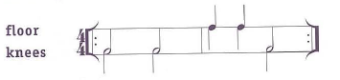 | To maintain a steady beat
Teach the song by echo, phrase by phrase | To develop a feel for singing in a minor key
Transfer body percussion patterns to melodic percussion  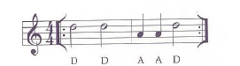 | Relating body percussion to melodic percussion if required
Perform melodic percussion with recorded version | Listening and performing
Sing song through in unison. Discuss where students felt they needed to breathe. Sing again, breathing at the end of each two-bar phrase | To develop a sense of phrasing in singing
Play the recorded version and ask students to raise their hands when they hear a long note held at the end of each phrase and on “oh no, oh no” | To develop appropriate breathing and an awareness of long and short notes when singing
Sing the song again with correct breathing and holding the long notes for their full value | Musical phrasing

Introducing the round
Activity | Purpose
Introduce the round by discussing the structure used on the recording:  - Introduction  - Unison (xl)  - Instrumental  - Round (x2)  - Coda | To be familiar with the structure of the song
Play the introduction again. Discuss how it is like section 3, “Oh no, oh no, oh no, go mango, mango” | Musical structure
Try singing section 3 as an ostinato to accompany the song | To accompany a song with vocal ostinato
Transfer section 3 to xylophone, recorder or another melodic instrument and accompany song in unison  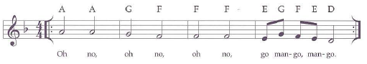 | Transferring melody to instruments
Divide the class into three groups and sing as a three-part round with the CD | To perform as a round in three parts
Try performing the round using melodic instruments to play the accompaniment from the chords on page 66 | To use melodic ostinato to maintain pitch and tonality
Record the class version of the round and discuss the blend of voices, dynamics, long notes, breathing and ways to improve the performance | To develop vocal blend and harmony
Record it again and compare the two versions | Listening and appreciating

