Connotation, imagery and symbol in visual arts
Creative arts Stage 1 student workbook
Name:
Class:

Overview
You will learn about the role of connotation, imagery and symbol in helping us learn more about the creative arts. These concepts can help to create meaning in songs and artworks.

Resources

Lesson 1
- Image of Centrepoint Tower by Esme Timbery (your teacher may have printed this up for you)
- Bailed up by Tom Roberts
- Fire’s on by Arthur Streeton
- Tram kaleidoscope by Frank Hinder
- Compare Keswick Siding with Bus terminus both by Jeffrey Smart
- The camp by Sidney Nolan
- Swimming before school by Ian Abdulla
- The doors by Edouard Vuillard
- Nine elements by Joe Tilson
- Drinka Pinta Milka by Derek Boshie
- Paintbrush
- Container of water
- Paver, plastic lid or cardboard
- Paper clay, air drying clay, playdough, dough or Blutak
- Paints of different colours

Lesson 2
- My Island Home by the Aboriginal Warumpi Band.
- Biber’s Sonata Representativa
- Nightingale
- Cuckoo
- Frogs
- Chicken
- Quail
- Cat
- James Ledger’s Indian Pacific
- Vivaldi’s Spring
- Rimsky-Korakov's Flight of the Bumblebee
- A variety of items or instruments (if available)
- Image of Broadway Boogie-Woogie (your teacher may have included this for you)
- Audio sample of Tommy Dorsey’s Boogie Woogie
- Audio sample of Beethoven’s Symphony Number 6 (‘Pastorale’) 45:42
- Art paper and paintbrushes of a variety of tip sizes
- Watercolour paints, pencils or paints in pastel colours

Lesson 1
Acknowledgement of Country
Discuss with your class or household about how Aboriginal people in Australia are the original owners of the land in your community. They have looked after this land for a long time and we all have the responsibility to continue this practice.
Reflect and make symbolic art
Go outside to a special place within your school or local environment. Where possible take a plastic surface, some cardboard, a paver or alternatively find a concrete, tiled or paved area. Take some water in a container and a paintbrush.
Look around at the environment in silence. Find something important about the environment – either natural or man-made.
Create a quick symbol of something in this environment that is important to you. Take a photo for your teacher to look at. Once it has vanished, repeat with another symbol and take a photograph. Your teacher wants to check you can show a symbol through your artwork. You can put your photos on the page below.
Here is an example to look at. It is a symbol (umbrella) of a wet area:
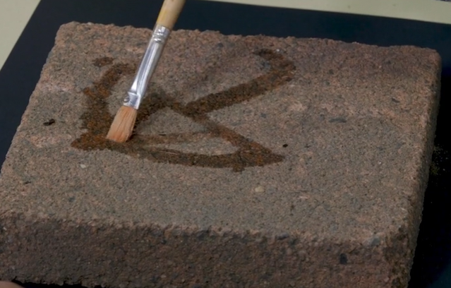
Look at some art
Look at the work Centrepoint Tower by Aboriginal artist Esme Timbery
Timbery is a Bidjigal artist whose family were shell workers from the Aboriginal mission community of La Perouse in Sydney.
How do you think this work was made?
Did you notice how the artist used traditional materials (the shells) that are important to Aboriginal culture to show a modern city symbol (the tower)?
Your symbol of Australia
Think again about your environment and consider an item that may be available to gather that symbolises Australia to you. Remember if you take something from nature such as shells from the beach, it must be returned once your artwork is complete.
Create a symbolic sculpture artwork and photograph it. For example, this may include leaves, shells or flowers and may also include cultural symbols important to your community or how you feel about Australia.
In the example below, a sculpture was created about a classic Australian symbol, the gum leaf, and was made from paper clay. Airdry clay is also a good alternative which can be handmade. Otherwise, use playdough, dough or blutak without painting it. Take a photo of your sculpture to share with your class. You can put your photo on the page below.
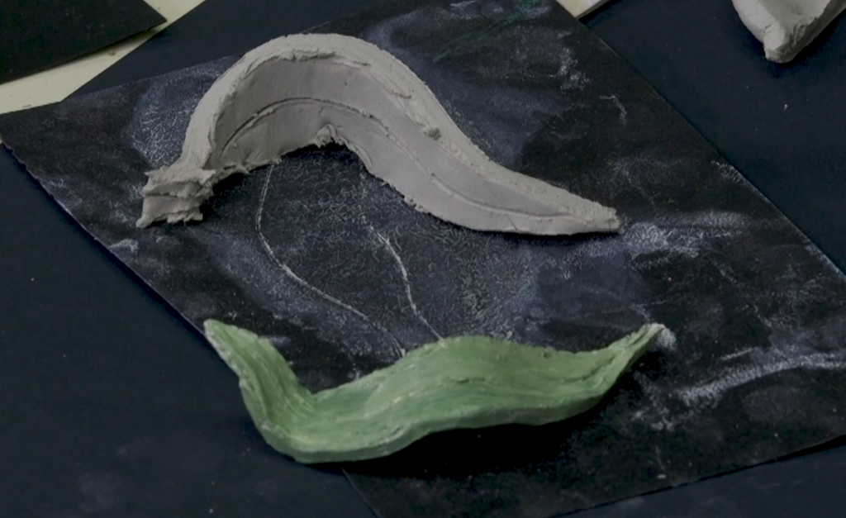

Blank page for your photographs

Look at some art
Artists represent ideas and meanings of their world through their artworks just like you did in your own symbolic works. Artists have been doing this throughout history.
Your teacher may have included these works for you as below:
Bailed up – Tom Roberts
Fire’s on – Arthur Streeton
Tram kaleidoscope – Frank Hinder
Keswick Siding with Bus terminus – both by Jeffrey Smart
The camp – Sidney Nolan
Swimming before school – Ian Abdulla
The doors – Edouard Vuillard
Nine elements – Joe Tilson
Drinka Pinta Milka – Derek Boshier
Write about this art
Complete the information in the table below for 2-3 artworks you like or that your teacher suggests. This will show your understanding of the meaning of the artworks. Some have been done for you.

Artwork title and artist | What is its hidden meaning about culture or country? | How does it tell us that?
Bailed up – Tom Roberts | Australia’s rugged bush, heat and bushrangers | The use of colours and images
Fire’s on’– Arthur Streeton
Tram kaleidoscope’ – Frank Hinder
‘Keswick Siding’ with ‘Bus terminus’ – Jeffrey Smart | Two unified but different images of suburban landscapes and transportation. | The same shapes and lines yet different colours and subject matter.
The camp – Sidney Nolan
Swimming before school – Ian Abdulla | Aboriginal people’s sense of community on the fringe of farmed land. | The image of people, water and the carefully shaped land.
The doors – Edouard Vuillard | Character in the corner, hidden.
Nine elements – Joe Tilson
Drinka Pinta Milka – Derek Boshier

Lesson 2
Learn about some music
Composers often use music to tell a story. Sometimes they do this through words or sometimes through the way the instruments sound (their ‘tone colour’) and the music they play.
Listen to each piece (or a section of it) and complete the parts of the table below that your teacher suggests.
- Listen to ‘My Island Home’ by the Warumpi Band. What do you think the song is about? How do you know?
- Heinrich Biber made the violin sound like animals in his ‘Sonata Representativa’. How does the composer make the instruments sound like these animals: a nightingale, a cuckoo bird, a frog, a chicken, a quail (a small bird) and a cat?
- Listen to the ‘Flight of the Bumblebee’ which is an orchestra piece by Rimsky-Korsakov. Move around the beat just like a bee flying and getting faster in speed (or tempo).
- Listen to some of James Ledger’s ‘Indian Pacific’. This piece sounds like the journey of a train across the country. Keep the beat and imagine you are on the train looking out the window. Does the strong beat remind you of that?
- Listen to ‘Spring’ from the ‘Four Seasons’ by Vivaldi. Vivaldi was trying to imitate birds, a running stream and a thunderstorm. Can you hear them?

Write about what you hear. Some answers have been done for you.
Music | What you hear
My Island Home by the Warumpi Band | Introduction with the watery sounds and the folk style instruments throughout. Shows a deep connection to Country.  Tempo speeds up, the music sounds much brighter and the dynamics get louder like a home arrival
Sonata Representativa by Heinrich Biber | Violin tone colour and sounds are like animals he is portraying.
Flight of the Bumblebee by Sergei Rachmaninoff.
Indian Pacific by James Ledger
Spring from the Four Seasons by Antonio Vivaldi. | High pitches like birds
Think about and make sounds
Think of one sound you can hear. What instruments or objects could you use to imitate that sound?
Some ideas might be:
- a whistle for a bird
- a glass like the wind
- hitting something strongly with your hands like a storm
- a paint brush on a table like sand or water
- a book slamming like thunder
- tissue coming out of a box like brushing your hair
- clicking a ring pull like a frog and so on.
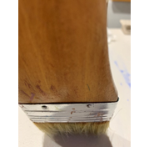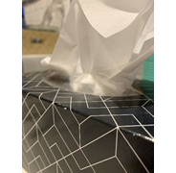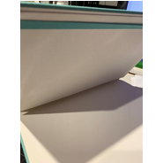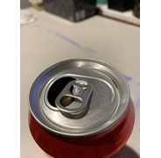
What sound is that?
Choose your sound and how you will represent it with an instrument or object. Record your sound or write about it:
The sound I chose is: _____________________________________________________

I can also make this sound by playing: ________________________________________

_______________________________________________________________________
Look at the sounds of art
Artworks are sometimes inspired by pieces of music. Sometimes musicians get meaning from artworks and other times artists make artworks based upon what they hear in a composition.
Look at the ‘Broadway Boogie-Woogie’ by Piet Mondrian. It is an image of the New York city map.
It was inspired by a jazz style of the day called boogie woogie music. One such example is Tommy Dorsey’s ‘Boogie Woogie.’ Listen to the music. You might like to have a dance!
Can you hear a link to the artwork? You might hear trumpet bursts and the repeated rhythms like traffic.
Do some art
Listen to a section of Beethoven’s ‘Symphony Number 6’ (‘Pastorale’) called Movement 2 which is about a running stream and the countryside. Can you hear the flute sounding like a stream or a bird? Can you picture the trees?
Listen again then paint or draw a picture about the music. You will probably want to use pastels and water colours if you can.
Your teacher may want to look at your artwork later and ask you about why you chose the colours and images that you did. Make sure your artwork is in landscape view and shows the gentle stream in the countryside like Beethoven’s work. The next page is left blank for your artwork.
Blank page for your Beethoven painting:

Talk and write about your art
After painting your artwork, write about it below or tell your teacher about it.
In my artwork I have shown _________________________________________________

_______________________________________________________________________

_______________________________________________________________________

The way I did this was with _________________________________________________

_______________________________________________________________________

_______________________________________________________________________
Write about what you learnt
Fill in your exit slip to tell your teacher about your learning.

Exit slip
Student name: ____________________________________ Date: _________________

One thing I now know better about the way artists share meaning through their artworks

________________________________________________________________________

________________________________________________________________________

One thing I am still puzzled about

________________________________________________________________________

_______________________________________________________________________

