The role of narrative in the creative arts
Creative arts workbook Stage 2
Name:
Class:

Overview
You will learn about the role of narrative in the creative arts. A narrative is sometimes called a story. A narrative can help to create meaning in songs, musical compositions and artworks.

Resources

Activity 1
- A folk song that you know that you can sing or listen to
- Someone in your household who knows a song with a story
- Student workbook

Activity 2
- A picture book
- Camera (if possible)
- Sharp coloured pencils
- Student workbook

Activity 3
- Student workbook

Activity 1 – narrative in folk songs
Resources
A folk song that you know. Folk songs often tell a story.

Warm up (sing a song)
Sing a folk song you know and keep the beat and pitch. Ask someone in your household to assist if you don’t know any. Some examples might include ‘Click Go the Shears’, ‘Waltzing Matilda’, ‘Sakura’, ‘Blowin’ in the Wind’, ‘Go Tell Aunt Rhody’, ‘I Know Where I’m Going’, ‘Mango Walk’ and so on.

Understanding narrative (learn a new folk song and identify its narrative)
What is your folk song called? What country is it from? What narrative (story) does it tell?
With someone in your household, think of two other folk songs they know. Sing or listen to those songs.
Think about these questions.
What is a folk song? (an expression of popular culture, often to tell a story of that culture)
What features of the music let you know that it is a folk song? (it may have a singer and a guitar for example)
What tells you it is a folk song? (the storyline, the instruments and the overall sound)
What are the instrumental tone colours (timbres) of instruments traditionally used when singing or performing folk songs? (often a guitar or a piano and a singer)
How might these instruments reinforce the meaning of the narrative in a folk song? (For example, why might a violin have been used instead of an electric guitar?)
Think about the folk song you chose to sing. Answer these questions:
What is the title? Who is the composer?
Title: ___________________________________________________________________
Composer: ______________________________________________________________
What country or culture is it from?
_______________________________________________________________________
How do you know it is a folk song?
_______________________________________________________________________
_______________________________________________________________________
What features of the music let you know it is a folk song?
_______________________________________________________________________
_______________________________________________________________________
_______________________________________________________________________
What instruments are used in the folk song?
_______________________________________________________________________
_______________________________________________________________________
_______________________________________________________________________
Think of three adjectives to describe the sound of each of the instruments (only do as many instruments as you think are actually in the song):
Instrument 1: ___________________________________________________________
Instrument 2: ___________________________________________________________
Instrument 3: ___________________________________________________________
How do the instruments reinforce the meaning of the narrative in your folk song?
_______________________________________________________________________
_______________________________________________________________________
_______________________________________________________________________
Write a list of two other folk songs you have discussed with someone in your household. Include the title, country it is from and a sentence or paragraph about the story it tells:
_______________________________________________________________________
_______________________________________________________________________
_______________________________________________________________________
_______________________________________________________________________
_______________________________________________________________________
_______________________________________________________________________
_______________________________________________________________________
Learn the second verse of the traditional Australian poem ‘My Country’ by Dorothea McKellar.
‘I love a sunburnt country,
A land of sweeping plains,
Of ragged mountain ranges,
Of droughts and flooding rains.
I love her far horizons,
I love her jewel-sea,
Her beauty and her terror -
The wide brown land for me!’
Retrieved with permission from the official Dorothea MacKellar website https://www.dorotheamackellar.com.au/archive/mycountry.htm
Recite this poem to a member of your household. Discuss the message you think the author is trying to communicate to her audience.
How does the narrative of this poem make you feel?
_______________________________________________________________________
_______________________________________________________________________
Do you think everyone who reads this poem would feel the same as you?
_______________________________________________________________________
_______________________________________________________________________
If this poem is made into a folk song, how might it make us feel about our country Australia?
_______________________________________________________________________
_______________________________________________________________________
_______________________________________________________________________
_______________________________________________________________________

Reflection
Think about what you have learnt in this activity. Use the two stars and a wish structure to guide your reflection.
Star  Something that went well! | Star  Something that went well! | Wish  A goal for next time…

Activity 2 – Narrative in visual arts
During this activity you will explore narrative in visual arts.
Resources
Any artworks about early Australia, paper, pencils or paints, access to a camera (if possible)

Narrative in early Australian artworks
There are many artworks that have become part of our Australian folk history and identity. Many examples are of the colonial history of Australia, the bush and early Australia.
There are many more examples available through the Art Gallery of NSW’s collection or in local galleries or books.
Some famous examples include:
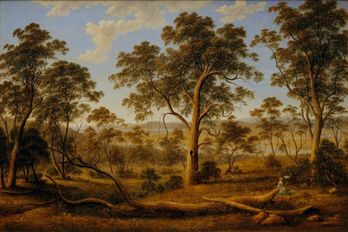
'Launceston and the river Tamar’ by John Glover (c.1832) Glover’s life with his wife Sarah in early Australia. Retrieved from the Art Gallery of NSW website https://www.artgallery.nsw.gov.au/collection/works/41.1972/
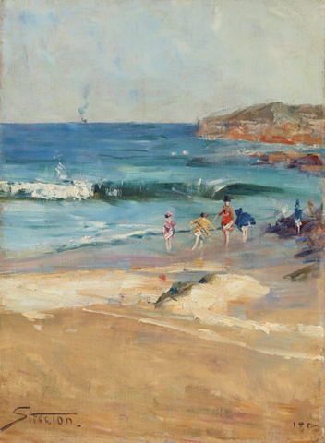
‘Beach scene’ by Arthur Streeton (1890) - an Australian beach image Retrieved from the Art Gallery of NSW website https://www.artgallery.nsw.gov.au/collection/works/9019/
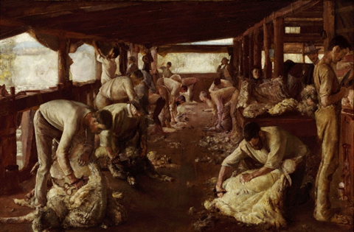
‘The Golden Fleece’ by Tom Roberts (1894) - famous shearing shed scene. Retrieved from the Art Gallery of NSW website https://www.artgallery.nsw.gov.au/collection/works/648/
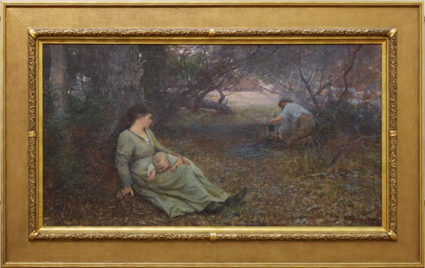
'On the wallaby track’ by Frederick McCubbin (1896) - famous scene of colonial struggle in the bush with rural work. Retrieved from the Arts Gallery of NSW website https://www.artgallery.nsw.gov.au/collection/works/572/
Reflect on the artist's use of colours, the implied textures, the use of the space such as the foreground, the background and the perspective. In some cases it is almost as though you can smell the landscape. How has the artist achieved this?

Select 2 artworks you find the most interesting and write in your workbook the name and date of the work, the artist and what narrative (or story) is being told through the artwork.
Think critically about each artwork and describe the details of it. Do you think the artists is portraying a positive or negative opinion of life in Australia? Write a brief summary about the artwork’s narrative and whether you think it is positive or negative, include the title and artist.
Title:___________________________________________________________________
Artist:_________________________________________________________________
Summary of the narrative (story): ____________________________________________
_______________________________________________________________________
_______________________________________________________________________
_______________________________________________________________________
Positive or negative image of Australia? _______________________________________
Why? __________________________________________________________________

Title:_________________________________________________________________
Artist:_________________________________________________________________
Summary of the narrative (story): ____________________________________________
_______________________________________________________________________
_______________________________________________________________________
_______________________________________________________________________
Positive or negative image of Australia? _______________________________________
Why? __________________________________________________________________
Reflection
Reflect on the way in which the narratives in these artworks relate to the folk songs learnt previously. Are there conflicting views of colonial Australia? What common relationship is there between the visual artworks and the musical compositions?
Create an artwork that reflects your identity and culture. This may be something like your own personal artwork version of a folksong. Consider your surroundings, the people that are important to your identity.
Where should your artwork be set? Think of a place that is important to you. For example, it might be at the beach, in the bush, on a farm, in an apartment or on a suburban street. Don’t forget to include your artists intent statement about what your work. Artist intent statements hang on the wall in a gallery and tell the audience about the artwork. Include its title.
The next page is intentionally blank for your artwork.
Write your artist intent statement:
Title of your work: _________________________________________________________
Artists intent statement: ____________________________________________________
_______________________________________________________________________
________________________________________________________________________

This page is intentionally blank for your artwork.

Activity 3 – narrative in drama
During this activity you will explore narrative in drama.
Resources
A picture book or a story from someone at home, access to a camera (if possible)

Narrative in a picture book
Choose a picture book and read it aloud to another member of your household or silently to yourself. If you do not have a picture book maybe a member of your family could tell you a story.
Think about what the picture book or story is about. What is the narrative (story) of this text?
Write a brief summary about the story’s narrative, include the title and author.
Title:___________________________________________________________________
Author:_________________________________________________________________
Summary of the narrative (story): ____________________________________________
_______________________________________________________________________
_______________________________________________________________________
_______________________________________________________________________

Understanding narrative – in drama

Choose a character from the picture book or story. Pose as this character and take a photo of yourself (either a selfie or taken by someone else). If possible, include the photo in this workbook. If you can’t take a photo, draw and label a picture of a character in a pose from the story. (labelled drawing or labelled photo)
Character name:
Choose an object from the picture book or story. Try to make your body into the shape of the object from the text such as a book, a globe, a bus, a tree or even a chair. Take a photo (either a selfie or taken by someone else). If possible, include the photo in this workbook. If you can’t take a photo, draw and label a picture of you in the shape of the object from the story. (labelled drawing or labelled photo)

Object name:
Choose a scene from the picture book or story. With someone from the household, use mime to sculpt each other into position to recreate that scene. Choose another scene (the one you think is most important) and create a postcard of that scene with other members of your household. If no one in your household is available, you can create a postcard on your own. Take a photo (either a selfie or taken by someone else). If possible, include the photo in this workbook. If you can’t take a photo, draw and label a postcard of the scene from the book. Include a person’s name and address, as if the postcard will be sent to them. (labelled drawing or labelled photo)
Scene title:

Reflection
Reflect on new information and understanding you have gained about the narrative of the picture book or story told through the dramatic interpretations you have created. Discuss your thoughts with someone in your household. Summarise your thoughts in a few sentences.
_______________________________________________________________________
_______________________________________________________________________
_______________________________________________________________________
_______________________________________________________________________

