Steel, stacks and steam

Unit overview
Students refer to industrial sites and structures as stimulus for artmaking. Students use drawing to document the site and painting, printmaking and mixed media works to develop the idea or concept. Students investigate built structures in the school environment and make artworks based on the investigations.

Subject matter
Places and spaces, objects.

Forms
Drawing, painting, printmaking.

Duration
6 to 8 weeks.

Resources
Enter art
- The curve of the bridge, Grace Cossington Smith, image no.4
Other
- felt pens
- soft pencils
- crayons
- oil pastels
- art paper
- camera and film
- clay (optional)
- ink or Edicol dyes
- screen for printing
- printing ink
- squeegee
- art paper
- newspaper
- scissors
- Styrofoam trays (recycled Styrofoam food packaging trays can be used for printing blocks. Cut away curved edges.)
- roller
- block printing ink
- biro
- waterproof board for rolling out ink
- acrylic paint
- brushes
- collection of small found objects that may represent industrial objects (e.g. clock parts, cotton reels, timber off-cuts)
- viewing frame

Outcomes and indicators

Making
VAS3.1: Investigates subject matter in an attempt to represent likenesses of things in the world.
- Responds to the diversity of visual images in industrial sites and structures in making artworks.
- Observes and records qualities of line, shape and texture revealed in industrial sites and structures.
VAS3.2: Makes artworks for different audiences assembling materials in a variety of ways.
- Experiments with drawing, painting and printing media to express features and qualities of the built environment.

Appreciating
VAS3.4: Communicates about the ways in which subject matter is represented in artworks.
- Identifies resemblances between subject matter in artworks and the features of things as they exist in the world.
- Talks and writes about the meaning of artworks.
Outcomes and other elements of the syllabus used in this document are copyright.
Creative Arts K-6 Syllabus © NSW Education Standards Authority (NESA) for and on behalf of the Crown in right of the State of New South Wales, 2006

Learning experience 1

Making drawings and photographs of an industrial site
- Visit a local industrial site or look at photographs of known sites.
Note: This activity is based on the industrial site of Port Kembla, NSW. Appropriate sites could include other industrial sites, farm machinery, car dumps, railway yards or construction sites.
- Write words to describe the site. Record structures of the site through sketches and photographs.
Note: Direct observation, drawing and reflection encourages students to look closely and to analyse the qualities of what they are drawing.
- Look for linear patterns, strong shapes and industrial textures, such as rusted surfaces.
- Use felt-tipped pens and pencils to record shapes and lines and soft pencil or charcoal to record textural qualities.
Note: Demonstrate drawing media which are suited to record each quality of the object, e.g. felt pen or pencil for line and detail, soft graphite pencil or charcoal for texture.
- Some sketches could be made with continuous line (the pen or pencil is used to trace around the edges and details of objects), without lifting from the paper.
- Explore depth in sketches by overlapping foreground and background objects.
- Make rubbings with crayons of some textured surfaces.
- Develop drawings by adding washes of diluted ink or Edicol dyes. Sketches can be cut up into sections and arranged in an artwork. The surface rubbings can also be incorporated.
Note: The drawings do not need to look like a representation of one view of the site. They might represent the “feel” of the whole site by combining drawings of separate parts of the site.
Some sketches can be used as starting points for other artworks.

Learning experience 2

Making prints about an industrial site
Refer to the drawings and photographs of industrial subjects.

Screen print
- Identify large, simple shapes in the drawings such as the side of a building or angular machine.
- Redraw these shapes on a large sheet of newspaper, leaving at least 5-6 cms of paper surrounding each shape. Make a stencil by cutting out the shapes. The negative shapes or holes will be the printed shapes. If shapes are to be different colours, cut separate stencils.
- Place the stencil between the screen and the art paper (litho is suitable) to be printed.
- Use a squeegee to drag the ink over the screen.
Note: To create interesting textures to suggest the weathered and rusted surfaces of industrial structures, two colours of ink can be placed on the screen so that when the squeegee is used to drag the ink down and through the screen mesh, the colours will mix resulting in a streaky effect.
Trial this technique before employing it in the lesson.

Block print
- Select one part of the drawing that has interesting linear qualities.
Note: Block printing is suited to representing linear qualities and texture while silk screen printing is better suited to creating shapes.
- Draw a rectangle or square around this part.
- Draw onto a piece of Styrofoam an enlarged view of the image within the rectangle or square.
- Use a sharp stick or ball point pen to etch the image into the surface of the Styrofoam.
- Roll acrylic (water-based) printing ink onto a waterproof board then roll it onto the Styrofoam plate. Press the inked surface onto a sheet of paper. Rub the back of the paper with the side of a clenched fist. Peel paper from the foam block.
Note: Trial any printing methods first to test results and ascertain the best viscosity of the medium.
- Print the block onto an area of the screen print.
- Further drawing or printing can be used for building textures or linear details.
Note: Carefully select the area to be printed over. The Styrofoam block print will obscure the image underneath unless transparent ink is used. Option: Use lino blocks instead of Styrofoam. Cut away larger areas of the background to create a linear pattern or texture.

Learning experience 3

Making paintings an collages about the industrial site
- Consider the drawings and/or the photographs of the industrial site. Select a drawing or part of a drawing (or photograph) that has interesting objects or shapes as well as overlapping shapes.
- Enlarge the drawing or part of it, onto a large sheet of paper or cardboard.
- Paint the shapes, keeping each shape distinct.
- Paint the background, considering this area as another shape.
- Add materials such as corrugated cardboard, found objects, Styrofoam or newspaper to create different areas of texture, colour, shape and pattern.
- The collaged parts can also be painted.
Note: Explain how layering images and objects can create a sense of depth.

Appreciating: reflecting
- Display the prints and collages.
- Describe the types of lines, shapes and textures that have been created.
- Refer to the written response to the site.
- How have you shown these qualities in your artworks?
- How do the words relate to the artworks?

Appreciating artworks
- Look at The curve of the bridge, by Australian artist, Grace Cossington Smith. It was painted during the construction of the Harbour Bridge.
- Are there any shapes or lines that remind you of structures or machinery in the site that you recorded? Describe these.
- What do you imagine the artist must have felt and experienced looking up at the bridge in
- 1928, a time when the massive structure was being built over the harbour?
- Can you think of any dramatic industrial structures in the area where you live?
Note: This painting is an example of how an artist has represented a built structure in an artwork. Explain that the artwork is about the construction of the Sydney Harbour Bridge.

Learning experience 4 (extension)

Making drawings and collages of structures in the school
- Walk around the school, observing features such as roof trusses, guttering, ceiling fans and decking.
- Using a viewing frame, make sketches of the structures emphasising regular, angular or complex lines and shapes.
Note: This activity can draw on concepts learned by creating artworks of industrial structures.
Make a viewing frame by cutting a rectangle from a piece of cardboard.
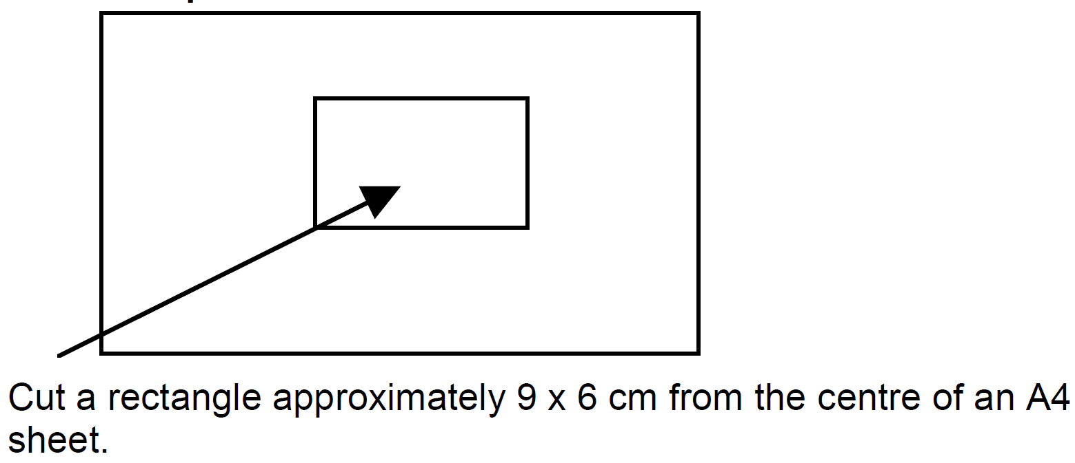
- Select one drawing and enlarge this composition onto a large sheet of paper.
- Using crayons or oil pastels, colour the main shapes. Use collage to create an area of interest.
- Using Edicol dyes, add washes of colour to the crayon image.

Appreciating: reflecting
- Consider the artworks made in the lesson and discuss the effects created.
Note: Organise a class exhibition of the students' works.
- Reflect in writing how the experience of making artworks about industry has changed the way you regard industrial sites.

