Still life with lute

Unit overview:
Students explore the aesthetic potential of musical instruments in artworks. They refer to artists who represent musical instruments as subject matter in still life artworks. Beginning with exploratory drawings, students’ progress to digital forms and paintings.

Subject matter
Objects.

Forms
Drawing, digital forms, painting.

Duration
4 to 6 weeks.

Resources
Image
- Cubist artworks with still life subject matter by Juan Gris, Georges Braque or Pablo Picasso
  - Hipernet webpage on Georges Braque
  - Artchive webpage on Juan Gris
  - Artchive webpage on Pablo Picasso
Enter art
- Still life with lute, Godfrey Miller, image no.11
Other
- soft pencils
- felt-tip pens
- ink and brushes
- Edicol dyes
- art paper
- musical instruments (e.g. drums, guitar, clarinet, etc)
- acrylic paint
- crayon or oil pastels
- sponge
- computer and software that enables manipulation of images

Outcomes and indicators

Making
VAS3.1: Investigates subject matter in an attempt to represent likenesses of things in the world.
- Closely observes details of musical instruments and makes artworks focusing on shape and form.
VAS3.2: Makes artworks for different audiences assembling materials in a variety of ways.
- Explores various techniques for layering images in paintings, collages and digital forms.

Appreciating
VAS3.3: Acknowledges that audiences respond in different ways to artworks and that there are different opinions about the value of artworks.
- Talks about how repetition and pattern affect an audience.
VAS3.4: Communicates about the ways in which subject matter is represented in artworks.
- Discusses the artist’s use of styles and techniques in an artwork.

Learning experience 1

Making drawings and paintings of musical instruments
- Sketch a range of musical instruments, focusing on the various shapes.
Note: Display musical instruments with a light source on one side. This will help students to see changes in tone that describe form.
- Depict the form or 3-dimensional quality of the instruments. Use soft graphite pencils to show a gradation of tone that describes roundness or solidity.
- Use other media to show different qualities of the instruments, e.g. felt pen or ink and brush to highlight the linear qualities of some instruments. Edicol dyes or ink washes can be used to enhance the form.

Appreciating artworks
- Look at Still life with lute by Godfrey Miller.
- Discuss the rich surface treatment of the artwork and the grouping of objects.
- What types of shapes and objects can you see?
- How has the artist arranged these? Are they clustered or spread out?
- How does the artist connect the objects in the work with the background?
- How is the surface made to appear textured?
- How has the artist enriched the surface?
Note: Explain that Miller has repeated similar colours in the objects and in the background and used lines to link objects with the background.
Miller has used small grid lines and broken the paint application into small areas of harmonious colour.

Learning experience 2

Making paintings or collages about musical instruments
- Use the sketches of musical instruments to create a frieze (arrangement of images in bands). Use instruments from the same classification, (woodwinds, brass, strings or percussion) arranging them in horizontal or vertical bands.
Note: Make photocopies of the drawings to provide multiple images.
- Experiment with different ways of creating textured backgrounds for the composition.
- Apply drawings and cut-out photocopies of instruments to the textured background bands.
Note: Combine crayon with dyes or watery paint; paint a layer of paint over a dry layer then scraping through and/or apply paint to the surface with a textured object such as a sponge or crumpled paper.

Appreciating: reflecting
- Inspired by the artwork, write a short poem about the sounds and qualities of the instruments that are represented. Use an element of repetition in the poem to create emphasis.
Note: Find examples of poetry and songs which feature repetition of phrases.
- Discuss the use of repetition in poetry, songs and student artworks.
- What effect does repetition have?
Note: Repetition in poetry, songs and artworks can create emphasis, pattern or rhythm. Repetition assists the audience to recognise and remember themes in a work.

Learning experience 3

Making digital artworks about music and instruments
- Use a graphics software program to create layers of images of instruments and musical notation in making artworks.
Note: Images could be scanned, repeated in digital layers and arranged into a composition.
- The two things to focus on in this are:
- colour
- repetition
- Use the artwork produced in the previous activity as the source material for this new work.
- Consider whether the work will be harmonious or contrasting.
- Consider whether the repetition of shapes, images and colours will be regular or irregular.
Note: Harmonious colours are close to each other on the colour wheel, e.g. orange, red-orange, red. Contrasting colours are opposite on the colour wheel, e.g. red and green, yellow and purple, blue and orange.
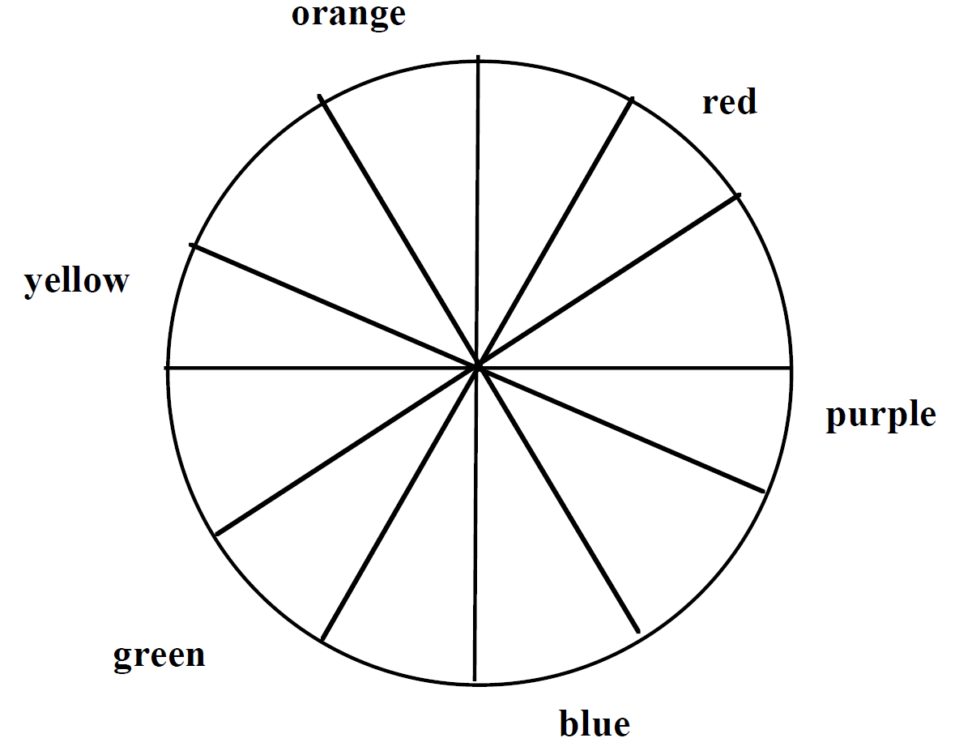
Irregular repetition or pattern is created by varying sizes and shapes of images and the spaces between these.

Appreciating: reflecting
- Consider the artworks produced by the class:
- Which ones are harmonious?
- Which ones are contrasting?
- Comment on the use of colour and repetition of the shapes to give harmony or contrast.

