1. Anatomy of type
Duration: 1-2 weeks

Driving question
Are fonts the clothing of typography?

Overview
Through the contexts of designer - design - world - audience, students explore a range of graphic media practices. Students will reflect on contemporary graphic design and the role of the designer across other disciplines and communities. Through critical and historical enquiry and studio practice, students will experiment and develop skills in image and text for print and screen. Using analogue and digital technologies such as, drawing, illustration, 3D construction and digital manipulations, students will develop a portfolio of graphic designs that include, typographic experiments, book design and public visual communications.
Sequences 1 - 8 form an introduction to graphic design focusing on the components of typography, image and layout. Students use their design journals to record, plan and experiment with the learnt class material. An online blog will be used to share and personalise their type journey. A publication of all the collated students practical outcomes in part 10, will form a cohesive published design object for exhibition and assessment.
Stage 5 outcomes
A student:
5.6 selects appropriate procedures and techniques to make and refine visual design artworks
5.7 applies their understanding of aspects of practice to critically and historically interpret visual design artworks
5.8 uses their understanding of the function of and relationships between artist – artwork –world – audience in critical and historical interpretations of visual design artworks
5.10 constructs different critical and historical accounts of visual design artworks
Visual Design 7-10 Syllabus © NSW Education Standards Authority (NESA) for and on behalf of the Crown in right of the State of New South Wales, 2004.

Content
This sequence explores the anatomy of typography and the conventions that make letters legible and unique. Students will analyse letterforms through the design principles of line, shape and colour with the conceptual agencies of design and the design world.
Focus areas
- Shape and letterform
- Structural and historical frames
- Designer and the design world.

Cross-curriculum content and key competencies
Information and communication technology
Difference and diversity
Numeracy
Literacy

Assessment
All activities require students to demonstrate their learning and are all assessment for learning activities.

Teaching and learning activities

Introduction
Students will:
- search the internet for an image of a five year old child’s handwriting of their name
- copy the image into their online blog, referencing where the image came from appropriately
- write a reflection in their blog entry of any memories they had when first learning to write their own name. If they are unable to remember learning to write, students can imagine and write a list on what steps they would need to take to teach a five year old student how to write
- in groups, share the image of the name, and discuss any letters that may be backward or badly formed
- research and write in their blogs definitions for terms ‘legibility’ and ‘readability’. Discuss this terminology as a class.
Watch the following videos as a class
- Beginning Graphic Design: Typography (00:06:23)
- History of Typography – Animated Short (00:05:09)
- Typography tutorial: Anatomy: Parts and shapes of type (00:05:08)
Students will:
- define the difference between a font and a typeface in their blogs
- discuss the difference as a class
- start a glossary section in their online blog and give graphic examples on each new term they learn
- investigate the types of fonts available in programs such as
  - Microsoft word
  - Adobe Illustrator
  - Adobe Photoshop
  - Indesign
- screenshot and paste their 10 favourite font types into their online blog with the name of the font as the text
- assign an adverb to each font type. An example of this could be
  - Bernard MT – crowded
  - Bradley hand – flowing
  - Helvetica – structured.
- research the internet for examples of old style, new style, modern and decorative type. Provide examples with definitions in their blogs
- visit online type foundry sites such as Linotype
- discuss the process a designer might use when designing a front
- reflect in their blogs an answer to the question:
  - ‘How do fonts enhance the work of a graphic designer?’

Technical skills
Materials required
- ruled graph paper
- tracing paper
- visual design journal/blog.
Students will:
- read the Anatomy of Type handout
- discuss the individual characteristics of the 26 letters that make up the alphabet
- discuss the characteristics that make up each of the 26 letters of the alphabet. The characteristics are shown in the Anatomy of Typography image (shown below) such as the stem, bowl, shoulder, bar and so on
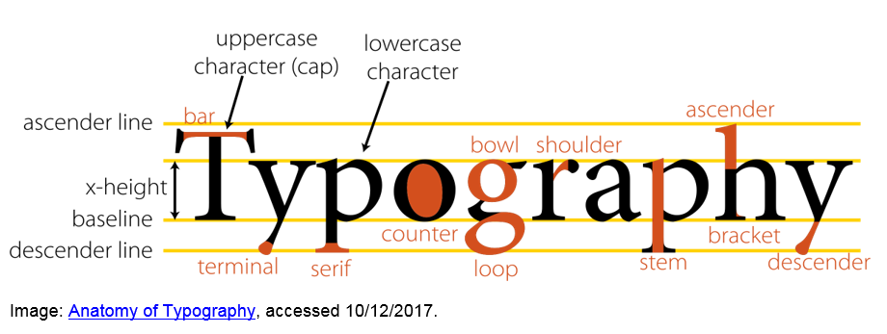
- copy and enlarge three letters by drawing upper and lower case using the graph paper.
When sharing the results as a class, discuss the letters that have distinct features and characteristics, for example Xx Bb and Gg.
Using the Jasper Johns drawings and an A3 sheet of paper, students will:
- select a new style or modern font they liked from the internet
- draw and overlay all letters of the alphabet similar to the drawing and painting of Jasper Johns (shown below)
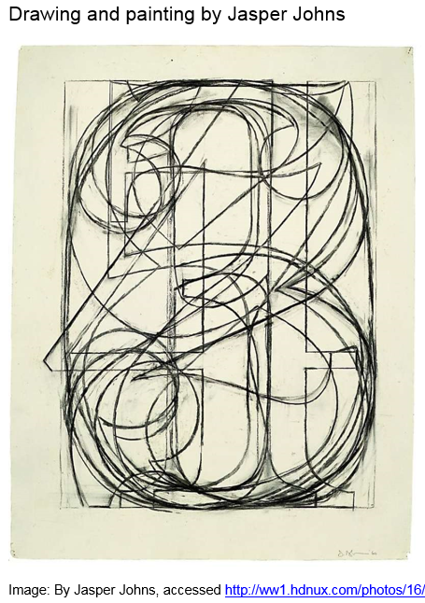
- repeat with numbers 0-9 using a different font.

Communicate
Students will complete a digital blog/visual design journal documenting the ideas and processes used throughout this sequence. This can be completed through one-note, Class Notebook or Google classroom.
The blog/visual design journal should contain:
- the process and technical skills used in practical classes
- personal reflections about the practical activities
- information gained through investigations or class discussions
- answers to questions asked in class
- a glossary of new words and terminology with graphic examples
- and thoughts of the different techniques and types explored.

Differentiation

Extension
Teachers are encouraged to provide students with acceleration activities if required.
Students could:
- photograph examples of typography used in public spaces and reflect and discuss the artists intentions and technique in their blog
- use the anatomy of typographic terms to analyse another students/artists work
- write a blog post addressing the driving question.

Life skills
Life skills outcomes
LS.2 explores a variety of materials, techniques and processes
LS.3 explores the function of a variety of visual designers and audiences
LS.9 uses a range of materials, techniques and processes to make visual design artworks
Visual Design 7-10 Syllabus © NSW Education Standards Authority (NESA) for and on behalf of the Crown in right of the State of New South Wales, 2004.
Students could:
- select a font and type the first letter of their name
- increase the size of the font and print
- using tracing paper, copy the letter, cut it out and trace around it onto a piece of cardboard
- cut out the shape and colour with paint
- discuss the process with the teacher or classmates.
This exercise can be repeated include other letters of their name, if needed.

Evaluate
Formative assessment can be used to determine learning progress throughout the lesson sequences. Teachers should informally assess a student’s level of understanding and adapt accordingly.

Reference list and resources
Visual Design 7-10 Syllabus © NSW Education Standards Authority (NESA) for and on behalf of the Crown in right of the State of New South Wales, 2004.
Lyon from Commercial Type, accessed commercialtype.com 11/01/2018.
Interlock from the Ed Benguiat Collection by House Industries, accessed houseind.com 11/01/2018.
Anatomy of Typography, accessed openclipart.org 10/12/2017.
Image 1 by Jasper Johns, accessed ww1.hdnux.com/photos.
Image 2 by Jasper Johns, accessed a.1stdibscdn.com/archivesE 10/12/2017.
www.linotype.com Linotype accessed 11/01/2018.
YouTube videos accessed 11/01/2018:
- Beginning Graphic Design: Typography (00:06:23)
- History of Typography – Animated Short (00:05:09)
- Typography tutorial: Anatomy: Parts and shapes of type (00:05:08).

