Mapping memory – Badger Bates

Resource booklet

Contents
Resource booklet 0
Mission Mob, Bend Mob, Wilcannia 1950s 2
Activity 1 – First impressions 3
Answers – Activity 1 4
Activity 2 – Badger Bates interview 5
Answers – Activity 2 6
Activity 3 – Signs and symbols 7
Activity 4 – Using maps 8
Answers – Activity 4 9
Activity 5 – Artmaking research 10
Activity 6 – Wilcannia Mission Camps and Cultural Places 13
Answers – Activity 6 15
References 16

Mission Mob, Bend Mob, Wilcannia 1950s
Figure 1 – Badger Bates (2009) Mission Mob, Bend Mob, Wilcannia 1950s [linocut on paper], Art Gallery of South Australia, © and image courtesy: Badger Bates. Printed image size: 72.0 × 42 cm.
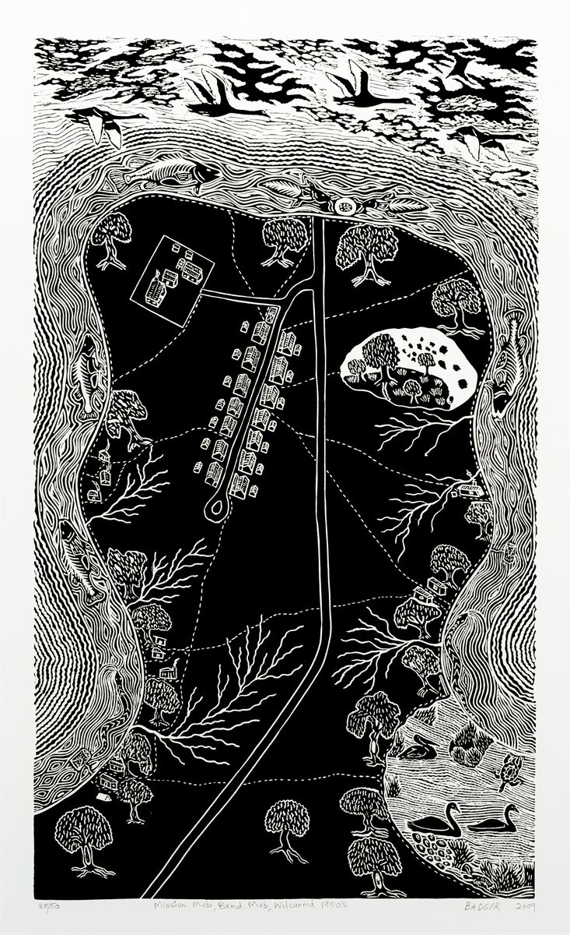
“Mission Mob, Bend Mob, Wilcannia 1950s” by Badger Bates is reproduced with the artist’s permission.

Activity 1 – First impressions
Look at the artwork Mission Mob, Bend Mob, Wilcannia 1950s, and complete the following questions using your knowledge of the structural and subjective frames.
Text boxes expand when using a digital version of this document.
- Write down 10 details that you observe in this artwork.

- Do you think this artwork is realistic? Why or why not?

- Do you think this is a landscape artwork? Why or why not?

- What perspective/angle of view has been used?

- Use subjective language to explain what the overall design reminds you of.

Answers – Activity 1
Student answers could include:
- Small groups of huts, 2 rows of houses, tents, dotted lines (tracks), double lines (roads?), trees, wavy lines (water?), branching lines (creeks?), flying birds, fish, fish eggs, snakes, turtles, fish traps, swimming birds, small water plants, a yabby.
- The artwork is not completely realistic. It shows real things but the designs are simple or use symbols. It wouldn’t look like this in real life.
- The artwork has some features of a landscape – it shows a place and some things that are in the place. It doesn’t really have a horizon or a foreground/background.
- It looks like an overhead, aerial, or bird’s eye view.
- The artwork looks like a map, especially the different lines that could show different roads or tracks. It tells us the location of different places in a landscape.

Activity 2 – Badger Bates interview
Watch the video excerpt Badger Bates interviewed 2010 for MCA Artist Voice (15:55) from (02:18 – 08:55), and answer the following questions using your knowledge of the subjective frame.
Text boxes expand when using a digital version of this document.
- Write down 4 childhood memories Badger Bates talks about in the video.

- List the features of the artwork that Badger Bates describes between (04:30) and (05:58).

- Why didn’t Badger Bates put the bridge or the town of Wilcannia in this artwork?

- Badger Bates talks about his grandmother, Granny Moysey, as a major influence. What are some things he said he learned from her?

Answers – Activity 2
Student answers could include:
- Living in a tin hut on the riverbank, learning to carve emu eggs from his grandmother when he was 8, watching his uncles carve boomerangs, having a ‘white dad and a black mum’, travelling with his grandmother to other communities like Bourke and Lake Cargelligo to escape the ‘welfare people’, learning Barkindji culture from his grandmother, making his own toys, going to the pictures.
- The mission, the mission school, the riverbank, tin huts, the river, fish, rainbow serpents, billabong, fish, yabbies, duck eggs, a white sandhill that was a burial ground, the Sydney road.
- Badger Bates said he didn’t put the bridge or the town into the artwork because he wasn’t allowed there. His grandmother thought that if he crossed the bridge he’d get caught by welfare and taken away.
- Badger Bates talks about his grandmother teaching him egg carving, Barkindji and Gurnu culture, and how to make boomerangs and stone axes.

Activity 3 – Signs and symbols
In his 2010 interview with the MCA (see Activity 2), Badger Bates says:
‘If you want to be an artist and do something, you shouldn’t muck with other people’s stuff what they do. You should do your own, or don’t do it at all, I reckon.’
Look at the artwork Mission Mob, Bend Mob, Wilcannia 1950s. The artist has used different symbolic designs to show different features of the landscape. For each feature listed, make a small thumbnail sketch of Badger Bates’ design, then come up with your own design for that feature.
Table 1 – Thumbnail sketches
Feature | Badger Bates’ symbol | Your symbol
Tree/
carved tree
Huts
Creeks
Roads and tracks
River water
Animals
Woven fish traps

Activity 4 – Using maps
Compare Mission Mob, Bend Mob, Wilcannia 1950s with current maps and aerial photographs of the area.
Go to SIX Maps and search for ‘Wilcannia’. Adjust the zoom level and position of the map to match the area shown in the artwork. Use the ‘Basemaps’ tool to switch between different views. The ‘Print PDF’ tool can be used to generate a full-page screenshot of your selected images – you should save a map image and an aerial photograph of the area and keep these in your visual arts diary.
Use the artwork and your map screenshots to answer the following questions:
- What do you usually use maps for? What features do maps typically have? Text boxes expand when using a digital version of this document.

- How is Mission Mob, Bend Mob, Wilcannia 1950s like a map? What features have been emphasised, stylised, added, or removed?
Table 2 – Features of Mission Mob, Bend Mob, Wilcannia 1950s
Emphasised | Stylised | Added | Removed
- What similarities and differences can you observe between current maps and aerial photography, and Badger Bates’ artwork? When you compare images, think about how the area has changed since the 1950s.
Table 3 – Comparison of current maps and Mission Mob, Bend Mob, Wilcannia 1950s
Similarities | Differences

Answers – Activity 4
Student answers could include:
Question 2:
Table 4 – Sample answers for Table 2 activity
Emphasised | Stylised | Added | Removed
The size of important features like trees, huts, the sandhill and the billabong. | The shape of the river and the design for the water.  Patterns made by creek beds. | Pictures of things like the rainbow serpent (Ngatji/Ngatyi), fish and other animals. | The bridge across the river and the town of Wilcannia.
Question 3:
Table 5 – Sample answers for Table 3 activity
Similarities | Differences
The mission school and two rows of houses are still there.  Some of the little creeks can be seen.  Most of the trees are close to the riverbank. | There are more buildings at the school and less houses at the mission.  There are new buildings around the billabong.  There are fence lines and new tracks.

Activity 5 – Artmaking research
Use the space provided, or your visual arts diary, to collate your research and begin planning your own design for a ‘mapping memory’ lino print.
Text boxes expand when using a digital version of this document.
- What place have you chosen to represent in your artwork?

- Explain your choice. What strong memory or personal connection do you have with this place?

- Collect some images that relate to your site to incorporate into your printmaking design. Make a record of your source material in Table 6 – record the source URL if using a website. Any digital materials collected should be saved together in a reference folder.
- It is recommended that you use SIX Maps to find maps and aerial photography – use the ‘Basemaps’ tool to switch between different views. The ‘Print PDF’ tool can be used to generate a full-page screenshot of your selected image.
- Refer to the Map of Indigenous Australia and related sources to learn about the Aboriginal heritage of your chosen site.
Table 6 – Source material and description
Source material | Description of material and date collected
Area map
Aerial photography
Map of Indigenous Australia
Photographs – your own photography, family photographs or other found images
Images of found objects – these could include things like souvenirs, other maps, or natural materials collected at the site
Site sketches
- Think of at least 5 specific features of the place that you can represent visually to communicate your memories and personal connections.
- In your visual arts diary or the table provided, design a sign/symbol to represent each feature, and explain why it is relevant to your memory or connection to the place.
Table 7 – Recording table
Specific feature of the place | Sign/symbol design for this feature | Explanation of relevance and representation of chosen feature

Activity 6 – Wilcannia Mission Camps and Cultural Places
In 2020, the area shown in Mission Mob, Bend Mob, Wilcannia 1950s was recognised for its rich cultural heritage and protected by the NSW government as an ‘Aboriginal Place’.
Read the media release ‘Wilcannia Mission Camps and Cultural Places declared an Aboriginal Place’ and complete the following tasks:
- Highlight any words or sentences that relate to cultural issues. This could include references to aspects of the site with cultural, community, spiritual and historic importance.
- In the space provided, list any specific examples of cultural values, activities, locations or artefacts that are referenced in the text. Text boxes expand when using a digital version of this document.

- Find definitions for the following features mentioned in the text. Make sure you record the source of any information you find.
Table 8 – Definition table
Term | Definition
Aboriginal canoe tree
Aboriginal coolamon tree
Aboriginal mound site
Aboriginal midden
Aboriginal heat retainer oven
Ngatyi/Ngatji/Nhatji
- In your visual arts diary, label a copy of Mission Mob, Bend Mob, Wilcannia 1950s with any locations or features mentioned in the text that you can identify in the artwork.
- Write a paragraph that explains the cultural perspectives revealed in Mission Mob, Bend Mob, Wilcannia 1950s. Use these cultural frame questions to guide your response:

Cultural frame questions
- What clues does the title of the artwork give about its intended meaning?
- How has the artist represented a particular cultural, social, or community group?
- How is this artwork about a particular time or place?
- Is the artist making the artwork from their own cultural perspective or exploring someone else’s?
- How does this artwork explore social issues like race and ethnicity, class and economic conditions, religion and spirituality, or the way humans interact with the environment?
- How does the artwork refer to any contemporary or historical events or ideas?
- What point of view, opinion, or cultural knowledge is the artist trying to communicate with audiences?

Answers – Activity 6
Sample paragraph
Mission Mob, Bend Mob, Wilcannia 1950s is a lino print made in 2009 by Barkindji artist Badger Bates. He was born in 1947 and brought up by his grandmother in the Wilcannia mission area that is shown in the artwork. The title refers to the places represented in the artwork – the Wilcannia mission, and the different people that lived there in the 1950s, including the artist and his grandmother. The artwork resembles a map and shows some important locations that have personal and cultural meaning for the artist. The Barka (Darling River) is very important for Barkindji people. It features in the artwork as being full of water and life, featuring images of fish and a full billabong with birds and river animals. On the left and right are two Ngatyis (rainbow serpents) that are associated with the creation of the Barka (Darling River). Mission Mob, Bend Mob, Wilcannia 1950s shows the places Badger Bates and other Aboriginal people lived, including tin huts on the riverbanks and the two rows of mission houses. These places are all connected by walking tracks and Bates has shown some of the large river red gum trees that grow on the riverbanks. Some of the trees have a large scar on them, showing the places where Aboriginal people cut away bark to make canoes to travel on the river. Another detail that shows audiences aspects of Barkindji culture and the importance of this place is a sandhill in the top right section of the artwork that represents a burial site. In an interview about this artwork, the artist says that he did not show the main town of Wilcannia or the bridge across the river because he was not allowed to go there. Badger’s grandmother was worried that he would get taken away by ‘welfare people’, because he had a white father and an Aboriginal mother. To stay safe, Badger Bates and his grandmother travelled around to different Aboriginal communities like Bourke and Lake Cargelligo. Badger Bates learned a lot of language and culture from his grandmother and other family members, including some of the carving techniques that he later used to make lino prints. In Mission Mob, Bend Mob, Wilcannia 1950s, Badger Bates shows audiences a place that is important to his personal history and highlights many features of the place that have cultural significance to Barkindji people.

References
Links to third-party material and websites
Please note that the provided (reading/viewing material/list/links/texts) are a suggestion only and implies no endorsement, by the New South Wales Department of Education, of any author, publisher, or book title. School principals and teachers are best placed to assess the suitability of resources that would complement the curriculum and reflect the needs and interests of their students.
If you use the links provided in this document to access a third-party's website, you acknowledge that the terms of use, including licence terms set out on the third-party's website apply to the use which may be made of the materials on that third-party website or where permitted by the Copyright Act 1968 (Cth). The department accepts no responsibility for content on third-party websites.
All material © State of New South Wales (Department of Education), 2021 unless otherwise indicated. All other material used by permission or under licence.
Visual Arts 7–10 Syllabus © 2003 NSW Education Standards Authority (NESA) for and on behalf of the Crown in right of the State of New South Wales.
© 2021 NSW Education Standards Authority. This document contains NSW Curriculum and syllabus content. The NSW Curriculum is developed by the NSW Education Standards Authority. This content is prepared by NESA for and on behalf of the Crown in right of the State of New South Wales. The material is protected by Crown copyright.
Please refer to the NESA Copyright Disclaimer for more information.
NESA holds the only official and up-to-date versions of the NSW Curriculum and syllabus documents. Please visit the NSW Education Standards Authority (NESA) website and the NSW Curriculum website.
Bates B (2009) Mission Mob, Bend Mob, Wilcannia 1950s [linocut on paper], Art Gallery of South Australia, Adelaide, Australia, accessed 31 October 2022.
Horton DR (1996) ‘Map of Indigenous Australia’, Explore, AIATSIS (Australian Institute of Aboriginal and Torres Strait Islander Studies) website, accessed 31 October 2022.
MCA (Museum of Contemporary Art Australia) (15 November 2016) ‘Badger Bates interviewed 2010 for MCA Artist Voice’ [video], MCA Australia, YouTube, accessed 31 October 2022.
State of New South Wales (Spatial Services, a business unit of the Department of Customer Service NSW) (n.d.) SIX (Spatial Information eXchange) Maps [website], accessed 31 October 2022.
State of New South Wales (Department of Planning and Environment) (30 October 2020) Wilcannia Mission Camps and Cultural Places declared an Aboriginal Place [media release], hosted on Trove, National Library of Australia, accessed 31 October 2022.

