7. Illustration and text
Duration: 1-2 weeks

Driving question
Could illustrative typography make sketches obsolete?

Overview
By studying the work of Australian designer Gemma O’Brien, students will gain knwoledge and experience in personalising typography. Students will use stylised images and letterforms to create a contemporary decorative text.
Stage 5 outcomes
A student:
5.4 investigates and responds to the world as a source of ideas, concepts and subject matter for visual design artworks
5.7 applies their understanding of aspects of practice to critically and historically interpret visual design art works
5.8 uses their understanding of the function of and relationships between artist – artwork –world – audience in critical and historical interpretations of visual design artworks
5.9 uses the frames to make different interpretations of visual design artworks
Visual Design 7-10 Syllabus © NSW Education Standards Authority (NESA) for and on behalf of the Crown in right of the State of New South Wales, 2004.

Content
Students will explore, apply and design typographic forms that combine pictures and words. They will create a new graphic that functions as both a letter and a word. Students will be introduced to the concepts and possibilities when experimenting with alternative surfaces to communicate with an audience.
Focus areas
- Shape and letterform
- Structural and subjective frames
- Design and audience.

Cross-curriculum content and key competencies
Civics and citizenship
Work, employment and enterprise
Information and communication technology

Assessment
All activities require students to demonstrate their learning and are all assessment for learning activities.

Teaching and learning activities

Introduction
Students will:
- create a blog post about the life and work of Australia graphic designer Gemma O’Brien. Some useful websites/articles are:
  - Gemma O’Brien & Her Career in Typography
  - Typography – Gemma O’Brien
  - Designers Journal – Profiles – Gemma O’Brien
- go to the website The Loop - Gemma O’Brien Typographer & Illustrator, study the Love/Fear images and answer below questions in their visual design journals/blog:
- Who do you think this artwork was created for and why?
- What do you think Gemma O’Brien is trying to say in this artwork? What is the meaning or message?
- How do your eyes move through these artworks? What choices did Gemma O’Brien make to cause that to happen?
- What juxtapositions do you notice when comparing the two artworks?
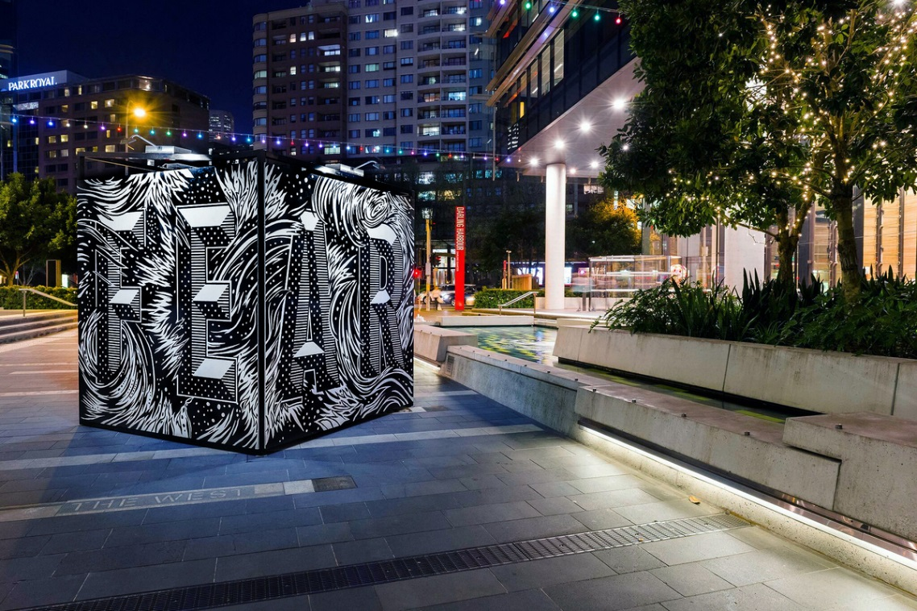
Image: ‘Fear’ from www.theloop.com.au/mrseaves/portfolio/lovefear, accessed 18/01/2018.
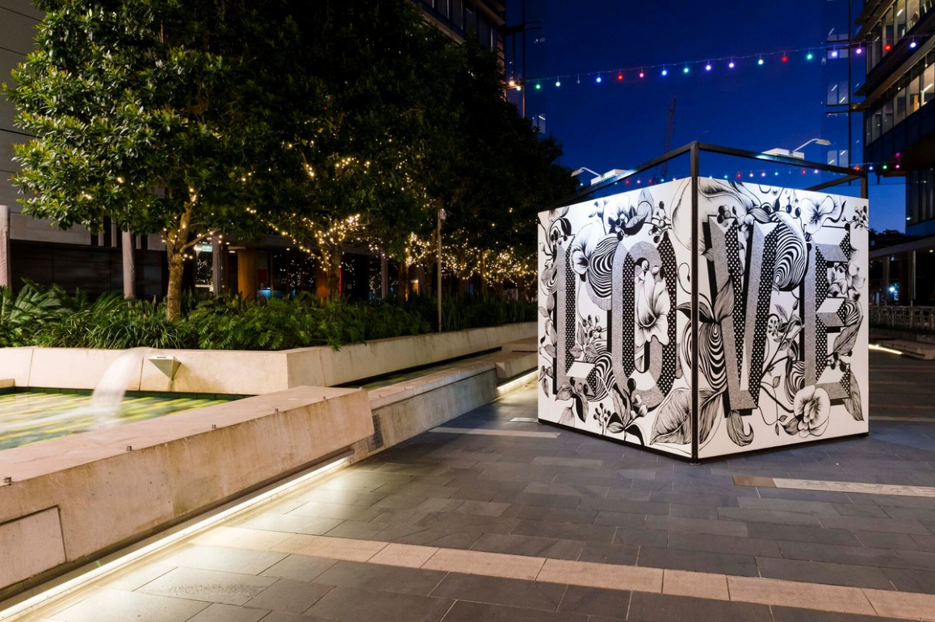
Image: ‘Love’ from www.theloop.com.au/mrseaves/portfolio/love, accessed 18/01/2018.
- watch the following videos, taking notes in their visual design journal/blog
  - Qantas Blank Canvas – Gemma O’Brien (00:02:15)
  - Gemma O’Brien: The art of lettering (00:02:48)
  - Mixing Typography and Illustration with Gemma O'Brien | Volcom | School Of Cool (00:02:14)
  - Gemma O’Brien Teaches You Block Lettering Techniques | Volcom | School Of Cool (00:01:18)
- discuss as a class
  - the relationship between illustration and typography
  - Gemma O’Briens intended audience.

Design making
Materials required
- A3 paper
- tracing paper
- visual design journal/blog
- colour pencils, watercolours, paints and felt tip markers
- white or gesso paint
- mobile phone or digital camera
- smooth surface object not exceeding 30cm x 30cm x 30cm.

Haiku
A haiku is a form of Japanese poetry that has 17 syllables broken into three lines of five, seven and five syllables.
Students will:
- compose a haiku about any topic of their choice
- choose a font on the computer that will outline the words in their haiku
- print out the word and trace onto tracing paper
- transfer the word onto an A3 sized paper
- illustrate the inside of each letter
- design and manipulate the words to blend into the background
- paint to complete the design
- exhibit
- reflect on the design process and journey in their visual design journal/blog.

Shapes and text
Students will:
- select a smooth surfaced object to use in their design. Some examples might be a box, a ball or a bottle.
- paint the object white using paint or preferably gesso, as it is easier to draw on
- choose two words with opposite meanings similar to ‘Fear’ and ‘Love’ used by Gemma O’Brien
- using only black and white, draw an illustrative text design for their words on paper or compose it using Photoshop or Illustrator
- include a pattern
- consider positive and negative space/images coming through and over letters
- transfer the design to the object with black marker pen or black ink
- paint their design - if on Photoshop or Illustrator, experiment with brush strokes and patterns
- photograph the creative process and publish onto their blog.

Communicate
Students will complete a digital blog/visual design journal documenting the ideas and processes used throughout this sequence. This can be completed through one-note, Class Notebook or Google classroom.
The blog/visual design journal should contain:
- the process and technical skills used in practical classes
- personal reflections about the practical activities
- information gained through investigations or class discussions
- answers to questions asked in class
- a glossary of new words and terminology with graphic examples
- and thoughts of the different techniques and types explored.

Differentiation

Extension
Teachers are encouraged to provide students with acceleration activities if required.
Students could:
- research the following artists
  - Zuzana Licko
  - Jonathan Hoefler
  - Tobias Frere-Jones.
- Investigate and answer the question – Who was Mrs Eaves?
- curate an exhibition of the classes finished graphic design objects in a space within the school e.g. library, or foyer
- name the exhibition and create hand-written invitations
- write a blog post addressing the driving question.

Life skills
Life skills outcomes
LS.1 experiences a variety of visual design procedures to make visual design artworks
LS.2 explores a variety of materials, techniques and processes
LS.8 explores ways to develop ideas in visual design artworks
Visual Design 7-10 Syllabus © NSW Education Standards Authority (NESA) for and on behalf of the Crown in right of the State of New South Wales, 2004.
Students could:
- re-watch the video Mixing Typography and Illustration with Gemma O'Brien | Volcom | School Of Cool (00:02:14)
- follow along with the steps in the video and create a watercolour illustrative text of the word ‘YES’.

Evaluate
Formative assessment can be used to determine learning progress throughout the lesson sequences. Teachers should informally assess a student’s level of understanding and adapt accordingly.

Reference list and resources
Visual Design 7-10 Syllabus © NSW Education Standards Authority (NESA) for and on behalf of the Crown in right of the State of New South Wales, 2004.
Mixing Typography and Illustration with Gemma O'Brien | Volcom | School Of Cool (00:02:14) www.youtube.com/watch?v, accessed 18/01/2018
Gemma O’Brien Teaches You Block Lettering Techniques | Volcom | School Of Cool (00:01:18) www.youtube.com/watch, accessed 18/01/2018
Qantas Blank Canvas – Gemma O’Brien (00:02:15) www.youtube.com/watch, accessed 18/01/2018
Gemma O’Brien: The art of lettering (00:02:48) www.youtube.com, accessed 18/01/2018
Gemma O’Brien & Her Career in Typography hercollective.com.au/gemma-obrien-career-in-typography, accessed 18/01/2018
Typography – Gemma O’Brien www.dedeceblog.com, accessed 18/01/2018
Designers Journal – Profiles – Gemma O’Brien www.designersjournal.net/jottings, accessed 18/01/2018
The Loop - Gemma O’Brien Typographer & Illustrator www.theloop.com.au/mrseaves, accessed 18/01/2018.

