Fiona Foley
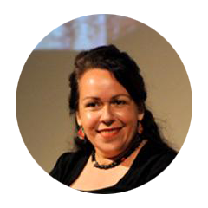
(Image: Foley, F. 2010).
Key artist: Fiona Foley.
Theme: events, political art, contemporary issues.
Time: 2018 (current).
Place: Australia.
Syllabus connections:
- frames, conceptual framework, practice.
Key art works addressed
- "Land Deal" - Installation
- "Forbidden"- Installation
- "HHH" – Costume /textiles
- "Nulla 4 Eva" #3 and IV – Photography.
General key words:
- symbolism, identity, community, personal experience, culture, racism, photography, difference, post modernism, popular culture, visual cues.
Sophisticated key terms/words:
- political voice, oppression, cultural pluralism, marginalised, Australian multiculturalism, social norms, ambiguity, mistreatment of humanity, evocative, discourse, intimate , distressing, stigmatic presence, art as provocation, alienation, disenfranchised and disillusioned.

Literary progression:
- speaking, listening, interacting, comprehension, process, vocabulary, writing (informative and persuasive), grammar (whole text, sentences), and spelling.
Explore Fiona Foley’s website.
What was your personal view about some of her artworks you looked at on her web site?
Critically look at the image and discuss
Sculpture titled 'The Annihilation of the Blacks' by Fiona Foley (left).
- How does Foley comment on racial injustice in her sculpture?
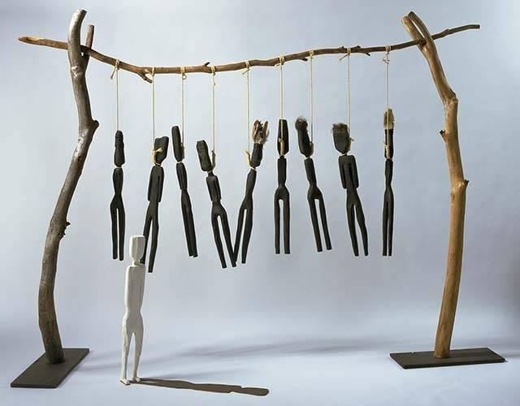
(Foley, 1986).

Art collectors review of Fiona Foley with comprehensive timeline of works.

Fiona Foley
Read the paragraphs below
“Witnessing to silence focuses on the eternal forces of nature, change and regeneration. It reminds us that nature is a dominant force that can govern people’s lives. The columns of ash and place names refer to the extremes of fire and flood experienced in the Australian bush. The sacred lotus lilies symbolize enlightenment and provide a space for contemplation and regeneration.” Foley describing her work (above).
Witnessing to Silence installations images
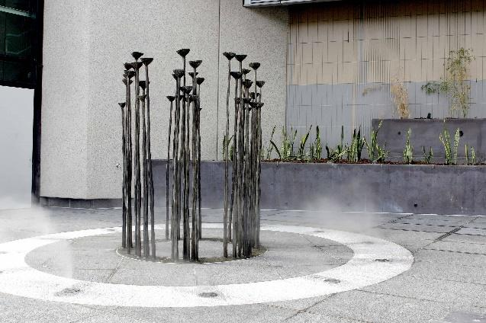
Witnessing to silence, Fiona Foley, (Burrows, 2005)
Laced flour and tin boxes, the art of Fiona Foley
Throughout her career, Fiona Foley has battled categorisation and challenged the preconceived notions inherent in the label 'Aboriginal artist'. Foley works in many media, yet her art is firmly grounded - in structure and meaning - in the traditions of her ancestral people, the Badtjala.
The Badtjala people have lived on the world's largest sand island, ‘K’gari’ (Fraser Island), since time immemorial. By the early part of the twentieth century, however, most of the Badtjala population had been massacred by white settlers and the survivors removed to Christian missions on the island or the mainland.
Foley was born on the mainland in 1964, and lived with her parents in regional Queensland before moving to Sydney where she became one of the first Aboriginal students to enroll at a European-style school of art. Here she encountered criticism from teachers who felt the approach to her work did not fall within the prescribed Western models of art making. Despite this, Foley graduated as a versatile artist working in everything from drawing to painting, print and photography to public sculpture and installation.
Written by Avril Quaill, World of Dreamings, National gallery of Australia, (Quaill, 2000).

Watch, listen, interpret and discuss the following video:
- Fiona Foley - part 1.
(Fiona Foley -part 1, part 2, 2018)
Discussion questions:
- why does she use the term "Dispersed"?
- she places bullets in the letter 'D' what does this symbolise?
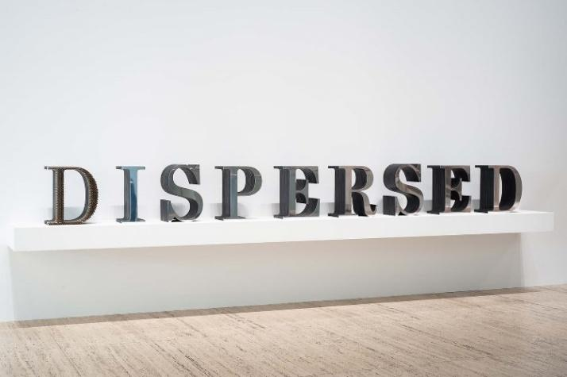
("DISPERSED - Fiona Foley QAGOMA Learning", 2018).

"Land deal" Fiona Foley
Land deal is an installation consisting of flour to create a spiral shape on the floor, together with a blanket, knives, mirrors, axes, a box with beads (white and blue), scissors and a text.
The text reads:
Land deal: After a full explanation of what my object was, I purchased two large tracts of land from them – About 600,000 acres, more or less – and delivered over to them the blankets, knives, looking-glasses, tomahawks, beads, scissors, flour, etc., as payment for the land and also agreed to give them a tribute, or rent, yearly.
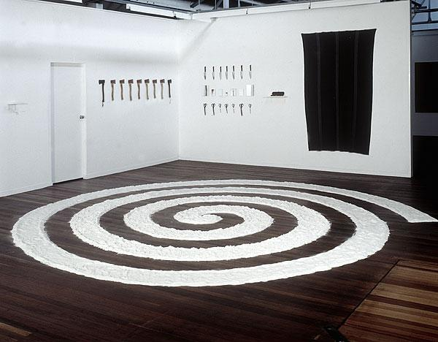
(Foley 1995).
The objects chosen for the installation are closely associated with the words by John Batman about his purchase of the land on which the city of Melbourne now stands; they are a symbolic representation of the many Indigenous groups across Australia and the way in which their land was taken from them. The spiral shape echoes similar grooved designs drawn in the sand for Aboriginal ceremonies. Objects that Batman sought to trade have been here exploited in a different sense, making this work rich in its layers of implication and irony.
Whilst the piece pertains to the purchase of Melbourne and Batman’s land deal, as with much of Foley’s work, it equally reflects of issues of custodianship, land possession and occupation of her country, ‘K’gari’ and other areas of Aboriginal Australia. ‘K’gari’ was renamed Fraser Island after Eliza Fraser (wife of a British captain whose ship was wrecked on the island in 1836). In this case it was not so much the ‘purchase’ of the island but the forcible removal of the Indigenous owners who were dispossessed of their traditional land.
Written by Anne Gray for the National Gallery of Australia, Canberra, 2002, (Gray, 2002).
- Explore “forbidden” further here
- Downloadable extension learning resource “Forbidden”, Fiona Foley".
Lead discussion questions
Art writer Anne Gray (above) states Foley’s objects are a symbolic representation of the many Indigenous groups across Australia and the way in which their land was taken from them.
- How has the artist referenced history in her contemporary installation?
- How does some of Foley’s objects relate to the “land deal” written by John Batman?
Key terms you could use in your discussion dialogue:
- stigmatic presence
- sovereignty
- ancestral bonds
- mistreatment on a humane level
- these political statements are confronting
- Foley's aim is to engage dialogue.

"HHH"- by Fiona Foley
Read the paragraphs below.
…References to Aboriginal and settler history are revealed in her work, where aesthetics, culture, the personal and the political are interwoven.
The costumes comprising HHH (Hedonistic Honky Haters) were created in 2004 at the International Studio Curatorial Program in New York—where they were modelled for a photographic series by Foley. The style of the brightly coloured robes and black hoods inverts the symbolism of the American white supremacist movement the Ku Klux Klan (KKK), with their characteristic white pointed hoods and robes. The acronym HHH is Foley’s invention. By using the African-American slang term for the white man, ‘honky’, she deliberately transposes the concept of white-on-black racial vilification espoused by the KKK.
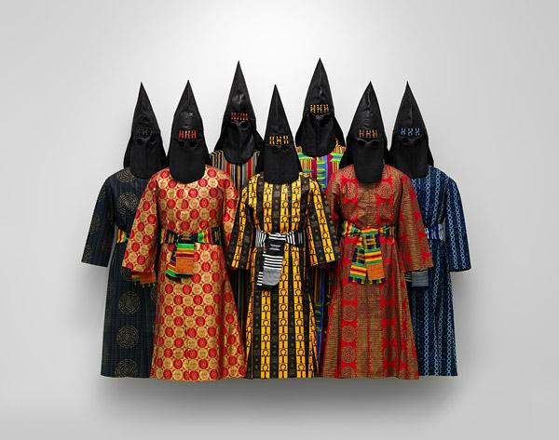
("Foley, Fiona | HHH", 2004)
When displayed en masse, as if converging on the viewer, the life-size costumes are challenging and confronting with their clear references to ideas of mob violence, fear and racism. Yet despite the gravity of the subject, the beauty of the printed fabrics—sourced by the artist from African import shops in Harlem—and the intricate details of their construction provide an aesthetically engaging visual impact.
("Foley, Fiona | HHH", 2014)
Watch, listen, interpret and discuss the following video:
- Fiona Foley - part 2.
(Fiona Foley -part 1, part 2, 2011).
Cultural frame questions
- What are the connotations of the phrase ‘white supremacists’?
- Identify and discuss the ways in which Foley has inverted meaning and thus inverted racism.

"Nulla 4 Eva #3" -Fiona Foley
Answer the following in a written response:
20min
- How is the artist Fiona Foley reflecting issues about cultural pluralism in her work
"Nulla for Eva"?
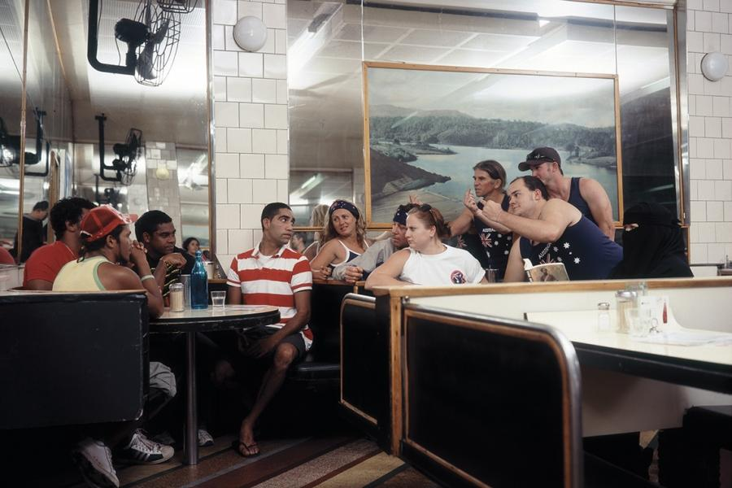
Fiona Foley, Nulla 4 eva #3, 2009 (Foley, 2009)
Key terms you could use in your writing:
- political voice
- diversity
- religious tolerance
- living together
- oppression
- Australian multiculturalism
- ambiguity
- mistreatment
- intimate and distressing
- stigmatic presence.
Text Extract
Fiona Foley’s series of photographs titled ‘Nulla 4 Eva’ infuse Aboriginal, Middle Eastern and Asian ethnicities onto the canvas of Cronulla’s whiteness, (Shaw, 2017).

"Nulla 4 Eva IV" - Fiona Foley
Discuss the following statement through a written response.
15min
- Artists contemplate connections between past and present to inform an audience. Discuss this referring to the image "Nulla 4 Eva IV" below by artist Fiona Foley.
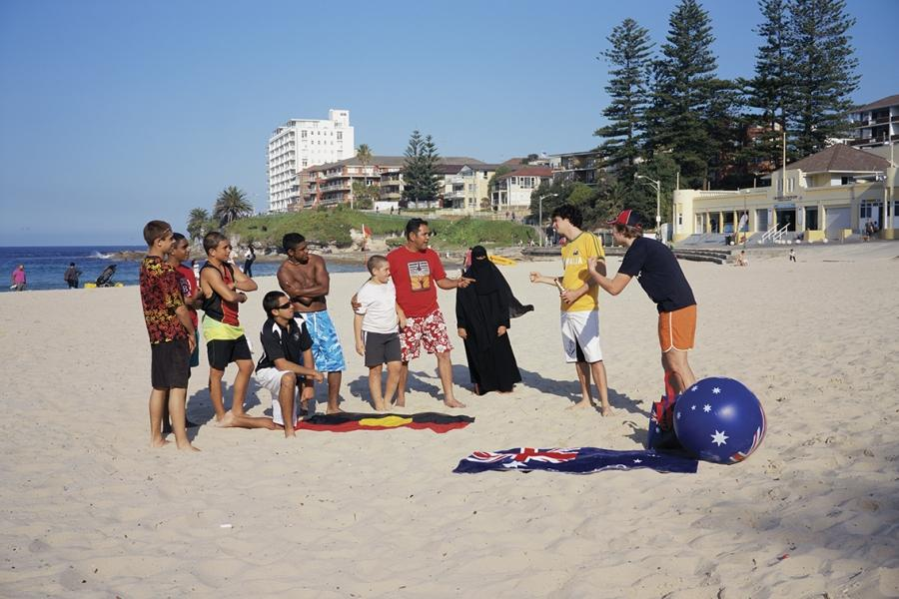
Fiona Foley, Nulla 4 eva IV, 2009, (Foley, 2009).
Key terms you could use in your writing
- political voice
- oppression
- sufferance
- distressing knowledge of specific regions and historical events
- effect of European colonisation
- race and power
- experience of abuse and racism
- Australian multiculturalism
- cultural pluralism
- reference the contemporary Australian art world
- a contemporary lens.

References for Booklet 4 Artist Fiona Foley
Burrows, S. (2005). UAP with Fiona Foley. Retrieved from https://www.uapcompany.com/studio/brisbane-magistrates-court
DISPERSED - Fiona Foley - QAGOMA Learning. (2018). Retrieved from https://learning.qagoma.qld.gov.au/artworks/dispersed/
Fiona Foley - part 1, part 2. (2011). [Image]. Retrieved from https://www.youtube.com/watch?v=4LvweA0fGzE
Foley, F. (1986). The Annihilation of the Blacks [Mixed media]. Canberra: National Museum of Australia.
Foley, F. (1995). Land Deal [Mixed Media]. Canberra: Collection National Gallery of Australia.
Foley, F. (2004). HHH [Textiles, costumes,]. Canberra: National Gallery of Australia.
Foley, F. (2009). Nulla 4 eva #3 [Ultrachrome print on Hahnemühle paper]. Perth: State Art Collection, Art Gallery of Western Australia.
Foley, F. (2009). Nulla 4 eva IV [Ultrachrome print on Hahnemühle paper]. Brisbane: http://niagaragalleries.com.au
Foley, F. (2010). Deepen the conversation – black opium symposium [Image]. Retrieved from http://blogs.slq.qld.gov.au/jol/2010/02/19/deepen-the-conversation-black-opium-symposium/
Foley,Fiona| HHH. (2004). Retrieved from https://artsearch.nga.gov.au/detail.cfm?irn=198627
Foley,Fiona| HHH. (2014). Retrieved from https://artsearch.nga.gov.au/detail.cfm?irn=198627
Gray, A. (2002). Land Deal [Text]. Canberra: National Gallery of Australia.
Quaill, A. (2000). World of Dreamings. Retrieved from https://nga.gov.au/Dreaming/Index.cfm?Refrnc=Ch8
Shaw, W. (2017). After Nulla: Through the Lens of Aboriginal Art. Journal Of Intercultural Studies, 38(3), 301-314. doi: 10.1080/07256868.2017.1314253
Witnessing to Silence an art installation by Fiona Foley. (2015). Retrieved from http://brismania.com/day-104-silent-witness/.

