Abdul Abdullah
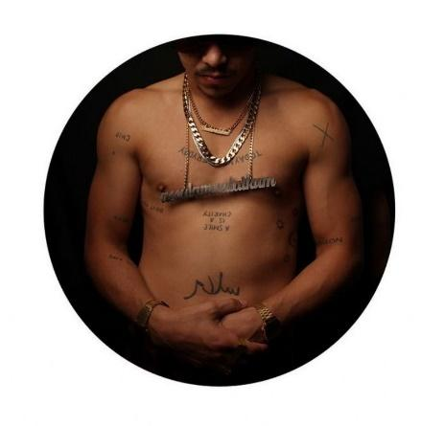
(Abdullah, 2013).
Key artist: Abdul Abdullah.
Theme: events, political art, contemporary issues.
Time: 2011- 2018 (current).
Place: Australia.
Syllabus connections
- Frames, conceptual framework and practice.
Key art works addressed
- "Them and us", photography.
- "Self-portrait you see monsters", photography.
- "Self-portrait as an ultra-nationalist", photography.
General key words
- Symbolism, identity, community, personal experience, culture, racism, photography, difference, post modernism, popular culture, visual cues.
Sophisticated key terms/words
- Political voice, oppression, cultural pluralism, marginalised, Australian multiculturalism, social norms, ambiguity, mistreatment of humanity, evocative, discourse, intimate , distressing, stigmatic presence, art as provocation, alienation, disenfranchised and disillusioned.

Literary progression
- Speaking, listening, interacting, comprehension, process, vocabulary, writing (informative and persuasive), grammar (whole text, sentences), and spelling.
Explore Abdul Abdullah's website.
What was your personal view some of his artworks you looked at on his web site?
Critically look at the image 'Home#1

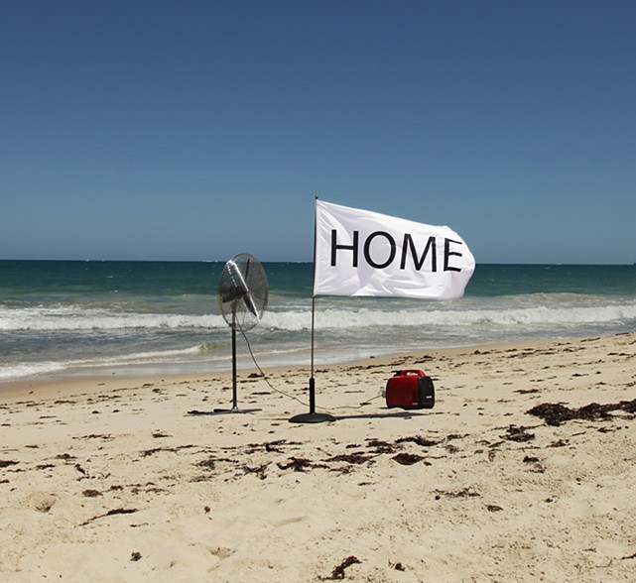
"Home#1" (Abdullah, 2013)
What was his conceptual concerns?
- Relating to events
- Political views
How has he created the work?
Material practice
- Photography techniques
- Processes
- Composition
- Size/ scale
- Lighting.

Abdul Abdullah
Read the paragraph below
Abdul Abdullah is an artist from Perth whose practice explores the identity and experience of marginalised members of the Australian community. His works are driven by symbolism and personal experience. As the son of a sixth-generation Australian and a Malaysian Muslim, he offers a unique perspective into ideas about contemporary Australian culture and what it means to be a young Australian Muslim today. He has been the recipient of various grants and awards including the Blake Prize for Human Justice in 2011 and most recently, he was named finalist in the Archibald Prize for his portrait of artist and activist Richard Bell.
(Abdullah, 2015)
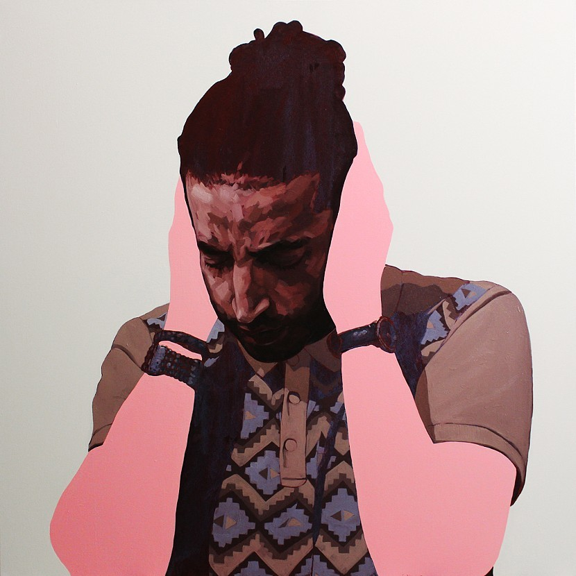
"Sometimes we cover our ears so we can't hear". (Abdullah, 2013)
Discuss:
- Abdul Abdullah's practice explores the identity and experience of marginalised members of the Australian community. Why is he concerned about this? How does his concept relate to his subject matter?
“I think, as a contemporary artist practising in 2017 with an eye on the future, it is essential to have a diverse practice. The value in what we do doesn’t reside in the materials we use—it’s in the ideas. Things can be manufactured, and things can be built. What differentiates a good piece of work from a shit one, is why it exists.”
("Abdul Abdullah’s an Artist you should get to Know", 2018)
More discussion questions
- What did he mean by diverse practice?
- Why does he value ideas over materials?

Watch, listen, interpret and discuss the following video:
- "Abdul Abdullah: The Bad Guy''
(de Kooning, Silcox & Abdullah, 2014)

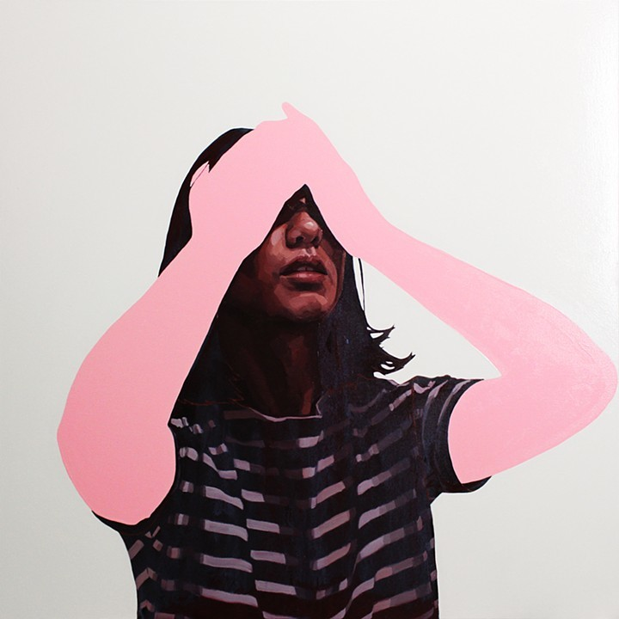
"Sometimes we cover our eyes so we can't see" (Abdullah, 2013)

Abdul Abdullah
Watch, listen, interpret and discuss the following video:
- "Don't call me aussie- combating prejudice through art"
(Abdullah, 2015)
Write key words to add to your word bank about the artist and key ideas he mentioned.
In the video the artist will briefly introduce a discussion about the following works you will be looking at in more depth:
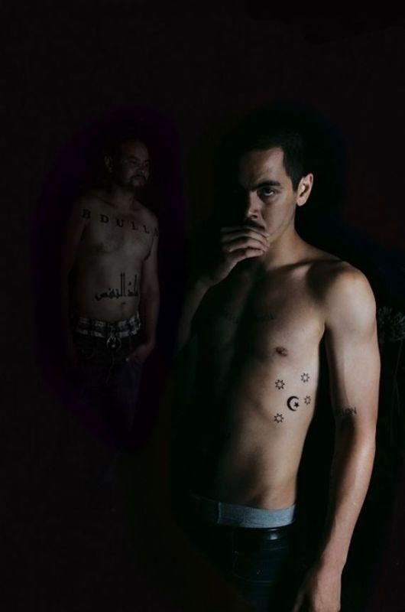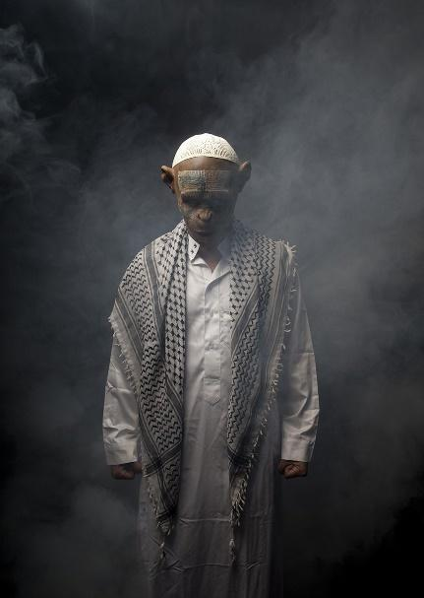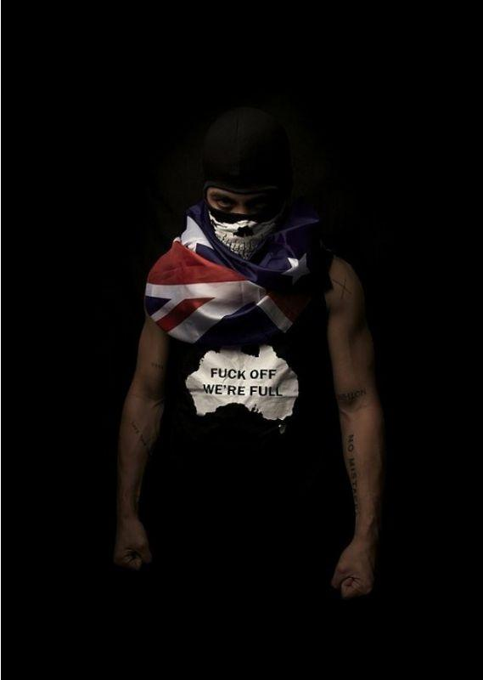
“Them and us” (Abdullah, 2011), “Self portrait you see monsters (Abdullah, 2014), “Self portrait as an ultranationalist” (Abdullah, 2013).
Lead discussion question:
- how has the artist Abdul Abdullah reflected events in society to inform his art practice?
Comprehension and Process
Read and discuss the statement below.
The race discrimination commissioner Tim Soutphommasane has described the Cronulla riot as “an episode of ugly jingoism”. He added: “People should remember it as a shameful episode of mob violence, rather than celebrate it as a source of national pride”.
Photographer: Andrew Quilty
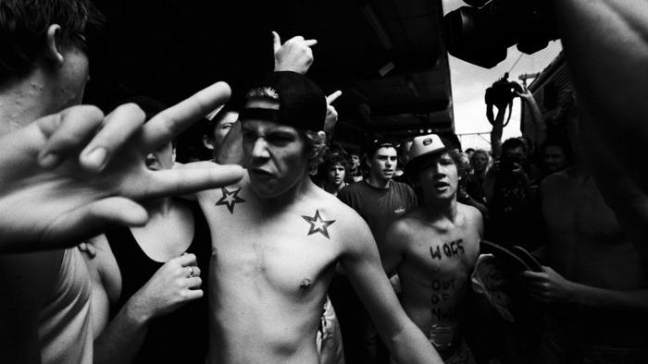 (Quilty, 2005).

"Them and us" by Abdul Abdulla
Excerpt from Nathan Beard's essay on 'Them and us'
The tattoo Abdul exhibits in the photographic work “Them and Us”, an emblem hybridising the Southern Cross with the Crescent moon symbol of Islam, further confuses and subverts existing codes of nationalism and masculinity which pervasively influence racist attitudes towards the ‘other’. This particular work also clearly articulates a personal struggle for Abdullah, in resolving how to be both a proud Muslim and a proud Australian, two conditions that should not be mutually exclusive but in the current political climate are conditioned to be almost diametrically opposed.
(Beard, 2011).
“Them and us” Digital print Artwork by Abdul Abdullah.
Photo by David C. Collins
164cm x 110cm
2011
Watch, listen, interpret and discuss the video clip from SBS news:
- Winner of the 2011 Blake Prize for Human Justice
(Winner of the 2011 Blake Prize for Human Justice, 2011).

Find out:
- what is the Blake art prize for?
- who is awarded it?
- where and when is it held?
Abdul Abdullah won the 2011 Blake Price for Human Justice:
- why did you think his work was judged to be the best representation of 'human justice'? (subjective)
- what key aspects of Australian culture did Abdul Abdullah focus on? (cultural)
- what technical refinements did he achieve in creating the work? (Material practice)
- the artist is standing in the picture (closest figure to the viewer) and thus was not the photographer, does that change how you view the work? Should he claim it as his own? (post-modern)

"You see monsters" by Abdul Abdullah
Do you think that of me?
His striking paintings, photographs and installations explore themes of belonging and alienation to give a voice to disenfranchised and disillusioned youth. Abdullah applies visual cues from popular culture and takes inspiration from civil unrest, like the London riots and the Arab Spring, in his body of work (Abbass, 2014).
- How is Abdul Abdullah demonstrating the ironic nature of belonging and alienation at the same time?

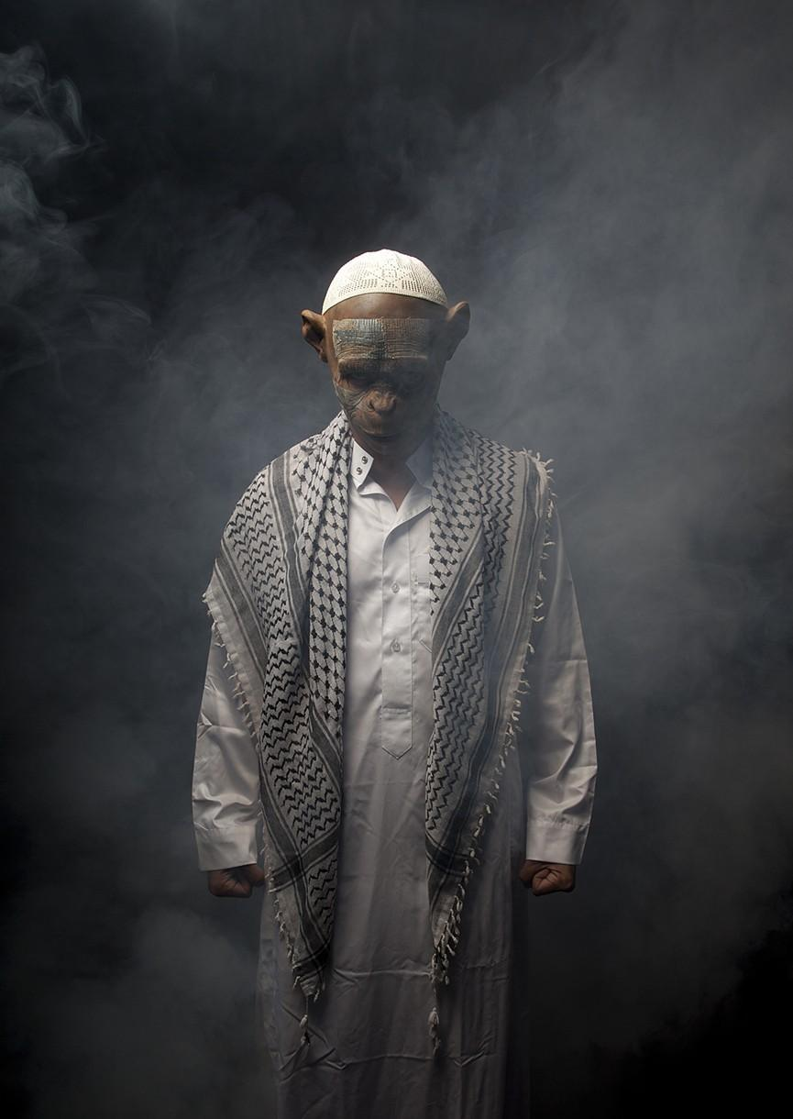
You see monsters
C-type print
2014
(Abdullah, 2014).

Watch, listen, interpret and discuss the following video:
- “You See Monsters trailer”
(Australian Centre for the Moving Image, 2017).
Abstract
The Australian Muslim community has been demonised and castigated for their religious identity in the wake of bigotry and racism that has echoed throughout Australian culture. Seven rising Muslim artists Abdul Abdullah, Cigdem Aydemir, Safdar Ahmed, Aamer Rahman, Abdul-Raman Abdullah, Sara Mansour and Zohab Zee Khan produce their own art which doesn’t shy away from these hidden truths, with the hope of fighting back against bigotry through creativity.
(Australian Centre for the Moving Image, 2017).
Extension
Research other artists listed above.

Radical
Answer the following in a written response:
15min questions
Frames
- Post-modernist artists can seek to expose the marginalised and mistreated, refer to "Radical" by Abdul Abdullah in your response.
Conceptual framework
- Examine how an artist can display his political opinions in an artwork, refer to "Radical” and/or other works by Abdul Abdullah in your response.
Practice
- An artist’s idea is more important than his materials, discuss this looking at the practice of Abdul Abdullah.

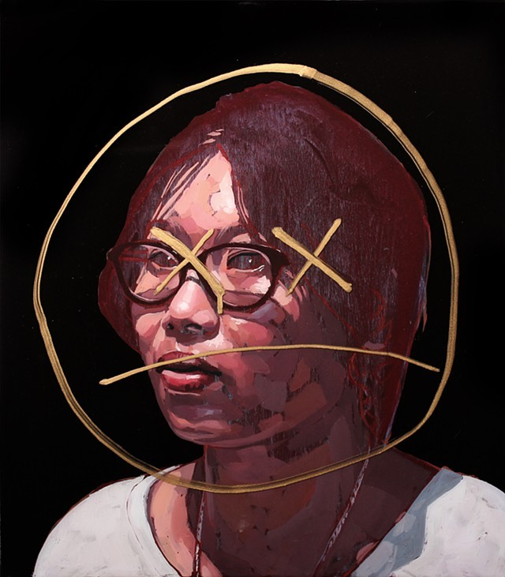
Radical
Oil, acrylic, resin and pen on board
40 x 35 cm
2016
(Abdullah, 2016).

References for Booklet 2, Artist Abdul Abdullah
Abbass, R. (2014). Artist captures the mood of the marginalised. Retrieved from https://www.aljazeera.com/indepth/features/2014/06/abdul-abdullah-australian-artist-marginalised-racism-ara-201462572052118236.html
Abdul Abdullah’s an Artist you Should get to Know. (2018). Monster Children. Retrieved from https://www.monsterchildren.com/55001/abdul-abdullahs-an-artist-you-should-get-to-know/
Abdullah, A. (2011). Them and us [Photography]. https://abdulabdullah.com/artwork/2032043-Them-and-us.html
Abdullah, A. (2013). Home#1 [Digital Print]. Sydney: https://abdulabdullah.com/section/340692-HOME.html
Abdullah, A. (2013). Maybe I am the bad guy [C-type print]. Sydney: https://abdulabdullah.com/section/373773-Homeland.html
Abdullah, A. (2013). Sometimes we cover our ears so we can't hear [Oil and enamel on canvas]. Sydney: https://abdulabdullah.com/section/373773-Homeland.html
Abdullah, A. (2013). Sometimes we cover our eyes so we can't see [Oil and enamel on canvas]. Sydney: https://abdulabdullah.com/section/373773-Homeland.html
Abdullah, A. (2014). You see monsters [Type C print]. https://abdulabdullah.com/artwork/3434099-You-see-monsters.html
Abdullah, A. (2015). Don't call me Aussie: Combating Prejudice With Art [Video]. https://tedxsydney.com/talk/dont-call-me-aussie-combating-prejudice-with-art/ TEDxSydney.com
Abdullah, A. (2016). Radical [Oil, acrylic, resin and pen on board]. Sydney: https://abdulabdullah.com/section/441645-Burden.html.
Australian Centre for the Moving Image. (2017). You See Monsters trailer [Video]. Retrieved from https://www.acmi.net.au/events/you-see-monsters-q/
Beard, N. (2011). Them and Us [Ebook]. Melbourne: Catalogue essay. Retrieved from https://abdulabdullah.com/artwork/2032043-Them-and-us.html
de Kooning, M., Silcox, B., & Abdullah, A. (2014). The bad guy [Video]. https://abdulabdullah.com/artwork/3654291-ABDUL-ABDULLAH-THE-BAD-GUY.html
Quilty, A. (2005). [C-Type Print]. Sydney: https://www.andrewquilty.com/
National Gallery of Australia. (2013). Indigenous art [Video]. Retrieved from https://vimeo.com/channels/indigenousart/63287336
The Board of the Special Broadcasting Service (SBS). (2011). Winner of the 2011 Blake Prize for Human Justice [Video]. https://abdulabdullah.com/artwork/2241804-The-Blake-Prize.html

