Music 2 HSC: Music of the last 25 years

‘Bend/Boogie/Break’ by Holly Harrison
Music 2 Stage 6 Syllabus © 2009 NSW Education Standards Authority (NESA) for and on behalf of the Crown in right of the State of New South Wales.
Contents
‘Bend/Boogie/Break’ by Holly Harrison 0
Rationale 3
‘Bend/Boogie/Break’ by Holly Harrison 4
Who is Holly Harrison? 4
Holly Harrison’s music 5
‘Bend/Boogie/Break’ (2018) 6
Musicology and aural 7
Activity 1: Research and brainstorm 7
Activity 2: Score analysis 8
Activity 3: Bend, boogie and break examples 11
Activity 4: Note bending 13
Activity 5: Moods 13
Activity 6: Harmonic analysis 14
Activity 7: Expressive techniques 14
Aural 16
Melodic and rhythmic dictation 16
Performance 18
Musicology and aural 20
Activity 1: Podcast activity 20
Activity 2: Jigsaw 21
Activity 3: Musicology extended response 23
Composition, musicology, aural and performance 24
Option 1 24
Option 2 25
Additional activities – Musicology and aural 28
Activity 1: Podcast activity 28
Activity 2: Research 28
Answers – Musicology and aural 30
Activity 3: Bend, boogie and break examples 30
Activity 4: Note bending 38
Activity 5: Moods 38
Activity 6: Harmonic analysis 39
Activity 7: Expressive techniques 40
Aural 42
Melodic and rhythmic dictation 42
Performance 43
Musicology and aural 44
Activity 1: Podcast activity 44
Activity 3: Musicology extended response 48
The concepts of music checklist 52
Duration 52
Pitch 52
Structure 53
Texture 53
Tone colour 54
Dynamics and expressive techniques 54
References 55

Rationale
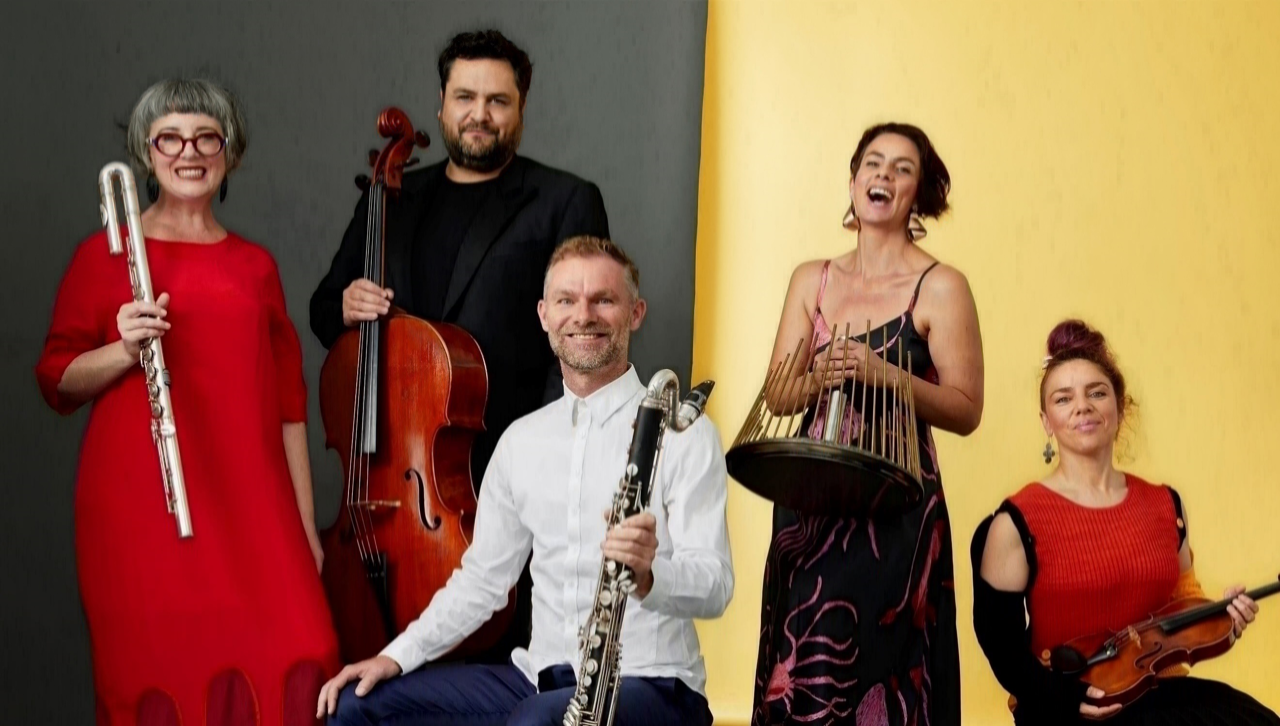
“EO 2022 – Yellow” by Keith Saunders © Ensemble Offspring (2022) and reproduced with permission.
This educational resource has been prepared for students studying the NSW Higher School Certificate Music 2 course as part of the mandatory topic ‘Australian Music of the Last 25 Years’. It is comprised of a piece titled ‘Bend/Boogie/Break’ written by Australian composer Holly Harrison. This piece is Harrison’s third work in a series commissioned by Penny Le Couteur and Greg Dickson and composed for Ensemble Offspring, Australia’s leading modern art music ensemble renowned for championing the music of living composers.
‘Bend/Boogie/Break’ premiered in a concert at the Sydney Conservatorium of Music on 29 September 2018. This concert featured sound worlds so distinctive, that the organisers had to coin a new name for the music and called the concert Spectral Tech.
This resource contains a variety of aural, musicology, performance, and composition activities suitable for study. Scores, worksheets, and answers for the teacher are also included. The activities contained in the resource provide students with opportunities to explore the musical concepts and compositional techniques that Harrison has utilised to represent the context of the work. Class performance activities are integrated to develop performance and score reading skills, and to further explore the compositional devices utilised. Students are then required to demonstrate their understanding of these devices through completion of the composition activities provided. A listening guide is included for score study, in addition to guided aural and musicology activities. Teachers should adapt these learning resources for their own teaching and learning context.
If you would like to provide feedback on this resource, please email CreativeArts7-12@det.nsw.edu.au.

‘Bend/Boogie/Break’ by Holly Harrison
Score distribution permissions for Curriculum Secondary Learners, Curriculum and Reform Directorate of the NSW Department of Education have been granted by @Holly Harrison (2022).

Who is Holly Harrison?
Holly Harrison by Steve Broadbent (2022) is reproduced with permission.
Holly Harrison is an award-winning Australian composer from Western Sydney. Her music is driven by the nonsense literature of Lewis Carroll, embracing stylistic juxtapositions, the visceral energy of rock, and whimsical humour. She was the Tasmanian Symphony Orchestra’s composer in residence from 2020-2021, and in 2022 is a tutor for the Tasmanian Symphony Orchestra’s Australian Composers’ School. Harrison is also a mentor for Omega Ensemble’s 2021 and 2022 CoLAB program for pre-professional composers.
Harrison’s music has been performed in Australia, Asia, Europe, and the USA. She has worked with the Melbourne, Sydney, Adelaide, Canberra, West Australian and Tasmanian Symphony Orchestras, Australia Ensemble, Ensemble Offspring, Alarm Will Sound, Nu Deco Ensemble, Orkest de Ereprijs, Het Gelders Orkest, and the Australian String Quartet. Her work ‘Splinter’ was a finalist in the Work of the Year: Large Ensemble category of the 2021 APRA AMCOS Art Music Awards. Recent highlights include the Australian Youth Orchestra touring ‘Frumious’ internationally in 2019 and writing the rock-inspired ‘Balderdash’ as the set string quartet work for the 2018 Melbourne International Chamber Music Competition.
Harrison plays drum kit and percussion in the experimental rock duo Tabua-Harrison (Music Trust 2021).
Holly Harrison’s music
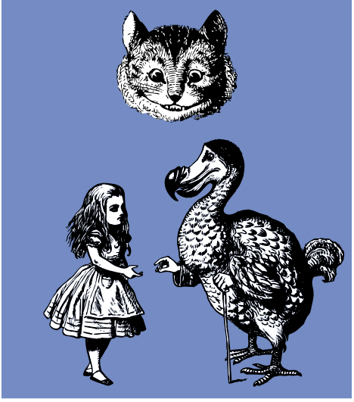
“Alice in wonderland wins a prize” by John Tenniel is in the Public Domain CC0.
‘On one level, I’m not overly concerned with style during the compositional process; I write in a way that feels natural and organic for me. I suspect this is a hallmark of my stylistically diverse musical background – I grew up playing classical trumpet in wind and brass bands, drums in punk rock/metal bands, and later flute in improvised rock bands. It’s impossible to even write that sentence without acknowledging genre or the existence of some sort of perceived classical versus vernacular divide. My music is the amalgam of my musical experiences and I try not to think of a particular style as being removed from another.
My music is inherently playful and mischievous, even the slower stuff. I like to have seriously good fun with it. For me, humour appears in my music when an instrument veers off in an unexpected direction or when two unlikely things are paired together. This is also informed by genre and style, how we identify different types of music, and how we expect them to sound.
The whimsical humour in my music very much stems from my obsession with Lewis Carroll and the Alice books. The stories are riddled with sudden scene and mood changes, bending of the rules, and Alice’s simultaneous matter-of-factness and temper fits. I love that the rules of logic can continually change, and in a dream world, this makes absolute sense – it’s all about the context that gives us permission to do this.
This concept of a changing sense of logic, or a warping of the sounds, has certainly inspired my musical language and humour. In this way, there’s a sort of self-consciousness of instruments which I find quite appealing. I like the idea of an instrument being aware that something might not be ‘quite right’ in the performance.’ (Harrison 2020).

‘Bend/Boogie/Break’ (2018)
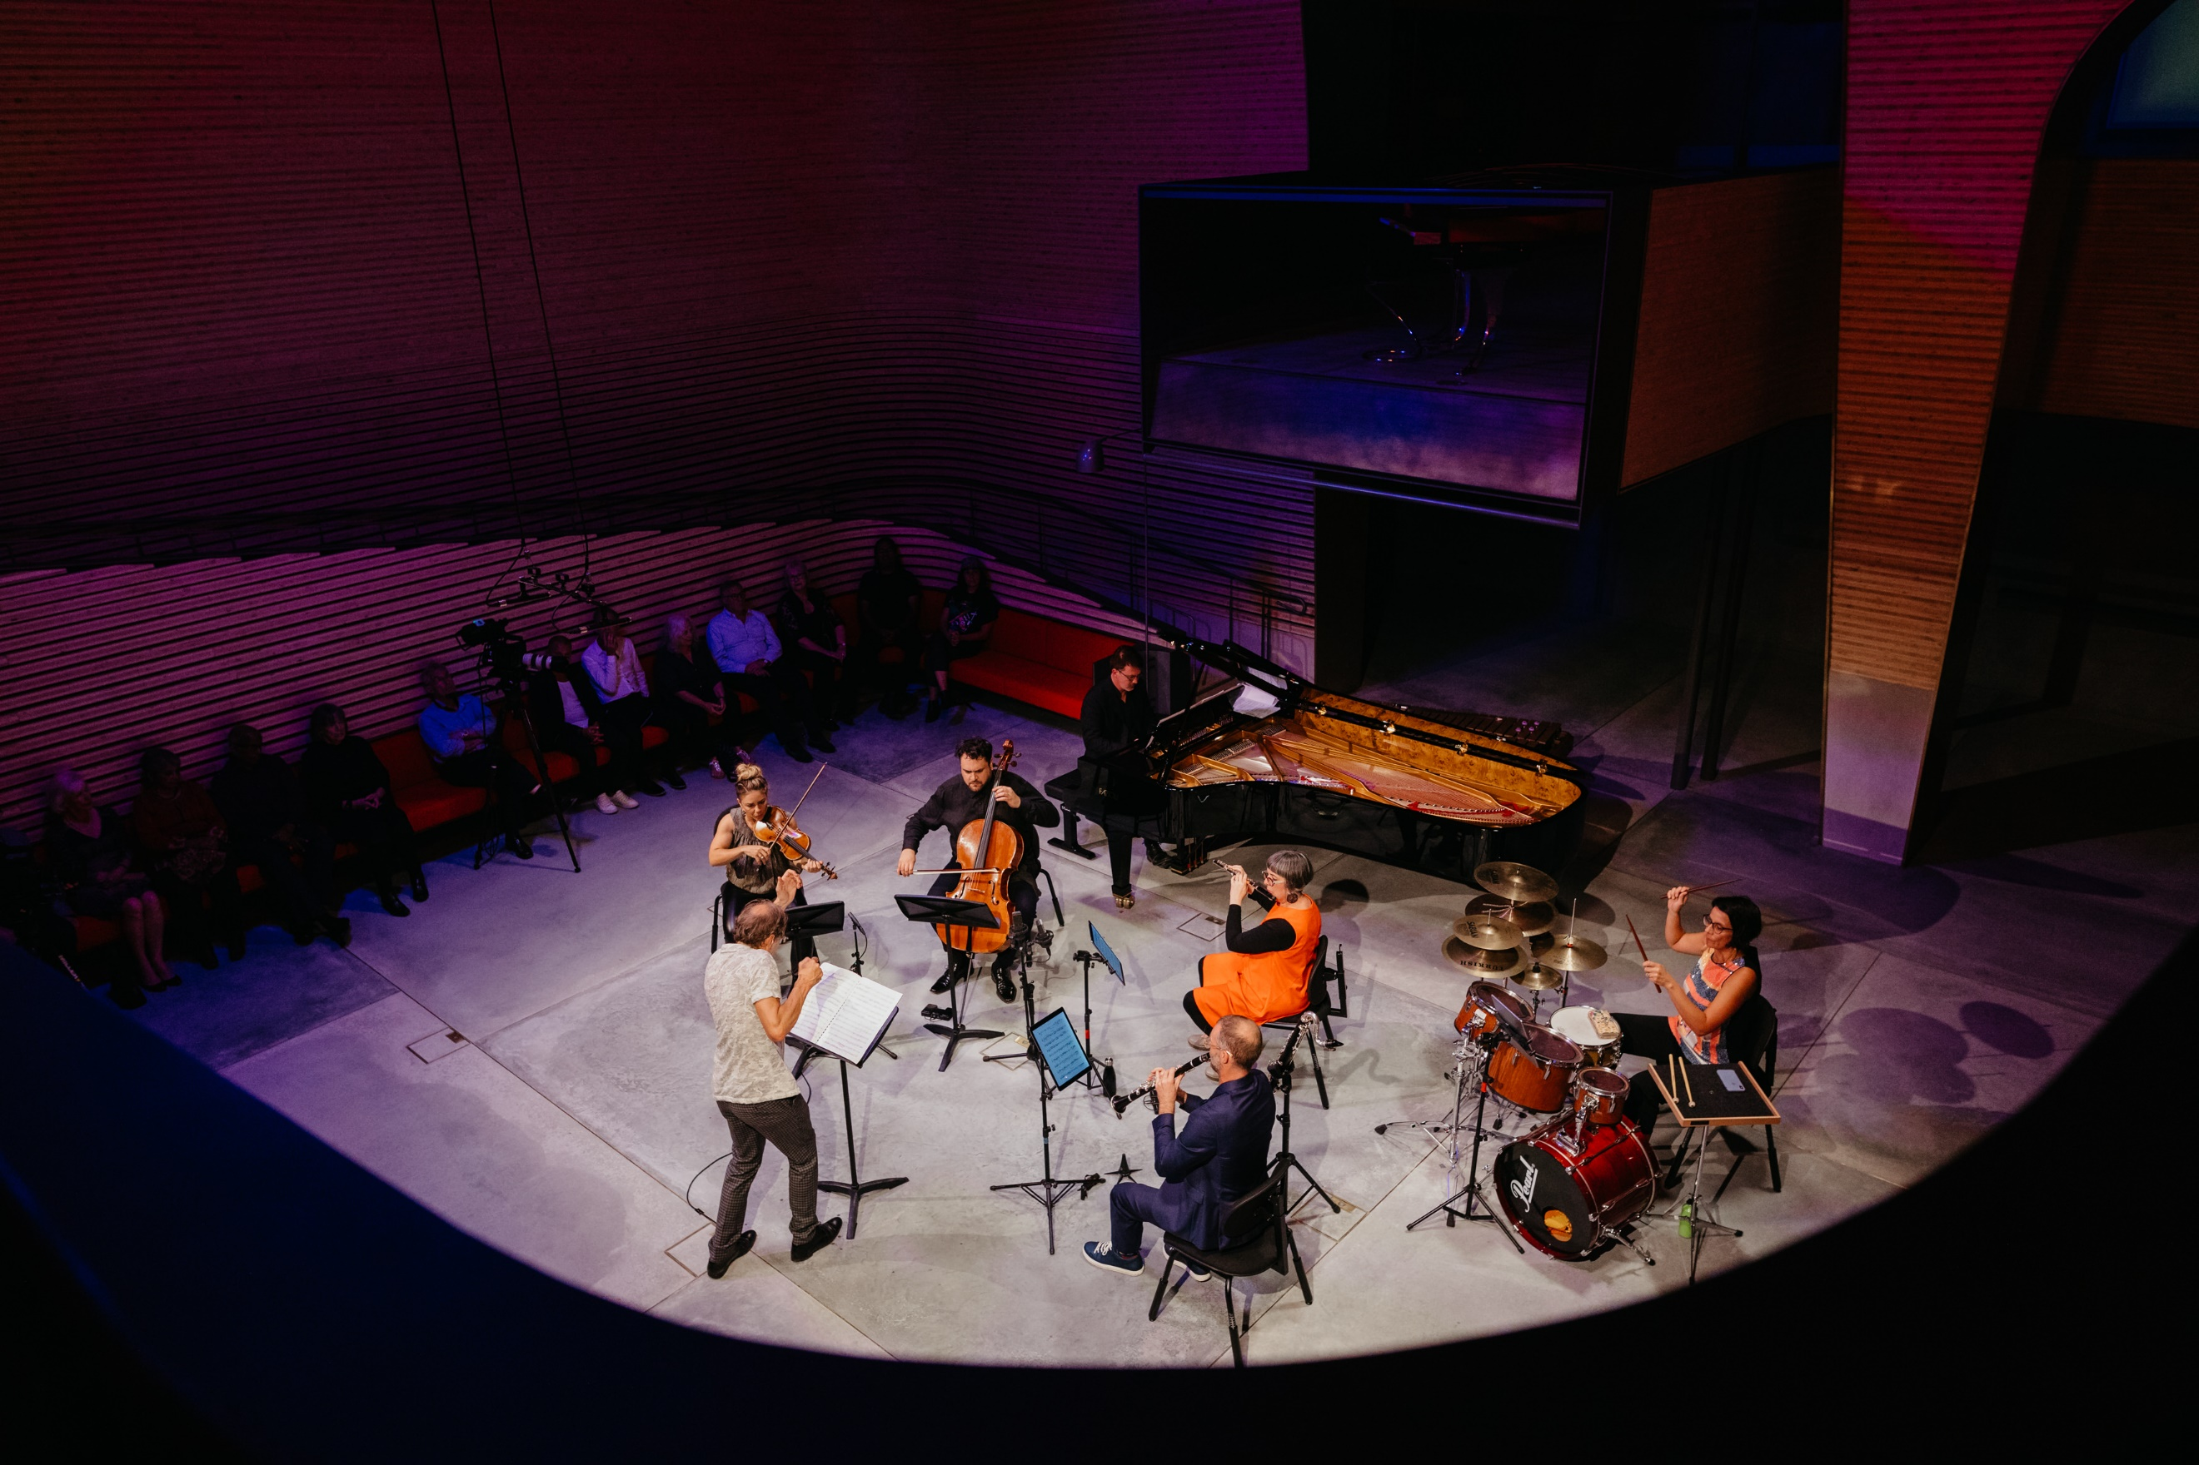
Image by Elin Bandmann © Ensemble Offspring (2022) and reproduced with permission.
Australian composer Holly Harrison wrote ‘Bend/Boogie/Break’ especially for Ensemble Offspring – a high profile collective of virtuosic and curious Australian instrumentalists championing the music of living composers. The piece is written for the full forces of Ensemble Offspring (flute, clarinet, violin, cello, percussion, and keyboard). In a short text written for the premiere of this piece, Harrison describes the collaboration:
‘One of the great things about working with this group is the opportunity to workshop the piece early on in the creative process. This makes it more collaborative from the get-go and allows us to write for the specific personalities and skills of the group – their insights and comments are invaluable. When we workshopped part of the piece back in April I found that while certain things worked, there were many elements that I wanted to change, including the percussion set-up, adding a longer, slower section in the middle, and creating a more prominent violin part. Ultimately, I kept a third of this original material and re-wrote the rest. This way of working offers a level of experimentation that acts as a vital sounding board. The end result of this work process was ‘Bend/Boogie/Break’, a piece which combines several musical styles and bears a title which in part reveals what the music is about.’ (Harrison 2018).

Musicology and aural

Activity 1: Research and brainstorm
- Go to Holly Harrison and write down 5 significant musical points about Harrison that may assist you in your study of this work.
- Listen to Ensemble Offspring perform Bend/Boogie/Break (10:16). Using the mind map below, brainstorm any interesting musical observations or first impressions that you have of the work. Consider how Harrison uses the 6 concepts of music to musically depict the 3-word title ‘Bend/Boogie/Break’ in your initial ideas.
Figure 1 – Bend/Boogie/Break mind map
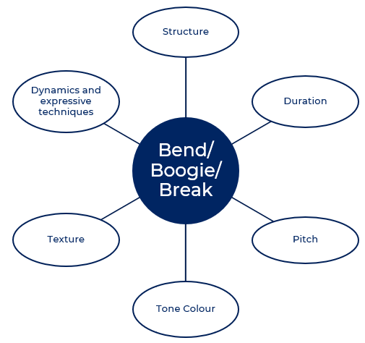
- Read the quote below which describes Harrison’s intentions of the title, ‘Bend/Boogie/Break.’ Make notes according to:
- the musical influences that reflect each word in the title
- Harrison’s compositional process.
‘The title describes the character of three recurring ideas in my work. ‘Bend’ refers to the use of glissandi and pitch bends in longer lines, ‘Boogie’ – to the underlying funk bass driving the piece, and ‘Break’ – as in to break apart or a ‘breakdown’ section (a nod to the metal-inspired rhythms towards the end). The work draws inspiration from post-rock riffs and timbres, funk rhythms, and honky-tonk piano, as well as the overarching idea of warping vinyl and things ‘going wrong’: perhaps bent out of shape, broken, or not quite right. It bends between moods: dark and brooding, joyous and fizzing.’ (Harrison in Spectral Tech 2018).
‘It’s worth noting that it was only after I had completed the piece, that I titled it ‘Bend/Boogie/Break’. Throughout the compositional process, it’s important for me to work instinctively from the get-go, combining this with more analytical and reflective moments as the work goes on. The title is a somewhat cheeky way to acknowledge the three main characteristics of the work, which I wasn’t always aware of during the compositional process but revealed themselves towards the end. This sort of reiterative approach, of making discoveries along the way, helps me to adjust ratios of sections and colour in the music during editing. The title ‘Bend/Boogie/Break’ is not intended to depict the structure of the work in a linear way, from left to right. Instead, I like to think that each section organically contains a bit of bend, a bit of boogie, and a bit of break, with threads shooting off in different directions and then tying back together at the end.’ (Harrison 2021)

Activity 2: Score analysis
- Listen to Bend/Boogie/Break (10:16) whilst following the score provided.
- Find and label specific examples on the score to support the information provided in the listening guide below.

Listening guide
Table 1 – Listening guide
Concepts | Musical features
Structure | - through composed, with continuous development and variation of musical material  - the piece bends between 2 different moods: ‘dark and brooding’ and ‘joyous and fizzing’  - some sections are clear and distinct, with clear changes in tempo, mood, texture, and instrumentation between sections  - extended melodic and rhythmic phrases are often constructed of short sub-phrases or cells
Duration | - mostly constant tempo, with slower middle sections  - frequent changes of meter (multimeter), mostly simple time – 4/4, 3/4, 2/4, 5/4, 6/4, occasionally irregular – 5/8, 7/8, creating sense of free time but with a consistent pulse  - semiquaver subdivisions used consistently, syncopated rhythms contrasting with longer sustained, pitch bending notes  - instruments often work in pairs or groups in rhythmic unison
Pitch | - suggestion of blues tonality featuring intervals such as minor 3rd, augmented 4th, minor 7th, with heavy use of chromaticism/free tonality  - use of quarter tones in pitch bending of sustained notes, often creating clashing dissonances transforming from unisons/octaves  - melodic lines often in unison/octaves or parallel 3rds/10ths  - chords often featuring open 5ths, reminiscent of rock/metal power chords  - frequent use of extension chords/added chords
Tone colour | - sextet – flute, bass clarinet/Bb clarinet, violin, cello, percussion, and keyboard  - contrasting tone colours – woodwind, strings, percussion, electronic  - different percussion instruments featured in different sections, sometimes in combination with vibraphone  - extremely wide pitch range  - selected passages played in the extremes of instrument registers  - extended techniques used to ‘rough-up’ the sound  - harsh timbre overall with use of distortion  - melodic, harmonic and rhythmic roles shared between the instruments throughout the piece
Texture | - texture changes between thick and thin in different sections  - mostly polyphonic texture throughout  - doubling of melodic lines (and other layers) in different instrumental combinations featured throughout  - unison passages in different instrumental combinations used to build tension  - rapidly changing melodic lines juxtaposed with slow moving/bending lines and more static, rhythmic layers
Dynamics and expressive techniques | - extended instrumental techniques featured such as jet whistle, flutter tongue, slap pizzicato, bowed vibraphone  - prominent use of jazz/rock articulations – accents, tenuto, staccato  - extremes of dynamics  - both gradual and sudden dynamic changes used  - prominent use of glissando and note bending  - prominent use of multiphonics and distortion

Activity 3: Bend, boogie and break examples
- Complete the table to discover how Harrison uses musical material to depict the character of the 3 recurring ideas, ‘Bend/Boogie/Break’, with reference to specific musical examples from the score.
Table 2 – Bend/Boogie/Break musical identification Table A
Instrumental part and bar numbers | Bend and/or boogie and/or break? | Description of how the selected word bend, boogie or break has been depicted musically, supported by related score extracts/bar numbers
clarinet, violin and cello  bar 147-152 | (Add category) | (Add description)
vibraphone, clarinet  bar 151-152 | (Add category) | (Add description)
violin, cello, clarinet, vibraphone  bar 154-155 | (Add category) | (Add description)
vibraphone, violin  bar 149-150 | (Add category) | (Add description)
tutti  bar 142-172 | (Add category) | (Add description)
flute, clarinet  bar 123-129 | (Add category) | (Add description)
keyboard  bar 203-204 | (Add category) | (Add description)
keyboard  bar 159 to end | (Add category) | (Add description)
tutti  bar 214 to end | (Add category) | (Add description)
keyboard, bass Clarinet  bar 1-52 | (Add category) | (Add description)
keyboard, bass clarinet  bar 72-88 | (Add category) | (Add description)
tutti  bar 37-130 | (Add category) | (Add description)
- Now it’s your turn to locate at least 3 more examples of how Harrison has used musical material to depict the character of the 3 recurring ideas; bend, boogie and break in her piece, with reference to specific musical examples from the score.
Table 3 – Bend, boogie, break identification Table B
Instrumental part and bar numbers | Bend and/or boogie and/or break? | Description of how the selected word bend, boogie or break has been depicted musically, supported by related score extracts/bar numbers
(Add instrument) | (Add category) | (Add description)
(Add instrument) | (Add category) | (Add description)
(Add instrument) | (Add category) | (Add description)

Activity 4: Note bending
Note bending is a prominent feature of ‘Bend/Boogie/Break.’ Identify the changes of pitch in the violin part from bars 147-152 (ascending or descending) and the amount of change (in ¼ tones) in each bar.
Table 4 – Violin pitch table
Section Q  bar number | Violin pitch direction (ascending or descending) | Amount of change (in ¼ tones)
Bar 147-148 | (Add direction) | (Add change amount)
Bar 148-149 | (Add direction) | (Add change amount)
Bar 149-150 | (Add direction) | (Add change amount)
Bar 150-151 | (Add direction) | (Add change amount)
Bar 151-152 | (Add direction) | (Add change amount)

Activity 5: Moods
The structure of Harrison’s piece ‘Bend/Boogie/Break’ also changes between 2 different moods: ‘dark and brooding’ and ‘joyous and fizzing.’ Describe how Harrison has achieved these 2 contrasting moods in the piece through her use of the musical concepts. In your answer, make specific reference to the score.
Table 5 – Mood table
Mood | Description of how this mood is achieved in terms of the use of music concepts, supported by related examples from the score
dark and brooding | (Add description)
joyous and fizzing | (Add description)

Activity 6: Harmonic analysis
- Using the score, identify the chords in Section C (bar 19) of the keyboard part and complete the table below.
Table 6 – Harmonic analysis table
Where | Type of chord
Bar 19, beat 1 – keyboard | (Add chord type)
Bar 19, beat 2 – keyboard | (Add chord type)
Bar 19, beat 3 – keyboard | (Add chord type)
- Why do you think Harrison favours the use of extended chords in ‘Bend/Boogie/Break’?

Activity 7: Expressive techniques
- Watch Flute extended techniques (3:29) by Lamorna Nightingale (flautist, Ensemble Offspring) who explains and demonstrates the use of flute extended techniques in ‘Bend/Boogie/Break’.
- Locate and define the performance extended techniques (musical terms and symbols) in the table below used in ‘Bend/Boogie/Break’.
Table 7 – Expressive techniques table
Musical term or symbol | Bar number | Instrumental part | Definition
jet whistle | (Add bar number) | (Add part) | (Add definition)
snap pizz. | (Add bar number) | (Add part) | (Add definition)
slap | (Add bar number) | (Add part) | (Add definition)
flz. | (Add bar number) | (Add part) | (Add definition)
secco | (Add bar number) | (Add part) | (Add definition)
slap pizz. | (Add bar number) | (Add part) | (Add definition)
arco. | (Add bar number) | (Add part) | (Add definition)
shake | (Add bar number) | (Add part) | (Add definition)
strum | (Add bar number) | (Add part) | (Add definition)
body slap | (Add bar number) | (Add part) | (Add definition)
nat. | (Add bar number) | (Add part) | (Add definition)
 | (Add bar number) | (Add part) | (Add definition)
 | (Add bar number) | (Add part) | (Add definition)
 | (Add bar number) | (Add part) | (Add definition)
bow  V | (Add bar number) | (Add part) | (Add definition)

Aural

Melodic and rhythmic dictation
- Notate the pitch and rhythm of the flute part (bars 63-65) from ‘Bend/Boogie/Break’ on the stave provided. The teacher will need to cue when the flute begins. Play Audio excerpt 1 (0:11).
Figure 2 – Score for flute part: 3 blank bars
- One of the rhythmic features of ‘Bend/Boogie/Break’ is the use of multimeter. There are 2 options for this activity.
- Option 1: Notate the rhythm of the flute part (bars 214-225) on the staves provided.
- Option 2: Notate the pitch and rhythm of the flute part (bars 214-225) on the staves provided.
Note: In this excerpt the flute is heard an octave higher than notated. The teacher will need to cue when the flute begins. Play Audio excerpt 2 (0:29).
Figure 3 – Score for flute part: 12 blank bars
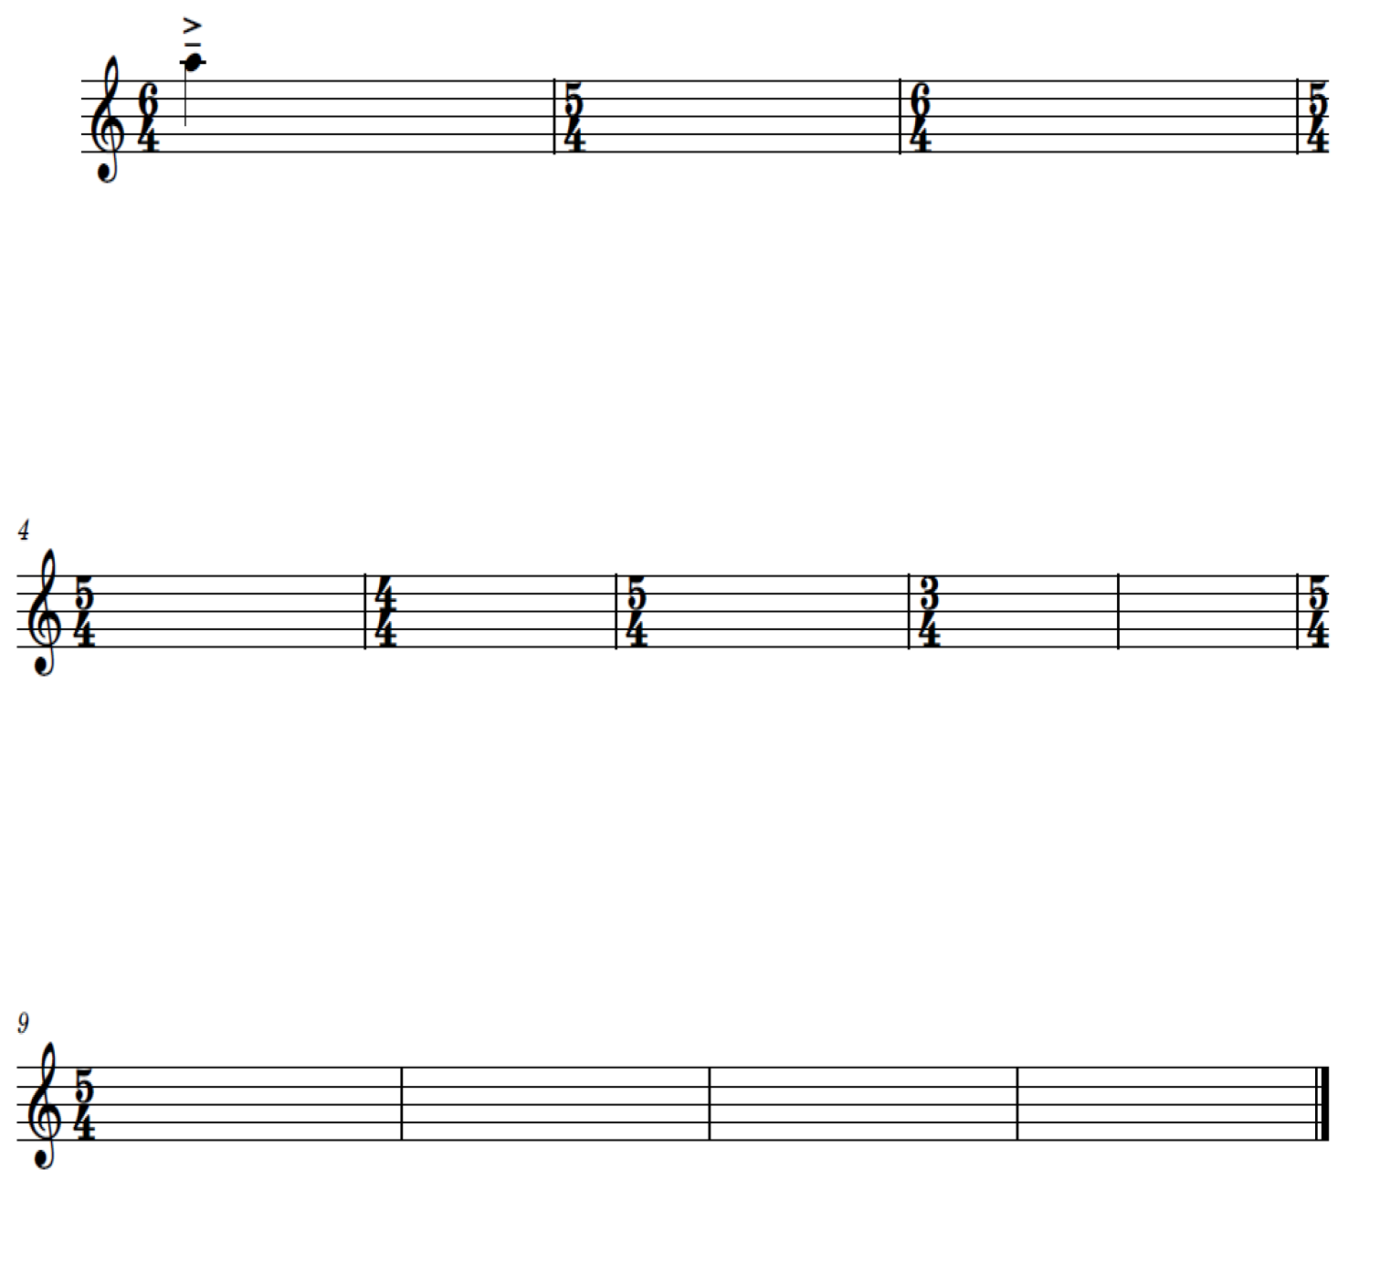

Performance
‘The range of nuance in articulation makes such a big difference to the style of any music. As a performer one of the biggest challenges of playing this music is the cross-over aspect of the style. How do you make classical instruments played by classically trained players sound ‘rock’!? Holly asks the players to use extended techniques to rough up the sound and this helps. We also spent a lot of time talking about articulation and note lengths in order to get the groove.’ – Lamorna Nightingale (Flautist, Ensemble Offspring)
- Watch Performance challenges of ‘Bend/Boogie/Break’ (2:37) by Lamorna Nightingale (flautist, Ensemble Offspring) in which Larmorna discusses some of the challenges that the performers faced when playing ‘Bend/Boogie/Break’.
- Watch ‘Bend/Boogie/Break’ articulation (2:51) by Lamorna Nightingale (flautist, Ensemble Offspring) in which Larmorna explains and demonstrates how to correctly perform the flute part in Section V – W from ‘Bend/Boogie/Break’ (with specific focus on articulation and note lengths to achieve the desired musical ‘groove’).
- Perform the flute part of Section V-W (bars 214-225) from ‘Bend/Boogie/Break’ as a class ensemble, focussing on the use of correct articulation and note lengths to achieve the desired musical style. Before you start, transpose the flute melody below in to at least 2 different keys so that it can be played in unison by:
- Bb instruments
- Eb instruments
- F instruments
- Alto clef instruments
- Bass clef instruments.

Figure 4 – Flute melody (Section V-W, bars 214-225)
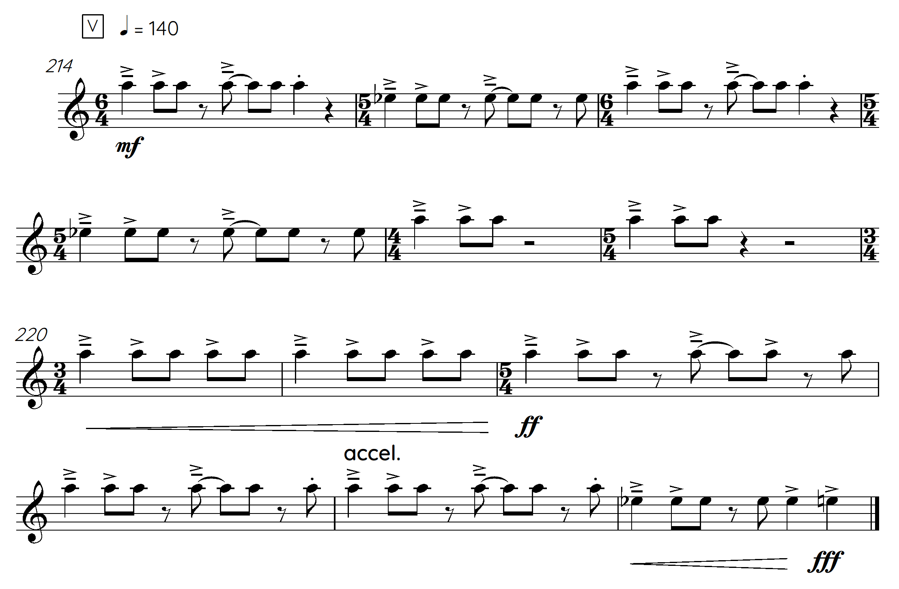

Musicology and aural
A characteristic of Harrison’s music is juxtaposing different musical styles within a single piece. In ‘Bend/Boogie/Break’ she has included the use of post-rock riffs, post-rock timbres, funk rhythms and honky-tonk inspired ideas as well as drawing on inspiration from spectral music.
‘She (Holly Harrison) is motivated by a range of genres that she has grown up with, from rock to classical and her own music is borderless as a result. She is able to draw on her knowledge from playing a range of diverse instruments in a variety of settings when composing.’ (Stefanakis 2021).

Activity 1: Podcast activity
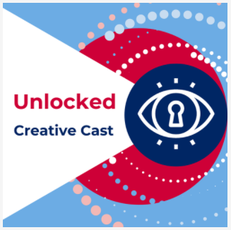
Listen to the Creative Cast ‘Unlocked – Australian music of the Last 25 years’ (39:34). In this episode, Australian composers Holly Harrison and Jessica Wells speak about their works titled ‘Bend/Boogie/Break’ and ‘Diminishing Species’. Joining them is Ensemble Offspring Artistic Director and percussionist Claire Edwardes. Listen to an insightful discussion that unlocks the compositional process used in both works through the composer and performer lens.
Answer the questions below related to Holly Harrison and her piece ‘Bend/Boogie/Break’ as discussed in the podcast. Please note, time stamps have been provided to assist you in finding the relevant information.
Podcast time stamp: 00:00 to 14:45
- What does Harrison’s music explore?
- What 3 ensembles does Harrison specialise in writing for?
- ‘Bend/Boogie/Break’ was commissioned by Ensemble Offspring to be included in what special musical program? What did this musical program explore?
- Where did Harrison get inspiration for her piece, ‘Bend/Boogie/Break’, and how did she get started on this composition?
- Define the term ‘spectralism’. Name the 2 famous spectral composers mentioned in the podcast and include their nationality.
- How did Harrison develop the musical material in ‘Bend/Boogie/Break’? Does she use a similar process for all her works?
- ‘Bend/Boogie/Break’ draws inspiration from post-rock riffs and timbres, funk rhythms, and honky-tonk piano. How does Harrison use these ideas in the piece? Are there any other musical styles that influenced ‘Bend/Boogie/Break’?
Podcast time stamp: 28:00
- How did Ensemble Offspring prepare to perform both Harrison’s piece ‘Bend/Boogie/Break’ and Jessica Wells’ piece ‘Diminishing Species’?
- What advice do both Harrison and Wells give to elective music students who lack confidence when composing their own music and/or performing Australian art music?
Podcast time stamp: 39:00
- Who are the 7 ‘up-and-coming’ Australian composers that Harrison, Wells and Edwardes identify as composers that we should all be watching out for and listening to?

Activity 2: Jigsaw
- Students divide themselves into 3 groups. Each group is allocated a column of activities from the table below.
- Students in each group divide the 3 activities between them and individually complete one activity each.
- The individuals in each group then come together and discuss their findings.
- Collaborate as a class using a shared word document to summarise each group’s findings for the entire table.
Table 8 – Jigsaw activity table
Group 1 | Group 2 | Group 3
Research the musical characteristics of post-rock music and summarise your findings using the concepts of music. Then, identify and notate examples of ideas inspired by post-rock music in ‘Bend/Boogie/Break’. | Listen to any piece by the French spectral composer Gerard Grisey. Summarise the similarities/differences between the piece that you listened to and ‘Bend/Boogie/Break’ using the concepts of music. | Listen to a song by Mogwai, a Scottish post-rock band that Harrison identifies as having had a big influence on her own music. Summarise the similarities/differences between the piece that you listened to and ‘Bend/Boogie/Break’ using the concepts of music.
Research the musical characteristics of honky-tonk music and summarise your findings using the concepts of music. Then find and notate examples of ideas inspired by honky-tonk music in ‘Bend/Boogie/Break’. | Listen to any piece by the French spectral composer Philippe Hurel. Summarise the similarities/differences between the piece that you listened to and ‘Bend/Boogie/Break’ using the concepts of music. | Listen to a different song by Frank Zappa, who Harrison identifies as having had a big influence on her own music. Summarise the similarities/differences between the piece that you listened to and ‘Bend/Boogie/Break’ using the concepts of music.
Research the musical characteristics of funk music and summarise your findings using the concepts of music. Then find and notate examples of ideas inspired by funk music in ‘Bend/Boogie/Break’. | Research the musical characteristics of spectral music and summarise your findings using the concepts of music. Then find and notate examples of ideas inspired by spectral music in ‘Bend/Boogie/Break’. | Listen to a different song by Jethro Tull, who Harrison identifies as having had a big influence on her own music. Summarise the similarities/differences between the piece that you listened to and ‘Bend/Boogie/Break’ using the concepts of music.

Activity 3: Musicology extended response
Use your class table summary from the previous activity to help you to individually answer the extended response question below (practice for HSC Question 4):
Explain how composers treat the concepts of music to create a particular style. In your response, refer to TWO works from the mandatory topic, Music of the last 25 years (Australian focus). Access NESA 2018 Music 2 HSC Paper, Question 4.
Answer this question with reference to ‘Bend/Boogie/Break’ and ONE other work that you have studied from the mandatory topic, Music of the last 25 years (Australian focus).

Composition, musicology, aural and performance

Option 1
In this composition activity, students will explore compositional techniques used by Harrison in ‘Bend/Boogie/Break.’ The aim of this composition activity is to create a short original piece that musically depicts a 3-word title.
- Create a title for your composition based on 3 contrasting descriptive words using alliteration. For example, ‘Calm/Cool/Crazy’ or ‘Forceful/Fleeting/Funky’.
- Carefully consider how to use the concepts of music to accurately depict each word in your chosen title. Complete the table below.
Table 9 – Composition word table
Word | How can the concepts of music be used to depict this word?
(Add word) | (Add notes)
(Add word) | (Add notes)
(Add word) | (Add notes)
- Compose a short melodic motif (1-2 bars) to musically depict each word in your 3-word title. (3 motifs total, one for each word).
- For each of your 3 melodic motifs, create at least 3 variations by applying specific compositional devices (melodic or rhythmic or harmonic). Refer to the composition resource booklet (pages 12-16) for a variety of techniques to explore. Each variation should retain recognisable elements of your original melodic motif, and it should be clear how it has been manipulated.
- Explore ways to combine your 3 original motifs and their variations in different combinations to create a suitable structure (composition scaffold) for your piece. Refer to the composition resource booklet (page 10).
- Compose a short original composition that musically depicts your 3-word title based on your 3 original motifs and their development. You are encouraged to also include suitable extended techniques in your composition.
- Perform or present your composition to the class.

Reflection
- Was your composition successful in depicting your chosen 3-word title? Is there any musical material that you could now further develop or adapt from this activity to incorporate into your music 2 core composition?
- Paste your ‘3-word’ composition experiment into your music 2 core composition portfolio.

Option 2
A characteristic of Harrison’s music is juxtaposing different musical styles within a single piece.
- Choose 2 contrasting musical styles.
- Research and listen to a variety of repertoire to identify the musical characteristics of your 2 chosen musical styles. What are the similarities and differences between your chosen styles? Summarise your findings in a Venn diagram.
Figure 5 – Musical styles similarities and differences Venn diagram
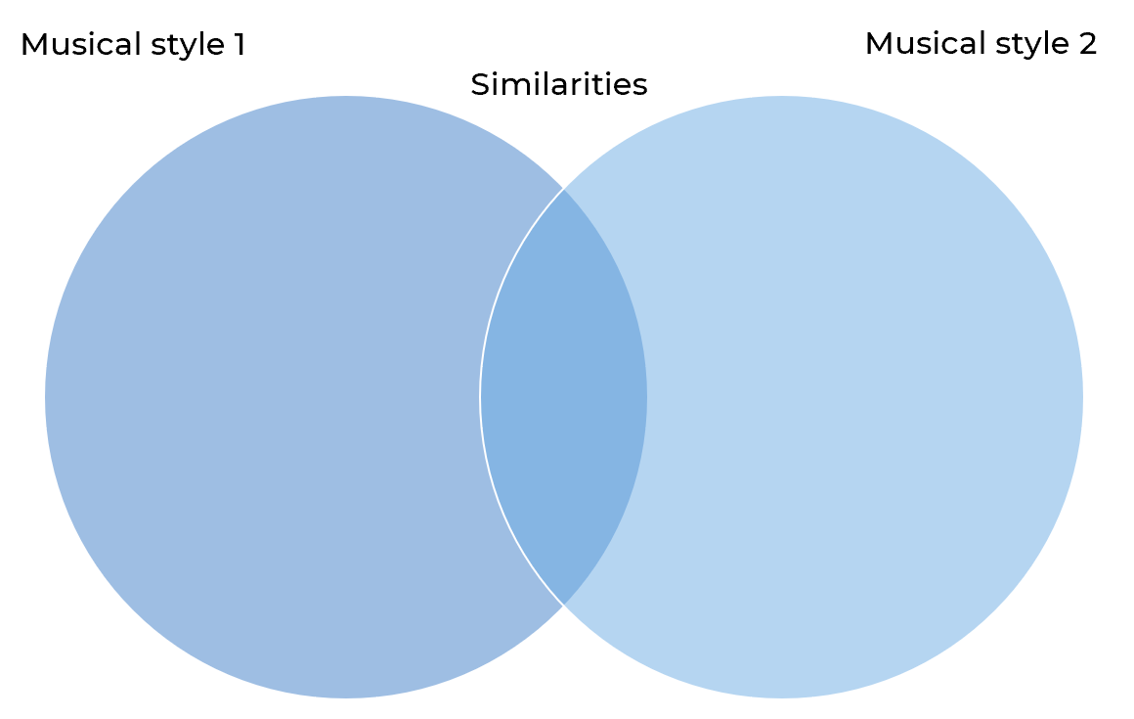
- Consider how you can explore the combination of your 2 musical styles in an original piece of music. Which features would you choose to focus on? How can you balance the use of features from each style and those they have in common?
- Complete a composition scaffold to plan out a structure for your composition. Aim to achieve a balance of unity and contrast. Refer to the composition resource booklet (page 10).
- Through improvisation on your preferred instrument, create 1 or 2 melodic and/or rhythmic ideas that can be used as themes in your composition.
- Manipulate these themes to create a short composition juxtaposing your 2 contrasting musical styles within a single piece.
- Create a title that combines the names of the 2 musical styles.

Reflection
- Was your composition successful in combining your 2 contrasting musical styles? Why/why not?
- Identify any musical material that you could now further develop or adapt from this activity to incorporate into your music 2 core composition.
- Paste your ‘juxtaposing different musical styles’ composition experiment into your music 2 core composition portfolio and document your reflection on the activity.

Additional activities – Musicology and aural

Activity 1: Podcast activity
Richard Gill was guest editor for the December 2014 issue of Limelight Magazine. In it featured an article, guided by Gill, that gave voice to 6 young Sydney-based musicians. Alicia Crossley (recorder), Holly Harrison (composer), Thomas Rann (cello), Nicholas Vines (composer), Anastasia Pahos (composer) and Alice Chance (composer/viola da gamba) (Limelight 2014).
Listen to the Limelight’s podcast Richard Gill interviews emerging classical musicians (1:12:49) and answer these questions:
- What attracted Harrison to music and how did she get her start? (0:44)
- What inspires Harrison to persevere with music/composition? (23:23)
- What are Harrison’s musical preferences? (27:10)
- Where did Harrison study composition? How has this influenced her musical style? (44:20)
- Are there any musicians that have influenced Harrison especially? If so, who are they and how have they influenced her musical style? (1:04:00)

Activity 2: Research
- Research the music of at least one of the musicians identified by Harrison in the podcast with Richard Gill as having influenced her own musical style and explain why you think Harrison considers this musician to be a ‘genre-bender in the ‘Rock-esque’ category’. Choose one of the musicians below:
- Miles Davies
- Ian Andersson/Jethro Tull
- Frank Zappa.
- Create a playlist of ‘Australian Music of the last 25 years’ by selecting at least 3 of your favourite pieces from Holly Harrison, and at least one song from each of the composers below who were mentioned in the ‘Unlocked: Australian Music of the Last 25 years’ podcast:
- Anne Cawrse
- Harry Sdraulig
- Felicity Wilcox
- Mary Finsterer
- Caitlin Yeo
- Alex Turley
- Ella Macens.

Answers – Musicology and aural

Activity 3: Bend, boogie and break examples
- Complete the following table to discover how Harrison uses musical material to depict the character of the 3 recurring ideas, ‘Bend/Boogie/Break’, with reference to specific musical examples from the score.
Table 10 – Bend/Boogie/Break musical identification answer table
Instrumental part and bar numbers | Bend and/or boogie and/or break? | Description of how the selected word bend, boogie or break has been depicted musically, supported by related score extracts/bar numbers
clarinet, violin and cello  bar 147-152 | Bend (pitch, volume) | On the most obvious level, bend can be thought of as a pitch-based concept (think about the use of strings and clarinet glissandi throughout).  In this example there is prominent use of pitch bending – quartertones, and unspecified bend up at end of phrase and also bending of volume with the use of crescendos.  Figure 6 – Clarinet, violin and cello: bar 147-152  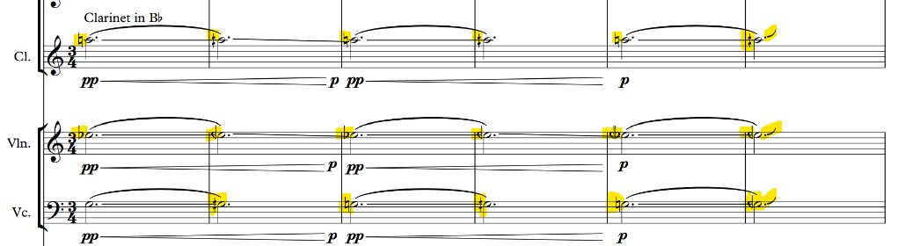
vibraphone, clarinet  bar 151-152 | Bend (pitch, tone colour) | In addition to pitch bending, bending can also extend into tone colour.  This section starts with vibraphone and clarinet playing in unison (G) then the clarinet bends up ¼ tone whilst the vibraphone stays on G and adds an F natural affecting the blending of tone colours.  Figure 7 – Vibraphone, clarinet: bar 151-152  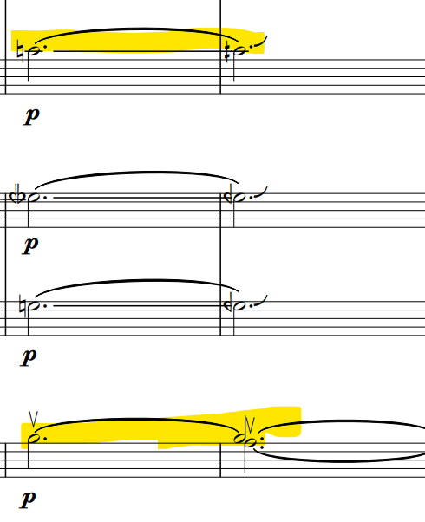
violin, cello, clarinet, vibraphone  bar 154-155 | Bend (pitch, tone colour, volume) | Three forms of bending are evident here:  - Bending of tone colour – the gradual shift of the bow towards the bridge starting to distort sound (violin and cello).  - Bending of volume – use of a crescendo  - Bending of pitch – the use of ascending/descending ¼ tones in melody (cello descends ¼ tone; violin ascends ¼ tone; clarinet ascends a semitone; vibraphone remains on G).  Figure 8 – Violin, cello, clarinet, vibraphone  bar 154 - 155  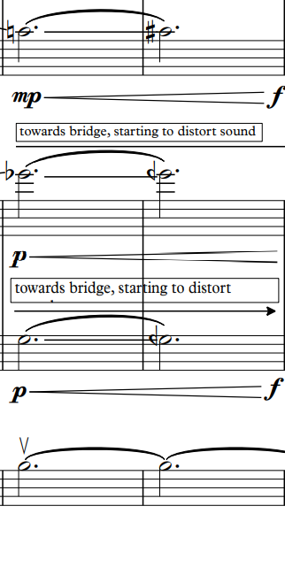
vibraphone, violin  bar 149-150 | Bend (pitch, tone colour) | In addition to pitch bending, bending can also extend into tone colour.  Here, the vibraphone and violin start playing in unison (Eb), then the violin bends up ¼ tone whilst the vibraphone stays on Eb effecting the blending of tone colours.  Figure 9 – Vibraphone, violin: bar 149-150  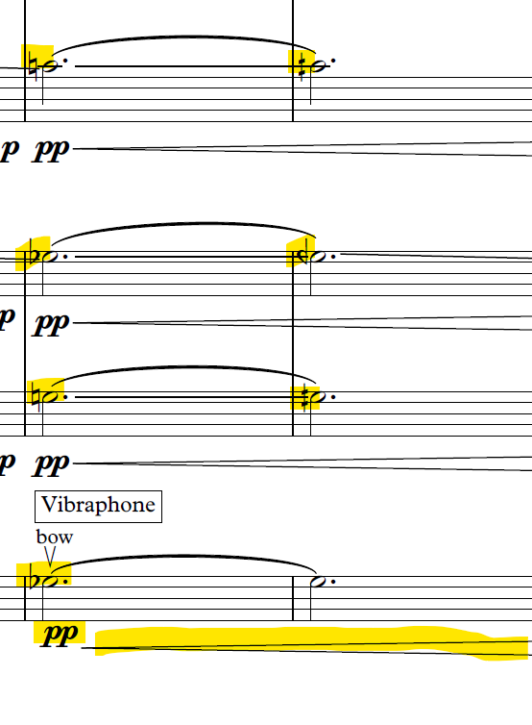
tutti  bar 142-172 | Bend and Break (pitch, tone colour, structure) | This slower middle section (P to S) demonstrates the pairing between bending and breaking. Structurally, Harrison was interested in how a section can bend (or warp) into the next. She suggests that the 5 bars before S (bar 167-171) provide an example of how pitch-bending and colour distortion can facilitate a structural bend. This gradual pitch and colour change here almost acts like a portal into a new section of the piece – ‘heavy funk’ – giving way to a new tempo, too (bar 172).  Figure 10 – Tutti: bar 167-172  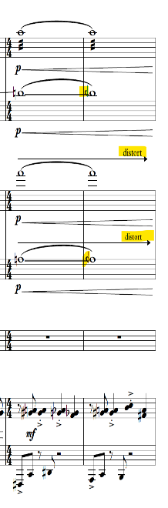  Figure 11 – Tutti: bar 169-171  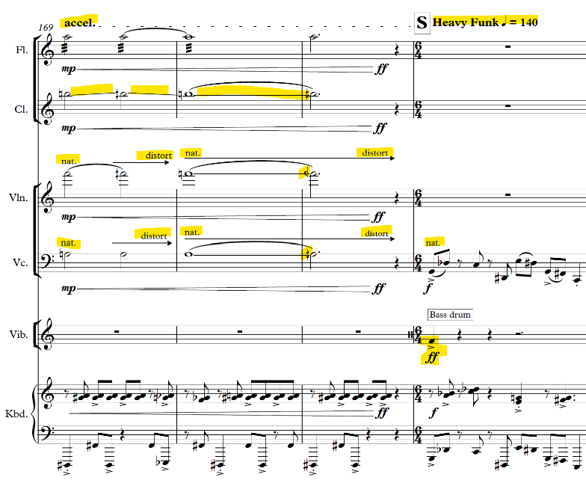
flute, clarinet  bar 123-129 | Break (tone colour) | The flute and clarinet are required to colour their playing with flutter-tongues, slap tongues, singing-while-playing, and jet whistles – all moving away from ‘breaking’ a more natural or traditional way of playing (for example, bar 123-129).  These expressive techniques are essential to creating a sound-world which seeks to be spontaneous and embrace a rock/jazz feel.  Figure 12 – Flute – flutter tongue (bar 123-126)  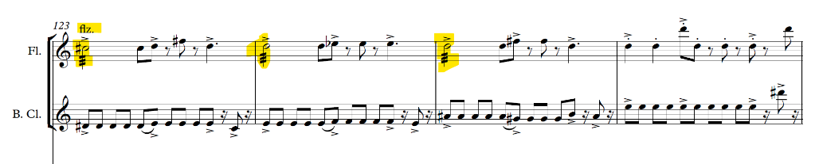
keyboard  bar 203-204 | Break (stylistic reference- heavy music breakdowns- repeated low note ostinati) | Here ‘break’ conjures up a stylistic reference, paying homage to heavy music breakdowns, often with repeated low note ostinati to create a groove (for example, the keyboard at rehearsal marks O and U).  Figure 13 – Keyboard at U (repeated low note ostinato)  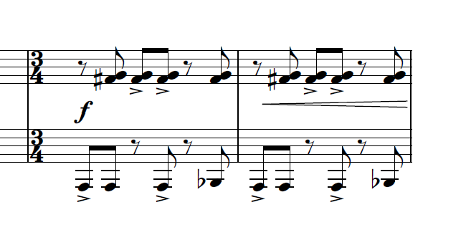
keyboard  bar 159 to end | Break (distorted timbre) | Here ‘break’ can be used to describe the distorted timbre of the keyboard into a Rhodes-like sound, where distortion breaks and disrupts the natural colour. With plenty of semi-tones heard in the keyboard from R to the end, this is purposefully done to make the listener think of a honky-tonky sound or an almost out-of-tune piano.  Figure 14 – Keyboard at R  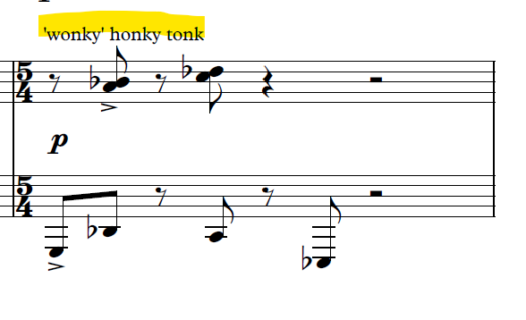
tutti  bar 214 to end | Break (structure) | Here, Harrison achieves a break in structure as outlined below:  bar 214-226  Full texture; features driving, syncopated rhythms (similar to heavy metal riff rhythms); repeated patterns; ‘busy’ continuous quaver/semiquaver rhythms in drums; accelerando; crescendo to fff all used to build the intensity towards the break in bar 226.  bar 223-225  Figure 15 – Tutti: bar 223-225  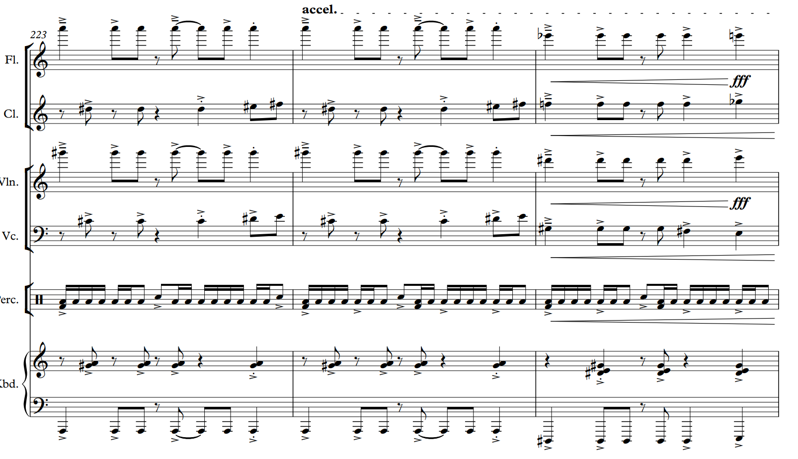  bar 226  Break – massive accent on bass drum/cymbal. Eb pitch in clarinet (high octave) and Eb pitch in keyboard (low octave). The cello/violin then enter on an Eb before descending in pitch. All instruments are played at fff with pitch and tone colour distortion. The drum semiquaver pattern becomes disjointed through the ad lib.  bar 227-229  Diminuendo, texture becomes thinner, disjointed drum solo figures and molto rall.  Tutti: bar 226 to end  Figure 16 – Tutti: Section W  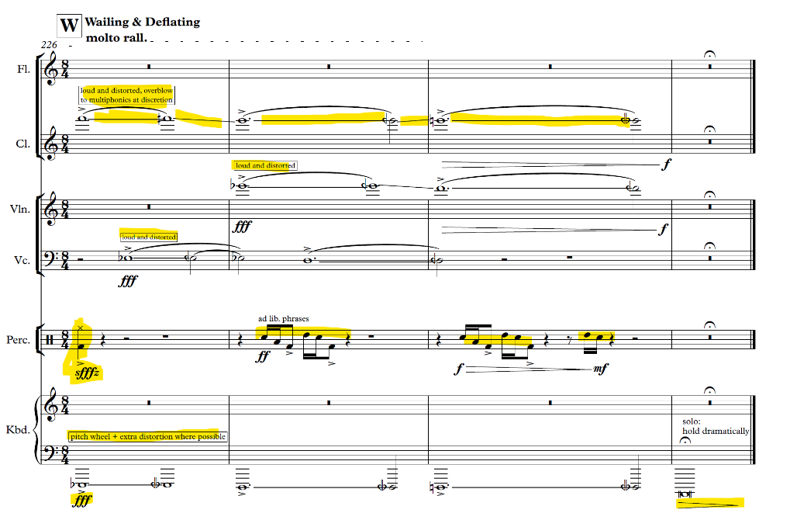
keyboard, bass Clarinet  bar 1-52 | Boogie | Harrison believes that boogie is just another way of thinking about rhythm and duration in the work. Groove is an integral aspect of her music. There are a series of grooves that appear throughout, offering a sense of drive and momentum.  bar 1-4 (Keyboard, LH)  Bass line: syncopated, semiquaver rhythms; ‘bluesy’ intervals featuring the use of a min 3rd (crotchets on beats 1-2); based loosely on a 2-bar repeated pattern.  Figure 17 – Keyboard bars 1-4  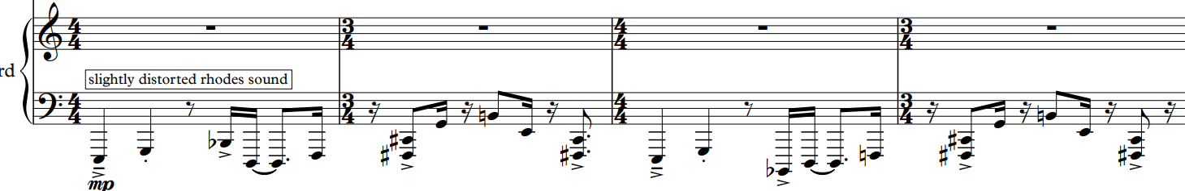
keyboard, bass clarinet  bar 72-88 | Boogie | Another groove can be seen here in the keyboard part offering a sense of drive and momentum.  bar 72-74 (Keyboard, LH)  Funk bass solo: syncopated, semiquaver rhythms; ‘bluesy’ intervals featuring a descending chromatic idea; based on a new 2 bar idea using an ‘improvisatory’ style. Accompanying parts- static & repetitive rhythms (RH keyboard, violin).  bar 72-74 (Keyboard, LH)  Figure 18 – Keyboard bar 72-74  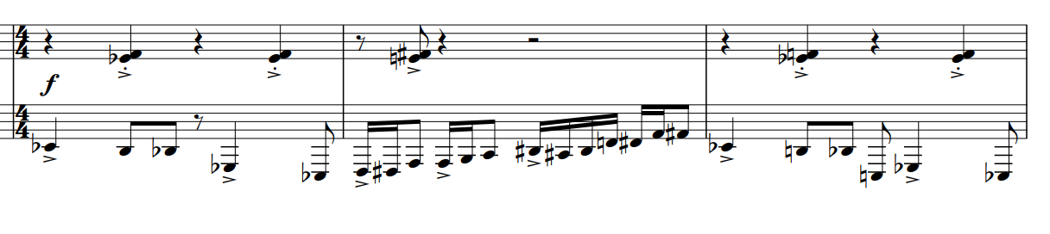
tutti  bar 37-130 | Boogie and Break  (pattern of groove and disruption) | Here boogie and break suggest a pattern of groove and disruption. Once the groove is set up, Harrison then has a lot of fun disrupting it. Once this occurs a few times, this then becomes a pattern unto itself, creating its own internal structure (for example, boogie, break, boogie, break, break, boogie). Rehearsal marks G to O (bar 37-130) demonstrate this back and forth of interrupted grooves. Harrison believes it’s impossible to separate duration from structure as each impacts the other on a micro and macro scale. For example:  I – ‘lyrical’; J – ‘funk bass solo’; L – simmering and percussive; M – ‘rocking’; O – ‘dramatic & swampy’.

Activity 4: Note bending
Note bending is a prominent feature of ‘Bend/Boogie/Break’. Identify the changes of pitch in the violin part from bars 147-152 (ascending or descending) and the amount of change (in ¼ tones) in each bar.
Table 11 – Violin pitch answer table
Section Q  bar number | Violin pitch direction (ascending or descending) | Amount of change (in ¼ tones)
Bar 147-148 | Ascending | ¼ tone
Bar 148-149 | Descending | ¼ tone
Bar 149-150 | Ascending | ¼ tone
Bar 150-151 | Descending | 2 × ¼ tones (1 × semitone)
Bar 151-152 | Ascending | 2 × ¼ tones (1 × semitone)

Activity 5: Moods
The structure of Harrison’s piece ‘Bend/Boogie/Break’ also changes between 2 different moods: ‘dark and brooding’ and ‘joyous and fizzing.’ Describe how Harrison has achieved these 2 contrasting moods in the piece through her use of the musical concepts. In your answer, make specific reference to the score.
Table 12 – Mood answer table
Mood | Description of how this mood is achieved in terms of the use of music concepts, supported by related examples from the score
dark and brooding | Melody played in a very low pitch range (LH keyboard/bass clarinet); melody features short, disjointed phrases and a combination of staccato/ legato phrasing; contrast between shorter note values in low melody and longer/sustained sounds in higher pitched counter-melody played by violin/cello; use of expressive technique (sfz, slides); dissonant chords. For example, Section A-B.
joyous and fizzing | Softer dynamics (p-mf) compared to previous section (mf-ff); ‘bubbly’ driving percussive semiquaver rhythms on cymbal; use of expressive techniques (‘breathy’ tonal quality and ‘fake’ notes on flute; pizz and slides on violin; accents). For example, Section L-M.

Activity 6: Harmonic analysis
- Using the score, identify the chords in Section C (bar 19) of the keyboard part and complete the table below.
Table 13 – Harmonic analysis answer table
Where | Type of chord
Bar 19, beat 1 – keyboard | C# 7-5 (no 3rd)
Bar 19, beat 2 – keyboard | G maj 7 #11 (no 3rd)
Bar 19, beat 3 – keyboard | E sus 2
- Why do you think Harrison favours the use of extended chords in ‘Bend/Boogie/Break’?
- To achieve the desired ‘post-rock’ musical style (incorporating characteristics of jazz/rock/funk).

Activity 7: Expressive techniques
- Watch Flute extended techniques (3:29) by Lamorna Nightingale (flautist, Ensemble Offspring) who explains and demonstrates the use of flute extended techniques in ‘Bend/Boogie/Break’.
- Locate and define the following performance extended techniques (musical terms and symbols) in the table below used in ‘Bend/Boogie/Break’.
Table 14 – Expressive techniques answer table
Musical term or symbol | Bar number | Instrumental part | Definition
jet whistle | Bar 1 | Flute | A forceful and loud attack of air.
snap pizz. | Bar 1 | Violin | Also called ‘Bartók pizzicato’, it can be produced in 2 ways:  1. Place the forefinger of the right hand underneath the string pulling upwards and releasing so that the string snaps against the fingerboard.  2. Pinch the string pulling vertically upwards and releasing creating the snap against the fingerboard. This technique creates a sharper attack sound.
slap | Bar 1 | Bass clarinet | Slap tonguing is an extended wind instrument technique which achieves a percussive effect that can be used on its own or to start a sustained pitch.
flz. | Bar 37 | Flute | Flutter tonguing is a wind instrument tonguing technique in which performers flutter or roll their tongue make a characteristic ‘frrrrrrrrrr’ sound.
secco | Bar 37 | Vibraphone | ‘Dry’ – played and released abruptly and without resonance.
slap pizz. | Bar 53 | Cello | The performer typically plucks the string away from the fingerboard with sufficient force to cause the string to ‘slap’ the fingerboard, producing the desired pitch and a distinctive slapping sound.
arco. | Bar 61 | Violin | Arco means with the bow and often appears in music after pizz. (pizzicato or plucked) passages of music.
shake | Bar 72 | Violin and cello | A jazz term describing a trill between one note and its minor third
strum | Bar 77 | Violin and cello | Running the fingers lightly across the strings (but in this case, the composer calls for an aggressive action).
body slap | Bar 93 | Cello | Striking the body of the cello with the palm of the hand
nat. | Bar 102 | Bass clarinet | Return to natural tonguing technique (after previously performing with ‘slap’ tonguing technique).
 | Bar 148 | Violin | Half flat – lowers the pitch by a quarter tone.
 | Bar 151 | Violin | Three-quarter flat (1 ½ semitones lower)  In this example ¼ tone flatter than E flat).
 | Bar 148 | Bass clarinet, cello | Half sharp – raises the pitch by a quarter tone.
bow  V | Bar 149 | Vibraphone | The performer uses a double bass bow placed perpendicular to the outer edge of the vibraphone bar at an angle of 90 degrees. The performer scrapes the bow with medium pressure, against the vibraphone bar in an upward motion (but can also be a down motion).

Aural

Melodic and rhythmic dictation
- Notate the pitch and rhythm of the flute part (bars 63-65) from ‘Bend/Boogie/Break’ on the stave provided. Play Audio excerpt 1.
Figure 19 – Flute: bar 63-65
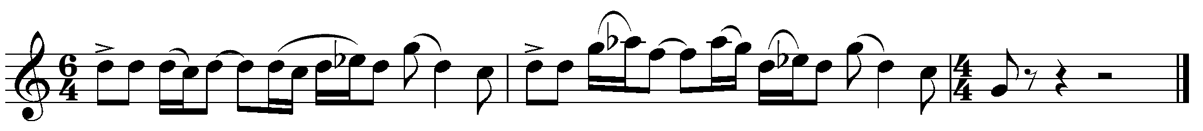
- One of the rhythmic features of ‘Bend/Boogie/Break’ is the use of multimetre. There are 2 options for this activity.
- Option 1: Notate the rhythm of the flute part (bars 214-225) on the staves provided.
- Option 2: Notate the pitch and rhythm of the flute part (bars 214-225) on the staves provided.
Note: In this excerpt the flute is heard an octave higher than notated. Play Audio excerpt 2.
Figure 20 – Flute melody (Section V-W, bars 214-225)

Performance
Perform the flute part of Section V-W (bars 214-225) from ‘Bend/Boogie/Break’ as a class ensemble, focussing on the use of correct articulation and note lengths to achieve the desired musical style. Before you start, transpose the flute melody below in to at least 2 different keys so that it can be played in unison by:
- Bb instruments
- Eb instruments
- F instruments
- Alto clef instruments
- Bass clef instruments
Figure 21 – Transposition of Flute melody (Section V-W, bars 214-225)
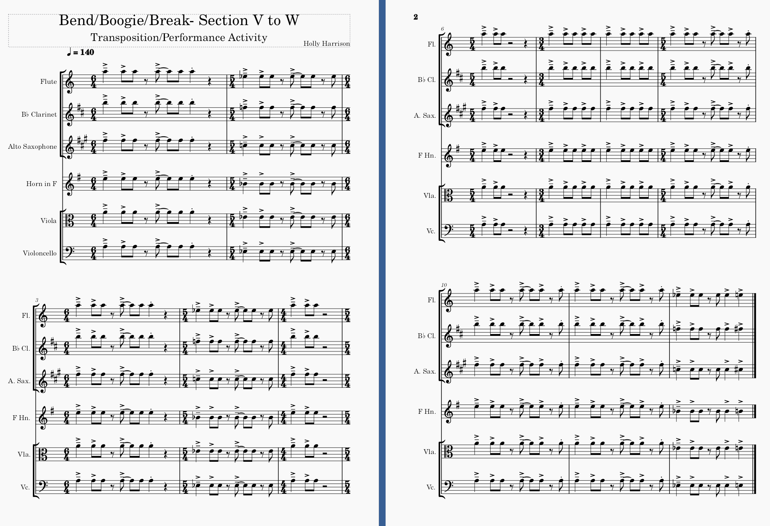

Musicology and aural

Activity 1: Podcast activity
Listen to the Creative Cast ‘Unlocked – Australian music of the Last 25 years’ (39:34). In this episode, Australian composers Holly Harrison and Jessica Wells speak about their works titled ‘Bend/Boogie/Break’ and ‘Diminishing Species’. Joining them is Ensemble Offspring Artistic Director and percussionist Claire Edwardes. Listen to an insightful discussion that unlocks the compositional process used in both works through the composer and performer lens.
Answer the questions below related to Holly Harrison and her piece ‘Bend/Boogie/Break’ as discussed in the podcast. Please note, time stamps have been provided to assist you in finding the relevant information.
Podcast time stamp: 00:00 to 14:45
- What does Harrison’s music explore?
The juxtaposition of styles and genres.
- What 3 ensembles does Harrison specialise in writing for?
Wind Band, Orchestra and Chamber Ensembles.
- ‘Bend/Boogie/Break’ was commissioned by Ensemble Offspring to be included in what special musical program? What did this musical program explore?
‘Bend/Boogie/Break’ was commissioned by Ensemble Offspring (funded by private donors) to be included in a project called Spectral Tech – a musical program exploring unusual sound worlds.
- Where did Harrison get inspiration for her piece, ‘Bend/Boogie/Break’, and how did she get started on this composition?
Inspiration came from Ensemble Offspring and working with the instrumentalists. Originally the piece was going to be a multimovement work but this idea was scrapped. The ‘bendy’ sound world was inspired by spectral music (use of ¼ tones) and is heard in the middle section of the piece. The title ‘Bend/Boogie/Break’ came to Harrison after the piece had already been written because she had the following 3 threads that she was trying to tie together:
- Funkiness/groove apparent throughout the work
- Honky-tonk – K/B Rhodes distorted sound
- Nod to spectralism – use of ¼ tones and ‘bendiness’ in middle section.
- Define the term ‘spectralism’. Name the 2 famous spectral composers mentioned in the podcast and include their nationality.
Spectralism is a French school of thought that looks at overtones and the way that overtones & different pitches sound against each other. Spectral music is not based on tonal harmony; instead, it includes all the different sounds that exist within the spectrum. Spectral music is about the way the harmonics of instruments stack and how this harmonic spectrum can be used as the harmonic basis of a composition. Two famous French spectral composers are: Gérard Grisey and Philippe Hurel.
- How did Harrison develop the musical material in ‘Bend/Boogie/Break’? Does she use a similar process for all her works?
Harrison starts with improvisation – playing trumpet and drums. Abstract use of percussion/ drums – using percussion as a blocking effect to help her to think texturally and experiment with different rhythms and how these can interlock together by using her 2 × hands; 2 × feet on the drum kit. She then makes lots of recordings of herself playing different things on a variety of instruments, then listens to the recordings to work out what material had ‘something’ that could be developed. She then starts to splice these ideas wand combined them together. Notation of her compositional ideas into a music notation program, like Sibelius, happens later, followed by editing after the brain/creative dump has happened. Harrison believes that composing is about being able to select what’s better than the thing that you created before – imagining what you can do with these ideas and how these ideas can be developed.
- ‘Bend/Boogie/Break’ draws inspiration from post-rock riffs and timbres, funk rhythms, and honky-tonk piano. How does Harrison use these ideas in the piece? Are there any other musical styles that influenced ‘Bend/Boogie/Break’?
Harrison’s use of post-rock riffs and timbres, funk rhythms, and honky-tonk piano in Bend/Boogie/Break is conceptual rather than literal.
- Honky tonk – use of distorted Rhodes keyboard sound; use of semi-tones and minor 2nds in RH.
- Post rock – the last quarter of the piece is like heavy funk (particularly the rhythm at the end). Mogwai (Scottish post-rock band are a big influence); heavy fuzz-sound used in post-rock, repeated ostinato; timbral/ textural changes that stack up over time to a big finish; Instruments that stack up – last section of piece marked.
- Heavy Rock – last section of the piece. Rhythm at end like strumming guitar – composing is quite a physical process for Harrison.
- Funk – inherent in the rhythms throughout; particularly in combination of keyboard/bass clarinet playing in unison at start – to simulate funk bass sound.
Podcast time stamp: 28:00
- How did Ensemble Offspring prepare to perform both Harrison’s piece ‘Bend/Boogie/Break’ and Jessica Wells piece ‘Diminishing Species’?
Ensemble Offspring’s process with composers is very collaborative. Claire believes that respect is key and that this must be 2 ways – between composers and performers. Ensemble Offspring is very open minded and experienced with improvisation and working with a wide range of different composers. As performers they are open to trying anything.
- What advice do both Harrison and Wells give to elective music students who lack confidence when composing their own music and/or performing Australian art music?
Suggestions include:
- Teachers need to be supportive by having performer workshops to test out student’s compositional ideas. Workshops should be done using ‘real’ instruments, then software should come in later in the process.
- Adjust expectations. Establish the right environment being able to compose in a comfortable way by starting with experimenting on instruments that the students play. They believe that you need to practice and learn ‘composition craft’ just as you must practise your instrument to improve.
- Learn how to take a germ of an idea and expand upon it – canon, inversion, retrograde, stack to create harmony, transpose notes, modulation, dynamics.
- Storyline often helps some students to envisage why your piece is doing certain things. Do not overdo it by cramming too many ideas into a piece.
- A variety of compositional techniques applied to your germ of an idea. Good notation is important and should be nicely formatted. YouTube ideas about formatting. Phrasing, articulation, dynamics are all important. Take a small little idea and grow it.
- Software can play faster than human beings. Be aware that metronome markings need to be pulled back a little bit to make it realistic. Performers aren’t robots!
- Consistency is the key to becoming a confident composer/performer. You must write lots of music. Repetition, trying and failing must happen before you can expect to create a masterpiece.
Podcast time stamp: 39:00
- Who are the 7 ‘up-and-coming’ Australian composers that Harrison, Wells and Edwardes identify as composers that we should all be watching out for and listening to?
Composers include:
- Anne Cawrse (Adelaide)
- Harry Sdraulig (Sydney)
- Felicity Wilcox (hybrid composer- film)
- Mary Finsterer (film and cross-over)
- Caitlin Yeo (film and cross-over)
- Alex Turley (Melbourne)
- Ella Macens (Sydney)

Activity 3: Musicology extended response
Use your class table summary from the previous activity to help you to individually answer the extended response question below (practice for HSC Question 4):
Explain how composers treat the concepts of music to create a particular style. In your response, refer to TWO works from the mandatory topic, Music of the last 25 years (Australian focus) NESA 2018 Music 2 HSC Paper, Question 4.
Answer this question with reference to ‘Bend/Boogie/Break’ and ONE other work that you have studied from the mandatory topic, Music of the last 25 years (Australian focus).

Discussion point suggestions
Holly Harrison’s music juxtaposes several different musical styles within a single piece. In ‘Bend/Boogie/Break’ she has included the use of post-rock riffs, post-rock timbres, funk rhythms and honky-tonk inspired ideas as well as drawing on inspiration from spectral music to create her own particular musical style.
Some of the composers, musicians, and bands that Harrison identifies as having influenced her natural and organic musical style include: Mogwai (a Scottish post-rock band), French spectral composers, Gérard Grisey and Philippe Hurel and ‘genre-benders’ in the ‘Rock-esque’ category, Miles Davies, an Andersson/ Jethro Tull, and Frank Zappa.
Post-rock riffs – Repeated rhythm at end, similar to strumming guitar. For example, flute: bar 223-226.
Figure 22 – Flute: bar 223-226
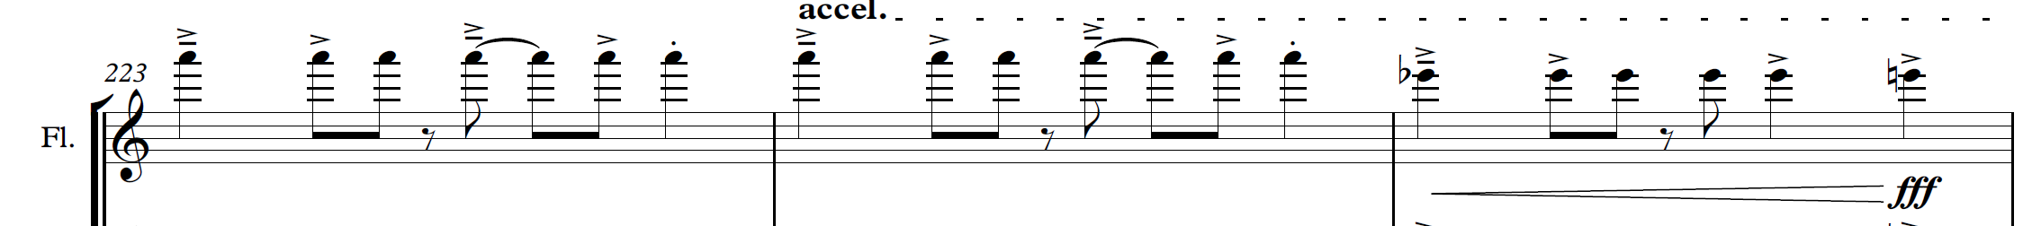
Post-rock structure – Last ¼ piece (Section S to the end) features repeated patterns with timbral/textural changes that stack up over time to a big finish (for example, tutti: bar 223-225).
Figure 23 – Tutti: bar 223- 225
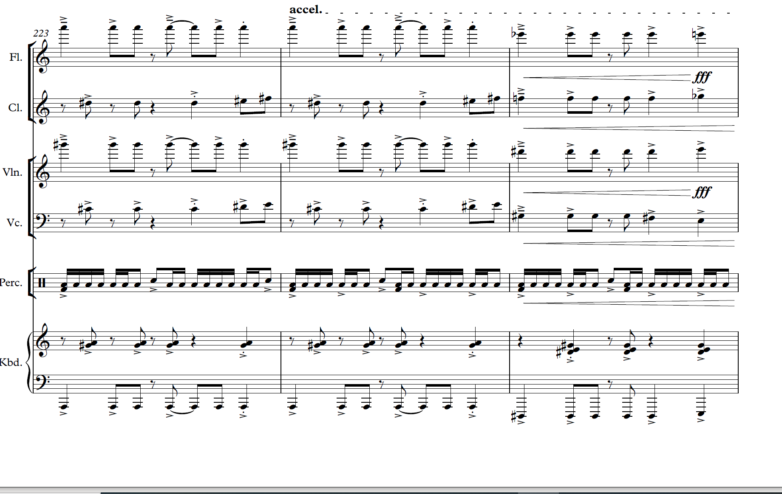
Post-rock timbres – Use of heavy fuzz sound. For example, Section A – bass clarinet and keyboard play in unison to simulate funk bass sound.
Figure 24 – Bass clarinet: Section A
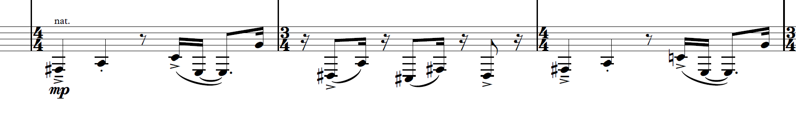
Funk – Inherent in the ‘groove’ rhythms used throughout (particularly the combination of keyboard/bass clarinet playing in unison at start).
For example, bass clarinet – section A
Figure 25 – Bass clarinet: Section A
Honky tonk – use of distorted Rhodes keyboard sound and semi-tones and minor seconds in the right hand to provide honky tonk effect. For example, bar 159.
Figure 26 – Keyboard: bar 159
Spectral music – The slower middle section (P to S) demonstrates the pairing between bending and breaking and includes vibraphone being played with a bow to bring out the full ‘spectrum’ of overtones in the notes in section Q.
For example, vibraphone with bow – Section Q.
Figure 27 – Vibraphone: Section Q
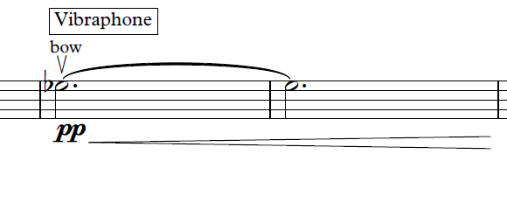

The concepts of music checklist

Duration
- Tempo – Adagio/Lento/Moderato/Allegro/Presto
- Tempo – changes/constant
- Time signature – constant/multimeter
- Rhythm is strict/rigid/free/indefinite
- Syncopation/polyrhythms/cross rhythms
- Ostinato/backbeat/anacrusis
- Accelerando/ritardando/rubato
- Note values – long/short/dotted
- Repeated rhythms
- Beat – strong/indefinite
- Bar lengths – regular/irregular/cycles

Pitch
- Tonality – major/minor/modal/atonal/pentatonic
- Modulations/key changes
- Rate of harmonic change
- Arpeggios/triads/drone
- Scales used – major/minor/chromatic/blues/mode/pitch sets
- Harmony – consonant/dissonant
- Melody – moves in steps/leaps
- Melodic contour – ascending/descending
- Range/intervals
- Phrase lengths
- Imitation/repetition/ostinato/sequence
- Ornamentation/improvisation
- Counter melody/call and response/canon
- Cadences – perfect/plagal/imperfect/interrupted
- Tone clusters

Structure
- Binary/ternary/rondo
- Theme and variations
- Through composed
- Strophic form
- Verse/chorus form
- 12 bar blues form
- How can you tell when a new section begins?
- Identify the number of bars in each section
- Macro (whole song) and micro (phrases) structure

Texture
- Thin/thick
- Monophonic/homophonic/polyphonic
- Roles of the instruments – melodic/harmonic/rhythmic
- How many layers of sound are there
- Changes in texture – sudden/gradual
- Unison/doubling/imitation
- Call and response/canon
- Motion – similar/contrary

Tone colour
- Performing media
- Aerophones/chordophones/membranophones/idiophones
- Electronic sounds
- Range – narrow/medium/wide
- Register – low/middle/high
- Description of sound – use adjectives to describe the timbre
- Role of each instrument
- Tone colour changes during the excerpt
- Describe the overall mood/atmosphere

Dynamics and expressive techniques
- Dynamics
- Sudden/gradual dynamic changes
- Articulation – legato/tenuto/staccato/accents
- Vibrato/tremolo/glissando/pizzicato
- Muting/strumming/picking/pedals
- Drum roll/distortion/amplification
- Extended techniques
- Double stopping/note bending/multiphonics
- Falsetto/scat/melisma

References
Links to third-party material and websites
Please note that the provided (reading/viewing material/list/links/texts) are a suggestion only and implies no endorsement, by the New South Wales Department of Education, of any author, publisher, or book title. School principals and teachers are best placed to assess the suitability of resources that would complement the curriculum and reflect the needs and interests of their students.
If you use the links provided in this document to access a third-party's website, you acknowledge that the terms of use, including licence terms set out on the third-party's website apply to the use which may be made of the materials on that third-party website or where permitted by the Copyright Act 1968 (Cth). The department accepts no responsibility for content on third-party websites.
All material © State of New South Wales (Department of Education), 2021 unless otherwise indicated. All other material used by permission or under licence.
Music 2 Stage 6 Syllabus © 2009 NSW Education Standards Authority (NESA) for and on behalf of the Crown in right of the State of New South Wales.
© 2021 NSW Education Standards Authority. This document contains NSW Curriculum and syllabus content. The NSW Curriculum is developed by the NSW Education Standards Authority. This content is prepared by NESA for and on behalf of the Crown in right of the State of New South Wales. The material is protected by Crown copyright.
Please refer to the NESA Copyright Disclaimer for more information.
NESA holds the only official and up-to-date versions of the NSW Curriculum and syllabus documents. Please visit the NSW Education Standards Authority (NESA) website and the NSW Curriculum website.
Cottis J and Harrison H (7 December 2020) ‘Orchestral moshing and the classical / vernacular divide’, Canberra Symphony Orchestra magazine, accessed 14 October 2022.
Ensemble Offspring (2018) Spectral Tech [PDF 404.46KB], Ensemble Offspring, accessed 14 October 2022.
Ensemble Offspring (27 March 2021) 'bend/boogie/break – Holly Harrison | Offspring Bites 3: En Masse' [video], Ensemble Offspring, YouTube, accessed 14 October 2022.
Harrison H (2022) Holly Harrison [website], accessed 14 October 2022.
Harrison H and Eslake S (27 September 2018) ‘Holly Harrison talks us through her music for Spectral Tech’, CutCommon Magazine, accessed 14 October 2022.
LimelightAU and Gill R (hosts) (December 2014) ‘Richard Gill interviews emerging classical musicians’ [podcast], Richard Gill, LimelightAU, accessed 14 October 2022.
Music Trust (31 August 2021) ‘Inside the musician: Holly Harrison: My Musical World’, The Music Trust: Loudmouth e-zine, accessed 14 October 2022.
NESA (NSW Education Standards Authority) (2021) ‘Music 2 2018 HSC exam pack’, HSC Exam papers, NESA website, accessed 14 October 2022.
Nightingale L (4 February 2022) 'Lamorna Nightingale "Bend/Boogie/Break" articulation' [video], Lamorna Nightingale, YouTube, accessed 14 October 2022.
Nightingale L (7 February 2022) 'Lamorna Nightingale flute extended techniques in Bend/Boogie/Break' [video], Lamorna Nightingale, YouTube, accessed 14 October 2022.
Nightingale L (7 February 2022) 'Lamorna Nightingale talks about challenges playing Bend/Boogie/Break' [video], Lamorna Nightingale, YouTube, accessed 14 October 2022.
Stefanakis M (28 May 2021) ‘En Masse: Offspring Bites 3. Ensemble Offspring’, The Music Trust: Loudmouth e-zine, accessed 14 October 2022.

