Music 2 HSC

Music of the last 25 years (Australian focus)

‘Diminishing Species’ by Jessica Wells

Table of contents
Music 2 HSC 1
Music of the last 25 years (Australian focus) 1
‘Diminishing Species’ by Jessica Wells 1
Table of contents 2
Rationale 3
‘Diminishing Species’ by Jessica Wells 4
‘The Surge’ 4
‘Diminishing Species’ 5
Who is Jessica Wells? 5
Musicology 5
Aural and musicology 6
Performance, aural and musicology 7
Composition, aural and performance 8
Musical features of ‘Diminishing Species’ 15
Musicology and aural – animal card activity 17
Musicology and aural – podcast activity 24
Additional resources 24
Answers 25
Who is Jessica Wells? 25
Musicology 25
Aural and musicology 26
Performance, aural and musicology 28
Musical features of ‘Diminishing Species’ 30
Musicology and aural – podcast activity 33
The concepts of music checklist 36
Duration 36
Pitch 36
Structure 37
Texture 37
Tone colour 37
Dynamics and expressive techniques 38
References 39

Rationale
This education resource has been prepared for students studying the NSW Higher School Certificate Music 2 course as part of the mandatory topic ‘Music of the Last 25 Years (Australian focus)’. It is comprised of a piece titled ‘Diminishing Species’ which is one of three interludes written by Australian composer Jessica Wells for a large scale ‘concept performance’ project titled ‘The Surge’, performed by Australia’s most well-known modern art music ensemble ‘Ensemble Offspring’. This resource contains a variety of aural, musicology, performance, and composition activities suitable for study. Scores, worksheets and answers for the teacher are also included.
The activities contained within the resource provide students with the opportunity to explore the musical concepts and compositional techniques that Jessica Wells has utilised to represent the context of the work. Class performance activities are integrated to develop performance, composition, aural, musicology and score reading skills, and to further explore the musical features of the work. Students are required to demonstrate their understanding of these musical features through completion of the composition activities provided. Guided listening activities are included to develop critical listening and musicology skills in preparation for the HSC musicology and aural paper. Teachers should adapt these learning resources for their own teaching and learning context.
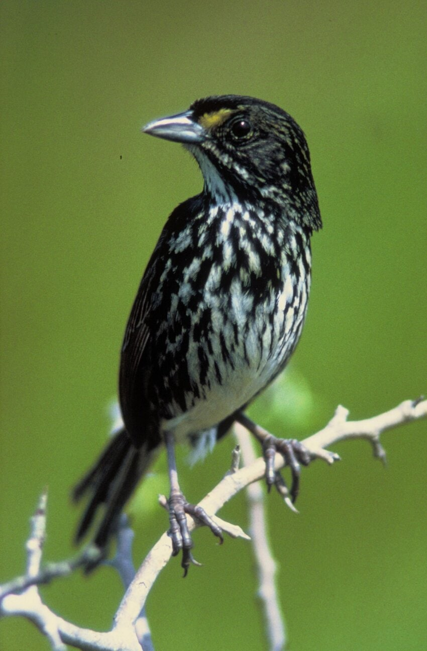
P.W Sykes, Dusky Seaside Sparrow, Pixnio [image] accessed 24/3/2022

‘Diminishing Species’ by Jessica Wells
Image of Ensemble Offspring, used with permission 2022.
‘Diminishing Species’ was written by Australian composer Jessica Wells as one of three interludes for a concept-based concert titled ‘The Surge’. Each work performed in ‘The Surge’ paid homage to the cultural, climate and political changes that occurred in the 1990s that transformed Australia and the world. Many of the pieces performed in ‘The Surge’ were newly commissioned and premiered by Australia’s leading art music ensemble ‘Ensemble Offspring’ in 2021.
The project was devised by Artistic Director/Percussionist of ‘Ensemble Offspring’ Claire Edwardes, in partnership with Australian guitarist Andrew Blanch. ‘The Surge’ comprised of 8 works by Australian composers for ‘Ensemble Offspring’ including Felicity Wilcox, Jessica Wells, Robert Davidson, Nigel Westlake and Peter Sculthorpe.

‘The Surge’
The 1990s were a riot of transformation that redefined both Australia and the world. ‘Creative Nation’ announced the central role of art in life and society, while the Mabo decision set off a chain reaction culminating in Paul Keating’s historic Redfern Address and the Australian Parliament’s landmark Native Title Act in 1993. The internet began to insinuate itself into every corner of contemporary experience, reshaping everything it touched. The scientific community, meanwhile, spoke about climate change, with politicians debating various claims. What are the sounds of this crucial decade?
Adapted from Ensemble Offspring (2022) Ensemble Offspring ‘The Surge’ Program Notes [website] date accessed 2/11/2021

‘Diminishing Species’
‘Diminishing Species’ is the second interlude in Jessica Wells’ series of works. According to the composer:
“This piece presents a frantic and busy texture using a ten-note scale, which represents the teeming planet of wildlife on earth. Each year of the decade is represented as a set of repeated bars that diminish in pitch material, slowly eroding one note at a time until only one note remains.
The powerful message of this work comes from the listener’s experience of the degradation of pitches, with most only noticing that a change has occurred at a very late point in the piece. Usually at around the 8th repetition where there are only three notes left. This brings forth the well-known phrase, “You don’t know what you have until it’s gone”.

Who is Jessica Wells?
Image of Jessica Wells, used with permission 2022.

Musicology
- Go to Jessica Wells; [website] (date accessed 1/11/2021) and write down 5 significant musical points about Jessica that may assist you in your study of the work.
- Watch the Jessica Wells (2021) ‘Diminishing Species (2021) [video] (00:00:00 – 00:01:20) (date accessed 2/11/2021) of composer Jessica Wells talking about her piece.
  - What does this piece explore?
  - How does Jessica symbolise this?
  - What is interesting about this symbolism?

Aural and musicology
Ensemble Offspring (2021) Jessica Wells - Diminishing Species (05:16) [video] date accessed 2/11/2021
- Using the mind map below, listen to ‘Diminishing Species’ and brainstorm any interesting musical observations or first impressions you have of the work. Consider aspects of the concepts of music in your initial ideas.
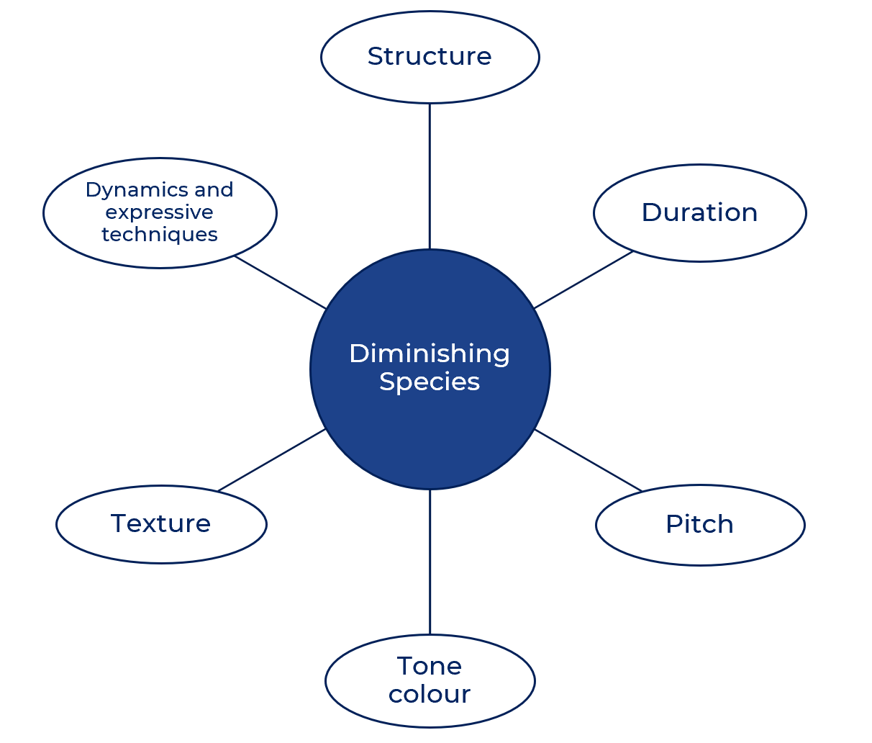
- Listen to ‘Diminishing Species’ again whilst following the score provided. Answer the following questions using the recording and the score.
  - Describe both the macrostructure and microstructure of this work. Some questions to help guide you may include:
  - How many sections are in this work?
  - How many bars is each section made up of? Is there a pattern to the microstructure?
  - What is the overall tonality of this work?
  - Is there a tonal centre? Identify the instrument which is fundamental in establishing the tonal centre and how this is achieved.
  - The main pitch material is conveyed by the guitar 1 and 2 and marimba. Describe the relationship between these instruments in bars 1 – 6.
  - Compare the use of duration in bars 1 - 4 (verse) compared to the refrain (bars 5 - 6).

Performance, aural and musicology
For the following questions, you will need the score of ‘Diminishing Species’ and a keyboard/piano.
- On the keyboard/piano, play the first bar of the guitar 1 part. What do you notice about the pitch choices and their corresponding contour?
- As the piece progresses, the pitch material is ‘diminished’, with one note disappearing from each section. Identify the 10-note pitch set used in section one starting on E, and write it on the stave below in ascending order:
- Play through this pitch set both ascending and descending. Which scale does this pitch set resemble most?
Identify which note is omitted in each section from sections 2 through to 10 and write the new pitch set for each section in the table below. You will need to fill out the ‘note omitted’ and ‘pitch set’ column. The first and last ones have been done for you.
Section | Note omitted | Pitch set | Chord
1 | none | E F G G# A A# B C C# D | Tone cluster
2
3
4
5
6
7
8
9
10 | G | E | pedal

- Play each pitch set as a chord on the keyboard. Identify the type of chord each pitch set is most similar to from the list of options below.
  - Minor
  - Diminished
  - Diminished 7th
  - Tone cluster
  - Pedal
Jessica Wells’ omission of notes one by one, was determined by her preference to end the piece with a minor tonality. Dissonance was achieved in the middle section by removing the ‘white notes’ and keeping the ‘black notes’ for dissonance.

Composition, aural and performance
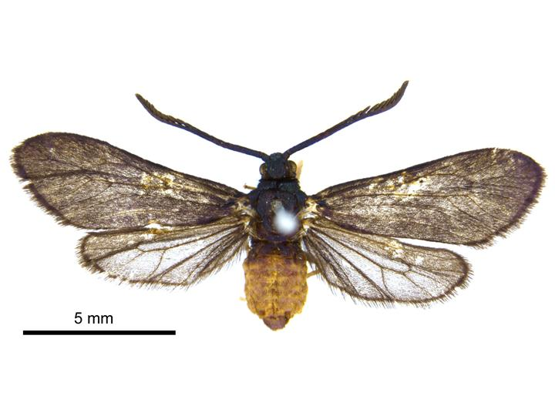
R. Henderson (2013) Levuana Iridescens Wikimedia commons [image] accessed 24/3/2022
In the following composition and aural activity, students will engage with their own Music 2 core composition and apply similar compositional techniques that Jessica Wells has used in her piece. The aim is to experiment with pitch, duration and textural elements to create new musical possibilities for students to explore and consider in the development of their own core composition.

Option 1
To complete option 1, your core composition must contain pitch material.
- For this activity, you will apply the ‘diminishing’ concept to your own composition by deleting a note at a time to create a series of adapted short compositions or variations. Select a section of your core composition (perhaps 8 bars or similar).
- Count how many pitches are used in your selected section/motif. This will determine how many variations you will create. Set up a template in notation software for each variation, and cut and paste your unedited section/motif into each variation. Number them.
- Consider which note is your ‘tonic’ or ‘pedal’ note, and the harmonic direction that you want to take your variations in. Through experimentation, consider the various note combinations which can be created by your original pitch material or scale choice and plan out the sequence in which each note will be omitted for each variation.
- The next step in this activity can be approached in one of the 2 ways listed below.
  - Delete the notes not needed in each variation which will then be replaced by rests. This reveals an interesting experiment in pitch, duration and texture.
  - Delete the pitches not required but replace those notes with alternative pitches that are contained within the pitch set used for that variation. This will then retain the rhythmic elements of the entire work.
- Perform your variations (if applicable).
An example of this composition activity is found below.

Composition example – option 1
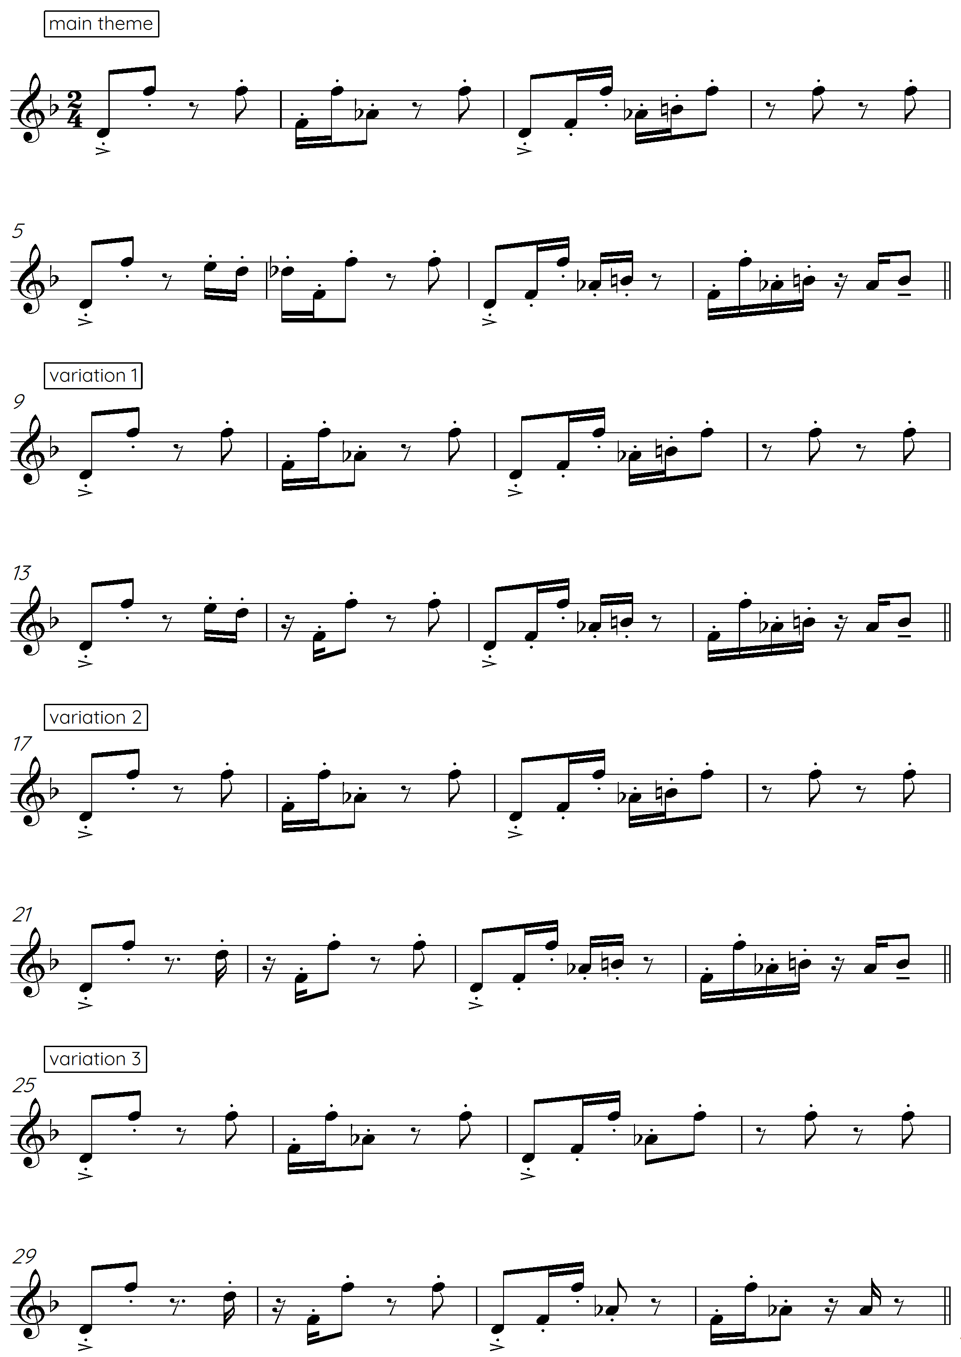

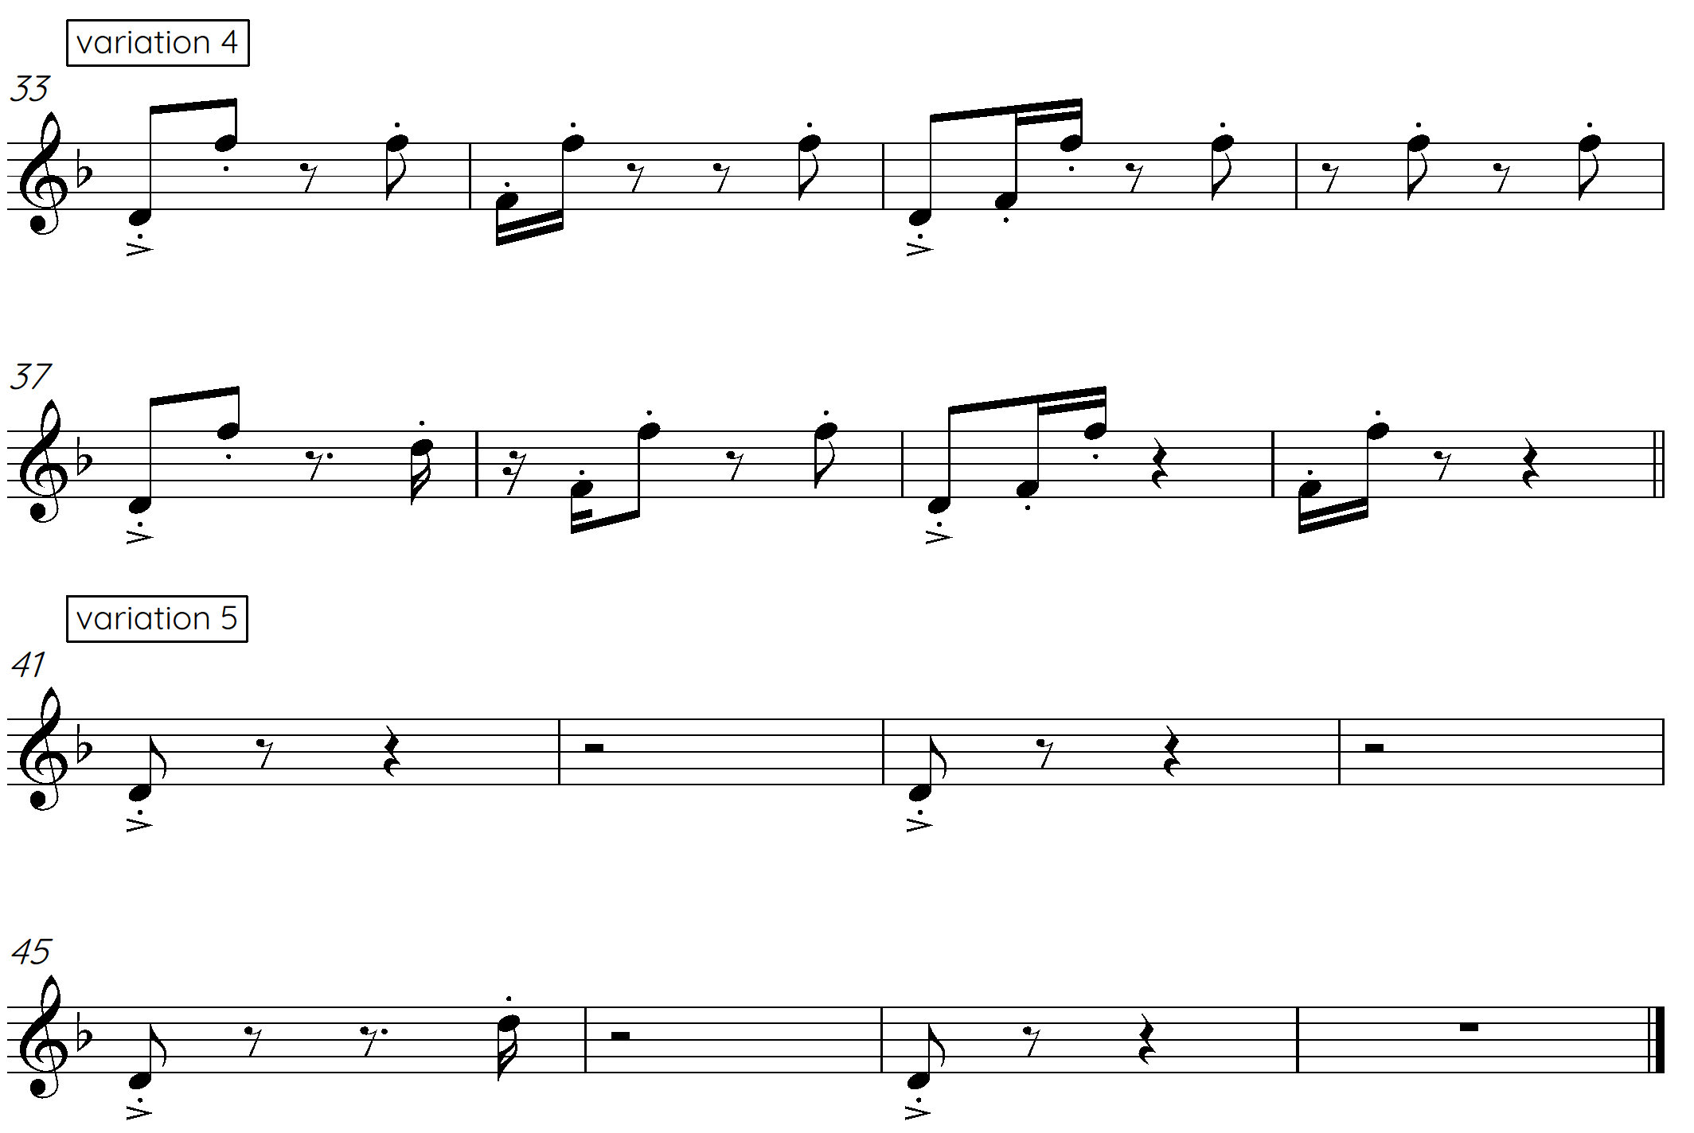
The original theme consists of a six-note pitch set including D F Ab B E Db. The notes were omitted starting from the Db, and working backwards through the pitch set.

Option 2
To complete option 2, your core composition will not contain pitch material.
- For this activity, you will apply the ‘diminishing’ concept to your own composition using rhythm. Select a section of your core composition (perhaps 8 bars or similar) and write down all the note values that your selected section contains.
- Count how many different note values are used in your selected section/motif. This will determine how many variations you will create. Set up a template in notation software for each variation and cut and paste your unedited section/motif into each variation and number them.
- Consider the rhythmic direction that you want to take your variations in. Through experimentation, consider the various rhythm combinations which can be created by your original musical material and plan out the sequence in which each note will be omitted for each variation.
- The next step in this activity can be approached in 2 ways.
  - Delete the notes not needed in each variation which will then be replaced by rests. This reveals an interesting experiment in duration and texture as the musical material diminishes to almost nothing.
  - Delete the note values not required but replace those notes with alternative rhythms that are contained within the rhythm set used for that variation.
- Perform your variations (if applicable).
An example of this composition activity is found below.

Composition example – option 2
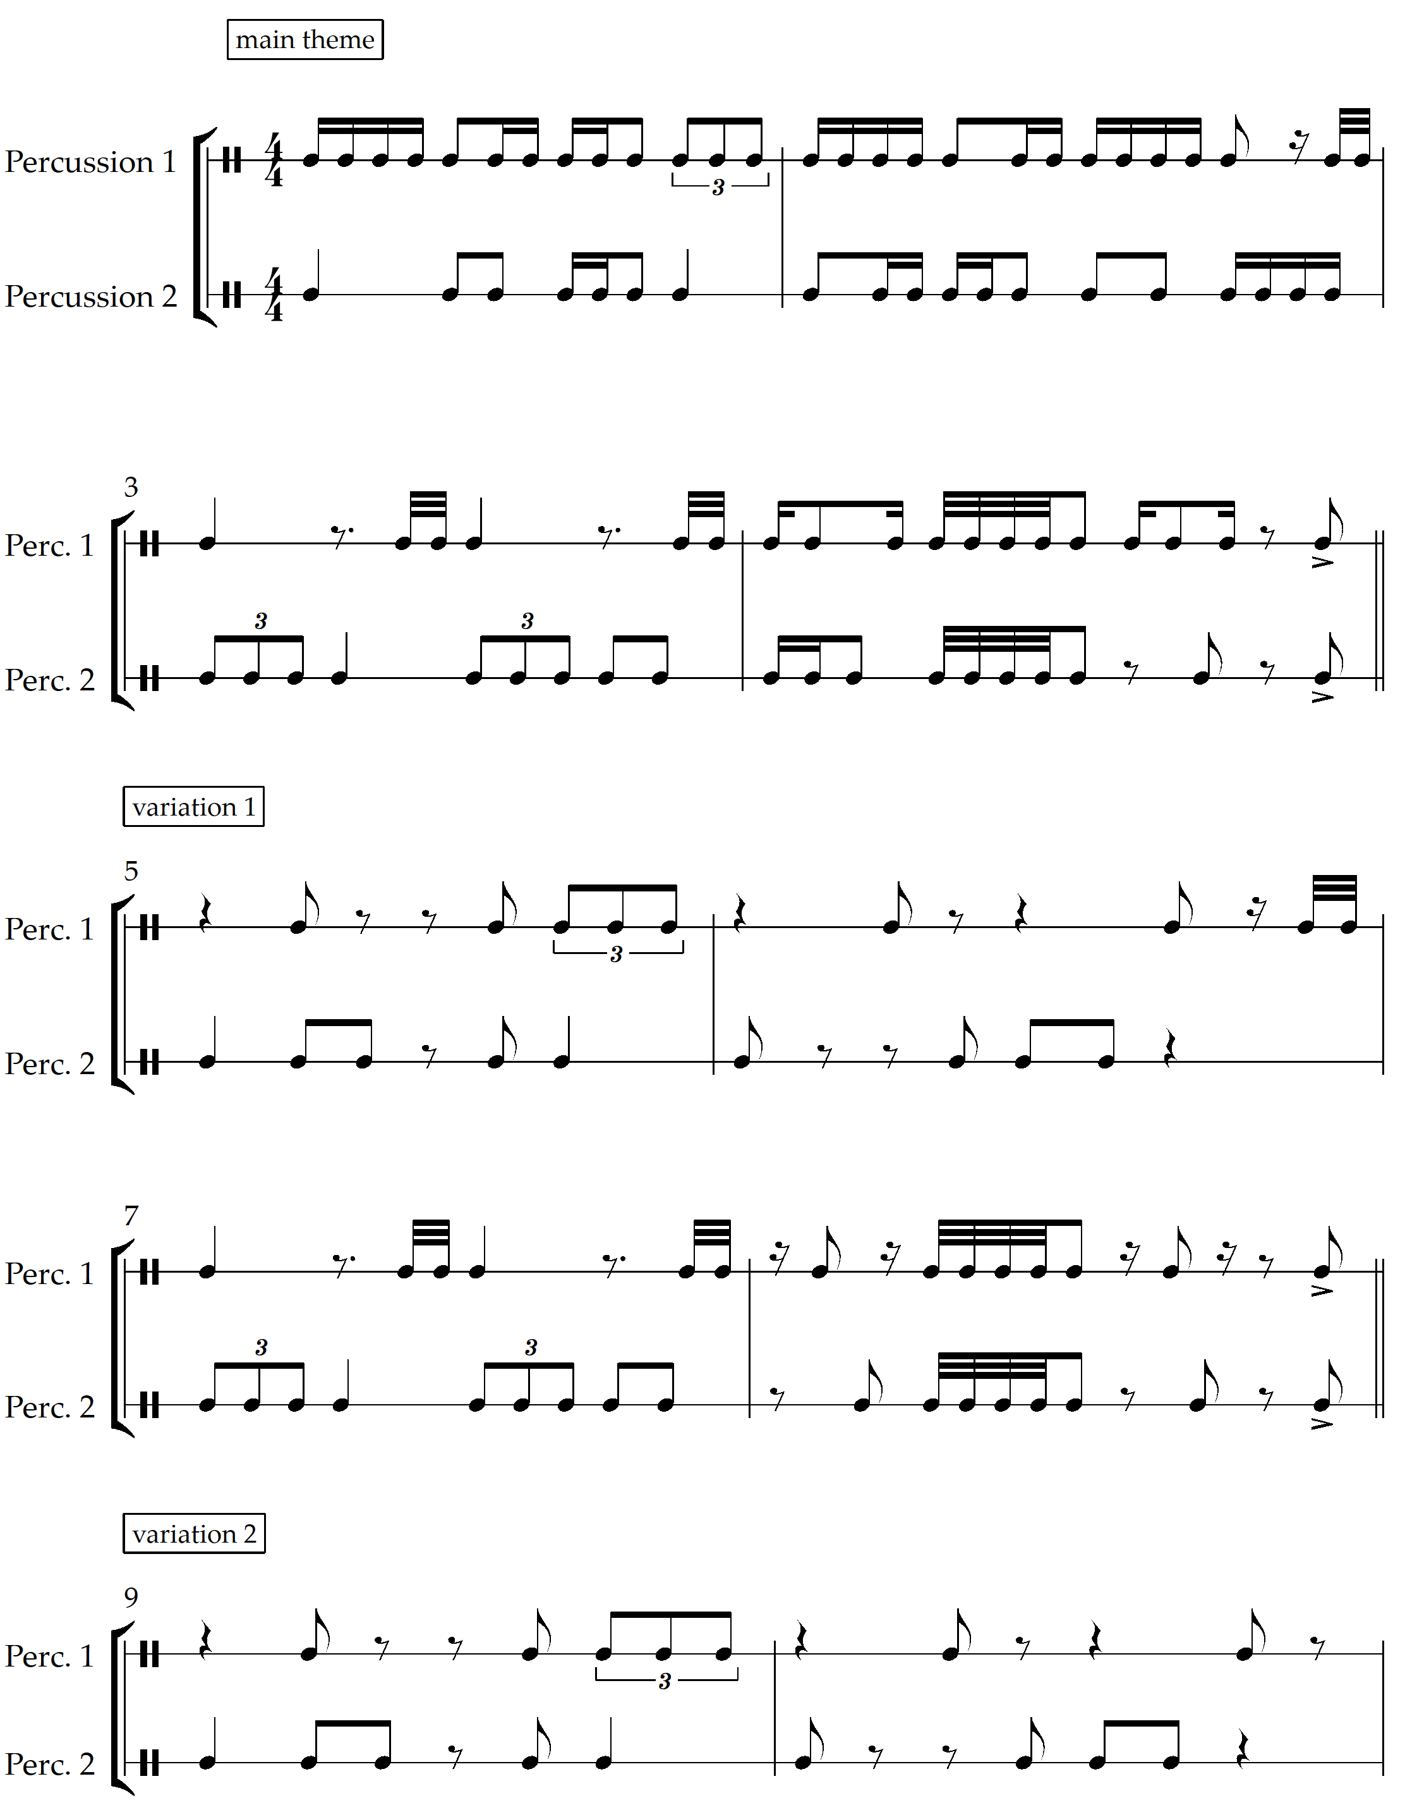
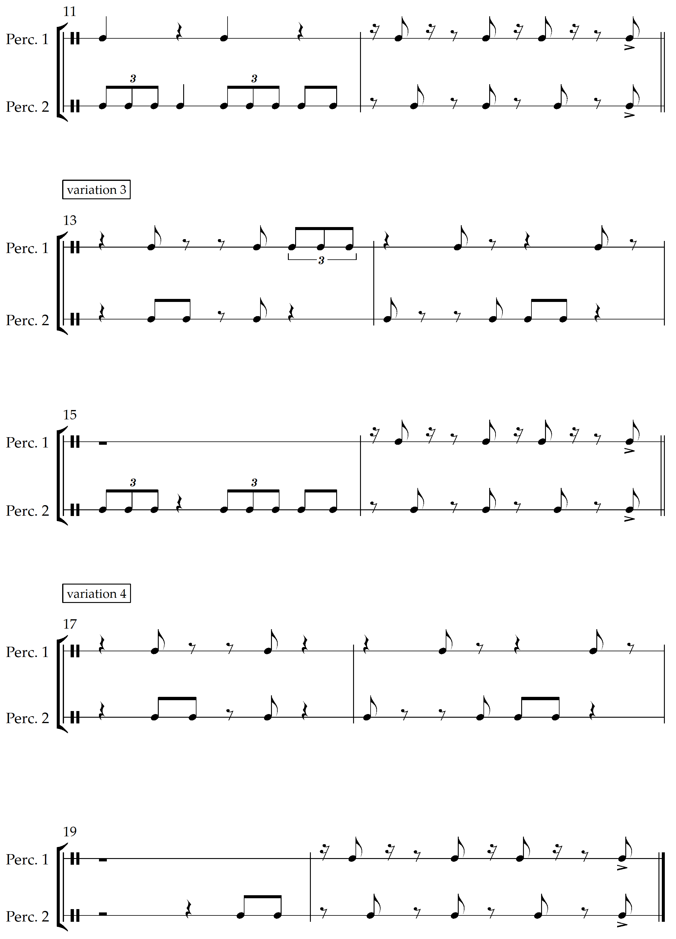
The original theme consisted of semiquavers, demi semi quavers, crotchets, quaver triplets and quavers. They were omitted in the same order, starting with the semiquavers.

Reflection
- How did the application of this compositional technique affect your original musical material in your core composition? Was it successful? Is there any musical material that you could now further develop or adapt from this activity to incorporate into your Music 2 core composition?
- Paste your ‘diminishing’ experiment into your composition portfolio.
Please note – the use of the word ‘diminishing’ in this context should not be confused with the musical term ‘diminished’ or ‘diminution’.

Musical features of ‘Diminishing Species’

Clock ticking
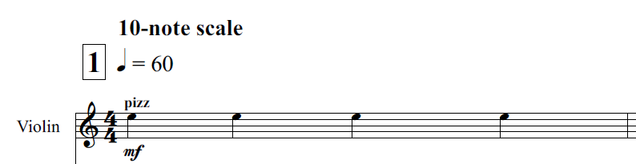
- Describe the musical material of the violin throughout the piece. Why do you think the composer has chosen to do this?
- When and how is the ‘clock ticking’ varied in the piece?

Flurry of notes
Jessica Wells describes the guitars and marimba parts as a ‘flurry of notes’ which symbolises the animals and busyness of the planet.
Identify a section in which this symbolism is represented through a ‘flurry of notes.’ Describe how this section creates ‘busyness’ and tension using the concepts of music.

Diminishing dynamics
Describe how the dynamics and expressive techniques change from section 8 to the end to reinforce the idea of ‘diminishing species.’

Tone Colour
Match up the instruments to the musical material or role that they primarily provide within the piece.
Violin | Bass clarinet | Trio | Suspended cymbal | Piano | Contrabass
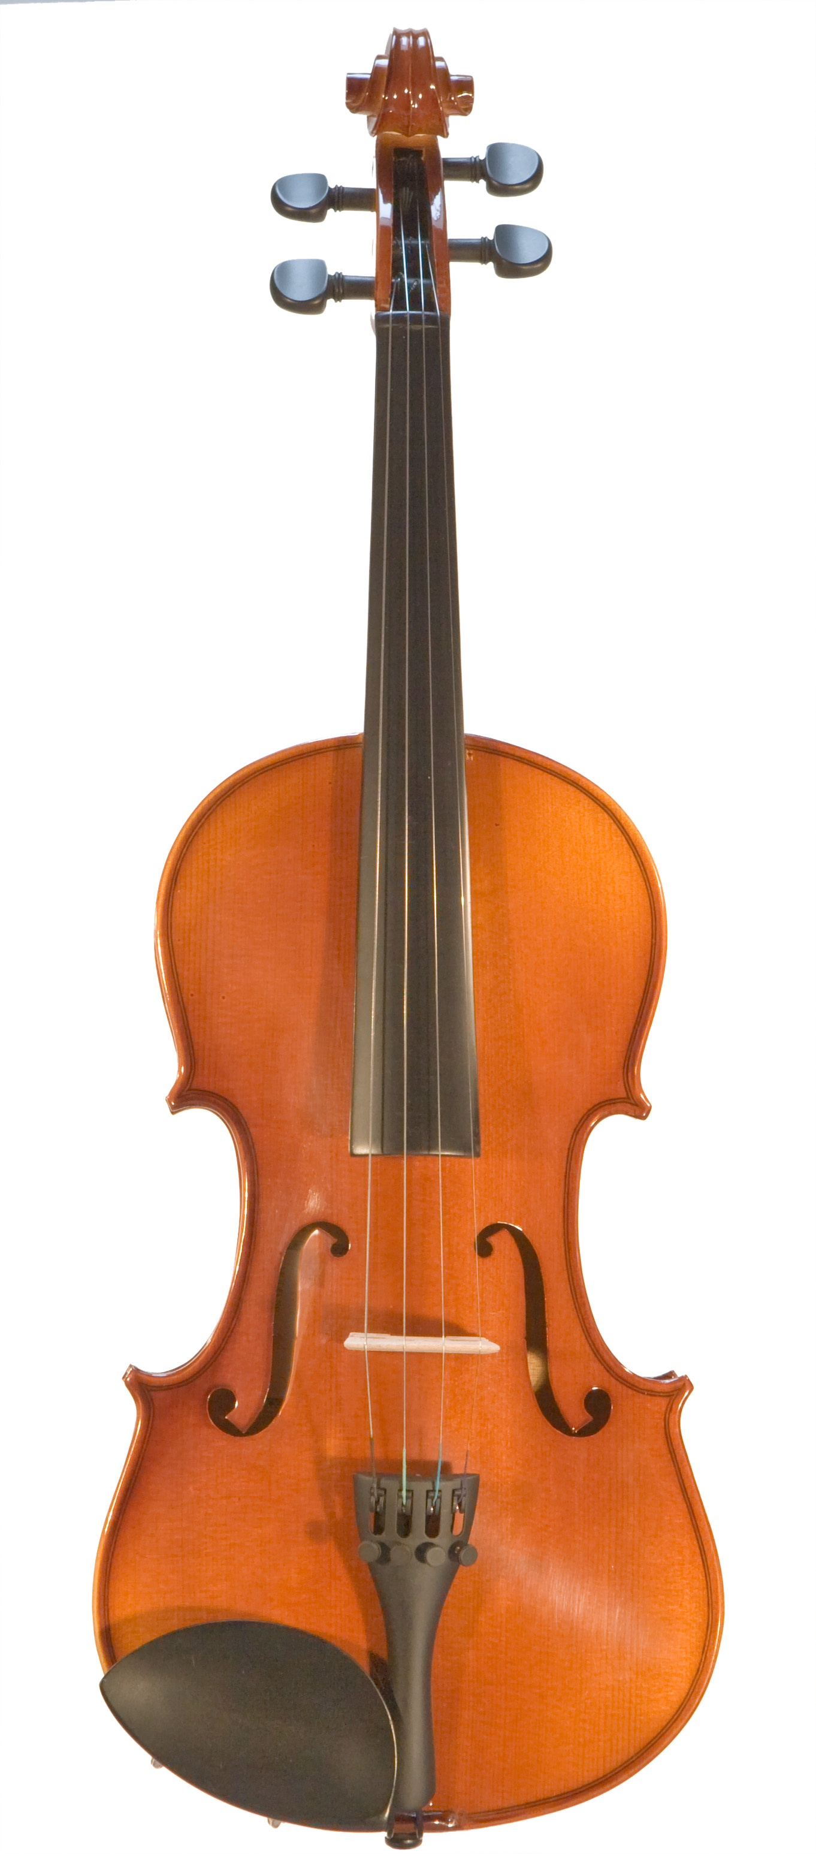 | 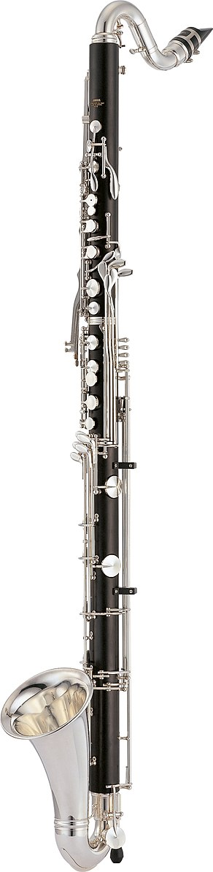 | 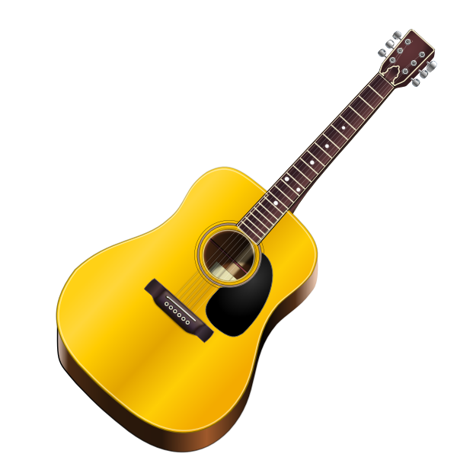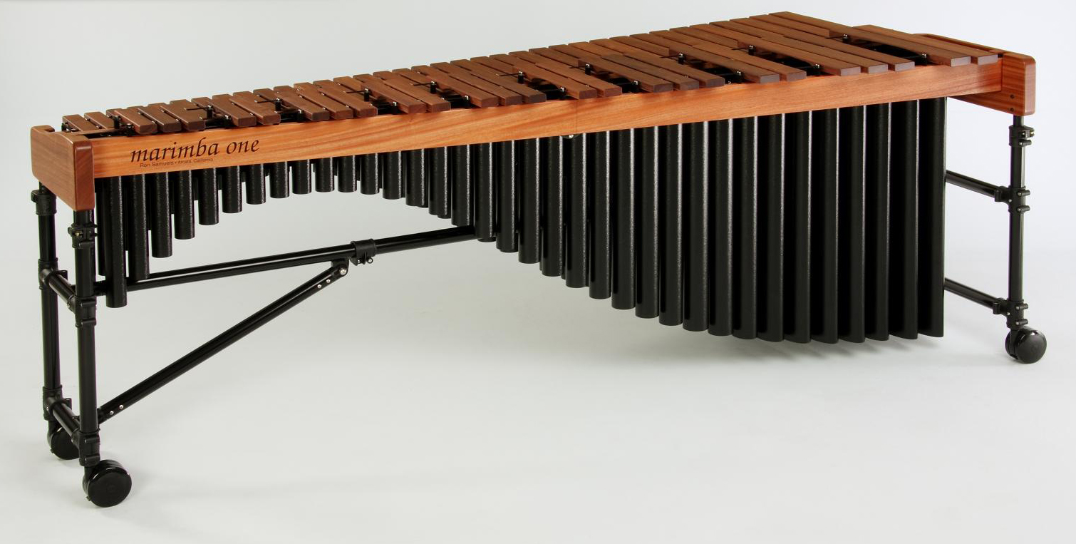 | 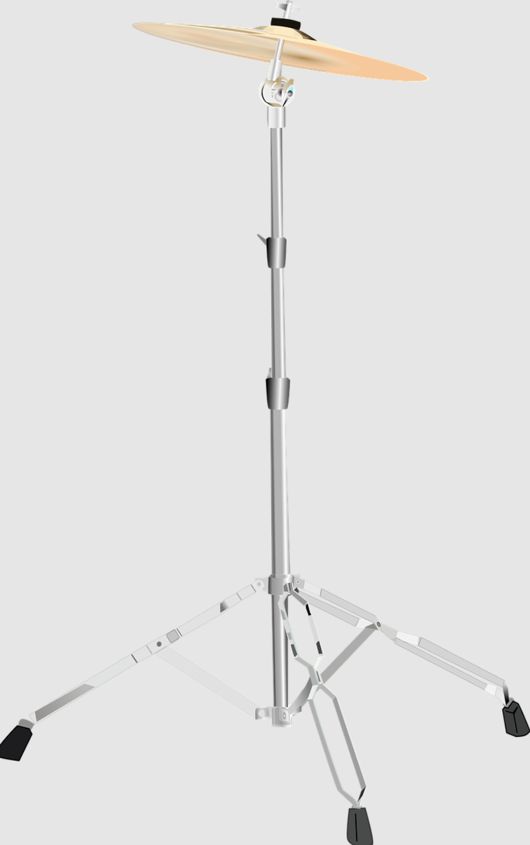 |  | 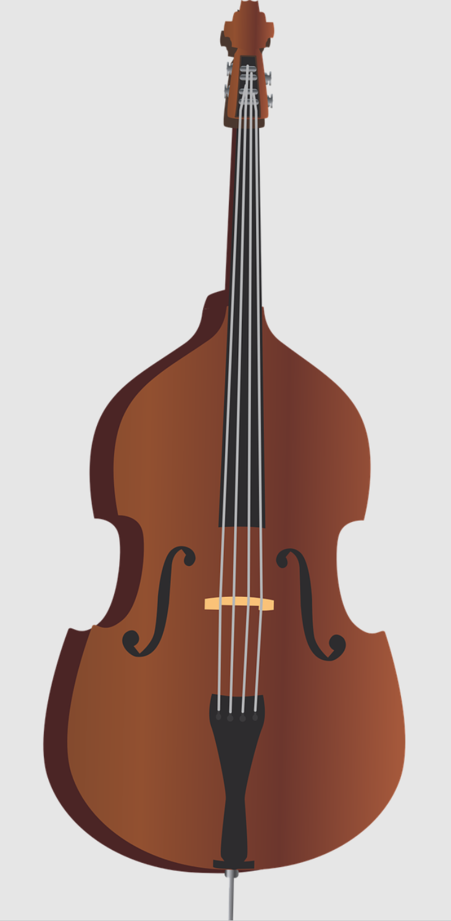
harmonic accompaniment | main melodic texture | textural contrast | harmonic grounding | metronome | washy colours
Note – please see image references in the reference list at the end of the resource.

Verse and refrain structure
In the film that accompanies the music, each section is presented as a different animal species that became extinct in the 1990’s. Jessica Wells has structured each section as a 4 bar verse followed by a 2 bar refrain. As the piece develops, the refrains become more varied and aggressive.
Identify which refrain is the first to become more aggressive and create tension. Which musical concepts contribute to this change in mood and how?

Musicology and aural – animal card activity
Teachers are to print and cut out the diminishing species cards from the table on pages 18 to 22. Students are to select one card from the 10 diminishing species cards distributed by the teacher.
- Analyse the corresponding refrain according to the concepts of music using either score annotations or dot points. An example is provided below.
Note – please see image references for the animal images in the reference list at the end of the resource.

Example
Refrain 1 – Dusky Seaside Sparrow
Refrain | Animal | Refrain score
1 | Dusky seaside sparrow (Ammospiza maritima nigrescens) | 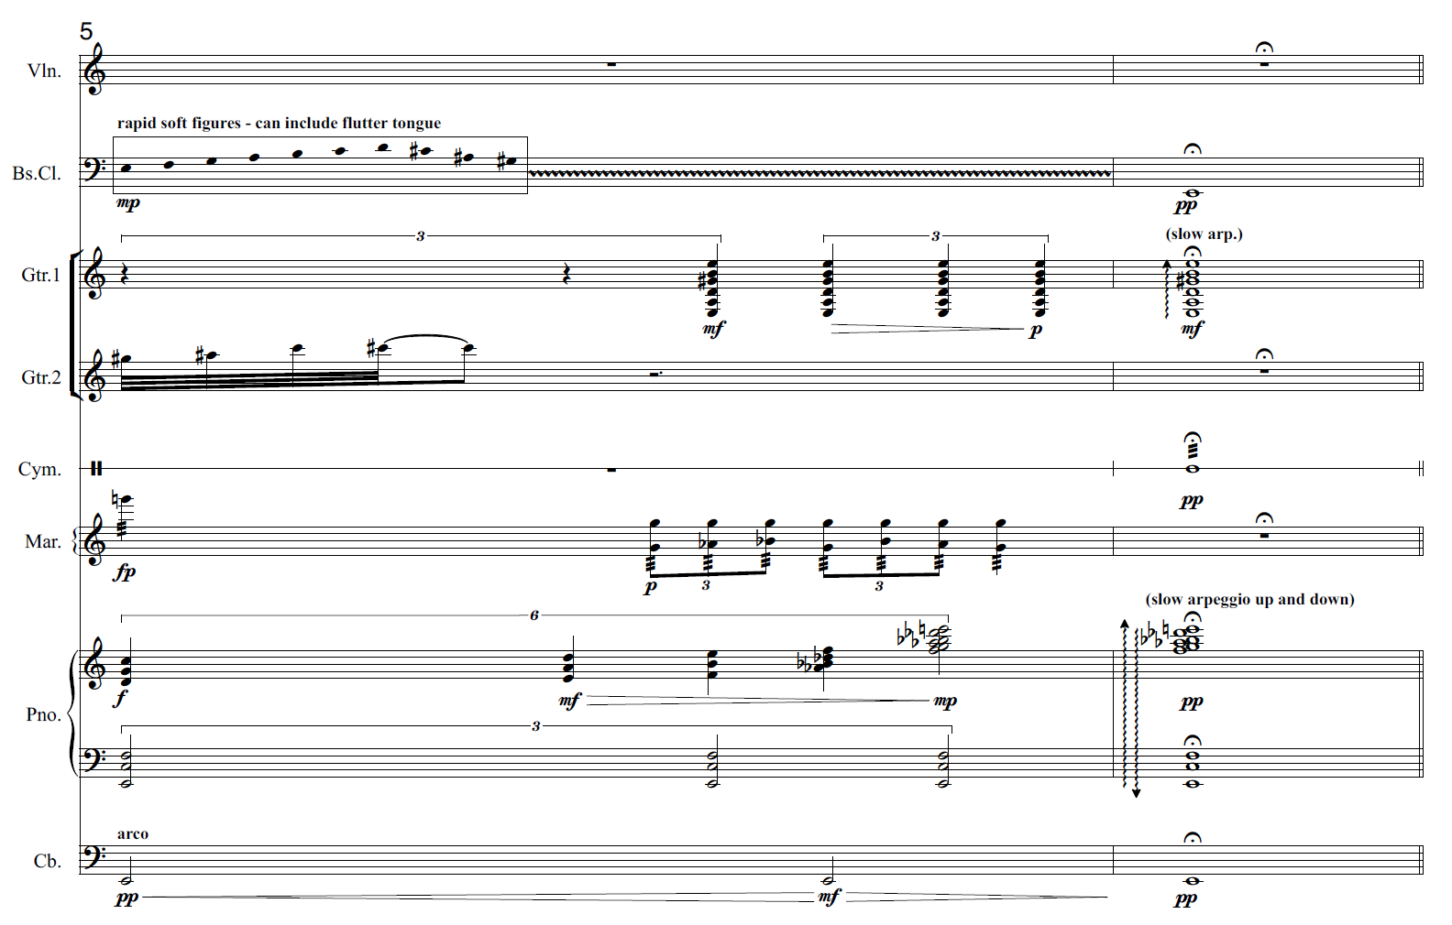
Sample answers:
- all instruments within the ensemble are utilised except for the violin
- complex rhythmic material including the use of triplets and sextuplets (irrational rhythms) create polyrhythms
- box notation is used in the bass clarinet part
- tone clusters in the guitar 1 and piano parts create dissonance
- the overall dynamic shape crescendos and descrescendos from pp to mf to pp.
- rhythmic ambiguity and an unclear sense of pulse is due to the use of the box notation, polyrhythms, slow arpeggio and fermata.
- the pitch contour is mainly ascending.
- the tonality is atonal with the double bass providing an E pedal
- a moderately thick, quasi polyphonic texture is used
- use of flutter tongue in the bass clarinet creates a feathery timbre
- 2 bar phrase.
- Pair and share: Students are to pair up with another student in the class and discuss the similarities and differences between the two chosen refrains by completing the table below:
Similarities | Difference

Diminishing species cards

Card 1
Refrain | Animal | Refrain score
1 | Dusky seaside sparrow (Ammospiza maritima nigrescens)

Card 2
Refrain | Animal | Refrain score
2 | 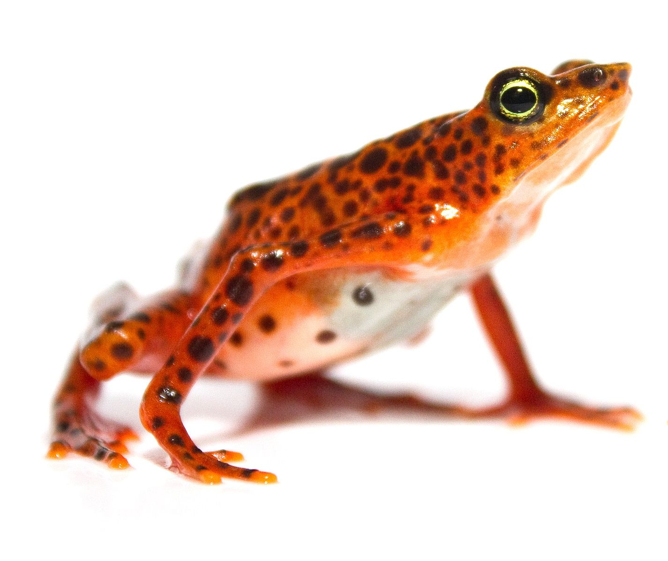  Scarlet harlequin toad  (Atelopus sorianoi) | 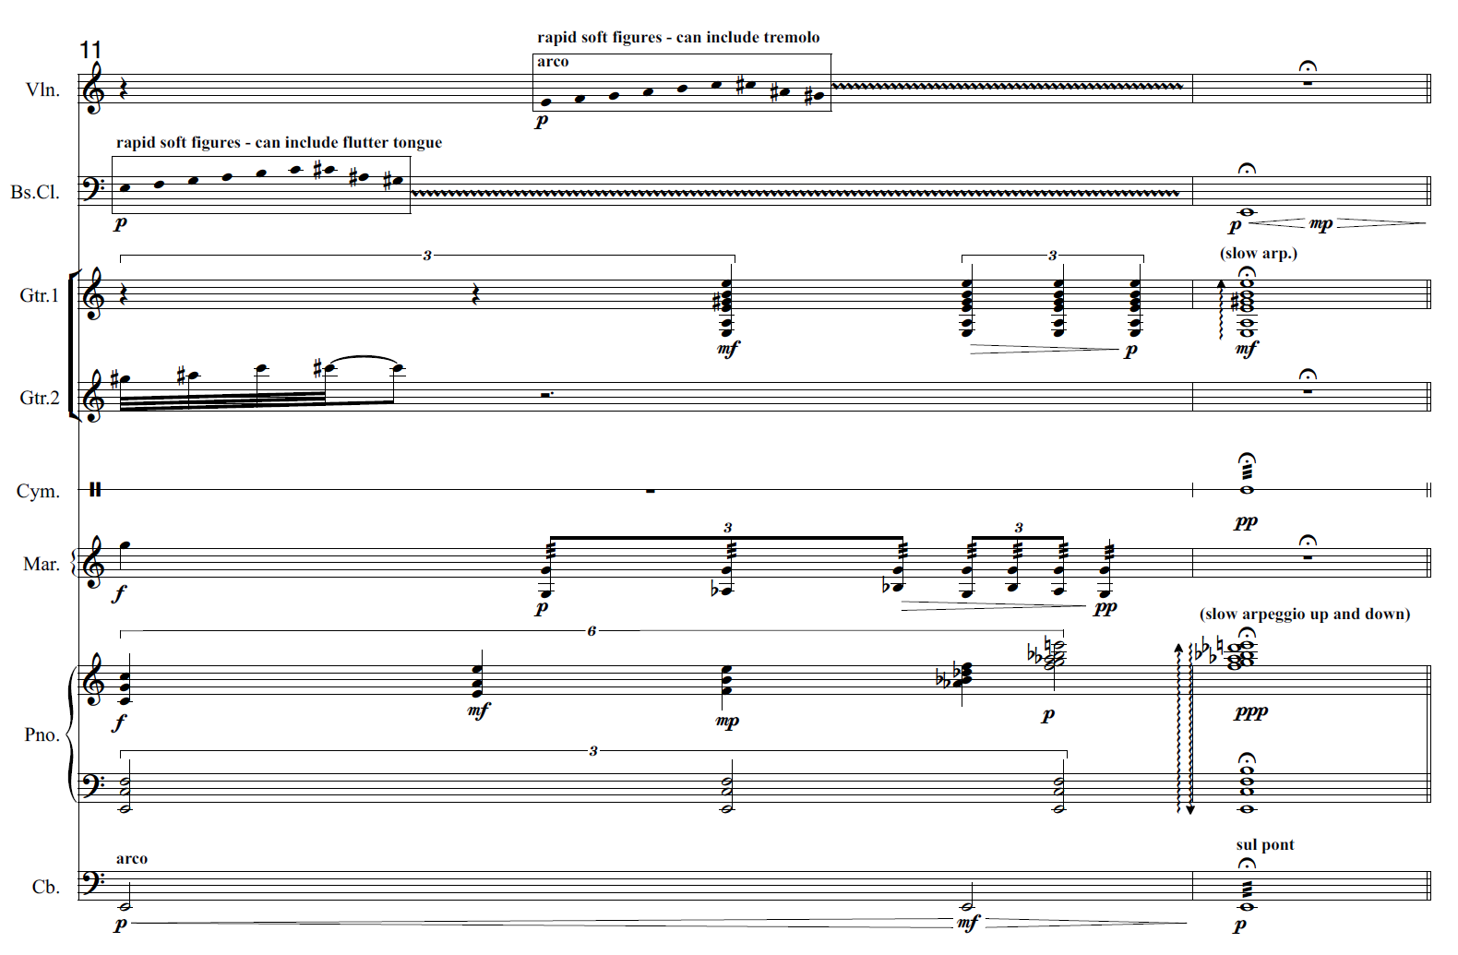

Card 3
Refrain | Animal | Refrain score
3 | Angel Island mouse (Peromyscus guardia) | 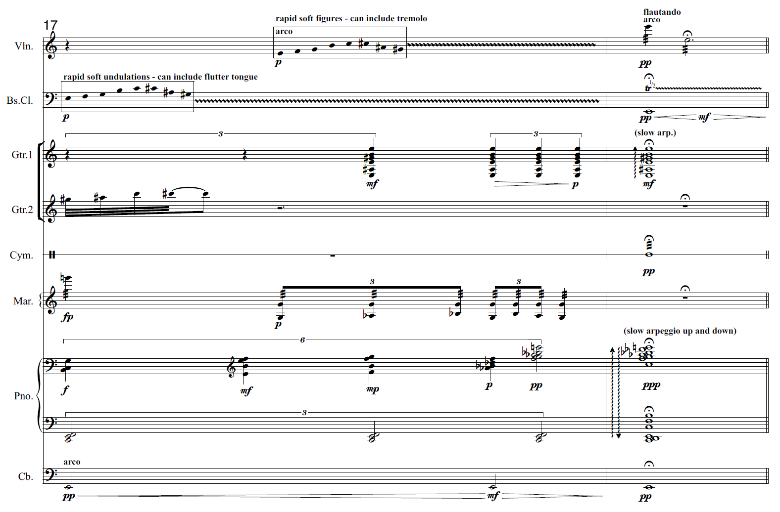

Card 4
Refrain | Animal | Refrain score
4 | 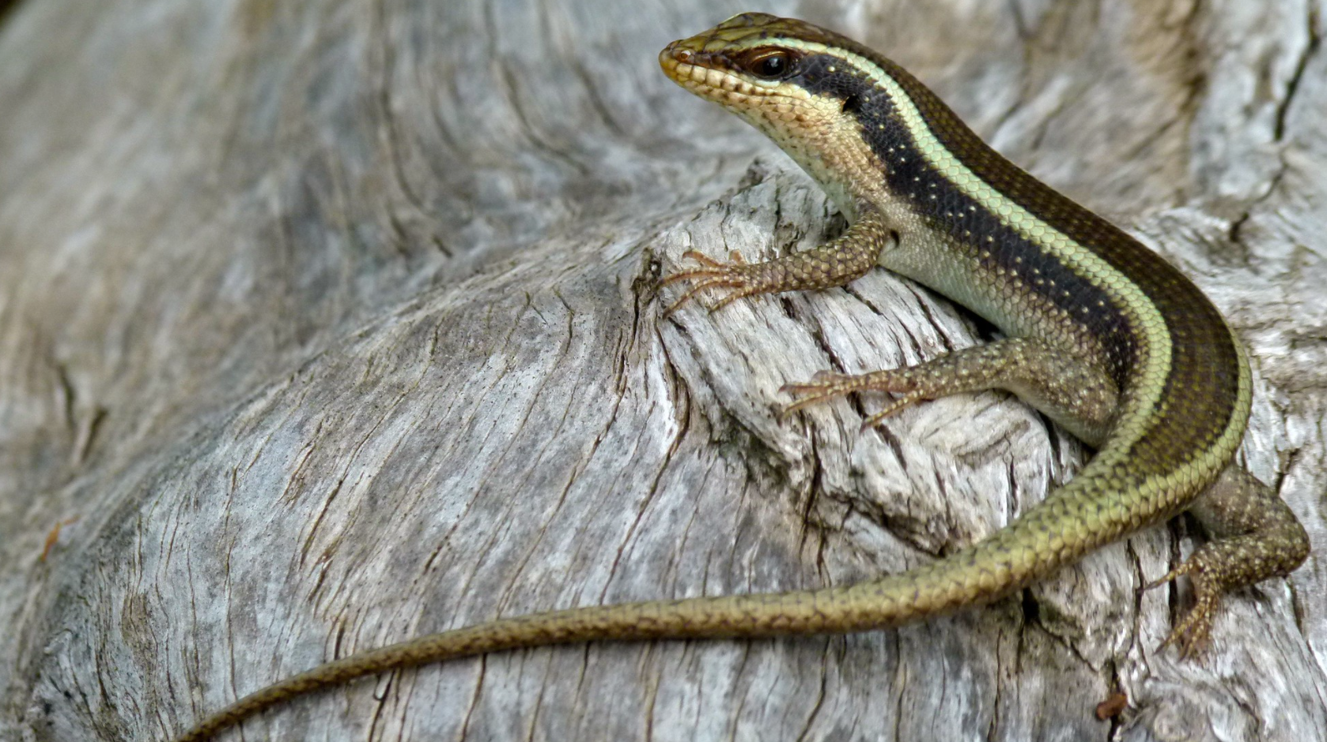  Monito Skink  (Spondylurus monitae) | 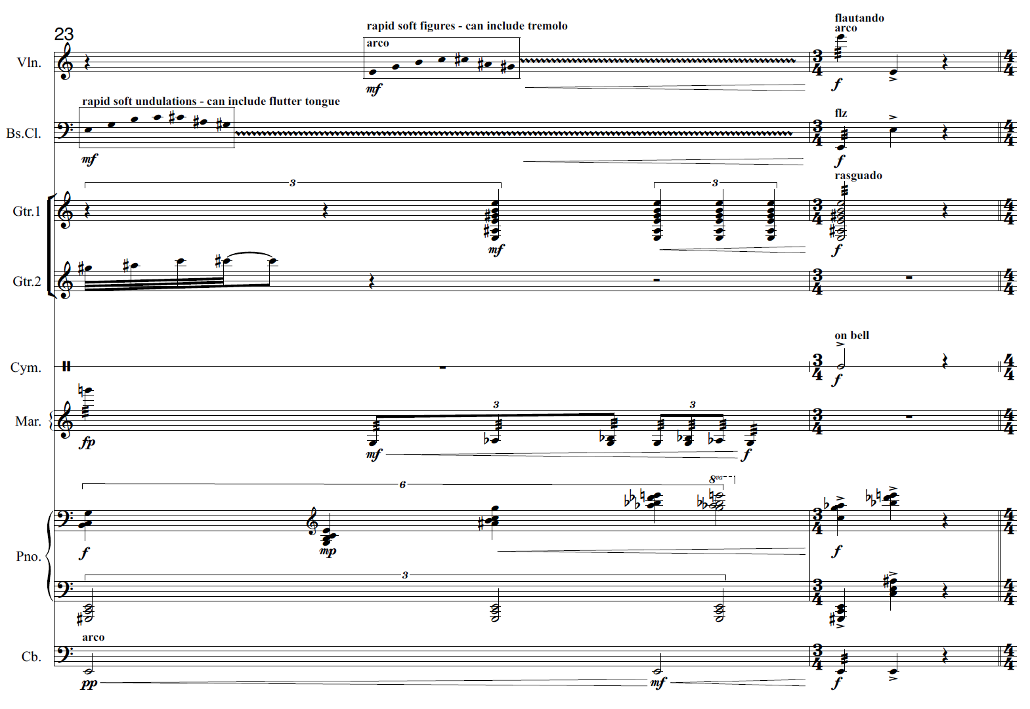

Card 5
Refrain | Animal | Refrain score
5 | 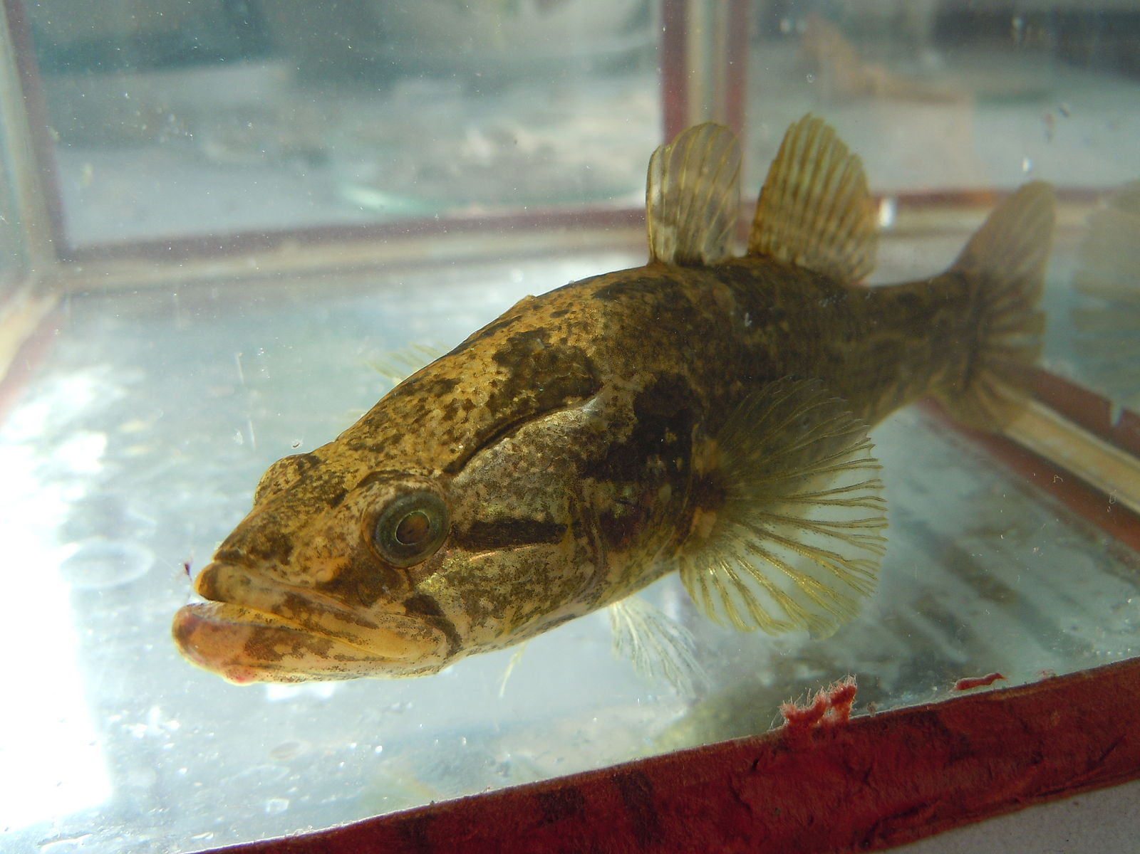  Danube delta dwarf goby (Knipowitschia cameliae) | 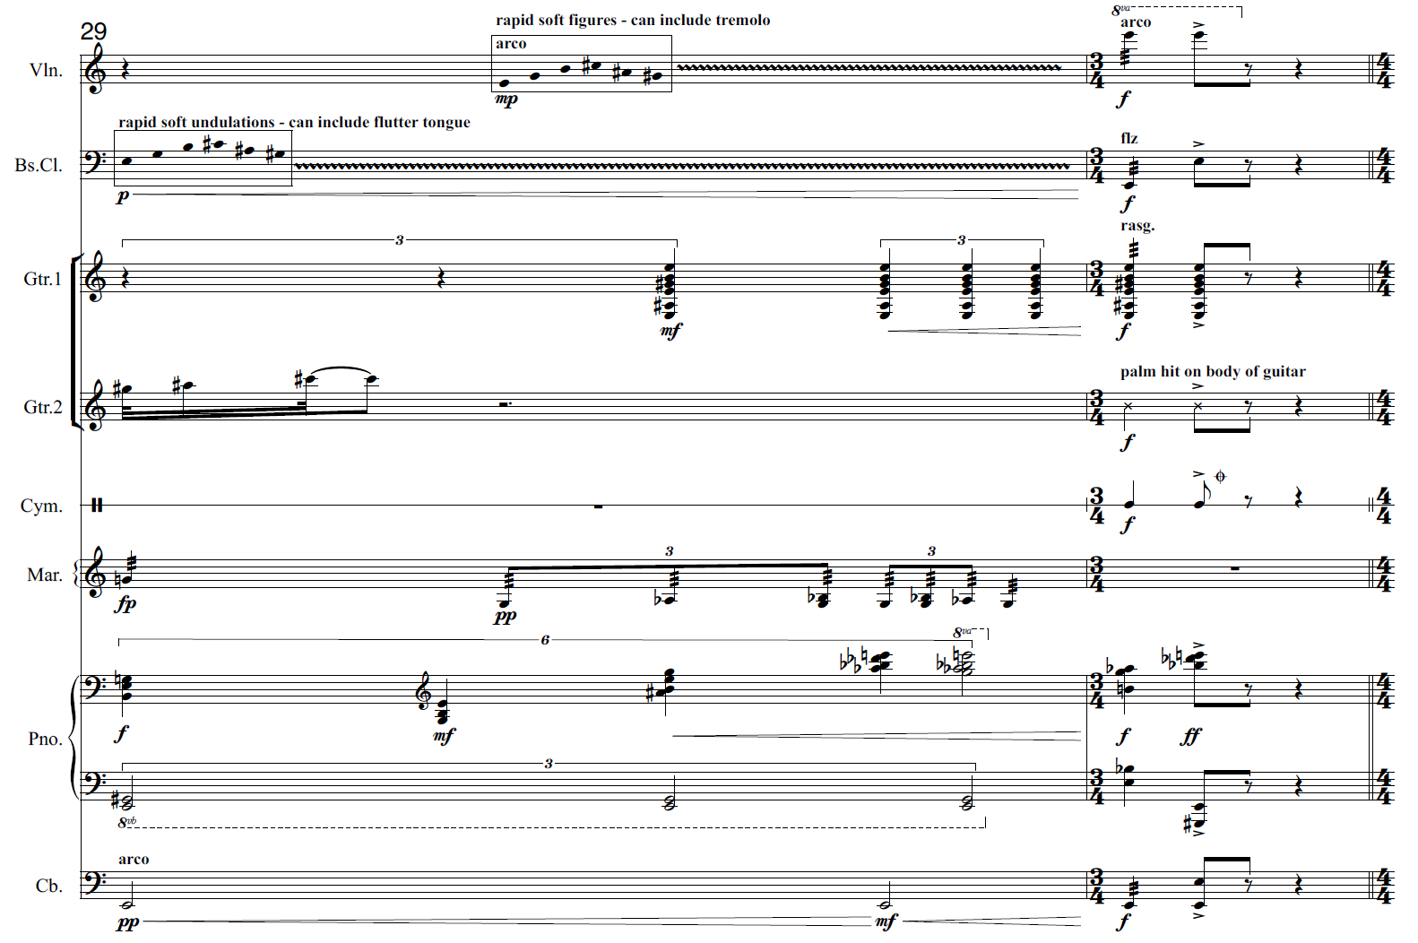

Card 6
Refrain | Animal | Refrain score
6 | 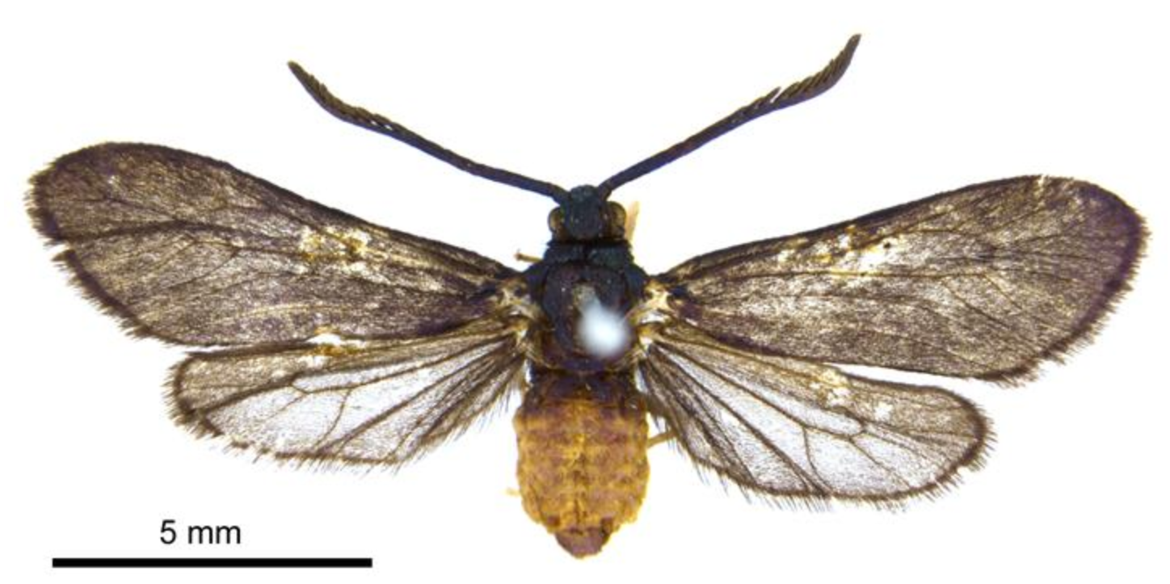  Levuana moth (Levuana iridescens) | 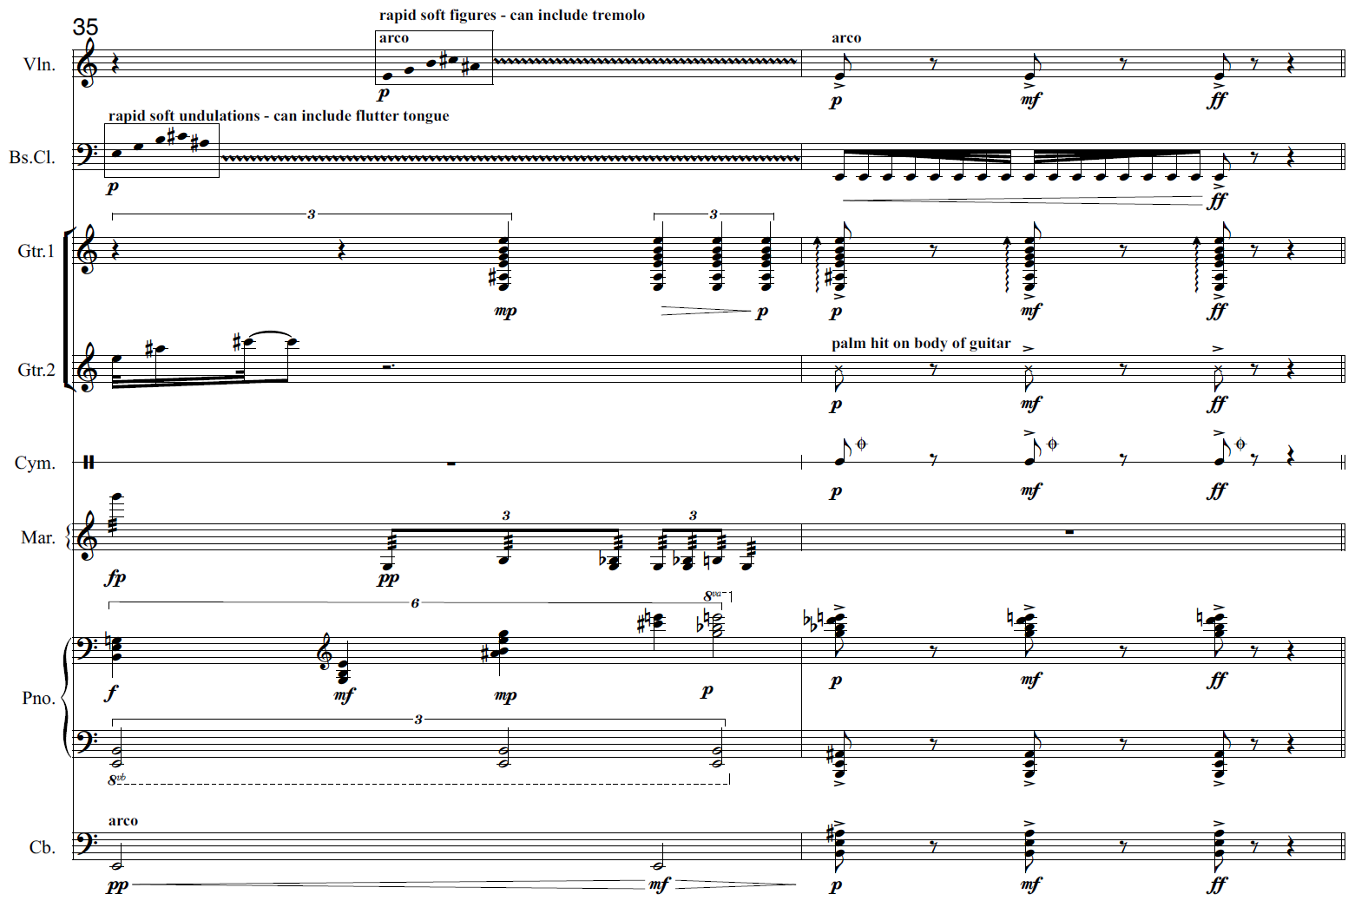

Card 7
Refrain | Animal | Refrain score
7 | 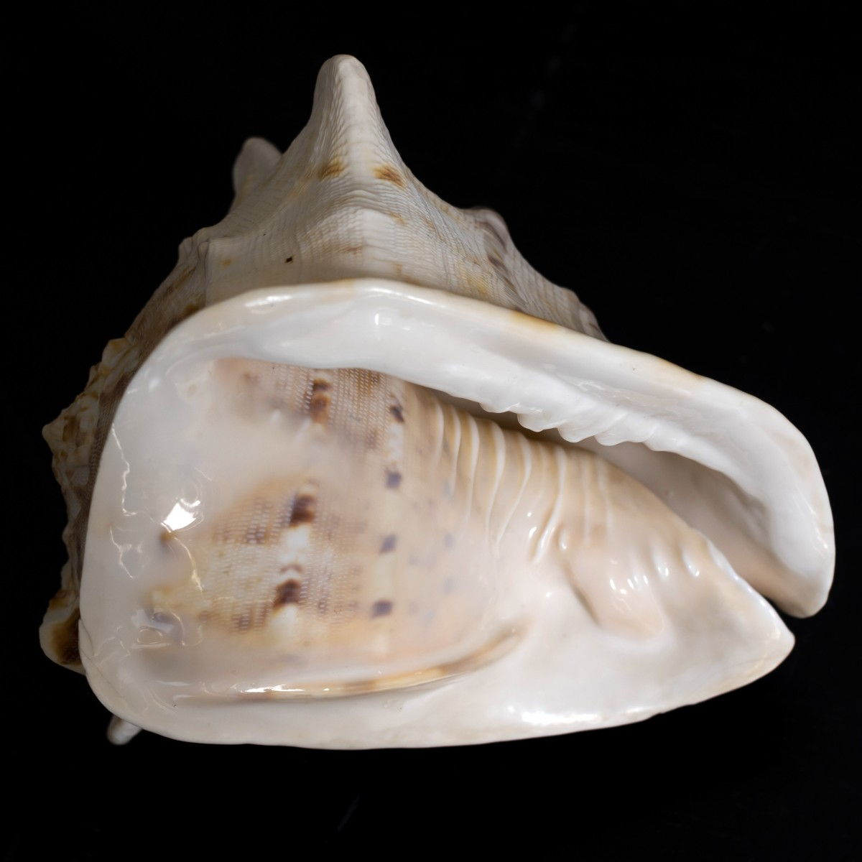  Sardohoratia sulcata mollusc  (Sardohoratia sulcate) | 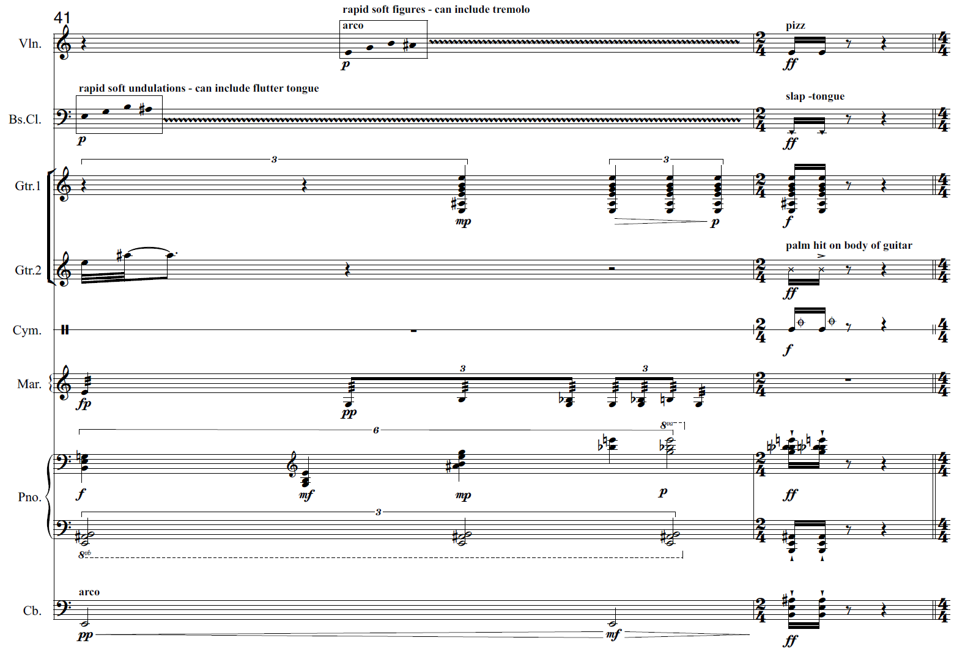

Card 8
Refrain | Animal | Refrain score
8 | 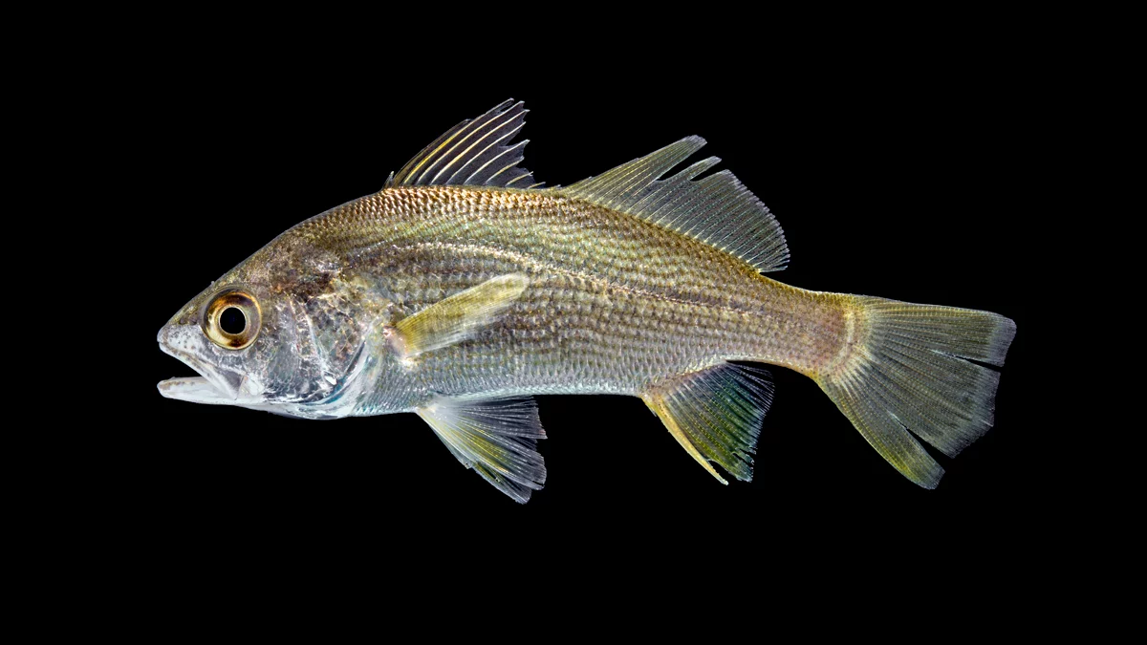  Pantanondon ‘Manombo’ fish  (Pantanodon sp. nov. 'Manombo') | 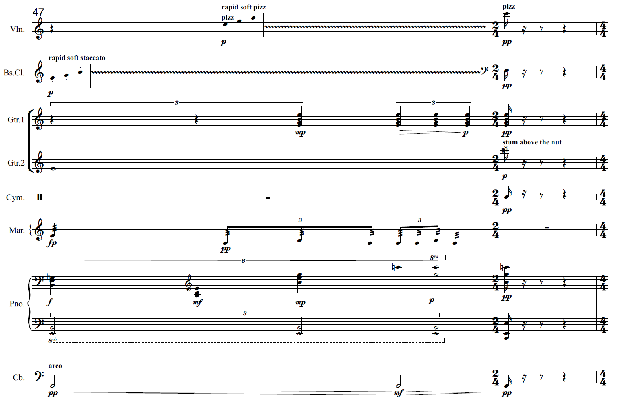

Card 9
Refrain | Animal | Refrain score
9 | 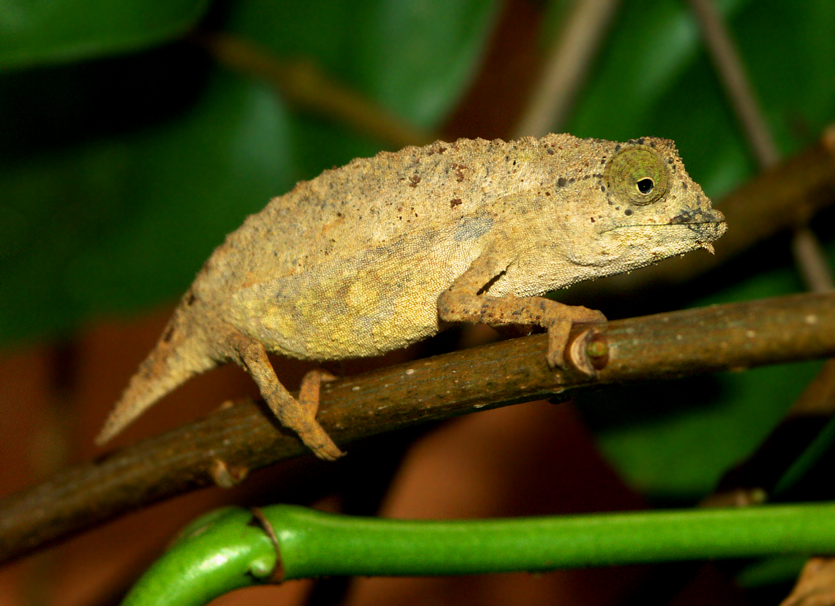  Chapman’s pygmy chameleon  (Rhampholeon chapmanorum) | 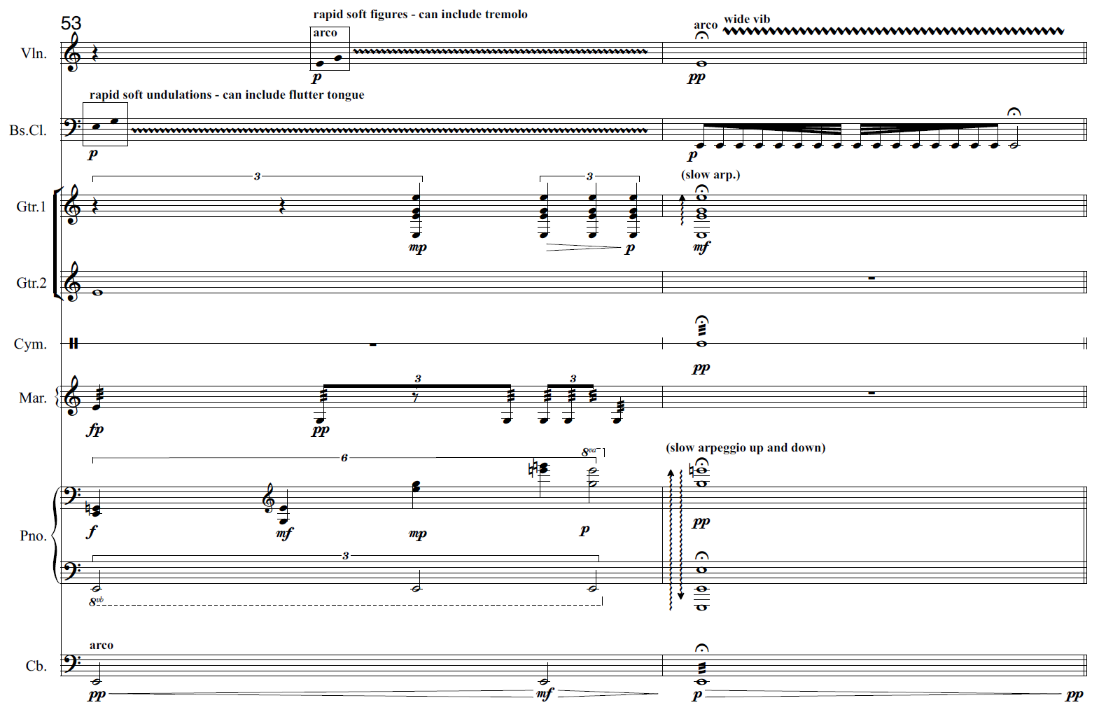

Card 10
Refrain | Animal | Refrain score
10 | 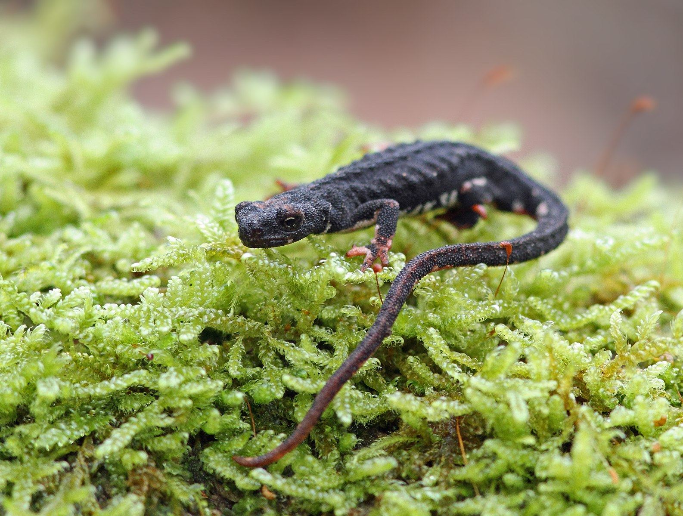  La Hoya minute salamander  (Thorius minydemus) | 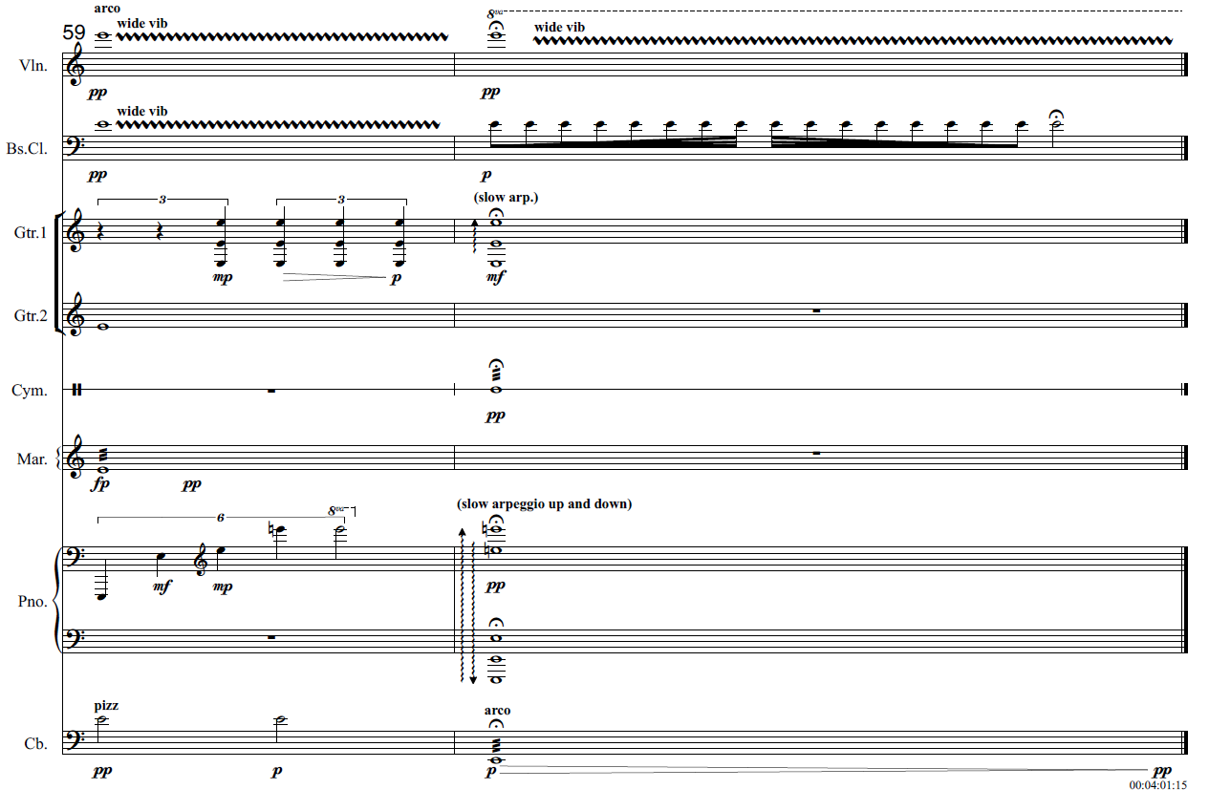

Musicology and aural – podcast activity
Listen to the Department of Education (2022) Creative Cast ‘Unlocked - Australian music of the Last 25 years.’ [podcast] date accessed 25/2/2021. In this episode, Australian composers Holly Harrison and Jessica Wells speak about their works titled ‘Bend/Boogie/Break’ and ‘Diminishing Species’. Joining them is Ensemble Offspring Artistic Director and percussionist Claire Edwardes. Listen to an insightful discussion that unlocks the compositional process used in both works through the composer and performer lens.
Answer the following questions whilst listening to the podcast:
- How did the collaboration with Ensemble Offspring and Jessica and Holly come about?
- Identify some of the musical features and the compositional process that Jessica used to create the piece.
- What were some of the musical challenges Jessica faced in composing ‘Diminishing Species’ for such a unique ensemble, and how did she overcome them?
- How would Jessica like performers to approach and prepare her piece for performance?
- How did Ensemble Offspring prepare to perform Jessica’s piece?
- What is one piece of advice that the composers and performers give to elective music students who lack confidence when composing their own music and/or performing art music that best resonates with you?
- Name one up and coming composer of Australian Music mentioned in this podcast that you are interested in exploring?

Additional resources
These resources provide additional information to support the development of skills provided in this resource. They could also be used to create additional activities by the teacher.
- Peter Mcullum (2021) Environmental stories tied up in splendid orchestral moments, Sydney Morning Herald performance review [website] date accessed 26/01/2022
- Department of Education (2021) Music extension composition resource booklet [website] date accessed 26/01/2022
SML Design (2022) Ensemble Offspring [website] date accessed 26/01/2022
- Lasso group Jessica Wells composer [website] date accessed 26/01/2022

Answers

Who is Jessica Wells?
Image permission from Jessica Wells 2022.

Musicology
- Go to Jessica Wells - composer [website] (date accessed 1/11/2021) and write down 5 significant musical points about Jessica that may assist you in your study of the work.
Answers may include:
- Jessica Wells is an Australian composer, orchestrator and arranger for concerts, films, theatre and album recordings
- Jessica's compositions cross many genres in the classical, commercial and film music worlds
- Jessica’s orchestral music and arrangements have been performed by many of the major Australian orchestras (SSO, MSO, TSO, WASO and QSO)
- Jessica also composes electronic music and has written children’s music for ABC Classic Kids
- Jessica’s works sometimes include multimedia aspects and collaborations with other artists and/or performers.
- Watch the Jessica Wells (2021) ‘Diminishing Species’ [video] (00:00:00 – 00:01:20) (date accessed 2/11/2021) of composer Jessica Wells talking about her piece.
  - What does this piece explore? This piece explores how throughout the decade of the 90’s there were animal species becoming extinct slowly over the decade.
  - How does Jessica symbolise this? By having a ten-note scale which then slowly diminishes one note at a time over the ten sections of the piece of which each represents a year of the decade. By the time we reach the end of the piece, we are down to one note.
  - What is interesting about this symbolism? That you don’t notice that the notes are missing until about the 8th section which is only made up of 3 notes. This is quite poignant because it shows the human condition in that we don’t realise what we’ve lost until it’s too late.

Aural and musicology
Ensemble Offspring (2021) Jessica Wells - Diminishing Species [video] (00:00:00 – 00:05:16) date accessed 2/11/2021
- Using the mind map below, listen to ‘Diminishing Species’ and brainstorm any interesting musical observations or first impressions you have of the work. Consider aspects of the concepts of music in your initial ideas.
Answers may include:
- atonal
- short note values and use of polyrhythms
- strong definite beat in the violin followed by an indefinite sounding section
- polyphonic like texture
- repeated sections
- busy moderately thick, textural layers
- high pitched notes play short motifs using an ascending scalic motion
- mixed chamber ensemble – violin, bass clarinet, guitars x 2, marimba, sus cymbal, piano, and double bass
- dissonant harmonies
- 4/4 time signature
- expressive techniques include pizzicato and short articulations and accents
- the dynamic remains fairly constant throughout
- the overall tone colour is twangy and bright.
- Listen to ‘Diminishing Species’ again whilst following the score. Answer the following questions using the recording and the score.
  - Describe both the macrostructure and microstructure of this work. Some questions to help guide you may include:
  - How many sections are in this work?
There are 10 sections in the whole work.
  - How many bars is each section made up of? Is there a pattern to the microstructure?
Each section consists of 6 bars total and is made up of a 4 bar ‘verse’ followed by a 2 bar ‘refrain.’ Each section has been developed through the omission of one note from the pitch set and the musical material has been altered according to the concepts of music.
  - What is the overall tonality of this work?
It begins atonal, however, it slowly modulates throughout to E minor, finishing with an E pedal.
  - Is there a tonal centre? Identify the instrument which is fundamental in establishing the tonal centre and how this is achieved.
The tonal centre is E which is provided by the repeated ‘E’ performed using pizzicato on the violin. This is meant to simulate a metronome or clock ticking.
  - The main pitch material is conveyed by the guitar 1 and 2 and marimba. Describe the relationship between these instruments in bars 1 – 6.
The two guitars and marimba form a trio, and serve as the main pitch layer for the piece. In bars 1 – 4, all three instruments begin with an ascending melodic figure which is played using a canonic like effect. Each line plays independent, complex rhythms, and contrary motion is seen between the parts as the section continues. The relationship between the instruments is equal and unified, with the three instruments balanced against each other to form a distinct, melodic textural layer. In bars 5 and 6, the trios’ role is altered as the bass clarinet and piano are featured. The guitars and marimba work more independently in these bars, and provide a harmonic and rhythmic layer.
  - Compare the use of duration in bars 1 - 4 (verse) compared to the refrain (bars 5 - 6).
Bars 1 – 4
The time signature is 4/4 and tempo is slow at 60 crotchet beats per minute. The beat is strong and clear, due to the violin playing crotchets on the beat using pizzicato. This serves as a metronome for the ensemble, whilst the melodic layer (guitars and marimba) utilise short, complex note values including semiquavers, demi semi quavers, dotted quavers. Use of syncopation and polyrhythms is enhanced through the use of ties in these parts as seen in bar 3. The canonic effect of these parts also highlights the imitation that occurs between the guitars and marimba (for example, bar 1.) The layering of these intricate rhythms creates a busy, polyphonic texture.
Bars 5-6
In bars 5 and 6, the duration elements provide contrast compared to bars 1 – 4. The beat and tempo remain definite and slow, however, it appears indefinite due to the rhythmic devices used. Bar 5 consists of box notation in the bass clarinet part. This allows the performer to improvise the note values of the prescribed pitches assigned in the box until the end of the bar. Rhythmic ambiguity is further enhanced by the irrational rhythms of minim, crotchet and quaver triplets, and crotchet sextuplets. Bar 6 contains a fermata and sustained semibreve in almost all parts. The slow arpeggio in both the guitar 1 and the piano further exaggerates the improvisatory rhythmic element to this section.

Performance, aural and musicology
For the following questions, you will need the score of ‘Diminishing Species’ and a keyboard/piano.
- On the keyboard/piano, play the first bar of the guitar 1 part. What do you notice about the pitch choices and their corresponding contour?
The notes ascend using ‘white’ keys and descend using ‘black’ keys.
- As the piece progresses, the pitch material is ‘diminished’, with one note disappearing from each section. Identify the 10 note pitch series used in section one starting on E, and write it on the stave below in ascending order: 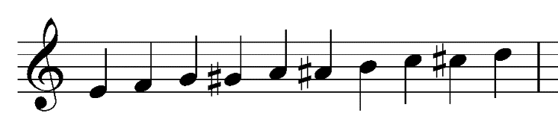
- Play through this pitch set both ascending and descending. Which scale does this pitch set resemble most?
The pitch set is similar to the chromatic scale.
- Identify which note is omitted in each section from sections 1 through to 10 and write the new pitch set for each section in the table below. You will need to fill out the ‘note omitted’ and ‘pitch set’ column. The first one and last one has been done for you.

Section | Note omitted | Pitch set | Chord
1 | none | EFGG#AA#BCC#D | Tone cluster
2 | D | EFGG#AA#BCC# | Tone cluster
3 | A | EFGG#A#BCC# | Tone cluster
4 | F | EGG#A#BCC# | Tone cluster
5 | C | EGG#A#BC# | Tone cluster
6 | G# | EGA#BC# | Diminished 7th
7 | C# | EGA#B | Diminished
8 | A# | EGB | Minor
9 | B | EG | Minor
10 | G | E | pedal
- Play each pitch set as a chord on the keyboard. Identify the type of chord each pitch set is most similar to from the list of options below:
  - Minor
  - Diminished
  - Diminished 7th
  - Tone cluster
  - Pedal
Jessica Wells’ omission of notes one by one, was determined by her preference to end the piece with a minor tonality. Dissonance was achieved in the middle section by removing the ‘white notes’ and keeping the ‘black notes’ for dissonance.

Musical features of ‘Diminishing Species’

Clock ticking
- Describe the musical material of the violin throughout the piece. Why do you think the composer has chosen to do this?
  - The composer has utilised the violin as a metronome to consolidate the tempo for the ensemble. Due to the other instrumental parts playing short note values using complex rhythms, the violin serves as an anchor, or marker point for the ensemble. The tempo of the piece at a crotchet = 60 is also intended to mimic a clock ticking. This is to symbolise time passing (in relation to the artistic intent and environmental message of ‘diminishing species’) and also to facilitate the video content to be synchronised easily.
- When and how is the ‘clock ticking’ varied in the piece?
  - The ‘clock ticking’ is played by the violin throughout the piece on a middle E using pizzicato and varies in dynamic from p, mp and mf. This continues throughout sections 1 – 7. In section 7 at bar 39, it is now represented in the upper register and continues to use pizzicato at a p and mp dynamic.

Flurry of notes
Jessica Wells describes the guitars and marimba parts as a ‘flurry of notes’ which symbolises the animals and busyness of the planet.
Identify a section in which this symbolism is represented through a ‘flurry of notes.’ Describe how this section creates ‘busyness’ and tension using the concepts of music.
Answers may include:
- canonic texture
- the guitar and marimba rhythms layered over each other create polyrhythms
- syncopation creates uncertainty and anticipation
- imitation contributes to the busy dialogue
- the dissonance creates tension
- long melodic lines of continual movement in the guitars and marimba creates momentum and busyness
- the shifting of white keys to black keys in the melodic contour creates uncertainty and tension

Diminishing dynamics
Describe how the dynamics and expressive techniques change from section 8 to the end of the piece to reinforce the idea of ‘diminishing species.’
Sample response:
From section 8 onwards, the overall dynamic shape of the piece starts to diminish. In section 8, this is done through the use of:
- p, mp and pp dynamics in all parts
- soft pizzicato in the violin and double bass in bar 43 and 44
- the high register of the violin, guitars, marimba and piano
- the soft rapid staccato seen in the bass clarinet part in bar 47
- the pp, unison semiquaver played at the conclusion of the section by all instruments.
Expressive techniques such as pizzicato in the violin and strumming above the nut in the guitar at bar 48 also contribute to the transparent timbre achieved. As sections 9 through to 10 continue, the texture becomes thinner as notes are omitted. Over the course of sections 8 through to 10, these dynamics and expressive techniques supported by pitch and textural variety, achieve a sense of ‘diminishing’.

Tone Colour
Match up the instruments to the musical material or role that they primarily provide within the piece.
Violin | Bass clarinet | Trio | Suspended cymbal | Piano | Contrabass
metronome | textural contrast | main melodic texture | washy colours | harmonic accompaniment | harmonic grounding

Verse and refrain structure
In the film that accompanies the music, each section is presented as a different animal that became extinct in the 1990’s. Jessica Wells has structured each section as a 4-bar verse followed by a 2-bar refrain. As the piece develops, the refrains become more varied and aggressive.
Identify which refrain is the first to become more ‘aggressive’. Which musical concepts contribute to this change in mood and how?
Answers may include:
- the refrain in Section 4 starts to become more aggressive due to the use of tone colour and dynamics and expressive techniques
- tremelo played by the violin and marimba, and flutter tongue played by the bass clarinet create an abrasive timbre
- the crescendo dynamic in all instruments in bar 23 creates tension, and builds up to the climax in bar 24
- the climax of this section at bar 24 is aggressive in its execution, and enhanced by expressive techniques that alter the timbre of each instrument. This includes flautando arco played by the violin which creates a resonant timbre, the flutter tonguing in the bass clarinet which creates a buzzing timbre, the rasguado in the guitar part which creates a rapid succession of notes with a resonant sound, and the playing of the cymbal on the bell which creates a harsh timbre.
- the use of accents in all parts in bar 24 creates unified hits and is played in a forceful manner.

Musicology and aural – podcast activity
Listen to the Department of Education (2022) Creative Cast ‘Unlocked - Australian music of the Last 25 years.’ [podcast] date accessed 25/2/2021. In this episode, Australian composers Holly Harrison and Jessica Wells speak about their works titled ‘Bend/Boogie/Break’ and ‘Diminishing Species’. Joining them is Ensemble Offspring Artistic Director and percussionist Claire Edwardes. Listen to an insightful discussion that unlocks the compositional process used in both works through the composer and performer lens.
Answer the following questions whilst listening to the podcast:
- How did the collaboration with Ensemble Offspring and Jess and Holly come about?
  - The piece was written as a commission for a project called ‘The Surge’.
- Identify some of the musical features and the compositional process that Jessica used to create the piece:
  - Jessica wrote three ‘interludes’ for the concert. ‘Diminishing Species’ was her ‘serious’ piece as she really wanted to look at how animals died out throughout the decade. She started by doing research on animals that went extinct during the 90’s.
  - The piece is accompanied by video. This involved Jess writing the piece first, and then having the video artist create the visuals afterwards. This process is unusual, as typically film music is written after the visual. The video artist performed ‘live’ along with the performers in time with them live.
  - The concept of the animals resulted in the use of symbolism. This involved a visual of the animal appearing on screen and disappearing at the end of each section of the music. The ‘diminishing’ pitch set reflects this symbolism.
  - Musical features include: repetition of each section with slight differences, the pitch material is made of 10 notes (10 years in a decade) and use of a ‘diminishing’ pitch set/scale, flurry of rhythms, the violin plays a repeated tonic note throughout which serves as a metronome.
- What were some of the musical challenges Jessica faced in composing ‘Diminishing Species’ for such a unique ensemble, and how did she overcome them?
  - Working with 2 guitarists was fascinating to Jessica. Jessica was confident the marimba could play fast notes, but was hoping the guitarists could make a ‘trio’ with the marimba and play fast passages too.
  - She layered the instruments accordingly to create the desired effect.
  - Jessica used the end of each section to bring everyone together in the sound with the ‘trio’ driving the texture.
  - She manipulated the concepts of music as she went to produce a successful composition. For example, she experimented with rhythmic changes to make it more playable, she experimented with dynamics to create a holistic dynamic shape for the piece.
- How would Jessica Wells like performers to approach and prepare her piece for performance?
  - Rehearsal. Enough rehearsal time is essential. Input from the performers is important in the composition process. Experimenting with the music in the composition process makes everyone ‘own it’ which makes a better piece and performance.
- How did Ensemble Offspring prepare to perform Jessica’s piece?
  - It is very much collaborative and a 2-way street. Performers are not just pawns to the composers, and it’s important to feed back to them. Likewise, the composers have to respect the performer’s views and experience on their instrument. From a performer’s perspective it is important to be open to anything.
- What is one piece of advice that the composers and performers give to elective music students who lack confidence when composing their own music and/or performing art music that best resonates with you?
  - support is essential including composer performer workshops
  - remember that composing is not a random process and that software can come later in the process – start on your instrument
  - adjust expectations of yourself
  - create the right environment for composing
  - learn your craft
  - use compositional techniques to develop your ‘germ’ of a musical idea.
  - experiment with using a ‘storyline’
  - create variety within the piece
  - refine your notation to ensure it is readable to a performer
  - be mindful that software can play faster that human beings – it is important to be realistic
  - don’t get set on the ‘sound world’ created my midi playback
  - not everything you write has to be amazing
  - failing is ok
  - consistency and practice is key when performing
- Name one up and coming composer of Australian Music mentioned in this podcast that you are interested in exploring?
  - Anne Cawrse
  - Felicity Wilcox
  - Harry Sdraulig
  - Mary Finsterer
  - Caitlin Yeo
  - Alex Turley
  - Ella Macens

The concepts of music checklist

Duration
- Tempo – Adagio/Lento/Moderato/Allegro?
- Tempo – changes/constant?
- Time signature – constant/multimeter?
- Rhythm is strict/rigid/free/indefinite?
- Syncopation/polyrhythms/cross rhythms?
- Ostinato/backbeat/anacrusis?
- Accelerando/ritardando/rubato?
- Note values – long/short/dotted?
- Repeated rhythms?
- Beat – strong/indefinite?
- Bar lengths – regular/irregular?

Pitch
- Tonality – major/minor/modal/atonal/pentatonic?
- Modulations/key changes?
- Rate of harmonic change?
- Arpeggios/triads/drone?
- Scales used – major/minor/chromatic/blues/mode?
- Harmony – consonant/dissonant?
- Melody – moves in steps/leaps?
- Melodic contour – ascending/descending?
- Range/intervals?
- Phrase lengths
- Imitation/repetition/ostinato/sequence?
- Ornamentation/improvisation?
- Counter melody/call and response/canon?
- Cadences – perfect/plagal/imperfect/interrupted?
- Tone clusters

Structure
- Binary/ternary/rondo
- Theme and variations
- Through composed
- Strophic form
- Verse/chorus form
- 12 bar blues form
- How can you tell when a new section begins?
- Identify the number of bars in each section.
- Macro (whole song) and micro (phrases) structure

Texture
- Thin/thick?
- Monophonic/homophonic/polyphonic?
- Roles of the instruments – melodic/harmonic/rhythmic?
- How many layers of sound are there?
- Changes in texture – sudden/gradual?
- Unison/doubling/imitation?
- Call and response/canon?
- Motion – similar/contrary?

Tone colour
- Performing media
- Aerophones/chordophones/membranophones/idiophones?
- Electronic sounds
- Range – narrow/medium/wide?
- Register – low/middle/high?
- Description of sound – use adjectives to describe the timbre.
- Role of each instrument
- Tone colour changes during the excerpt
- Describe the overall mood/atmosphere

Dynamics and expressive techniques
- Dynamics
- Sudden/gradual dynamic changes?
- Articulation — legato/tenuto/staccato/accents?
- Vibrato/tremolo/glissando/pizzicato?
- Muting/strumming/picking/pedals?
- Drum roll/distortion/amplification?
- Double stopping/note bending/multiphonics?
- Falsetto/scat/melisma?

References
Jessica Wells (2021) ‘Diminishing Species’ [score] accessed 31/03/2022
P.W Sykes, Dusky Seaside Sparrow, Pixnio [image] accessed 24/3/2022
R. Henderson (2013) Levuana Iridescens Wikimedia commons [image] accessed 24/3/2022
Ensemble Offspring (2022) Ensemble Offspring ‘The Surge’ Program Notes [website] date accessed 2/11/2021
Lasso group, Jessica Wells - composer [website]date accessed 1/11/2021
Jessica Wells (2021) ‘Diminishing Species (2021) [video] (01:20) date accessed 2/11/2021
Ensemble Offspring (2021) Jessica Wells - Diminishing Species [video] (05:16) date accessed 2/11/2021
Department of Education (2022), Creative Cast ‘Unlocked - Australian music of the Last 25 years.’ [podcast] date accessed 25/2/2021.
A. Kniesel (2007) Violin front Wikimedia commons [image] accessed 24/03/2022
Yamaha corporation (2017) Yamaha bass clarinet Wikimedia commons [image] accessed 24/03/2022
Free SVG (2014) Acoustic guitar [image] accessed 24/03/2022
Marimbaone (2008) Marimba one 4000 series Wikimedia commons [image] accessed 24/03/2022
Blubberfisch (2017) Crash cymbal Pixabay [image] accessed 24/03/2022
T. Knott (2006) Piano Wikimedia commons [image] accessed 24/03/2022
L. Mahler (2018) Double bass Pixabay [image] accessed 24/03/2022
B. Gratwicke (2010) Toad Mountain Harlequin Frog Wikimedia commons [image] accessed 24/03/2022
Pxfuel Wood mouse [image] accessed 24/03/2022
B. Dupont (2011) Striped skink Wikimedia commons [image] accessed 24/03/2022
Y. Kvach (2012) Chinese sleeper 2 Wikimedia commons [image] accessed 24/03/2022
C. Philip shell Pxhere [image] accessed 24/03/2022
NCFishes (2022) Bairdiella chrysoura [image] accessed 24/03/2022
R.J. Blach (2007) Rieppeleon brevicaudatus Wikimedia commons [image] accessed 24/03/2022
Bourke ten Cate (2018) Northern speckled salamander Wikimedia commons [image] accessed 24/03/2022

