The role of narrative in the creative arts
Creative arts Stage 2 learning sequence

Resource considerations
This lesson sequence allows for continuity of student learning and could be adapted to fit in with your existing teaching and learning program. Students will be supported to meet outcomes from a Key Learning Area. Each task has a duration of 30 minutes and could be used in conjunction with your framework, designed using the K-6 template. This lesson sequence uses a balance of synchronous and asynchronous learning strategies. The tasks provide options for students with and without technology. They can be used with any online platform. Suggestions about how your school will plan students’ learning from home and ways to communicate with students can be found through the Learning at home, school planning page. Assessment strategies are included to ensure evidence of learning is monitored and collected.

Stage 2 learning sequence
Outcomes
VAS2.1 Represents the qualities of experiences and things that are interesting or beautiful by choosing among aspects of subject matter.
VAS2.2 Uses the forms to suggest the qualities of subject matter.
VAS2.3 Acknowledges that artists make artworks for different reasons and that various interpretations are possible.
MUS2.1 Sings, plays and moves to a range of music, demonstrating a basic knowledge of musical concepts.
MUS2.4 Identifies the use of musical concepts and musical symbols in a range of repertoire.
DRAS2.1 Takes on and sustains roles in a variety of drama forms to express meaning in a wide range of imagined situations.
DRAS2.2 Builds the action of the drama by using the elements of drama, movement and voice skills.
DAS2.2 Explores, selects and combines movement using the elements of dance to communicate ideas.
Learning sequence overview – students explore the role of narrative in the creative arts to evoke meaning in artworks in music, visual arts, drama and dance.
Key concepts – narrative, perspective, point of view, character, style, genre, artists, audiences, artworks, the world
Key language – narrative, tempo, dynamics, pitch, colour, line, shape, form, perspective, tone colour (timbre), instruments, role-play, mime, composition, artist intent, interpretation, pattern, environment, rhythm, duration, identity
Key inquiry question – How does artist intent change the narrative of an artwork for an audience?

Aim of lesson sequence
- Students will learn about the role of narrative in the creative arts to create meaning for an audience.
- A variety of musical compositions with both lyrics and without will be explored to discover the techniques that composers and performers use to enhance the meaning of a narrative.
- Techniques used in artwork to evoke a narrative will be explored.
- Several ways of exploring the meaning of a narrative will be explored through dramatic forms using either short animated film or a student-selected picture book.
- Students will create their own artworks to demonstrate their understanding of a musical composition’s intention and the ways in which style can add to the meaning of an artwork.

Teacher notes
- Narrative in the creative arts and English are interconnected. The links between them will enhance understanding of the concept of narrative in both Key Learning Areas.
- Students should be provided with the opportunity to engage in interpreting narrative through available compositions in music, literary works and visual artworks.
- Encourage the students to continue to develop their knowledge and skills of each artform using appropriate language and techniques in the relevant artform such as tempo, dynamics, mime, movement, expression, line and colour.
- Students should interpret narrative through creating their own artworks in response to a musical stimulus. These should be accompanied by a student written artist intent statement to assist in creating meaning for their audience.

Activities
- Narrative in song
  - Digital: Learn to sing the song ‘Bring me down some of that rain' from Vocal Ease MORE (Module 2). Use this animated score as a guide. Pause and play to assist you to learn the song. The lyrics are also included at the end of this document. Practice keeping the beat with the animated score and following the moving score.
This song covers material that may be sensitive to students who have experienced long-term drought conditions. It is important to note that its focus is a narrative which is based upon the composer’s life experiences. This itself is an interesting discussion point about the relationship between music and narrative. Depending upon circumstances, it may be appropriate to ask the students to comment on the ways that the song helped them to understand the composer’s story about living through drought. Discuss that folk songs are songs that often tell a story.
The students should comment in the digital learning platform about the following discussion points:
    - What features of the music let you know that it is an Australian song?
    - What is a folk song (an expression of popular culture, often to tell a story of that culture)?
    - What tells you it is a folk song? (the storyline, the instruments and the overall sound).
    - Use these instrument guides to explore the instrumental tone colours (timbres) of the featured instruments: the violin and the tin whistle. Think of three adjectives to describe the sound of each of the instruments below. Write these down and add to the class online digital platform.
    - How do the instruments reinforce the meaning of the narrative? (For example, the sound of the tin whistle)
    - What other Australian folk songs do the students know? Some examples might include ‘Click Go the Shears’, ‘Waltzing Matilda’ and ‘Bound for Botany Bay’ and so on.
    - Ask the students to consider what other folk songs they or their household members may know? Perspectives from a variety of cultures in welcomed here.
    - Folksongs are a universal way of telling stories and there are examples in many cultures. What story did they tell? How does the music contribute to this story telling?
Violin
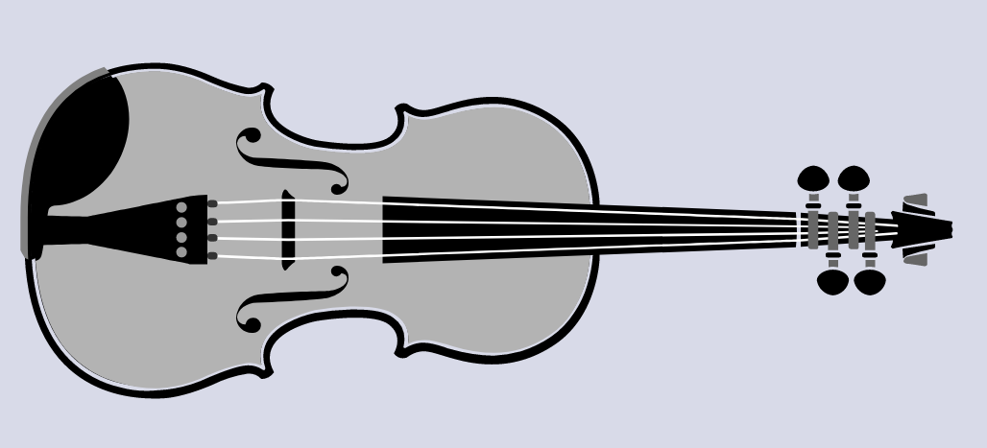
Tin whistle
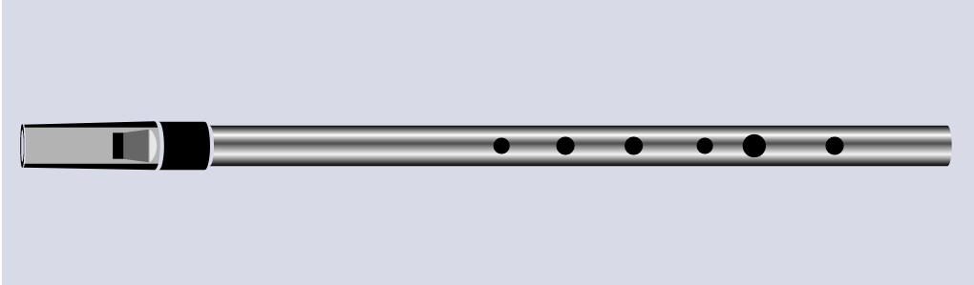
  - Non-digital: With household members, discuss what folk songs are known. Different cultural perspectives are encouraged depending upon the students’ circumstances. Some examples might include ‘Click Go the Shears’, ‘Waltzing Matilda’, ‘Sakura’, ‘Blowin’ in the Wind’, ‘Go Tell Aunt Rhody’, ‘I Know Where I’m Going’, ‘Mango Walk’ and so on. What story did they tell? How does the music contribute to this story telling? Write this information in the student workbook.
Students are encouraged to add as many as they can to this list. This information should include the name of the song, the country it is from and any other information they know about it.
The students should then select one folksong of their choice and learn to sing it. This should be practiced with a recording or a household member. Focus should be on keeping the beat and thinking about keeping their pitch as accurate as possible whilst singing. Once the song has been learnt, the students should then comment further in their student workbooks about the following discussion points:
    - What is a folk song (an expression of popular culture, often to tell a story of that culture)?
    - What features of the music let you know that it is a folk song?
    - What tells you it is a folk song? (the storyline, the instruments and the overall sound).
    - If listening to a folk song, choose three instruments to explore the instrumental tone colours (timbres). Think of three adjectives to describe the sound of each of the instruments.
    - How do the instruments reinforce the meaning of the narrative? (For example, why might a violin have been used instead of an electric guitar?)
Learn the second verse of the traditional Australian poem ‘My Country’ by Dorothea McKellar which has been converted into a variety of folksongs. Discuss the origins of this poem and its role in creating Australian identity and love of country:
‘I love a sunburnt country,
A land of sweeping plains,
Of ragged mountain ranges,
Of droughts and flooding rains.
I love her far horizons,
I love her jewel-sea,
Her beauty and her terror -
The wide brown land for me!’
Retrieved with permission from the official Dorothea Mackellar website https://www.dorotheamackellar.com.au/archive/mycountry.htm
How does the narrative of this poem make students feel? Is this necessarily a universal feeling about Australia? What role does a poem such as this, which has been converted into a folk song, have in making us feel about our country and situation? Students should comment in their workbooks.

- Narrative in visual arts
  - Digital: There are many artworks that have become part of our Australian folk history and identity. Many examples are from the colonial history of Australia and the bush. Many artworks tried to create a national identity and often a love (or sometimes disdain) for country. Examples include:
    - ‘Launceston and the river Tamar’ by John Glover (c.1832) Glover’s life with his wife Sarah in early Australia
    - ‘Rainy day’ by Charles Conder (1888) - an usual colonial work showing lush green grass
    - ‘Beach scene’ by Arthur Streeton (1890) - an Australian beach image
    - ‘A token of friendship’ by Arthur Collingridge (1890) - a girl feeding a cow in the Australian bush
    - ‘The Golden Fleece’ by Tom Roberts (1894) - famous shearing shed scene
    - 'On the wallaby track’ by Frederick McCubbin (1896) - famous scene of colonial struggle in the bush with rural work
    - ‘Reinforcements: troops marching’ by Grace Cossington-Smith (c.1917) soldiers marching
    - ‘Bonfire in the bush’ by Grace Cossington Smith (c.1937) a colourful image of girls in the bush
    - ‘Sunday evening’ by Russell Drysdale (1941) the struggles of an outback family
    - ‘The wasteland II’ by Jeffrey Smart (1945) of the desolation at the Flinders Ranges in South Australia
    - ‘First-class marksman’ by Sidney Nolan (1946) the isolated figure of Ned Kelly
There are many more examples available through the Art Gallery of NSW’s Collection website that share multiple perspectives and narratives of Australian identity both colonial, more recent and in Aboriginal art.
Students should select 3 of the artworks they find the most interesting and write in the digital platform the name and date of the work, the artist and what narrative (or story) they believe is being told through the artwork.
Encourage the students to think critically about the artwork and to describe the details of the artwork that portray the narrative to them. Do they think the artists is portraying a positive or negative opinion of life in Australia?
Reflect on the artist’s use of common techniques. For example, the colours, the implied textures, the use of the space such as the foreground, the background and the perspective. In some cases, it is almost as though you can smell the landscape. How has the artist achieved this?
Students are encouraged to reflect on the way in which the narratives in these artworks relate to the folk songs learnt previously. Are there conflicting views of colonial Australia? What common relationship is there between the visual artworks and the musical compositions?
Ask the students to find out from their family members if there are any artworks that were important in shaping their identity or of their culture.
Ask the students to create an artwork that reflects their narrative, story and identity. This may be something like their own personal artwork version of a folksong. They should consider their surroundings, the people that are important in their identity and where they would like the artwork to be set. For example, the students may wish to set the artwork at the beach, in the bush, on a farm, in an apartment or on a suburban street. Students may choose whatever form they wish to present their artwork as. For example, a drawing, painting or sculpture.
Photograph these artworks and upload to the class digital platform along with a student written artist intent statement. This should indicate what the intention of the work is and the narrative behind it.
  - Non-digital: There are many artworks that have become part of our Australian folk history and identity. Many examples are from the colonial history of Australia, the bush and often were attempts to solidify a national identity and often a love (or sometimes disdain) for country. Examples include:
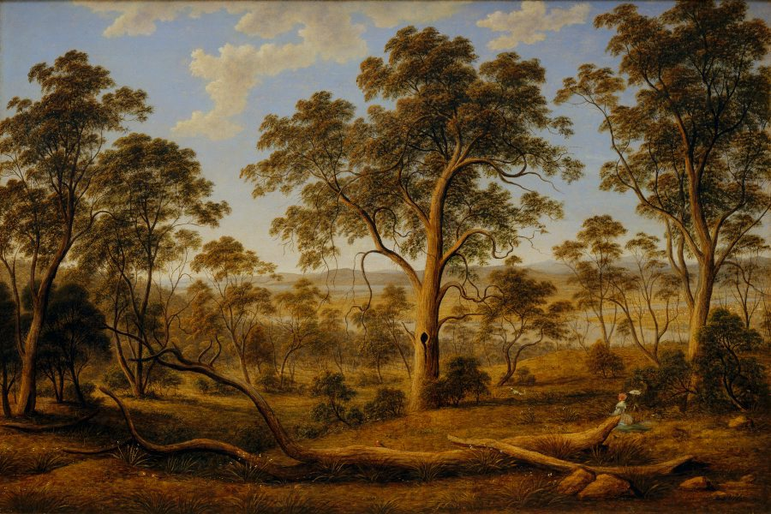
'Launceston and the river Tamar’ by John Glover (c.1832) Glover’s life with his wife Sarah in early Australia. Retrieved from the Art Gallery of NSW website https://www.artgallery.nsw.gov.au/collection/works/41.1972/
    - 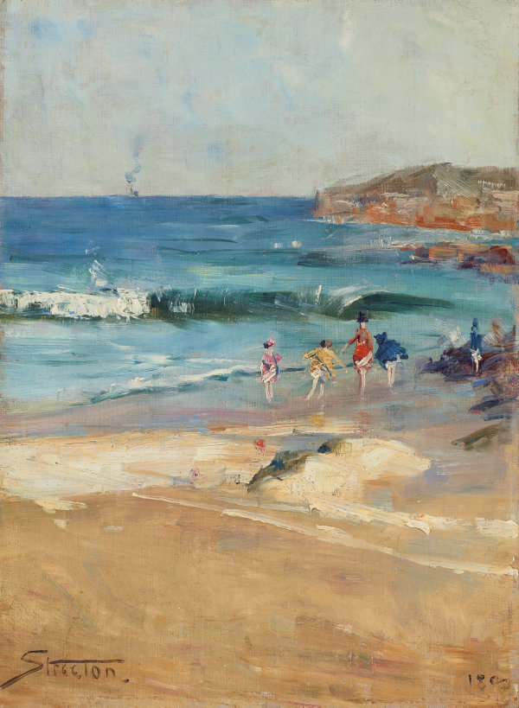
    - ‘Beach scene’ by Arthur Streeton (1890) - an Australian beach image Retrieved from the Art Gallery of NSW website https://www.artgallery.nsw.gov.au/collection/works/9019/

    - 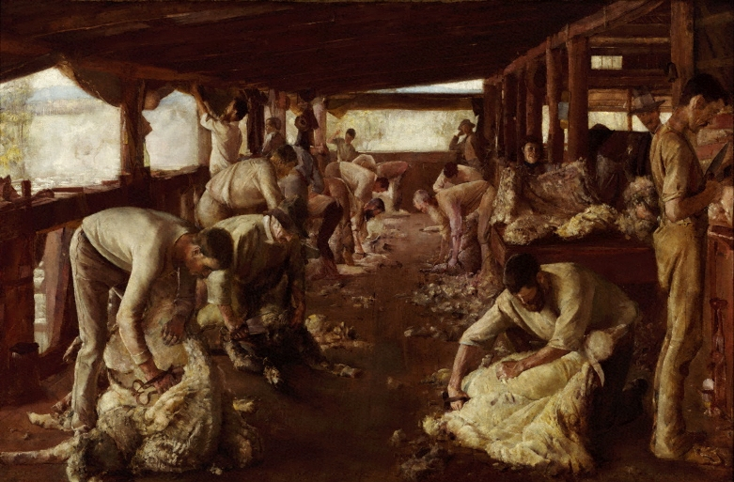
    - ‘The Golden Fleece’ by Tom Roberts (1894) - famous shearing shed scene. Retrieved from the Art Gallery of NSW website https://www.artgallery.nsw.gov.au/collection/works/648/

    - 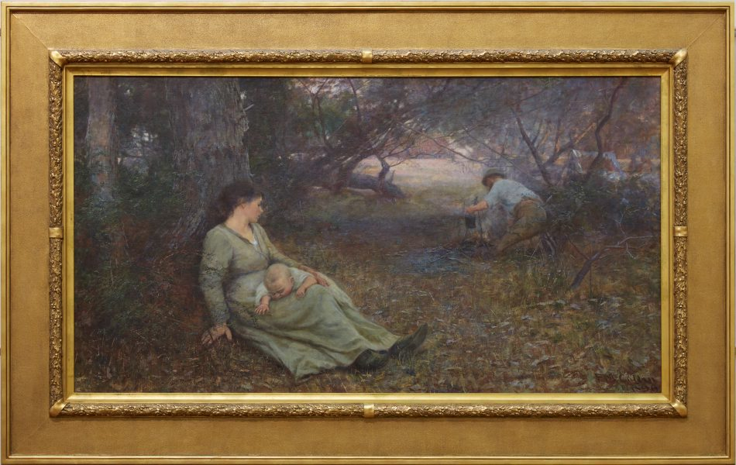
    - 'On the wallaby track’ by Frederick McCubbin (1896) - famous scene of colonial struggle in the bush with rural work. Retrieved from the Arts Gallery of NSW website https://www.artgallery.nsw.gov.au/collection/works/572/

There are many more examples available through the Art Gallery of NSW’s Collection that share a multiple of perspectives and narratives of Australian identity both colonial, more recent and in Aboriginal art. Students may have access to their own examples and are encouraged to include these as well.
Students should select 2 artworks from their workbook that they found the most interesting. Then students are to write in their workbooks the name and date of the work, the artist and what narrative (or story) they believe is being told through the artwork. Encourage the students to think critically and to describe the details of the artwork that portray the narrative to them. Do they think the artists is portraying a positive or negative opinion of life in Australia?
Reflect on the artist’s use of common techniques. For example, the colours, the implied textures, the use of the space such as the foreground, the background and the perspective. In some cases. it is almost as though you can smell the landscape. How has the artist achieved this?
Students are encouraged to reflect on the way in which the narrative in these artworks relate to the folk songs learnt previously. Are there conflicting views of colonial Australia? What common relationship is there between the visual artworks and the musical compositions?
Ask the students to find out from their family members if there are any artworks that were important in shaping their identify or of their culture.
Ask the students to create an artwork that reflects their identity and their culture. This may be something like their own personal artwork version of a folksong. They should consider their surroundings, the people that are important in their identity and where they would like the artwork to be set. For example, the students may wish to set the artwork at the beach, in the bush, on a farm, in an apartment or on a suburban street. This should also include a student written artist intent statement.

- Narrative in drama and a little bit of dance
a. Digital: Ask the students to watch the short, animated film ‘The Fantastic Flying Books of Mr Morris Lessmore’. Ask the students to consider what the film was about and to ask a question in the class digital platform for other students about the film’s content or narrative.
In a comfortable place, students should pose as either Mr Lessmore, the lady, Humpty Dumpty or the girl. Take a photo (either a selfie or taken by someone else) to upload to the digital platform. Label the character being portrayed.
Next try to make the shape of an object from the film such as the flying book, the globe, the bookshelf or the chair. Again, take a photo (either a selfie or taken by someone else) to upload to the digital platform. Label the object being portrayed.
Ideally with another person from the household where possible, use mime and sculpt each other into position to represent a moment from the film. For example, the woman flying with the book bouquet, Humpty Dumpty introducing himself, Mr Lessmore giving a book away. This sculpting video may assist in understanding ways of working through this process.
To further enhance student understanding of the narrative of the film, create a ‘postcard’ from the story. This should be around one of the most pivotal moments in the film. For example, the flying books following Mr Lessmore, Mr Lessmore giving books out to people, or Mr Lessmore or the woman floating away with the balloon bouquet and so on. Ideally this should be done with some other members of the household using this supporting video to assist.
Alternatively, where a group of household members are not available, the students may wish to create one on their own or to draw a postcard from the story. Again, take a photo (either a selfie or taken by someone else) to upload to the digital platform. Label the scene being portrayed in this ‘postcard’. Who would the students send it to?
Ask the students to reflect on what further information has been gained about the narrative of this animated story through their dramatic interpretations through discussions with their household or peers.
b. Non-digital: Students should read a picture book they may have access to. If the student does not have access to a picture book, a household member may share a story with the student. Ask the students to consider what the story is about and to write a very brief overview in their student workbook, including both the title and the author or storyteller.
In a comfortable place, students should pose as a character from the story then take a photo (either a selfie or taken by someone else). Where possible they should include this image in their student workbook or alternatively draw themselves in this role. They should then label the character being portrayed.
Next, they should try to make the shape of an object from the story such as a book, a globe, a bus, a tree or even a chair depending on the selected story. Again, take a photo (either a selfie or taken by someone else) or draw the object in the student workbook. Label the object being portrayed.
Ideally with another person from the household where possible, use mime and sculpt each other into position in a moment from the story.
Take this one step further to create a ‘postcard’ from the story using a different scene and one which is potentially the most important. Ideally this should be done with some other members of the household.
Alternatively, where a group of household members are not available, the students may wish to create one on their own or to draw a postcard from the story. Include this in the student workbook and label the scene being portrayed in this ‘postcard’. Students should label their ‘postcards’ with a person’s name and address as though they are going to mail it.
Ask the students to reflect on what further information has been gained about the narrative of this animated picture book or story through their dramatic interpretations, discuss with their household and summarise their thoughts in the student workbook.

Differentiation
Differentiation is a targeted process recognising that individuals learn at different rates and in different ways. Differentiation refers to deliberate adjustments to meet the specific learning needs of all students.
Here are some questions that you might consider when adapting the learning sequence to meet the needs of your students:
- What adjustments might you put in place for students who require additional support to access the task? For example, how will they get help when needed?
- Do you need to adjust the content to ensure it is adequately challenging and allows students to operate at their own level of thinking, skill and knowledge?
- Will you adapt the instructions so they are provided in a way that EAL/D students can easily interpret them? For example, through the use of visuals, checklists, diagrams or flow charts.
- Could you suggest ways that home language can be used as a tool to support learning? For example, bilingual dictionaries.
- Can you demonstrate that you value the Identity, culture, heritage and language of your Aboriginal students through your teaching practices?

Assessment
- Did the student recognise that people have different views about artworks and their meanings that are informed by their understanding of such things as the circumstances of the work, the artist’s intentions and skill, and what the work is about?
- Could the student talk about and think about their intentions for artmaking? Could they recognise how these may affect their selection of ideas, materials, tools and techniques and methods of working?
- Could the student identify basic musical features of the music that is performed and listened to such as rhythm, tempo, pitch, structure, dynamics, or tone colour?
- Were the students able to take on both individual and group roles?

Activity resources
- Online teaching resource (e.g. Google slides)
- Student workbooks for printing
- Parent/caregiver advice (a short explanation of the lesson sequence and the role they will play)
- Bring me down some of that rain by Tracy and Paul Burjan
Verse 1
It’s been dry so long, dust fills the air.
Cattle moving slowly past the creek bed,
Promise water every year.
Verse 2
But the rains don’t come,
They forgot to come.
And it’s hard out here, wondering will it ever end,
Does this drought mean we’re all but done.
Chorus
Rain oh rain, give me life end the pain.
Let my creeks flow again.
Blow the whistle on the train as it passes once again,
‘cause the rain is here.
Verse 3
The trucks pulled in,
To take my herd away.
And I’m wondering is it real, who would help me, could you help me,
Should I start to pray?
Vocal solo
Oooo, ooo, ooo.
Violin solo
Verse 4
I’ve worked this land so long,
40 years or more.
Seems I’ve given it my life, my blood, my sweat
And all what for?
Verse 5
Well it’s been good to me,
I won’t complain.
But please oh please,
send me down some of that rain.
Chorus
Rain oh rain, give me life end the pain.
Let my creeks flow again.
Blow the whistle on the train as it passes once again,
‘Cause the rain is here (sing twice).
It’s here, ohhh, it’s here.

