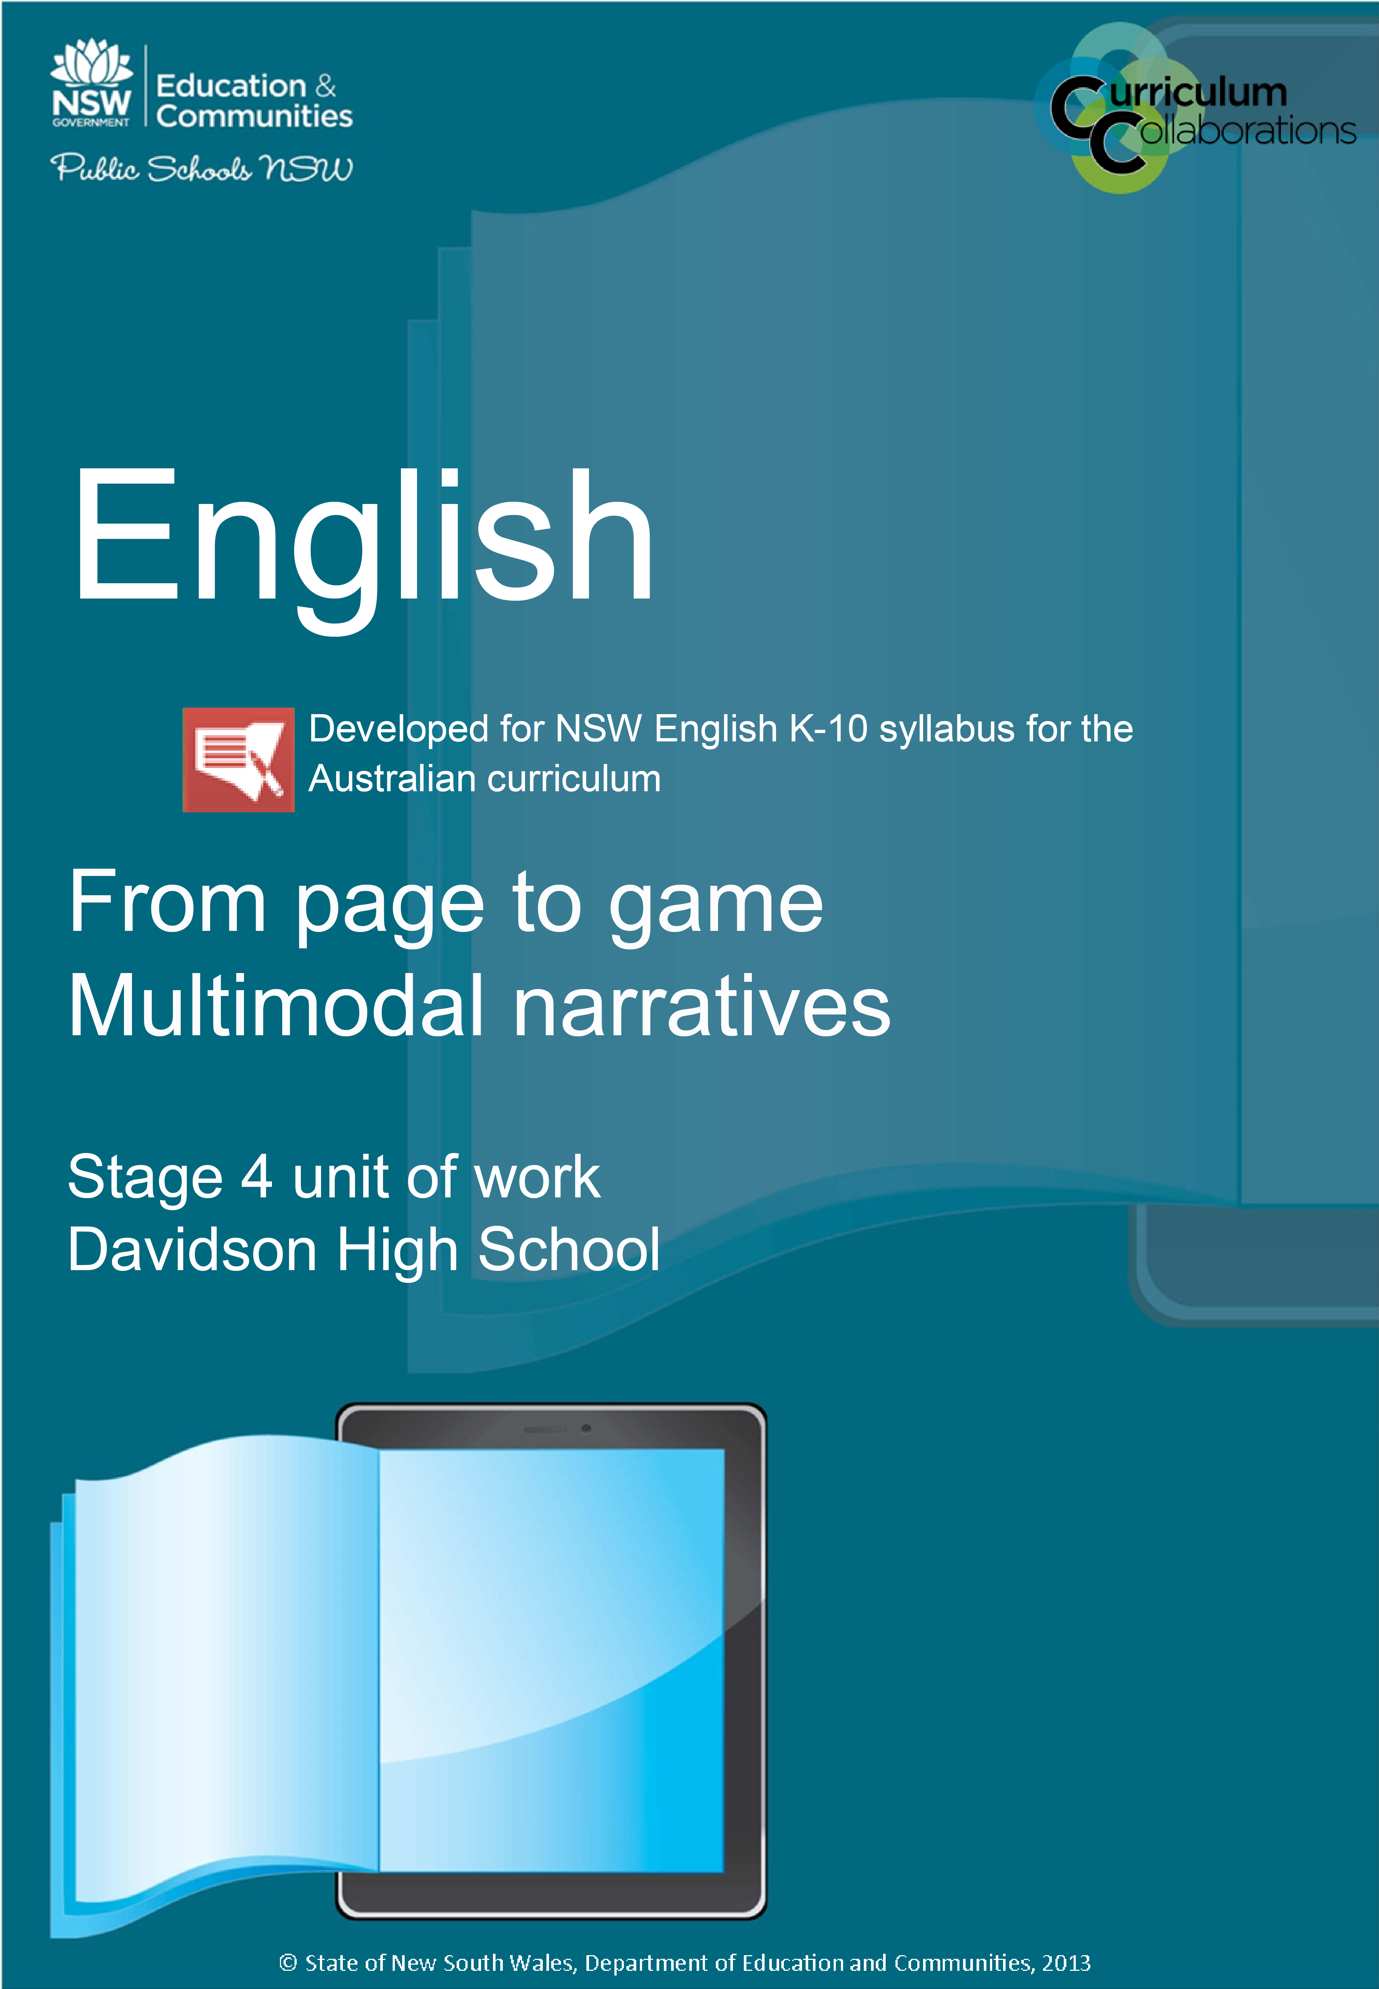

From page to game – resources

Contents
English – from page to game 4
Resource 1 4
Think Pair Share 4
Resource 2 5
Think Pair Share 5
Resource 3 6
List of graphic novels suitable for Stage 4 6
Resource 4 7
To read or to leave 7
Sample review 8
Resource 5 9
A novel without words – does that sound scary? Or is it just Scarygirl? 9
Resource 6 10
It’s written all over your face 10
Resource 7 11
An unlikely hero and an unexpected villain 11
Resource 8 13
Same but different 13
Resource 9 14
Elements and techniques particularly relevant to Scarygirl 14
Resource 10 15
Resource 10 continued 16
Resource 11 17
Emotional rollercoaster 17
Resource 12 18
Game to be a gamer 18
Resource 13 19
The girl’s got moves! 19
Sample game review 20
Resource 14 21
Were you a dream team? 21
Appendix 1 22
KWL chart 22
Appendix 2 23
Glossary 23
Brief glossary 24
Appendix 3 27
Extended glossary 27

English – from page to game

Resource 1

Think Pair Share
What are the features and conventions of graphic novels?
Think (my thoughts and ideas)

Pair (what my partner and I think)

Share (what my peers shared)

Resource 2

Think Pair Share
What are the features and conventions of adventure computer games?
Think (my thoughts and ideas)

Pair (what my partner and I think)

Share (what my peers shared)

Resource 3

List of graphic novels suitable for Stage 4

Manga
- Arai, Takahiro (2009) Cirque du freak/Darren Shan, HarperCollins, UK
- Chan, Queenie (2005) The Dreaming [series] Tokyopop, USA
- FUJIYAMA, Kairi (2007) Dragon eye, Vol. 2, Random House, USA
- MASHIMA, Hiro (2008) Fairy tail 1, Del Rey, USA

Graphic novels
- Almond, David & McKean, Dave (2008) The savage, Walker, UK
- Dunning, John Harris & Singh, Nikhil (2011) Salem Brownstone: all along the watchtower, Walker, UK
- Gaiman, Neil & Russell, P. Craig (2008) Coraline, adapted and illustrated by P. Craig Russell, HarperCollins, USA
- Higson, Charlie & Walker, Kev (2008) Silverfin: the graphic novel, Penguin Group, UK
- Hinds, Gareth (2007) Beowulf, Candlewick, UK
- Horowitz, Anthony (2007) Point Blanc: the graphic novel, Walker, UK
- Horowitz, A. & Johnston, A. & Damerum, K. & Takasaki, Y. (2006) Stormbreaker: the graphic novel, Walker Books, UK
- Jurevicius, Nathan (2009) Scarygirl, Allen & Unwin, NSW
- Kibuishi, Kazu (2008) Amulet: book one,the stonekeeper, Graphix, USA
- Lee, Tony (2009) Outlaw: the legend of Robin Hood: a graphic novel, Walker, UK
- Riviere, Francois (2007) Death on the Nile adaptation (The Agatha Christie adventures), Harper, London
- Riviere, Francois (2007) Murder on the Orient Express adaptation (The Agatha Christie adventures), Harper, London
- Starke, Ruth & Holfeld, Greg (2008) Captain Congo and the crocodile king, Working Title Press, SA
- Starke, Ruth & Holfeld, Greg (2011) Captain Congo and the Klondike gold, Working Title Press, SA
- Starke, Ruth & Holfeld, Greg (2009) Captain Congo and the Maharaja's monkey, Working Title Press, SA
- Tan, Shaun (2006) The arrival, Lothian, Vic

Resource 4

To read or to leave
The choice is yours.
You have the power.
May the force be with you.

Task 1
Select any graphic novel of your choice to read and review. Venture into your school or local libraries, check out what you have on your bookshelves at home or be inspired to buy your own graphic novel. (See the list of suggested texts, Resource 3.)

Task 2
After reading your chosen text, you are to write a concise review of the text, 100–150 words in length.
The review should be persuasive, either convincing others ‘to read or to leave’ the chosen text. You therefore must ensure you use language of high modality.
Details should be provided about events, setting and characterisation in the text (particularly the portrayal of the hero or main protagonist).
You should also comment on how language and images are combined in a graphic novel to influence a reader’s emotional and intellectual responses. This means: How do the words and pictures encourage the reader to feel and think?

Task 3
Your peers will be assessing the quality of your review using the following criteria:
Student’s name:
Criteria | Shazam | Ka-pow | Pow | Wham | Zonk
Details about events, setting and characterisation are clearly expressed
Convincing argument expressed using language of high modality
Understanding of how the reader is encouraged to feel and think a certain way
Marked by:

Sample review
Intriguing and heart-warming, ‘Scarygirl’, by Nathan Jurevicius, is a story for people of all ages. You will be lured by this graphic novel’s detailed illustrations as you follow an abandoned girl (part octopus) on her quest to find the strange man from her nightmares. With no written text, this tale allows you to explore the visual cues that inspire your own narrative. Yep, that’s right, it’s a novel without words. How cool is that?
A kind-hearted octopus, named Blister, rescues Scarygirl, disguising her abnormalities with a pirate costume. Multiple settings become the backdrop for this story as Burriguru, a knowledgeable creature, initiates the journey to the city in search of the secrets of Scarygirl’s past. Betrayed by those who were presumed trustworthy, Scarygirl experiences many thrilling turns of events.
This book is impossible to put down. Its quirky characters are so endearing. You will become as compelled as Scarygirl to seek the answers.
(Thank you to Ms Sly’s 8EN1 2012 for this review.)

Resource 5

A novel without words – does that sound scary? Or is it just Scarygirl?

Task 1
- Make a list of ten synonyms for the adjective scary.
- In what way are these adjectives contradictory to the initial impressions you have of Scarygirl? Look at the front cover of the text and the image next to her character profile.
- Make a list of ten adjectives that you think would be more appropriate to describe this character.
A sentence of twenty-five words is used to describe the protagonist in this graphic novel. Interestingly, you will discover how so few words can still tell us a lot.
Abandoned and washed up on a deserted peninsula,
Scarygirl, with determination and resourcefulness, is on
a mission to find the man behind her haunting dreams.
A powerful verb opens this sentence. Abandoned suggests that this girl has been dumped, ditched, discarded and forgotten by her parents or guardians.
The phrasal verb, washed up, and the adjective, deserted, qualify the description of the setting and add to the pitiful image of Scarygirl. This encourages a sympathetic reaction.
Abstract nouns, determination and resourcefulness, ascertain Scarygirl’s heroic strengths.
The hero’s quest is established as Scarygirl’s goal is clearly identified in the Infinitive to find the person who haunts her dreams.
Humour is incorporated at the end of Scarygirl’s profile as her list of likes includes smell of old leather and dislikes randomly highlight hairless rats, cheese breath.

Task 2
Choose two other character profiles to analyse. Identify verbs, adjectives, abstract nouns and clichés where appropriate.

Task 3
Compose your own 25–30 word character profile for the superhero identity you created in a previous lesson or invent a new quirky character to describe in a limited, but effective choice of words.

Resource 6

It’s written all over your face

Task 1
Focusing on pages 10 and 11 of Nathan Jurevicius’ Scarygirl, create a flowchart of emotions depicted in the facial expressions of Scarygirl and Blister starting at frame 3 (Blister only) and ending at frame 12 (Scarygirl only).

Task 2
Unusually presented speech or thought bubbles are used when the characters symbolically converse with each other on pages 24 to 25. Working with a partner or a group of three, read the symbolic conversation to inform your composition of a scripted dialogue amongst Scarygirl, Bunniguru and Blister. Consciously select vocabulary that you believe is suited to the different characters. You are to perform your dialogue for the class, making sure you modulate your voices to suit the characters.

Extension activity
Students could compose a soundscape to complement their performance.

Resource 7

An unlikely hero and an unexpected villain

Task 1
Nathan Jurevicius deliberately selected the size, shape and number of panels to influence the pace in which his visual narrative is read.
Compare the layout of the panels in page 26 with those on page 27.
- What is happening in the larger panel on page 26 and why is this panel a different size and shape to the others?
- What order do you read the panels on page 27?
- What effect do the contrasting colours have on how the reader views circumstances depicted in page 26 compared with page 27?

Task 2
Confusion in the representation of good and evil is seen in on pages 48 and 49. Subverting the traditional conventions of a hero’s quest, Scarygirl has a terrifying encounter with the Tree of Knowledge. Record Scarygirl’s array of thoughts as depicted in this double page spread. To create an authentic voice, use stream of consciousness style writing. Post your work on edmodo.

Task 3
Fill in the following table to demonstrate your understanding of shots and angles:
Page | Shots/angles | Description of the shot or angle and its effect on how it positions the reader
 | Extreme close-up
 | Extreme close-up
 | Close-up
 | Close-up
 | Mid shot
 | Mid shot
 | Long shot
 | Long shot
 | Extreme long shot
 | Extreme long shot
 | Low angle shot
 | Low angle shot
 | High angle shot
 | High angle shot

Resource 8

Same but different
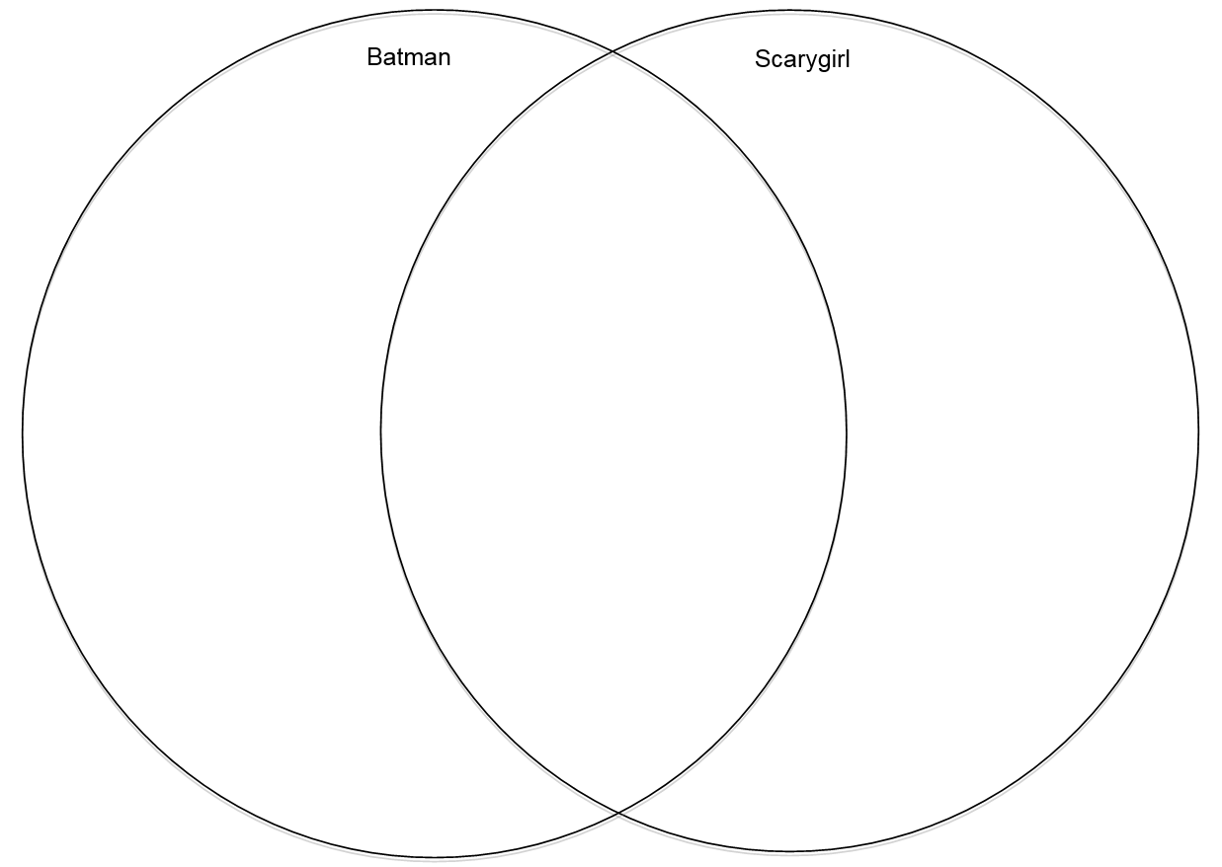
Fill in the Venn diagram with the following features to highlight similarities and differences between the characterisation of Batman and Scarygirl:

orphaned
city’s hero
no alias
part girl
saves lives
creature of the night
secret identity
has a guardian
supported by a sidekick
wears a costume
has a single mission
part man
part creature
haunted by dreams
creature of the ocean
mysterious past
has enemies
no super powers
lives a double life
on a quest for the truth
has special skills

What do you think makes Batman a popular superhero?
In what ways is Scarygirl an unconventional hero?
To whom does Scarygirl appeal? Why?

Resource 9

Elements and techniques particularly relevant to Scarygirl
Balloons or bubbles

Splash page

Layout

Shots

Reading path (vectors)

Symbolia

Colour

Angles

Resource 10
Fill in the blanks in the outline below to become familiar with the formula for writing a body paragraph in an essay. (That’s right, there’s a formula like in Mathematics and, when you understand the formula, it’s easy!)

quotations
visual
synonyms
concluding
techniques
poetic
begin
question
interpret
evaluate

Every paragraph in the body of an English essay must with a statement sentence. This sentence tells the reader exactly what the paragraph will be focusing on and it makes a direct link to the essay question by including the key words in the question or
for the key words.
Every paragraph in the body of an English essay must include analysis of techniques specific to the form of the text being analysed. For example, if you are analysing a film, you must focus on film techniques; for poetry you would discuss devices; and for a graphic novel, you would write about techniques including elements specific to graphic literature.
Every paragraph in the body of an English essay must the effect of
the techniques that have been identified. You must explain what impact the create (particularly how do the techniques influence the responder to view the text in a certain way).
Every paragraph in the body of an English essay must include specific examples from the text to support ideas raised. Direct from the text are commonly used as the examples. In a visual text, however, you have to refer to describe and a particular image or part of an image.
Every paragraph in the body of an English essay must have a sentence/s that draws a link between the statement sentence and the essay .

Resource 10 continued
Here’s the formula:
S statement
T techniques
E effect
E examples
L link
Please note – effect and examples can switch positions in the formula so you may also see the formula as this:
S statement
T techniques
E examples
E effect
L link
Either way if you follow this formula, your body paragraphs will be as strong as STEEL! (Lame, I know, trust English teachers to come up with a simile to remind you of a formula )

Resource 11

Emotional rollercoaster
Watch the introduction to Scarygirl by Nathan Jurevicius - The Game and compose a line graph to record the shift in emotions encouraged when viewing the animation. On the X-axis, list the following events:
- falling into the water
- looking up at flying objects
- seeing Bunniguru through porthole
- encountering Tree of Knowledge and Treedweller
- underwater
- meeting Blister
- seeing vision of strange man
- waking from nightmare
On the Y-axis, use at least five emoticons to depict the changing emotions. Plot the emotions on the graph then join them with a line using a ruler.
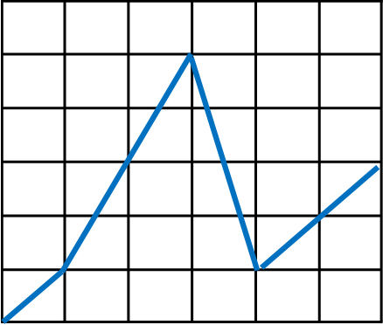

Resource 12

Game to be a gamer
Adventure game

Action game

Simulation game

Platform game

Role playing game

Strategy game

Real-time strategy game

First person/third person game

Side scrolling game

Other:

Resource 13

The girl’s got moves!

Task 1
From your experience with Scarygirl by Nathan Jurevicius - The Game, address the following:
- Outline narrative of the game (What does Scarygirl’s quest involve?).
- What parts of the fantasy world did you explore in your game playing?
- How did you solve the puzzles you encountered?
- How did you preserve your life?
- How did you lose life and how did you die?
- What did you discover in your dialogue with non-player characters?
- What items did you gather?
- How was your score collated at the end of each stage in the game?
- What successes did you have in playing the game?
- How did the game’s design keep you engaged?
- What was challenging (or frustrating) about the game’s design?
- How would you modify the game to make it more appealing?

Task 2
Take on the role of game reviewer and write an informative review of Scarygirl: The Game. Your review should following the following structure:
- introduction
- overview of the game’s narrative
- gameplay
- graphics
- sound and music
- conclusion with a rating.

Sample game review
If you were captivated by Nathan Jurevicius’ graphic novel, Scarygirl, you are going to love its transformation into an adventure platform game. This interactive multimodal text positions you in the role of the octopus girl, who encounters many challenges in her quest to discover the truth behind the strange man haunting her dreams.
Beginning in her tree-house, you control Scarygirl’s venture across numerous settings seeking guidance from characters such as Bunniguru and Blister. Running, swimming, spinning jumps and climbing are movements you will easily master to experience the multiple platforms in this adventure game. Uninviting creatures get in your way and take away your life, which you can replenish by collecting fish. Your score is also enhanced through the collection of crystals generously scattered in all levels.
A quirky ‘emo’ character with wild black hair, pale skin and her lips stitched together, Scarygirl, is reminiscent of Tim Burton’s creations. Even though the graphics are basic 2D, the worlds you encounter provide a visual spectacle. Bold colours and a variety of unusual creatures will maintain your interest.
Subtle music and sounds complement this game, adding to the allure of the mysterious journey. The vague, menacing tones increase the drama of the game and heighten your senses, particularly in the more demanding moments of action.
For experienced gamers, Scarygirl does not provide anything new, but with the options of skill level ranging from “I just want pretty picture” to “Please don’t hurt me” to “I have eight arms” players can be appropriately challenged. This is an engaging adventure platform game for young gamers and is easily accessible on the web.
Rating –
(Thank you to Ms Sly’s 8EN1 2012 for this review.)

Resource 14

Were you a dream team?
Name:
Question | Write your response here
What did you enjoy about working in a game design team?
What did you find challenging about working in a game design team?
What strength/s did you bring to the team?
What planning and organisational strategies did you use effectively?
What would you do differently in a team assessment in the future?
What work environments would you use skills you have developed in this assessment?
Reflecting on the work completed in this unit, do you feel you have answered the question: How can we transform a narrative from page to game?

Appendix 1

KWL chart
Topic – how can we transform a narrative from page to game?
What I know | What I want to know | What I have learned

Appendix 2

Glossary
While a study of comic books and graphic literature will inevitably incorporate a range of terminology from literature, art and film, there are some specific technical terms that may be useful when critiquing sequential art narratives.
There are two lists presented here:
- a brief glossary of terms for readers who are beginning to discuss ideas on the techniques used by composers of graphic literature
- a more extensive list of terms for those who wish to analyse this format in more detail.
These lists are not definitive and can be added to as required.
The coloured pages below are from:
Cory Doctorow’s Futuristic Tales of the Here and Now
CC licence to share and remix.
Download at the Internet Archive:
Manga from:
Ubunchu! By Hiroshi Seo
CC licence

Brief glossary
Term | Definitions | Visual explanation
Balloon or bubble | Symbol used in comics art to indicate the direct words or thoughts of a particular character. The tail of the balloon or bubble indicates who is uttering the words.
Caption box | Square or rectangular box used in comics art to present the voice of an external or omniscient narrator. These are used to present information on time, place, or event and to further the narrative process.
Closure | A term coined by Scott McCloud in reference to the mental activity completed by a reader as he/she shifts from one panel to another across the gutters. The gutters allow a reader to mentally fill in the activity that occurs in the story between one panel and the next. | 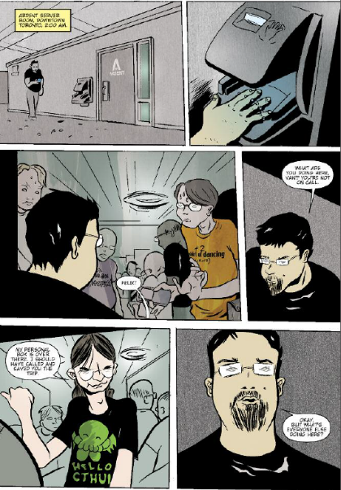
Frames or panels | The discrete boxes used to enclose visual moments in sequential art. They often have borders, but may also be presented as borderless panels.
Gutters | the blank spaces between the panels. A reader mentally fills in the action in the gutters.
Motion lines | Horizontal, vertical or spherical lines emanating from a person or object to indicate movement and speed. | 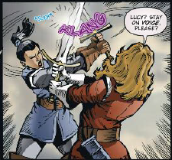
Reading path | Sequential art narrative composers place elements of their composition in a way that creates a path for a reader to follow. This path should reflect the pace and action involved in the visual or visu-verbal story. | 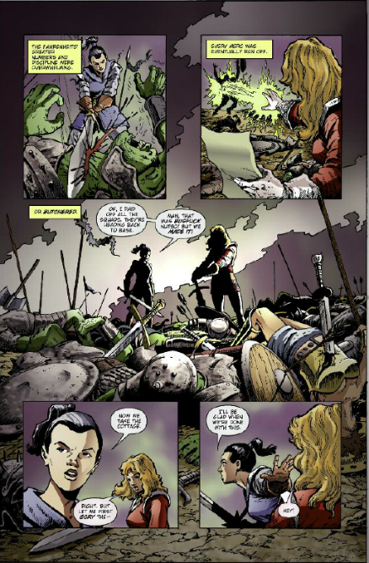
Sequential art | A number of picture panels which are made up of particular moments and placed in a consecutive sequence for the purpose of telling a story, giving step-by-step directions or communicating a complex idea. | 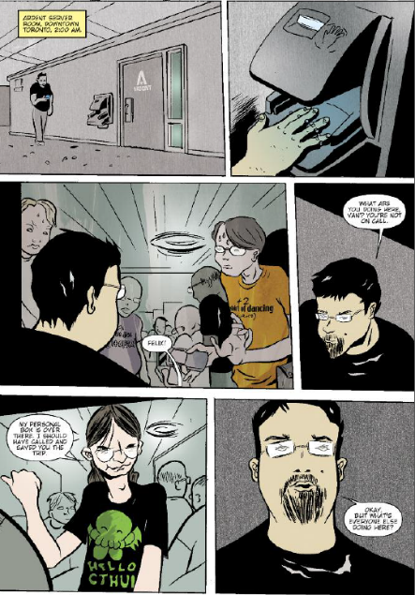
Splash page | A page with one whole illustration, usually used for a title page, but is sometimes used within a sequential narrative for effect, detail, significance of a moment and/or slowing the reading process. | 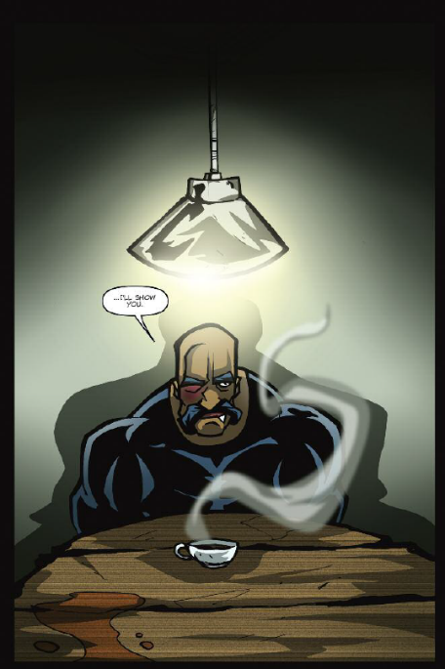
Symbolia | Composers of graphic literature use a great variety of pictorial and verbal symbols that have become part of the vocabulary of comic book format. A series of z z z z’s emanating from a person indicates sleeping and perhaps snoring. Musical notes suggest music playing or someone singing or whistling. #@%! in a speech bubble indicates swearing. Context is important to give specific meaning to symbolia. | 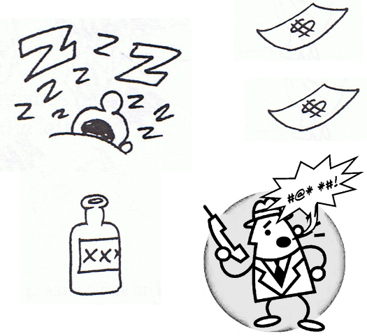

Appendix 3

Extended glossary
Term | Definitions | Visual explanation
Bande dessinée | ‘Drawn strips’: the name for comics in France and Belgium. Some well-known examples in English translation are The Adventures of Asterix by René Goscinny and illustrated by Albert Uderzo and The Adventures of Tin Tin by Georges Rémi. | 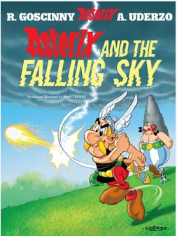  Asterix and the Falling Sky, Albert Uderzo. Originally published as Le Ciel lui tombe sur la tête by Les Editions Albert René in 2005.
Chiaroscuro | The use of strong contrasts of light and shade for dramatic impact. It is particularly evident in gothic and crime noir comic genres. | 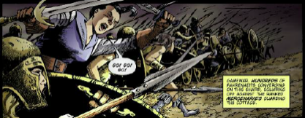
Emenata | Lines that emerge from or emanate from an image and depict the sensory nature of an object, for example, how it feels or smells.
Genre | A category of artistic composition with similar characteristics, subject matter, form or style. Typical comic genres include: horror, adventure, fantasy, crime, science fiction, superheroes and war.
Graphic novel | A term applied by creators or publishers to longer, self-contained sequential art narratives in an attempt to distinguish them from the briefer, serialised versions of comics.  ‘What is a graphic novel?’ by Jessica Abel  http://dw-wp.com/2010/10/what-is-a-gn-pdf | 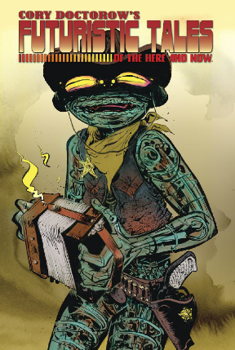
Intertextual links | Use of images from other known literature, visual arts or media arts and the incorporation of these within a new composition. The connections are made by readers who are familiar with the earlier works.
layout | The way panels are presented and arranged within the totality of the page. A composer selects the size, shape and number of panels for particular effect and to direct the reading pace and flow. | 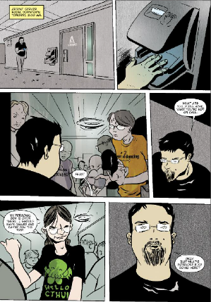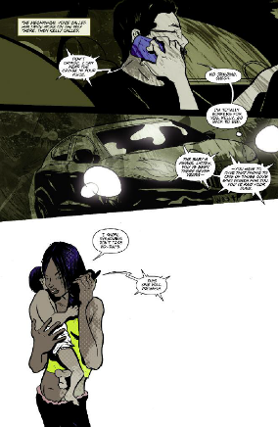
Manga | Japanese comics style. This style has a unique layout and a character representation often depicted with large, exaggerated eyes and hairstyles. Manga is frequently rapidly paced and highly emotional. | 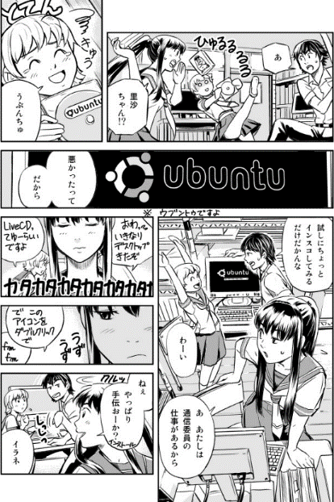
Onomatopoeia | Words that represent, mimic and depict sound. These words are often presented in burst bubbles and/or by using dramatic pictorial fonts.
Symbols | Images or words that are used to present notions and ideas that go beyond the images or words that are immediately conveyed. | – danger, poison, death etc  – monarch, ruler, royalty etc
Visual metaphor | A picture of something that is used to express another idea or notion. For example, Picasso’s dove which has come to be understood as a visual metaphor for peace.

http://www.scarygirl.com/world.php
http://archive.org/details/CoryDoctorowsFuturisticTalesOfTheHereAndNow
http://pigux.com/ubunchu/ep1/ubunchu01_english_rtl.pdf

