Resource 5 – word map

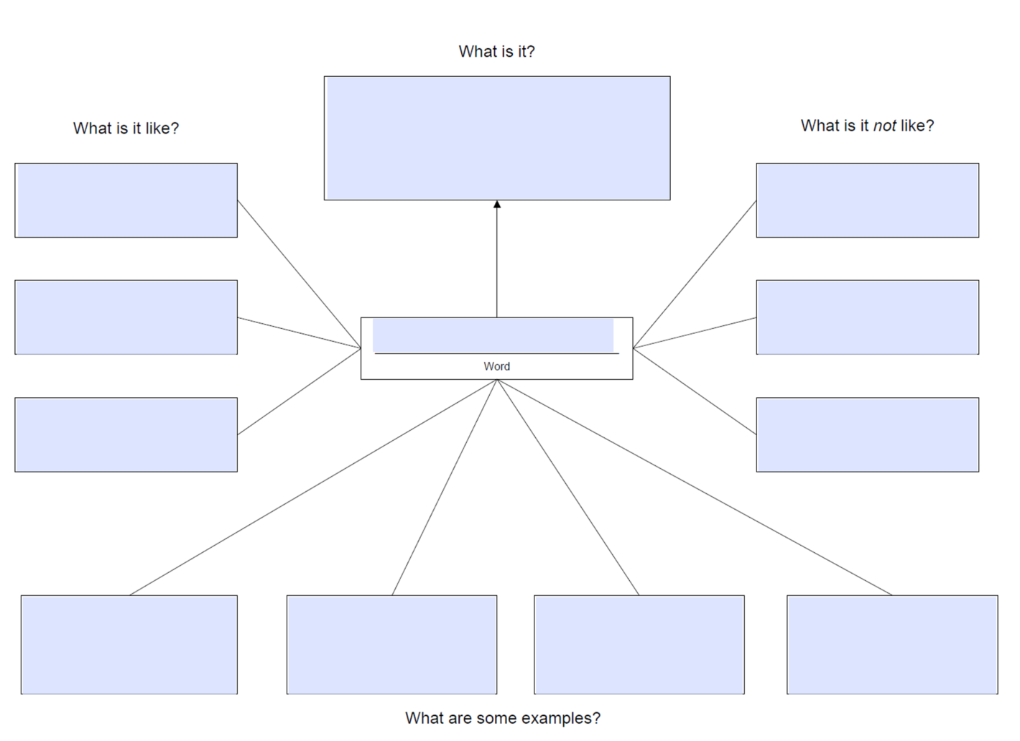

© 2006 Education Oasis™ educationoasis.com May be reproduced for classroom use only.

