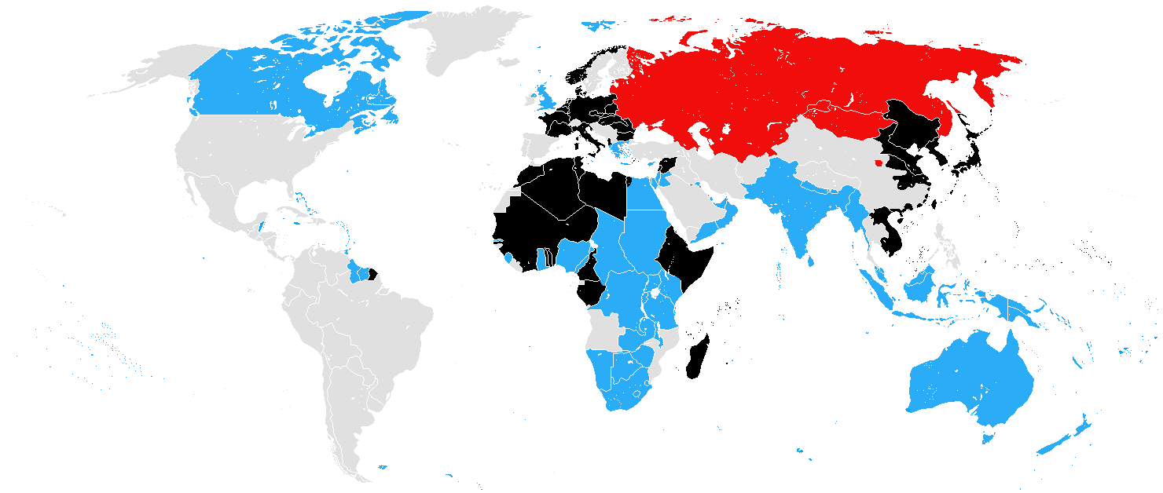

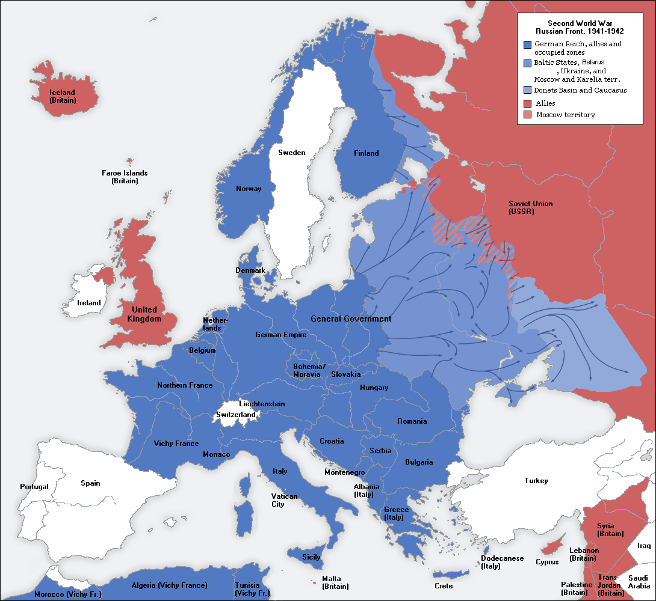

From [Wikipedia](https://commons.wikimedia.org/wiki/Atlas_of_World_War_II)