Student resource

Engagement phase – English Standard Module B
Module case study – Module B – Close study of literature
Case study text – The Curious Incident of the Dog in the Night-time, Mark Haddon (prose fiction) Red Fox/Random House, 2014, ISBN: 9781782953463
Technology focus – Microsoft Sway (support outlined in resource 2) for student-centred presentation

Resource one – Syllabus statement Standard Module B
In this module, students develop an informed understanding, knowledge and appreciation of a substantial literary text. Through their development of considered personal responses to the text in its entirety, students explore and analyse the particular ideas and characteristics of the text and understand the ways in which these characteristics establish its distinctive qualities.
Students study one text chosen from the list of prescribed texts. They engage in the extensive exploration and interpretation of the text and the ways composers (authors, poets, playwrights, directors, designers and so on) portray people, ideas, settings and situations in texts. By analysing the interplay between the ideas, forms and language within the text, students appreciate how these elements may affect those responding to it. Students produce critical and creative responses to the text, basing their judgements on a detailed knowledge of the text and its language features.
Through reading, viewing or listening, students analyse, assess and comment on the text’s specific language features and form. They express increasingly complex ideas, clearly and cohesively, using appropriate register, structure and modality. They draft, appraise and refine their own texts, applying the conventions of syntax, spelling and grammar appropriately.
Through their analyses and assessment of the text and their own compositions, students further develop their personal and intellectual connections with, and enjoyment of the text, enabling them to express their informed personal interpretation of its significance and meaning.
English Standard Stage 6 Syllabus © NSW Education Standards Authority (NESA) for and on behalf of the Crown in right of the State of New South Wales, 2017.

Resource two – Technology
Sway is a presentation app that is available within the Microsoft 365 suite. If you are going to create your own Sway from scratch, select the Microsoft 365 icon in your student portal and then choose Sway from within the apps.
If your teacher has shared a Sway template with you, you will receive a link to that template through your email or notice board. Make sure your teacher has set it to ‘can edit’ so you can work on it! Follow his or her instructions carefully: she will let you know what you can change and what you must keep the same. Generally, the order of ‘cards’ will be set, and you will be asked to fill in your own content.
Here are screenshots of the two opening two cards of a Sway template on this topic, taken from the ‘dashboard’ view.
Note: when you have finished working on your ‘cards’ select play to see the Sway as a proper presentation.
Screenshot 1 – the ‘title’ card
Depending on your teacher’s instructions you may need to keep the title the same, but you will be able to edit and put in your own image.
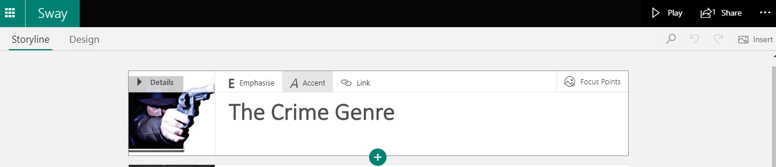
Image: Stick Em Up by Bart, licenced under CC BY-NC 2.0
Screenshot 2 – an ‘image’ card
An example of an ‘image’ card. In edit mode you will be able to replace the picture with a choice of your own, create your own caption, then add to or change the text.
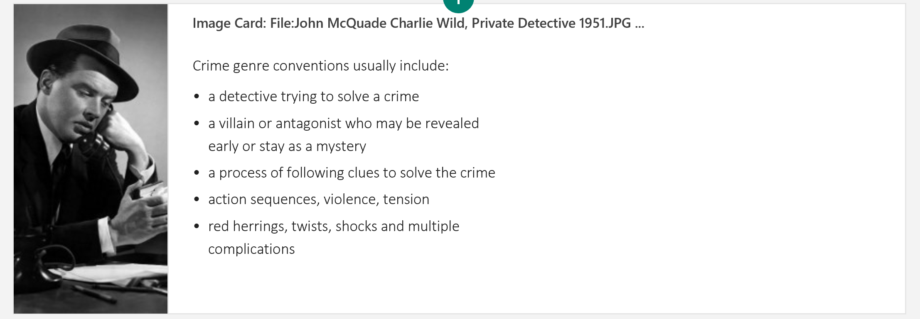
Image: John McQuade Charlie Wild, Private Detective 1951 by CBS, licensing released under public domain

Resource three - Socratic questioning
Explore this online. Here are some questions for ‘conceptual clarification’:
- Why are you saying that?
- What exactly does this mean?
- How does this relate to what we have been talking about?
- What is the nature of …?
- What do we already know about this?
- Can you give me an example?
- Are you saying … or …?
- Can you rephrase that?

