Geography for those new to teaching the subject

Table of contents
Geography for those new to teaching the subject 1
Table of contents 2
About this resource 3
The Geography K-10 Syllabus 4
Learning analysis 4
Syllabus components 6
Learning across the curriculum 9
Becoming familiar with reading the syllabus 10
How to keep up to date with syllabus changes and professional development 13
Resources for Geography K-10 16
Geographical tools 17
The importance of fieldwork 18
Simple fieldwork in Geography K-10 18
Organising a major fieldwork activity 21
Fieldwork activities for each stage 24
Some geography basics 31
What is geography? 31
Professional associations 32
Online resources 32
Geography websites 32
Teaching and learning strategies 34

About this resource
This resource is designed to help teachers new to teaching K-10 geography. This involves gaining an understanding of:
- the K-10 geography syllabus
- fieldwork
- resources for geography
- questions asked by geographers
- professional organisations
- online resources
- teaching and learning resources.
The information in this resource is not designed to cover all the subject matter or geographical tools. This resource is to build knowledge and understanding for teachers who are new to the subject of Geography K-10.
The information and graphics used in this resource will assist teachers to develop lessons in geography. Content within this section has been developed with the NSW Department of Education curriculum support professional learning materials and the Geography K-10 Syllabus.
Geography K-10 Syllabus © NSW Education Standards Authority (NESA) for and on behalf of the Crown in right of the State of New South Wales, 2015.

The Geography K-10 Syllabus
The aim of the Geography K-10 Syllabus is to stimulate students’ interest in and engagement with the world. Through geographical inquiry, students develop an understanding of the interactions between people, places and environments across a range of scales in order to become informed, responsible and active citizens.
A study of geography in Years 7-10 builds on students’ prior learning and experience with the geography K-6 syllabus. Students learn to explain patterns, evaluate consequences and contribute to human and natural environments.
Components of the Geography K-10 Syllabus have been linked to a series of questions that teachers need to analyse before teaching geography.

Learning analysis

Why does learning matter in geography?
Geography matters because the subject enables students to become active, responsible and informed citizens. Geographical learning is outlined in the syllabus rationale and aim and objectives.

What do I want students to learn in geography?
Students learn to develop knowledge and understanding of geography through geographical inquiry which involves students acquiring, processing and communicating geographical information. Student learning uses a variety of geographical tools and fieldwork. The key inquiry questions and content descriptions for each stage are used with the:
- geographical concepts
- geographical skills
- geographical tools.

What do I want students to do or produce in geography?
Students use geographical inquiry to produce geographical responses and/or actions. Learning across the curriculum components are inclusive and are embedded throughout the syllabus.

How am I going to do it?
Student learning is shown through the course content which is referenced in the:
- concepts continuum
- skills continuum
- tools continuum.

How well do I expect them to do it?
Student’s expectations are shown in the geography syllabus outcomes and stage statements.

Syllabus components
The Geography K-10 Syllabus consists of geographical concepts, geographical inquiry skills and geographical tools integrated throughout the syllabus. These components are mapped in a series of continuums at each stage of student learning. The continuums in Geography K-10 (PDF 448KB) consist of:
- geographical concepts
- geographical inquiry skills
- geographical tools.

Geographical concepts
- Place
- Space
- Environment
- Interconnection
- Scale
- Sustainability
- Change
These geographical concepts are integral to geographical understanding and are applied across the subject to identify a question or guide a student’s geographical investigation.

Geographical inquiry skills
Geography is distinguished by the kinds of questions geographers ask (the ‘What …?’, ‘… is where?’, ‘Why there?’ and ‘Why care?’) of an issue.
Geographical inquiry skills involve individual or group investigations that start with geographical questions. The geographical inquiry proceeds through to the collection, evaluation, interpretation and analysis of information, to the development of conclusions and proposals for actions. Geographical inquiry skills include:
- acquiring geographical information
- processing geographical information
- communicating geographical information.
Please see the table titled ‘Defining Geography “What Is, Where, Why There and Why Care?”’ which further highlights each of the four elements. Students are required to think deeply, critically and conceptually as part of the geographical inquiry process.

Successful geographical inquiry involves the willingness to ask, speculate on, and answer geographical questions about what exists and where, where they are, and how they got there.
Geographical questions deal with:
- location and extent (place and scale)
- distribution and pattern (space and interconnection)
- spatial association and interaction (environment and interconnection)
- spatial change (change and sustainability).
Students will apply their understanding of geographical concepts, geographical skills and use geographical tools during an inquiry process to acquire, process and communicate geographical information and form proposals, and where appropriate, act upon them.
When studying geographical phenomenon, geographers are required to use their geographical knowledge and understanding, inquiry skills and tools through the lens of the geographical concepts.
Watch the video Geography: What is it for? (duration 4:28).

Geographical tools
Geographical tools are used by geographers during an inquiry to acquire, process and communicate geographical information. Student’s advance from application to development of tools as they progress along the continuum of learning. The tools are used to represent, synthesise and communicate findings of geographical inquiry.
Geographical tools include:
- maps (M)
- fieldwork (F)
- graphs and statistics (GS)
- spatial technologies (ST)
- visual representations (VR).
Students participating in inquiry-based learning are expected to think geographically and work geographically.
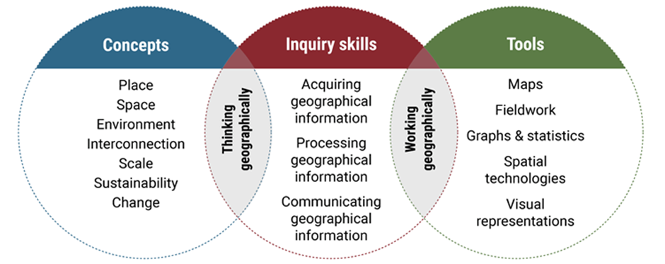
This model is an adaptation of a diagram in Inquiry-based Learning in Geography by Dr Grant Kleeman, Macquarie University, presented at the Canberra Geography Roadshow, November 2015.

Learning across the curriculum
Learning across the curriculum content, including cross-curriculum priorities and general capabilities, assists students to achieve broad learning outcomes. The learning outcomes are defined in the NESA K-10 Curriculum Framework and Statement of Equity Principles, and the Melbourne Declaration on Educational Goals for Young Australians (December 2008).
The geography syllabus includes cross-curriculum priorities, general capabilities and other NESA identified learning areas.
Cross-curriculum priorities enable students to develop understanding about and address the contemporary issues they face. Cross-curriculum priorities are:
- Aboriginal and Torres Strait Islander histories and cultures
- Asia and Australia’s engagement with Asia
- sustainability
General capabilities encompass the knowledge, skills, attitudes and behaviours to assist students to live and work successfully in the 21st century. The general capabilities are:
- critical and creative thinking
- ethical understanding
- information and communication technology capability
- intercultural understanding
- literacy
- numeracy
- personal and social capability.
The NESA syllabuses include other areas identified as important learning for all students:
- civics and citizenship
- difference and diversity
- work and enterprise.
Shown above is the learning across the curriculum content which must be incorporated, and can be identified by icons. Use the Guide to the new NSW syllabus (PDF 460KB) for more information on the layout of the syllabus and pages 31-34 of the Geography K-10 Syllabus (PDF 1.8MB) for more detail.
Geography K-10 Syllabus © NSW Education Standards Authority (NESA) for and on behalf of the Crown in right of the State of New South Wales, 2015.

Becoming familiar with reading the syllabus
A guide to reading the Geography K-10 Syllabus
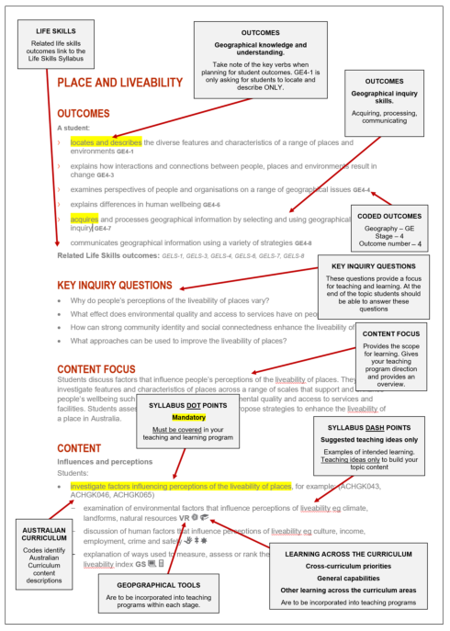
Warning: History K-10, Geography K-10 and Commerce 7-10 syllabuses use different terminology. Dot points that end with including require the subsequent dot points to be taught. They are not examples.

Geography K-10 content
Content topics from Early Stage 1 to Stage 5 in geography.
Stage | Content
Early Stage 1 | - People live in places
Stage 1 | - Features of places  - People and places
Stage 2 | - Places are similar and different  - The earth’s environment
Stage 3 | - Factors that shape places  - A diverse and connected world
Stage 4  (minimum 100 hours) | - Landscapes and landforms  - Place and liveability  - Interconnections  - Water in the world
Stage 5  (minimum 100 hours) | - Sustainable biomes  - Changing places  - Environmental change and management  - Human wellbeing

Stage statements
The stage statements are summaries of the knowledge, understanding, skills, values and attitudes that have been developed by students as a result of achieving the outcomes for the relevant stage of learning. The stage statements can be used as an ‘end point’ for summative tasks and report writing.
Stage statements: Early Stage 1
Understanding | By the end of Early Stage 1, students identify familiar places and recognise why some places are special or important to people and how they care for them. They recognise that places can be represented on maps.
Inquiry | Students acquire information by observing, talking to others and viewing, reading and/or listening to texts. They use geographical tools and communicate geographical information in a range of forms. Students reflect on their learning from the findings of their inquiry.
Stage statements: Stage 1
Understanding | By the end of Stage 1, students describe the natural features of different places, including the weather and seasons, and recognise that places exist across a range of scales. They describe human features of places, including how spaces can be arranged for different purposes. Students investigate how places are managed and cared for and discuss the connections people have to different places.
Inquiry | Students pose questions and collect and record information to answer these questions. They represent data in tables and on maps. They interpret geographical information to draw conclusions. Students present findings in a range of communication forms using simple geographical terms. They reflect on their learning and suggest actions in response to the findings of their inquiry.
Stage statements: Stage 2
Understanding | By the end of Stage 2, students examine the characteristics of places in different locations from the local to the national scale. They describe interconnections between people and the environment. They identify simple patterns in the distribution of the features of places. Students recognise the importance of the environment and examine how different perceptions influence people’s responses to a geographical challenge.
Inquiry | Students develop geographical questions to investigate and collect and record relevant data and information to answer these questions. They represent data by constructing tables and graphs and maps featuring cartographic conventions. They read maps to determine location, direction and distance. Students interpret data and draw conclusions. They present findings using geographical terminology in a range of communication forms. They reflect on their learning and propose individual action in response to a local geographical challenge and identify the expected effects of their proposed action.
Stage statements: Stage 3
Understanding | By the end of Stage 3, students describe the diverse characteristics of places in different locations across local and global scales. They explain interactions between people, places and environments and identify factors influencing interconnections. Students compare spatial distributions and patterns among phenomena. They explore how people respond to a geographical challenge and investigate reasons for differing perspectives.
Inquiry | Students develop geographical questions to frame an inquiry. They use a variety of strategies to locate, collect and record relevant data and information to answer inquiry questions. They represent data in different forms. Students interpret data and other information to identify and compare spatial distributions, patterns and trends, infer relationships and draw conclusions. They present findings and ideas using geographical terminology in a range of communication forms. They propose solutions, and may take action, in response to a geographical challenge and describe the expected effects of their proposal.
Stage statements: Stage 4
Understanding | By the end of Stage 4, students describe geographical processes that influence the features and characteristics of places and environments across a range of scales. They describe how places are perceived and valued differently and explain interconnections within environments and between people, places and environments. Students investigate environmental change and differences in human wellbeing and discuss strategies for addressing geographical challenges, taking into account environmental, economic and social factors.
Inquiry | Students undertake geographical inquiry to build knowledge and understanding of people, places and environments through the collection, collation and analysis of primary data and secondary information. Students propose explanations for spatial distributions, patterns and trends and infer relationships. They propose solutions, and may take action to address contemporary geographical challenges and predict outcomes. Students participate in fieldwork to collect primary data and develop their personal capabilities and workplace skills.
Stage statements: Stage 5
Understanding | By the end of Stage 5, students explain geographical processes that change features and characteristics of places and environments over time and across scales and explain the likely consequences of these changes. They analyse interconnections between people, places and environments and propose explanations for distributions, patterns and spatial variations over time and across scales. Students compare changing environments, analyse global differences in human wellbeing, explore alternative views to geographical challenges and assess strategies to address challenges using environmental, social and economic criteria.
Inquiry | Students undertake geographical inquiry to extend knowledge and understanding, and make generalisations and inferences about people, places and environments through the collection, analysis and evaluation of primary data and secondary information. They propose explanations for significant patterns, trends, relationships and anomalies in geographical phenomena. Students propose solutions, and may take action to address contemporary geographical challenges, taking into account alternative points of view and predicted outcomes.
Geography K-10 Syllabus © NSW Education Standards Authority (NESA) for and on behalf of the Crown in right of the State of New South Wales, 2015.

How to keep up to date with syllabus changes and professional development

SchoolBiz
SchoolBiz is the primary channel for communication to school staff within the department. SchoolBiz is published during the term and includes:
- critical reading
- important dates
- professional learning and development, events and resources
- school administration and management
- program updates
- curriculum and cocurricular
- expressions of interest
- anniversaries and celebrations.
To find out about what is happening in the department please access ‘critical reading’ for up to date information. To supplement accreditation and be informed of professional learning opportunities, access ‘Professional learning and development, events and development, events and resources’. Network meetings, quality teaching rounds and professional learning opportunities can be located in SchoolBiz. Environmental Education Centres often post information on fieldwork professional learning activities for K-10.

HSIE e-NEWS
HSIE e-NEWS is produced and distributed each term by the HSIE 7-12 advisor through email and the HSIE statewide staffroom. Use the online form to register for HSIE e-NEWS. Key learning areas of the HSIE website includes information on syllabus implementation and teaching resources.

HSIE statewide staffroom
The HSIE statewide staffroom is space for HSIE teachers to collaborate, share resources and seek advice from HSIE curriculum advisors. There are several history specific channels and regular meetings to engage with news and updates in HSIE teaching, as well as professional learning. The statewide staffroom is run through Microsoft Teams.

NESA News
NESA News is a weekly publication distributed to subscribers via email each Monday. Follow the link to subscribe to the email list to ensure you are up to date on:
- HSC and Record of School Achievement (RoSA)
- HSC minimum standards
- syllabus changes, updates and consultations
- determining grades
- examination format updates and specifications
- subject selection
- accreditation
- NESA endorsed professional development.

Resources for Geography K-10
There is a wide variety of resources to use in geography including textbooks, skills workbooks, maps, posters, geography puzzle books, ICT resources including subscriptions to atlases, web tools, apps, videos and an array of useful, up-to-date websites. Use these resources to assist and enhance your teaching.
The NSW Department of Education has a variety of geography K-6 programs and K-6 resources. These resources include:
- programing ideas
- teaching and learning frameworks
- Learning across the curriculum content
- how to organise Geography K-6 in small school settings
- geographical toolkit
- geography terminology continuum
- professional learning opportunities.
In addition, the website has a variety of geography 7-10 programs and 7-10 resources. These resources include:
- Geography 7-10 teaching and learning frameworks
- sample learning and teaching sequence including life skills
- using the National Literacy and Numeracy learning progressions in Geography 7-10
- Learning across the curriculum content.
There are a range of textbook resources for Stages 4 and 5 geography, but many textbooks include in-depth material that may not suit your school context and students. Textbooks may be used as a guide to gain an understanding of a topic and determine what activities will suit your students. The teacher should use their knowledge on the topic to create additional resources or find supplementary resources that can be used as part of a learning sequence. It is important to make geography real for students using relevant examples from their local environment.
The dynamic nature of geography means that teachers need to be well informed of issues happening in the natural and human environment. Teachers need to be able to lead discussions which are current in the media. Local issues can be a catalyst for class discussion and increase student engagement with the course content. Care should be taken to ensure that stimulus materials used to support teaching and learning are kept current, relevant and culturally sensitive.
The teaching and learning programs in your faculty need to be analysed and consulted with your subject coordinator or head teacher for the suggested timing of topics or units within topics that suit the school context.

Geographical tools
Students develop skills in working with geographical tools.
The geographical tools can be mapped using the K-10 geographical tools continuum in the syllabus. Content pages indicate where specific geographic tools could be taught.
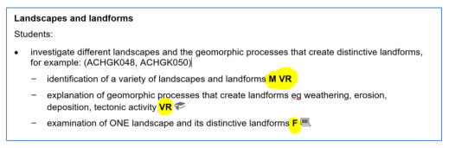
Geography K-10 Syllabus © NSW Education Standards Authority (NESA) for and on behalf of the Crown in right of the State of New South Wales, 2015.
Also look out for teacher professional learning courses for geography teachers. There are courses offered specifically for teachers without a background in geography and teachers new to teaching geography. The NSW Geography Teacher’s Association and the Environmental and Zoo Education Centres deliver professional learning courses for geographical tools. There are a range of geographical tools resources available commercially, including workbooks as well as PowerPoint lessons and online video tutorials. In addition, inquire into what your school or faculty has and examine the catalogues sent to the school.
The Geographical Toolkit K-6 (DOCX 3.88MB) shows the interconnections between geographical concepts, geographical inquiry and geographical tools. The Geography Toolkit enables students to think and work geographically when investigating geographical knowledge and understanding. This is an effective resource for ‘out of field’ teachers (K-12) to introduce the basics of geographical tools of maps, fieldwork, graphs and statistics, spatial technologies and visual representations.
Warning: Geography teachers often call geographical tools ‘skills’. This is not to be confused with geographical inquiry skills.

The importance of fieldwork
Fieldwork is fundamental to the study of geography. It is the means by which students can engage and develop a deep knowledge and understanding of geographical inquiry, processes and communicate information about geography in the real world. Fieldwork enables students to:
- be immersed in a variety of real world environment
- be actively engaged in geographical inquiry
- investigate geographical phenomena in an authentic learning context
- learn through a variety of teaching and learning approaches
- use a wide range of geographical tools
- explore geographical processes within environments
- locate, collect and record primary data and information
- explore varying perspectives on geographical issues.
Fieldwork should never be an end in itself – it should always be part of a geographical inquiry, starting with prior learning, setting geographical questions, followed by field activities and follow-up work to interpret and analyse primary data and communicate conclusions.
Effective fieldwork should:
- be planned in advance
- be mapped to student outcomes and content for relevance
- contain guided activities to support students in their inquiry
- involve students being active participants in the collection of geographical data.

Simple fieldwork in Geography K-10
Fieldwork can be undertaken at school, in the local area or at more distant places. Experiences can range from a part of a lesson, a full day excursion to an overnight camp. Fieldwork sites could include:
- school grounds
- local neighbourhood
- natural areas, for example national parks, reserves
- beach, estuaries, wetlands agricultural areas
- towns and cities.

School grounds
Students could investigate problems that occur on the playground such as waste disposal or conduct a traffic count at the school fence. School ground fieldwork activities could include:
- field sketching on the oval
- recording temperature and humidity in different locations
- conducting a treasure hunt using compasses
- identifying clouds
- vegetation and animal life
- using a clinometer to measure slopes.

Local neighbourhood
The local neighbourhood provides a cost-effective opportunity for students to make real world connections with geography. Fieldwork activities could include:
- conducting a field sketch to study the changes in the local environment
- local library research of local geographic community
- observation of pollution in a local creek
- measure the gradient of a slope in the park
- photograph litter pollution in a local street
- line drawing from a photograph
- survey neighbours/interview residents about a local issue
- identify features of places or observe the connections between people and places in your local area. Students could create a Tour Builder of what is in the local area.

Excursions
Short day excursions outside of the school are integral for geographical understanding. Students are given the opportunity to enhance their knowledge through observing, mapping, measuring and recording real world phenomena. Teachers can:
- organise a visit to an Environmental and Zoo Education Centre (EZEC)
- organise a visit to NSW National Parks and Wildlife Service (NPWS)
- conduct fieldwork in urban places such as the local town or suburb
- visit coastal environments to observe environmental change
- visit a farm to investigate food production
- visit a local town to assess wellbeing or liveability.
Other fieldwork activities may include:
- visit an Aboriginal community/organisation
- an ecotourism business
- a cross-curricular day trip with Science or History.

Virtual excursions
The web-based Google Earth is a virtually immersive experience allowing students to appreciate the awe and wonder of geography by visiting places around the world with 3D imagery. Launching Google Earth in Chrome offers a superior experience allowing students to walk down the streets of New York City or visit historic sites in Athens or explore Ho Chi Minh City in the Voyager function.

Aboriginal and/or Torres Strait Islander significant sites
When proposing fieldwork for Aboriginal or Torres Strait Islander sites, consult with local communities and your local Aboriginal Education Consultative Group (AECG). Students, teachers and accompanying parents and carers need to be familiar with protocols for visiting the site and working with Aboriginal communities. Refer to Working with Aboriginal Communities: A Guide to Community Consultation and Protocols (PDF 1.7MB) on the NESA website.

Organising a major fieldwork activity
When organising large excursions, plan for the cohort to attend the excursion. Consider including more than one subject, for example, join with history and/or science. History and geography classes with semesterised timetables would benefit from this format. This works well in Stages 4-5 where history, geography and science are mandatory subjects. Benefits include:
- increases connections between subjects and the real world – seeing the same place from different perspectives
- reduces disruption at the school, particularly for learning areas not involved
- increases student/teacher ratios and simplifies teacher cover arrangements
- is cost effective, eliminating the need to hire casual teachers and creating a value for money excursion that is more affordable for all students to attend.

Fieldwork equipment
There is a variety of fieldwork equipment that schools can purchase. Due to the potential expense, faculties will often purchase fieldwork resources over a period of years or share resources with other faculties within a school. Provided are possible places where you can access fieldwork equipment:
- The HSIE or social sciences faculty in secondary schools.
- Other faculties including science, maths and PDHPE.
- Some of these tools might not be available at your school – an excursion to the local Environmental Education Centre is a good opportunity for new teachers to geography to engage in fieldwork ad gain confidence in using fieldwork equipment.
Schools can purchase fieldwork instruments from educational/science suppliers. It is also possible to make some tools, such as a clinometer, quadrat or dip net.
Items that may be collected for a geography fieldwork toolkit could include, but are not limited to:
compasses | water quality testing kit | stop watches
thermometers | turbidity tube | clinometer
hygrometer | trundle wheel | soil testing kit
light meter, sound level meter | 100m retractable tape measure | quadrats (1m2)
weather vane | stream flowmeter | hand held soil sampling auger
dip nets and buckets | clipboards with pens attached | anemometer
native vegetation, animal and weed identification charts | topographic map of the local area (laminated) | 360° camera (to create virtual fieldwork)
Fieldwork activities should be integrated into teaching and learning programs, mapped against student outcomes, answer the inquiry questions and be appropriate for the age of the students. In addition to formal fieldwork, incidental opportunities enable students to make impromptu observations, for example when moving through the school.
Fieldwork becomes more comprehensive as students move through the stages. By Stages 4 and 5 (S4, S5), students use sophisticated fieldwork equipment and techniques to collect complex data and information.
Fieldwork activities may include:
- plotting location, natural and human features on maps (ES1, S1, S2, S3, S4, S5)
- recording observations through sketches and photographs (ES1, S1, S2, S3, S4, S5)
- counting and plotting facilities for people (ES1, S1, S2, S3, S4, S5)
- surveying people to collect information (ES1, S1, S2, S3, S4, S5)
- counting plants using quadrats (S2, S3, S4, S5)
- measuring distances, temperature, humidity (S2, S3, S4, S5)
- collecting aquatic and terrestrial invertebrates (S2, S3, S4, S5)
- testing water quality, turbidity (S3, S4, S5)
- recording change in features along a transect (S3, S4, S5)
- calculating direction and aspect using a compass (S3, S4, S5).
Use the Six Maps site to determine what topographic map is required for your local area. You can purchase maps from the website or from online map stores. It is advisable to laminate maps used for fieldwork. Many map stores will laminate for an additional cost. Once fieldwork equipment is purchased it is a good idea to have laminated instructions on how to use equipment. Students can read the instructions in the field and can cycle through fieldwork stations to collect primary data. Include in your toolkit a laminated checklist of equipment to keep track of all items (see images below).
Year 10 Geography Environmental Change Fieldwork, 2019
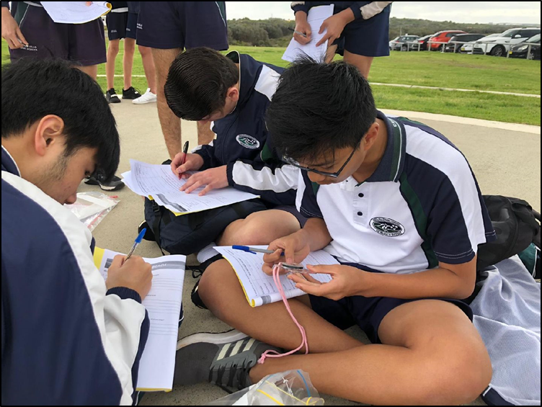
Fieldwork stations instruction sheet, 2019
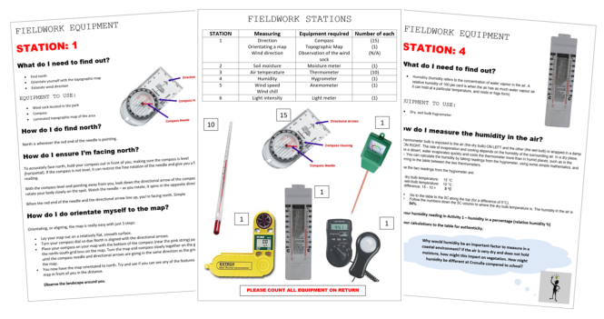

Fieldwork activities for each stage

Early Stage 1
Focus: observe and record data.
Refer to: GeogSpace Selecting a fieldwork site: Foundation year (PDF 234KB), and Early Stage 1 geography learning and teaching framework: My school grounds (DOCX 79KB).
Early Stage 1 syllabus content | Potential fieldwork sites | Suggested fieldwork tools and activities
Important places | School grounds, classroom | Photography, sensory activities, tallies, informal mapping, pictorial maps
Aboriginal or Torres Strait Islander places | Local Aboriginal places | Sensory activities, interviews, photography

Stage 1
Focus: observe, collect and record data and conduct surveys.
Refer to: GeogSpace Selecting a fieldwork site: Years 1 and 2 (PDF 196KB) and geography learning and teaching frameworks Stage 1 documents (various DOCX).
Stage 1 syllabus content | Potential fieldwork sites | Suggested fieldwork tools and activities
Features of places | Local park, school grounds, natural area, for example bushland, beach, lake, wetland, river bank | Photography, sensory activities, invertebrate hunts, tallies, rubbings, sketching, informal mapping, large scale maps, for example school site map, pictorial maps
Weather and seasons | School grounds | Measuring rain, temperature, wind using formal and informal units; observations through senses
How places are organised | School hall, Covered Outdoor Learning Area (COLA), Out of School Hours (OOSH), local recreation area | Pictorial maps, photography, sketching, interviewing, surveys, tallies, informal mapping
Australian places | Local neighbourhood | Photography, mapping, tallies, sketching, rubbings, sensory activities
People’s connections to places | School, local shops, park, library, sports facilities, natural areas | Interviewing, surveys, tallies (for example modes of transport to school), photography
Local and global connections | Natural areas, Aboriginal sites | Photography, interviews, sensory activities

Stage 2
Focus: observe, measure, collect and record data, conduct surveys or interviews. Fieldwork activities may include using fieldwork instruments such as measuring devices, maps and photographs.
Refer to: GeogSpace Selecting a fieldwork site: Years 3 and 4 (PDF 280KB), and Geography learning and teaching frameworks Stage 2 documents (various DOCX).
Stage 2 syllabus content | Potential fieldwork sites | Suggested fieldwork tools and activities
Similarities and differences between places | Home town or city (for comparison with distant places) | Photography, sketching, line drawings, sketch maps, tallies, sound and video recordings
Different environments  Significance of environments | Natural area, for example rainforest, woodland, eucalypt forest, wetland, state forest | Photography, sensory activities, animal surveys, invertebrate hunts, plant surveys, tallies, sketches, informal maps, large scale maps
Perception of environments  Protection of environments | Nature reserve, national or state park, cultural heritage site | Photography, mapping, sketching, surveys, sensory activities, waste audits, large scale maps

Stage 3
Focus: observe, measure, collect and record data, conduct surveys and interviews. Fieldwork activities may include using fieldwork instruments such as measuring devices, maps, photographs, compasses, and Global Positioning System (GPS).
Refer to: GeogSpace Selecting a fieldwork site: Years 5 and 6 (PDF 254KB), and Geography learning and teaching frameworks Stage 3 documents (various DOCX).
Stage 3 syllabus content | Potential fieldwork sites | Suggested fieldwork tools and activities
Factors that change environments (can be combined with Humans shape places) | Site with multiple uses, for example national park picnic ground, river bank development, recreational reserve | Photography, field sketches, plant and animal surveys, tallies, sketching, sketch maps, water quality testing, interviewing, surveys, tallies, compasses and GPS
Humans shape places | Site affected by a contemporary land use issue, for example waterway, bushland or recreational reserve, harbour foreshore | Photography, field sketches, plant and animal surveys, tallies, sketching, mapping, water quality testing, interviewing, surveys, tallies

Stage 4
Focus: observe, measure, collect and record data, develop and conduct surveys and interviews. Fieldwork activities may include using fieldwork instruments such as weather instruments, vegetation identification charts, compasses, GPS and Geographic Information System (GIS).
Refer to: GeogSpace Selecting a fieldwork site: Years 7 and 8 (PDF 254KB); and Geography learning and teaching frameworks Stage 4 documents (various DOCX).
Stage 4 syllabus content | Potential fieldwork sites | Suggested fieldwork tools and activities
Landscapes and landforms  Landscapes and landforms  Value of landscapes and landforms  Changing landscapes | A landscape with distinct landforms such as a national park | Photography, field sketches, transects, compasses and GPS, develop and conduct interviews, surveys, water quality testing, mapping
Place and liveability  Influences and perceptions  Access to services and facilities  Environmental quality  Community  Enhancing liveability | Local suburb, town, city | Photography, field sketches, tallies, interviews, surveys, mapping
Water in the world  The water cycle  The value of water | School grounds, local suburb, lake, river wetlands, beach, local water waste treatment facility | Photography, field sketches, transects, compasses and GPS, develop and conduct interviews, surveys, water quality testing, mapping

Stage 5
Focus: observe, measure, collect and record data, develop and conduct surveys and interviews. Fieldwork activities may include using fieldwork instruments such as weather instruments, vegetation identification charts, compasses, clinometers GPS and GIS or remote sensing.
Refer to: GeogSpace Selecting a fieldwork site: Years 9 and 10 (PDF 256KB), and Geography learning and teaching frameworks Stage 5 documents (various DOCX).
Stage 5 syllabus content | Potential fieldwork sites | Suggested fieldwork tools and activities
Sustainable biomes  Biomes  Biomes produce food  Challenges to food production  Food security | Zoo, local farm | Photography, field sketches, plant and animal surveys, sketching, sketch maps, soil testing, interviewing, water quality testing, compasses and GPS
Changing places  Urban settlement patterns | Local town, suburb or city | Photography, field sketches, plant and animal surveys, tallies, sketching, mapping, interviewing, surveys
Environmental change and management  Investigative study | Site affected by environmental change for example wetlands, beach, forest, waterways | Photography, field sketches, plant and animal surveys, sketching, sketch maps, soil testing, interviewing, water quality testing, compasses and GPS

Fieldwork activities
Fieldwork activity ideas including sensory fieldwork, interviews and surveys (people, animal and plant) are located in the Geographical toolkit (DOCX 3.88MB).

Fieldwork resources
A checklist for undertaking fieldwork (PDF 452KB), Geogspace Australia
Fieldwork ideas and resources, Geographical Association UK

Environmental and zoo education centres
Environmental and zoo education centres (EZEC’s) are NSW public schools staffed by trained teachers. EZEC’s support schools K-12 by providing a variety of programs to suit the geography syllabus. Each EZEC offers a unique experience that relates to their specific geographic location and are related to the NSW syllabus and appropriate stage.
Pre and post-excursion materials are provided and these programs can be an effective start for teachers wanting to experience high quality fieldwork. In addition, the teachers from EZEC’s often work in schools to support environmental programs and sustainability initiatives. Many EZEC’s offer professional learning activities for teachers, which are advertised in SchoolBiz.
There are 25 EZEC locations in NSW extending to Wagga Wagga, Dubbo, and the north and south coast of New South Wales. Program overviews are available on each EZEC’s website.
Hunter/Central Coast
- Awabakal Environmental Education Centre
- Wetlands Environmental Education Centre
- Rumbalara Environmental Education Centre
Illawarra and South East Region
- Bournda Environmental Education Centre
- Illawarra Environmental Education Centre
New England
- Thalgarrah Environmental Education Centre
North Coast
- Cascade Environmental Education Centre
- Dorroughby Environmental Education Centre
Riverina
- Riverina Environmental Education Centre
Sydney
- Botany Bay Environmental Education Centre
- Observatory Hill Environmental Education Centre
- Royal National Park Environmental Education Centre
Sydney – north
- Field of Mars Environmental Education Centre
- Gibberagong Environmental Education Centre
- Taronga Zoo and Western Plains Education Centre
Sydney – south west
- Camden Park Environmental Education Centre
- Georges River Environmental Education Centre
- Wooglemai Environmental Education Centre
Sydney – west
- Brewongle Environmental Education Centre
- Longneck Lagoon Environmental Education Centre
- Penrith Lakes Environmental Education Centre
Western NSW
- Red Hill Environmental Education Centre
- Wambangalang Environmental Education Centre
- Warrumbungle National Park Environmental Education Centre
- Taronga Zoo and Western Plains Education Centre

National Parks and Wildlife Services
The NSW National Parks and Wildlife Service offers a range of education services including resources and excursions in regions around New South Wales:
- Sydney and surrounds
- NSW Central Coast
- Blue Mountains and country NSW
- NSW North Coast
- NSW South Coast
- Snowy Mountains
- Outback NSW and Murray-Riverina

Some geography basics

What is geography?
Geography is the study of places and the relationships between people and their environments. Geographers explore both the physical properties of earth’s surface and the distribution of human societies. The examination of how human culture interacts with the natural environment, and the way that locations and places can have an impact on people. Geography seeks to understand where things are found, why they are there, and how they develop and change over time.

Questions that geographers ask
- What is it?
- Where is it?
- Why is it there?
- How did it get like this?
- Should it be like this?
- Why is it changing?
- What is the impact of it being there?
- How is it changing over time?
- What groups are involved?
- What do different groups think?
- What might happen in the future?
- What should we do about it?
- What action might be appropriate?

Professional associations
There are a variety of professional associations that teachers can join that can benefit teachers new to geography. Schools often have an annual membership with associations. Check with your head teacher, which associations they may subscribe to.
- Geography Teachers Association of New South Wales (GTANSW)
- Australian Geography Teachers Association (AGTA)
GTANSW have a broad collection of resources for Early Stage 1 – Stage 3 whereas the AGTA have free access to all resources from past AGTA conferences on the website. In addition, teachers may investigate their geographical region for additional associations. For example, the Western Sydney Social Sciences Teachers Association WeSSSTA supports teachers around the state in the area of geography.

Online resources
NSW Department of Education HSIE
There are resources on the department’s website including
- Geographical toolkit K-6 (useful for 7-10 too)
- Geography K-6 teaching and learning frameworks
- Guide to using picture books in geography
- Geography terminology continuum K-10
- Geography organisation ideas for small schools
- Learning across the curriculum – cross curriculum priorities teacher resources K-10
  - Aboriginal and Torres Strait Islander histories and cultures
  - Sustainability
  - Asia and Australia’s engagement with Asia

Geography websites
ABC Education | MetEye – BOM
ABC Splash – Geography | National Geographic
Australian Bureau of Statistics | National Geographic MapMaker Interactive
Barangaroo learning portal | National Geographic – Kids (K-6)
BBC Bitesize Geography (UK) | NationMaster
Behind The News | NSW National Parks and Wildlife Service
Bureau of Meteorology | NSW Spatial Services
Cool Australia | Royal Geographical Society (UK)
Gapminder – Dollar Street | Scootle (Australian Curriculum)
Gapminder – graphing tools | State Library of NSW
Geography all the way (UK) | Sustainable Schools
Geography Education | Sydney Water
Geographypods (UK) | Ted Ideas worth spreading
GeogSpace | The World Factbook – Central Intelligence Agency
GeoGuessr | UNESCO
Geoscience Australia | United Nations CyberSchoolBus
Google Earth | Visualisation of global weather conditions
Google Maps | World Economic Forum
Great Barrier Reef GBRMPA | World Heritage
GTA NSW Primary Geography Alive (K-6) | World Vision

Teaching and learning strategies
The department has developed a suite of learning activities and learning tools to integrate information and communications technology (ICT) in teaching practice. This website is available as a resource hub that provides a variety of ICT tools for teachers so they can embed technology into the curriculum.
The Learning activities selector is characterised by:
- collaboration
- discussion
- feedback and reflection
- guided
- explicit
- demonstration
- experiential
- independent.
The Learning tools selector can filter for activities, geographic information or even free tools.
The Teacher Toolkit has a variety of resources to help teachers establish an engaging and orderly classroom. These include but are not limited to:
- classroom management
- opening activities
- checking for understanding
- partner practice
- group practice
- independent practice
- reading strategies
- games
- closing activities.
Future focused resources has toolkits, information and links. The resources can be filtered based on areas of interest including of learning and teaching, learning spaces and technology.

