History Stage 3
Colonial settlement and life

Contents
Topic – The Australian colonies 3
Key inquiry questions 3
Overview 3
Outcomes 3
Content 4
Historical inquiry skills 4
Selected historical concepts 5
Assessment 6
Vocabulary 6
Teaching and learning activities 7
Inquiry 1 – British colonies after 1800 7
Stimulus 7
Historical inquiry step 1 – question 8
Historical inquiry step 2 – research 9
Historical inquiry step 3 – analyse 11
Historical inquiry step 4 – evaluate 11
Historical inquiry step 5 – communicate 11
Reflection 12
Inquiry 2 – settlement patterns 13
Stimulus 13
Historical inquiry step 1 – question 14
Historical inquiry steps 2 and 3 – research and analyse 15
Historical inquiry step 4 – evaluate 20
Historical inquiry step 5 – communicate 20
Reflection 20
Inquiry 3 – impacts of settlement 21
Stimulus 21
Historical inquiry step 1 – question 22
Historical inquiry steps 2 and 3 – research and analyse 22
Historical inquiry step 4 – evaluate 25
Historical inquiry step 5 – communicate 26
Reflection 26
Inquiry 4 – daily colonial life 27
Stimulus 27
Historical inquiry step 1 – question 28
Historical inquiry steps 2 to 5 – research, analyse, evaluate, communicate 28
Historical inquiry step 4 – evaluate 30
Historical inquiry step 5 – communicate 30
Reflection 30
Resources 31
References 33

Topic – The Australian colonies
Duration: 6 weeks – 90 minutes per week

Key inquiry questions
- What do we know about the lives of people in Australia's colonial past and how do we know?
- How did an Australian colony develop over time and why?
- How did colonial settlement change the environment?

Overview
Students undertake 4 short inquiries:
- Inquiry 1 – a guided inquiry into the reasons for the establishment of British colonies in Australia after 1800
- Inquiry 2 – a guided inquiry into settlement patterns
- Inquiry 3 – a semi-guided inquiry into impacts of settlement
- Inquiry 4 – an independent inquiry into daily colonial life.
Note 1: these 4 inquiries are sequential. They provide the understandings needed for the history teaching and learning sequence – Colonial development.
Note 2: the teaching and learning sequence, Colonial immigration, could follow this learning sequence to create a 10 week teaching and learning sequence.

Outcomes
A student:
- HT3-1 describes and explains the significance of people, groups, places and events to the development of Australia
- HT3-2 describes and explains different experiences of people living in Australia over time
- HT3-5 applies a variety of skills of historical inquiry and communication.
Outcomes and other syllabus material referenced in this document are from History K–10 Syllabus © NSW Education Standards Authority (NESA) for and on behalf of the Crown in right of the State of New South Wales, 2012.

Content
Reasons (economic, political and social) for the establishment of British colonies in Australia after 1800 (ACHHK093)
Students:
- discuss why the British government set up colonies in Australia after 1800.
The nature of convict or colonial presence, including the factors that influenced patterns of development, aspects of the daily life of inhabitants (including Aboriginal and Torres Strait Islander peoples) and how the environment changed (ACHHK094)
Students:
- outline settlement patterns in the nineteenth century and the factors which influenced them
- discuss the impact of settlement on local Aboriginal peoples and the environment
- discuss the diverse relationships between Aboriginal peoples and the British
- investigate the everyday life of a variety of men and women in post-1800 colonial settlements using a range of sources and explain their different experiences

Historical inquiry skills
- Comprehension: chronology, terms and concepts
- respond, read and write to show understanding of historical matters
- sequence historical people and events (ACHHS098, ACHHS117)
- use historical terms and concepts (ACHHS099, ACHHS118)
- Analysis and use of sources
- locate information relevant to inquiry questions in a range of sources (ACHHS102, ACHHS121)
- compare information from a range of sources (ACHHS103, ACHHS122)
- Perspectives and interpretations
- identify different points of view in the past and present (ACHHS104, ACHHS123)
- Empathetic understanding
- explain why the behaviour and attitudes of people from the past may differ from today
- Research
- identify and pose questions to inform an historical inquiry (ACHHS100, ACHHS119)
- identify and locate a range of relevant sources to support an historical inquiry (ACHHS101, ACHHS120)
- Explanation and communication
- develop historical texts, particularly narratives and descriptions, which incorporate source material (ACHHS105, ACHHS124)
- use a range of communication forms (oral, written, graphic) and digital technologies. (ACHHS106, ACHHS125)

Selected historical concepts
- Continuity and change: some things change over time and others remain the same, eg aspects of both continuity and change in Australian society throughout the twentieth century.
- Cause and effect: events, decisions or developments in the past that produce later actions, results or effects, eg events and other reasons that led to migration to Australia; reasons for the struggle for rights and freedoms for various groups in Australia.
- Perspectives: people from the past will have different views and experiences, eg differing attitudes of various groups to Federation or to granting rights and freedoms to women and Aboriginal peoples.
- Empathetic understanding: an understanding of another's point of view, way of life and decisions made in a different time, eg differing attitudes and experiences of living in an Australian colony; understanding the experiences of Aboriginal and Torres Strait Islanders, women and migrants throughout the twentieth century.
- Significance: the importance of an event, development or individual/group, eg determining the importance (significance) of various peoples' contributions to the development of a colony.
- Contestability: historical events or issues may be interpreted differently by historians, eg British 'invasion' or 'settlement' of Australia.

Assessment
All activities require students to demonstrate their learning. All are assessment for learning activities.

Vocabulary
- Cause, effect, significance, perspective, empathy
- Observe, examine, summarise, record, sequence, infer, speculate, representation, conclude
- Colonial, colony, penal, settlement, establishment, settlement patterns, influence, factors, consequences, impacts
- British, European, government, convict, free settler, inhabitants, indentured, Aboriginal, Torres Strait Islander, Indigenous, inhabitants, resistance, frontier conflict, environment, experience

Teaching and learning activities
This learning sequence comprises 4 sequential inquiries.

Inquiry 1 – British colonies after 1800
Through a guided inquiry, students use a variety of secondary sources to investigate the reasons for the establishment of British colonies in Australia after 1800.

Stimulus
Students listen to and think about the words in the folksong, Van Diemen’s Land [sic] in Source 1, viewing the lyrics in Source 2.

Source 1
Celtic Note (19 September 2014) Ronnie Drew - Van Diemen's Land (2:15)

Source 2
Australian folk songs (n.d) Van Diemen’s Land
First 4 verses of ‘Van Diemen’s Land’ [sic] folksong, Anon
Come all you gallant poachers that ramble free from care
That walk out of a moonlight night with your dog your gun and snare
Where the lofty hare and pheasant you have at your command
Not thinking that your last career is on Van Diemen's Land
There was poor Tom Brown from Nottingham, Jack Williams and poor Joe
Were three as daring poachers as the country well does know
At night they were trepanned by the keeper's hideous hand
And for fourteen years transported were unto Van Diemen's Land
Oh when we sailed from England we landed at the bay
We had rotten straw for bedding we dared not to say nay
Our cots were fenced with fire we slumber when we can
To drive away the wolves and tigers upon Van Diemen's Land
Oh when that we were landed upon that fatal bay
The planters they came flocking round full twenty score or more
They ranked us up like horses and sold us out of hand
They yoked us up to the plough my boys to plough Van Diemen's Land
Discuss the story told by the ballad, asking source analysis questions such as:
- What is a poacher?
- From what country were the convicts sent?
- Where is Van Diemen’s Land?
- Why were the men sent there?
- How were the convicts treated on arrival?
- What were the convicts’ feelings about Van Diemen’s Land? How do you know?
- What else would you like to know about convicts in Van Diemen’s Land?
Relate the song to prior knowledge of the First Fleet, the establishment of the British colony at Port Jackson, and the everyday life of First Fleeters at Sydney Cove, covered in Stage 2.
Explain that Sydney Cove was Australia’s first penal colony and that during the 1800s the British established other penal colonies in Australia, such as Van Diemen’s Land (Tasmania) and Moreton Bay in Queensland. Also explain that the British established additional colonies that became states, such as Victoria and Western Australia.
Ask students to infer potential reasons for the establishment of these post-1800s British colonies across Australia.

Historical inquiry step 1 – question
With reference to the discussions in relation to Source 1, formulate a set of inquiry questions.
Note: historical questions ask how, what, why, who, when.
Sample questions
- What British colonies were established in Australia during the 1800s?
- How were these British colonies established?
- Why were British colonies established during the 1800s?
Note: inquiry questions may need to be redesigned through the historical inquiry process.

Historical inquiry step 2 – research
Establishment of British colonies in the 1800s
Collectively view and listen to the traditional song in Source 2 and extract the key information it provides on the establishment of British penal colonies in Australia from 1800. Students use Sources 3, 4 and 5 to complete Table 1, identifying key information that answers the inquiry questions.

Source 3
MartinGlobalPictures (14 October 2009) Moreton Bay – Convict Australia (3:35)

Source 4
Education Services Australia (n.d) Australia in the 1820s: Penal settlements, Australia in the 1810’ and 1820’s
From 1810 to 1821, the fledging colony of New South Wales underwent significant transformation at the hands of Governor Lachlan Macquarie and his wife Elizabeth Macquarie. Their vision for the colony was to transform it from a penal convict establishment to a society reflective of the best of Britain.
Macquarie believed in the potential of emancipated and reformed convicts to create a new society and supported their participation in business and society. He also implemented a large public works program and the establishment of legal and commercial institutions. With an extensive building program, Sydney grew through these years with new roads and bridges, the new botanical gardens, the first hospital, a Supreme Court and Hyde Park Barracks. He also encouraged building works like roads and bridges around Sydney and in Hobart.
Following the reforms of Governor Macquarie, who returned to England in 1821, Britain was increasingly concerned that the colony was not strict enough with convicts. The British government wanted transportation to be seen by the general population as a terrifying prospect and as a deterrent to crime. New convict settlements were then set-up at Moreton Bay, Macquarie Harbour and Port Macquarie.

Source 5
National Museum of Australia (2022) Separation of Tasmania
Once it was known to be a separate island, the British saw Van Diemen’s Land as being vulnerable to the territorial claims of other nations. In 1803 the Governor of New South Wales, Philip Gidley King, anxious to pre-empt the French, sent 49 people under the command of Lieutenant John Bowen to establish a settlement in the Derwent estuary. The following year, David Collins, who had been appointed Lieutenant Governor of Van Diemen’s Land, arrived in the Derwent from England with 430 people. His settlement became Hobart. Small and remote, Van Diemen’s Land would soon become a secondary punishment site for convicts who had reoffended after their arrival in New South Wales or were not amenable to control. The geography of the selected site at Port Arthur on the Tasman Peninsula was exceptionally well suited to its role. The history of Van Diemen’s Land as a convict island dogged its reputation, and after transportation ceased in 1853 the island’s name was changed to Tasmania.
Table 1 – Penal settlements in Australia after 1800
Source number | Title | Creator and date | Key information | Questions raised | Comment on reliability
3 | Moreton Bay | Traditional song, undated
4 | Australia in the 1820s: Penal settlements | My Place, undated
5 | Separation of Tasmania | National Museum of Australia

Historical inquiry step 3 – analyse
Working together, students analyse their information presented in Table 1. Students:
- list the British colonies established in Australia in the early 1800s
- highlight the reasons for the establishment of British settlements
- classify the reasons into social, economic and political and complete Table 2.
Table 2 – Reasons for establishing British colonies in Australia after 1800
Reason | Issue | Immediate solution | Longer term effects
Social
Economic
Political
Sample response: Political | Britain feared the French might colonise Van Diemen’s Land | Establish penal colonies on Van Diemen’s Land | Establishment of colony of Tasmania in 1855

Historical inquiry step 4 – evaluate
Guide the students in evaluating the reliability of the 3 secondary sources used. Did they draw on primary sources? What is the authority of the creators? Do the inquiry questions need to be redesigned as a result of analysing and evaluating sources?

Historical inquiry step 5 – communicate
Letter home
In role as a convict sent from NSW to either a penal settlement at Van Diemen’s Land, or to Moreton Bay, students write a letter to their family at home explaining their change in location. They outline the intent of the British in establishing the new penal colony as an immediate solution to an issue. They also predict the longer term effects.

Reflection
Students reflect on the historical inquiry process, reflecting on what they learned, how they learned it and what else they would like to find out.

Inquiry 2 – settlement patterns
Through a guided inquiry, students investigate settlement patterns in NSW and Australia. They use historical maps and other information to identify the influencing factors. Impacts of influencing factors are explored in greater depth in Inquiry 3.
Note: an in-depth investigation into the consequences of one of the major influencing factors is covered in a separate history teaching and learning framework: Colonial development.

Stimulus
Activate prior knowledge and map-reading skills using the historic map in Source 6. Note: The map is available as a zoomable image.
Students use Think-Pair-Share to analyse the map and consider the following questions:
- Where were the first colonial farms in the settlement?
- Why were they established in those locations?
- How did the establishment of early farms influence the early growth of the settlement? (Hint: What was needed to service the farms?)
- What other developments and factors may have influenced the spread of the settlement?
- What factors constrained the expansion of the settlement?

Source 6
Figure 1 – Sketch of settlements in New South Wales, 20 August 1796
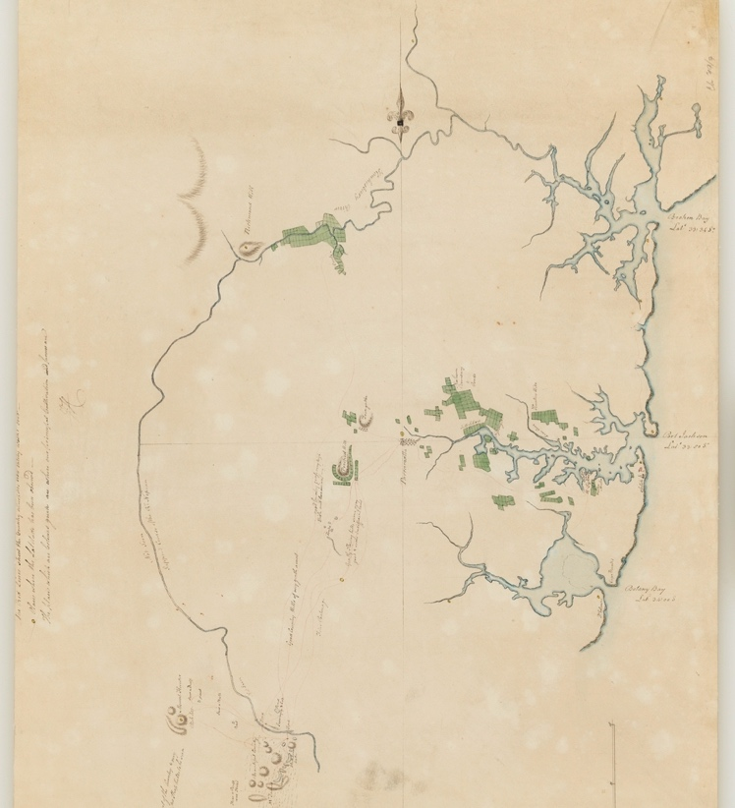
‘New South Wales sketch of the settlements 20th August 1796’ by John Hunter, courtesy of State Library of NSW, Dixon Map Collection and is in the Public Domain.
The original shows west at the top but has been reproduced here cropped and rotated left 900. The map is signed by Governor John Hunter and represents the boundaries of the settlements in the Sydney region. The note at the top of the map explains:
'the red lines shew [sic] the country which lately has been walked over ... The places which are coloured green are where our principal cultivation and farms are.'

Historical inquiry step 1 – question
With reference to their Think-Pair-Share discussions, students formulate inquiry questions.
Sample questions
- What were the settlement patterns in Australia in the 1800s?
- What factors influenced settlement patterns?
Note: inquiry questions may need to be redesigned through the historical inquiry process.

Historical inquiry steps 2 and 3 – research and analyse
Settlement patterns in eastern Australia
Use the information in Source 7 as an overview of the growth of the colony and the factors that influenced settlement. Students examine the 1838 and 1858 maps, using the online zoomable images for close examination. They use See-Think-Wonder questions to analyse and compare the 2 maps.
Students complete Table 3 listing differences between the maps in Sources 8 and 9. As a class, discuss the students’ observations and inferences to clarify the factors that influenced settlement patterns in NSW and Victoria.

Source 7
Bureau of Infrastructure, Transport and Regional Economics (BITRE) (2014) The evolution of Australian towns, Report 136, Canberra, ACT. Chapter 3, page 13
Early settlement
The first colony in Sydney grew relatively quickly but was constrained to the west until the route over the mountains was established. That crossing, in 1813, allowed settlement over the ranges to complement earlier coastal settlements in the Hunter and the Illawarra south to Batemans Bay (Roberts 1924). The establishment of further colonies at what are now Hobart (in 1804), Brisbane (1824), Perth (1829), Adelaide (1836) and Melbourne (1837) expanded the development focus from the original colony (Australian Government 2010).
Occupation spread from each new base at varying speeds with the underlying motive being ownership and development of new grazing and farming lands punctuated by frenzied ‘rushes’ for gold and other minerals. Settlement was a competitive business with the occupation of grazing land by ‘squatters’ closely following the initial explorers, and often preceding the establishment of effective government administration.
The towns that followed the spread of European population from the colonial bases reflected the needs of the basic industries that spawned further growth and development. Key shapers of the location of those industries were geography, climate and natural resources, land tenure arrangements that allowed agriculture to replace grazing, mining discoveries and better transport (especially rivers and railways).

Source 8
Figure 2 – map of the south-eastern portion of Australia by John Arrowsmith, 1838
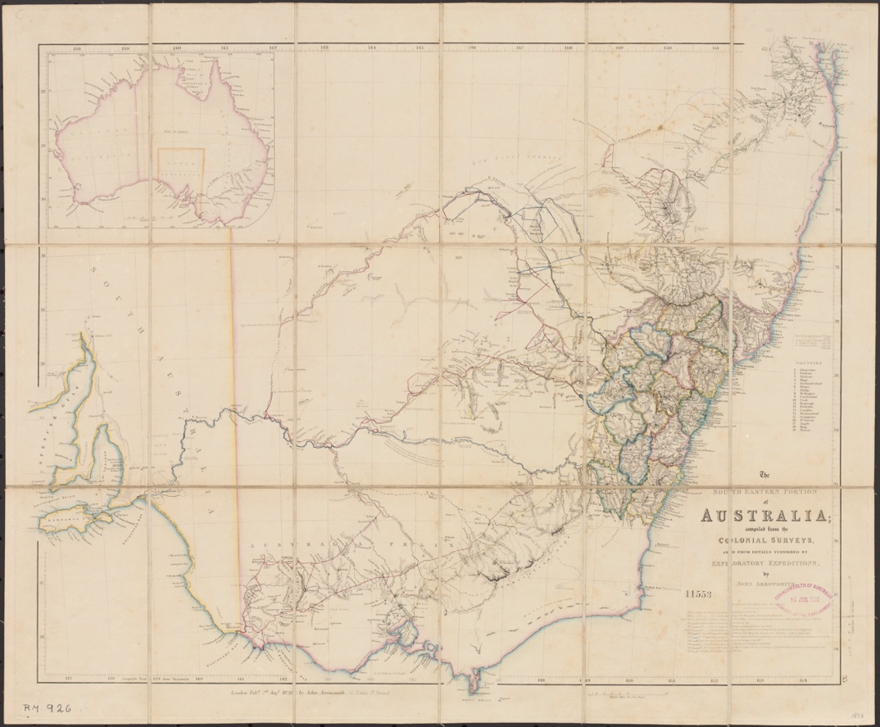
‘The South Eastern portion of Australia’ by John Arrowsmith courtesy of the National Library of Australia and is in the Public Domain.
The map shows 19 counties out and around Sydney in NSW, routes of inland explorers from 1817 to 1837 and notes describing the land.

Source 9
Figure 3 – the South Eastern portion of Australia, John Arrowsmith, 1858
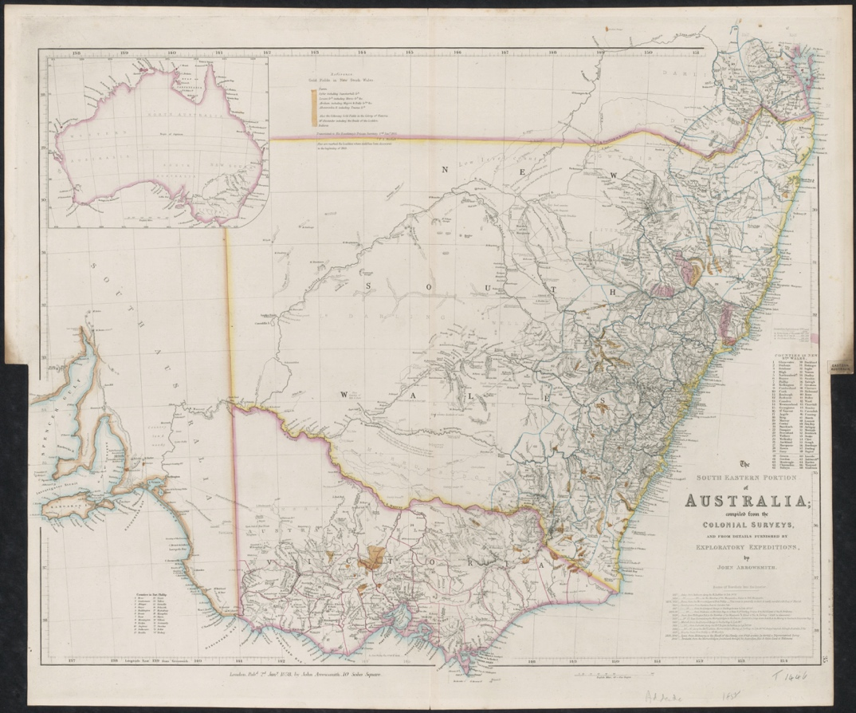
‘The South Eastern portion of Australia’ by John Arrowsmith courtesy of the National Library of Australia and is in the Public Domain.
The map shows 67 counties in NSW and 24 in Victoria. It shows the routes of inland explorers, with notes describing the land and locations of gold discoveries since 1853, shown in yellow.
See-Think-Wonder prompts
See
- What data is represented on each map?
- How many counties are shown and what is their location?
- What is the pattern of settlement?
- What inland exploration routes are shown?
- What descriptions of landscapes are included?
- What has changed between the maps?
Think
- Why do you think the maps were created?
- Why are the exploration routes shown?
- What is the intent of the descriptions of the landscapes?
- What do the maps tell you about the patterns of settlement?
- How will settlement continue to spread? Why do you think that?
Wonder
- What do you wonder about when viewing the maps?
Table 3 – comparison between 1838 and 1858 maps of south-eastern Australia
Changes 1838 to 1858 | Reasons | How I know | What I wonder
Settlement patterns – Australia
Students examine and compare the 1853 and 1876 maps in Sources 10 and 11, using the online zoomable images for close examination. They zoom in to NSW to examine changes since the 1858 map in Source 9. Students use See-Think-Wonder questions to analyse and compare the maps using the questions listed for the previous activity. As a class, discuss the students’ observations and inferences to clarify the factors that influenced settlement patterns in Australia.
Using Think-Pair-Share, students predict the changes to settlement they would observe on a map of Australia created in 1896, 20 years on from the 1876 map.

Source 10
Figure 4 – the Australian Colonies, 1853
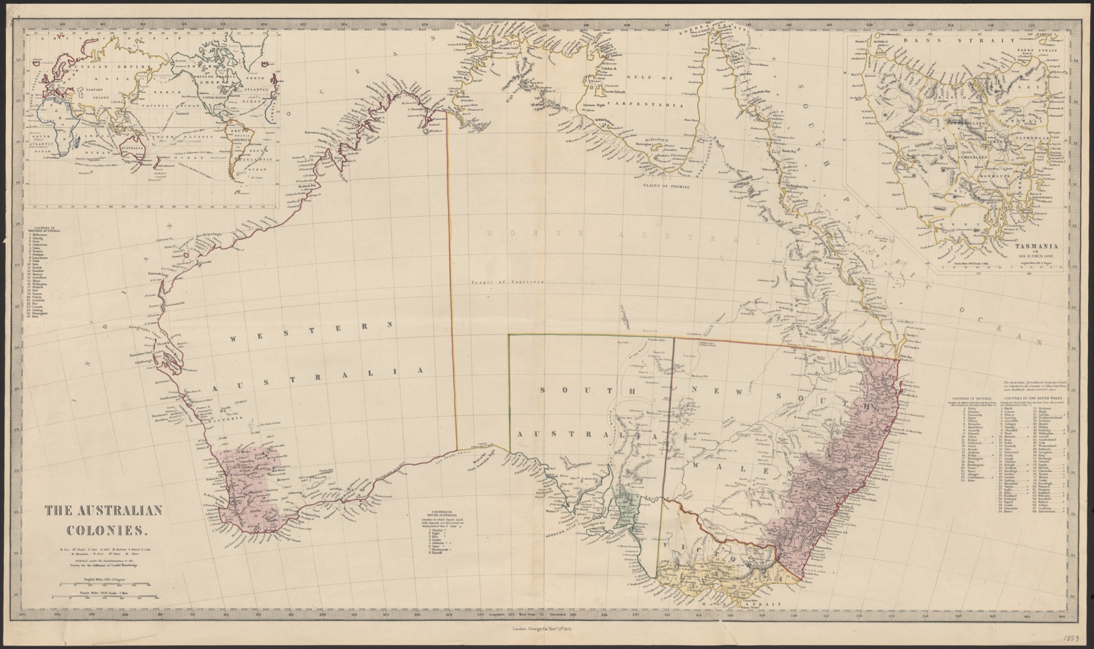
‘The Australian colonies’ by Superintendence of the Society for the Diffusion of Useful Knowledge courtesy of National Library of Australia and is in the Public Domain.
The shaded areas represent the counties in each state, which are listed by number and name.

Source 11
Figure 5 – The Australian Colonies, 1853
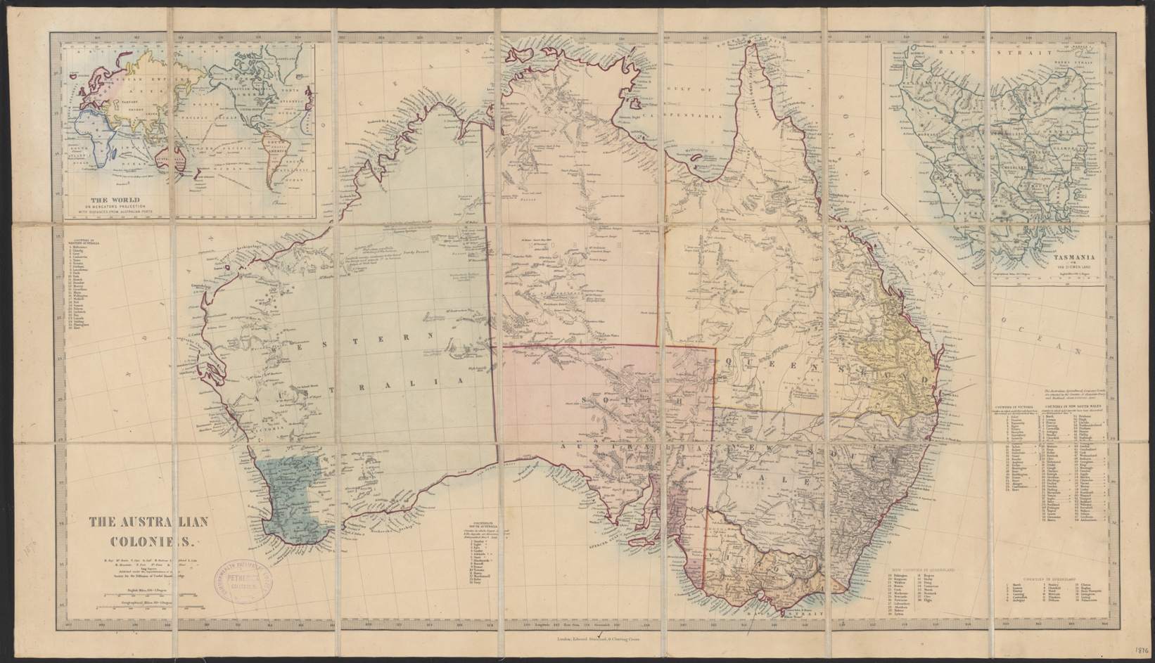
‘The Australian colonies’ by Superintendence of the Society for the Diffusion of Useful Knowledge courtesy of National Library of Australia and is in the Public Domain.

Historical inquiry step 4 – evaluate
Guide the students in evaluating the reliability of the sources: What is the reliability of historic maps as sources? What is the authority of the makers? Do the inquiry questions need to be redesigned as a result of analysing and evaluating the sources?

Historical inquiry step 5 – communicate
Report on the spread of the colony
In role as the Surveyor General of NSW, in either 1858 or 1876, students write a short progress report to London outlining the progress and pattern of settlement in the eastern part of Australia, since the 1830s. The report should make reference to the maps and identify the influencing factors and their effects on the spread of settlement and provide some future predictions.

Reflection
Students reflect on the historical inquiry process, reflecting on what they learned, how they learned it and what else they would like to find out.

Inquiry 3 – impacts of settlement
Through a semi-guided inquiry, students investigate the impacts of the spread of European settlement on Aboriginal people and the environment. They identify the points of view of the British settlers and Aboriginal people in order to understand causes and effects and to identify relationships between the 2 groups.
Note: deeper investigation into the impacts of one development or event will be investigated in the history teaching and learning framework: Colonial development.

Stimulus
Students examine Source 12. In groups, they create a graffiti board of their first responses, reactions and questions in relation to the painting.

Source 12
Figure 6 – cleared land at the Government Agricultural Establishment Castle Hill, 1806
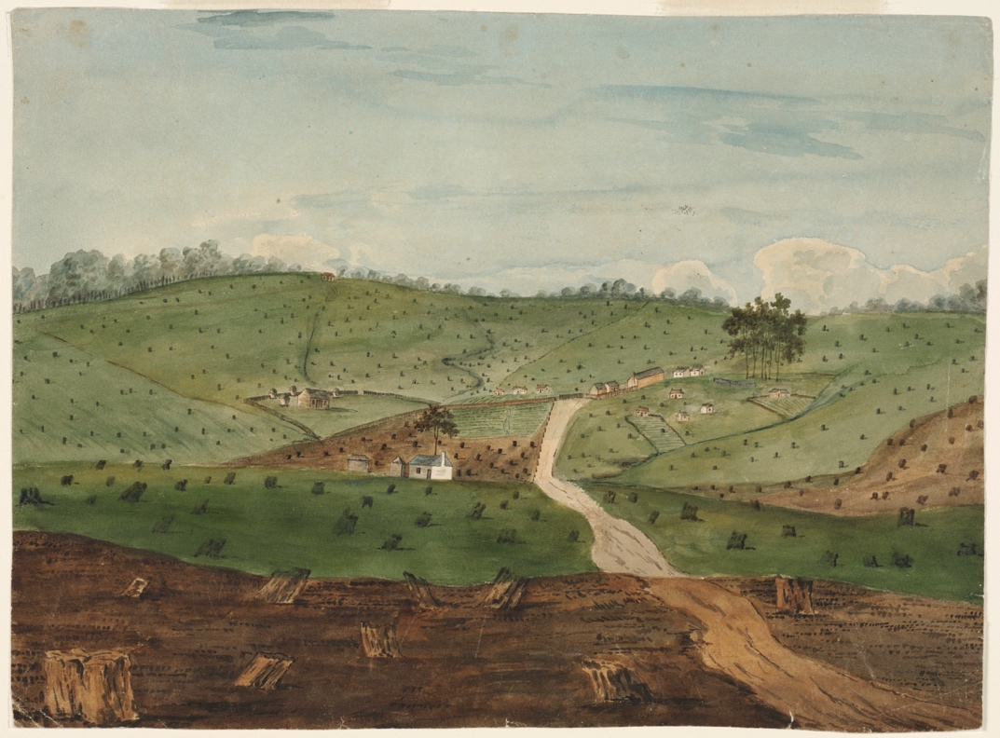
‘Unsigned watercolour 1793-1850. Additional note on reverse: `now call Dural 1875'. Collection of sketches’ by J W Lewin, P P King, P G King and others, courtesy of Mitchell Library, State Library of New South Wales and is in the Public Domain.

Historical inquiry step 1 – question
With reference to their graffiti boards, students formulate a set of inquiry questions.
Sample questions
- How did settlement change the environment?
- How were biodiversity and waterways impacted by environmental changes?
- What was the impact of European settlement on local Aboriginal people?
- What were the relationships between Aboriginal peoples and the British?
Note: inquiry questions may need to be redesigned through the historical inquiry process.

Historical inquiry steps 2 and 3 – research and analyse
Environmental changes and impacts
Students examine and read Sources 12, 13 and 14. With a partner, they analyse and discuss the sources using source analysis questions and then complete Table 4. Suggested questions:
- Observe and read – what are the natural features of the environment?
- Observe and read – what are the human changes to the environment?
- Think – what do the sources provide evidence of?
- Infer – why have people changed the environments?
- Infer – how would biodiversity and waterways be impacted by the environmental changes?
- Infer – how would Aboriginal people be impacted by the environmental changes?

Source 13
Figure 7 – Waugh-hope, the house of Mr J M Waugh, at Jamberoo, near Kiama, NSW, 1840-1845
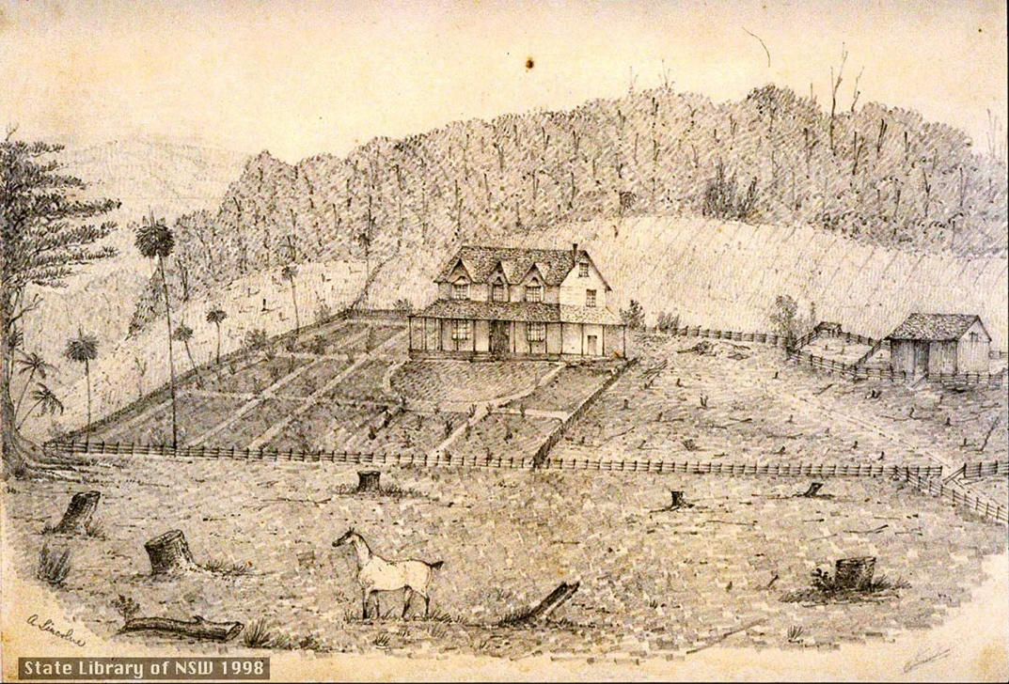
‘Waugh-hope / Jamberoo – Illawarra’ by Abraham Lincolne, courtesy of State Library of NSW and is in the Public Domain.
Illustrator, Abraham Lincolne, recorded settlements and views of the Illawarra. He was a farmer, stock agent, writer and sketcher, renting Fig Tree Farm in the Illawarra until it was ruined by floods.

Source 14
Trove (n.d) Article reporting the effects of rain on agricultural lands in Bathurst, the Hawkesbury and the Hunter. Published in The Australian, Friday 26 November 1830, page 3
The heavy rains have done extensive damage to the forward wheat crops; whole fields of which are laid or have been swept away by alluviations of the creeks and rivers. In the Bathurst country, the rain a couple of weeks back had rather done good than harm, and the settlers thereabouts who have been paying 12s per bushel for their wheat lately, anticipate abundant crops. Along the Hawkesbury, settlers who cultivated the lowlands have of course felt the consequences by this time. The inundations will fertilise their lands no doubt, but 'while the grass grows the steed starves.'
Others have suffered more or less through their own carelessness. At Hunter's river where farms were badly ploughed, and where the seed was little else than scratched into the ground, rust has appeared extensively, – whole acres flattering to the eye, crumbling to dust under the fingers. The tobacco grounds have also been over-saturated.
Table 4 – impacts of settlement on the environment
Source and date | Evidence of change | Immediate impacts | Longer term consequences | Reliability of source
12: Watercolour, 1806
13: Sketch, 1840-45
14: News article, 1830
Impacts of settlement on Aboriginal people
View Sources 15 and 16. During a second viewing, note the viewpoints of Aboriginal people and of the British settlers. Identify their actions influenced by their viewpoints. Discuss the effects of the spread of settlement on Aboriginal peoples, using a concept map to record impacts.
With reference to the concept map and Sources 15 and 16, students complete Table 4 and Table 5.

Source 15
ABC Education (21 January 2022) Interactions between Europeans and Aboriginal Tasmanians (3:24)

Source 16
ABC Education (21 January 2022) Impact of European settlement on Aboriginal Tasmanians (2:38)
Table 5 – responses of Aboriginal peoples to British settlement
Aboriginal peoples’ views of colonists | Actions | Effects on Aboriginal people | How I know
Table 6 – responses of British settlers when occupying Aboriginal lands
British peoples’ views of Aboriginal people | Actions | Effects of Aboriginal people | How I know
Relationships between Aboriginal people and the British
Collectively analyse some of the key events listed between 1813 and 1890 in Source 17 that clearly provide evidence of the relationship between Aboriginal people and the British. Identify the relationship between Aboriginal people and the British exemplified in the event.
With reference to Table 6 and Source 17, generate a list of words that describe the views of the British to Aboriginal people, and the views of Aboriginal people to the British. Discuss how points of view impacts on relationships between groups of people.

Source 17
Australian Museum (2020) Aboriginal & Torres Strait Islander collection timeline – 1500 to 1900

Historical inquiry step 4 – evaluate
Guide the students in evaluating the reliability of the sources. What primary sources did the secondary sources draw on? Do the inquiry questions need to be redesigned as a result of analysing and evaluating sources?

Historical inquiry step 5 – communicate
Perspectives and empathy
In role as an Aboriginal person impacted by the colonists, students create a response to communicate the impacts of settlement. This could be a poem, prose, recorded monologue, annotated illustration or other communication product.

Reflection
Students reflect on the historical inquiry process, reflecting on what they learned, how they learned it and what else they would like to find out.

Inquiry 4 – daily colonial life
Through an independent inquiry, students investigate the daily life of 2 very different groups of people in colonial Australia. Students select and use secondary and primary sources to locate information and evidence that tells the story of aspects of daily life of their chosen groups. Through the eyes of individuals from their groups, students communicate their story.

Stimulus
Students listen to and think about the words of the folksong, Moreton Bay, in Source 18, viewing one of the verses in Source 19.
Discuss the story told by the ballad, asking source analysis questions such as:
- Where is the narrator’s home country and who did he leave behind?
- In what Australian penal establishments has the narrator served time?
- What does the ballad tell us about the daily life of a convict?

Source 18
MartinGlobalPictures (14 October 2009) Moreton Bay – Convict Australia (3:35)

Source 19
Australian Folk Songs (n.d) Verse from Moreton Bay folk song
Captain Logan was the commander of the Moreton Bay Penal Settlement in Queensland between 1826 and 1830 and was known and hated for his harsh ways. He was killed in 1830 by Aboriginal people whilst surveying the upper parts of the Brisbane River.
For three long years I was beastly treated
And heavy irons on my legs I wore
My back from flogging was lacerated
And oft times painted with my crimson gore
And many a man from downright starvation
Lies mouldering now underneath the clay
And Captain Logan he had us mangled
All at the triangles of Moreton Bay

Historical inquiry step 1 – question
Students formulate their own set of inquiry questions.
Note: inquiry questions may need to be redesigned through the historical inquiry process.

Historical inquiry steps 2 to 5 – research, analyse, evaluate, communicate
Independent research task
Working in pairs, in jigsaw style, students undertake an independent inquiry into what daily life was like for 2 different types of colonial inhabitants. Students:
- select 2 different groups of people, as per the list below
- formulate one or two inquiry questions
- locate one secondary source and 3 primary sources for each group selected that provides information or evidence on clothing, diet, leisure, paid and unpaid work, language, housing and other aspects of daily life
- summarise key information from the secondary source
- identify evidence in the primary sources that verifies, enhances or illustrates information in the secondary source
- organise key information and evidence in a source analysis table, as per Table 7
- communicate their story in a creative or dramatic manner, through the eyes of a representative of each group, demonstrating empathy and understanding.
Suggestions of groups for investigation
- European family and a specific Aboriginal or Torres Strait Islander language group
- Convicts and a free settlers
- Children of an aristocrat and an orphan children
- Officers and servants
- Governors’ wives and convict female factory women
- South Sea Islander indentured workers and sugar cane plantation owners
- Chinese immigrant miners and British prospectors
- Afghan immigrant cameleers and British explorers.
Table 7 – Source analysis table
Title | Creator and date | Reliability, bias | Key information | Questions raised
The Voyage game (optional)

Source 20
Australian National Maritime Museum (2023) The Voyage Game
Can you keep the convicts alive?
The year is 1830. You're the Surgeon Superintendent aboard a convict vessel transporting its human cargo from Britain to the far reaches of the known world – Van Diemen’s Land. You're charged with delivering several hundred convicts to the colony in the shortest time with minimum loss of life. This is the way to make money and further your reputation and position. Are you up to the task?
The Voyage is an online game based on real convict voyages. Players make decisions, solve problems and deal with conflicts on a perilous journey across the globe.
As an optional activity, or for students needing an alternative activity, students play The Voyage Game in Source 20. After playing, they verbally explain their key understandings of the daily life of a shipboard convict, and as an officer, aboard a convict ship travelling to Tasmania during the 1830s.

Historical inquiry step 4 – evaluate
During their research, students analyse sources for usefulness and evaluate them for reliability. Do the inquiry questions need to be redesigned as a result of analysing and evaluating sources?

Historical inquiry step 5 – communicate
Presentation
In pairs, students communicate stories of both people in a creative or dramatic manner, demonstrating empathy and understanding, and making reference to primary sources.
Students present their peoples’ stories to the class or a greater audience. This could be in person through performance, a ‘colonial lives’ expo, gallery of cartoons or artworks, video clips of re-created scenarios, or through other uses of technology.

Reflection
Students reflect on the historical inquiry process, reflecting on what they learned, how they learned it and what else they would like to find out.

Resources
Books
- The Story of Rosy Dock by Jeannie Baker (1995) – PRC 3–4
- Mustara by Rosanne Hawke and Robert Ingpen (2006) – PRC 3–4
- Lost: a True Tale from the Bush by Stephanie Owen Reader (2009) – PRC 3–4
- The Dog on the Tuckerbox by Corinne Fenton and Peter Gouldthorpe (2008) – PRC 5–6
- Waltzing Matilda by A.B. Paterson, John Williamson and Freya Blackwood (2007) – PRC 5–6
- William Bligh: A Stormy Story of Tempestuous Times by Michael Sedunary and Bern Emmerichs (2016) – PRC 5-6
- My Place by Nadia Wheatley and Donna Rawlins (1987) –PRC 5–6
Websites
Inquiry 1
- Education Services Australia (n.d) Australia in the 1820s: Penal settlements
- State Library of New South Wales (2024) The convict experience
- Libraries Tasmania (n.d) Convicts in Van Diemen’s Land, now Tasmania
Inquiry 2
- State Library of New South Wales (2024) Crossing the Blue Mountains
- Bureau of Infrastructure, Transport and Regional Economics (BITRE) (2014) The evolution of Australian towns, Report 136
Inquiry 3
- National Library of Australia (n.d) Frontier Conflict: First Australians Resistance to Colonial Expansion
- Sydney Barani (2013) Aboriginal people and place
Inquiry 4
- Museum of Australian Democracy (n.d) What was life like in New South Wales in the late 1800s?
- Australian National Maritime Museum (n.d) The Voyage Game: Classroom Activities
- ABC Education (2022) Outback House: 1860s Colonial life
- Education Services Australia (n.d) Decade Timeline 1878–before time
- University of NSW (2023) Indigenous Terminology
Digital collections
- Trove
- State Library of NSW
- State Records of NSW

References
This resource contains NSW Curriculum and syllabus content. The NSW Curriculum is developed by the NSW Education Standards Authority. This content is prepared by NESA for and on behalf of the Crown in right of the State of New South Wales. The material is protected by Crown copyright.
Please refer to the NESA Copyright Disclaimer for more information https://educationstandards.nsw.edu.au/wps/portal/nesa/mini-footer/copyright.
NESA holds the only official and up-to-date versions of the NSW Curriculum and syllabus documents. Please visit the NSW Education Standards Authority (NESA) website https://educationstandards.nsw.edu.au/wps/portal/nesa/home and the NSW Curriculum website https://curriculum.nsw.edu.au/.
History K–10 Syllabus © NSW Education Standards Authority (NESA) for and on behalf of the Crown in right of the State of New South Wales, 2012.

© State of New South Wales (Department of Education), 2024
The copyright material published in this resource is subject to the Copyright Act 1968 (Cth) and is owned by the NSW Department of Education or, where indicated, by a party other than the NSW Department of Education (third-party material).
Copyright material available in this resource and owned by the NSW Department of Education is licensed under a Creative Commons Attribution 4.0 International (CC BY 4.0) license.
This license allows you to share and adapt the material for any purpose, even commercially.
Attribution should be given to © State of New South Wales (Department of Education), 2024.
Material in this resource not available under a Creative Commons license:
- the NSW Department of Education logo, other logos and trademark-protected material
- material owned by a third party that has been reproduced with permission. You will need to obtain permission from the third party to reuse its material.
Links to third-party material and websites
Please note that the provided (reading/viewing material/list/links/texts) are a suggestion only and implies no endorsement, by the New South Wales Department of Education, of any author, publisher, or book title. School principals and teachers are best placed to assess the suitability of resources that would complement the curriculum and reflect the needs and interests of their students.
If you use the links provided in this document to access a third-party's website, you acknowledge that the terms of use, including licence terms set out on the third-party's website apply to the use which may be made of the materials on that third-party website or where permitted by the Copyright Act 1968 (Cth). The department accepts no responsibility for content on third-party websites.

