History Stage 3
Significant Australians

Contents
Topic – Australia as a nation 3
Key inquiry question 3
Overview 3
Outcomes 3
Content 3
Historical inquiry skills 4
Selected historical concepts 5
Assessment 5
Vocabulary 5
Teaching and learning activities 6
Inquiry 1 – guided inquiry into David Unaipon 6
Stimulus 6
Historical inquiry step 1 – question 7
Historical inquiry step 2 – research 7
Historical inquiry step 3 – analyse 10
Historical inquiry step 4 – evaluate 11
Historical inquiry step 5 – communicate 11
Reflection 12
Inquiry 2 – student-led inquiry on a significant Australian 12
Historical inquiry step 1 – question 12
Historical inquiry step 2 – research 12
Historical inquiry step 3 – analyse 13
Historical inquiry step 4 – evaluate 14
Historical inquiry step 5 – communicate 14
Reflection 14
Resources 15
References 16

Topic – Australia as a nation
Duration: 3 weeks – 90 minutes per week

Key inquiry question
- What contribution have significant individuals and groups made to the development of Australian society?

Overview
Inquiry 1 is a guided inquiry into Aboriginal inventor, writer, musician, preacher and spokesman, Robert Unaipon, who is remembered on Australia’s fifty-dollar note. Inquiry 2 is an independent inquiry into an individual or group who has made a significant contribution to Australia. If students are competent in the historical inquiry process, Inquiry 1 can be omitted.

Outcomes
A student:
- HT3-3 identifies change and continuity and describes the causes and effects of change on Australian society
- HT3-5 applies a variety of skills of historical inquiry and communication.
Outcomes and other syllabus material referenced in this document are from History K–10 Syllabus © NSW Education Standards Authority (NESA) for and on behalf of the Crown in right of the State of New South Wales, 2012.

Content
The contribution of individuals and groups, including Aboriginal people and/or Torres Strait Islanders and migrants, to the development of Australian society, for example in areas such as the economy, education, sciences, the arts, sport (ACHHK116)
Students:
- using a range of sources, research and describe the contribution of Aboriginal and Torres Strait Islander peoples and other groups to Australian society

Historical inquiry skills
- Comprehension: chronology, terms and concepts
- respond, read and write to show understanding of historical matters
- sequence historical people and events (ACHHS098, ACHHS117)
- use historical terms and concepts (ACHHS099, ACHHS118)
- Analysis and use of sources
- locate information relevant to inquiry questions in a range of sources (ACHHS102, ACHHS121)
- compare information from a range of sources (ACHHS103, ACHHS122)
- Perspectives and interpretations
- identify different points of view in the past and present (ACHHS104, ACHHS123)
- Empathetic understanding
- explain why the behaviour and attitudes of people from the past may differ from today
- Research
- identify and pose questions to inform an historical inquiry (ACHHS100, ACHHS119)
- identify and locate a range of relevant sources to support an historical inquiry (ACHHS101, ACHHS120)
- Explanation and communication
- develop historical texts, particularly narratives and descriptions, which incorporate source material (ACHHS105, ACHHS124)
- use a range of communication forms (oral, written, graphic) and digital technologies. (ACHHS106, ACHHS125)

Selected historical concepts
- Continuity and change: some things change over time and others remain the same, for example, aspects of both continuity and change in Australian society throughout the twentieth century.
- Cause and effect: events, decisions or developments in the past that produce later actions, results or effects, for example, events and other reasons that led to migration to Australia; reasons for the struggle for rights and freedoms for various groups in Australia.
- Perspectives: people from the past will have different views and experiences, for example, differing attitudes of various groups to Federation or to granting rights and freedoms to women and Aboriginal peoples.
- Empathetic understanding: an understanding of another's point of view, way of life and decisions made in a different time, for example, differing attitudes and experiences of living in an Australian colony; understanding the experiences of Aboriginal and Torres Strait Islanders, women and migrants throughout the twentieth century.
- Significance: the importance of an event, development or individual/group, for example, determining the importance (significance) of various peoples' contributions to the development of a colony.

Assessment
All activities require students to demonstrate their learning. All are assessment for learning activities.

Vocabulary
- Investigate, locate, examine, observe, interview, infer, summarise, record, primary source, secondary source, reliable, evidence, perspective, reproduce, recreate, role play, historical narrative
- Role, occupation, contribution, significance, influence, motivation, action, colony, challenge, criticism, success, legacy, remember, commemorate

Teaching and learning activities
This learning sequence comprises 2 inquiries.

Inquiry 1 – guided inquiry into David Unaipon
Students investigate the contribution of David Unaipon to Australia. They write his biography and explain his contribution to Australia.
Note: if students are competent in the historical inquiry process, Inquiry 1 can be omitted, or used for students who need an inquiry scaffold. David Unaipon has been selected as he is remembered on Australia’s $50 note. An alternative person or group can be investigated.

Stimulus
Collectively examine Source 1. Students make inferences about the significance of the diagrams and text associated with the image. They make inferences on the contributions of David Unaipon to Australia.

Source 1
Figure 1 – Image of David Unaipon on the Australian $50 note
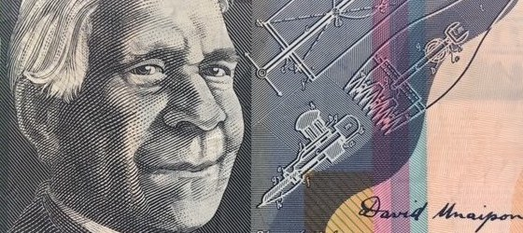
Note: Image meets the Reserve Bank of Australia copying guidelines

Historical inquiry step 1 – question
With reference to the students’ inferences, formulate a set of inquiry questions relating to the significance of David Unaipon to Australia.
Sample questions
- Who is David Unaipon?
- Where and when was he born and raised?
- What were his occupations and interests?
- How has David Unaipon contributed to Australia?
- Why is David Unaipon a significant person?
- What is his legacy and how is he remembered?
Note: inquiry questions may need to be redesigned through the historical inquiry process.

Historical inquiry step 2 – research
Biography of David Unaipon
Students use Sources 2 to 6 to develop a biography of David Unaipon. They organise their information in the source analysis table in Table 1.

Source 2
State Library of South Australia (2023) Biography of David Unaipon
Author, inventor, preacher
Extract: Unaipon grew up at Raukkan (then the Point McLeay Mission) on Lake Alexandrina, south east of Adelaide. His father was one of the first Aboriginal converts at the Point McLeay Mission, so Unaipon was educated at the mission school but he also learned traditional stories and skills...... From a young age Unaipon was a keen student, particularly interested in science, literature and music. He became an excellent organist. Unaipon began to experiment with perpetual motion, ballistics and other areas of physics. In 1909 he patented a design for modified mechanical shears for sheep-shearing and between then and 1944 he lodged nine more applications for patents for other inventions. Many of his ideas and designs were ahead of their time, including the design of a helicopter based on the motion of a boomerang...

Source 3
Figure 2 – Patent specification for mechanical sheep sheers developed by David Unaipon, 1909
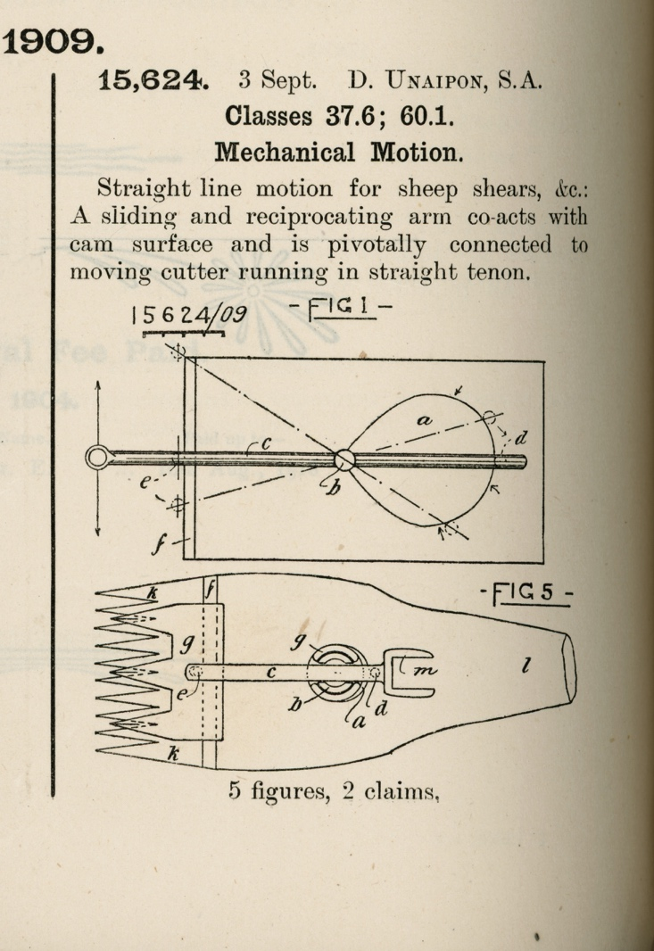
‘Patent specification. Mechanical motion. Sheep shears. No. 15,624, 1909’ by David Unaipon, courtesy of State Library of South Australia and is in the Public Domain.

Source 4
Trove (n.d) Extract from ‘Mr David Unaipon visiting Singleton: Brilliant Aboriginal student and inventor’, Singleton Argus, 4 September 1939, page 3
He is a man of wide accomplishments, being recognised as one of Australia's leading anthropologists, having written more than one work on this subject. His opinion is constantly sought by the authorities of Adelaide University on this subject. His attainments, however, are not limited to this study.
David Unaipon is a man of recognised and genuine scientific attainments. It was he who discovered unilateral motion and the method of applying it. It will come as a surprise to the people of this district to know that their shearing machines are dependent upon this discovery. Without Mr Unaipon's work, the modern shearing machine would not be possible.
Nor is that the limit to which he has gone in the field of invention. A discovery of interest is a method he has perfected for causing an aeroplane to rise straight up from the ground, or to remain stationary in the air. Because he fears its possible misuse in war, he will not make this available for use.
Mr Unaipon is a brilliant and charming speaker. Recently, when in Sydney, it became known that he was preaching at St. Andrew's Cathedral, the A.B.C., at the last minute, suspended part of its normal programme especially to broadcast his address.

Source 5
State Library of New South Wales (n.d) Transcript from the handwritten preface to David Unaipon’s book, ‘The legendary tales of the Australian Aborigines’, written in 1924 to 1925
The image from the fifty-dollar note is a reproduction of the last paragraph of the preface, in David Unaipon’s handwriting.
My race - the Aborigines of Australia - has a vast tradition of legends, myths and folk-law stories. These, which they delight in telling to the younger members of the tribe, have been handed down orally for thousands of years. In fact, all tribal law and customs are, first of all, told to the children of the tribe in the form of stories, just as the white Australian mother first instructs her children with nursery stories: Of course the mothers and the old men, in telling these stories, drag them out to a great length, putting in every detail, with much gesture and acting, but in writing them down for our white friends I have used the simplest form of expression, in order that neither the meaning nor the "atmosphere" may be lost.
As a full-blooded member of my race, I think I may claim to be the first - but, I hope not the last - to produce an enduring record of our customs, beliefs and imaginings.
David Unaipon
Figure 3 – close up of text on $50 note
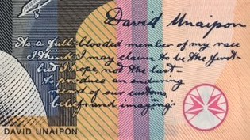
Note: image from fifty-dollar note meets the Reserve Bank of Australia copying guidelines
The handwritten preface can be viewed in the original volume of The legendary tales of the Australian Aborigines by David Unaipon (1924-1925), courtesy of Mitchell Library, State Library of NSW.

Source 6
State Library of New South Wales (n.d) Additional primary sources in the biography planner: Significant individuals: David Unaipon
Table 1 – source analysis table
Source number | Title and date | Who created it and why? | Key information | What it provides evidence of | Questions raised

Historical inquiry step 3 – analyse
Students analyse their information in Table 1 to answer the inquiry questions and create a biography of David Unaipon. They organise their information in Table 2.
Table 2 – biography of David Unaipon
Category | Key information | Evidence in sources
Name
Date of birth and death
Place of birth and death
Occupation and role
Works and inventions
Contribution to Australia
Significance to Australia
Challenges
Legacy
Commemoration

Historical inquiry step 4 – evaluate
Review the evaluations of the reliability of the sources in Table 2 and Table 3. Are there inconsistencies or contradictions between the sources? Do the inquiry questions need to be redesigned as a result of analysing and evaluating sources?

Historical inquiry step 5 – communicate
What’s on the fifty-dollar note?
On an enlarged image of a $50 note, students label and annotate the significance and meaning of the images and text around the portrait of David Unaipon, explaining his contributions to Australia.

Reflection
Students reflect on the historical inquiry process, reflecting on what they learned, how they learned it and what else they would like to find out.

Inquiry 2 – student-led inquiry on a significant Australian
Students undertake a student-led inquiry into a significant individual or group who made a notable contribution to Australia. They communicate through designing and annotating a new Australian monetary note that draws on primary sources, presented briefly as a PechaKucha.
Note: the student inquiry is intended to be a short research task. It could be undertaken concurrently with the guided class inquiry, or instead of the guided class inquiry.

Historical inquiry step 1 – question
Students select a notable colonial and formulate a set of inquiry questions.
Sample questions
- Who is the person or group?
- Where and when was the person born and raised?
- What were the person’s occupation and interests?
- How has the person contributed to Australia?
- Why is the person significant to Australia?
- What is the person’s legacy and how is he or she remembered?

Historical inquiry step 2 – research
Students locate and use secondary and primary sources. They use source analysis skills to interrogate the sources. Students use Table 3 to organise their information from the sources. Sources could include newspaper articles sourced through Trove, paintings, photographs and biographies.
Table 3 – source analysis table
Source number | Title and date | Who created it and why | Key information | What it provides evidence of | Questions raised

Historical inquiry step 3 – analyse
Table 4 – biography of a significant Australian
Category | Key information | Evidence in sources
Name
Date of birth and death
Place of birth and death
Occupation and role
Works and achievements
Contribution to Australia
Significance to Australia
Challenges
Legacy
Commemoration

Historical inquiry step 4 – evaluate
During research and analysis, students evaluate the reliability of the sources. Are there inconsistencies or contradictions between the sources? Do the inquiry questions need to be redesigned as a result of analysing and evaluating sources?

Historical inquiry step 5 – communicate
Design for a new note
Students create a visual representation of their significant Australian suitable for featuring on a new Australian $75 dollar note. The image should show a portrait of the person and make reference to primary sources that show aspects of the person’s life and achievements. Students label and explain the features of their design and provide justification as to why their person should be the one included on the new note. Designs are presented to the class as a Pecha Kucha (for example, 20 slides for 20 seconds speaking time each)

Reflection
Students reflect on the historical inquiry process, reflecting on what they learned, how they learned it and what else they would like to find out.

Resources
Books
- Tea and sugar Christmas by Jane Jolly and Robert Ingpen (2014) – PRC K-2
- Meet the flying doctors by George Ivanoff and Ben Wood (2016) – PRC 3-4
Teacher resource
- State of New South Wales (Department of Education) (2023) Guide to picture books in History K-10
Digital collections
- National Archives Australia
- Trove
- State Archives and Records of NSW

References
This resource contains NSW Curriculum and syllabus content. The NSW Curriculum is developed by the NSW Education Standards Authority. This content is prepared by NESA for and on behalf of the Crown in right of the State of New South Wales. The material is protected by Crown copyright.
Please refer to the NESA Copyright Disclaimer for more information https://educationstandards.nsw.edu.au/wps/portal/nesa/mini-footer/copyright.
NESA holds the only official and up-to-date versions of the NSW Curriculum and syllabus documents. Please visit the NSW Education Standards Authority (NESA) website https://educationstandards.nsw.edu.au/wps/portal/nesa/home and the NSW Curriculum website https://curriculum.nsw.edu.au/.
History K–10 Syllabus © NSW Education Standards Authority (NESA) for and on behalf of the Crown in right of the State of New South Wales, 2012.

© State of New South Wales (Department of Education), 2024
The copyright material published in this resource is subject to the Copyright Act 1968 (Cth) and is owned by the NSW Department of Education or, where indicated, by a party other than the NSW Department of Education (third-party material).
Copyright material available in this resource and owned by the NSW Department of Education is licensed under a Creative Commons Attribution 4.0 International (CC BY 4.0) license.
This license allows you to share and adapt the material for any purpose, even commercially.
Attribution should be given to © State of New South Wales (Department of Education), 2024.
Material in this resource not available under a Creative Commons license:
- the NSW Department of Education logo, other logos and trademark-protected material
- material owned by a third party that has been reproduced with permission. You will need to obtain permission from the third party to reuse its material.
Links to third-party material and websites
Please note that the provided (reading/viewing material/list/links/texts) are a suggestion only and implies no endorsement, by the New South Wales Department of Education, of any author, publisher, or book title. School principals and teachers are best placed to assess the suitability of resources that would complement the curriculum and reflect the needs and interests of their students.
If you use the links provided in this document to access a third-party's website, you acknowledge that the terms of use, including licence terms set out on the third-party's website apply to the use which may be made of the materials on that third-party website or where permitted by the Copyright Act 1968 (Cth). The department accepts no responsibility for content on third-party websites.

