What are places like?
HSIE geography Early Stage 1 student workbook
Name:
Class:

Overview
You will learn to identify the important features of the place you live in. You will learn to draw a map of this place and show the important things by drawing pictures.

Resources

Activity 1
- coloured pencils
- construction materials (optional)
- camera (optional)

Activity 2
- help from an adult
- a soft toy
- camera (optional)
- large piece of paper
- computer access (optional)

Activity 1
During this activity you will explore the features of the place you live.
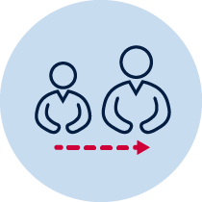Talk to an adult in your family about the changes they have seen happen to the home or the street you live in. Ask them why they think those changes might have happened.
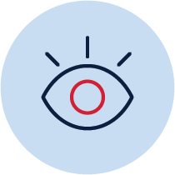Choose a window in your home. Look out the window in the morning and the evening and look at what you can see. Draw a picture of what you see in the morning and the evening. You could also take photos of what you see. Describe any changes you saw between the morning and the evening.
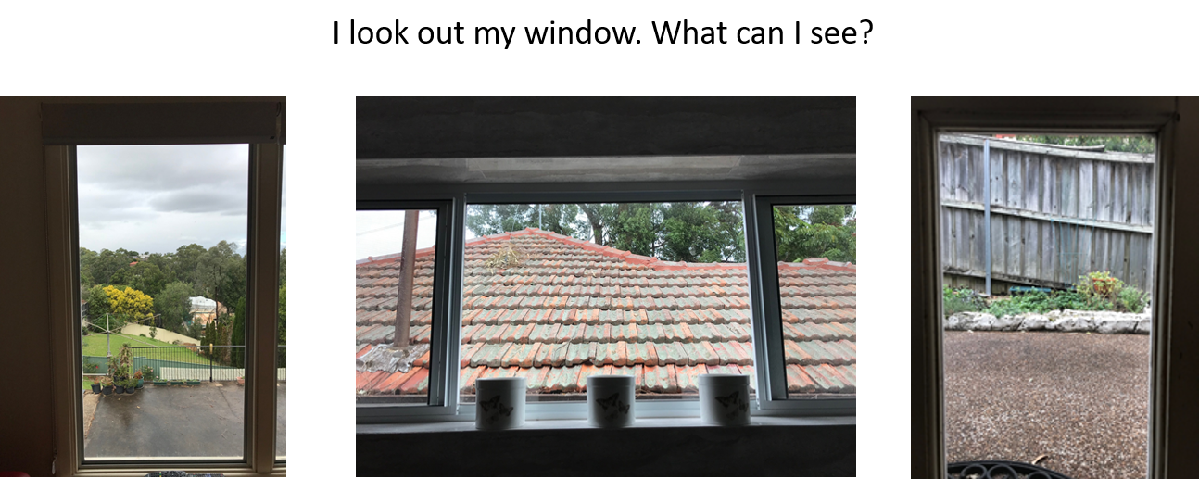
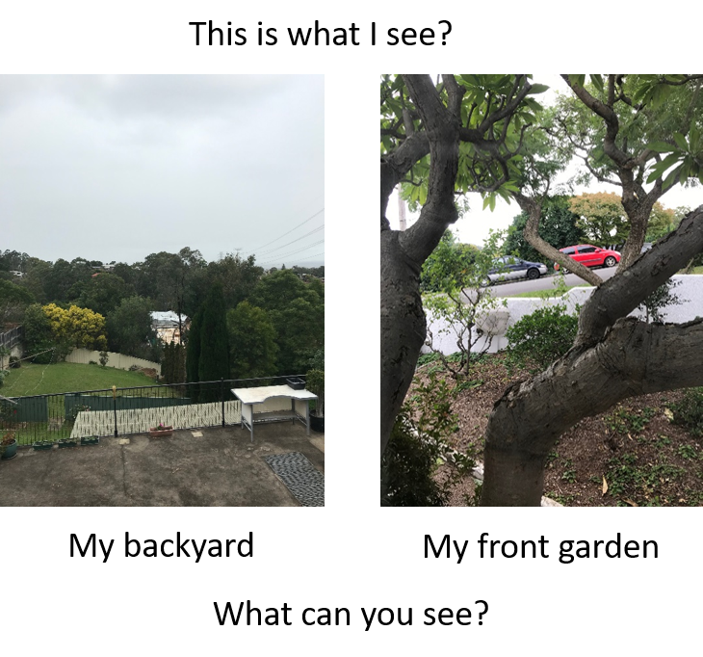
OR
Stand at the front of your home in the morning and the evening and observe what you can see in your street.
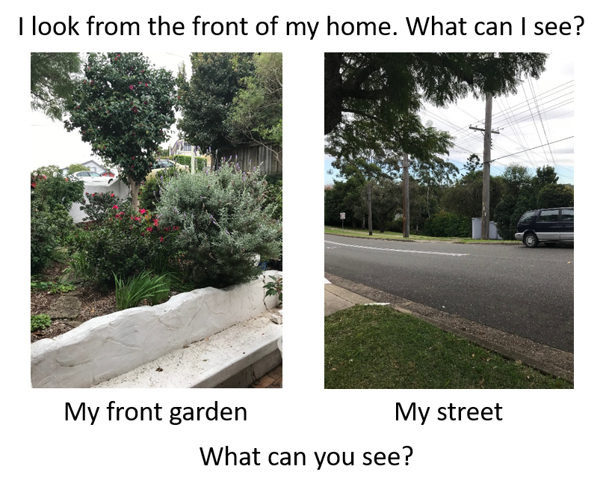
Draw what you see out the window or at the front of your house.
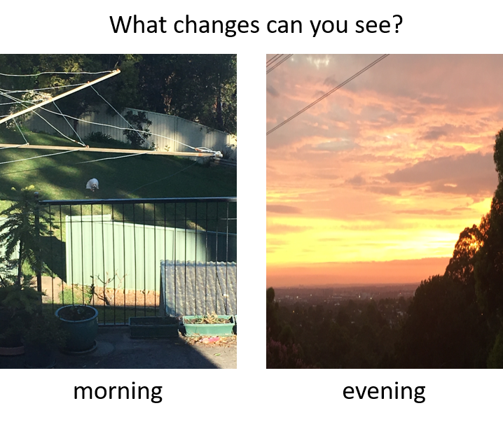
Tell a family member the changes you see. Write a sentence together.
I saw __________________________________________________________________
_______________________________________________________________________
_______________________________________________________________________
Talk with an adult about the things you saw out the window or in the street. Circle the words of things you saw. Write some words of your own.
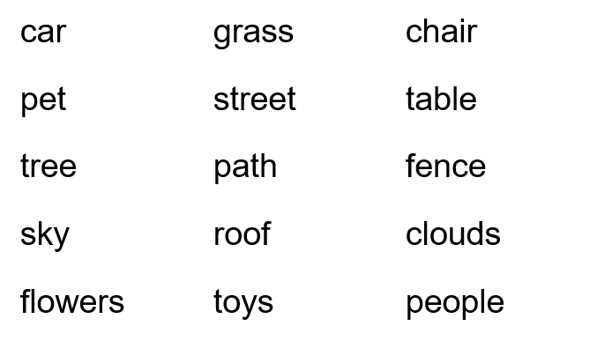
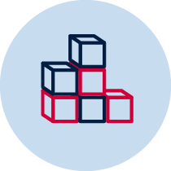Look out the window or go outside and stand at the front of your home again. Draw a picture and label the things you see. Or you can make a model of what you see. Use building blocks or recycled containers, such as boxes, plastic bottles and cardboard. Label the parts of your model, take a photo and add it to this workbook.

Activity 2
During this activity you will make a map of the place you live. You will use pictures on your map to show places and important things.
Imagine you are walking around your home, garden, a park near your home or up and down your street. Think about what you might see.
Now imagine you are a bird, or in a helicopter, flying over your home. Think about what you might see as you look down at the ground. Imagine if you flew over your whole street, or your school. What might you see?
Write your ideas.
If I walked around, I might see _______________________________________________________________________
________________________________________________________________________
If I flew over my home, I might see _______________________________________________________________________
________________________________________________________________________
Look at the photos of piglet. See how piglet looks different when you look at him from the front, the side and the top. A front view is called an eye-level view. Looking from the top is called a bird’s-eye view.
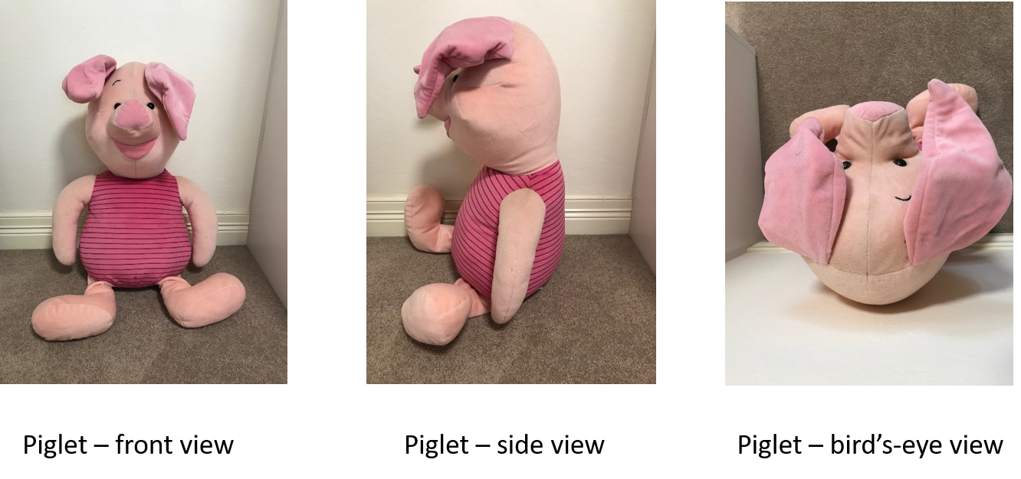
Look at the tiger toy. Do some parts of the toy seem to disappear in different views?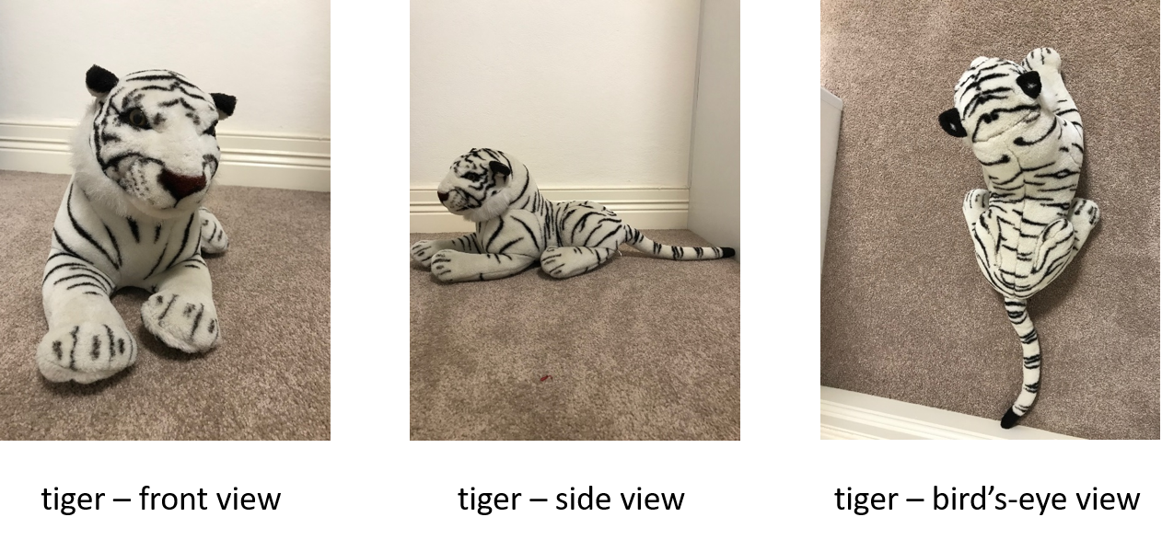
Can you see how the tail and back legs of the tiger disappear in the front view? You can only see three legs in the side view. In the bird’s-eye view the tiger’s face and some of the paws have disappeared!
Try this yourself.
Choose a soft toy. Stand it up against a wall and look at it from the front and the top.
Think about these questions.
- Does it look the same from both views?
- Does it look different?
- How is it different?
- Do some parts seem to disappear?

Draw or take photos of your toy.
Did you know that buildings, gardens and parks can also be seen from these two different views? Your drawing of the view through the window or at your front door was a front (eye-level) view. Look at the three shapes.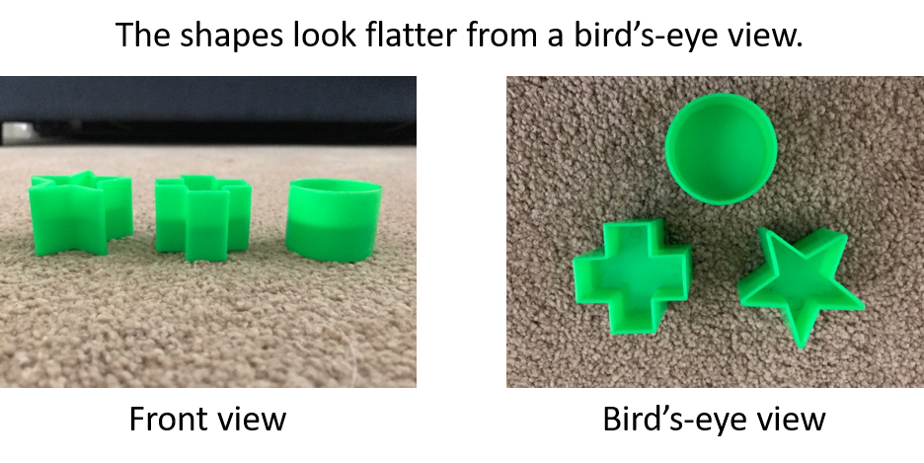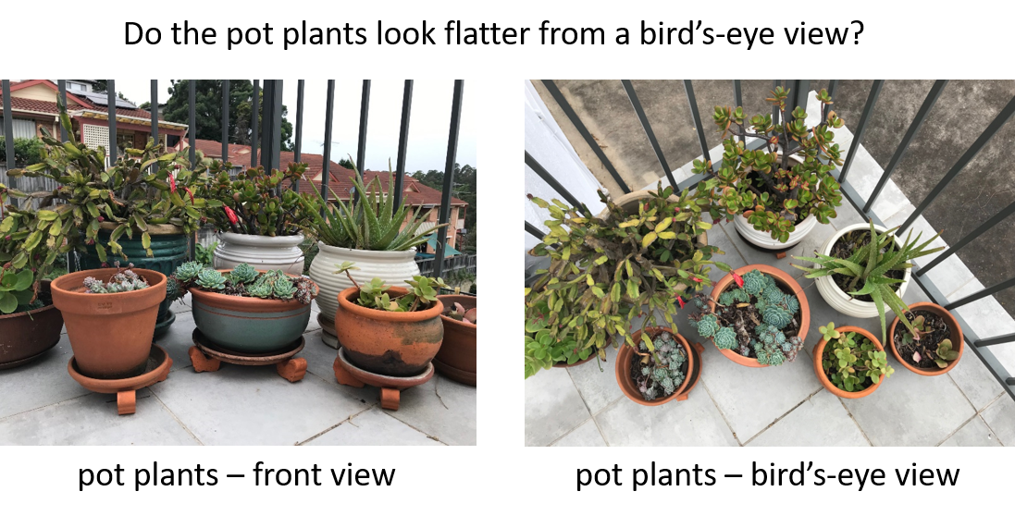
What is a map?
Maps help people find their way from one place to another place. Some maps are drawn or printed on paper. Some maps are drawn using a computer. Most maps show a bird’s-eye view of a place. Maps make places and objects look flat. Maps can use pictures to show objects in a place.
Look at the 2 maps. Can you see any pictures? Why do you think there are pictures on the maps?
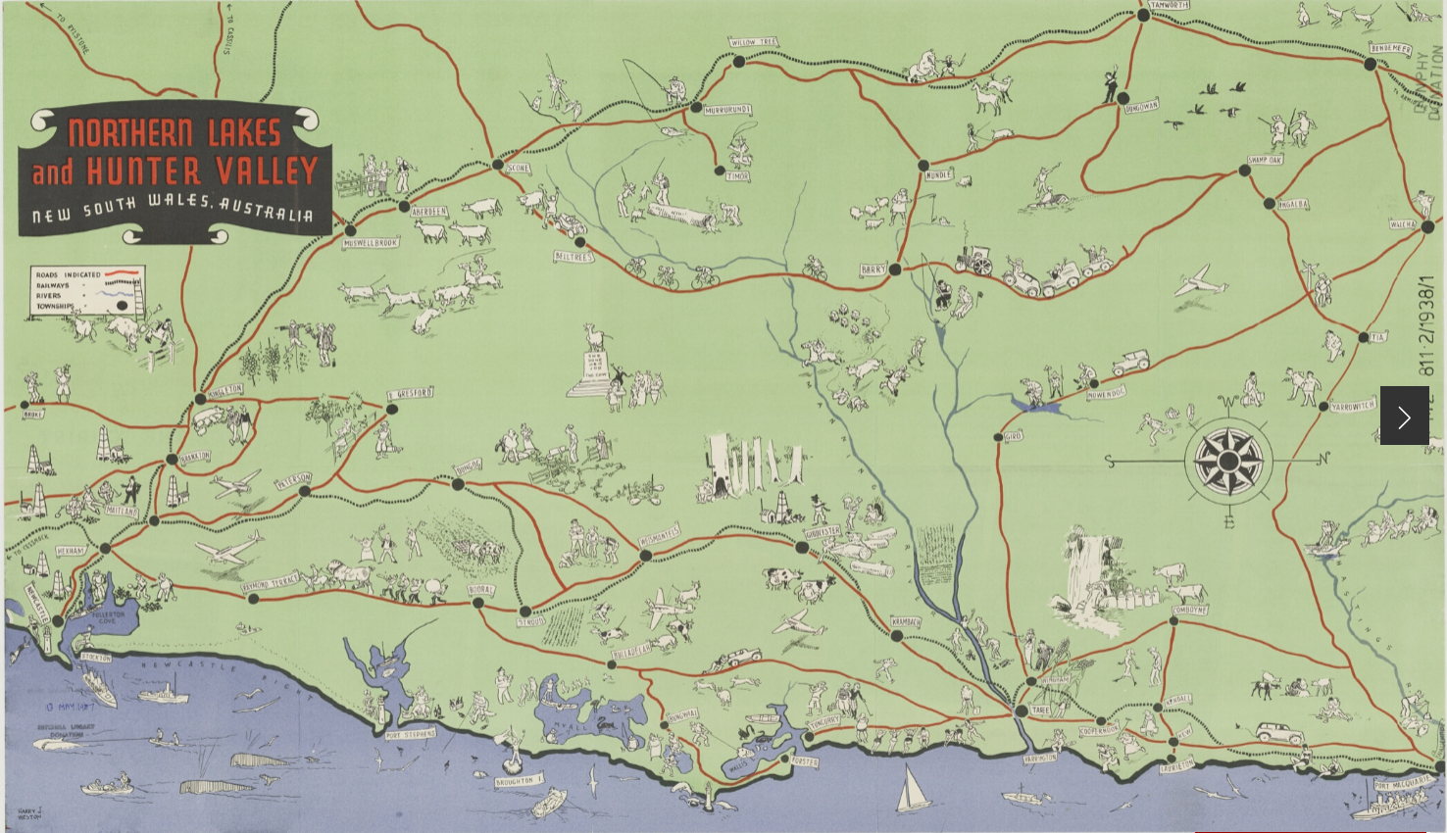
From the collection of the State Library of NSW, Creative Commons Attribution 4.0. (https://www.sl.nsw.gov.au/learning/locating-places-people-live-places/pictorial-maps)
Look at the map of Taronga Zoo, Sydney, NSW.
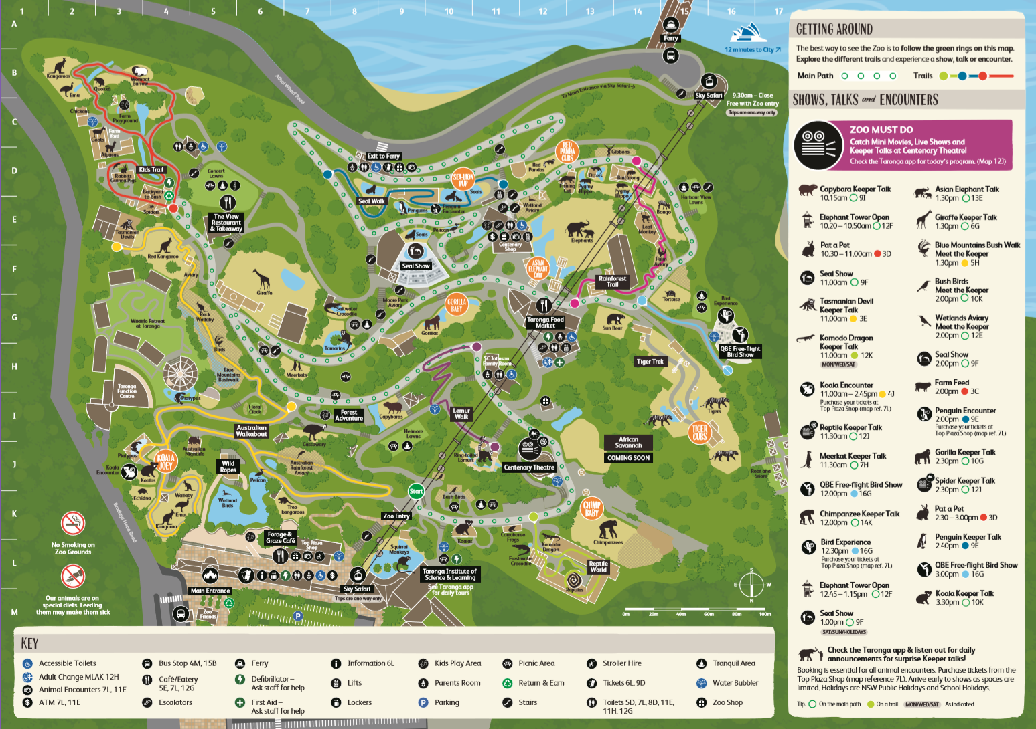from Taronga Conservation Society, Australia https://taronga.org.au/sydney-zoo
Can you see how the maps use pictures to represent places or important things?
If you have a map at your home, try and see how you can travel from one place to another. To use a map, you need to have instructions about how to get to a place. Instructions might tell you to walk along a street, turn left, walk over a bridge, through the park, turn right, walk along the street and you come to a shop.
You are going to make a map using pictures but first you need to choose the place the map will be about. It could be a map of your backyard, a park, your street or somewhere else you visit with your family. First you need to explore the place you will be drawing on your map.
Go on a walk with an adult.
You need to ask an adult to help you. Go for a walk together around the place you have chosen. You might be able to take photos of important places or things on your walk.
Think about these questions as you walk.
- What places do you see?
- What important things do you see?
- Are they near to each other or a long way apart?
- What instructions are you following as you go on your walk?
  - Are you walking straight?
  - Are you turning left, or right?
  - Do you have to climb up anything such as a hill or steps?
You are going to make a map of the places and important things you saw on your walk. Think about the pictures you might draw on your map. Try to remember if places or things are near each other or far away from each other. Label the places and things on your map. Make sure your map has a title to tell people the name of the place.
Some maps have labels in a separate list, some maps have labels on them pointing to the pictures. You choose how you want to label the pictures on your map. You will need a piece of paper and coloured pencils or you might like to try and draw your map using a computer. Your map might look like this map on a piece of paper or it might look like the map drawn using a computer.
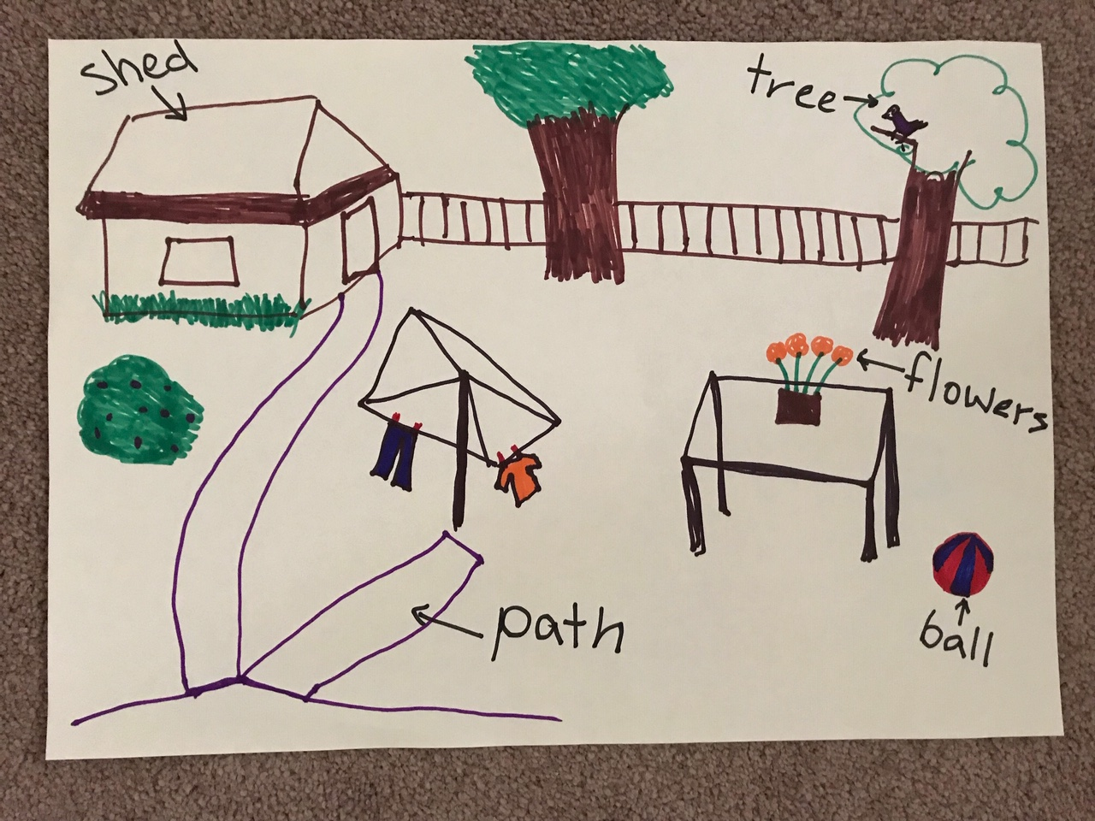
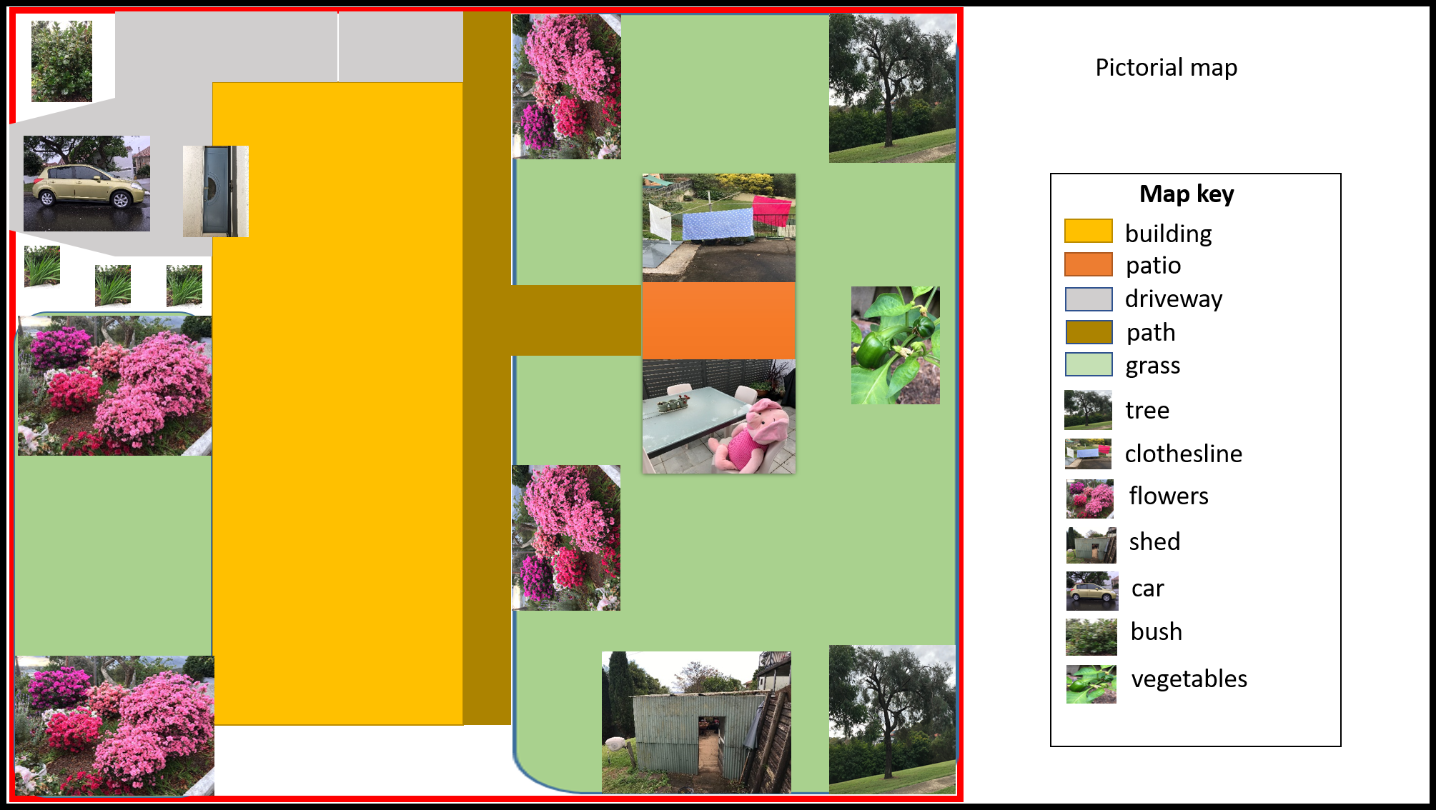

Reflection
Think about the map you made. Use the two stars and a wish structure to guide your reflection.
Star  Something that went well! | Star  Something that went well! | Wish  A goal for next time…

