Features of places
Geography student workbook Stage 1
Name:
Class:

Overview
You will learn about how spaces in your home are used for a variety of purposes, and how to care for the spaces around your home.

Resources

Activity 1
- Lead pencils, coloured pencils
- paper

Activity 2
- Picture of your favourite place (from previous activity)
- Poster “Step up to clean up”
- Lead pencils, coloured pencils
- paper

Activity 1
During this activity you will explore the spaces in and around your home and identify the features of them.
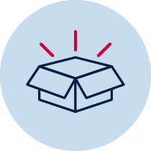 Resources
Colour pencils, lead pencils
Read
What are some of the places we use around home every day?
Brainstorm/think
Think about all the different spaces that you use in and around your home.
Read
You are going to conduct a survey of the features of places around home that you use every day.
A survey is a tool used to collect information or data. Surveys can be done by asking other people for information, or by observing and recording data.
Features are characteristics or traits that can be observed. Features distinguish one thing from another. For example, animals have the following features:
- head
- arms
- legs
- body
Brainstorm/think
You are going to do a survey of the places and spaces around your home. To do this, you will use the T-chart below.
Go for a walk around your home and write down a list of all the spaces that you use. This can include indoor and outdoor spaces. If you need more space to write, use a piece of paper and staple it to this workbook. While you are surveying, write down some features of each place or space in the right-hand column of your T-chart. An example is provided for you.
Name of space | Features
bedroom | bed, desk, window, wardrobe, posters
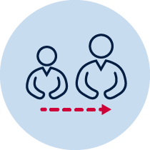 Adult support
Share your T-chart with a parent or carer. Ask them to help you compare the places and spaces in your survey. To do this, identify features that are similar and features that are different in each place or space.
Draw
From your T-chart, identify your favourite place or space. Draw a picture of this in the space provided below. Use the name of the place or space as the title for your drawing.
Title:

Activity 2
During this activity you will learn about how people care for places and spaces. You will create a care plan for your favourite place or space.
Adult support
Share your picture of your favourite place or space with a parent or carer. Identify the features of this place or space.
Read
Read the poster “Step up to clean up”, created for the Clean Up Australia Day organisation.
Brainstorm/think
Think about the places and space on your T-chart, discuss with a parent, carer or sibling how and why people care for places and space. For example, gardens, playgrounds and parks need to be cleaned and grass kept mown so that the places remain clean, safe and healthy places to play.
Create/make
You are going to prepare a care plan for your favourite place or space. Start this by creating a list of tasks that might need to be completed.
Task name
Discuss
With a parent of carer, discuss the order of tasks for your care plan. Think about which tasks would need to be done daily and which tasks would need to be done first, before other tasks. For example, when cleaning up a playground, garden, or park, it would be better to remove rubbish before the grass is mowed, otherwise the lawn mower would shred the rubbish and spread it – making more mess and harder to clean up.
Create/make
Create a care plan for your favourite place or space by rewriting your task list in order from first to last.
Care plan
Hands on
Put your care plan into action. See if you can maintain your favourite place or space so that it remains clean, safe and healthy.

