Features of places
HSIE Geography Stage 1 student workbook
Name:
Class:

Overview
You will learn to identify the natural and human features of a place near where you live. You will identify the activities that happen in that place. You will learn to draw a map of a local place and show where activities are located on the map.

Resources

Activity 1
- coloured pencils
- construction materials (optional)
- camera (optional)

Activity 2
- help from an adult
- camera (optional)
- large piece of paper
- computer access (optional)

Activity 1
During this activity you will explore the natural and human features of a place near where you live.
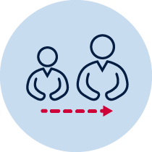 Talk to an adult in your family about the changes they have seen happen to the street or other place near where you live such as the local shops or park. Ask them these questions to find out information about the changes to the place.
- What changes have happened to the buildings and other human made features such as paths or cars?
- What changes have happened to the natural features such as trees or grass?
- Why do they think these changes might have happened?
Think about the features of the place your family member talked about. The places we live have been built and changed by people. That means places have both natural and human features.
Natural features of a place are the plants, rocks, hills and valleys in that place.
Human features have been made by people and include buildings, roads, footpaths, fences and play equipment.
With your family member, discuss the natural and human features in the place you talked about. Identify features as natural or human features.

Look at the two photos. List the natural and human features you can see in each photo.
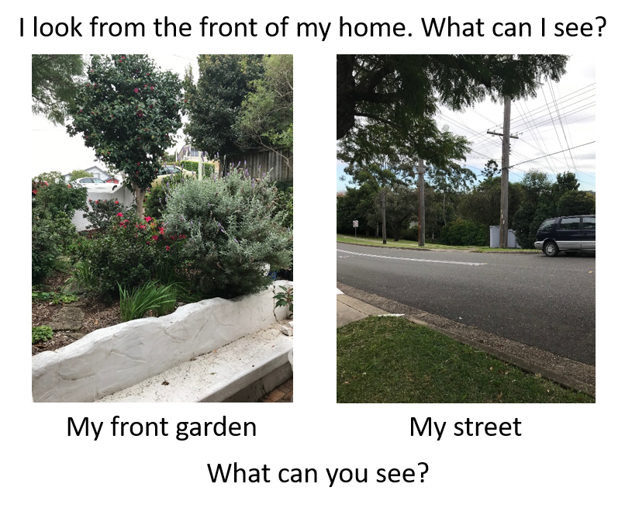

Think about the activities that happen at the local park, shops or in your street. Think about how you do those activities and why those activities are found there.
For example:
- Why is there a carpark at the shops? People can park their car close to the shop.
- Why is the play equipment at the park? Kids can have fun at the park.
Choose 5 activities that happen in local places. Write the name of the activity and the reason those activities are found there.
Activity name | Activity reason
Play on play equipment in the park | Kids can have fun at the park.
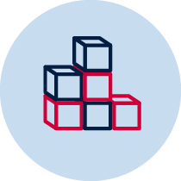 Choose a familiar local place. For example, your street, local shops, park or school. You might be able to explore this local place with a family member and take photos of the natural and human features. Geographers have a special name for exploring a place. They call it field work. Describe what the local place looks like, what activities are there and suggest why those activities might be found there.
Draw a picture of the local place and label features of the local place
Or
Make a model of the local place. Use building blocks or recycled containers, such as boxes, plastic bottles and cardboard. Label the features of your model, take a photo and add it to this workbook.

Drawing of a local place
Write
Identify and list the natural features in your drawing or model.
Identify and list the human features in your drawing or model.
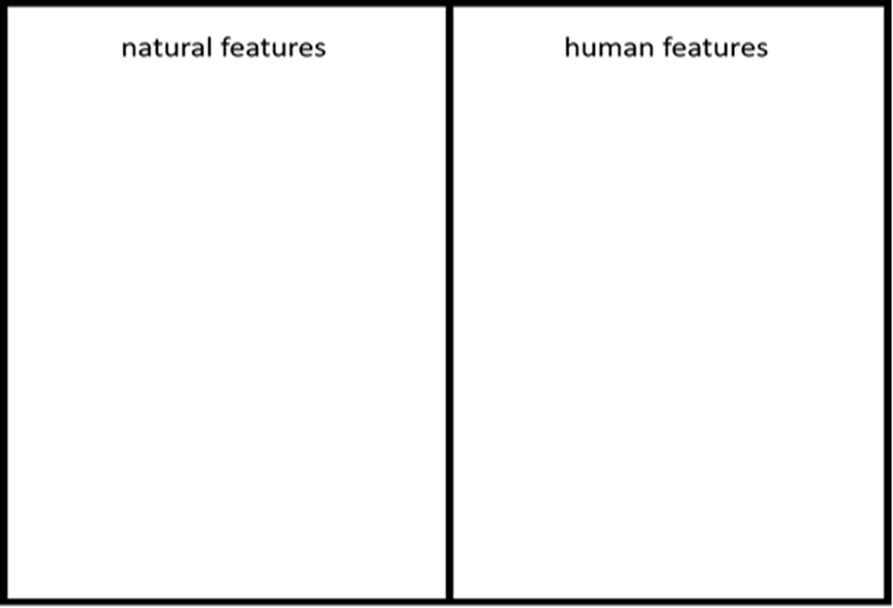

Activity 2
During this activity you will make a map of a local place. You will use pictures and/or symbols on your map to show natural and human features in the place.
Imagine you are walking up and down your street, around the local shops, park or school. Think about what you might see.
Now imagine you are a bird, or in a helicopter, flying over these local places. Think about what you might see as you look down at the ground. Imagine if you flew over your whole local area. What might you see?
Write your ideas.
If I walked around my local area I might see ____________________________________
________________________________________________________________________
________________________________________________________________________
________________________________________________________________________
________________________________________________________________________
If I flew over my local area I might see ________________________________________
________________________________________________________________________
________________________________________________________________________
________________________________________________________________________
________________________________________________________________________

Look at the photos of piglet. See how piglet looks different when you look at him from the front and the top. A front view is called an eye-level view. Looking from the top is called a bird’s-eye (aerial) view.
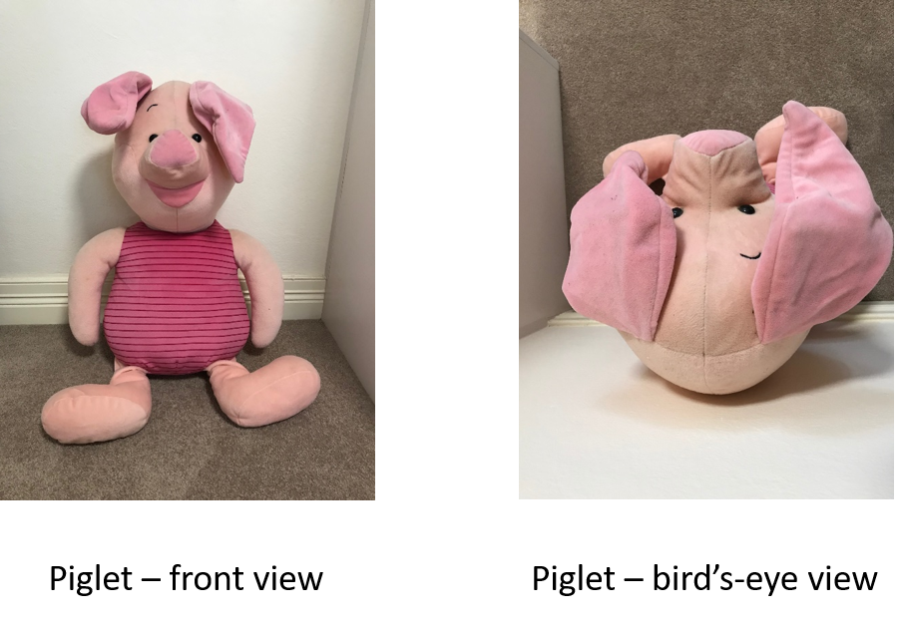
Did you know that buildings, gardens and parks can also be seen from these two different views? Your drawing or model of the local area was a front (eye-level) view. Look at the three shapes.
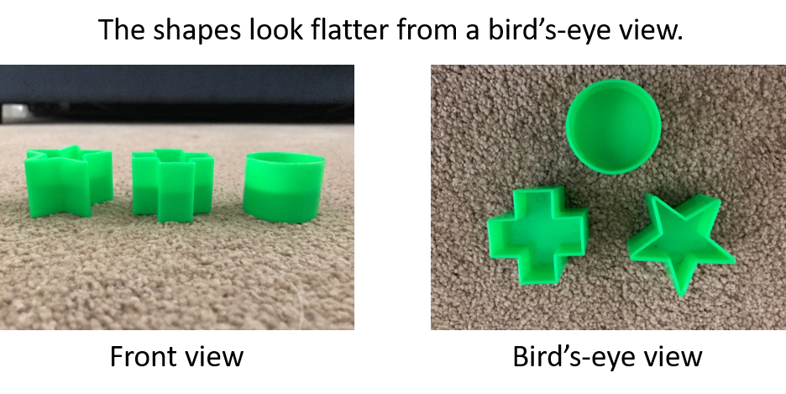
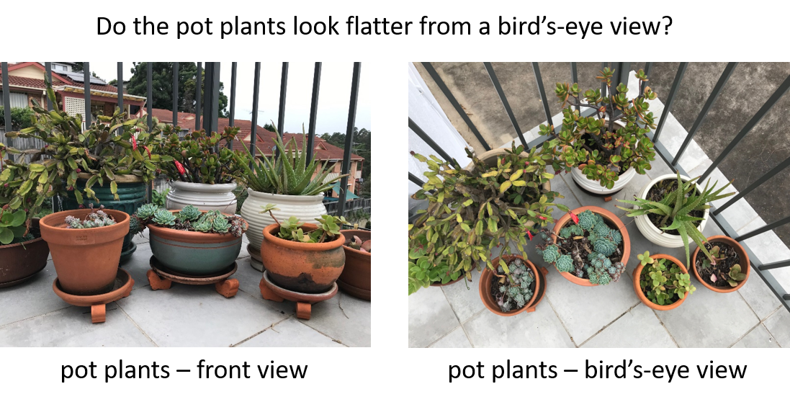
What is a map?
Maps help people find their way from one place to another place. Some maps are drawn or printed on paper. Some maps are drawn using a computer. Most maps show a bird’s-eye (aerial) view of a place. Maps make places and objects look flat. Maps can use pictures or symbols to show the natural and human features in a place.
Look at the 2 maps. Can you see any pictures? Why do you think there are pictures on these maps?
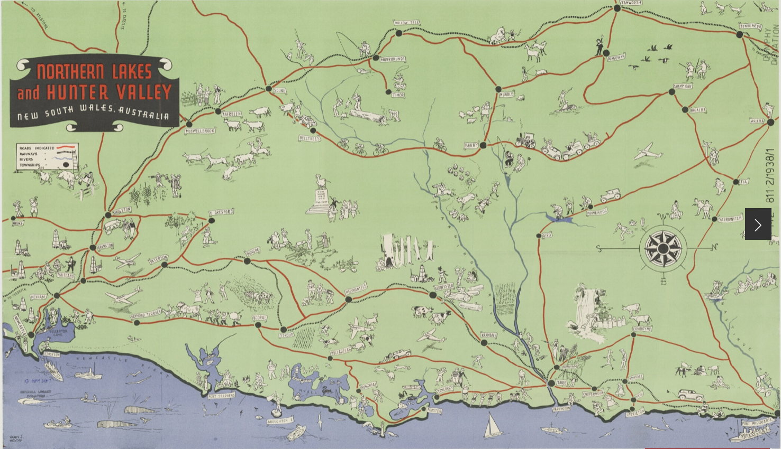
From the collection of the State Library of NSW, Creative Commons Attribution 4.0. (https://www.sl.nsw.gov.au/learning/locating-places-people-live-places/pictorial-maps)

Look at the map of Taronga Zoo, Sydney, NSW.
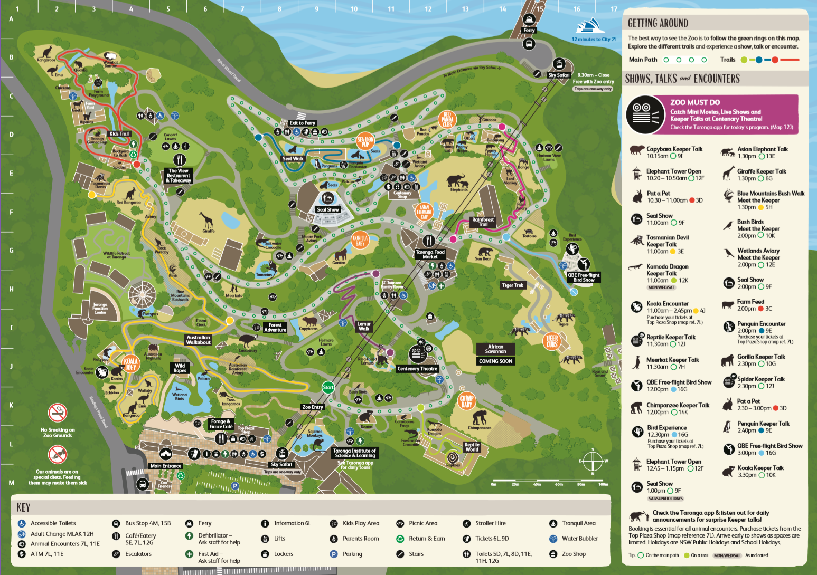
from Taronga Conservation Society, Australia https://taronga.org.au/sydney-zoo
Can you see how the maps use pictures and symbols to represent places and features?
If you have a map at your home, try and see how you can travel from one place to another. To use a map, you need to have instructions about how to get to a place. Instructions might tell you to walk along a street, turn left, walk over a bridge, through the park, turn right, walk along the street and you come to a shop.
You are going to make a map using pictures and/or symbols but first you need to choose the place the map will be about. It could be a map of your street, local shops, park, or somewhere else you visit with your family. You need to explore the place you will be drawing on your map. You might choose the place you explored in the first lesson.

Go on a walk with an adult.
You need to ask an adult to help you. Go for a walk together around the place you have chosen. You might be able to take photos of natural and human features on your walk.
Think about these questions as you walk.
- What places do you see?
- What natural and human features do you see?
- Are they near to each other or a long way apart?
- What instructions are you following as you go on your walk?
  - Are you walking straight?
  - Are you turning left or right?
  - Do you have to climb up anything such as a hill or steps?
You are going to make a map of the natural and human features you saw on your walk. Try to remember if places or things are near each other or far away from each other. Label the features that are on your map. Make sure your map has a title to tell people the name of the place.
Think about the pictures and symbols you might draw on your map. Maps use symbols to represent pictures of the features of a place. They are very simple drawings and represent the natural and human features.
Some maps have labels in a separate list (called a map key), some maps have labels on them pointing to the pictures and symbols. You choose how you want to label the pictures and symbols on your map. You will need a piece of paper and coloured pencils or you might like to try and draw your map using a computer. Your map might look like the map on a piece of paper or it might look like the map drawn using a computer.

In kindergarten you might have drawn a map that looks like this.
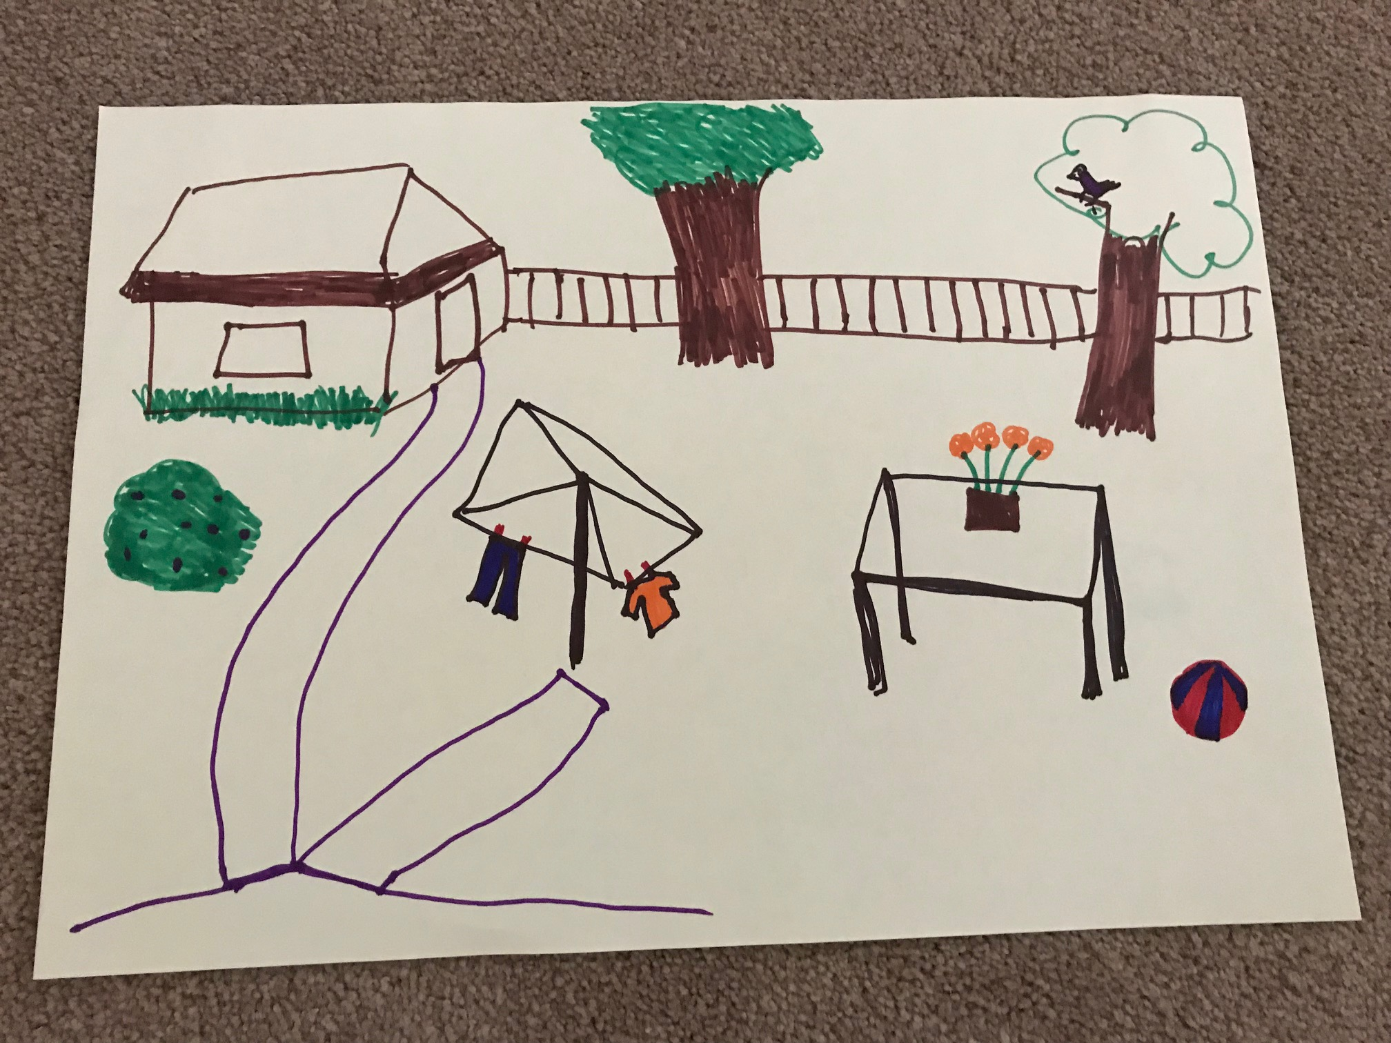
Now you are going to try to make a map using symbols to replace pictures. Your map could look like this. Can you see how this map uses a map key to explain the pictures, or symbols, on the map.
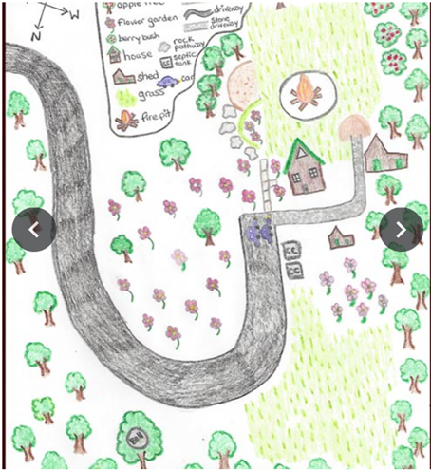
Local Places, Gibberagong Environmental Education Centre
https://sites.google.com/education.nsw.gov.au/lessons-in-nature/es1/local-places
In kindergarten you might have drawn a digital map that looks like this.
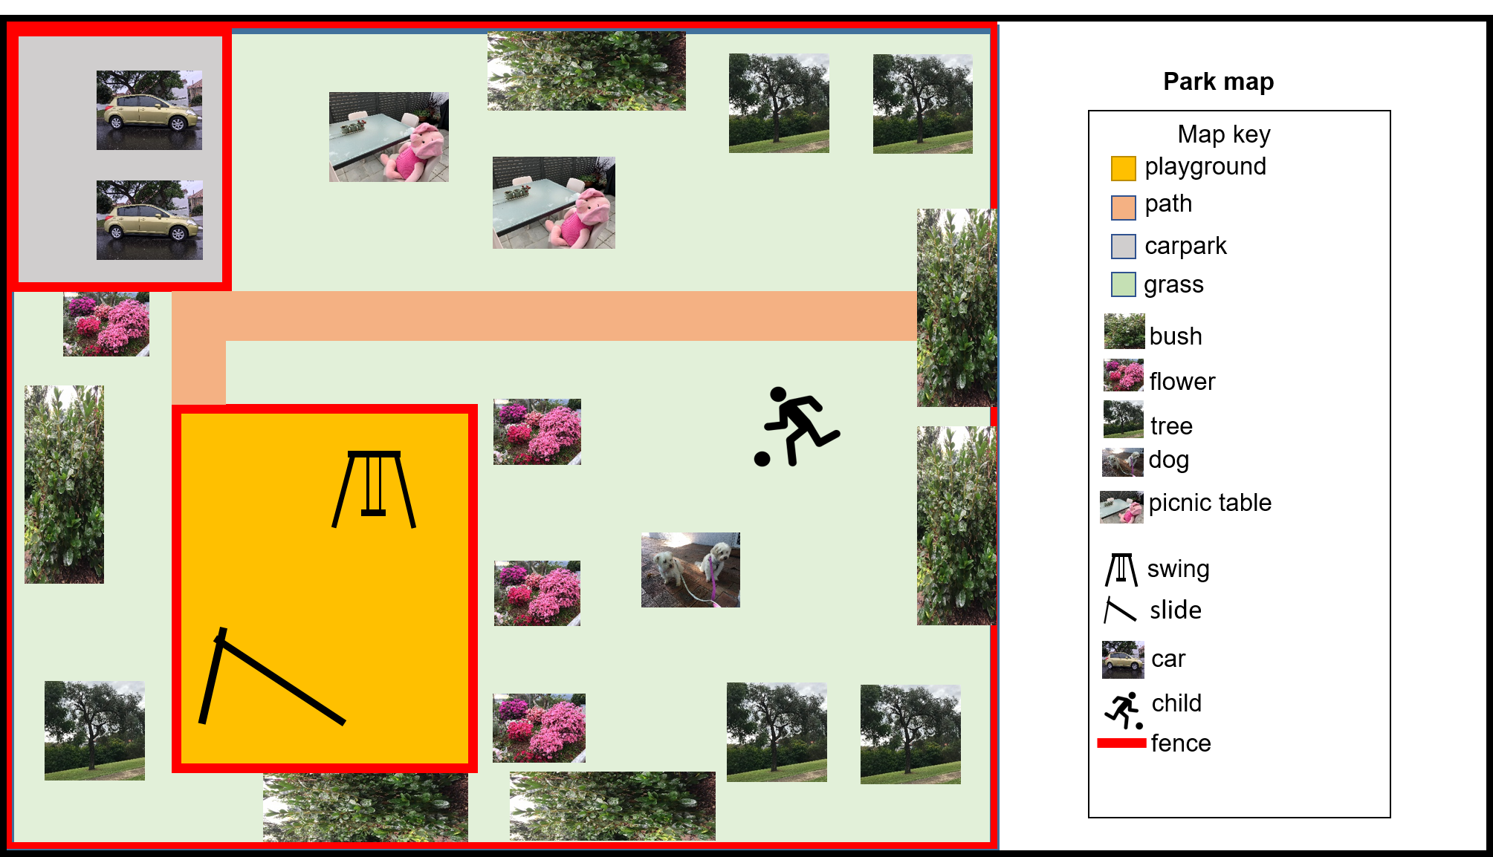
Now you could try to make a digital map using symbols to replace pictures. Your map could look like this. Can you see how this map uses a map key to explain the pictures, or symbols on the map?
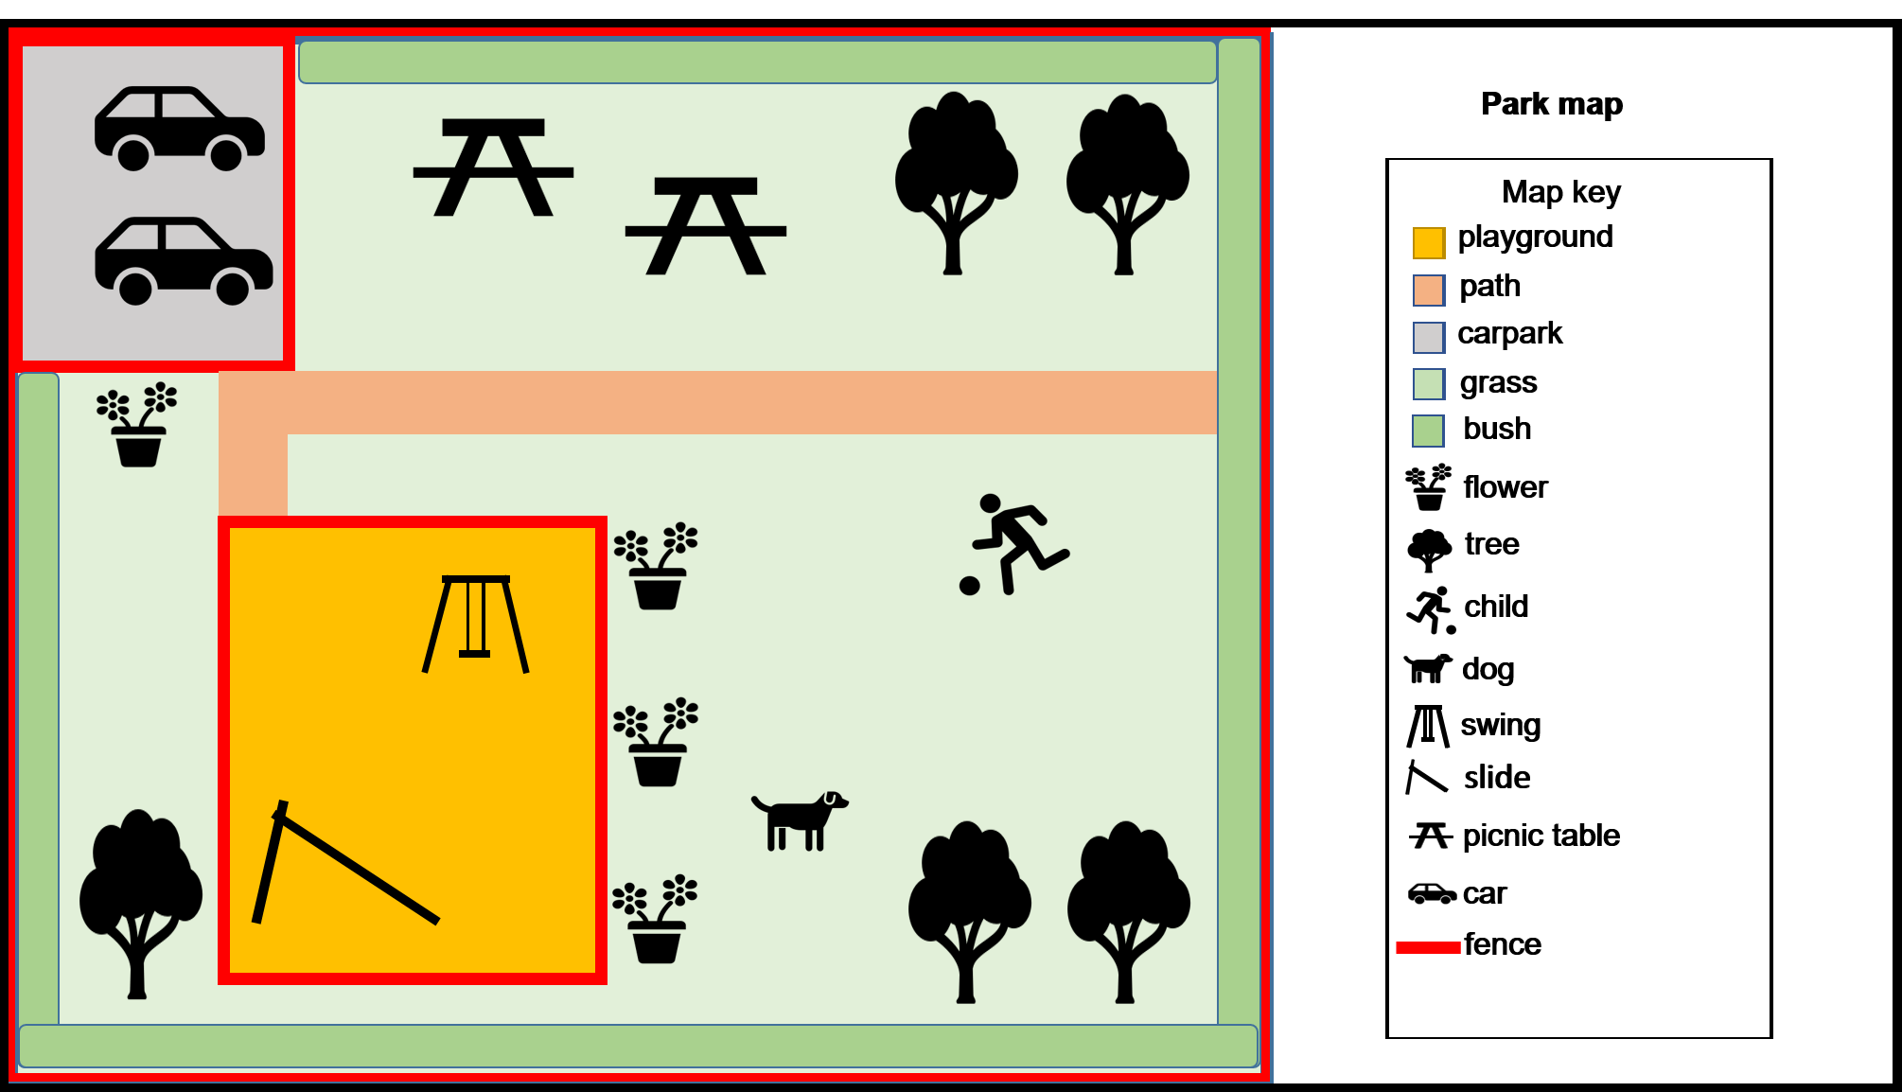

My map of my local place
Map of my local place

Reflection
Think about the map you made. Use the two stars and a wish structure to guide your reflection.
Star  Something that went well! | Star  Something that went well! | Wish  A goal for next time…

