HSIE: Geography stage 3 resources

The following activities correspond to the resource worksheets 1-5 in the learning sequence for S3 Geography: A diverse and connected world.

Please use all worksheets in a booklet form or choose and print the ones you want as you need them.

HSIE: Geography S3 worksheet 1
Name:
Class:

The continent of Asia
Watch the video clip National Geographic Kids Asia, Destination World for an overview of the continent of Asia.
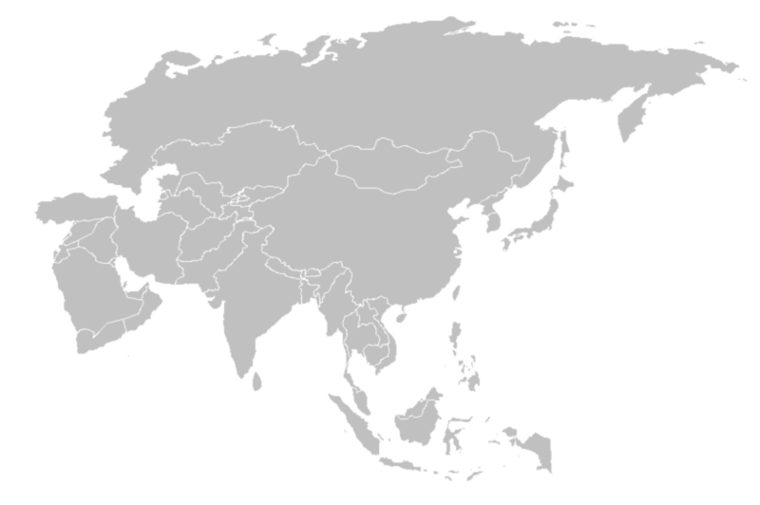
This file is licensed under the Creative Commons Attribution-Share Alike 3.0 Unported license.
There are 48 countries on the continent of Asia. Label 15 of them on the map.
Complete the information table below using the 15 Asian countries you have labelled above.

Country | Population | Land area km² | Main language | Main religion | Distance from Australia

HSIE: Geography S3 worksheet 2
Name:
Class:

Postcards from Asia
Choose 2 countries from your list that have very different statistics in your data table and are geographically distant from each other. Highlight them.
Investigate these countries’ differences further by writing a postcard from each country that reflects some of the following aspects of life there:
- economic – wealthy, poor, resources to trade with other countries, employment
- demographic – population, elderly or younger people, population density
- geographic – sights and landmarks, tourism, natural and built environments
- social – lifestyle, religion, education, family size and structure.
Make sure you place yourself in both countries and write in first person (I, me, we). It is not meant to be an information report but a recount of the unique sights, activities, foods and experiences you have enjoyed (or not enjoyed) while you have visited.
Country 1: _______________________________________
Country 2: _______________________________________
Don’t forget your postcard has two sides, one for writing and the other for pictures. Postcards also need that country’s current 2021 stamp and an address to send to.

HSIE: Geography S3 worksheet 3
Name:
Class:

Asia’s Indigenous people
From your list of 15 countries from Asia, many will have Indigenous peoples. Just like Asia, Australia has its own Indigenous peoples, the Aboriginal and Torres Strait Islander peoples, who have continually lived on the land we now call Australia for many thousands of years before European settlers came. Every time we have an acknowledgment of country during events and meetings, we are paying our respects to the Traditional Custodians of the land we are on.
Watch the clip about International Day of World’s Indigenous people and select and investigate one Indigenous population from one of the 15 Asia countries you selected. Briefly summarise who they are, their culture and the challenges they face being the first people of, or native to, that land.
Country: ____________________________________
Indigenous people of Asia
________________________________________________________________________________________________________________________________________________________________________________________________________________________________________________________________________________________________________________________________________________________________________________________________________________________________________________________________________________________________________________________________________________________________________________________________________________________________________________________________

HSIE: Geography S3 worksheet 4
Name:
Class:

Australia’s trade partners
Import means that Australia buys products from other countries and brings these products into our country to be used. These are often products we don’t produce ourselves.
Export means that Australia sells our products, which we produce here, to other countries.
View this table that shows who Australia’s top export countries are in the world. In other words, these are the countries that buy what Australia sells.
Highlight the countries that are from Asia. What does this tell you about Australia’s export trade?
____________________________________________________________________________________________________________________________________________________________________________________________________________________________________________________________________________________________________________
What do you think these countries are buying from Australia? Why?
____________________________________________________________________________________________________________________________________________________________________________________________________________________________________________________________________________________________________________
Research the top 10 export products that Australia sells to the world and complete the table.

Australian top 10 exports
1.
2.
3.
4.
5.
6.
7.
8.
9.
10.

HSIE: Geography S3 worksheet 5
Name:
Class:

Tokyo Olympic Games 2020
International sporting events, like the Olympic Games, are amazing to watch. Cheering on your country and recognising the sporting success of competitors every four years is a highlight for many people. Even though the Olympic Games in Japan has been rescheduled for 2021, preparations have not stopped in Tokyo.
Watch the three Tokyo Olympic Games clips, Tokyo 2020 Summer Olympics, 2020 Olympics 1 year out and The Venues of Tokyo to understand how the city of Tokyo has transformed in preparation for the Olympic Games. Discuss this topic in terms of trade and economy. Olympic host countries see an increase in trade, which can also lead to increased foreign investment.
Countries that host the Olympic Games invest billions of dollars hoping to see a boom in their economy, from increased tourism spending to infrastructure updates such as roads, buildings or communications such as Internet upgrades.
Investigate how the Tokyo Games has impacted people and places on a local, city/state and global scale. Investigate not only the preparation and cost of the games, but how it will affect the lives of people and the places they live while the games are in progress in Japan. Give examples.

Tokyo Olympics – how does it impact people and places at a local level?
________________________________________________________________________________ ________________________________________________________________________________________________________________________________________________________________________________________________________________________________________________________________________________________________________________________________________________________________________________________________________________________________________________________________________________________________________________________________________________________________________________________________________________________________________________________________

Tokyo Olympics – how does it impact people and places at a city/state level?
________________________________________________________________________________ ________________________________________________________________________________________________________________________________________________________________________________________________________________________________________________________________________________________________________________________________________________________________________________________________________________________________________________________________________________________________________________________________________________________________________________________________________________________________________________________________

Tokyo Olympics – how does it impact people and places on a global scale?
________________________________________________________________________________ ________________________________________________________________________________________________________________________________________________________________________________________________________________________________________________________________________________________________________________________________________________________________________________________________________________________________________________________________________________________________________________________________________________________________________________________________________________________________________________________________

