HSIE: Geography Skills focus workbook Stage 3
Name:
Class:

Overview
You will learn about the geographical skills of mapping and data representation. You will construct tables, graphs and maps, and interpret these to identify distributions and draw a conclusion about how climate influences the distribution of where people live.

Resources

Activity 1
- colour pencils

Activity 2
- colour pencils

Activity 1 – Tables and graphs
During this activity you will explore tables and graphs using climate data. You will do a survey of Australian animals, record data in a table, create a graph and write a conclusion.
Resources – lead pencil, ruler, eraser, colour pencils

Weather and seasons
Reflection
What do you remember about climate?
Select the sentence that best describes climate.
- Climate and weather are the same thing.
- Climate and seasons are the same thing.
- Climate is the pattern of weather over a day.
- Climate is the pattern of weather over a long period of time.

Purpose and features of tables
A table is a graphical tool used for recording data. Geographers conduct field surveys to collect data, and they record this in a table. Most data tables have similar features that need to be included when you construct a data table.
Select the features that are common to all tables.

- title
- rows
- columns
- data
- images or photographs
- row headings
- column headings
- straight lines

Observe/find
Climate data is often recorded as a table or a graph. The table below is an example of the monthly climate data for Sydney, NSW. Look at the table and identify some features of a table.
Climate data for Sydney, NSW.
Month | Average temperature high/low (⁰C) | Average rainfall (mm)
January | 26/19 | 101
February | 26/19 | 119
March | 25/18 | 132
April | 23/15 | 127
May | 20/12 | 117
June | 17/9 | 134
July | 16/8 | 96
August | 17/9 | 80
September | 20/11 | 68
October | 22/14 | 77
November | 24/16 | 84
December | 25/18 | 77
Observe/find
Compare the climate data table for Sydney, NSW with another data table for Broken Hill, NSW by the Bureau of Meteorology. The data table for Broken Hill is similar because it has a title, columns, rows and column titles. It is different because it has row titles. Some of the data is the same as the data in the table for Sydney. It has average monthly high temperature, average monthly low temperature, and average (mean) rainfall for each month.
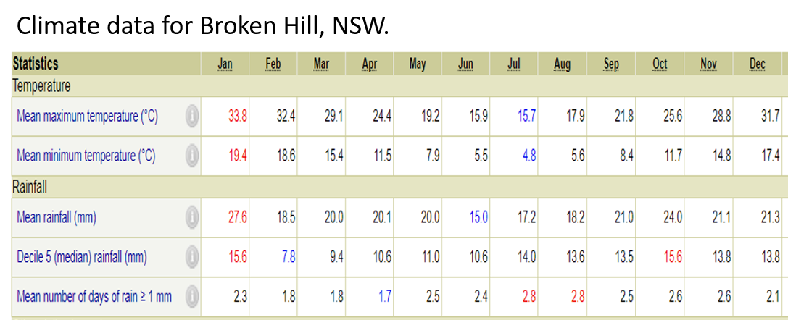
Observe/find
Can you see any patterns in the climate data for Sydney or Broken Hill? Choose one of the tables and identify a pattern in the average monthly rainfall. Think about which months the rainfall is highest and which months the rainfall is lowest then write a conclusion in sentence form in the space below.
The pattern in rainfall for Sydney/Broken Hill (circle your choice) is….
______________________________________________________________________________________________________________________________________________________________________________________________________________________________________________________________________________
Checklist
List some features of data tables
Feature 1. _____________________________________________
Feature 2. _____________________________________________
Feature 3. _____________________________________________
Feature 4. _____________________________________________

Purpose and features of graphs
A graph is a visual representation of data. The images below show some different types of graphs.
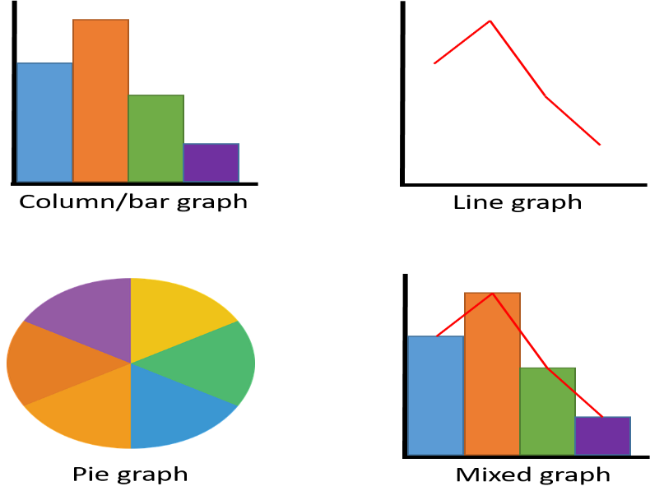

Creating a climate graph
Climate graphs are a visual representation of data from climate data tables. Frequently, climate graphs show two data sets – one set for temperature and one set for rainfall. The climate graph on the next page shows temperature and rainfall for Broken Hill, NSW. This graph has been created using Microsoft Excel.

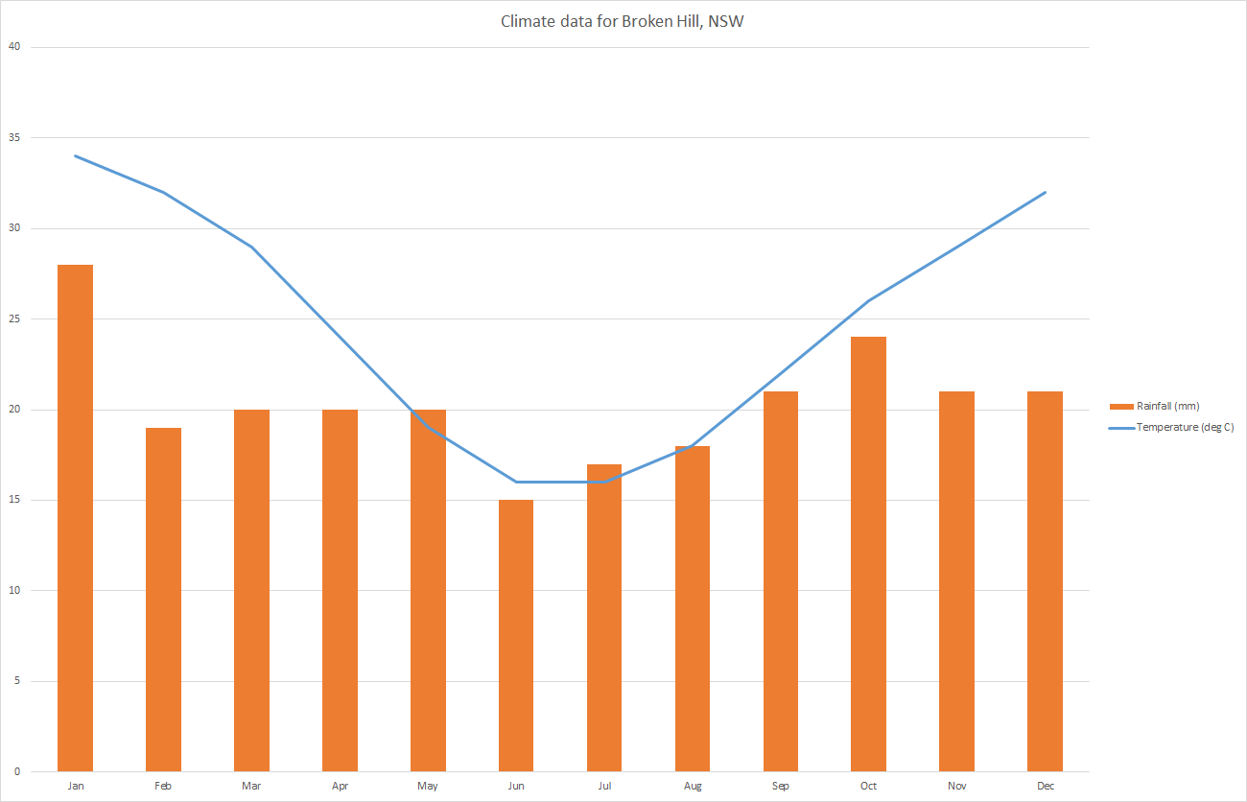The same data has been used to create a hand-drawn graph on grid paper on the next page. Compare the two graphs and observe the similarities between them.
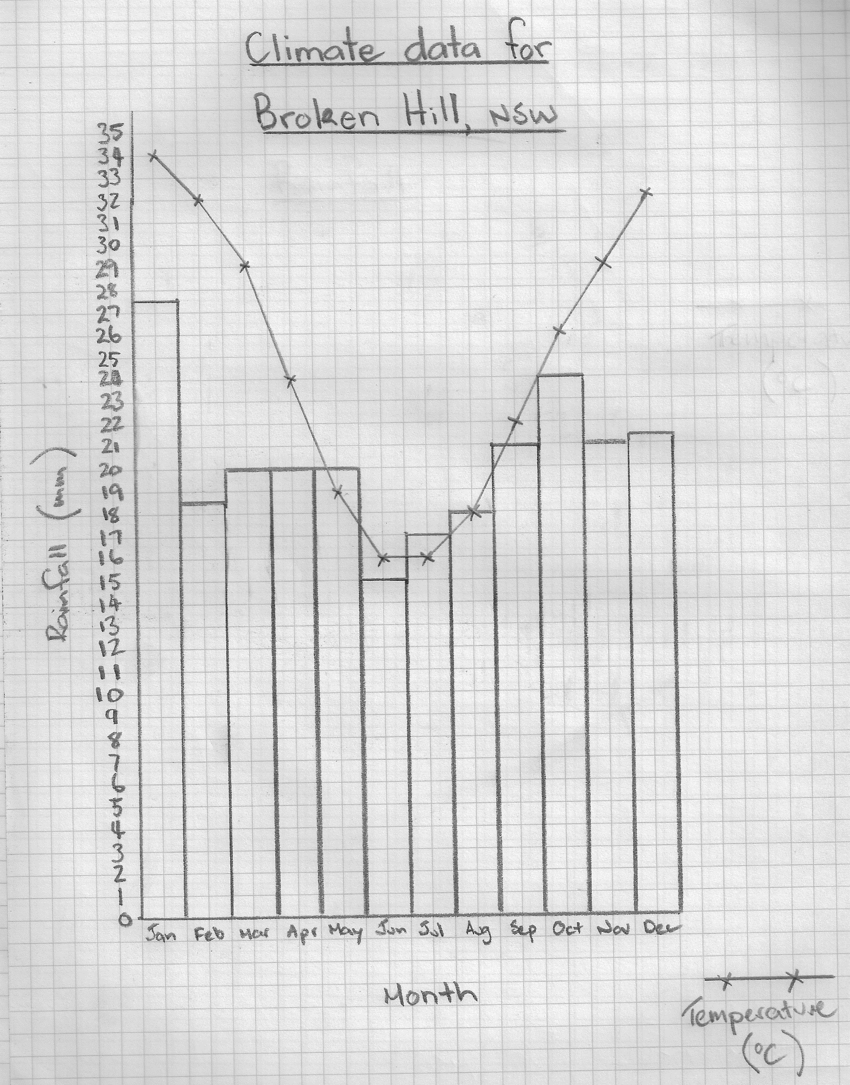Do you think it’s easier to see patterns or trends in a data table or a graph? (Circle your choice).

Climate comparison
Using the grid provided, draw a climate graph for temperature and rainfall using the data provided for Sydney, NSW. Alternatively look up and graph the climate data for student’s local region plus a second, different region in NSW.
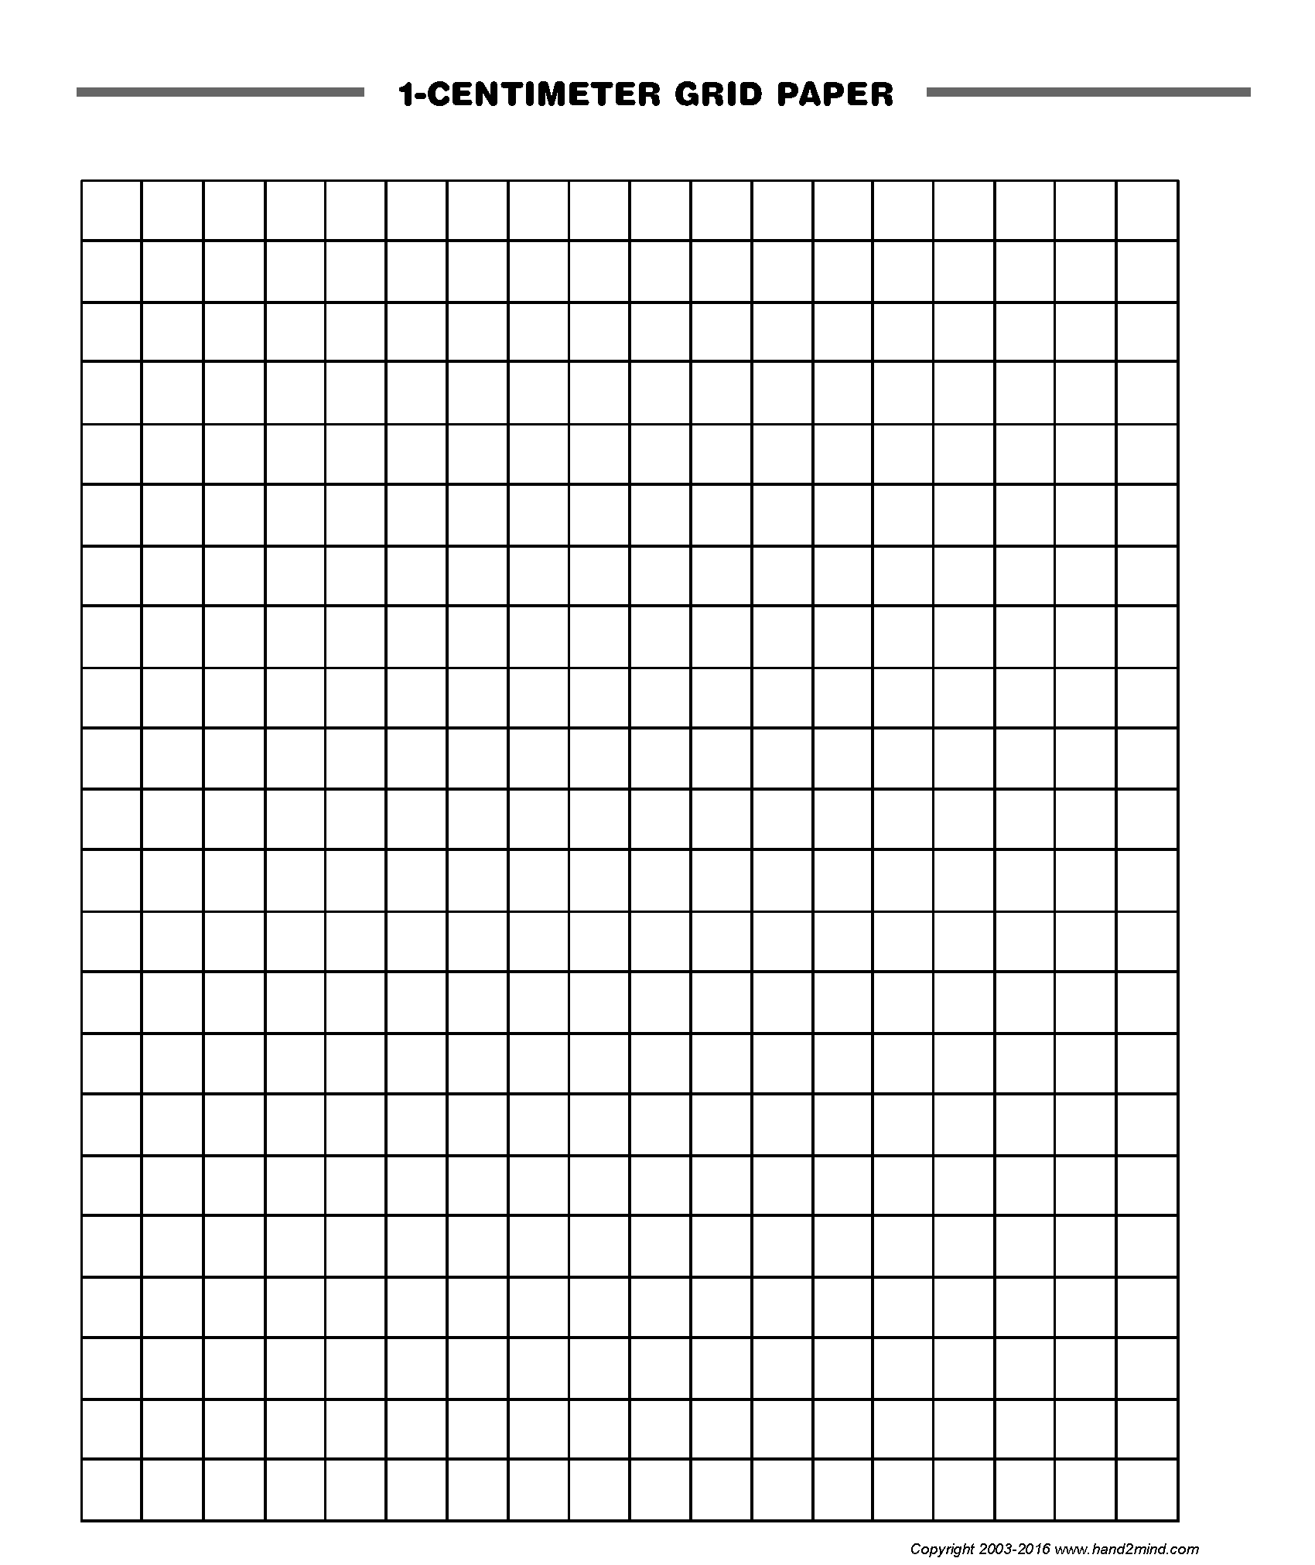Compare the climate graphs and think about how climate could influence where people live. Use the Claim-Evidence-Reason graphic organiser below to make an argument supporting the impact of climate on where people live.
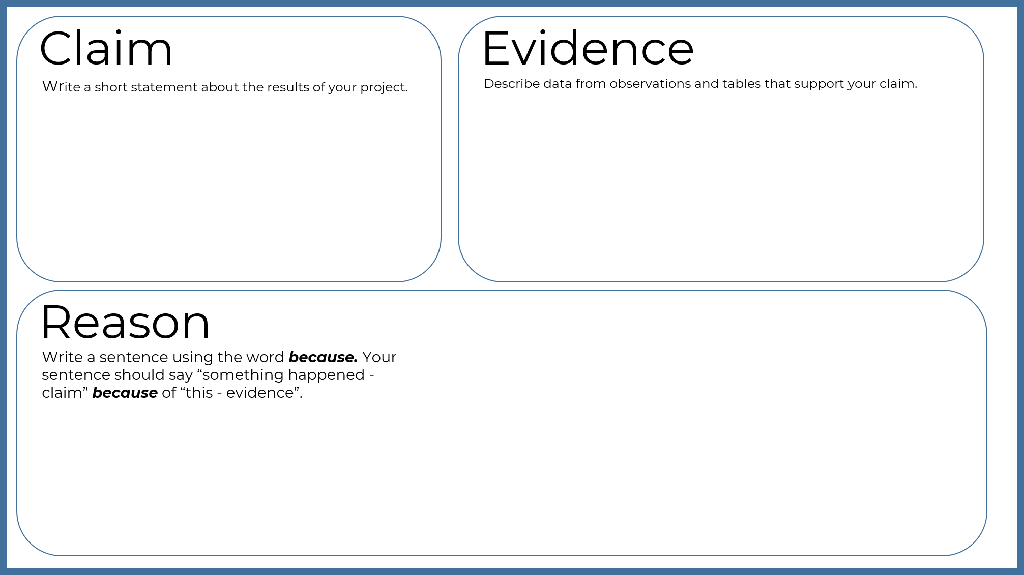
Long term climate
Observe/find

The following table shows temperature and rainfall data each decade for NSW over the past 100 years.
Decade | Average temperature (⁰C) | Average rainfall (mm)
1910s | 22.8 | 434
1920s | 22.3 | 494
1930s | 22.1 | 509
1940s | 22.3 | 468
1950s | 22.5 | 596
1960s | 22.7 | 518
1970s | 22.9 | 592
1980s | 22.7 | 539
1990s | 22.7 | 551
2000s | 23.1 | 476
2010s | 23.3 | 496

Create/make
Construct a bar graph for average temperature for NSW over the past 100 years.
One a separate grid, construct a line graph for average rainfall (use a scale of 1 cm – 10mm) for NSW over the past 100 years.

Title: Average temperature for NSW over the past 100 years.

Title: Average rainfall for NSW over the past 100 years.
Observe/find
Compare the two graphs. Can you identify any trends or patterns?
Write
Write a 1-sentence conclusion describing the temperature data.
________________________________________________________________________________________________________________________________________________________________________________________________________________________
Write
Write a 1-sentence conclusion describing the rainfall data.
________________________________________________________________________________________________________________________________________________________________________________________________________________________
Write/Extension
Write a 1-sentence conclusion describing the temperature and rainfall data.
________________________________________________________________________________________________________________________________________________________________________________________________________________________

Reflection
Think about what you have learned in this activity. Use the two stars and a wish structure to guide your reflection.
Star  Something that went well! | Star  Something that went well! | Wish  A goal for next time…

Activity 2 - Mapping
During this activity you will conduct a vegetation survey, collect and record data, and create a vegetation map to show the distribution of plants at school or at home.
Resources – lead pencil, ruler, eraser, colour pencils

Climate maps
Geographers use climate maps to identify patterns in the distribution of climate. This data can be combined with vegetation data and an inference drawn about the influence of climate on the distribution of vegetation. The information can then be used to help plan new and future developments that may influence where people live.
The map on the next page shows the different climate regions in NSW. The approximate locations of Sydney and Broken Hill are shown on this map.
Observe/find
Identify the climate types for Sydney and Broken Hill and write them below.
Sydney: ____________________________________________________________

Broken Hill: __________________________________________________________

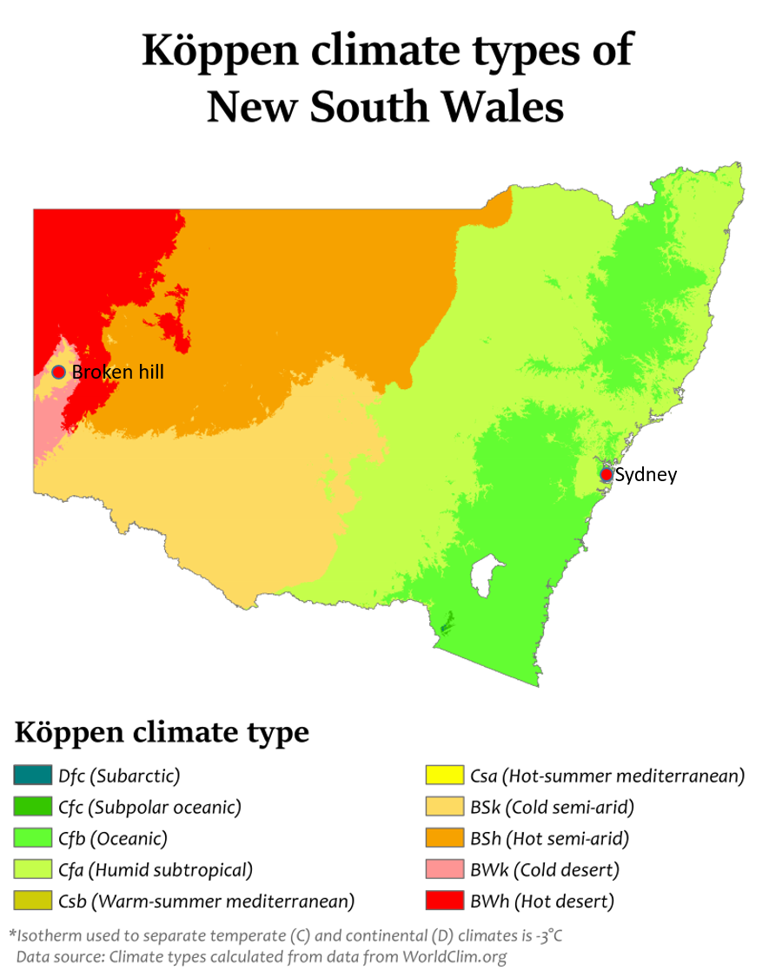
By Adam Peterson - Own work, CC BY-SA 4.0, https://commons.wikimedia.org/w/index.php?curid=50646657

Vegetation survey
Geographers use vegetation surveys to identify patterns in the distribution and density of plant growth. This information can be used to help plan new developments like housing estates, parks and other recreation areas.
Hands on
Conduct a vegetation survey at school or at home. Use the tally table below to record your observations. For grass, estimate how much area is covered and record this as a percentage. For example, 100% of the ground which is not gardens. Ask a parent or carer to help you identify plant names. If you need more space, use a separate sheet of paper and staple it to this page.
Plant | Tally | Total

Maps
In geography, maps are another way to visually represent data. A map should include the following features:
- title
- legend
- scale
- drawn on a grid.
A legend shows the colours and symbols that are used on the map. Colour shading may be used to represent the density of vegetation from light to heavy. For example, one area may be half-covered in grass where another area is fully covered. You could use shading to indicate how thick the grass cover is.
Some other features that can be shown on maps include:
- road
- building/structure
- pool/pond/dam/lake
- fence
- boundary
- playground/sport field
- tree
- flower
- grass
Scale is the relative size of objects represented on a map. For example, 1 cm on the map equals 1 m in real life (Scale: 1 cm = 1 m).
Vegetation map
A vegetation map shows the distribution and abundance of plants in an area. The vegetation map on the next page shows the distribution and abundance of plants at a person’s home. Notice how the map has a title, legend, scale and is drawn on a grid.

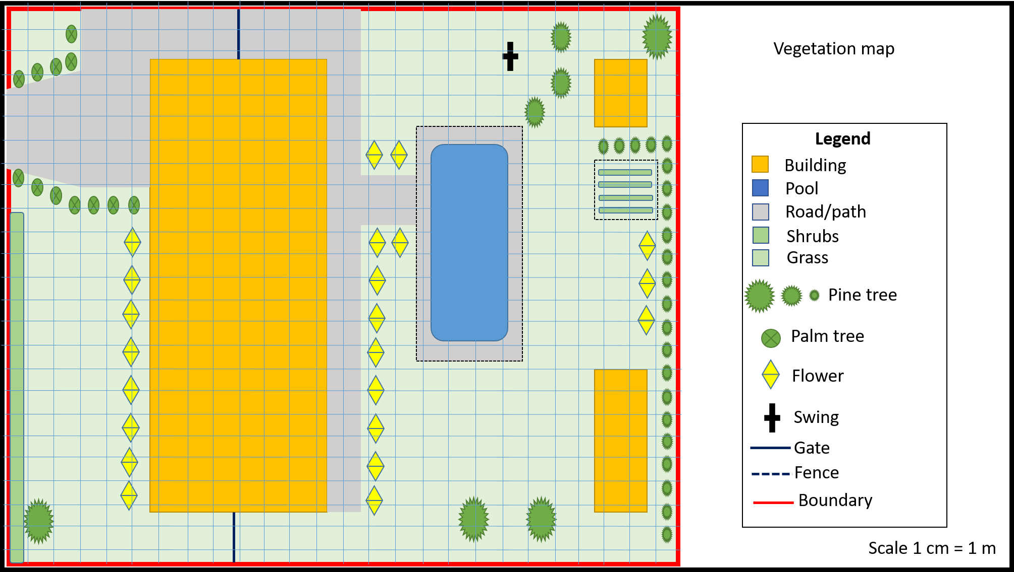

Hands on
Use the data from your survey tally table to construct a vegetation map of your school or home. If you need more space, use a sheet of 1 cm grid paper and staple it to this page.
Large-scale vegetation map
A vegetation map shows the distribution and abundance of plants in an area. The state vegetation map below shows the distribution of vegetation types in NSW. Notice how this map has a scale and a legend.
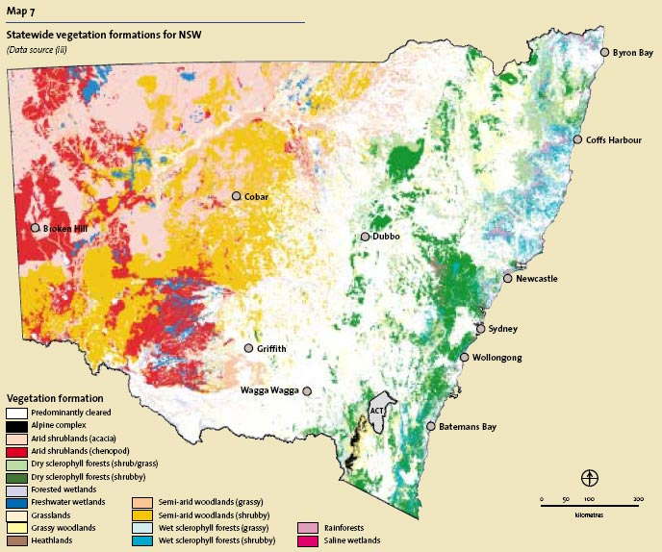
© State of New South Wales (Department of Planning, Industry and Environment), 2004
Observe/find
Identify the vegetation types for Sydney and Broken Hill and write them below.
Sydney:
______________________________________________________________________
Broken Hill:
______________________________________________________________________

Making an inference
An inference is a conclusion that is based on evidence and reasoning.
Observe/find
Review the climate information from the data tables and graphs in Activity 1 for Broken Hill and Sydney. Then compare this information with the information from the climate types map as well as the vegetation types map for Broken Hill and Sydney. Can you identify a trend or pattern relating to the vegetation and climate?
Think about how many people live in Sydney compared to Broken Hill. How do you think climate and vegetation might influence where people live?
Use the Claim-Evidence-Reason graphic organiser to construct your inference.
Write/Extension
Write a 1-paragraph conclusion describing the influence of climate and vegetation on where people live.
________________________________________________________________________________________________________________________________________________________________________________________________________________________________________________________________________________________________________________________________________________________________________________________________________________________________________________________________________________________________________________________________________________

Reflection
Think about what you have learned in this activity. Use the two stars and a wish structure to guide your reflection.
Star  Something that went well! | Star  Something that went well! | Wish  A goal for next time…

Unless otherwise stated, images used in this workbook are sourced from Pixabay.
Climate data is reproduced by permission of Bureau of Meteorology, © 2020 Commonwealth of Australia.

