Geography Stage 4
Water in the World
This resource has been designed to support teachers by providing a range of tasks based on syllabus content. Tasks can be incorporated into context driven teaching and learning programs in full or can be used to supplement existing programs. All content is textbook non-specific to ensure equity.
Contents
Overview 3
Key inquiry questions 3
Outcomes 3
Capacity matrix 5
Learning sequence 1 – water resources 6
Characteristics and spatial distribution of global water resources 6
Learning sequence 2 – how the water cycle connects people and places 10
Water cycle processes 10
Water flow and availability within a catchment 11
Learning sequence 3 – Australia’s water resources 16
The variability of Australia’s water resources 16
Variations in freshwater availability between continents 20
Learning sequence 4 – water scarcity and water management 22
The nature, extent and causes of water scarcity in different countries 22
Strategies used to overcome water scarcity in different countries 24
Investigative study – overcoming water scarcity in Australia – Snowy Hydro Scheme 26
Individual action contributing to water management 28
Learning sequence 5 – the value of water 36
The different ways people value water 36
Cultural and spiritual value of water 36
Economic value of water 37
Aesthetic value of water 37
Importance of water in India 39
Learning sequence 6 – natural hazard investigation 41
The nature and causes of flooding 41
The impact and management of flooding – Lismore, Northern New South Wales 2022 43
Assessment task 45
Outcomes 45
Syllabus content 45
Task 45
Marking criteria 46
Appendix – capacity matrix 48
References 51

Overview
Students examine water as a resource and the factors influencing water flows and availability of water resources in different places. They investigate the nature of water scarcity and assess ways of overcoming it. Students discuss variations in people’s perception about the value of water and the need for sustainable water management. Students also investigate processes that continue to shape the environment including an atmospheric or hydrologic hazard.

Key inquiry questions
- Why does the spatial distribution of water resources vary globally and within countries?
- How do natural and human processes influence the distribution and availability of water as a resource?
- What effect does the uneven distribution of water resources have on people, places and environments?
- What approaches can be used to sustainably manage water resources and reduce water scarcity?

Outcomes
A student:
- GE4-1 locates and describes the diverse features and characteristics of a range of places and environments
- GE4-2 describes processes and influences that form and transform places and environments
- GE4-3 explains how interactions and connections between people, places and environments result in change
- GE4-5 discusses management of places and environments for their sustainability
- GE4-7 acquires and processes geographical information by selecting and using geographical tools for inquiry
- GE4-8 communicates geographical information using a variety of strategies
Geography K–10 Syllabus © NSW Education Standards Authority (NESA) for and on behalf of the Crown in right of the State of New South Wales, 2015.

Capacity matrix
Note: explain to the class how to use the Capacity matrix (Appendix). Ensure students understand and can distinguish between information, knowledge, know-how and wisdom categories in the matrix.
The Capacity matrix can be used as a formative assessment tool that clarifies student understanding of course concepts for the duration of the learning sequence. For more information, see Quality Learning Australasia’s The Capacity Matrix. Please note that teachers need to register to access the free resources on this site.
Review the Capacity matrix for geographical terms relating to the topic ‘Water in the World’. Using different colours for the matrix criteria, shade or tick where you think you are according to the matrix categories for each geographical concept or glossary term. The criteria for the matrix include:
- information – at this level, you have heard of the term and/or you can recall basic facts about it
- knowledge – at this level, you can explain and know what the term or concept means
- know-how – at this level, you can draw connections between this geographical term or concept and relate it to other concepts or situations
- wisdom – at this level, you can use the term or concept in new contexts or teach others.
You will revisit this matrix throughout the learning sequence.

Learning sequence 1 – water resources
Students:
- investigate the characteristics and spatial distribution of global water resources, for example: (ACHGK037)
- classification of water resources
- identification of different forms of water used as resources
- examination of spatial distribution patterns of water resources.

Characteristics and spatial distribution of global water resources
Note: explicitly teach students how to draw pie charts. Access Common Graphs (2:58) and Pie Charts and Protractors (5:06) for a detailed explanation on how to read and draw a pie chart. The video explains how to convert data to percentages for drawing a pie chart. Students are provided with the percentages and will only need to follow the steps for drawing, not calculations.
- Review the estimated global water distribution table and create a pie chart to illustrate the data.
Table 1 – estimates of global water distribution
Water source | Percentage of total water
Salt water | 97%
Frozen | 2.06%
Available freshwater | 0.94%
- Conduct a peer assessment by swapping and checking your peer’s pie chart against the following marking criteria. Make suggestions for improvement.
Table 2 – peer assessment pie chart
Criteria | Yes | No | Comments
Title clear and concise | ☐ | ☐
Angles measured accurately | ☐ | ☐
Pie chart presented | ☐ | ☐
Spelling correct | ☐ | ☐
Graph illustrated neatly | ☐ | ☐
- Review the estimated global freshwater distribution table and create a pie chart to illustrate the data.
Table 3 – global freshwater distribution
Water source | Percentage of total water
Icecaps and glaciers | 68.7%
Groundwater | 30.1%
Surface water | 0.3%
Other | 0.9%
- Conduct a peer assessment by swapping and checking your peer’s pie chart against the following marking criteria. Make suggestions for improvement.
Table 4 – peer assessment pie chart
Criteria | Yes | No | Comments
Title clear and concise | ☐ | ☐
Angles measured accurately | ☐ | ☐
Pie chart presented | ☐ | ☐
Spelling correct | ☐ | ☐
Graph illustrated neatly | ☐ | ☐
Access Enviro Friendly – Map of Average Rainfall in Australia and answer the following:
- What type of map is this?
- How do you know the source of the map information is reliable and accurate?
- Identify 2 locations in Australia that received 1500 mm or above of rainfall in 2022.
- Identify 2 locations in Australia that received 300 mm or below of rainfall in 2022.
- Identify the average rainfall for your school’s location in 2022.
Access Failing Rains and Thirsty Cities: Australia’s Growing Water Problem and watch the video Where our water goes (4:07). Outline why water management in Australia is a necessity.
With a partner, identify the different ways people use water and use the following table to categorise the summary.
Table 5 – summary of different water uses
Use | Description | Example
Agriculture | Using water on the land to produce food crops, non-food crops, and livestock
Commercial | Using water as a resource to make money
Industrial | Using water for the modernisation of a country
Recreational | Using water for enjoyment when one is not working
Domestic | Using water for general living requirements
With a partner, use the following table to discuss how the use of water might differ between countries around the world.
Table 6 – difference between countries’ water use
Use | World | High-income countries | Low-income countries
Domestic | 8% | 11% | 8%
Industrial | 22% | 59% | 10%
Agriculture | 70% | 30% | 82%
Read Water insecurity – the demand for water and Think-Pair-Share answers to the following:
- Identify the locations most prone to water scarcity around the world.
- Compare the extent of the water footprint between high- and low-income countries.
- Identify key factors affecting freshwater supply.
- Identify one impact of freshwater availability and elaborate on how it affects human wellbeing.
- Identify the positive and negatives associated with one strategy used to increase water supply.

Learning sequence 2 – how the water cycle connects people and places
Students:
- Investigate how the operation of the water cycle connects people and places, for example: (ACHGK038)
- identification of water cycle processes
- explanation of water flows within a catchment area
- examination of factors influencing water flows and the availability of water resources in different places, for example, latitude, altitude, topography, location, climate change.

Water cycle processes
Note: ‘Love Water, Use it Wisely’ is a Central Coast water education program. The site provides multiple resources relevant to the content descriptors in ‘Water in the World’. Teachers may wish to access the ‘Love Water, Use it Wisely’ program and adjust accordingly for their classes.
Teachers will need to print a blank water cycle diagram for the next activity in the learning sequence.
Your teacher will provide you with an unlabelled water cycle diagram. Reflect on your prior knowledge of the water cycle and complete what you know.
Watch How does rain form and what is the water cycle? (1:47) and NASA | Earth’s Water Cycle (5:52) and contribute any new information learnt to your water cycle diagram.
Conduct a Think-Pair-Share answering the following questions:
- Is hail and snow considered precipitation?
- Once water reaches the earth’s surface, what happens to it?
- Is there a specific point where the water cycle begins and ends?
- Is water in each stage of the cycle for the same amount of time or does it vary? Why?
- What are some structures or events that might change certain parts of the water cycle?
Note: The Story of a River might be an engaging exercise to complete if resources, time, and school context are appropriate.
Review The Urban Water Cycle and explain the difference between the water cycle and the urban water cycle.

Water flow and availability within a catchment
Note: the following task will require you to supply students with the Topographic Drainage Divisions and River Regions Map and a blank map of Australia.
Access Where does water go after it rains? (1:54) and review the Topographic Drainage Divisions and River Regions Map provided by your teacher. On a map of Australia, identify and label the catchment area you are located in.
Watch Understanding the Watershed (2:49) and Episode 3 – Geography of the Clarence River Catchment (3:55). Draw an illustration for each of the catchment features:
- watershed
- tributaries
- waterfall
- floodplain
- river mouth.
Note: the Murray–Darling Basin Authority have produced the resource Influences on the water cycle for geography Stage 4. The following group investigation has been adapted from the site resources for the purpose of examining the factors influencing water flow in a catchment, including location, topography, seasonality, variability, and evaporation. The site provides useful links, video stimulus, and worksheets for the topic.
In groups, investigate the effect of location on the water cycle. View the Cloud Fraction animation on NASA’s Earth Observatory and complete the following table:
Table 7 – Earth's cloud summary
Cloud cover | Jan | Feb | Mar | Apr | May | Jun | Jul | Aug | Sep | Oct | Nov | Dec
Most cloudy
Least cloudy
View the global Water Vapor animation and answer the following questions:
- Where is the most water in the atmosphere?
- Does this align with your group’s Earth cloud summary table?
- Where is it consistently hottest?
- Where is it consistently coldest?
- What conclusions can you draw from this data?
In groups, investigate the effect of topography on the water cycle. View Australia, Shaded Relief and Colored Height topography map and answer the following questions:
- Where are the highest mountains?
- Where are the lowest areas?
- Why do you think Australia is so flat?
- How does Australia’s highest mountain, Mount Kosciusko, compare to Mount Everest and some others in the world?
In your group, view the Average annual, seasonal and monthly rainfall map and compare with the Climate classification map to answer the following questions:
- How do the topography and climate zones match up with the rainfall? (Is the rainfall higher in the tropics? Is it lower in the arid zones?)
- What about rainfall on either side of a mountain range? Can you see areas where this is obvious?
- Which zone do you live in?
In your group, investigate the effect of seasonality on the water cycle. View Total Rainfall map and answer the following questions:
- What times of year are wetter?
- What times of year are driest?
- Compare this effect (wet versus dry) in the north of Australia and in the south. Does the same pattern occur? If not, describe what happens.
In your group, view the Rainfall percentiles map and change the percentile field to ‘90%’ for the period ‘May-July’ (timescale 3 months). This map now shows that there is only a 10% chance that rainfall for a site will be above the shown value. Answer the following questions:
- How likely is it that the area west of the Great Dividing Range in south-east Australia will receive rainfall above 300 mm at this time of year?
- Click through the rest of the time periods. What part of this area does get rainfall above 300 mm at any time during the year?
- When and where do you think most rain falls in the south-east of Australia?
In your group, investigate the effect of variability on the water cycle.
- View the Rainfall variability map. What do you notice about where rainfall is most variable?
In your group, investigate the Climate dogs (Enso, Indy, Ridgy, Sam, and Eastie). Watch a video about each of the dogs and discuss how they each influence rainfall:
- Climatedogs: ENSO (1:23)
- Climatedog Indy (1:27)
- Climatedog Ridgy (1:43)
- Climatedog Sam (2:01)
- Climatedogs: EASTIE (1:41)
In your group, answer the following questions. You may need to revisit some, or all, of the videos previously discussed:
- What are the 4 main factors leading to south-east Australia’s high rainfall variability?
- What conclusions have you drawn about Australia’s rainfall patterns in general?
In your group, investigate the effect of evaporation on the water cycle. View the Average annual evaporation map and the Australian Landscape Water Balance map and answer the following questions:
- Where is evaporation the lowest?
- Where is evaporation the highest?
- Use Australian Landscape Water Balance map to review how much water is in the soil. Select ‘Root zone soil moisture’ and ‘Year’ in the aggregation boxes at the top left. Then move through some years using the arrows above. Which places have moderate to high soil moisture (roughly)?
- How do things change year to year?
- Looking at 2007, and west of the Great Dividing Range in the south-east, what could you say about conditions for growing things?
- Look at ‘Actual evapotranspiration’. View each month of the year. When is it highest and lowest?
Thinking about Australia’s places, what things do you think are adding to evaporation rates? Using information obtained in your group investigation, construct a long response answering the question. Outline how factors of location, topography, seasonality, variability, and evaporation influence water flow within a catchment.
In pairs, identify ways humans change the way water flows in a catchment.
Access the Snowy Hydro Virtual excursion and watch Water a journey westward (6:37). As a class, conduct a Think-Pair-Share answering the following:
- Explain why the Snowy Hydro Scheme was constructed.
- Outline how the Snowy Hydro Scheme has changed the way water flows in the catchment.
- Identify the impacts the Snowy Hydro Scheme has had both east and west of the Great Dividing Range.
- Identify the benefits of changing the catchment patterns of the Snowy Hydro.

Learning sequence 3 – Australia’s water resources
Students:
- investigate the quantity and variability of water resources in Australia and other places, for example: (ACHGK067)
- analysis of spatial variation in Australia’s water resources, for example, groundwater, rivers
- explanation of variations in freshwater availability across Australia, for example, precipitation, groundwater, runoff
- assessment of variations in freshwater availability between continents.

The variability of Australia’s water resources
Note: the Murray–Darling Basin Authority resource Water availability in Australia has been adapted from the site resources for the purpose of examining water availability in Australia in this learning sequence. The site provides useful links, video stimulus, and worksheets for the topic.
Explore the data in Table 8 below and discuss as a class the amount of water available for human use.
Table 8 – water distribution on Earth
Type of water | % of Earth’s water
Water vapour | 0.001%
Freshwater on the surface (rivers, lakes, swamps) | 0.025%
Freshwater under the ground | 0.615%
Freshwater frozen in icecaps, glaciers, and snow | 2.15%
Salty water under the ground | 0.93%
Salty water in the oceans | 97.2%
Identify each of the following fact points as true or false:
- Two towns in the Meghalaya region of India are the world’s wettest places with over 11,000 mm of rain per year.
- South America is the wettest continent, averaging 933 mm of rain per year.
- The driest continent is Antarctica (average of 166 mm of rain per year).
- Australia (whole continent) receives an average of 419 mm of rain per year, making it the driest inhabited continent on Earth.
View Common graphs (2:57) and use the data in Table 9 below to create individual bar charts for basin river length or basin discharge.
Table 9 – world river comparison of data
River basin | Area (km²) | Main river length (km) | World length ranking | Long-term average discharge (m³ per second)
Amazon | 7,000,000 | 6,750 | 1 | 209,000
Congo | 3,680,000 | 4,667 | 9 | 41,200
Nile | 3,400,000 | 6,695 | 2 | 2,830
Mississippi | 3,200,000 | 3,734 | 4 | 16,792
Murray–Darling | 1,059,000 | 2,508 | 15 | 400
St. Lawrence | 1,030,000 | 3,058 | 25 | 16,800
Mekong | 811,000 | 4,023 | 12 | 16,000
Danube | 801,463 | 2,857 | 30 | 7,130
Exchange completed bar charts with a classmate and complete a peer assessment.
Table 10 – peer assessment bar chart
Criteria | Yes | No | Comments
Title clear and concise | ☐ | ☐
Bars measured accurately | ☐ | ☐
Bar chart presented | ☐ | ☐
Spelling correct | ☐ | ☐
Graph illustrated neatly | ☐ | ☐
Identify the following facts about the Nile, Amazon, and Murray–Darling rivers from your bar chart or the table:
- length of the river
- long-term average discharge.
Note: the Murray–Darling Basin Authority Water availability in Australia resources provides worksheets that illustrate the delta size of the Nile, Amazon, and Murray–Darling rivers. It is suggested teachers access this resource to support students with the following activity.
Students will also require a map of the Murray–Darling Basin.
Conduct a quick internet search to identify the delta size in square kilometres for the Nile, Amazon, and Murray–Darling rivers.
Based on what you have learnt so far, what can you conclude about the Murray in comparison to other large rivers around the world?
Your teacher will provide you with a map or poster of the Murray–Darling Basin. Investigate the map and answer the following questions:
- What are the 3 largest rivers in the Basin?
- Where do the Murray and the Darling join?
- Where does the Murray River flow out to sea?
Use the following stimulus with a partner to predict which catchments in the Basin are likely to receive the most inflow and explain the pattern of rainfall across the Basin.
- Average annual, seasonal and monthly rainfall map
- Catchments in the Murray–Darling Basin map.
Note: the following activities are adapted from the Murray–Darling Basin Authority Water availability in Australia resource. The answers to the questions pertaining to inflow variability one-year inflow graph are published with the graph. It is suggested teachers provide the graph separate to the site to ensure sufficient assessment.
Access Murray–Darling Basin Authority Water availability in Australia and review Part 5 ‘Elaborate understanding of inflow variability’. Use the one-year inflow graph and answer the questions in the Water availability worksheet.
With a partner, role play the following scenario:
- Student one is an exchange student from New Zealand. They are confused about how much rainfall your local area receives and how green the environment is. They had assumed Australia was all outback, deserts, and dry climate.
- Student 2 is a student who has recently learnt all about the variations in Australia’s climate. They are going to explain to the exchange student what they have learnt about why Australia’s water resources are so variable.
With the same partner from the scenario task, compose a response to the question ‘Why is Australia’s water availability considered variable and how does this impact people and places?’ Use examples from our study of the Murray–Darling Basin in your response.

Variations in freshwater availability between continents
Note: access Water around the world and conduct a Dictogloss with the class by reading aloud the passages for ‘Uneven share’ and ‘Wasteful ways’.
Teachers may wish to revisit the teaching strategy See-Think-Wonder prior to teaching this learning sequence.
Your teacher will lead a Dictogloss exercise. A passage of text will be read to you. As your teacher dictates, make a list of key words you hear from the passage. On the second dictation of the same reading, add any new key words to your list. Once finished the dictation, reconstruct the reading in your own words and summarise the content delivered.
Access Water around the world and review the ‘World Water Use’ infographic. Conduct a See-Think-Wonder for the infographic:
- Observe the ‘World Water Use’ infographic and identify what you see. Identify any particular aspects or information that stands out from the rest.
- Consider the ‘World Water Use’ infographic and ask yourself ‘What is happening with the information and image?’ Identify what is happening and justify or explain your answer.
- Identify questions that the infographic raises. Share your questions with the class and vote on the most important questions raised.
- Your teacher will divide your class into groups. Each group will research and respond to one of the questions raised in the See-Think-Wonder activity.
Note: Our World in Data Water – Water Use and Stress provides multiple graphs and maps that illustrate global freshwater access and freshwater use in agriculture and industry. This resource could be utilised to extend students in HPGE classroom settings.
For further information on different types of maps, you may like to access Introduction to maps (3:39). Depending on where this topic is placed in Stage 4 scope and sequence at your school, you may like to use this video to design a basic introduction to different types of maps task for students.
Access Freshwater Availability and answer the following:
- What type of map is represented here?
- What does this map illustrate?
- Which continents experience stress and scarcity levels of freshwater availability?
- Identify the level of freshwater availability Australia experiences.
- Predict what is likely to happen to Australia’s freshwater availability if populations rise significantly.
- Predict what is likely to happen to China’s freshwater availability if populations rise significantly.
- Identify ways countries can manage freshwater to help ensure access in the future.

Learning sequence 4 – water scarcity and water management
Students:
- investigate the nature of water scarcity and ways of overcoming it, for example: (ACHGK040)
- description of the nature, extent and causes of water scarcity in different countries
- assessment of strategies used to overcome water scarcity and the role of governments, non-government organisations, individuals and communities in sustainable water management
- proposal of individual action contributing to water management.

The nature, extent and causes of water scarcity in different countries
Note: it is suggested that the Assessment task for the learning sequence be issued at this stage in the sequence of ‘Water in the World’.
View the Water Scarcity Clock and identify the number of people in the world under stress due to water scarcity for 1990, 2020, and 2030. As a class, discuss the term ‘water scarcity’.
Use Global water crisis: Facts, FAQs, and how to help and Water Stress: A Global Problem That’s Getting Worse to define water scarcity, also known as water stress.
Use Water Stress: A Global Problem That’s Getting Worse to identify the difference between physical scarcity and economic scarcity.
View Introduction to maps video (3:39) and access the Water Stress Is a Global Challenge map, approximately halfway down the Water Stress a Global Problem That’s Getting Worse article. Answer the following questions:
- What type of map is this?
- What are the darker shaded areas on the map illustrating?
- Outside of physical scarcity, what other factors does this map illustrate?
- What causes of water scarcity around the world are outlined in the annotation on this map?
Watch Explained | World’s Water Crisis (18:42) and complete a class Google Jamboard titled ‘Filing facts on the world’s water crisis’. Every student is required to contribute no less than 5 useful facts they acquired from viewing the documentary.
With a partner, visit Water Scarcity in India and discuss the cause and effect relationships of water scarcity for India’s economy, society, and environment.
With a partner, complete the explanation table (Table 11) to illustrate the interconnection of water scarcity in India and the impact to economy, society, and environment. Examples of linking statements include: resulted in, led to, caused, initiated, had the effect of, will cause, ended in, will lead to.
Table 11 – cause and effect explanation template
Cause | Linking phrase | Effect
Weak monsoons previous 2 years |  | drought stressed farmers
A population of 25 million people |  | water deliveries to residents in city areas
Unsafe or unavailable water connections and infrastructure | resulted in
 | led to | disrupted farming and energy production, the 2 largest users of water
Water management
Over-pumping of wells | will cause
Delhi’s reliance on ground water wells
Complete a long response for the following question: ‘Explain how the lack of water management, climate, and population has impacted people in India. In your response, refer to India’s economy, society, and environment.’
Reflect on your long response by completing a self-assessment.
Table 12 – explanation self-assessment template
Have you included | Yes/No | Thoughts on how to improve
A clear and relevant title | Y/N
An introductory paragraph with a concise opening sentence | Y/N
A paragraph for each of the following factors, economy, society, and environment | Y/N
2–3 paragraphs with examples of how the water crisis has impacted people in India | Y/N
Common use of linking phrases throughout response. Examples might include led to, as a result, due to | Y/N
Relevant geographical terms and concepts | Y/N
A conclusion that summarises your explanation | Y/N

Strategies used to overcome water scarcity in different countries
Note: the resources provided in Get Connected: Water in the world are now free to download. The resource statistics are somewhat dated, however, the resource might still prove useful as a stimulus or reading project. For example, the different water perspectives cards are relevant and could be used as a discussion starter on perspectives of water use in different countries.
At this stage in the sequence, you may like to revisit mapping BOLTSS rules with your class. The BOLTSS and scale (4:06) video provides a simple overview of this skill requirement.
Access Google Earth and search ‘Kenya’s Northern Rift Valley’. On a blank map of Africa, locate and label the following:
- Kenya
- Uganda
- Tanzania
- Somalia
- Ethiopia
- South Sudan.
In Google Earth, change the view of Kenya’s Northern Rift Valley to 3D and visually explore the area. Identify the features you observe of the physical and human environment.
In Google Earth, search for your home town and identify the features you observe of the physical and human environment.
Outline how Kenya’s Northern Rift Valley is similar or dissimilar to your local environment.
Watch Walking in Sabina's Shoes | World Vision (13:26) and as a class, discuss the following:
- Did the film answer any of the questions developed in the See-Think-Wonder activity?
- How did Sabina and her community overcome water scarcity?
- Predict the changes that would occur in Sabina’s life if a running water tap was provided at the village.
Watch Walking in Sabina’s Shoes – An Update (6:17) and identify how providing flowing water to her village has changed Sabina’s life since the first documentary.
Note: students will need to be familiar with latitude and longitude to complete the following task. You may wish to review the video Latitude and longitude (4:24) with the class prior to commencing the task.
With a partner, access Google Earth and search for Singapore. Explore the map and answer the following:
- What is Singapore’s latitude and longitude?
- Identify Singapore’s nearby neighbours.
- Describe Singapore’s physical and human environment.
- Propose reasons why Singapore would experience water scarcity.
Complete the Plus, Minus, Interesting (PMI) table below for Singapore. Resources such as How Singapore is putting a stop to water running out and The Singapore Water Story (4:15) will support your answer.
Table 13 – Plus, Minus, Interesting (PMI) chart
Water strategy | Plus  (positives) | Minus  (negatives) | Interesting
Importing water
Recycling water
Collecting and storing water
Desalination plants

Investigative study – overcoming water scarcity in Australia – Snowy Hydro Scheme
Note: the Snowy hydro virtual excursion is a video series that has been developed by NSW teachers at Southern Cross School of Distance Education in consultation with NSW National Parks and Wildlife Services and the Snowy Hydro Authority. The series is designed to be viewed independently or as a whole.
The following investigative study will draw on the most relevant episodes to address the content descriptor, investigate the nature of water scarcity and ways of overcoming it (SCHGK040).
View the Snowy Hydro: Acknowledgement of Country (2:26) and identify traditional lands where these films were created.
Contribute to a class Google Jamboard, brainstorming the class’s collective prior knowledge of the Snowy Hydro Scheme.
View Snowy Hydro: Environment and Location (3:57) and use Google Earth to locate and label the following onto a blank map of Australia:
- Great Diving Range
- Murray–Darling Basin
- Tasman Sea
- Lake Eyre
- Mount Kosciusko
- Murray–Darling River.
View Snowy Hydro: The story behind the Snowy Scheme (5:58) and with a partner, answer the following:
- Suggest reasons why the Snowy Mountains region was considered a good location for hydroelectricity.
- Explain what a rain shadow is and how it impacted on water scarcity, west of the Great Dividing Range.
View Snowy Hydro: What is hydroelectricity? (6:14) and with a partner complete a SWOT analysis to summarise the strengths, weaknesses, opportunities, and threats associated with the construction of the Snowy Hydro Scheme.
Table 14 – SWOT analysis Snowy Hydro Scheme
Strengths: | Weaknesses:
Opportunities: | Threats:
Explain why the Snowy Hydro is a source of renewable energy.
View Snowy Hydro: Water a journey westward (6:37) and construct a flow chart using Storyboarding that illustrates the movement of water through the Snowy Hydro Scheme.
Identify the environmental impact of reduced river flow in a catchment.
Identify the strategies used by the Snowy Hydro Authority to limit environmental impact during and post the construction of the Snowy Hydro Scheme.
View Snowy Hydro: The need for renewable energy (6:03) and the resources provided in this investigation to complete a Think-Pair-Share thinking routine to answer the following:
- Explain the term ‘sustainability’.
- Explain the term ‘renewable resource’.
- Explain how the Snowy Hydro Scheme has protected Australians from water scarcity.
- Predict the impact of a growing Australian population on water scarcity.

Individual action contributing to water management
Note: the Working With Water Game examines water as a resource and the factors influencing water flows and availability of water resources in different places. Content includes water resources, the water cycle, and water scarcity and management.
This SimCity styled game has students battle natural disasters to keep the water supply to their community. The game is available in many platforms including Apps and web browser. It will require some review and understanding by the teacher prior to delivery in the classroom.
Play Working With Water Game and once complete, reflect on your success in the game to complete the following summary table.
Table 15 – Working With Water Game summary
Use | Percentage
Untreated captured
Untreated in storage
Treated produced
Treated in storage
With a partner, reflect on your experiences with the Working With Water Game and discuss the following questions:
- What prior knowledge did you have about water management in a catchment?
- How difficult did you find managing the challenges that arose while playing?
- What did you learn from playing this game that you did not know before about water management and catchments?
- What links can you make between this catchment and your own town or city’s water management system?
Note: the following water audit exercises are adapted from Water audit on the Sydney Water website. Another useful water audit source can be found at Water audit on the Love Water, Use it Wisely website. To complete a school water audit, student groups will require a printed copy of the Water Audit Recording Sheet.
Access Sydney Water for useful guides on how to read a water meter and water bill. Students will require a school map, copy of the school’s water bill, a measuring jug, a stopwatch (or phone app), clipboard, and the Water Audit Recording Sheet.
For more information on conducting geographical inquiry with your class, you may like to access Geographical inquiry (2:59).
In small groups discuss your school’s water use and complete a Parking lot summary that identifies:
- questions we need to ask about our school’s current water use
- ideas about ways our school can better manage water use
- what we plan on doing with the information we obtain.
Consolidate the Parking lot brainstorms into a class set of goals for research. You may wish to include:
- how you will research how much water your school uses
- the number of water devices your school has
- efficiency of school water devices
- how people in the school are using the water
- how many litres of water per student could be saved each day.
Use the water use in schools table and predict your school’s water use rating. You will come back to this task and compare your findings to see how accurate your predictions were.

Table 16 – water use in schools
Litres | Rating
<5 L | Very low water use (may be due to shared facilities)
5–12 L | Normal to efficient water use
12–24 L | Medium water use
24–50 L | High water use
>50 L | Extremely high water use
As a class, discuss your fieldwork risk assessment and identify any potential risks or concerns regarding your audit.
Watch the water audit video How Much Water Does Your School Use? (6:34) and with your group, review the Water Audit Recording Sheet provided by your teacher.
Your teacher will allocate your group an area of the school to audit. Conduct your audit by completing the following:
- Gather in your group with your plan and your equipment.
- Use the Water Audit Recording Sheet to fill in information about the devices in your area using a tally.
- For each leaking tap you find (a tap that can’t be turned off properly), hold the measuring jug under the tap and using the stopwatch or watch, work out how much water is wasted in one minute. Write this information under the table. Put a mark where the leaking device is on the map.
- Look at your water bill to find out how much water the school uses every day.
- Read your school’s water meter.
Share findings as a class and review the information by completing the following:
- Add together each group’s tally to get the total number of devices.
- Add the leaking devices from each group’s map onto a class map to show where all the leaking devices are located.
- Calculate how much water could be lost through leaking devices in a year by adding up all the millilitres (mL) of water lost from each group’s Water Audit Recording Sheet using the following table.
Table 17 – school water lost through leaks
A | B | C | D | E
Water lost in one minute mL/min | Water lost in one hour (A × 60) mL/hr | Water lost in 24 hours (B × 24) mL/day | Converted to litres (C / 1000) L/day | Water lost in a year (D × 365) L/year
Note: where possible, acquire the school’s water bill for the following activity. If not available, it is suggested teachers develop a mock-up school water bill to insert into the following activity.
Look at your school’s water bill to find out how much water the school uses every day. Divide the amount of water used by the number of people working and learning at your school. Use the following table to identify an estimated water use rating:
Table 18 – water use in schools
High school | Rating
<5 L | Very low water use (may be due to shared facilities)
5–12 L | Normal to efficient water use
12–24 L | Medium water use
24–50 L | High water use
>50 L | Extremely high water use
Discuss your research findings and ways you can help your school become more water efficient. Identify on a Google Jamboard, ways your school can save water and reasons why water use may by higher than normal if that result was acquired.
Note: the following task requires fieldwork. Ensure you follow school and departmental policy for excursions. There are several steps involved in undertaking a waterbug survey in a waterway. Access Guide to running waterbug sessions and Exploring the world of waterbugs with students (4:48) for a better understanding of the process.
Fieldwork equipment required for this task includes: a net, bucket, trays, ice cube containers, spoons, pipettes, magnifying glasses, recording sheets, clipboards, identification charts, and a camera. Access Waterbug identification guide and resources for a waterbug identification chart and a waterbug data sheet.
Your teacher will organise the class into small groups. You will be allocated an area on a river, creek, or stream to conduct a waterbug and river health survey. Use the fieldwork equipment supplied by your teacher to complete the following:
- Using a net, collect a sample and put it into a bucket.
- Divide your sample between sorting trays. Each group should have at least 2 sorting trays.
- Using spoons, put different bugs in the different sections of an ice cube tray.
- Use the Waterbug identification chart provided by your teacher to identify the different waterbugs present in your sample.
- Record your observations and tally onto the Waterbug data recording sheet.
- When complete, return the waterbugs and left-over water in the bucket to the collection point.
Using the Waterbug data recording sheet provided by your teacher, tally your group’s signal value and the number of different types of waterbugs collected. Then divide the signal number by the number of different types of waterbugs collected. This will give you an indication of the overall health of the waterway surveyed.
Note: for a detailed outline on how to conduct a habitat assessment, visit Guide to running waterbug sessions. The habitat assessment recording sheet, provided on Page 16 of the Teacher guide provides a detailed description and overview of how to conduct a habitat assessment.
Use the habitat assessment recording sheet your teacher provides you to assess the overall health of the site your group has been allocated. You need to observe and rate the following features:
- bank erosion
- verge vegetation
- in stream habitats
- stream flow.
Identify your habitat assessment rating and share findings with your class.
As a class, discuss:
- the diversity of waterbugs that were found
- the importance of waterbug diversity in a waterway
- each group’s indication value for the overall health of the waterway surveyed
- any anomalies or significant differences in the data
- the overall health of your waterway
- the habitat assessment rating
- the varying states of river health between sites allocated to groups
- any ways your group could have improved on the fieldwork process
- any ways your group would take action on any problems relating to river health recorded.
Use the geographical fieldwork report template to plan a report for the waterbug and stream health fieldwork.
Table 19 – geographical fieldwork report scaffold
Key feature | Description and plan
Introduction | Describe the geographical issue being investigated.  Outline hypothesis or focus question.
Location | Describe the location of the fieldwork sites and explain why these were chosen.  Provide maps.
Fieldwork process | Describe the methods used to collect data and explain why these were chosen.
Results | Describe the data collected.  Explain how the data aligns to the hypothesis or answers the focus question.  Provide evidence in the form of tables, graphs, illustrations, maps, charts, or diagrams.
Conclusion and evaluation | Discuss the limitation of the investigation.  Make recommendations for managing the issue.  Where appropriate, use illustrations to illustrate how recommendations would address the issue.  Suggest individual action that can be taken to address any issues or to protect the water source in the future.
References | Cite any resources used.
Note: The High School Water Education Program provides an engaging and useful scenario study called Platypus Creek Estate Activity. The tasks require students to calculate water requirements for a vegetable producing farm and consider management implications of their choices. The activity provides an engaging and useful way of embedding numeracy and sustainability into the topic area.

Learning sequence 5 – the value of water
Students:
- investigate the economic, cultural, spiritual and aesthetic values of water for people, including Aboriginal and Torres Strait Islander Peoples and/or peoples of the Asia region, for example: (ACHGK041)
- description of the ways water is used by people, for example, agricultural, commercial, industrial and recreational uses
- discussion of variations in people’s perceptions about the value of water, for example, economic versus aesthetic
- comparison of the importance of water to ONE Aboriginal or Torres Strait Islander community and/or ONE Asian community.

The different ways people value water
With a partner, brainstorm the different ways people value water using the headings provided in the table below.
Table 20 – the different values of water
Economic | Spiritual | Cultural | Social

Cultural and spiritual value of water
Use a Think-Pair-Share thinking routine and the resources below to complete answers to the research questions:
- What role does oral story telling play in valuing water in Aboriginal and Torres Strait Islander peoples?
- How does Aboriginal and Torres Strait Islander peoples’ water management illustrate a deep understanding of the functioning of the water cycle?
- Why is water so important to Aboriginal and Torres Strait Islander peoples?
Resources for this task:
- Year 7 Water in the World: Water in Aboriginal Culture
- University of Melbourne’s Indigenous Knowledge Institute – Water
- Water in Aboriginal culture – Walk with the Waugal 360 experience.
Outline how water has cultural and spiritual value to people.

Economic value of water
View Australia’s water markets (5:14) and answer the following questions:
- What is a water market?
- Where do available water resources need to be provided?
- What is water trading?
- How has water scarcity contributed to the development of a water reform in Australia?
Outline how water has economic value to people.

Aesthetic value of water
Note: define the concept aesthetic value by visiting What Is Aesthetic Value? and provide the class with a definition for the geographical term.
View the images below and identify how they make you feel:
Figure 1 – waterfall
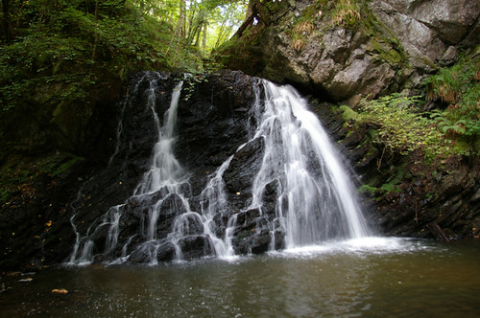
‘Waterfall’ by PontyPete is licensed under CC BY-NC-SA 2.0.
Figure 2 – beach with palm trees
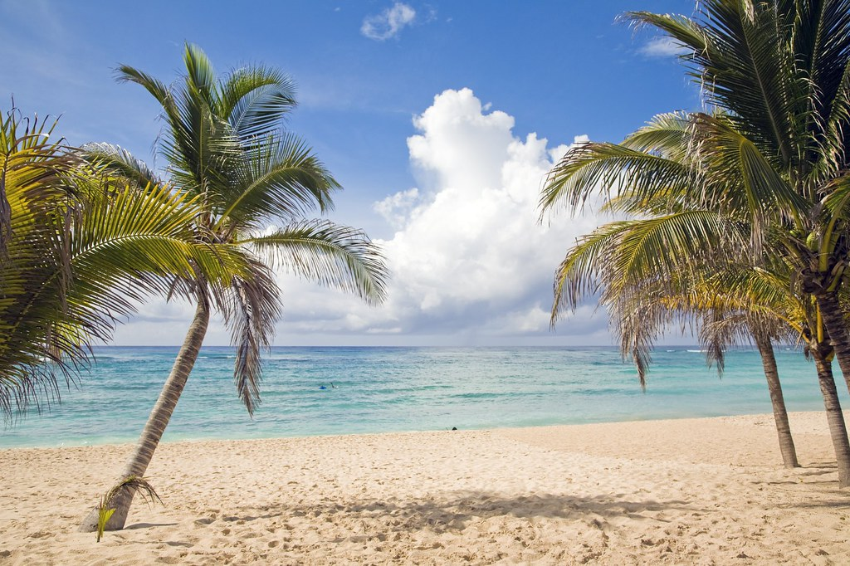
‘Beach Palm Trees Riviera Maya’ by Grand Velas Riviera Maya is licensed under CC BY-SA 2.0.
Figure 3 – snowy mountains with lake
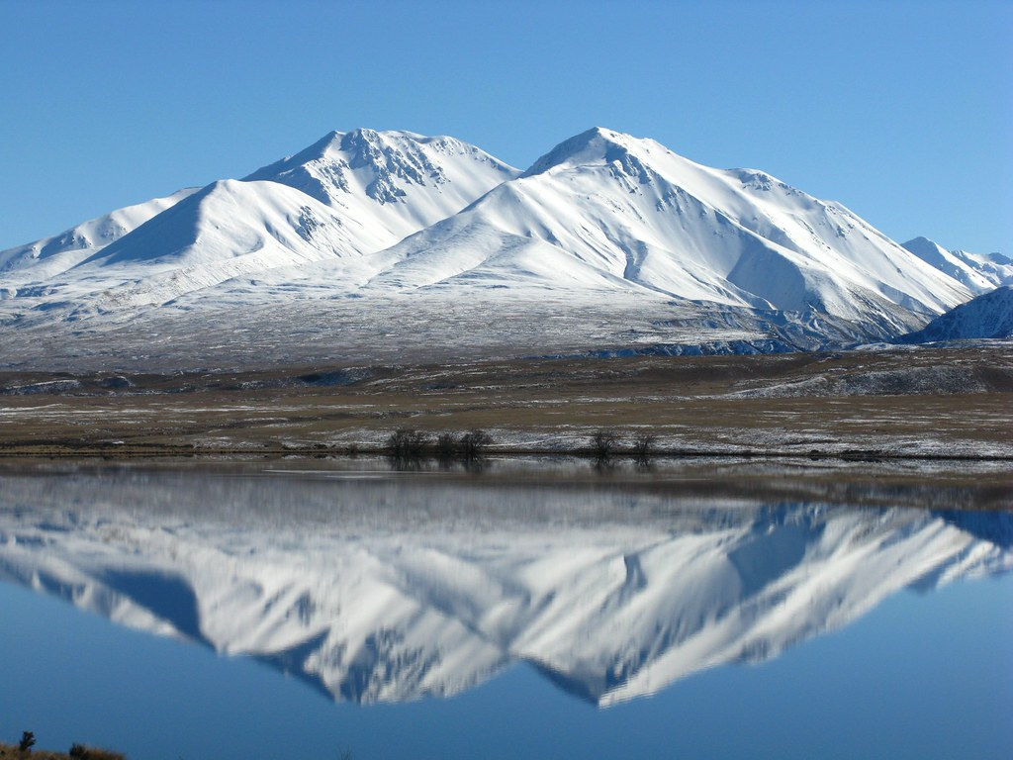
‘Snow Mountains Reflecting’ by Evan Forester is licensed under CC BY 2.0.
Figure 4 – flowing creek
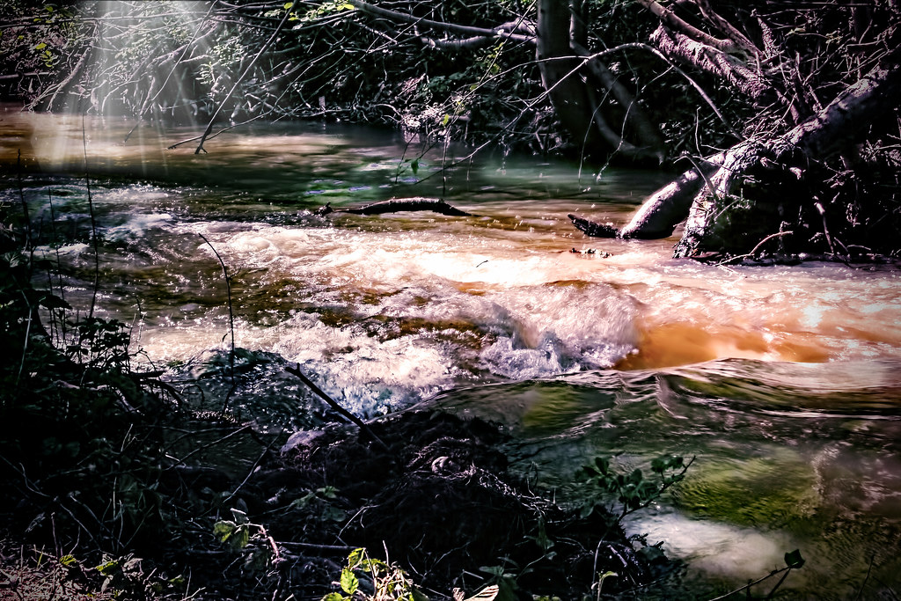
‘A beautiful creek’ by bluesbby is licensed under CC BY 2.0.
Outline how water has aesthetic value to people.

Importance of water in India
Use the following resources to summarise the importance of water to India’s people and environment:
- The Yamuna, India’s most polluted river (9:58)
- The Spiritual Significance of Water in India
- Chasing Rivers, Part 2: The Ganges (23:29).
Table 21 – the value of water in India summary
Economic | Spiritual | Cultural | Social
Complete a Venn Diagram for the following question ‘Compare and contrast the value of water in Australia and India’.

Learning sequence 6 – natural hazard investigation
Students:
- investigate ONE contemporary atmospheric hazard or hydrologic hazard including causes, impacts and responses, for example: (ACHGK042)
- explanation of the spatial distribution, cause and impact of the disaster
- examination of responses by individuals, groups and government to the impact of the disaster
- prediction of the impact of climate change on the occurrence, frequency and extent of this type of hazard
- discussion of management strategies to reduce the future impact of similar hazard events.

The nature and causes of flooding
Note: in this unit, students will learn about the natural hazard, flooding. Sensitivity should be used in selecting activities that are appropriate for your school context and cohort. Where students have experienced recent flooding, activities may need to be significantly adapted.
Provide students with a copy of Figure 5 for the next task in the learning sequence.
Figure 5 – looking into the past
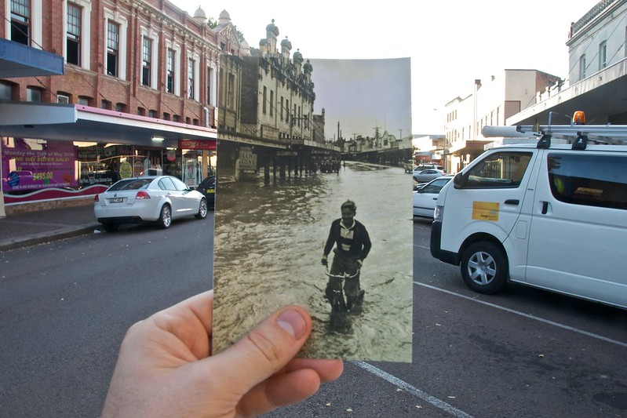
‘Looking into the past’ by Nomad Tales is licensed under CC BY-SA 2.0.
Conduct a Quick write using the image provided by your teacher.
- Look at the image provided by your teacher and think about what you are seeing.
- Identify the first thoughts and images that come into your mind.
- Write about any feelings, thoughts, or memories you have that associate with the natural hazard, floods.
Conduct a Think-Pair-Share to answer the question ‘What causes flooding?’
Watch Understanding Floods (3:14) and Understanding Flood Classifications (2:15) and outline the key causes of flooding in Australia. Ensure you include:
- riverine flooding
- flash flooding
- storm surge
- king tide
- snow melt.
Use Google Maps to locate your home or the home of a relative. Identify if the home located is situated on any of the following:
- riverine floodplain
- area prone to urban flash flooding
- coastal storm surge area
- estuarine environment prone to king tide
- in the snow where snow melt might increase water level.
Note: the following group research task will require students to be allocated a previous flood disaster. Flood disasters could include, Gundagai (June 1852), Brisbane (April 1974), Hawkesbury and Georges River (August 1986), Brisbane (January 2011), Lismore (February 2022). Provide the class with a map of Australia to locate and label their flooded area.
Your teacher has provided your class with a map of Australia and an Australian flood disaster to research. As a class, you will compile your research into a presentation titled ‘History of the worst floods in Australia’ using Google Slides. Each group will need to research the following information for their allocated location:
- day, month, year
- number of deaths
- impact to property
- action taken post disaster
- locate and label on class map of Australia.

The impact and management of flooding – Lismore, Northern New South Wales 2022
Note: students will need to be familiar with latitude and longitude to complete the following task. You may wish to review the video Latitude and longitude (4:24) with the class prior to commencing the task.
Access Google Earth and search for Lismore, NSW:
- What is the latitude and longitude for Lismore?
- What is the main river running through the city of Lismore?
- Zoom out and describe Lismore’s location in relation to the major cities, Brisbane and Sydney.
Access Floodplains and floods and with a partner discuss:
- the key reasons Lismore experiences the natural hazard, floods
- the long history Lismore has with natural disasters of floods
- the strategies the government has implemented in the past to minimise the impact of floods on people and property in Lismore and the surrounding area.
Access What is the La Niña and what does it mean for Australian weather? and explain why understanding the atmospheric circulation and consequent impact on weather in Australia is important to residents in flood prone locations.
Access Lismore’s worst-ever flood disaster – 2022 (7:02) and answer the following questions:
- What did you observe?
- What sparked curiosity?
- What is one question you now have?
As a class, compile the questions identified in the previous activity and vote for 3 as focus research questions. With a partner, compile a short response to each focus question and contribute findings to a class Google Slide.
Access Flooding and flood management and answer the following questions:
- What geological feature will contribute to the cause of flooding?
- What is a hydrograph?
- What is hard engineering management?
- What is soft engineering management?
- What is a disadvantage of a dam or reservoir?
- What is river dredging?
- What is a disadvantage of flood warning?
- What is an advantage of floodplain zoning?
Imagine you are a resident in Lismore and are developing a flood action plan for your property. Access Emergencies and disasters and explicitly identify the steps you would take to protect yourself and your property from the natural hazard, flood.

Assessment task
Note: when using this task, ensure it is placed on the school template and follows all assessment requirements.

Outcomes
- GE4-3 explains how interactions and connections between people, places and environments result in change
- GE4-8 communicates geographical information using a variety of strategies

Syllabus content
Investigate the nature of water scarcity and ways of overcoming it (ACHGK040).

Task
You are a representative of the World Health Organisation and have been tasked the responsibility of applying for funding from the United Nations for economic support of a country facing water scarcity.
You will need to choose from one of the following nations to represent to the panel:
- China
- Botswana
- Saudi Arabia
- India
- Qatar.
To convince the panel, you will need to give a 3-minute presentation outlining why your country is in most need of the support. Your presentation should:
- describe which human actions have caused the water scarcity
- explain the scale of water scarcity
- explain why your chosen country is at the greatest risk of water scarcity in 2040
- assess how well one strategy used to combat this problem has worked
- outline how the funding will be used to combat water scarcity in your country.
Resources to get you started
- Future global urban water scarcity and potential solutions
- Water Shortage: Causes and Effects
- Water Scarcity in Africa: Everything You Need to Know
- Water Governance: Blueprint To Tackle Water crisis
- Global water crisis: Facts, FAQS, and how to help
- The Water Crisis

Marking criteria
Table 22 – assessment marking criteria
Grade | Criteria
A | - Demonstrates extensive knowledge and understanding of global challenges of water scarcity and its management  - Displays sophisticated skills to select, acquire and process geographical information, using an extensive range of strategies to communicate effectively
B | - Demonstrates thorough knowledge and understanding of global challenges of water scarcity and its management  - Displays high-level skills to select, acquire and process geographical information, using an extensive range of strategies to communicate effectively
C | - Demonstrates sound knowledge and understanding of global challenges of water scarcity and its management  - Displays sound skills to select, acquire and process geographical information, using a range of strategies to communicate effectively
D | - Demonstrates basic knowledge and understanding of global challenges of water scarcity and its management  - Displays basic skills to select, acquire, process and/or communicate geographical information
E | - Demonstrates elementary knowledge and understanding of global challenges of water scarcity and its management  - Displays elementary skills to select, acquire, process and/or communicate geographical information

Appendix – capacity matrix
Note: a general concept and glossary list has been outlined. However, you may wish to add further terminology or skills to the capacity matrix.
Key classification
- Information – recall basic facts or heard of this before
- Knowledge – can explain and know what it means
- Know-how – can draw connections between this geographical term or concept and relate them to other concepts or situations
- Wisdom – can use the term or concept in new contexts or teach others
Shade or tick information, knowledge, know-how, and wisdom as you progress with your understanding of the geographical concept or term. At the end of the learning sequence, reflect on your progress and discuss with your teacher if you observe any areas you can improve.
Table 23 – glossary of concepts and terms
Glossary word | Information | Knowledge | Know-how | Wisdom
biodiversity | ☐ | ☐ | ☐ | ☐
conservation | ☐ | ☐ | ☐ | ☐
convergent boundary | ☐ | ☐ | ☐ | ☐
cross section | ☐ | ☐ | ☐ | ☐
crust (earth) | ☐ | ☐ | ☐ | ☐
deposition | ☐ | ☐ | ☐ | ☐
divergent boundary | ☐ | ☐ | ☐ | ☐
erosion | ☐ | ☐ | ☐ | ☐
field sketch | ☐ | ☐ | ☐ | ☐
geomorphic | ☐ | ☐ | ☐ | ☐
Indigenous Protected Area | ☐ | ☐ | ☐ | ☐
landforms | ☐ | ☐ | ☐ | ☐
landscapes | ☐ | ☐ | ☐ | ☐
latitude | ☐ | ☐ | ☐ | ☐
lava | ☐ | ☐ | ☐ | ☐
longitude | ☐ | ☐ | ☐ | ☐
magma | ☐ | ☐ | ☐ | ☐
mantle | ☐ | ☐ | ☐ | ☐
national park | ☐ | ☐ | ☐ | ☐
photo sketch | ☐ | ☐ | ☐ | ☐
plate tectonics | ☐ | ☐ | ☐ | ☐
rock cycle | ☐ | ☐ | ☐ | ☐
sustainability | ☐ | ☐ | ☐ | ☐
topographic mapping | ☐ | ☐ | ☐ | ☐
traditional ecological knowledge | ☐ | ☐ | ☐ | ☐
transformative boundary | ☐ | ☐ | ☐ | ☐
values (aesthetic, cultural, spiritual, and economic) | ☐ | ☐ | ☐ | ☐
volcano | ☐ | ☐ | ☐ | ☐
weathering | ☐ | ☐ | ☐ | ☐
worldview | ☐ | ☐ | ☐ | ☐

References
This resource contains NSW Curriculum and syllabus content. The NSW Curriculum is developed by the NSW Education Standards Authority. This content is prepared by NESA for and on behalf of the Crown in right of the State of New South Wales. The material is protected by Crown copyright.
Please refer to the NESA Copyright Disclaimer for more information https://educationstandards.nsw.edu.au/wps/portal/nesa/mini-footer/copyright.
NESA holds the only official and up-to-date versions of the NSW Curriculum and syllabus documents. Please visit the NSW Education Standards Authority (NESA) website https://educationstandards.nsw.edu.au/ and the NSW Curriculum website https://curriculum.nsw.edu.au.
Geography K-10 Syllabus © 2015 NSW Education Standards Authority (NESA) for and on behalf of the Crown in right of the State of New South Wales.
7NEWS Australia (28 February 2022) ‘Lismore’s worst-ever flood disaster – 2022 | 7NEWS’ [video], 7NEWS Australia, YouTube, accessed 15 December 2022.
Australian Broadcasting Corporation (ABC) (23 November 2021) 'Where does water go after it rains?' [video]’, ABC Education, ABC website, accessed 15 December 2022.
Australian Environmental Education (n.d.) The Story of a River, Australian Environmental Education website, accessed 15 December 2022.
Australian Environmental Education (n.d.) The Urban Water Cycle, Australian Environmental Education website, accessed 15 December 2022.
Australian Government Department of Agriculture (15 May 2018) ‘Australia’s water markets (5 minute version)’ [video], Australian Government Department of Agriculture, YouTube, accessed 15 December 2022.
British Broadcasting Corporation (BBC) (2022) Flooding and flood management, BBC Bitesize website, accessed 15 December 2022.
BBC (2022) Water insecurity – the demand for water, BBC Bitesize website, accessed 15 December 2022.
Bureau of Meteorology (BOM) (n.d.) Evaporation: Average Monthly & Annual Evaporation, Bureau of Meteorology website, accessed 15 December 2022.
BOM (n.d.) Topographic Drainage Divisions and River Regions, Bureau of Meteorology website, accessed 15 December 2022.
BOM (2016) Climate classification maps, Bureau of Meteorology website, accessed 15 December 2022.
BOM (2020) Average annual, seasonal and monthly rainfall, Bureau of Meteorology website, accessed 15 December 2022.
BOM (2020) Rainfall percentiles, Bureau of Meteorology website, accessed 15 December 2022.
BOM (2020) Rainfall variability, Bureau of Meteorology website, accessed 15 December 2022.
Bureau of Meteorology (28 November 2019) ‘Understanding Flood Classifications’ [video], Bureau of Meteorology, YouTube, accessed 15 December 2022.
Bureau of Meteorology (28 November 2019) ‘Understanding Floods’ [video], Bureau of Meteorology, YouTube, accessed 15 December 2022.
Central Coast Council (n.d.) High School Water Education Program, Love Water, Use it Wisely website, accessed 15 December 2022.
Central Coast Council (n.d.) ‘Platypus Creek Estate Activity’, High School Water Education Program, Love Water, Use it Wisely website, accessed 15 December 2022.
Circle of Blue (2022) Water Scarcity in India, Circle of Blue website, accessed 15 December 2022.
ClimateKelpie (3 October 2016) ‘Climatedog Sam: bringer of cold fronts from the Southern Ocean (Southern Annular Mode)’ [video], ClimateKelpie, YouTube, accessed 15 December 2022.
Corpus Christi College (2021) ‘Water in Aboriginal culture’, Year 7 Water in the World, Robert McCormack Library website, accessed 15 December 2022.
d-maps (2022) Australia: Commonwealth of Australia, d-maps.com, accessed 15 December 2022.
Doyle K (24 November 2021) ‘What is the La Niña and what does it mean for Australian weather?’, ABC Weather, ABC News website, accessed 15 December 2022.
Enviro Friendly (2020) Map of Average Rainfall in Australia, Enviro Friendly website, accessed 15 December 2022.
Free World Maps (2021) Free printable maps of Africa, FreeWorldMaps.net, accessed 15 December 2022.
He C, Liu Z, Wu J, Pan X, Fang Z, Li J and Bryan BA (2021) ‘Future global urban water scarcity and potential solutions’, Nature Communications, 12(4667), https://doi.org/10.1038/s41467-021-25026-3, accessed 15 December 2022.
Heggie J (2022) Failing Rains and Thirsty Cities: Australia’s Growing Water Problem, National Geographic website, accessed 15 December 2022.
Horticulture Industry Networks (n.d.) BOM Tool: Australian Landscape Water Balance, Horticulture Industry Networks website, accessed 15 December 2022.
Isha Foundation (29 July 2019) The Spiritual Significance of Water in India, Isha Foundation website, accessed 15 December 2022.
jeygenraam (24 September 2015) ‘Pie Charts and Protractors’ [video], jeygenraam, YouTube, accessed 15 December 2022.
Kari Constanza (3 July 2013) ‘Walking in Sabina’s Shoes--An Update’ [video], Kari Constanza, YouTube, accessed 15 December 2022.
Klobucista C and Robinson K (2022) Water Stress: A Global Problem That’s Getting Worse, Council on Foreign Relations website, accessed 15 December 2022.
Lai O (26 June 2022) Water Shortage: Causes and Effects, Earth.org, accessed 15 December 2022.
Lismore City Council (2022) Emergencies and disasters, Lismore City Council website, accessed 15 December 2022.
Math Worksheets 4 Kids (2022) Water Cycle Worksheets, Math Worksheets 4 Kids website, accessed 15 December 2022.
McMahon M (30 October 2022) What Is Aesthetic Value?, SmartCapitalMind website, accessed 15 December 2022.
Melbourne Water (1 May 2017) 'Exploring the world of waterbugs with students' [video], Melbourne Water, YouTube, accessed 15 December 2022.
Melbourne Water (2020) ‘Waterbug identification guide and resources’, Activities for all ages, Melbourne Water website, accessed 15 December 2022.
Melbourne Water (2022) ‘Guide to running waterbug sessions’, Teacher resources by year level, Melbourne Water website, accessed 15 December 2022.
Met Office – UK Weather (16 April 2014) ‘How does rain form and what is the water cycle?’ [video], Met Office – UK Weather, YouTube, accessed 15 December 2022.
Mlaba K (2022) Water Scarcity in Africa: Everything You Need to Know, Defeat Poverty, Global Citizen website, accessed 15 December 2022.
Murray–Darling Basin Authority (n.d.) ‘Water availability worksheet’, Lesson packages downloads, Murray–Darling Basin Authority, accessed 15 December 2022.
Murray–Darling Basin Authority (2020) Influences on the water cycle, Murray–Darling Basin Authority website, accessed 15 December 2022.
Murray–Darling Basin Authority (2020) Water availability in Australia, Murray–Darling Basin Authority website, accessed 8 December 2022.
Murray–Darling Basin Authority (2022) Catchments in the Murray–Darling Basin, Murray–Darling Basin Authority website, accessed 15 December 2022.
Murray–Darling Basin Authority (2022) Maps: Murray–Darling Basin map, Bureau of Meteorology website, accessed 15 December 2022.
Murray–Darling Basin Authority (2022) Posters, stickers and cards, Bureau of Meteorology website, accessed 15 December 2022.
NASA (National Aeronautics and Space Administration) (2000) Australia, Shaded Relief and Colored Height, NASA Earth Observatory website, accessed 15 December 2022.
NASA (2000) Cloud Fraction, NASA Earth Observatory website, accessed 15 December 2022.
NASA (2000) Total Rainfall, NASA Earth Observatory website, accessed 15 December 2022.
NASA (2002) Water Vapor, NASA Earth Observatory website, accessed 15 December 2022.
NASA (2022) NASA Earth Observatory [website], accessed 15 December 2022.
NASA Goddard (3 August 2012) ‘NASA | Earth’s Water Cycle’ [video], NASA Goddard, YouTube, accessed 15 December 2022.
National Geographic (18 November 2014) ‘Chasing Rivers, Part 2: The Ganges | Nat Geo Live’ [video], National Geographic, YouTube, accessed 15 December 2022.
National Geographic (2022) Freshwater Availability, National Geographic website, accessed 15 December 2022.
Netflix (17 April 2020) ‘Explained | World’s Water Crisis | FULL EPISODE | Netflix’ [video], Netflix, YouTube, accessed 15 December 2022.
New South Wales (NSW) Government Department of Education (n.d.) BOLTSS and scale, NSW Department of Education, accessed 15 December 2022.
New South Wales (NSW) Government Department of Education (n.d.) Common graphs, NSW Department of Education, accessed 15 December 2022.
New South Wales (NSW) Government Department of Education (n.d.) Introduction to maps, NSW Department of Education, accessed 15 December 2022.
New South Wales (NSW) Government Department of Education (n.d.) Latitude and longitude, NSW Department of Education, accessed 15 December 2022.
New South Wales (NSW) Government Department of Education (n.d.) Snowy Hydro virtual excursion, NSW Department of Education, accessed 15 December 2022.
Oregon State University Ecampus (3 May 2016) 'Understanding the Watershed' [video], Oregon State University Ecampus, YouTube, accessed 15 December 2022.
QLA (Quality Learning Australasia) (n.d.) The Capacity Matrix, QLA website, accessed 15 December 2022.
Ritchie H and Roser M (2018) Water Use and Stress, Our World In Data website, accessed 15 December 2022.
Rous County Council (n.d.) Floodplains and floods, Rous County Council website, accessed 15 December 2022.
sgPUB (7 October 2014) ‘The Singapore Water Story’ [video], sgPUB, YouTube, accessed 15 December 2022.
State of Victoria (Department of Environment and Primary Industries) (12 December 2011) ‘Climatedogs: ENSO’ [video], NSW DPI Agriculture, YouTube, accessed 15 December 2022.
State of Victoria (Department of Environment and Primary Industries) (27 February 2012) ‘Climatedogs: EASTIE’ [video], NSW DPI Agriculture, YouTube, accessed 15 December 2022.
State of Victoria (Department of Environment and Primary Industries) (23 May 2014) ‘Climatedog Indy’ [video], Depi Victoria, YouTube, accessed 15 December 2022.
State of Victoria (Department of Environment and Primary Industries) (23 May 2014) ‘Climatedog Ridgy’ [video], Depi Victoria, YouTube, accessed 15 December 2022.
State Government of Victoria (Department of Education) (2020) ‘Dictogloss’, Literacy Teaching Toolkit, Department of Education website, accessed 15 December 2022.
Sydney Water (2022) Sydney Water [website], accessed 15 December 2022.
Sydney Water (2022) Water audit: How water-efficient is your school?, Sydney Water website, accessed 15 December 2022.
SydneyWaterTV (20 October 2017) ‘How Much Water Does Your School Use?’ [video], SydneyWaterTV, YouTube, accessed 15 December 2022.
Taylor M and Accheri C (17 January 2020) ‘How Singapore is putting a stop to water running out’, Global Centre on Adaptation, accessed 15 December 2022.
The Australian Museum (2022) Water around the world, The Australian Museum website, accessed 15 December 2022.
The Guardian (7 July 2017) ‘The Yamuna, India’s most polluted river’ [video], The Guardian, YouTube, accessed 15 December 2022.
The Hindu (16 February 2022) Water Governance: Blueprint To Tackle Water crisis, The Hindu website, accessed 15 December 2022.
The University of Melbourne (2017) ‘Water’, Aboriginal and Torres Strait Islander School Curricula, The University of Melbourne website, accessed 15 December 2022.
Water Corporation (2022) ‘Water in Aboriginal culture’, School programs, Water Corporation website, accessed 15 December 2022.
Water.org (2022) The Water Crisis, Water.org, accessed 15 December 2022.
World Data Lab (n.d.) Water Scarcity Clock [website], accessed 15 December 2022.
World Vision (8 December 2010) ‘Walking in Sabina’s Shoes | World Vision’ [video], World Vision, YouTube, accessed 15 December 2022.
World Vision Australia (2022) Get Connected: Water in the world, World Vision Australia website, accessed 15 December 2022.
World Vision Australia (2022) Global water crisis: Facts, FAQs, and how to help, World Vision Australia website, accessed 15 December 2022.

© State of New South Wales (Department of Education), 2022
The copyright material published in this resource is subject to the Copyright Act 1968 (Cth) and is owned by the NSW Department of Education or, where indicated, by a party other than the NSW Department of Education (third-party material).
Copyright material available in this resource and owned by the NSW Department of Education is licensed under a Creative Commons Attribution 4.0 International (CC BY 4.0) license.
This license allows you to share and adapt the material for any purpose, even commercially.
Attribution should be given to © State of New South Wales (Department of Education), 2022.
Material in this resource not available under a Creative Commons license:
- the NSW Department of Education logo, other logos and trademark-protected material
- material owned by a third party that has been reproduced with permission. You will need to obtain permission from the third party to reuse its material.
Links to third-party material and websites
Please note that the provided (reading/viewing material/list/links/texts) are a suggestion only and implies no endorsement, by the New South Wales Department of Education, of any author, publisher, or book title. School principals and teachers are best placed to assess the suitability of resources that would complement the curriculum and reflect the needs and interests of their students.
If you use the links provided in this document to access a third-party's website, you acknowledge that the terms of use, including licence terms set out on the third-party's website apply to the use which may be made of the materials on that third-party website or where permitted by the Copyright Act 1968 (Cth). The department accepts no responsibility for content on third-party websites.

