History Early Stage 1
Important family events

Contents
Topic – Personal and family histories 3
Key inquiry questions 3
Overview 3
Outcomes 3
Content 3
Historical inquiry skills 4
Selected historical concepts 5
Assessment 5
Vocabulary 6
Teaching and learning activities 7
Inquiry 1 – sharing stories of past celebrations 7
Stimulus 7
Historical inquiry step 1 – question 8
Historical inquiry steps 2 and 3 – research and analyse 8
Historical inquiry step 4 – evaluate 9
Historical inquiry step 5 – communicate 9
Reflection 10
Inquiry 2 – celebrating special events 10
Stimulus 10
Historical inquiry step 1 – question 12
Historical inquiry steps 2 and 3 – research and analyse 12
Historical inquiry step 4 – evaluate 13
Historical inquiry step 5 – communicate 13
Reflection 14
Resources 15
References 16

Topic – Personal and family histories
Duration: 5 weeks – 90 minutes per week

Key inquiry questions
- What stories do other people tell me about the past?
- How can stories be told and shared?

Overview
Personal and family histories provides students with the opportunity to learn about their own history and that of their family; this may include stories from a range of other cultures and other parts of the world. As participants in their own history, students build on their knowledge and understanding of how the past is different to the present.
This learning sequence comprises 2 inquiries – sharing stories of past celebrations and celebrating special events. Students use a variety of sources including stories, photographs and personal artefacts to investigate how stories can be communicated, how stories can differ depending on who is telling them and to identify and record information about significant events.

Outcomes
A student:
- HTe-1 communicates stories of their own family heritage and the heritage of others
- HTe-2 demonstrates developing skills of historical inquiry and communication.
Outcomes and other syllabus material referenced in this document are from History K–10 Syllabus © NSW Education Standards Authority (NESA) for and on behalf of the Crown in right of the State of New South Wales, 2012.

Content
How the stories of families and the past can be communicated, for example through photographs, artefacts, books, oral histories, digital media and museums (ACHHK004)
Students:
- use a variety of sources including photographs or a treasured object from their homes, to recount stories about their families and discuss how sources are used to answer the question 'How do we know?'
- discuss the significance of the chosen treasured object or photograph (it may be important or significant to themselves but not to others)
- recognise that stories of the past may differ depending on who tells the story, for example, stories of their childhood told by themselves and another member of the family.
How they, their family and friends commemorate past events that are important to them (ACHHK003)
Students:
- share experiences of family, school and local events that are celebrated or observed
- identify and record a variety of holidays and special events observed in Australia and other countries, for example, birthdays, anniversaries and festivals. Consider the significance of these dates.

Historical inquiry skills
- Comprehension: chronology, terms and concepts
- respond by demonstrating active listening behaviour, through discussion and by recalling and retelling stories
- sequence familiar objects and events (ACHHS015)
- distinguish between the past, present and future (ACHHS016)
- Use of sources
- explore and use a range of sources about the past (ACHHS018)
- identify and compare features of objects from the past and present (ACHHS019)
- Perspectives
- explore a point of view (ACHHS020)
- Empathetic understanding
- recognise differences and similarities between individuals and families in the past and present
- Research
- pose questions about the past using sources provided (ACHHS017)
- Explanation and communication
- develop a narrative about the past (ACHHS021)
- use a range of communication forms (oral, graphic, written, role play) and digital technologies (ACHHS022)

Selected historical concepts
- Cause and effect: events, decisions or developments in the past that produce later actions, results or effects, for example, simple cause and effect in stories.
- Perspectives: people from the past will have different views shaped by their experiences, for example, exploration of a point of view and understanding that stories may vary depending on who is the narrator.
- Empathetic understanding: developing an understanding of another's views, life and decisions made, for example, development of an understanding of difference and similarities between families.
- Significance: importance of an event, development or individual/group, for example, the personal importance of a treasured object; significant events in students' lives and the importance and meaning of special days and holidays.

Assessment
All activities require students to demonstrate their learning. All are assessment for learning activities.

Vocabulary
- Listen, observe, explore, examine, identify, record, describe, sequence, compare, explain, discuss, illustrate, write, present, reflect
- Story, photograph, object, artefact, book, video, event, source, point of view
- Holidays, events, celebrate, significant, special, family

Teaching and learning activities
This learning sequence comprises 2 inquiries.

Inquiry 1 – sharing stories of past celebrations
Students explore how stories of family and the past can be communicated. They use sources to recount information about their family and discuss how sources are used to answer questions. Students recognise that stories of the past may differ depending on who tells the story.

Stimulus
People use photographs to remember events that happened in the past. Not all stories are written down but are remembered by passing on stories using photographs.

Source 1
Figure 1 – Children’s birthday party, Sam Hood, circa 1930
‘Children's birthday party at the home of Mrs Lucy Jane Moran 1930s’ by Sam Hood, State Library of New South Wales is licensed under Flickr: The Commons.
This is a photograph from the early 1900s of a children’s birthday party. Observe the photograph of the birthday party. Ask students:
- What do you think is happening in the photograph?
- How many people can you see?
- Who do you think is in the photograph?
- Where do you think they are?
- When do you think this photograph was taken?
- How is this birthday celebration of the past different to a birthday celebration today?
Students will have varying ideas about what is happening in the photograph. Discuss how stories can change as they are passed on from person to person as they might have a different memory or point of view of the celebration.

Historical inquiry step 1 – question
After observing the photograph, and guided by the syllabus dot points, generate a class set of inquiry questions, for example:
- How can stories be told and shared?
- How does your family tell stories about past celebrations?
- Why are stories different when they are told by different people?
Note: inquiry questions may need to be redesigned through the historical inquiry process.

Historical inquiry steps 2 and 3 – research and analyse
Stories of my family
Collect a variety of items that could be used to tell students about a family celebration, which could be one of your own. These could include photographs, videos, invitations, written items or significant objects. Share the story of the family celebration using these items.
Identify different ways that families can share stories about past celebrations to pass on information. These include writing, talking or sharing photographs, videos and other significant objects. Ask students to talk to their family about a special family celebration and bring to school some significant items to tell the class about the celebration. Allow students to share their stories and create a class mind map of all of the different ways that stories were shared.
Students create an artwork that illustrates their special family celebration. Create a display of all the special family celebrations that the class has shared. Using the display discuss how different celebrations or events may be significant to them but not to others.
Stories from different points of view
Read a story that includes a variety of points of view. An example of a story that could be used is They all saw a cat by Brendan Wenzel.

Source 2
Brendan Wenzel (2016) They all saw a cat
Explain to students that people can have a different point of view of the same thing depending on their experience and memory. Create a display that includes four of the characters in the book. Record key words that highlight each of the character’s viewpoints about the cat and discuss why they might be different.
Classroom celebration
Host a celebration organised by the class. During the celebration take photographs and video to record the event. After the event ask students to give a recount of the event. Discuss how each recount was different depending on who told the story.

Historical inquiry step 4 – evaluate
Ask the students to recall some of the sources used to collect information about family celebrations of the past. Discuss the reliability of the sources. Whose view is presented? What might be missing or forgotten?

Historical inquiry step 5 – communicate
Family celebration
Using a significant object or photograph students tell a story about a family celebration that has been passed onto them. They tell the class who passed on the story and include details of when it was, where it was, who was there, what happened.

Reflection
Students reflect on the historical inquiry process, reflecting on what they learned, how they learned it and what else they would like to find out.

Inquiry 2 – celebrating special events
Students share experiences of how they, their family and friends commemorate past events that are important to them. They identify and record a variety of holidays and special events observed in Australia and other countries and consider the significance of these.

Stimulus
Brainstorm the different events that students celebrate with their family, for example, birthdays, ANZAC Day, new year, Easter, Christmas, Ramadan.
Examine the photographs of different events in sources 3 and 4. Discuss what students think is happening in each photograph. How do they know? Do they celebrate any of these events with their family?

Source 3
Figure 2 – Chinese New Year 2008
‘Chinese New Year in Ireland 2008’ by Sebastian Dooris is licensed under CC by PDM1.0.

Source 4
Figure 3 – ANZAC Day March, Canberra, NSW, 2006
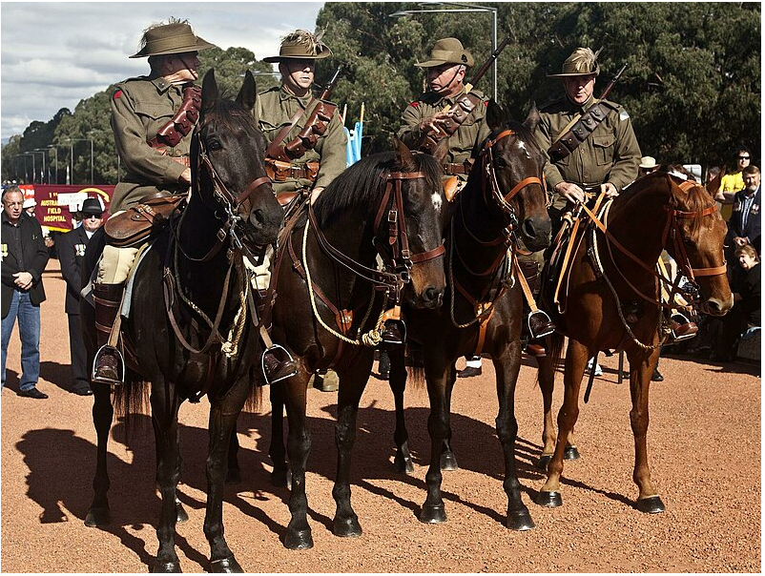
‘ANZAC Day Canberra’ by John is licensed under CC BY-SA 2.0.

Historical inquiry step 1 – question
After observing the photographs, and guided by the syllabus dot points, generate a class set of inquiry questions, for example:
- What special events does my family celebrate?
- How does my family celebrate special events?
- How do other families celebrate special events?
- What are some special events that are celebrated in Australia and other countries?
- Why are these events considered significant?

Historical inquiry steps 2 and 3 – research and analyse
Special events our class celebrates
Read a collection of stories that include the celebration of a variety of different special events and discuss how they were celebrated. Examples of stories that could be used are Happy birthday to you by Dr Seuss and A New Year’s reunion: a Chinese story by Yu Li-Qiong.

Source 5
Dr Seuss (2003) Happy birthday to you

Source 6
Yu Li-Qiong (2013) A New Year’s reunion: a Chinese story
Ask students to identify special events that their family celebrates. Using a Y-chart, students record information about one of the special events, what the event looks like, sounds like and feels like.
Students share their Y-chart with a classmate. They identify 2 things that are similar about their family event and 2 things that are different and report back to the class.
Explain to students that families celebrate special events in all different ways. Some are similar to the way your family celebrates and some are different which makes them special.
Significant events in Australia and around the world
Discuss the meaning of the term ‘significant’. Identify and record a variety of holidays and significant events observed in Australia and other countries on a class calendar.
Read a story about a significant event. An example of a story that could be used is My Grandad Marches on ANZAC Day by Catriona Hoy and Benjamin Johnson.

Source 7
Catriona Hoy and Benjamin Johnson (2008) My Grandad Marches on ANZAC Day
After reading the story, brainstorm why the event is significant and how it is remembered. Students may have a variety of ways that they and their family observe the significant event which may be different from others in the class.
Ask students to identify a significant event that their family celebrates. They could be prompted by the class calendar of significant events that the class created but should not be limited to this. Students create role plays in small groups which would provide a snapshot of how they celebrate the day. After the role play allow students time to explain what was happening.

Historical inquiry step 4 – evaluate
Discuss the reliability of photographs and stories of different special events. Do they provide a true representation of the event and how it can be celebrated? Do the inquiry questions need to be redesigned as a result of analysing and evaluating sources?

Historical inquiry step 5 – communicate
Design a special event to celebrate
Students create an artwork of a new event to celebrate. When creating the artwork students think about what the event would be, when it would be celebrated, why it would be celebrated and how it would be celebrated. Students explain the special event to the class using their artwork.

Reflection
Students reflect on the historical inquiry process, reflecting on what they learned, how they learned it and what else they would like to find out.

Resources
Picture books
- They all saw a cat by Brendan Wenzel (2016)
- Happy birthday to you by Dr Seuss (2003)
- A New Year’s reunion: a Chinese story by Yu Li-Qiong (2013)
Digital collections
- State Library of New South Wales: Historical photograph sets on Flickr

References
This resource contains NSW Curriculum and syllabus content. The NSW Curriculum is developed by the NSW Education Standards Authority. This content is prepared by NESA for and on behalf of the Crown in right of the State of New South Wales. The material is protected by Crown copyright.
Please refer to the NESA Copyright Disclaimer for more information https://educationstandards.nsw.edu.au/wps/portal/nesa/mini-footer/copyright.
NESA holds the only official and up-to-date versions of the NSW Curriculum and syllabus documents. Please visit the NSW Education Standards Authority (NESA) website https://educationstandards.nsw.edu.au/wps/portal/nesa/home and the NSW Curriculum website https://curriculum.nsw.edu.au/.
History K–10 Syllabus © NSW Education Standards Authority (NESA) for and on behalf of the Crown in right of the State of New South Wales, 2012.

© State of New South Wales (Department of Education), 2024
The copyright material published in this resource is subject to the Copyright Act 1968 (Cth) and is owned by the NSW Department of Education or, where indicated, by a party other than the NSW Department of Education (third-party material).
Copyright material available in this resource and owned by the NSW Department of Education is licensed under a Creative Commons Attribution 4.0 International (CC BY 4.0) license.
This license allows you to share and adapt the material for any purpose, even commercially.
Attribution should be given to © State of New South Wales (Department of Education), 2024.
Material in this resource not available under a Creative Commons license:
- the NSW Department of Education logo, other logos and trademark-protected material
- material owned by a third party that has been reproduced with permission. You will need to obtain permission from the third party to reuse its material.
Links to third-party material and websites
Please note that the provided (reading/viewing material/list/links/texts) are a suggestion only and implies no endorsement, by the New South Wales Department of Education, of any author, publisher, or book title. School principals and teachers are best placed to assess the suitability of resources that would complement the curriculum and reflect the needs and interests of their students.
If you use the links provided in this document to access a third-party's website, you acknowledge that the terms of use, including licence terms set out on the third-party's website apply to the use which may be made of the materials on that third-party website or where permitted by the Copyright Act 1968 (Cth). The department accepts no responsibility for content on third-party websites.

