History Stage 1
Changing technology

Contents
Topic – The past in the present 3
Key inquiry question 3
Overview 3
Outcomes 3
Content 3
Historical inquiry skills 4
Selected historical concepts 5
Assessment 5
Vocabulary 5
Teaching and learning activities 6
Inquiry 1 – family structures past and present 6
Stimulus 6
Historical inquiry step 1 – question 6
Historical inquiry steps 2 and 3 – research and analyse 7
Historical inquiry step 4 – evaluate 8
Historical inquiry step 5 – communicate 8
Reflection 8
Inquiry 2 – the impacts of changing technology 9
Stimulus 9
Historical inquiry step 1 – question 10
Historical inquiry steps 2 and 3 – research and analyse 10
Historical inquiry step 4 – evaluate 13
Historical inquiry step 5 – communicate 13
Reflection 13
Resources 14
References 15

Topic – The past in the present
Duration: 5 weeks – 90 minutes per week

Key inquiry question
- How have changes in technology shaped our daily life?

Overview
This learning sequence consists of 2 short inquiries – the changing technology in the home and community and the impacts of changing technology. In the first, students investigate how technology has changed in their home and community. They discuss the similarities and differences of technology from the past and sequence them over time. In the second, students explore the way technology has changed the way we communicate. They use a range of communication forms to explain the impact of changing technology on people’s lives.

Outcomes
A student:
- HT1-3 describes the effects of changing technology on people's lives over time
- HT1-4 demonstrates skills of historical inquiry and communication.
Outcomes and other syllabus material referenced in this document are from History K–10 Syllabus © NSW Education Standards Authority (NESA) for and on behalf of the Crown in right of the State of New South Wales, 2012.

Content
The impact of changing technology on people's lives (ACHHK046)
Students:
- identify examples of changing technologies in their home or community
- discuss the similarities and differences of technology from the past through a range of sources and sequence them over time
- use a range of communication forms to explain how one example of changing technology affected people's lives.

Historical inquiry skills
- Comprehension: chronology, terms and concepts
- discuss and recount stories of family and local history
- sequence familiar objects and events (ACHHS031, ACHHS047)
- distinguish between the past, present and future (ACHHS032, ACHHS048)
- Use of sources
- explore and use a range of sources about the past (ACHHS034, ACHHS050)
- identify and compare features of objects from the past and present (ACHHS035, ACHHS051)
- Perspectives
- explore a point of view within an historical context (ACHHS036, ACHHS052)
- Empathetic understanding
- recognise that people in the local community may have lived differently in the past
- Research
- pose questions about the past using sources provided (ACHHS033, ACHHS049)
- Explanation and communication
- develop a narrative about the past (ACHHS037, ACHHS053)
- use a range of communication forms (oral, graphic, written, role play) and digital technologies (ACHHS038, ACHHS054)

Selected historical concepts
- Cause and effect: events, decisions or developments in the past that produce later actions, results or effects, for example, how everyday life has changed over time; how changing technologies affected peoples' lives over time.
- Continuity and change: some things change over time and others remain the same, for example, changes and similarities in family life over time; aspects in the local community that have changed or remained the same.

Assessment
All activities require students to demonstrate their learning. All are assessment for learning activities.

Vocabulary
- Ask, listen, observe, explore, examine, identify, record, describe, sequence, compare, recall, explain, discuss, recount, illustrate, write, present, role play, reflect
- Time, past, present, similar, different
- Story, photograph, object, book, collection, video, museum, source, timeline
- Technology, change, impact, cause, effect

Teaching and learning activities
This learning sequence comprises 2 inquiries.

Inquiry 1 – family structures past and present
Students use sources to identify examples of changing technologies in their home and community. They discuss the similarities and differences of technology from the past and sequence them over time.

Stimulus
Museum
Prepare a ‘museum’ collection containing a variety of old and new objects and photographs, that show changes in communication technology over time. Students walk through the museum exploring the different objects. The objects and photographs could include an old phone, mobile phone, television, radio, computers old and new, a letter, mailbox, noticeboard, internet or examples of a mail delivery service by horse, car, van or bike.
As a class examine and identify each object and decide if it is from the past or the present. Discuss the similarities and differences between the different types of communication technology and sequence them from oldest to newest.

Historical inquiry step 1 – question
After exploring the museum, and guided by the syllabus dot points, generate a class set of inquiry questions, for example:
- What is technology?
- How has it changed?
- What are the similarities and differences of technology from the past to present?
Note: inquiry questions may need to be redesigned through the historical inquiry process.

Historical inquiry steps 2 and 3 – research and analyse
Changes in technology over time
Complete a Think-Pair-Share with students in response to the question: What is technology? Ask students to think and write or draw their answers to the question. Students then discuss their thoughts in a pair and then share their combined ideas with the class to create a class mind map. Revisit the mind map during the inquiry and add new facts that students have learned.

Source 1
Jeannie Baker (2002) Window
Complete a shared reading of the book and focus on the changes in technology from the past to the present. The shared reading is used to model the skill of posing questions about the past using the book as a source. Ask students what they can see in each window and how it changes over time. Create a timeline that shows the changes in technology in each window scene.
Ask students to talk to their parents or grandparents to find out how technology has changed since they were children. Students provide a recount of the information to the class. Create a display that captures the information with the focus being ‘How has technology changed over time?’
Similar and different
Re-read the book Window. Change the focus of the shared reading to look at the similarities and differences between the technology of the past and the present. Concentrate on one form of technology to record the similarities and differences from the past to the present. Record using illustrations and words.
Explore the classroom museum. Choose a piece of communication technology, for example, the phone and discuss with students the type of phone communication they have at their house and then share your own experience with phones in your household growing up explaining how the phone has changed. Brainstorm what a phone can be used for in the present compared to the past, for example, text messaging, internet, music.
Discuss the similarities and differences between a phone of the past and a mobile phone today. Ask students:
- What do the phones look like? How are they used?
- What are the differences and similarities in their function?
- How has the use of the phone advanced?
- What form of communication did people use before phones were invented?
In pairs students choose a different piece of communication technology from the museum which represents the past and the present. Students complete a Venn diagram to record similarities and differences in the technology. Students share their ideas with the class.

Historical inquiry step 4 – evaluate
Ask the students to recall some of the sources used to collect information about technology of the past. Discuss the reliability of the sources. Whose view is presented? What might be missing or forgotten?

Historical inquiry step 5 – communicate
Museum guide
Students choose one object they have learned about in the museum. Students create a label for the object that includes some key words or facts which highlight what the object is used for and how it has changed over time.

Reflection
Students reflect on the historical inquiry process, reflecting on what they learned, how they learned it and what else they would like to find out.

Inquiry 2 – the impacts of changing technology
Students explore the way technology has changed the way we communicate. They use a range of communication forms to explain the impact of changing technology on people’s lives.

Stimulus
Brainstorm the different technology that students use to communicate with their family and each other.
Examine the photographs in Sources 2 and 3. Ask students to complete a See-Think-Wonder about the 2 sources. What do they see in the photos? What do they think of? What do they wonder about?

Source 2
Figure 1 – Air mail envelope and letter
‘Texture: Envelope – Green’ by Jeric Santiago is licensed under CC BY 2.0.

Source 3
Figure 2 – Meeting the mailman, circa 1884-1917
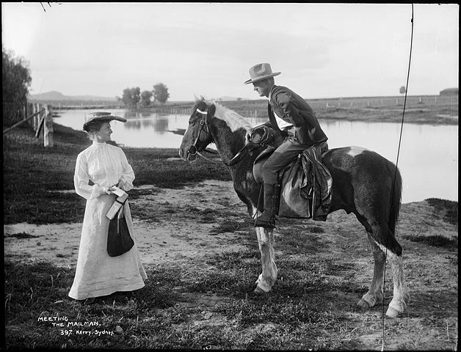
‘Meeting the mailman’ by Powerhouse Museum is licensed under Flickr: The Commons.

Historical inquiry step 1 – question
After observing the photos, and guided by the syllabus dot points, generate a class set of inquiry questions, for example:
- How has technology changed the way we communicate?
- What impacts has technology had on people’s lives?
Note: inquiry questions may need to be redesigned through the historical inquiry process.

Historical inquiry steps 2 and 3 – research and analyse
Technology and communication

Source 4
Nick Bland (2016) The fabulous friend machine and Radhiah Chowdhury (2016) The fabulous friend machine: Teacher notes
Share the book with students, emphasising the highlighted words. Ask students: How was Popcorn a friend to the other farm animals? What was the impact of Popcorn’s use of the ‘fabulous friend machine’ on her friends and on herself? How do we know how Popcorn’s friends felt about the mobile phone?
Re-read Source 4, to the mobile phone find. Discuss how Popcorn communicated with her friends before discovering the phone. How did people communicate before messaging via smart phones?

Source 5
Australia Post (n.d) Our history (1:33), timeline and historical photos and Australian Screen (NFSA) (2024) Australia Post – 200 Years (1988) clip 1 (2:25).
Examine the images representing changes in postal and telegraph technologies in Australia over the past 200 years. Brainstorm the changes that students observed.
Students write a letter to their family that outlines changes in mail technologies. They address an envelope and insert their letter.
What are the impacts of changing phone technologies on people’s lives?
‘...she was so busy sending messages, she didn’t even look up to say hello’ – Nick Bland (2016)
Re-read Source 4, from the phone discovery. How did Popcorn’s behaviour change when she discovered the phone? What was the impact on each of her friends?
Students use role play to enact the interactions of Popcorn and her friends before and after the phone discovery. Use hot-seating for students to share their feelings.
Scan through the icons on a mobile device, either projected or personally. Identify the features of the device and discuss their benefits, for example taking and sending photographs and videos, Internet access, emailing.
Collectively construct a cause and effect table showing the positive and negative impacts of present-day mobile phones and devices.
Table 1 – impacts of phone technologies
Feature of device | Positive impact | Negative impact
How have School of the Air technologies changed? What are the impacts?
Popcorn and her friends lived on Fiddlesticks Farm in the country. Children growing up on remote farms do their schooling at home through a distance education provider, originally by radio and mail, and now by computer, satellite and broadband technologies. Schools include School of the Air and Aurora College.

Source 6
Figure 3 – A School of the Air primary student in regional Queensland takes class via two way radio, circa 1960
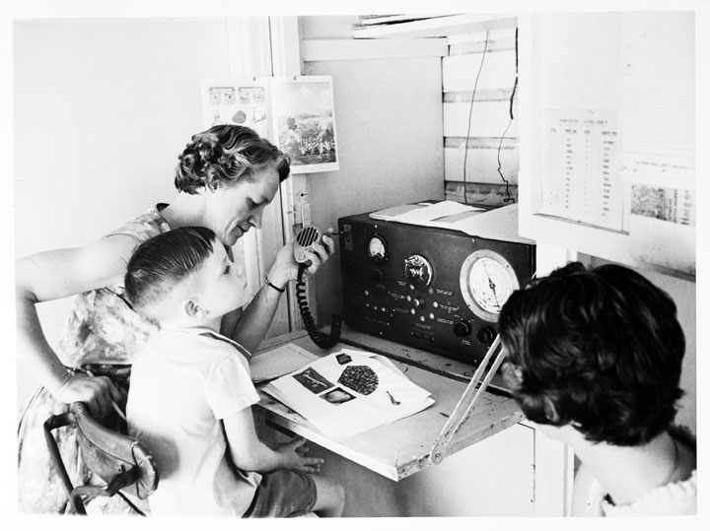
‘A School of the Air primary student in regional Queensland takes class via two way radio’ by Premier's Department, State Public Relations Bureau, Photographic Unit is in the Public Domain.

Source 7
Alice Springs School of the Air (2024) Our History
Observe Source 6 then click on the hyperlink and scroll through the timeline in Source 7, examining the photographs of students and the school. Locate and view additional School of the Air photographs in Google Images and Trove – Pictures. Copy a selection that represent changes in time and save in a folder for digital use or printing.
Students sequence and label the saved School of the Air photographs digitally, or manually, to create a timeline showing the changing technologies used by remote students and their teachers. They verbally explain the changes and the impacts the changes have had on students.

Historical inquiry step 4 – evaluate
Discuss the reliability of photographs and stories of how communication technology has changed over time. Do they provide a true representation of the changes in technology and how it has impacted our lives? Do the inquiry questions need to be redesigned as a result of analysing and evaluating sources?

Historical inquiry step 5 – communicate
The most valuable technology to communicate
Ask students to think about the following questions:
- What piece of communication technology can you not live without?
- How has it changed the way you communicate?
Students ask a grandparent or a parent to share their own thoughts on the same questions. Students create a short video or animation to share the responses.

Reflection
Students reflect on what they learned, how they found out and what else they would like to know.

Resources
Picture books
- Window by Jeannie Baker (2002)
- The fabulous friend machine by Nick Bland (2016)
Video
- Australia Post (n.d) Our history (1:33)
- Australian Screen (NFSA) (2024) Australia Post – 200 Years (1988) clip 1 (2:25)
- Alice Springs School of the Air (2024) Our History

References
This resource contains NSW Curriculum and syllabus content. The NSW Curriculum is developed by the NSW Education Standards Authority. This content is prepared by NESA for and on behalf of the Crown in right of the State of New South Wales. The material is protected by Crown copyright.
Please refer to the NESA Copyright Disclaimer for more information https://educationstandards.nsw.edu.au/wps/portal/nesa/mini-footer/copyright.
NESA holds the only official and up-to-date versions of the NSW Curriculum and syllabus documents. Please visit the NSW Education Standards Authority (NESA) website https://educationstandards.nsw.edu.au/wps/portal/nesa/home and the NSW Curriculum website https://curriculum.nsw.edu.au/.
History K–10 Syllabus © NSW Education Standards Authority (NESA) for and on behalf of the Crown in right of the State of New South Wales, 2012.

© State of New South Wales (Department of Education), 2024
The copyright material published in this resource is subject to the Copyright Act 1968 (Cth) and is owned by the NSW Department of Education or, where indicated, by a party other than the NSW Department of Education (third-party material).
Copyright material available in this resource and owned by the NSW Department of Education is licensed under a Creative Commons Attribution 4.0 International (CC BY 4.0) license.
This license allows you to share and adapt the material for any purpose, even commercially.
Attribution should be given to © State of New South Wales (Department of Education), 2024.
Material in this resource not available under a Creative Commons license:
- the NSW Department of Education logo, other logos and trademark-protected material
- material owned by a third party that has been reproduced with permission. You will need to obtain permission from the third party to reuse its material.
Links to third-party material and websites
Please note that the provided (reading/viewing material/list/links/texts) are a suggestion only and implies no endorsement, by the New South Wales Department of Education, of any author, publisher, or book title. School principals and teachers are best placed to assess the suitability of resources that would complement the curriculum and reflect the needs and interests of their students.
If you use the links provided in this document to access a third-party's website, you acknowledge that the terms of use, including licence terms set out on the third-party's website apply to the use which may be made of the materials on that third-party website or where permitted by the Copyright Act 1968 (Cth). The department accepts no responsibility for content on third-party websites.

