History Stage 2
Celebrations and commemorations

Contents
Topic – Community and remembrance 3
Key inquiry question 3
Overview 3
Outcomes 3
Content 4
Historical inquiry skills 4
Selected historical concepts 5
Assessment 5
Vocabulary 6
Teaching and learning activities 7
Inquiry 1 – significant Australian events 7
Stimulus 7
Historical inquiry step 1 – question 9
Historical inquiry steps 2 and 3 – research and analyse 9
Historical inquiry step 4 – evaluate 11
Historical inquiry step 5 – communicate 11
Reflection 11
Inquiry 2 – semi-guided inquiry into ANZAC Day 12
Stimulus 12
Historical inquiry step 1 – question 12
Historical inquiry steps 2 – research 13
Historical inquiry step 3 – analyse 14
Historical inquiry step 4 – evaluate 14
Historical inquiry step 5 – communicate 14
Reflection 15
Inquiry 3 – student-led inquiry student-led inquiry on a global celebration or commemoration 16
Stimulus 16
Historical inquiry step 1 – question 16
Historical inquiry steps 2 and 3 – research and analyse 17
Historical inquiry step 4 – evaluate 17
Historical inquiry step 5 – communicate 17
Reflection 18
Resources 19
References 20

Topic – Community and remembrance
Duration: 4 weeks – 90 minutes per week

Key inquiry question
- How and why do people choose to remember significant events of the past?

Overview
This topic provides a study of local, state and national symbols and emblems of significance, and celebrations and commemorations, both locally and in other places around the world. This learning sequence consists of 3 inquiries – significant Australian events, a guided inquiry into ANZAC Day and a student-led inquiry on a global celebration or commemoration.
In the first inquiry, students investigate important days and weeks that are celebrated or commemorated in Australia. They identify and describe local, state and national symbols and discuss their origins, symbolism and significance. In the second inquiry, students investigate the commemoration of ANZAC Day. Through a guided inquiry, students use a range of sources to determine the importance and significance of the day, how it is commemorated in Australia and what symbols and emblems are associated with ANZAC Day. In the third inquiry, students work independently, or in groups, to identify a global celebration or commemoration to investigate. They conduct an inquiry into the origin and significance of the celebration or commemoration and record and communicate their information through an infographic or poster.

Outcomes
A student:
- HT2-1 identifies celebrations and commemorations of significance in Australia and the world
- HT2-5 applies skills of historical inquiry and communication.
Outcomes and other syllabus material referenced in this document are from History K–10 Syllabus © NSW Education Standards Authority (NESA) for and on behalf of the Crown in right of the State of New South Wales, 2012.

Content
Days and weeks celebrated or commemorated in Australia (including Australia Day, ANZAC Day, Harmony Week, National Reconciliation Week, NAIDOC Week, National Sorry Day) and the importance of symbols and emblems (ACHHK063)
Students:
- identify and describe local, state and national symbols and discuss the origins, symbolism and significance, for example, the school logo, Australian and Aboriginal and Torres Strait Islander flags, coats of arms from states and Australia
- identify important Australian celebrations and commemorations and discuss their origins and significance in society.
Celebrations and commemorations in other places around the world; for example, Bastille Day in France, Independence Day in the USA, including those that are observed in Australia, such as Chinese New Year, Christmas Day, Diwali, Easter, Hanukkah, the Moon Festival and Ramadan (ACHHK064)
Students:
- identify global celebrations and commemorations, including those of the major world religions
- describe the origin of these celebrations.

Historical inquiry skills
- Comprehension: chronology, terms and concepts
- respond, read and write, to show understanding of historical matters
- sequence familiar people and events (ACHHS065, ACHHS081)
- use historical terms (ACHHS066, ACHHS082)
- Analysis and use of sources
- locate relevant information from sources provided (ACHHS068, ACHHS084, ACHHS215, ACHHS216)
- Perspectives and interpretations
- identify different points of view within an historical context (ACHHS069, ACHHS085)
- Empathetic understanding
- explain how and why people in the past may have lived and behaved differently from today
- Research
- pose a range of questions about the past (ACHHS067, ACHHS083)
- plan an historical inquiry
- Explanation and communication
- develop texts, particularly narratives (ACHHS070, ACHHS086)
- use a range of communication forms (oral, graphic, written) and digital technologies (ACHHS071, ACHHS087)

Selected historical concepts
- Significance: importance of an event, development or individual/group, for example, the significance/importance of national days/holidays; the significance of the contributions of an early settler.
- Empathetic understanding: developing an understanding of another's views, life and decisions made, for example, developing an understanding of the life and attitudes of an early colonist or convict.

Assessment
All activities require students to demonstrate their learning. All are assessment for learning activities.

Vocabulary
- Ask, investigate, observe, locate, examine, identify, record, describe, compare, explain, discuss, write, present
- Story, oral history, photograph, video, source, reliable source, primary source, secondary source, historical narrative, importance, significance
- Celebrate, commemorate, local, state, national, global, international, symbol, emblem, logo, flag, coat of arms, origin

Teaching and learning activities
This learning sequence comprises 3 inquiries.

Inquiry 1 – significant Australian events
Students investigate important days and weeks that are celebrated or commemorated in Australia. They identify and describe local, state and national symbols and discuss their origins, symbolism and significance. They use this information to complete further historical inquiries.
It is important to consider the diversity of the students in your class during this unit. If possible you could incorporate this diversity when discussing significant events that are celebrated and commemorated in Australia.

Stimulus
Provide students with photographs of events that are celebrated or commemorated in Australia or use the photographs below. What do they see, think and wonder about the photos? What symbols do they recognise in the photographs that give them a clue to what event is being celebrated or commemorated?

Source 1
Figure 1 – Harmony Day, 21 March 2010
‘Harmony Day’ by DIAC images is licensed under CC BY 2.0.

Source 2
Figure 2 – Royal Australian Navy band, Anzac Day march, Adelaide, South Australia
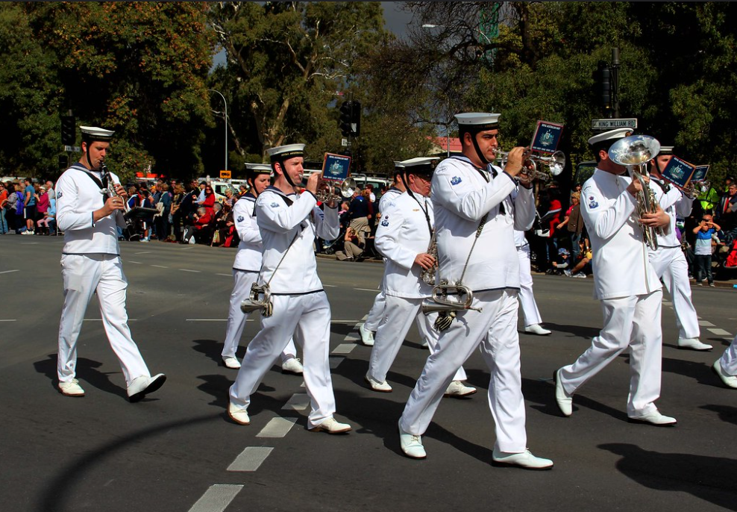
‘ANZAC Day, Adelaide, 25 April 2013’ by Jenny Scott is licensed under CC BY-NC 2.0

Source 3
Figure 3 – NAIDOC Week celebration at Mosman Library, NSW, 2011
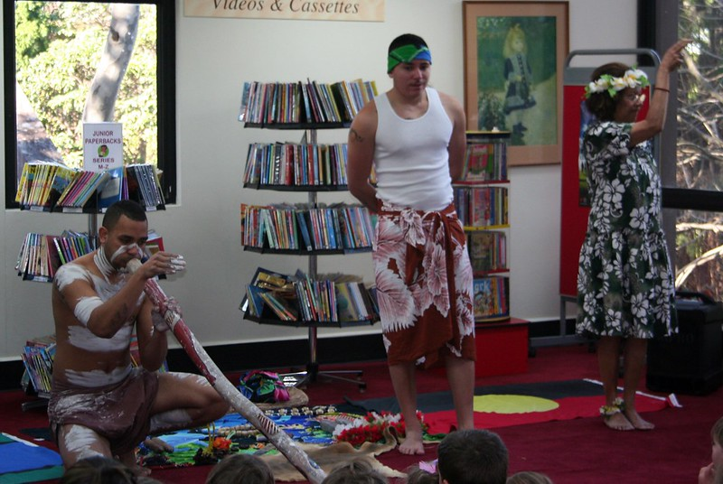
‘NAIDOC Week Show’ by Mosman Library is licensed under CC BY 2.0.

Historical inquiry step 1 – question
Using the See-Think-Wonder strategy and guided by syllabus dot points, generate a class set of inquiry questions to find out more about the significant days and weeks that are celebrated and commemorated in Australia and the symbols and emblems that are associated with them.
Sample questions
- What are the significant days that are important to us? Why?
- What is the difference between a celebration and a commemoration?
- What are Australia’s important symbols and emblems?
- How are significant days celebrated or commemorated?
Note: inquiry questions may need to be redesigned through the historical inquiry process.

Historical inquiry steps 2 and 3 – research and analyse
Important days that we celebrate or commemorate
Complete a Think-Pair-Share with students. Students brainstorm the days that they celebrate or commemorate each year, then share this with a pair and as a pair share this with the class. Create a class display of the days. Ask students why they think these days are important.
Ask students, ‘What is the difference between a celebration and a commemoration?’ In pairs allow students to come up with their own definitions and share them with the class.
Provide students with a variety of images that represent celebrations and commemorations such as a birthday, Christmas day or NAIDOC week and commemorations such as ANZAC Day, Remembrance Day or Sorry Day.
See-think-wonder prompts
Using the photographs students complete a see, think, wonder using the prompts below.
See
- What is in the photograph?
- How are the people in the photograph dressed?
- How do the people in the photograph look?
Think
- Where was the photograph taken? How do you know?
- When was the photograph taken?
- How do you know the photograph is of a celebration or commemoration?
Wonder
- What do you wonder about when examining the photograph?
As a class create a definition for a celebration and a commemoration. Using these definitions, sort the class display of days into celebrations and commemorations.
Australia’s symbols and emblems
Ask students to draw as many symbols or emblems they can in 5 minutes. Students compare their sketch with a pair and then share the symbols and emblems they had in common with the class.
Provide students with a variety of images that represent different local, state and national symbols and emblems. These may include the school logo, Australian and Aboriginal and Torres Strait Islander flags and coats of arms from states and Australia. Ask students if they can identify the symbols and describe the significance of them.
In pairs students choose a celebration, commemoration, symbol or emblem and research it’s history. Some examples of the questions they could research include:
- When did it become official?
- Why is it important/significant?
- Why was it chosen?
- How is it used, celebrated or commemorated?
- Are there any other interesting facts about it?
Students present their findings to the class using a poster or digital presentation.
From the information obtained as a class and as individuals, collectively identify the information that will be useful to assist in answering the inquiry questions. Assist students to determine which source(s) to include or exclude and start to develop an historical opinion about the importance and significance of different celebrations, commemorations, symbols and emblems to Australians.

Historical inquiry step 4 – evaluate
Discuss the reliability of research conducted. What information might be missing? What other sources could be used in future inquiries? Do the inquiry questions need to be redesigned as a result of evaluating the sources?

Historical inquiry step 5 – communicate
Design a new celebration or symbol – historical narrative
Students create a new celebration or symbol for Australia. Students create a poster to advertise their celebration or symbol. They verbally tell a narrative that outlines what the celebration or symbol is, why it is important, how it is used or celebrated.

Reflection
Students reflect on the historical inquiry process, reflecting on what they learned, how they learned it and what else they would like to find out about significant Australian celebrations, commemorations, symbols or emblems.

Inquiry 2 – semi-guided inquiry into ANZAC Day
Students investigate the commemoration of ANZAC Day. Through a semi-guided inquiry, students use a range of sources to determine the importance and significance of the day, how it is commemorated in Australia and what symbols and emblems are associated with ANZAC Day.

Stimulus

Source 4
Jackie French and Mark Wilson (2014) A day to remember
Before reading the book ask students: What is ANZAC Day? Why do we commemorate ANZAC Day? Read the book to students and discuss the images and symbols on each page. Ask students, ‘What is something you learned about why we celebrate ANZAC Day?’
As a class complete a ‘know, want to know, what I learned’ (KWL) chart to find out what students already know about ANZAC Day. Ask students to identify things that they would like to find out during the inquiry. What do they see, think and wonder about the photos? What is different and what is the same today?

Historical inquiry step 1 – question
Using the KWL chart and guided by syllabus dot points, generate a class set of inquiry questions to find out more about ANZAC day including when and how it originated, its importance and significance to Australians, how it is commemorated in Australia and what symbols and emblems are associated with ANZAC Day.
Sample questions
- When and how did the commemoration of ANZAC Day begin?
- Why do we commemorate ANZAC Day?
- How is it commemorated?
- Why is it important to Australians?
- What symbols and emblems are associated with ANZAC Day?
Note: inquiry questions may need to be redesigned through the historical inquiry process.

Historical inquiry steps 2 – research
Provide students with at least one primary source and at least one secondary source to support the semi-guided inquiry.
Examples include:
- ABC Education: The meaning of ANZAC Day (1:17) – this video shares the thoughts and feelings of five different people about ANZAC Day.
- Australian War Memorial – this website provides a variety of resources that explore how and why ANZAC day is commemorated. It also provides information about virtual excursions and memorial boxes for the classroom.
- Trove, The National Library of Australia – this website brings together content from libraries, museums, archives, repositories and other research. It includes photographs and information from communities around Australia.
- State Library of NSW on Flickr – this website provides photographs of ANZAC Day commemorations.
- Department of Veterans’ Affairs – this website provides a resource called Here they come – A day to remember. It includes videos that explain the symbols and emblems that are used to commemorate ANZAC Day.
Guide students in extracting information from the sources to answer the inquiry questions. Model the use of a source analysis table.
Table 1– source analysis table
Source number | Title and date | Who created it? | Why was it created? | Whose view is it? | Key information | Questions raised
Invite a guest speaker from the local RSL sub branch to the school. Ask them to explain why it is important to commemorate ANZAC Day, how it is commemorated in the local community and what symbols and emblems are associated with ANZAC Day commemorations.

Historical inquiry step 3 – analyse
From the information obtained, collectively identify the information that will be useful to assist in answering the inquiry questions. Assist students to determine which source(s) to include or exclude and start to develop an historical opinion about the commemoration of ANZAC Day and the symbols and emblems associated with it.
Update the KWL chart to highlight what students have learned as a result of the research and talk and other things that they want to find out about the ANZAC Day.

Historical inquiry step 4 – evaluate
Guide the students in evaluating the reliability of the sources. Are the sources believable? Are there inconsistencies or contradictions between the sources? Do the inquiry questions need to be redesigned as a result of analysing and evaluating sources?

Historical inquiry step 5 – communicate
The commemoration of ANZAC Day
Students create an information text that outlines what they have learned about the commemoration of ANZAC Day. Students could include information about how and why we commemorate ANZAC Day, why it is important to Australians and the symbols and emblems that represent ANZAC Day. Encourage students to use a range of communication methods to create and present their information text including written, graphic and oral. Provide students with the option of using digital technology to create the text.

Reflection
Students reflect on the historical inquiry process using their original KWL chart. They reflect on what they learned, how they learned it and what else they would like to find out.

Inquiry 3 – student-led inquiry student-led inquiry on a global celebration or commemoration
Working independently, or in groups, students select one feature of the local community to investigate. Students may choose a feature such as education, entertainment, work, daily life or another feature they have identified. They use a variety of sources to undertake their investigation. Students outline how and why this feature has changed or remained the same in the local community. They demonstrate the historical inquiry process throughout their inquiry.

Stimulus

Source 5
Loretta Seto and Renné Benoit (2013) Mooncakes
Share the book with the students, providing time for students examine the details within the illustrations. The book is about the celebration of the Chinese Moon Festival. The Festival is celebrated on the fifteenth day of the eighth month of the lunar calendar. Re-read Source 5 to the students. What were the family’s Moon Festival traditions?
In Chinese culture, a circle symbolises unity and oneness. The Moon Festival celebrates the moon at its most round and is celebrated together as a family, eating circular mooncakes and the hanging of round lanterns. Re-read Source 5, analysing the use of circle shapes in the illustrations, for example mooncakes, lanterns, teapot, teacups. How does this enhance meaning in the text?
Ask students to brainstorm other significant celebrations and commemorations that are observed around the world. What do they know about the origins of these? What symbols are related to these celebrations or commemorations?

Historical inquiry step 1 – question
Students identify a global celebration or commemoration to investigate. They formulate a set of inquiry questions they can answer through their research.
Sample questions:
- When did the celebration or commemoration begin? Why is it important?
- How is it commemorated or celebrated?
- Who celebrates or commemorates it?
- What are some icons or symbols related it?
- What are some interesting facts about the commemoration or celebration?
Note: inquiry questions may need to be redesigned through the historical inquiry process.

Historical inquiry steps 2 and 3 – research and analyse
Students locate, summarise and analyse information from at least 3 sources. Sources could include books, newspapers, internet sites, photographs, letters, diaries and oral histories. They summarise and record key information in Table 2.
Table 2 – source analysis table
Source number | Title and date | Who created it? | Why was it created? | Whose view is it? | Key information | Questions raised

Historical inquiry step 4 – evaluate
Students evaluate the reliability of their sources. Are there inconsistencies or contradictions between the sources? Do the inquiry questions need to be redesigned as a result of analysing and evaluating sources?

Historical inquiry step 5 – communicate
International advisor
Students create a digital infographic or poster advertising a significant celebration or commemoration in another country. The poster should include a brief statement explaining its origins and significance, the date of the event and icons and symbols that relate to the event. Encourage students to use a range of communication forms to present their findings.

Reflection
Students reflect on their historical inquiry process and information communicated in their infographic, by answering the questions:
- What did I do well in the historical inquiry process?
- What did I find challenging in the process?
- How do I know the information I communicated?
- What else do I want to find out?

Resources
Books
- A day to remember by Jackie French and Mark Wilson (2014)
- Mooncakes by Loretta Seto and Renné Benoit (2013)
Video
- ABC Education: The meaning of ANZAC Day (1:17)
Websites
- Australian War Memorial
- Trove, The National Library of Australia
- State Library of NSW on Flickr
- Department of Veterans’ Affairs

References
This resource contains NSW Curriculum and syllabus content. The NSW Curriculum is developed by the NSW Education Standards Authority. This content is prepared by NESA for and on behalf of the Crown in right of the State of New South Wales. The material is protected by Crown copyright.
Please refer to the NESA Copyright Disclaimer for more information https://educationstandards.nsw.edu.au/wps/portal/nesa/mini-footer/copyright.
NESA holds the only official and up-to-date versions of the NSW Curriculum and syllabus documents. Please visit the NSW Education Standards Authority (NESA) website https://educationstandards.nsw.edu.au/wps/portal/nesa/home and the NSW Curriculum website https://curriculum.nsw.edu.au/.
History K–10 Syllabus © NSW Education Standards Authority (NESA) for and on behalf of the Crown in right of the State of New South Wales, 2012.

© State of New South Wales (Department of Education), 2024
The copyright material published in this resource is subject to the Copyright Act 1968 (Cth) and is owned by the NSW Department of Education or, where indicated, by a party other than the NSW Department of Education (third-party material).
Copyright material available in this resource and owned by the NSW Department of Education is licensed under a Creative Commons Attribution 4.0 International (CC BY 4.0) license.
This license allows you to share and adapt the material for any purpose, even commercially.
Attribution should be given to © State of New South Wales (Department of Education), 2024.
Material in this resource not available under a Creative Commons license:
- the NSW Department of Education logo, other logos and trademark-protected material
- material owned by a third party that has been reproduced with permission. You will need to obtain permission from the third party to reuse its material.
Links to third-party material and websites
Please note that the provided (reading/viewing material/list/links/texts) are a suggestion only and implies no endorsement, by the New South Wales Department of Education, of any author, publisher, or book title. School principals and teachers are best placed to assess the suitability of resources that would complement the curriculum and reflect the needs and interests of their students.
If you use the links provided in this document to access a third-party's website, you acknowledge that the terms of use, including licence terms set out on the third-party's website apply to the use which may be made of the materials on that third-party website or where permitted by the Copyright Act 1968 (Cth). The department accepts no responsibility for content on third-party websites.

