HSIE: History S2 workbook
Name:
Class:

Overview
Stage 2 – Community and Remembrance
This topic provides a study of identity and diversity in both a local and broader context. Moving from the heritage of their local area, you will explore the historical features that have been lost and retained. You will examine early transport in the local community and New South Wales through a guided inquiry. You will use a range of sources to describe and explain how and why transport has changed or remained the same.
Key inquiry questions:
- How has our community changed?
- What features have been lost and what features have been retained?

Resources
- pens, pencils
- paper
- this workbook
- help from an adult

Activity 1
During this lesson you will:
- describe and examine early transport in the local community and New South Wales
- use a range of sources to describe and explain how and why transport has changed or remained the same.
Resources – pens, pencils, paper, student workbook
Brainstorm/think Observe/see Write
Examine the 4 photographs of transport in New South Wales in the early 1900’s (Sources 1-4).
What do you see, think and wonder about the photographs?
What is different and what is the same today?
Source 1: The Family in a Horse and Buggy, Sydney, Australia c.1880-1923
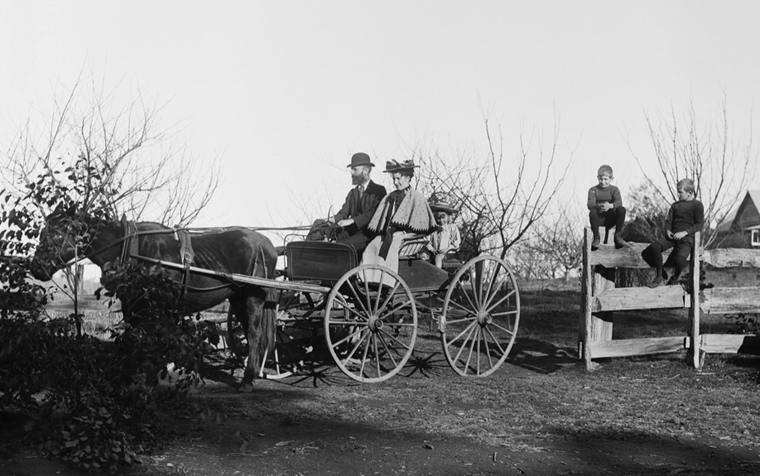
Powerhouse Museum https://collection.maas.museum/object/31990#&gid=1&pid=1
No known copyright restrictions
Source 2: Bus, Newcastle c 1912
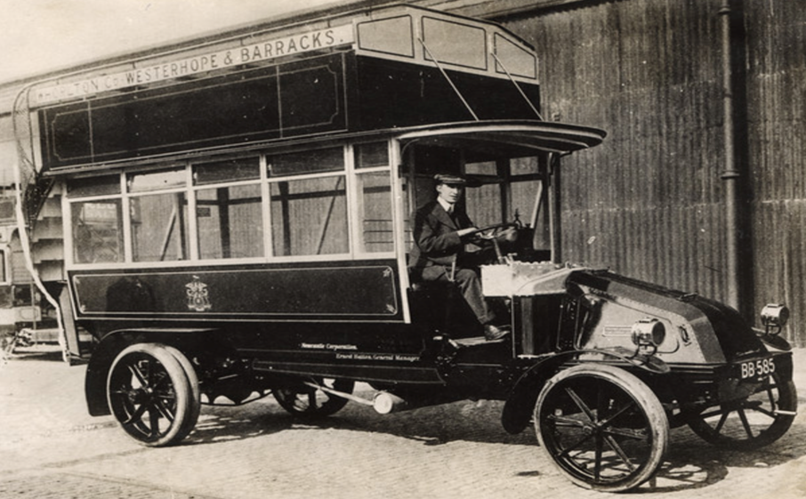
Newcastle Library https://www.flickr.com/photos/newcastlelibraries/4076461634/in/album-72157622840940288/
No known copyright restrictions.

Source 3: Vintage Car, Sir WG Armstrong

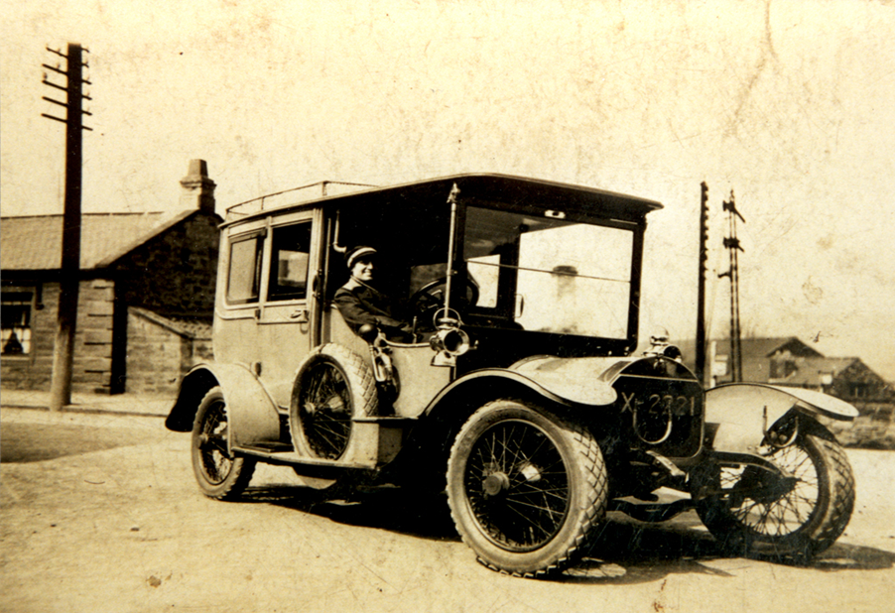
Flickr https://tinyurl.com/y4afhwj4 No known copyright restrictions

Source 4: Sydney tram on George Street, down from Grosvenor Street looking north, November 1931, Unknown photographer

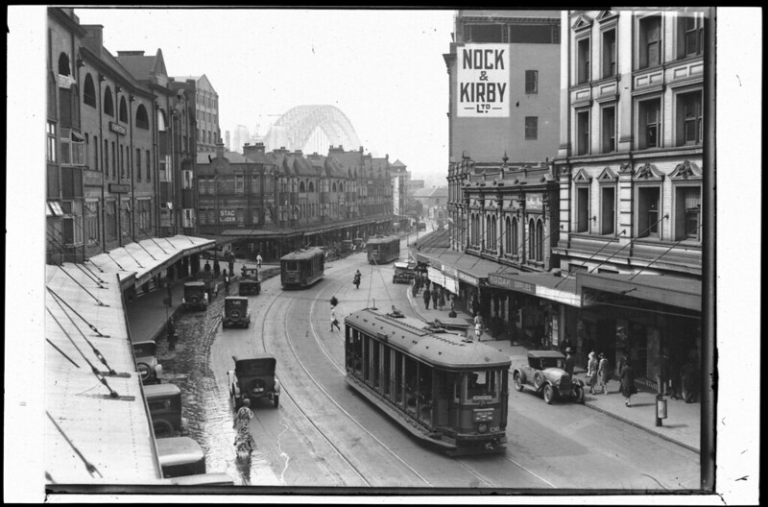

Historical photo sets on Flickr, State Library of NSW

What do you see, think and wonder about the photographs (in sources 1-4)?
See | Think | Wonder
What is different and what is the same today?
Same | Different

Brainstorm/think Observe/see Write
Think about your local area. What forms of transport are available in your local area? Has transport changed or remained the same in your local area. Interview your parents or grandparents to see if they have seen any change in transport in their local area.
Sample questions that you can ask:
How did people travel around the local area in the past? What different modes of transport were used in your local area?

How do people travel in the local area now? Would you travel short or long distances using this type of transport?

What forms of transport have changed or remained the same in the local community and New South Wales?

Does this type of transport make access to places easier or faster than in the past? How?
Reflect Write
Create a mind map or display of the information you have collected.

Activity 2
Reflect/think Observe/see Read Write

View the video: ABC Education This video highlights the variety of transport in Australia today. It highlights the different types of transport available in Australia.
Look at the photographs (source 1-4) from Activity 1.
Decide which sources are primary sources and which sources are secondary sources of information. Write a brief meaning of the terms primary sources and secondary sources. Provide some examples of each.
Primary sources | Secondary sources
Definition and examples: | Definition and examples:

Brainstorm/think Observe/see Write Draw
With an adult supervisor go for a walk around the local community to observe the transport used.
Before you go on the walk brainstorm what sort of transport you might see. On the walk record the transport you observe by writing, drawing or taking photographs.
What types of transport did I see on my walk

Create a mind map to record as many observations as you can about transport in the past and present.
Mind Map – transport in the past and present

Use a Venn diagram to compare and contrast early transport to modern transport. What has changed and what has remained the same?

Reflection
Think about what you have learnt in this activity. Use the two stars and a wish structure to guide your reflection.
Star  Something that went well! | Star  Something that went well! | Wish  A goal for next time…

