History Stage 2
The First Fleet and its impacts

Contents
Topic – First contacts 3
Key inquiry questions 3
Overview 3
Outcomes 3
Content 4
Historical inquiry skills 4
Historical concepts 5
Assessment 6
Vocabulary 6
Teaching and learning activities 7
Inquiry 1 – the First Fleet 7
Stimulus 7
Historical inquiry step 1 – question 8
Historical inquiry step 2 and 3 – research and analyse 8
Historical inquiry step 4 – evaluate 11
Historical inquiry step 5 – communicate 11
Reflection 12
Inquiry 2 – the colony at Port Jackson 13
Stimulus 13
Historical inquiry step 1 – question 15
Historical inquiry steps 2 and 3 – research and analyse 15
Historical inquiry step 4 – evaluate 17
Historical inquiry step 5 – communicate 17
Reflection 17
Inquiry 3 – impacts of British colonisation 18
Stimulus 18
Historical inquiry step 1 – question 21
Historical inquiry steps 2 and 3 – research and analyse 21
Historical inquiry step 4 – evaluate 24
Historical inquiry step 5 – communicate 24
Reflection 25
Summative task 25
Resources 26
References 27

Topic – First contacts
Duration: 10 weeks – 90 minutes per week
It is recommended that students have undertaken the department’s First contacts learning sequences, Australia’s first peoples and Journeys of exploration found at Planning, programming and assessing history K–6, prior to undertaking this learning sequence.

Key inquiry questions
- Why did Europeans settle Australia?
- What was the nature and consequence of contact between Aboriginal and/or Torres Strait Islander Peoples and early traders, explorers and settlers?

Overview
Students examine European exploration and colonisation in Australia to the early 1800s. Students examine the impact of exploration on other societies, how these societies interacted with newcomers, and how these experiences contributed to their cultural diversity.
This learning sequence consists of 3 inquiries. In the first inquiry, students investigate the reasons, causes and effects of the voyage of the First Fleet to New South Wales and its disembarkation at Port Jackson. The second inquiry examines the early development of the colony at Port Jackson and the experiences of those living there. In the third inquiry, students investigate the nature of contact and the impacts of the spreading colony on the local Aboriginal Peoples.

Outcomes
A student:
- HT2-4 describes and explains effects of British colonisation in Australia
- HT2-5 applies skills of historical inquiry and communication.
Outcomes and other syllabus material referenced in this document are from History K–10 Syllabus © NSW Education Standards Authority (NESA) for and on behalf of the Crown in right of the State of New South Wales, 2012.

Content
Stories of the First Fleet, including reasons for the journey, who travelled to Australia, and their experiences following arrival (ACHHK079).
Students:
- identify reasons for the voyage of the First Fleet and explain why various groups were passengers
- describe the establishment of the British colony at Port Jackson
- using a range of sources, investigate the everyday life of one of the following who sailed on the First Fleet and lived in the early colony: a soldier, convict, ex-convict, official.
The nature of contact between Aboriginal people and/or Torres Strait Islanders and others, for example, the Macassans and the Europeans, and the effects of these interactions on, for example, families and the environment (ACHHK080).
Students:
- describe the nature of contact between Aboriginal people and/or Torres Strait Islander peoples and others, including Aboriginal resistance
- explain the term terra nullius and describe how this affected the British attitude to Aboriginal and Torres Strait Islander peoples
- use sources to identify different perspectives on the arrival of the British to Australia
- outline the impact of early British colonisation on Aboriginal and Torres Strait Islander peoples' country.

Historical inquiry skills
- Comprehension: chronology, terms and concepts
- respond, read and write, to show understanding of historical matters
- sequence familiar people and events (ACHHS065, ACHHS081)
- use historical terms (ACHHS066, ACHHS082)
- Analysis and use of sources
- locate relevant information from sources provided (ACHHS068, ACHHS084, ACHHS215, ACHHS216)
- Perspectives and interpretations
- identify different points of view within an historical context (ACHHS069, ACHHS085)
- Empathetic understanding
- explain how and why people in the past may have lived and behaved differently from today
- Research
- pose a range of questions about the past (ACHHS067, ACHHS083)
- plan an historical inquiry
- Explanation and communication
- develop texts, particularly narratives (ACHHS070, ACHHS086)
- use a range of communication forms (oral, graphic, written) and digital technologies (ACHHS071, ACHHS087)

Historical concepts
- Continuity and change: some things change over time and others remain the same, for example, aspects in the local community that have either changed or remained the same; changes to the lives of Aboriginal peoples with the arrival of the First Fleet.
- Cause and effect: events, decisions or developments in the past that produce later actions, results or effects, for example, how conditions and decisions in Britain resulted in the journey of the First Fleet; causes of change in the local area/state.
- Perspectives: people from the past will have different views and experiences, for example, views on the arrival of the British in Australia from a British and an Aboriginal point of view.
- Empathetic understanding: developing an understanding of another's views, life and decisions made, for example, developing an understanding of the life and attitudes of an early colonist or convict.
- Significance: importance of an event, development or individual/group, for example, the significance/importance of national days/holidays; the significance of the contributions of an early settler.

Assessment
All activities require students to demonstrate their learning. All are assessment for learning activities.

Vocabulary
- Investigate, examine, identify, record, describe, sequence, compare, explain, discuss, illustrate, reflect
- Source, reliable source, primary source, secondary source, evidence, creator, point of view, perspective, audience, bias, stereotype, generalisations, relevance, reliability, historical question, historical narrative
- First Fleet and settlement – voyage, travel, sail, fleet, transported, passenger, prisoner, gaol, prison hulk, convict, ex-convict, soldier, marine, governor, establishment, penal, colony, colonisation, cause, effect, consequence
- Settlement, rations, punishment, exploration, shingling party, marquee, brick field, parade, saw pit, stone quarry
- Nature of contact – Aboriginal, Torres Strait Islander, Indigenous, Traditional Owners, inhabitants, contact, interaction, resistance, British, arrival, terra nullius, perspective, attitude, colonisation, invasion, dispossession, impact, consequences

Teaching and learning activities
This learning sequence comprises of 3 inquiries. Throughout the learning sequence, teachers are to be sensitive to the differing perspectives of British colonisation of Australia by Aboriginal and non-Aboriginal people. Ensure a balance of viewpoints are investigated.

Inquiry 1 – the First Fleet
Students investigate the reasons for the journey of the First Fleet, its ships, people, route and destination. They take on a role as a First Fleet convict to communicate historical information.

Stimulus

Source 1
ABC Behind the News (4 February 2014) First Fleet (4:35)

Source 2
ABC Education (12 October 2021) Transportation and the First Fleet (3:40)
View the videos First Fleet (4:35) and Transportation and the First Fleet (3:40). Students ‘turn and talk’ to discuss new knowledge from the videos. Generate a class cause and effect chart that summarises the information presented – crime in England, overflowing prisons, establishment of the fleet, choice of destination, goal of voyage, human cargo.
Discuss how the information was conveyed in the videos. Discuss questions such as:
- Why did actors take on a role as convicts?
- How did they know what to say and what to dress up in?
- If you were in role as a First Fleet convict where would you find reliable information about your experiences of the journey?
Students complete a KWLH chart that outlines what they already know and what they would like to know about the First Fleet and British colonisation of Australia.

Historical inquiry step 1 – question
With reference to the students’ KWLH charts, students generate a set of inquiry questions to find out more about the journey of the First Fleet.
Sample questions
- Why did the First Fleet travel to Australia?
- What ships made up the First Fleet?
- Who travelled on the First Fleet?
- When did the First Fleet leave England?
- Where did the First Fleet travel from and to?
- Where did the First Fleet stop on its journey?
- When did the First Fleet arrive in New South Wales?
- Where did the First Fleet disembark in Australia?
- Why did Governor Philip select that location?
- How long was the First Fleet’s journey?
- How do we know about the First Fleet?
Note: inquiry questions may need to be redesigned through the historical inquiry process.

Historical inquiry step 2 and 3 – research and analyse
Invite students to select a First Fleet convict with the intent of creating an historical narrative in first person voice, through the eyes of their convict.

The Fleet

Source 3
Museums of History NSW (2024) First Fleet Ships and First Fleet Voyage
Share Source 3 with the students to provide names and images of the ships, a map of the voyage and the staff on the ships.

My convict

Source 4
University of Wollongong (1999) First Fleet online database
Demonstrate a simple search in the First Fleet online database. In the simple search page, students complete some fields to find a convict of interest to them. Pairs of students may choose ‘partners in crime’ and undertake the following research and communication activity collaboratively. Students record key information about their convict using Table 1.
Table 1 – First Fleet convict
Convict | Information
Name
Aliases (other names)
Gender
Date of birth
Occupation
Crime
Partners in crime
Punishment
Age transported
Ship
The journey
Guide students in extracting information from secondary sources to answer the inquiry questions. They record key information in summary form as dot points in table 2, including sources used. Encourage students to locate and draw on at least one primary source that provides evidence of the answer to at least one inquiry question. For instance, Source 5 shows the First Fleet entering Port Jackson on 27 January as the final destination. State Library NSW holds a series of Bradley drawings of the voyage – William Bradley’s drawings from his journal ‘A voyage to New South Wales’, c.1802.

Source 5
Figure 1 – entrance of Port Jackson 27 January 1788 by William Bradley, c.1802
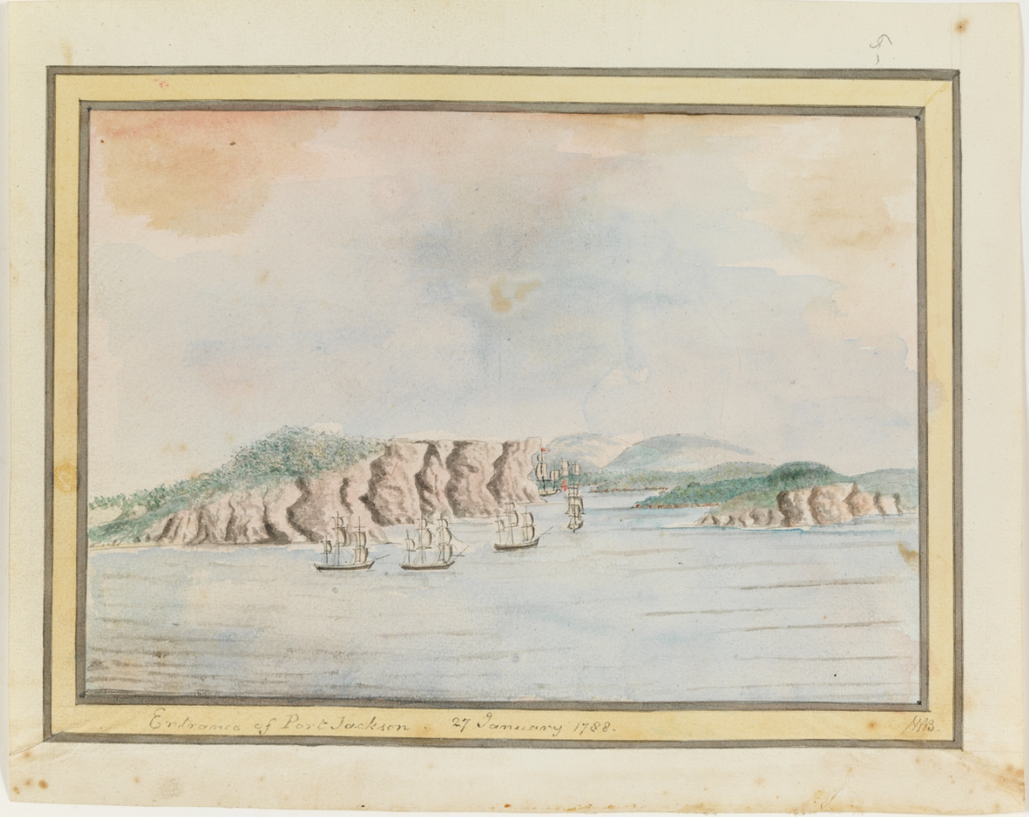
‘Entrance of Port Jackson 27 Janury 1788' from William Bradley’s journal ‘A Voyage to New South Wales', provided by the Mitchell library, State Library of New South Wales Collection. This work is in the Public Domain.
Table 2 – Journey of the First Fleet
Question | Key information | How I know
Why did the First Fleet travel to Australia?
What ships made up the First Fleet?
Who travelled on the First Fleet?
When did the First Fleet leave England?
Where did the First Fleet travel from and to?
Where did the First Fleet stop on its journey?
When did the First Fleet arrive in New South Wales?
Where did the First Fleet disembark in Australia?
Why did Governor Philip select that location?
How long was the First Fleet journey?
Provide evidence of an aspect of the journey from a primary source.

Historical inquiry step 4 – evaluate
Students compare their answers with another student’s answers, noting inconsistencies or contradictions. Students use other sources to verify conflicting or inconsistent information. They discuss their choice of sources in regard to reliability.

Historical inquiry step 5 – communicate
Through my eyes – historical narrative
In role as their First Fleet convict, students compose a personal recount of the First Fleet journey that includes the information gathered in Tables 1 and 2. This could be communicated:
- in writing as a series of journal entries or an autobiography
- visually through a series of annotated sketches in a storyboard or series of sketches
- orally as a recorded podcast
- dramatically in role as a role play or video.

Reflection
Students reflect on the historical inquiry process using their original KWLH chart. They reflect on what they learned, how they learned it and what else they would like to find out about British colonisation of Australia.

Inquiry 2 – the colony at Port Jackson
Students investigate and describe the establishment of the British colony at Port Jackson. They independently investigate the experiences of either a soldier, convict, ex-convict or official who lived in the colony in its early years, to the early 1800s.

Stimulus

Source 6
Figure 2 – Sketch and description of the settlement at Sydney Cove Port Jackson on the 16th of April, 1788, not quite three months into settlement. Sketch by transported convict Francis Fowkes.
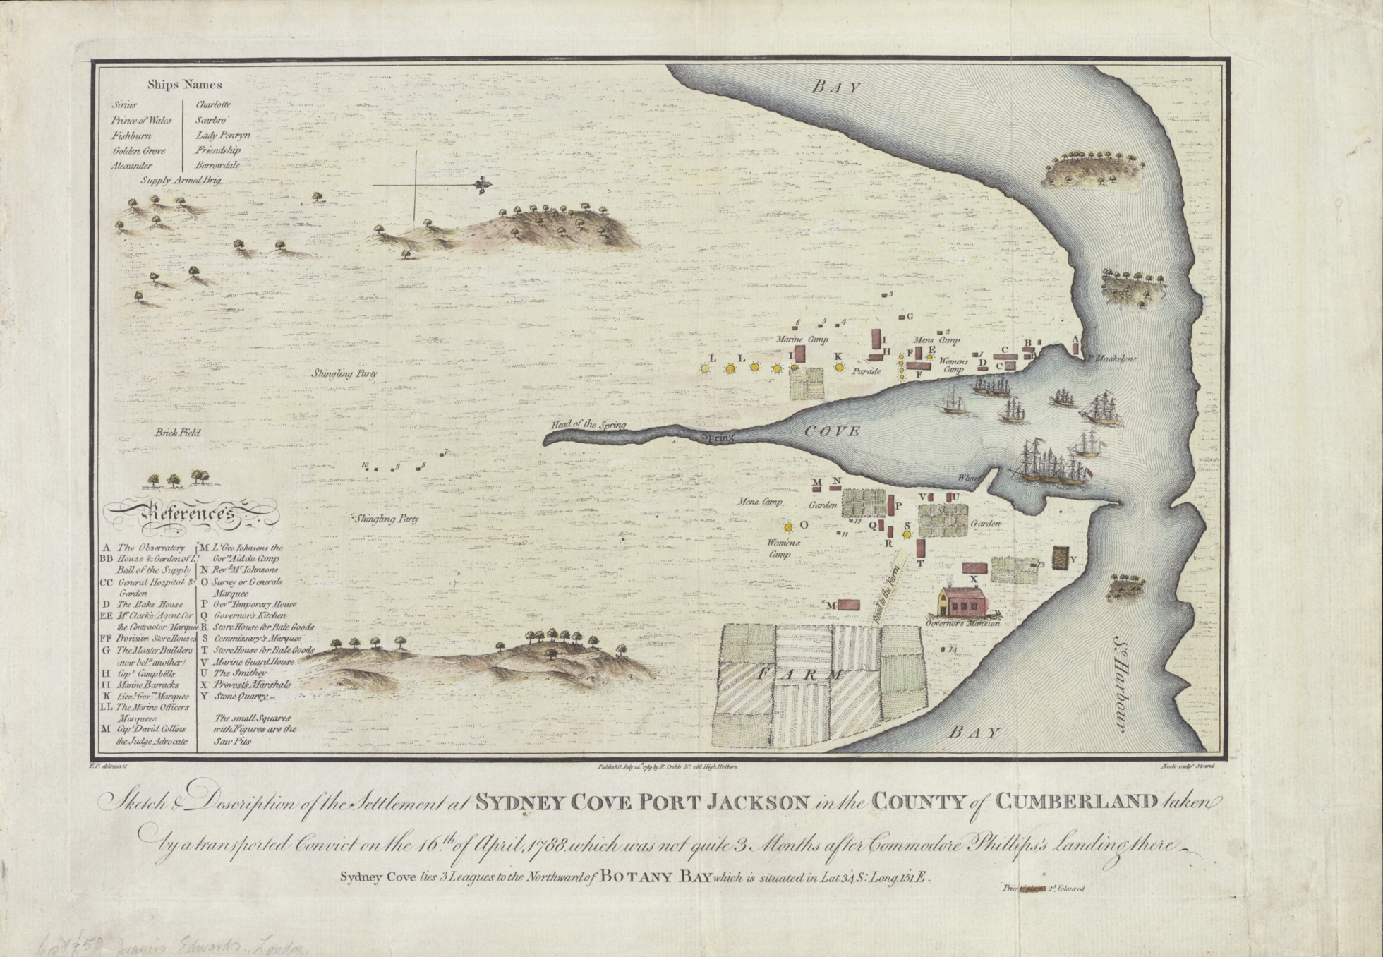
‘Sketch and description of the settlement at Sydney Cove Port Jackson in the County of Cumberland taken by a transported convict on the 16th of April, 1788, which was not quite 3 months after Commodore Phillips's landing there’ by Francis Fowkes housed by the National Library of Australia and is in the Public Domain.
Students individually or as a class examine Source 6 using the zoom tools on the online image – Sketch and description of the settlement at Sydney Cove Port Jackson on the 16th of April, 1788 by Francis Fowkes. Before personal interrogation of the map using See-Think-Wonder prompts, undertake the following as a class:
- Define and locate images of ‘marine’, ‘shingling party’, ‘marquee’, ‘brick field’, ‘parade’, ‘stone quarry’, ‘saw pit’.
- Note that the small numbered squares on the map are saw pits. Locate the saw pits.
- Interpret the purposes of the buildings labelled with letters using the legend titled ‘references’.
- List the names and positions of paid officers listed in the reference list.
See-Think-Wonder
Students use See-Think-Wonder question prompts to closely examine the image and extract information it provides about the first three months of the colony.
See
- Locate the places people live – house, mansion, camp, marquee.
- Locate places that produce or store food – garden, farm, store.
- Locate places that produce building materials – shingles, bricks, stone, timber (saw pits), nails (smithy).
- Locate the places of marines and officers.
- Locate the hospital.
- Locate the fresh water supply.
Think
- If you were standing at the marine camp looking east, what buildings and structures would you see and what would they be made from?
- If you were standing on the wharf and looking south-west, what might you see, hear and smell?
- If you went for a walk west from the head of the spring, what might you see people doing?
- What challenges would the British people face in the first three months of colonisation?
- What impacts would the settlement have had on the natural environment in its first three months of establishment?
- What immediate impacts would the settlement have had on the local Aboriginal Peoples?
Wonder
- What questions does the map raise?
- What else would you like to know?
3D model
Optionally, as a class construct a large labelled 3D model of the map. This could be done on a table in the learning space or as an ephemeral model in the school’s sandpit, using loose natural materials. Refer to sources showing eye-level views of the early colony such as William Bradley’s sketch, Sydney Cove, Port Jackson, 1788.

Historical inquiry step 1 – question
With reference to the students’ KWLH charts, and questions raised by the map of the colony, generate a class set of inquiry questions to find out more about everyday life in the early years of the colony and the experiences of the various people who lived there.
Sample questions
- What were the roles of soldiers, convicts, ex-convicts and officials in the colony?
- What were the experiences of the different people who lived in the colony?
Note: inquiry questions may need to be redesigned through the historical inquiry process.

Historical inquiry steps 2 and 3 – research and analyse
Students select, or are allocated, a person or group of people who lived in the colony in its early years. These could be taken from the people and groups listed on the map in Source 6. Ensure there is a diversity of roles – soldiers, convicts, ex-convicts and officials.
Students use a range of sources to independently research everyday life of their person in the colony. They draw information from at least one primary source, for instance, a painted view or map of a section of the colony or an artefact such as a tool or an item of clothing. Students compile their information in Table 3.
Table 3 – life in the colony
Question | Key information | How I know
Where do you live?
What is your dwelling made from?
What are the buildings like around your home?
What is the natural environment around you like?
What work do you do and what tools do you use?
What do you wear and how do you get your clothes?
What do you eat and how do you get your food?
What other people do you have dealings with?
What daily challenges do you face and how do you overcome them?
Provide evidence of an aspect of life in the colony from a primary source.
Sources may include:
- Museums of History New South Wales (2024) What was life in early Sydney like for convicts?
- ABC Education (2023) Child convicts of Australia
- Museums of History New South Wales (2024) Child convicts of Australia,
- Museums of History New South Wales (2024) Convicts
- National Museum of Australia (n.d) Convict cargo, contains information on Governor Arthur Phillip
- State Library of NSW (2024) The convict experience
- Museums of History New South Wales (2024) The convicts’ colony, (text-heavy)

Historical inquiry step 4 – evaluate
Students compare their answers with those of another student researching a similar person. They note differences, inconsistencies or contradictions. Students use other sources to verify conflicting or inconsistent information. They discuss their choice of sources in regard to reliability.

Historical inquiry step 5 – communicate
Hot seat
Students undertake an in-role activity such as hot seat to communicate information about their everyday life in the early years of the colony. Alternatively, students sketch a series of cartoons to illustrate a typical day in their life or write a letter home recounting their life in the colony.

Reflection
Students reflect on the historical inquiry process using their KWLH chart from Inquiry 1. They reflect on what they learned, how they learned it and what else they would like to find out.

Inquiry 3 – impacts of British colonisation
Students investigate the nature and consequence of contact between the local Aboriginal Peoples and early settlers of the expanding colony at Port Jackson.
In order to begin to understand the impacts of colonisation on Aboriginal Peoples, students need to have a deep understanding of what life was like for Aboriginal and/or Torres Strait Islander People before the arrival of the British. It is recommended that students have undertaken the department’s First contacts learning sequence, Australia’s first peoples found Planning, programming and assessing history K–6, or similar, prior to undertaking this inquiry.
Note: inform Aboriginal students that there will be names and images of Aboriginal people who have died in the information sources in this learning sequence. Also be aware of the differing perspectives on colonisation by Aboriginal Peoples and non-Aboriginal people and the sensitive nature of this topic. Also note that primary sources use terminology in relation to Aboriginal Peoples that is not appropriate today. Guide students to use the term ‘Aboriginal Peoples’.

Stimulus
Activate prior knowledge on what life was like for Aboriginal Peoples before the arrival of the British and the importance of Country and Place to Aboriginal Peoples.

Source 7
Figure 3 – first interview with the ‘Native Women’ at Port Jackson New South Wales, State Library of NSW
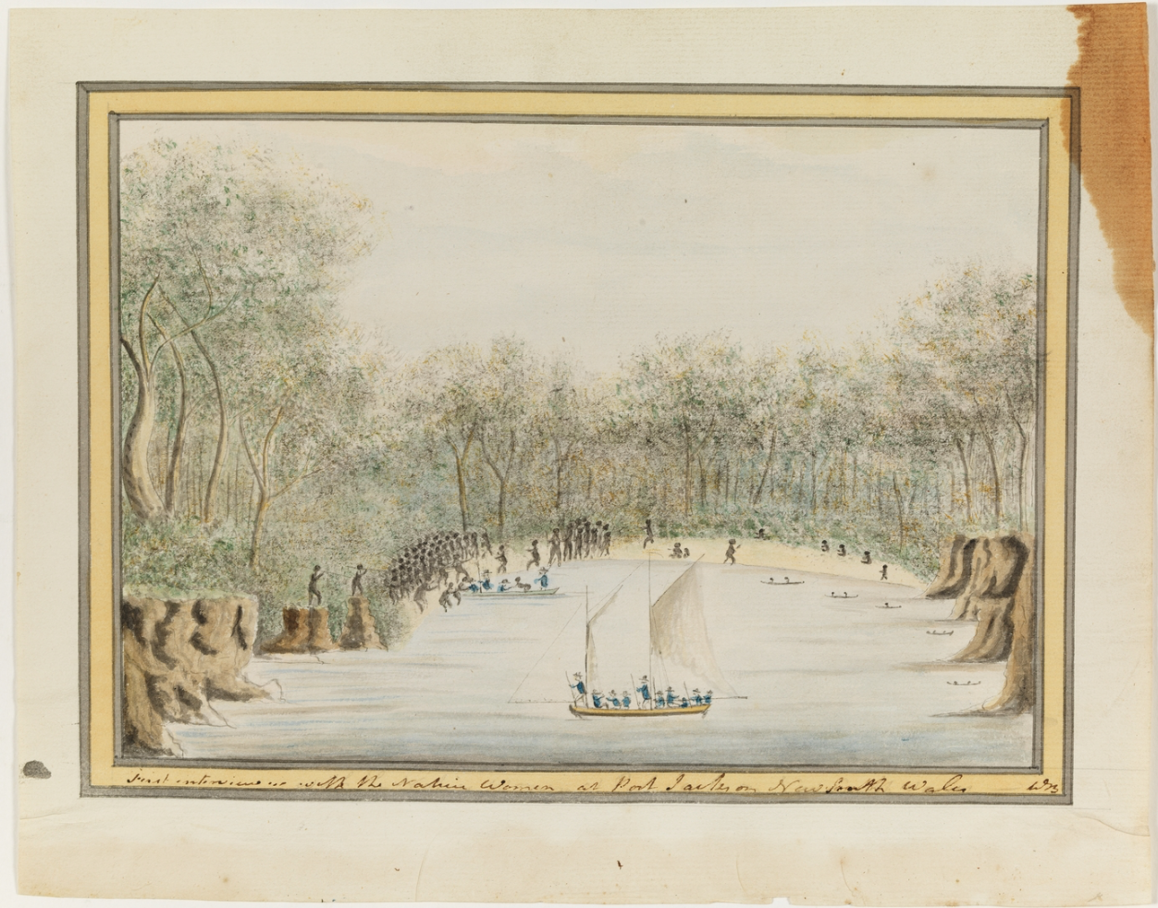
‘First interview with the Native Women at Port Jackson New South Wales’ from William Bradley’s journal ‘A Voyage to New South Wales', provided by the Mitchell library, State Library of New South Wales Collection. This work is in the Public Domain.

Source 8
Figure 4 – view of Sydney Cove, New South Wales, 1802, State Library of New South Wales.
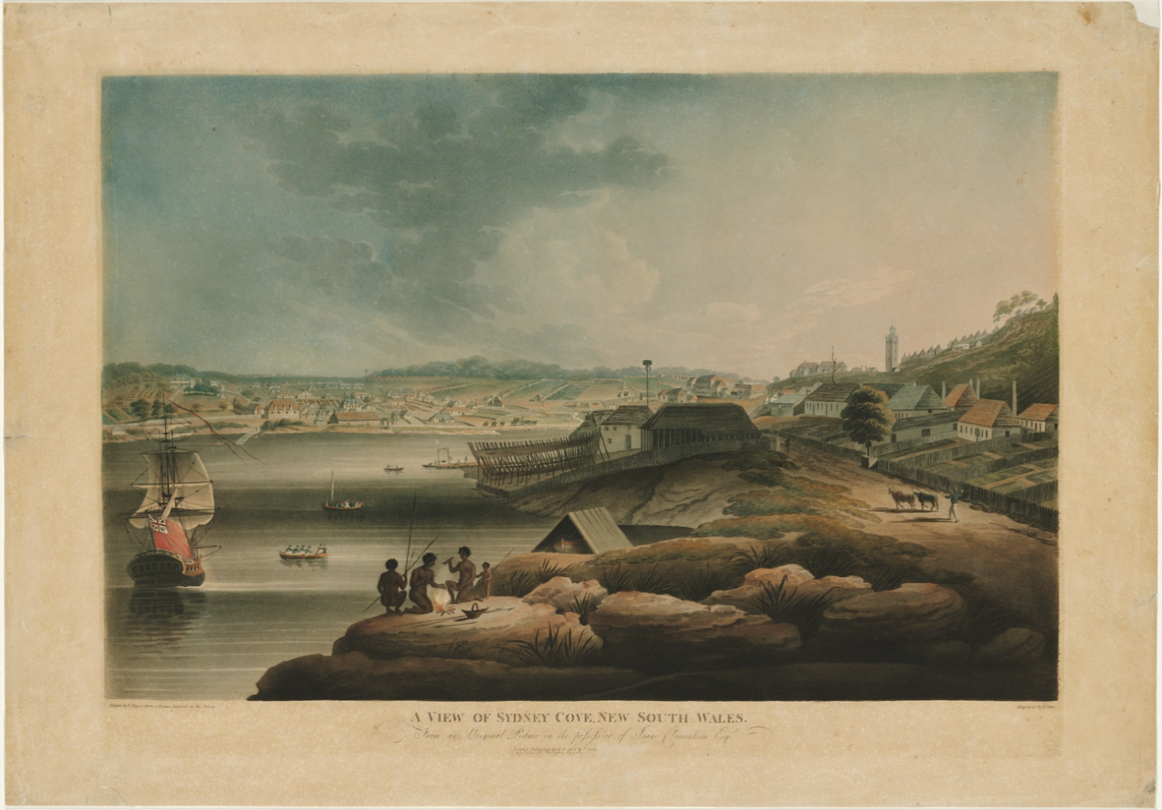
‘View of Sydney Cove, New South Wales, from an original picture in the possession of Isaac Clementson Esqr., 1802 / drawn by E. Dayes from a picture painted at the colony, engraved by F. Jukes’, provided by the Mitchell library, State Library of New South Wales Collection. This work is in the Public Domain.
Students view the 2 illustrations of Sydney Cove in Sources 7 and 8, artists’ impressions of the arrival of the British in Sydney Cove in 1788 and Sydney Cove in 1802. Observe ways in which the environment has been changed between 1788 and 1802. Brainstorm potential impacts of the environmental changes on the local Gadigal Peoples.
Discuss the reliability and accuracy of paintings as sources of information. Note that paintings portray the creator’s perspectives, biases and artistic license, however can give valuable visual impressions of a place in time.
Students use Think-Pair-Share to discuss the following questions:
- What activities are the Aboriginal women doing on the right side of the illustration in Source 7?
- How are the Aboriginal people on the left side of the illustration in Source 7 responding to the British?
- What are the Aboriginal family in the foreground of the 1802 illustration doing?
- Do you think an Aboriginal family could live in that location in 1802? Why or why not?
- The term ‘terra nullius’ means ‘nobody’s land’. Was that true of Australia? How do you know?
- What are some potential immediate impacts on the Gadigal Peoples of the British colony at Sydney Cove?
- What would be the longer-term impacts on the Gadigal Peoples of the British colony?

Historical inquiry step 1 – question
Generate a class set of inquiry questions to investigate the nature of contact between the local Aboriginal Peoples and the British and the effects of the interactions.
Sample questions
- Who are the Traditional Custodians of Sydney Cove?
- What are some examples of contact between the British and the Aboriginal Peoples? How do we know?
- How were Aboriginal Peoples impacted by the colonisation of New South Wales?
- What are some different perspectives on the arrival of the British to Australia?
Note: inquiry questions may need to be redesigned through the historical inquiry process.

Historical inquiry steps 2 and 3 – research and analyse
The following activities are best completed as semi-guided tasks.
Spearing the governor

Source 9
Natural History Museum (6 April 2012) First Fleet: Spearing the Governor (4:13),
Collectively view the video in Source 9, First Fleet: Spearing the Governor. Note: the male narrator uses the term ‘Aborigines’ which is not appropriate in Australia. The term ‘Aboriginal Peoples’ is a more respectful term to use, as used by the female narrator, Dr Sandy O’Sullivan. Recall the nature of contact between the Gadigal Peoples and Governor Phillip at Manly as depicted in the painting in the video. Record the key points in a class concept map.
Significant Aboriginal people in Sydney Cove
Working in jigsaw groupings, students research the following significant Aboriginal people in the early years of the colony. They use a biography template to record the information. Inform Aboriginal students that there will be names and images of Aboriginal people who have died in the information sources. Students share their information with their group.
- Arabanoo, first known as Manly
- Bennelong
- Pemulwuy
- Yemmerrawannie
- Colebee, also known as Coleby.
1789 smallpox epidemic

Source 10
State Library New South Wales (2024) Smallpox outbreak
Students read, or are read, the description of the smallpox epidemic in Source 10. They generate a cause and effect chart or consequences wheel to express the immediate and flow-on impacts of the smallpox epidemic on the Aboriginal Peoples in the Sydney area, for instance, loss of cultural knowledge and loss of language. (Note: viewing images of people suffering from smallpox is not appropriate for Stage 2 students.)
Colonisation or invasion
Share the picture book, What’s your Story? by Rose Giannone and Bern Emmerichs (Berbay Publishing, 2016). Identify Leonard’s and his Aboriginal friend, Milba’s, perspectives on the First Fleet’s arrival in Australia. Students use Think-Pair-Share to discuss:
- Are their friendship and views a true representation of the perspectives of Aboriginal Peoples and the British? Why or why not?
- Was Australia colonised or invaded?
- How can we investigate different perspectives?
Explain that there are varying perspectives on the British colonisation/invasion of Australia, particularly between Aboriginal and non-Aboriginal people. Explore the issue in a balanced way, guided by the Controversial issues in schools policy and the related Controversial issues in schools – procedures. Use the following process to investigate the issue:
- Define the words ‘colonisation’, ‘settlement’, ‘invasion’, ‘resistance’ and ‘dispossession’.
- Identify various people’s perspectives on the issue.
- Locate, analyse and evaluate the evidence on the varying perspectives.
- Outline or communicate the evidence for people’s perspectives.
- Reflect on the evidence to form informed and considered opinions.
Students use Table 4 to access the sources and record key information. If available, also view the first 14 minutes of the video, First Australians, Episode 1: They Have Come to Stay, SBS (free but account required). Assist students in extracting information from the sources to obtain evidence of differing perspectives.
Use a Socratic seminar or fishbowl as a strategy for students to communicate the differing perspectives.
Table 4 – Perspectives source analysis table
Source title and date | Who created it? | Why was it created? | Whose view is it? | Key information | Questions raised
A brief Aboriginal history, Paragraphs 1-3 | Aboriginal Heritage Office | Education and information | Aboriginal Peoples
1787 Draught instructions for Governor Phillip | English Secretary of State, Lord Sydney | Instructions for Governor Phillip | British aristocracy of 1787
First Australians, Episode 1: They Have Come to Stay | SBS | Education | Both perspectives

Historical inquiry step 4 – evaluate
Reflect on the sources used throughout the inquiry. Consider a balance of perspectives, reliability and credibility of the sources.

Historical inquiry step 5 – communicate
Impacts on Aboriginal Peoples
Students use a series of dramatic freeze frames to portray examples of contact and interactions between Aboriginal Peoples and the British and/or examples of impacts of the colonisation on the lives of Aboriginal Peoples.
Use the strategy, thought tracking, to ‘tap in’ and enable students to verbally express their thoughts and understandings. De-role the students so they step out of their characters and roles. Debrief the activity using quiet time for reflection, questioning and discussion.
Note: whilst students should be able to demonstrate empathetic understanding, it is important that they don’t carry guilt for actions of the past.

Reflection
Students reflect on the historical inquiry process and what they learned. They list unanswered questions or aspects of British colonisation and the nature of contact that they wonder about.

Summative task

Source 11
National Museum Australia (n.d) Exile or opportunity? 1788: Captain Arthur Phillip establishes a convict settlement at Sydney Cove
Students scan through or read the main points on the webpage and examine the primary sources. Students answer the 3 questions posed on the page. If typed into the site, students copy and paste their answers into a document that can be accessed by the class teacher. This can be used as an assessment task for the full learning sequence.

Resources
Picture books
- What’s your Story? by Rose Giannone and Bern Emmerichs (2016)
- Beth, story of a Child Convict by Mark Wilson (2017)
- The First Fleet by Alan Boardman and Roland Harvey (1982)
- Cooee Mittigar by Jasmine Seymour and Leanne Mulgo Watson (2019)
Novels
- Birrung the Secret Friend by Jackie French (2015)
- Tom Appleby, Convict Boy by Jackie French (2004)
Websites
- Australian National Maritime Museum (n.d) Convict voyages, online game
- National Library of Australia (n.d) First contacts Digital Classroom, student activities
- State Library of NSW (2024) From Terra Australis to Australia

References
This resource contains NSW Curriculum and syllabus content. The NSW Curriculum is developed by the NSW Education Standards Authority. This content is prepared by NESA for and on behalf of the Crown in right of the State of New South Wales. The material is protected by Crown copyright.
Please refer to the NESA Copyright Disclaimer for more information https://educationstandards.nsw.edu.au/wps/portal/nesa/mini-footer/copyright.
NESA holds the only official and up-to-date versions of the NSW Curriculum and syllabus documents. Please visit the NSW Education Standards Authority (NESA) website https://educationstandards.nsw.edu.au/wps/portal/nesa/home and the NSW Curriculum website https://curriculum.nsw.edu.au/.
History K–10 Syllabus © NSW Education Standards Authority (NESA) for and on behalf of the Crown in right of the State of New South Wales, 2012.

© State of New South Wales (Department of Education), 2024
The copyright material published in this resource is subject to the Copyright Act 1968 (Cth) and is owned by the NSW Department of Education or, where indicated, by a party other than the NSW Department of Education (third-party material).
Copyright material available in this resource and owned by the NSW Department of Education is licensed under a Creative Commons Attribution 4.0 International (CC BY 4.0) license.
This license allows you to share and adapt the material for any purpose, even commercially.
Attribution should be given to © State of New South Wales (Department of Education), 2024.
Material in this resource not available under a Creative Commons license:
- the NSW Department of Education logo, other logos and trademark-protected material
- material owned by a third party that has been reproduced with permission. You will need to obtain permission from the third party to reuse its material.
Links to third-party material and websites
Please note that the provided (reading/viewing material/list/links/texts) are a suggestion only and implies no endorsement, by the New South Wales Department of Education, of any author, publisher, or book title. School principals and teachers are best placed to assess the suitability of resources that would complement the curriculum and reflect the needs and interests of their students.
If you use the links provided in this document to access a third-party's website, you acknowledge that the terms of use, including licence terms set out on the third-party's website apply to the use which may be made of the materials on that third-party website or where permitted by the Copyright Act 1968 (Cth). The department accepts no responsibility for content on third-party websites.

