History Stage 2
Journeys of exploration

Contents
Topic – First contacts 3
Key inquiry question 3
Overview 3
Outcomes 3
Content 3
Historical inquiry skills 4
Selected historical concepts 5
Assessment 5
Vocabulary 5
Teaching and learning activities 6
Inquiry 1 – guided inquiry on an early sea explorer 6
Stimulus 6
Historical inquiry step 1 – question 6
Historical inquiry step 2 – research 7
Historical inquiry step 3 – analyse 7
Historical inquiry step 4 – evaluate 8
Historical inquiry step 5 – communicate 8
Reflection 8
Inquiry 2 – guided inquiry on mapping Australia’s coast 9
Stimulus 9
Source 2 9
Reflection 14
Inquiry 3 – student-led inquiry on an early sea explorer 15
Historical inquiry step 1 – question 15
Reflection 17
Resources 18
References 19

Topic – First contacts
Duration: 4 weeks – 90 minutes per week.

Key inquiry question
- Why did the great journeys of exploration occur?

Overview
Students undertake a guided inquiry into the journeys of one early sea explorer. They undertake a second guided inquiry to investigate the question, ‘Who discovered Australia?’ They use early maps and journals held in the digital collections of Australian museums. Students have the option of undertaking a student-led inquiry into an early explorer. This can replace the first guided inquiry.

Outcomes
A student:
- HT2-3 describes people, events and actions related to world exploration and its effects
- HT2-5 applies skills of historical inquiry and communication.
Outcomes and other syllabus material referenced in this document are from History K–10 Syllabus © NSW Education Standards Authority (NESA) for and on behalf of the Crown in right of the State of New South Wales, 2012.

Content
The journey(s) of at least ONE world navigator, explorer or trader up to the late eighteenth century, including their contacts with other societies and any impacts (ACHHK078)
Students:
- discuss the significance of opening of world trade routes by early explorers such as Vasco da Gama, Columbus, Magellan
- outline the voyages of one early explorer, for example, Zheng He, Torres, Jansz (Janszoon), Tasman, Captain Cook or La Perouse, and explain the impact of their voyages
- discuss the question 'Who discovered Australia?

Historical inquiry skills
- Comprehension: chronology, terms and concepts
- respond, read and write, to show understanding of historical matters
- sequence familiar people and events (ACHHS065, ACHHS081)
- use historical terms (ACHHS066, ACHHS082)
- Analysis and use of sources
- locate relevant information from sources provided (ACHHS068, ACHHS084, ACHHS215, ACHHS216)
- Perspectives and interpretations
- identify different points of view within an historical context (ACHHS069, ACHHS085)
- Empathetic understanding
- explain how and why people in the past may have lived and behaved differently from today
- Research
- pose a range of questions about the past (ACHHS067, ACHHS083)
- plan an historical inquiry
- Explanation and communication
- develop texts, particularly narratives (ACHHS070, ACHHS086)
- use a range of communication forms (oral, graphic, written) and digital technologies (ACHHS071, ACHHS087)

Selected historical concepts
- Cause and effect: events, decisions or developments in the past that produce later actions, results or effects, for example, how conditions and decisions in Britain resulted in the journey of the First Fleet; causes of change in the local area/state.
- Perspectives: people from the past will have different views and experiences, for example, views on the arrival of the British in Australia from a British and an Aboriginal point of view.
- Significance: importance of an event, development or individual/group, for example, the significance/importance of national days/holidays; the significance of the contributions of an early settler.

Assessment
All activities require students to demonstrate their learning. All are assessment for learning activities.

Vocabulary
- Observe, examine, identify, summarise, record, describe, sequence, conclude, explain
- Primary source, secondary source, reliability, bias, journal, biography, evidence
- Journey, world, navigator, navigation, explorer, exploration, trader, contact, interactions, inhabitants, indigenous, society, trade route, unknown, voyage, discover, continent, conflict, colonisation, cause, effect, impact, consequences, significance

Teaching and learning activities
This teaching framework comprises 3 inquiries.

Inquiry 1 – guided inquiry on an early sea explorer
Students examine early sea exploration and its significance through a guided inquiry into one explorer.
Note: this can be replaced with a student-led inquiry into one explorer of choice.

Stimulus

Source 1
ABC Education (2023) Mapping the age of discovery (5:13)
In 2009, a Dutch antique map dealer found the original 1525 map of Magellan’s circumnavigation of the world undertaken in 1519–1522. It is the oldest known map of the Pacific Ocean. In the video in Source 1, the Dutch owner of the map shows it to the map curator of the State Library of NSW. They discuss the significance of the map and Magellan’s journey.
View Source 1 then use the ‘Things to think about’ questions on the ABC Education page to guide discussion.
Students generate a ‘See-Think-Wonder’ chart about ‘Sea Journeys of Exploration’.

Historical inquiry step 1 – question
With reference to the students’ See-Think-Wonder charts, use collaborative learning strategies to generate a class set of inquiry questions for one of the early explorers sent to open world trade routes, for example, Janszoon (Dutch, early 1600s), Magellan (Portuguese, early 1500s), Zheng He (Chinese, early 1400s).
Resource: The Voyages Of Discovery, State Library of NSW
Sample questions
- Who was the explorer?
- When and where were his journeys?
- Why did he undertake his journeys?
- How were his journeys recorded?
- What were the impacts of his journeys at the time?
- How are his journeys significant?
Note: inquiry questions may need to be redesigned through the historical inquiry process.

Historical inquiry step 2 – research
Provide at least one primary and one secondary source on the selected explorer, for example, a biography of the explorer and an original map of the journey. Guide students in extracting information from the sources to answer the inquiry questions. Model the use of a source analysis table.
Table 1 – early sea explorer source analysis table
Source number | Title and date | Who created it? | Why was it created? | Whose view is it? | Key information | Questions raised

Historical inquiry step 3 – analyse
Flowchart of the significance of the journeys
From the information obtained, collectively identify the impacts of the explorer’s sea journey/s and what changed as a result of the journey(s). For example, Zheng He is credited with increasing Chinese power of the seas of the Asian region, expanding Chinese trading relationships and increasing Chinese immigration to South-East Asia.
Collectively create a flowchart to illustrate the causes and effects of the explorer’s journey and its significance. Causes and effects may include interactions with indigenous peoples resulting in conflict, spread of diseases such as smallpox, colonisation and trade relations. Other impacts may include mapping of unknown lands resulting in further exploration and future colonisation.

Historical inquiry step 4 – evaluate
Guide the students in evaluating the reliability of the sources. Are there inconsistencies or contradictions between the sources? Do the inquiry questions need to be redesigned as a result of analysing and evaluating sources?

Historical inquiry step 5 – communicate
Memorial plaque
Students imagine they are working at a museum and have been asked to write the text for a plaque to go on the base of a statue honouring the explorer. Students summarise the significance of the explorer’s journeys in 70 words or less.

Reflection
Students reflect on the historical inquiry process, reflecting on what they learned, how they learned it and what else they would like to find out.

Inquiry 2 – guided inquiry on mapping Australia’s coast
Students examine early European exploration and charting of Australia’s coasts through examination of early maps and journals.

Stimulus
First mapped part of Australia.

Source 2
Figure 1 – copy of map made in 1606 of the voyage of Willem Janszoon in the Duyfken
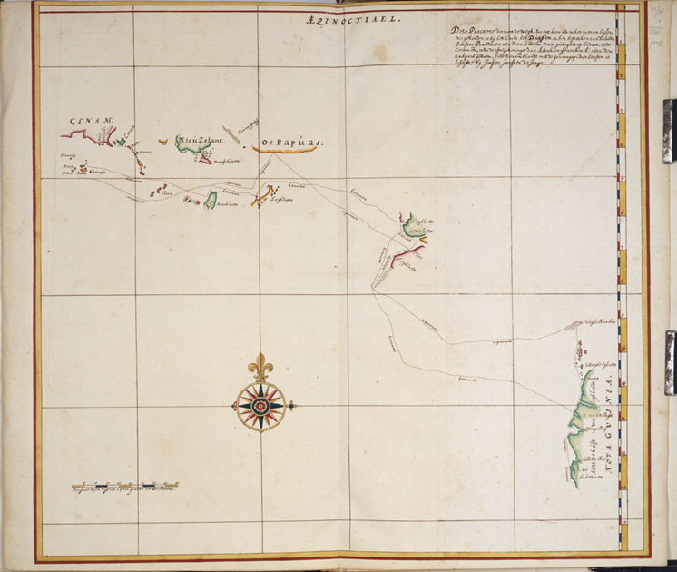
‘Copy of map made in 1606 of the voyage of Willem Janszoon in the Duyfken’. Copy made circa 1670, State Library of Queensland and is in the Public domain.

Source 3
Figure 2 – contemporary map of the voyage of Willem Janszoon in 1605–06
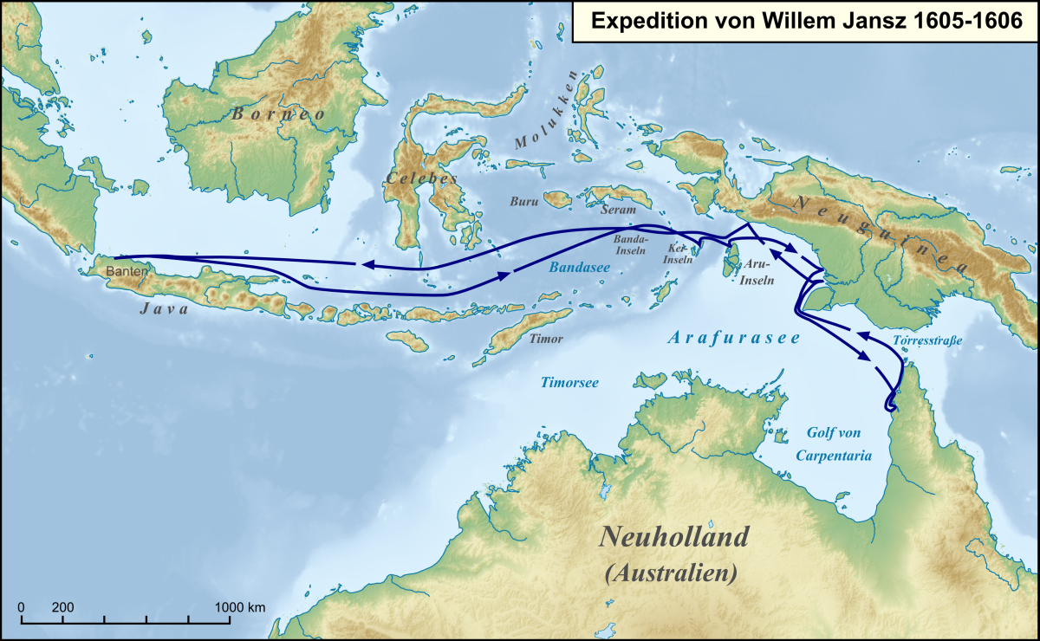
‘Karte der Route der Expedition von Willam Jansz 1605 bis 1606’ by Lencer is licensed under CC BY-SA 3.0
In order to search for trading opportunities beyond the reaches of the lands they knew existed, the Dutch East India Company sent Willem Janszoon (Jansz) on a journey of exploration. In 1605 he and his crew set off in the ship the Duyfken. Willem took it south-east, charting lands as he went. Janszoon landed on the western tip of Australia’s Cape York Peninsula, not realising it was a separate continent. Willem Janszoon is considered to be the first authenticated European to have landed on Australia.
Students examine Sources 2 and 3. For a closer look, use the viewing tools in the State Library of Queensland’s online record. Use the ‘See-Think-Wonder’ prompts to guide observations and discussion. Record questions raised.
See
- What information is included on the 1606 map?
- What locations are shown?
- What part of Australia is shown on the map?
Think
- Why are parts of the 1606 map incomplete?
- Who may Janszoon had contact with during his journey?
- What were the potential impacts of Janszoon’s voyage?
- Why is the map significant?
Wonder
- What do you wonder about after viewing the map of Janszoon’s 1606 journey?

Historical inquiry step 1 – question
With reference to the discussion around Janszoon’s 1606 map in Source 2, formulate a class set of inquiry questions. For example:
- Who mapped other parts of the Australian coast and when?
- What Europeans landed on Australian shores and when?
- What were the impacts on Aboriginal and Torres Strait Islander people?
Note: inquiry questions may need to be redesigned through the historical inquiry process.

Historical inquiry step 2 – research

Source 4
NSW State Library (n.d) Voyages of Discovery
Voyages of Discovery
Students view the maps, letters and journals in Source 4. They select 2 of the primary sources and complete Table 2.
Table 2 – source analysis table
Source number | Title and date | Who created it? | Why was it created? | Whose view is it? | Key information | Questions raised

Source 5
National Library of Australia (n.d) Endeavour voyage
Endeavour voyage (optional)
Students work through selected questions in Source 5, making notes as appropriate. This National Library of Australia digital classroom page includes a link to the complete digitised copy of James Cook’s journal (accessed by expanding the background information label), a link to a video showcasing the journal and a journal extract recounting contact with Aboriginal people.
Tasman’s journal (optional)

Source 6a
State Library of NSW (n.d) Abel Tasman journal

Source 6b
State Library of NSW (n.d) The journal of Abel Jansz Tasman, 1642
Select View online to be directed to Project Gutenberg Australia for documents translated into English. Scroll down to find entry for December 2. See extract below.

That they had heard certain human sounds, also Music resembling that of a Drum or a small Gong, which was not far from them, but they had seen nobody.
That they have seen 2 trees about 2 or 2 ½ fathom in thickness, 60 or 65 feet high, under the branches, in which trees had been cut with flint axes and the bark had been peeled off in order to climb up and rob the birds’ nests in the way of stairs. Each well measured 5 feet from the other, so that they presumed that the people here must be very tall or that they must by some device know how to climb the said trees.
Students view the original journal of Abel Tasman in Source 6a. They read the extract in Source 6b, written on 2 December 1662. This entry provides evidence of Aboriginal people encountered on Tasman’s journey. With reference to Sources 5 and 6, students create a T-chart listing the evidence that Tasman and Cook were aware of the existence of Aboriginal people in Australia in 1642 and 1770. Column headings: ‘Tasman’s journal, 1642’ and ‘Cook’s journal, 1770’.

Historical inquiry step 3 – analyse
Timeline of Australia on the map
Students use the information in Source 4 to create a timeline of the mapping of Australia between 1606 and 1788. They highlight dates of landings and of contact with Aboriginal and Torres Strait Islander peoples.
Using a pair and share or jigsaw strategy, pose the question and discuss: ‘Who discovered Australia?’ Consider alternative words and terms to ‘discovered’ and the views of Aboriginal and Torres Strait Islander people.

Historical inquiry step 4 – evaluate
Guide the students in evaluating the reliability of the sources. Are there inconsistencies or contradictions between the sources? Do the inquiry questions need to be redesigned as a result of analysing and evaluating sources?

Historical inquiry step 5 – communicate
Students write a persuasive paragraph to answer the question, ‘Who discovered Australia?’ They draw on their research and analysis to provide evidence for their views and statements.

Reflection
Students reflect on what they learned, how they found out and what else they would like to know. Students also reflect on the practices modelled by museum staff in handling historic ‘treasures’ and identifying evidence within them.

Inquiry 3 – student-led inquiry on an early sea explorer
Working independently, or in groups, students select one early world explorer. They outline the voyages of their chosen explorer and explain the impact of their voyages. Students demonstrate the historical inquiry process throughout their inquiry.
Note: the student inquiry is intended to be a short research task. It could be undertaken concurrently with the guided class inquiry, or instead of the guided class inquiry.

Historical inquiry step 1 – question
Students formulate a set of inquiry questions they can answer through their research.
Sample questions
- Who was (insert name of explorer)?
- What were his journeys?
- What was the purpose of his journeys?
- What were the impacts of his journeys?
- How are his journeys significant?
Note: inquiry questions may need to be redesigned through the historical inquiry process.

Historical inquiry steps 2 and 3 – research and analysis
Students locate, summarise and analyse information from 2 secondary sources and, if possible, one primary source. They summarise and record key information in Table 3.
Table 3 – source analysis table
Source number | Title and date | Who created it? | Why was it created? | Whose view is it? | Key information | Questions raised

Historical inquiry step 4 – evaluate
Students evaluate the reliability of their sources. Are there inconsistencies or contradictions between the sources? Do the inquiry questions need to be redesigned as a result of analysing and evaluating sources?

Historical inquiry step 5 – communicate
Explorer’s diary
In role as their explorer, students create a diary entry for part of a day in their explorer’s journey in which a significant event occurred. The journal entry should state the reasons why the journey occurred and a future view of the significance of the journey to world history.
Suggested format
- Name of explorer, for example, Ferdinand Magellan
- Place of origin of journey, date of leaving, purpose of journey, for example, ‘We left Spain on 20 September 1519 to undertake a voyage to the Spice Islands.’
- Journal entry date and place, for example, 21 November 1520, Magellan Straits.
- Description of the event that occurred that day, for example, ‘Today we started our journey into the straits. This is unchartered territory that no ship has gone before. I predict it will lead to a great ocean on the other side. If it does, these straits are sure to be named after me.’
- Significance of the journey, for example, ‘I believe I will be remembered for discovering the Magellan Straits. They will be used by ships as a short cut for hundreds of years. I will also be remembered for leading the first expedition to cross the Pacific Ocean and the first to circumnavigate the globe.’

Reflection
Students reflect on their historical inquiry process and information communicated in their journal, by answering the questions:
- What did I do well in the historical inquiry process?
- What did I find challenging in the process?
- How do I know the information I communicated?
- What else do I want to find out?

Resources
Inquiry 1 and 3 – early sea explorers
Picture books
- The Great Voyages of Zheng He by Demi (2012)
- Adventures of the Treasure Fleet: China Discovers the World by Ann Bowler and Lak-Khee Tay-Audouard (2006)
- Meet Captain Cook by Rae Murdie and Chris Nixon (2013)
Websites and resources
- The Mariner’s Museum and Park (2024) Age of Discovery – biographies of early explorers
- National Library Australia (n.d) Digital Classroom: Dirk Hartog 1616-2016 – 400 years of Dutch-Australian connections (5:47)
- National Library of Australia (n.d) Early Explorers
- PBS Education (2024) PBS World Explorers (28 videos)
Inquiry 2 – mapping Australia’s coast
- National Museum of Australia (n.d) Janszoon maps northern Australian coast
- First sight: the Dutch mapping of Australia 1606-1697, State Library NSW (Archived exhibition)
- First sight - the Dutch mapping of Australia 1606-1697 (PDF 1.9 KB)
- New and very accurate map of the world, 1662, by Blaeu, State Library NSW
- State Library NSW (n.d) Tasman Map, 1644
- The Vereenigde Oostindische Compagnie (The Dutch East India Company) – includes links to first maps of Australia in chronological order, National Library Australia

References
This resource contains NSW Curriculum and syllabus content. The NSW Curriculum is developed by the NSW Education Standards Authority. This content is prepared by NESA for and on behalf of the Crown in right of the State of New South Wales. The material is protected by Crown copyright.
Please refer to the NESA Copyright Disclaimer for more information https://educationstandards.nsw.edu.au/wps/portal/nesa/mini-footer/copyright.
NESA holds the only official and up-to-date versions of the NSW Curriculum and syllabus documents. Please visit the NSW Education Standards Authority (NESA) website https://educationstandards.nsw.edu.au/wps/portal/nesa/home and the NSW Curriculum website https://curriculum.nsw.edu.au/.
History K–10 Syllabus © NSW Education Standards Authority (NESA) for and on behalf of the Crown in right of the State of New South Wales, 2012.

© State of New South Wales (Department of Education), 2024
The copyright material published in this resource is subject to the Copyright Act 1968 (Cth) and is owned by the NSW Department of Education or, where indicated, by a party other than the NSW Department of Education (third-party material).
Copyright material available in this resource and owned by the NSW Department of Education is licensed under a Creative Commons Attribution 4.0 International (CC BY 4.0) license.
This license allows you to share and adapt the material for any purpose, even commercially.
Attribution should be given to © State of New South Wales (Department of Education), 2024.
Material in this resource not available under a Creative Commons license:
- the NSW Department of Education logo, other logos and trademark-protected material
- material owned by a third party that has been reproduced with permission. You will need to obtain permission from the third party to reuse its material.
Links to third-party material and websites
Please note that the provided (reading/viewing material/list/links/texts) are a suggestion only and implies no endorsement, by the New South Wales Department of Education, of any author, publisher, or book title. School principals and teachers are best placed to assess the suitability of resources that would complement the curriculum and reflect the needs and interests of their students.
If you use the links provided in this document to access a third-party's website, you acknowledge that the terms of use, including licence terms set out on the third-party's website apply to the use which may be made of the materials on that third-party website or where permitted by the Copyright Act 1968 (Cth). The department accepts no responsibility for content on third-party websites.

