History Stage 3
Migration stories

Contents
Topic – Australia as a nation 3
Key inquiry questions 3
Overview 3
Outcomes 3
Content 4
Historical inquiry skills 4
Selected historical concepts 5
Assessment 6
Vocabulary 6
Teaching and learning activities 7
Inquiry 1 – guided inquiry into waves of migration 7
Stimulus 7
Historical inquiry step 1 – question 8
Historical inquiry step 2 – research 8
Historical inquiry step 3 – analyse 13
Historical inquiry step 4 – evaluate 13
Historical inquiry step 5 – communicate 13
Reflection 14
Inquiry 2 – student-led inquiry into a migrant’s story 15
Stimulus 15
Historical inquiry step 1 – question 17
Historical inquiry steps 2 and 3 – research and analysis 18
Historical inquiry step 4 – evaluate 19
Historical inquiry step 5 – communicate 19
Reflection 19
Resources 20
References 22

Topic – Australia as a nation
Duration: 4 weeks – 90 minutes per week.

Key inquiry questions
- Who were the people who came to Australia? Why did they come?
- What contribution have significant individuals and groups made to the development of Australian society?

Overview
Inquiry 1 is a guided inquiry in which students use primary and secondary sources to investigate the reasons people migrated to Australia from 1945, with a focus on post-war British and European migration.
Inquiry 2 is a student-led inquiry in which students record an oral history of a migrant person’s experiences of migration and produce a short documentary to communicate their story.

Outcomes
A student:
- HT3-3 identifies change and continuity and describes the causes and effects of change on Australian society
- HT3-4 describes and explains the struggles for rights and freedoms in Australia, including Aboriginal and Torres Strait Islander peoples
- HT3-5 applies a variety of skills of historical inquiry and communication.
Outcomes and other syllabus material referenced in this document are from History K–10 Syllabus © NSW Education Standards Authority (NESA) for and on behalf of the Crown in right of the State of New South Wales, 2012.

Content
Stories of groups of people who migrated to Australia (including from one Asian country) and the reasons they migrated, such as World War II and Australian migration programs since the war (ACHHK115).
Students:
- use sources such as oral history to research stories of migration to Australia, including the experiences of ONE Asian family, explaining reasons for migration
- explain how migrants have contributed to Australian society.

Historical inquiry skills
- Comprehension: chronology, terms and concepts
- respond, read and write to show understanding of historical matters
- sequence historical people and events (ACHHS098, ACHHS117)
- use historical terms and concepts (ACHHS099, ACHHS118).
- Analysis and use of sources
- locate information relevant to inquiry questions in a range of sources (ACHHS102, ACHHS121)
- compare information from a range of sources (ACHHS103, ACHHS122).
- Perspectives and interpretations
- identify different points of view in the past and present (ACHHS104, ACHHS123).
- Empathetic understanding
- explain why the behaviour and attitudes of people from the past may differ from today.
- Research
- identify and pose questions to inform an historical inquiry (ACHHS100, ACHHS119)
- identify and locate a range of relevant sources to support an historical inquiry (ACHHS101, ACHHS120).
- Explanation and communication
- develop historical texts, particularly narratives and descriptions, which incorporate source material (ACHHS105, ACHHS124)
- use a range of communication forms (oral, written, graphic) and digital technologies. (ACHHS106, ACHHS125).

Selected historical concepts
- Continuity and change: some things change over time and others remain the same, for example, aspects of both continuity and change in Australian society throughout the twentieth century.
- Cause and effect: events, decisions or developments in the past that produce later actions, results or effects, for example, events and other reasons that led to migration to Australia; reasons for the struggle for rights and freedoms for various groups in Australia.
- Perspectives: people from the past will have different views and experiences, for example, differing attitudes of various groups to Federation or to granting rights and freedoms to women and Aboriginal peoples.
- Empathetic understanding: an understanding of another's point of view, way of life and decisions made in a different time, for example, differing attitudes and experiences of living in an Australian colony; understanding the experiences of Aboriginal and Torres Strait Islanders, women and migrants throughout the twentieth century.
- Significance: the importance of an event, development or individual/group, for example, determining the importance (significance) of various peoples' contributions to the development of a colony.
- Contestability: historical events or issues may be interpreted differently by historians, for example, British 'invasion' or 'settlement' of Australia.

Assessment
All activities require students to demonstrate their learning. All are assessment for learning activities.

Vocabulary
- Investigate, locate, examine, observe, interview, infer, summarise, record, primary source, secondary source, reliable, evidence, perspective, reproduce, recreate, role play, historical narrative.
- Europe, Asia, immigrant, emigrant, migrated, migrant, migration, refugee, asylum, asylum seeker, visa, cause, effect, push and pull factor, ‘populate or perish’, persecute, deport, journey, opportunity, challenge, experience, contribution, society, significance.

Teaching and learning activities
This learning sequence comprises 2 inquiries.

Inquiry 1 – guided inquiry into waves of migration
Students use primary and secondary sources to investigate the reasons people migrated to Australia in the four main waves of migration from 1945, with a focus on post-war British and European migration.

Stimulus
Read the article in Source 1. Discuss the push and pull factors that influenced the Greek orphan girl’s migration to Australia. That is, what factors pushed her out of her birth country and pulled her to migrate to Australia?
Students infer the feelings of the girl arriving in Australia and what her ‘worldly goods’ might have been. In groups of 3, students role play the family’s greeting and introduction to her new home.
Students complete the first 2 columns of a KWL chart on post 1900s migration to Australia.

Source 1
12 February 1948 'Greek Migrant Girl’, The Sydney Morning Herald (p 4).
A pretty 11 years old Greek war orphan stepped from an aircraft at Mascot yesterday afternoon to start a fresh life in a new country.
Carrying a suitcase containing most of her worldly goods, she looked anxiously at the awaiting crowd greeting the plane from Athens. She could not recognise her adopted parents - she had never seen them - but a man in a grey suit at once stepped forward to claim her.
The girl, Paraskevoula Stathoulia, who had lost her father in a German massacre at Kalavrita, has been adopted by Mr and Mrs Con Anthony, of Maroubra Bay Road, Maroubra Junction.
Mr and Mrs Anthony lost their only child soon after its birth. They decided to adopt a Greek war orphan and wrote to relatives in Greece. A photograph of Paraskevoula was sent and they agreed to bring her to Australia. In the bustle of Customs examination, hearing a strange language, Paraskevoula almost burst into tears, but she controlled herself and shortly afterwards she walked firmly away as a member of a family once again.
– Article courtesy of National Library of Australia, text out of copyright.

Historical inquiry step 1 – question
With reference to their KWL charts, students formulate a set of inquiry questions using the historical questioning scaffold of ‘who, what, when, where, how and why’.
Sample questions
- Who were the people who migrated to Australia after 1900?
- When and why did they migrate to Australia?
- From where did these people migrate?
- What opportunities were promoted for a life in Australia?
- What were their migration experiences?
- How have migrants contributed to Australia?
Note: inquiry questions may need to be redesigned through the historical inquiry process.

Historical inquiry step 2 – research
Reasons for migration to Australia

Source 2
Australian Department of Home Affairs (13 July 2015) 70 years of post-war migration (3:31)

Source 3
SonyFMAM (18 January 2022) First Wave of Post World War 2 Migration to Australia
Students view the videos to gain an overview of post war migration to Australia. Identify and clarify the key push and pull factors that influenced migration to Australia through questions such as: Why did Australia want to increase its population? How did the Australian Government attract British immigrants? What positive opportunities did Australia offer British immigrants (pull factors)? Who were displaced persons? What were the negative factors that pushed them out of their country? What pull factors did Australia offer to displaced persons?
Students use Sources 2 and 3, and other secondary sources, to complete Table 1.
Table 1 – Reasons for migration to Australia
Major waves of migration | Start date | The people | Push factors | Pull factors
Ten pound poms | 1945
Displaced persons | 1947
Boat people | 1976
Asylum seekers | 1999
Pull factors for post-war British and European migrants
Students examine one of the posters in Source 4 or 5. Working in pairs, informed by their information in Table 1, students use visual literacy and source analysis skills to analyse the poster. They use sticky notes, digital annotation and/or the source analysis scaffold in Table 2, to identify:
- what promises were being promoted to British and European migrants
- how Australia was portrayed at the time
- how an improved climate and lifestyle was portrayed.

Source 4
Figure 1 – Land of Tomorrow, Joe Greenberg (1949), Department of Immigration. Poster such as these were displayed in Displaced Persons’ camps in Europe to encourage migration to Australia.
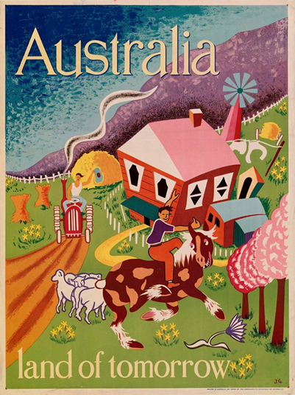
‘Australia Land of Tomorrow, circa 1948’ by Joe Greenburg is licensed under CC by PDM 1.0

Source 5
Figure 2 – Poster advertising migration to Australia, 1962. A series of posters and advertisements were produced to encourage British families to migrate to Australia. These British migrants were known colloquially as ‘Ten Pound Poms’
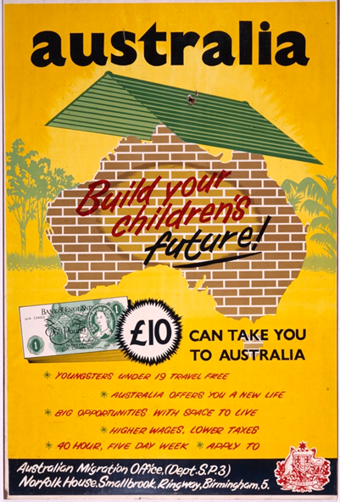
‘Immigration - Promotional Activities - Ten-pound fare poster (1962)’ by Australian Migration Office courtesy of National Archives Australia.

Table 2 – Migration poster analysis
Analysis questions | Source analysis | Questions raised
Key information
What is the poster showing, overall, and in the detail?
What it provides evidence of
What evidence does the poster contain about migration to Australia?
Who created it and why
When, where, why and by whom was the poster made?
Reliability and usefulness
How reliable, valid and useful is the poster as a source?
Personal experiences of post-war migration
View the videos in Sources 6, 7 and 8. Identify the type of source each video provides and discuss how each provides evidence of people’s migration experiences. Brainstorm other types of sources that would provide evidence of migration experiences.
In Table 3, students list the key information from of Sources 6, 7 and 8 and evaluate their reliability.

Source 6
ABC Education (11 Jul 2022) A Dutch migrant in Lavington (2:41).
The oral history of a Dutch woman’s experiences of her migration to Australia.

Source 7
Australian Screen NFSA (2024) A World for Children (2:54), circa 1962.
A documentary about a group of migrants arriving at Bonegilla Migrant Reception and Training Centre in northern Victoria.

Source 8
NSW National Parks and Wildlife Service (13 July 2016) Scheyville in 1959, During the Migrant Era (4:46), courtesy of Bert Franzen, 1959.
A silent film taken by a 1959 resident showing daily life at the Scheyville Migrant Accommodation Centre in Pitt Town, NSW.

Table 3 – personal migration experiences – source analysis table
Source number | Title and date | Who created it and why | Key information | What it provides evidence of | Reliability and usefulness | Questions raised
5 | A Dutch migrant in Lavington, 2013
6 | A world for children, c.1962
7 | Scheyville in 1959

Historical inquiry step 3 – analyse
Students compare the information in Table 2 and Table 3.
Using pair and share, or as a class, students discuss the question: How was actual life in Australia similar and different to what was promoted to British and European migrants by the Australian Government? This could be represented as a Venn diagram.

Historical inquiry step 4 – evaluate
Review the evaluations of the reliability of the sources in Tables 2 and 3. Are there inconsistencies or contradictions between the sources? Do the inquiry questions need to be redesigned as a result of analysing and evaluating sources?

Historical inquiry step 5 – communicate
Role play of post-war migration experience
Working in groups, students take on role as either a displaced family, or young British family, attracted to the prospect of migrating to Australia who are influenced by either Source 3 displayed on the wall of their Displaced Persons’ camp or source 4 displayed at a local community facility in Birmingham, England.
Students role play 3 snap-shots in the family’s migration journey. In role as a particular family member, they represent the different perspectives of each family member:
- pre-migration – a family conversation in which one parent tries to persuade the other parent to migrate to Australia, providing push and pull factors in their argument, with the resolution being the decision to migrate
- arrival at an Australian migrant centre – arrival and first impressions of Australia at a migrant accommodation centre such as Bonegilla Migrant Reception and Training Centre or Scheyville Migrant Accommodation Centre
- settled in their own home Australia – a family dinner in their own home in which they reflect on the family’s decision to migrate to Australia.

Reflection
Students reflect on the historical inquiry process, reflecting on what they learned, how they learned it and what else they would like to find out.

Inquiry 2 – student-led inquiry into a migrant’s story
Students undertake a student-led inquiry into a group, or individual, who migrated to Australia between 1945 and the present. Where possible, students undertake primary research by interviewing local people who have migrated to Australia from their school, family, friends or local community. With reference to the oral history obtained through interview, and other primary sources, students share the person’s migration story in a short documentary. In communities without ready access to migrants, students use recorded oral histories.
Note: the syllabus states that students investigate the story of a group who migrated from one Asian country so ensure some students select an Asian migrant’s story to share with the class.

Stimulus

Source 9
A photographer captures the image of Vietnamese refugees awaiting rescue by the United States Navy, 1984. Found 560 kilometres northeast of Cam Ranh Bay, Vietnam, these 35 Vietnamese refugees were rescued from their 10.5 metre fishing boat after spending 8 days at sea
Figure 3 – Vietnamese Boat People, PH2 Phil Eggman (15 May 1984)
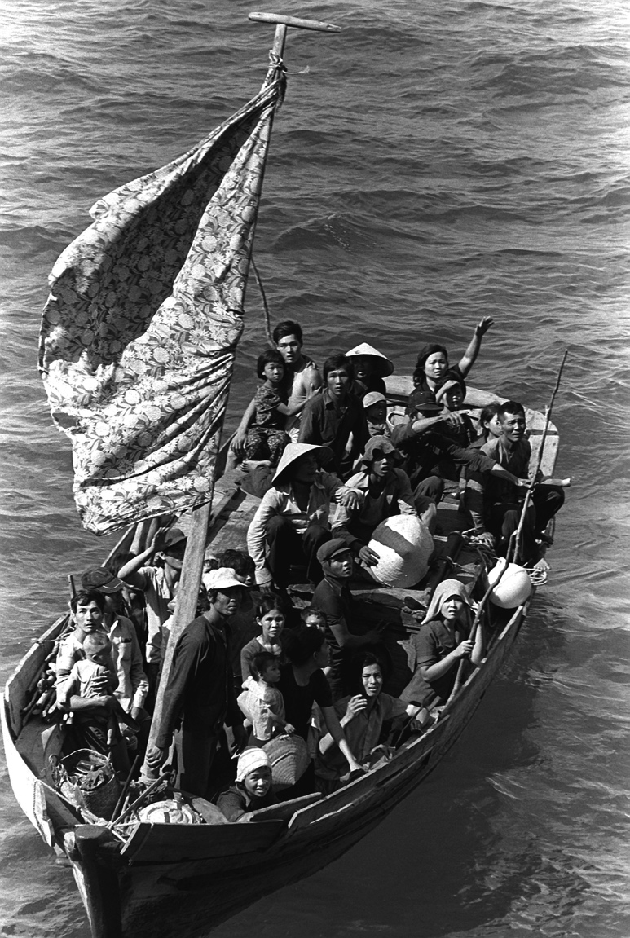
‘35 Vietnamese refugees wait to be taken aboard the amphibious command ship USS BLUE RIDGE (LCC-19)’ by Phil Eggman is in the Public Domain.

Source 10
National Maritime Museum of Australia, Kim Tao (2015) A fishing boat called Freedom: The story of Tu Do
View Source 9 and read the story of the Tu Do, in Source 9. The Tu Do was one of 6 small boats that arrived in Darwin Harbour on 21 November 1977 carrying Vietnamese refugees.
As the story is read, students jot words or sketch images to create ‘graffiti boards’ to represent their reactions, emotions and questions. In groups students discuss their responses and questions.
Activate prior knowledge of the groups of people who have migrated to Australia from 1945 to the present. Ask students what sources would provide information on the stories of people then outline the independent research task.
Research task – oral history project
Students:
- identify and select an individual or group who migrated to Australia between 1945 and the present. Where possible this should be a person known to the student, for example, a person from their family or friends, or from school or the local community.
- undertake primary research through interviewing the selected person and video recording the interview to record their oral history. If a personal interview is not possible, students use a pre-recorded oral history selected from the collections in the resources list.
- photograph, or locate photographs of, primary sources that provide evidence of the selected person’s heritage or migration experiences and that add ‘colour’ to their migration story.
- obtain additional information from at least one secondary source, if required.
- share their person’s migration story with the class through a 2 to 3 minute documentary that embeds the oral history and 2 other primary sources.

Historical inquiry step 1 – question
With reference to their graffiti boards, class discussions and their selected person, students formulate a set of inquiry questions using the historical questioning scaffold of ‘who, what, when, where, how and why’. Refer to the sample questions in Inquiry 1.
Note: inquiry questions may need to be redesigned through the historical inquiry process.
Students also develop a set of oral history interview questions. Sample interview questions:
- What is your country of birth?
- When did you migrate to Australia?
- Why did you migrate to Australia?
- What were your experiences on your journey to Australia?
- What were your experiences when you settled in Australia?
- What special objects did you bring with you?
- How has your life changed and remained the same?
- How do you like living in Australia?
- How have migrants from your birth country contributed to Australia?

Historical inquiry steps 2 and 3 – research and analysis
Students use Tables 4 and 5 to record information sourced from the interview and other primary and secondary sources.
Table 4 – oral history recording scaffold
Topic | Responses
Name and country of birth
Year of migration
Reasons for migration (push and pull factors)
Experiences on migration journey
Experiences in Australia
Changes and continuities in lifestyle
Contributions of migrant group to Australia
Table 5 – source analysis table
Source number | Title and date | Who created it and why | Key information | What it provides evidence of | Reliability and usefulness | Questions raised

Historical inquiry step 4 – evaluate
During research and analysis, students evaluate the reliability of the sources. Are there inconsistencies or contradictions between the sources? Do the inquiry questions need to be redesigned as a result of analysing and evaluating sources?

Historical inquiry step 5 – communicate
Mini documentary:
Students plan, storyboard and create a 2- to 3-minute documentary that communicates their person’s migration story. The documentary should set the context of the time period in Australian or world events, embed extracts from the recorded oral history and, if possible, other primary sources.

Reflection
Students reflect on the historical inquiry process, reflecting on what they learned, how they learned it and what else they would like to find out.

Resources
Migration stories – oral histories
- National Archives of Australia (n.d) Migrant stories
- Immigration Museum (2024) Immigrant stories
- Immigration stories - Australian National Maritime Museum
- NSW Migration Heritage Centre (2014) Stories about migrating to Australia video playlist (12 videos)
- Australian Department of Home Affairs (2017) Refugee Week 2017 playlist (4 videos)
Digital collections
- National Archives Australia
- Trove
- State Archives and Records of NSW
Books
- I'm Australian Too by Mem Fox and Ronojoy Ghosh (2017) (PRC K–2)
- Ziba Came on a Boat by Liz Lofthouse and Robert Ingpen (2007) (PRC 3–4)
- The Little Refugee by Anh Do, Suzanne Do and Bruce Whatley (2011) (PRC 3–4)
- My Two Blankets by Iren Kobald and Freya Blackwood (2014) (PRC 3–4)
- Ships in the Field by Suzanne Gervey and Anna Pignataro (2012) (PRC 3–4)
- A True Person by Gabiann Marin and Jacqui Grantford (2007) (PRC 3–4)
- Ali's Story by Andy Glynne and Salvador Maldonado (2017) (PRC 3–4)
- The Wishing Cupboard by Libby Hathorn and Elizabeth Stanley (2002) (PRC 3–4)
- The Peasant Prince by Li Cunxin and Anne Spudvilas (2017) (PRC 5–6)
- The Arrival by Shaun Tan (2006) (PRC 7–9)
- Out by Angela May George and Owen Swan (2016)
- The Lotus Seed by Sherry Garland and Tatsuro Kiuchi (1993)
- The Big Book of Australian History by Peter Macinnis (2017)
Teacher resources
- A guide to using picture books in history K-10, Department of Education, 2017
- Refugees and migration: Upper primary English, Year 6 (PDF 1.1KB), Global Words: English for Global Education

References
This resource contains NSW Curriculum and syllabus content. The NSW Curriculum is developed by the NSW Education Standards Authority. This content is prepared by NESA for and on behalf of the Crown in right of the State of New South Wales. The material is protected by Crown copyright.
Please refer to the NESA Copyright Disclaimer for more information https://educationstandards.nsw.edu.au/wps/portal/nesa/mini-footer/copyright.
NESA holds the only official and up-to-date versions of the NSW Curriculum and syllabus documents. Please visit the NSW Education Standards Authority (NESA) website https://educationstandards.nsw.edu.au/wps/portal/nesa/home and the NSW Curriculum website https://curriculum.nsw.edu.au/.
History K–10 Syllabus © NSW Education Standards Authority (NESA) for and on behalf of the Crown in right of the State of New South Wales, 2012.

© State of New South Wales (Department of Education), 2024
The copyright material published in this resource is subject to the Copyright Act 1968 (Cth) and is owned by the NSW Department of Education or, where indicated, by a party other than the NSW Department of Education (third-party material).
Copyright material available in this resource and owned by the NSW Department of Education is licensed under a Creative Commons Attribution 4.0 International (CC BY 4.0) license.
This license allows you to share and adapt the material for any purpose, even commercially.
Attribution should be given to © State of New South Wales (Department of Education), 2024.
Material in this resource not available under a Creative Commons license:
- the NSW Department of Education logo, other logos and trademark-protected material
- material owned by a third party that has been reproduced with permission. You will need to obtain permission from the third party to reuse its material.
Links to third-party material and websites
Please note that the provided (reading/viewing material/list/links/texts) are a suggestion only and implies no endorsement, by the New South Wales Department of Education, of any author, publisher, or book title. School principals and teachers are best placed to assess the suitability of resources that would complement the curriculum and reflect the needs and interests of their students.
If you use the links provided in this document to access a third-party's website, you acknowledge that the terms of use, including licence terms set out on the third-party's website apply to the use which may be made of the materials on that third-party website or where permitted by the Copyright Act 1968 (Cth). The department accepts no responsibility for content on third-party websites.

