Stage 4 History: Angkor/Khmer Empire (c. AD 802 – c. 1431)
This resource has been designed to support teachers by providing a range of tasks based on syllabus content. Tasks can be incorporated into context driven teaching and learning programs in full or can be used to supplement existing programs. All content is textbook non-specific. Specific targeted teaching activities to support critical and creative thinking in the history classroom have been indicated under the Critical and creative thinking activity boxes.
Contents
Key inquiry questions 3
Outcomes 3
Historical concepts 3
Historical skills 4
Key terminology 5
Learning sequence 1: Introduction to the Khmer Empire 6
Content 6
Khmer Empire place in history 6
Extent and importance of the Khmer Empire 6
Khmer society and everyday life 7
Learning sequence 2: Angkor’s rise to prominence 9
Content 9
Key cultural, economic and political features of Angkor/Khmer Empire 9
Status and power in the Khmer Empire 10
Roles and relationships of key groups in Angkor/Khmer Empire 12
The wealth of the Khmer Empire 12
Angkor’s rise to prominence 12
Learning sequence 3: Source analysis of cultural achievements 13
Content 13
The land and its resources 13
The Mekong and Tonle Sap 13
Water management 15
Cultural achievements 18
Learning sequence 4: Site study 19
Content 19
The magnificent Temple of Angkor Wat 19
Learning sequence 5: Theories of decline and legacy 21
Content 21
Decline of an empire 21
The importance and significance of Angkor Wat today 22
Assessment task 23
Outcomes 23
Syllabus content 23
Task 23
Marking Criteria 25

Key inquiry questions
- How did societies change from the end of the ancient period to the beginning of the modern age?
- What key beliefs and values emerged and how did they influence societies?
- What were the causes and effects of contact between societies in this period?
- Which significant people, groups, and ideas from this period have influenced the world today?

Outcomes
A student:
- HT4-2 describes major periods of historical time and sequences events, people and societies from the past
- HT4-4 describes and explains the causes and effects of events and developments of past societies over time
- HT4-6 uses evidence from sources to support historical narratives and explanations
- HT4-7 identifies and describes different contexts, perspectives and interpretations of the past
- HT4-9 uses a range of historical terms and concepts when communicating an understanding of the past
- HT4-10 selects and uses appropriate oral, written, visual and digital forms to communicate about the past.
Outcomes and other elements of syllabus references in this document are from the History K-10 Syllabus © 2012 NSW Education Standards Authority (NESA) for and on behalf of the Crown in right of the State of New South Wales.

Historical concepts
- Continuity and change: changes and continuities over a broad period of time, for example, the Roman Empire
- Cause and effect: developments, decisions and events from the past that produced later actions, results or consequences
- Perspectives: different perspectives of participants in a particular historical context, such as the conquered and the conqueror
- Empathetic understanding: the actions, attitudes and motives of people in the context of the past
- Significance: the importance of an historical event, development or individual in an historical context
- Contestability: historical sources, events or issues may be interpreted differently by historians, for example, the ‘fall’ of the Roman Empire

Historical skills
- Comprehension: chronology, terms and concepts
- read and understand historical texts
- sequence historical events and periods (ACHHS205, ACHHS148)
- use historical terms and concepts (ACHHS206, ACHHS149).
- Analysis and use of sources
- identify the origin and purpose of primary and secondary sources (ACHHS209, ACHHS152)
- locate, select and use information from a range of sources as evidence (ACHHS210, ACHHS153)
- draw conclusions about the usefulness of sources (ACHHS211, ACHHS154).
- Perspectives and interpretations
- identify and describe different perspectives of participants in a particular historical context (ACHHS212, ACHHS155).
- Empathetic understanding
- interpret history through the actions, attitudes and motives of people in the context of the past (ACHHS212, ACHHS155).
- Research
- ask a range of questions about the past to inform an historical inquiry (ACHHS207, ACHHS150)
- identify and locate a range of relevant sources, using ICT and other methods (ACHHS208, ACHHS151)
- use a range of communication forms and technologies.
- Explanation and communication
- develop historical texts, particularly explanations and historical arguments that use evidence from a range of sources (ACHHS213, ACHHS156)
- select and use a range of communication (oral, graphic, written and digital) to communicate effectively about the past (ACHHS214, ACHHS157).

Key terminology
agriculture, Angkor, baray, civilisation, climate change, decline, empire, heritage, Khmer, king, religion, temple, trade, UNESCO, war, water management

Learning sequence 1: Introduction to the Khmer Empire

Content
The way of life in the Khmer Empire, including social, cultural, economic and political features (including the role of the king) (ACDSEH011)
Students:
- identify key sites and the extent of the Angkor/Khmer Empire during this period
- describe everyday life in the Angkor/Khmer Empire.

Khmer Empire place in history
Note: Teachers may choose to use a KWLH chart for individual tasks or to illustrate building knowledge for the duration of the learning sequence.
The Angkor Wat and Siem Reap Cambodia Guided Tour – 6K 360 VR Video allows students to stop the video and explore the temple.
Critical and creative thinking activity: KWLH chart
Complete a KWLH chart prior to watching Angkor (2:31) and Angkor Wat and Siem Reap Cambodia Guided Tour – 6K 360 VR Video (6:32).
At the conclusion of each film identify any additional information on your KWLH chart.
Use Time Graphics to fill in the Khmer Empire and other civilisations to see where the Khmer Empire fits into the history you have already studied.

Extent and importance of the Khmer Empire
Note: If teachers wish to make a link to depth study 1 use the criteria for selection from UNESCO to conduct a Jigsaw activity to classify Angkor as a world heritage site and report findings in a shared Google Jamboard.
As a class scale down Google Earth to view Angkor and discuss its location in the context of Asia and the world. Record an account of the class discussion in your book.
Identify the extent of the Khmer Empire South East Asia 1215CE and on a map of Cambodia and neighbouring country boundaries use Google Maps to locate and label the following sites:
- Temple of Angkor Wat
- Jayatataka Baray
- West Baray
- Ta Prohm Temple
- Krong Siem Reap
- Phnom Penh
- Vietnam
- Thailand
- Laos.

Khmer society and everyday life
Watch The Khmer Empire – Cambodia’s Medieval Splendour 2009 Animation (3:06), Simulating 24 Hours at Medieval Angkor Wat (1:47) and Visualising Angkor: 360 Market (2019) (0:25) and use the information to write a two-sentence description for each of the following:
- clothing
- buildings
- tools and technology
- farming
- food
- religious events
- army.
Critical and creative thinking activity: Venn diagram
Buddhism and Hinduism were the 2 major Khmer religions. Access What is Buddhism? and Introduction to Hinduism to create a Venn diagram to identify commonalities and differences between Buddhism and Hinduism.

Learning sequence 2: Angkor’s rise to prominence

Content
The way of life in the Khmer Empire, including social, cultural economic and political features (including the role of the king) (ACDSEH011)
Students:
- outline key cultural, economic and political features of life in the Angkor/Khmer Empire
- identify the roles and relationships of key groups in the Angkor/Khmer Empire.
The reasons for Angkor’s rise to prominence, including wealth from trade and agriculture (ACDSEH060)
Students:
- describe the status and power of the king
- explain how the wealth from trade and agriculture contributed to Angkor’s rise to prominence.

Key cultural, economic and political features of Angkor/Khmer Empire
Note: Explicitly teach the key characteristics of social class and status of the Khmer Empire. Ensure you include the rich, peasants and monks.
Copy and complete into your book a social pyramid (see Blank Pyramid Charts) for the Khmer society. Ensure the social pyramid includes:
- king
- priests
- nobles
- soldiers
- farmers
- slaves.
Using the information from your social pyramid, complete Table 1:
Table 1 – Social pyramid
Social position | Key facts and details about class and status
Rich
Peasants
Monks
Summarise the key characteristics of social class and status of the Khmer society.

Status and power in the Khmer Empire
Use the following resources to complete Table 2 summarising key facts about leaders of the Khmer Empire across time.
- Chronology Of Cambodian History: Jayavarman II
- Britannica – Suryavarman II: king of the Khmer empire
- The Angkor Empire’s National Health Service
Table 2 – Key leaders of the Khmer Empire
Leader | Key facts and details
Jayavarman II (802-850)
Suryavarman II (1112-1152)
Jayavarman VII (1181-1218)

Critical and creative thinking activity: Think-Pair-Share
With a partner, use Think-Pair-Share to rank these factors in order of importance from the perspective of a Khmer Empire king:
- bring badly needed rain
- keep the spirits of Khmer ancestors at peace
- deliver the high officials their titles and emblems
- construct a new temple
- decorate old temples for the new year
- grant land and slaves to new temples and monasteries
- construct new irrigation works
- maintain old irrigation works
- conduct foreign affairs, especially with Champa in the East and with various tributary states to the north and west.
In pairs, compose a paragraph justifying your rankings.
Using your judgements from the previous activity, complete Peer discussion and conferencing and answer the following questions:
- Were the roles and responsibilities of the Khmer Empire king achievable?
- What roles and responsibilities of the Khmer Empire king are similar to official roles and responsibilities of modern leaders?
Thinking from the perspective of a peasant, what factors would influence whether you liked the king?

Roles and relationships of key groups in Angkor/Khmer Empire
Note: Explicitly teach dictogloss as a strategy for summarising large segments of historical information from a text. Use Khmer Empire to conduct a dictogloss that summarises the roles and relationships of people in Khmer society.

The wealth of the Khmer Empire
Visit Commerce and Trade and answer questions 1-3 on the website.
Visit Goods and Exchange and answer questions 1 and 2 on the website.
Visit Relations with China and answer the following questions:
- Outline the kinds of tribute that Cambodia sent to China. How did the Chinese respond to this tribute?
- Read the quote from Hong-wu: Year 16, Month 4, Day 22 (24 May 1383). Can you think of some reasons why the Chinese imperial court wanted to keep such detailed records? What does this tell us about the tributary system?
- How did a small state like Cambodia benefit from being part of the Chinese tributary system?
Extension question:
Consider the language used in Zhou Daguan’s writing and in the excerpts from the Ming Dynasty. How did the imperial court view China’s position internationally?

Angkor’s rise to prominence
Watch Foreign Correspondent: Mysteries of Angkor (5:48) and Angkor Wat archaeological digs yield new clues to its civilization’s decline to complete a Plus, Minus, Interesting (PMI) on the rise and fall of Angkor.

Learning sequence 3: Source analysis of cultural achievements

Content
The cultural achievements of the Khmer civilisation, including its system of water management and the building of the temples of Angkor (ACDSEH061)
Students:
- using a range of sources and the site of Angkor as an historical source, describe what it reveals about Angkor/Khmer life and culture. This could include:
- the system of water management.

The land and its resources
Use Google Earth to scale down and view current day Cambodia. Locate and illustrate the Khmer Empire South East Asia 1215CE on a map of Cambodia using Google Maps or an atlas. Add the following geographical features to the map:
- major mountain ranges
- major river systems
- major cities.
Critical and creative thinking activity: Brainstorming
Conduct a brainstorm to consider the key features of the environment and geography of the Khmer Empire. Use this information to write a 100-word response describing how the location and environment of the Khmer Empire might have influenced the civilisation.

The Mekong and Tonle Sap
Examine Figures 1-3 below, and the photographs from Water technologies of the Khmer civilisation. Describe what the photos reveal about the Khmer civilisation and their system of water management.
Figure 1
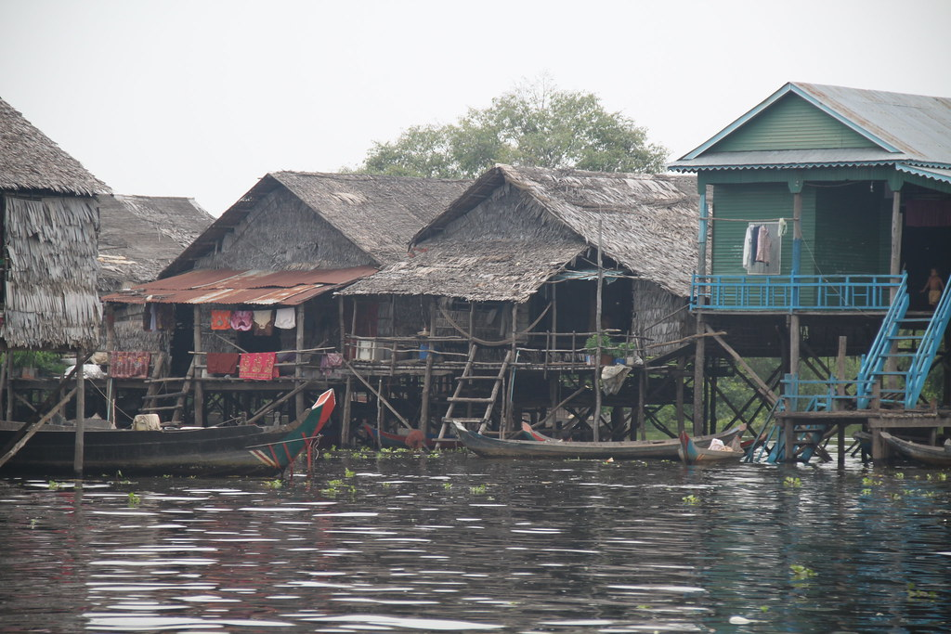
"Tonle Sap Lake" by Gary Lee Todd, Ph.D. is licensed under CC0 1.0.
Figure 2
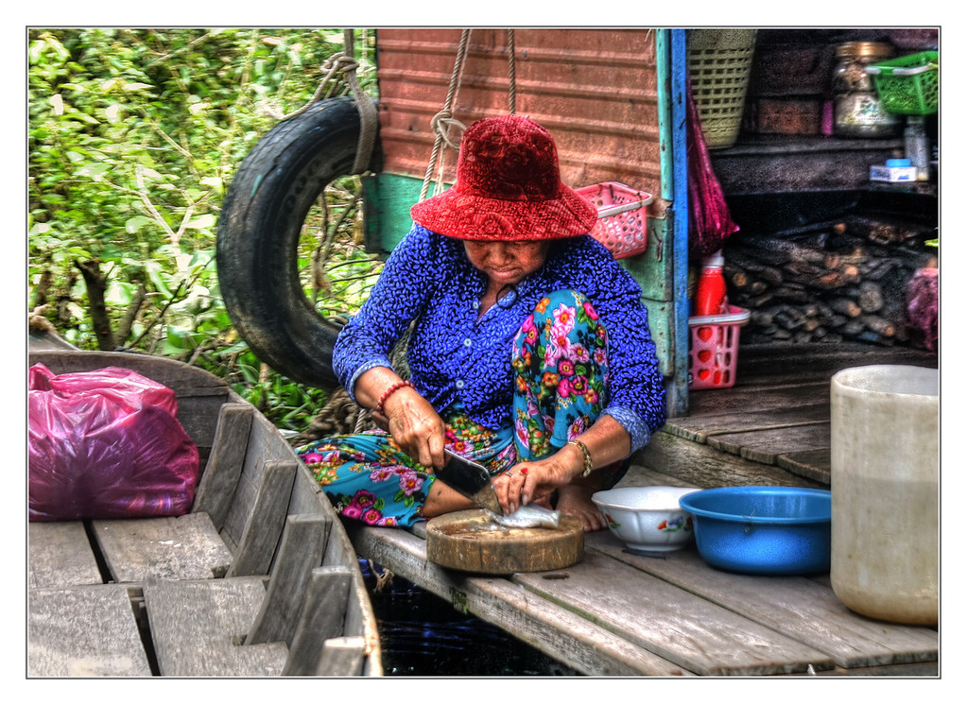
"Tonle Sap Lake K – Chong Kneas the floating village 02" by Daniel Mennerich is licensed under CC BY-NC-ND 2.0.
Figure 3
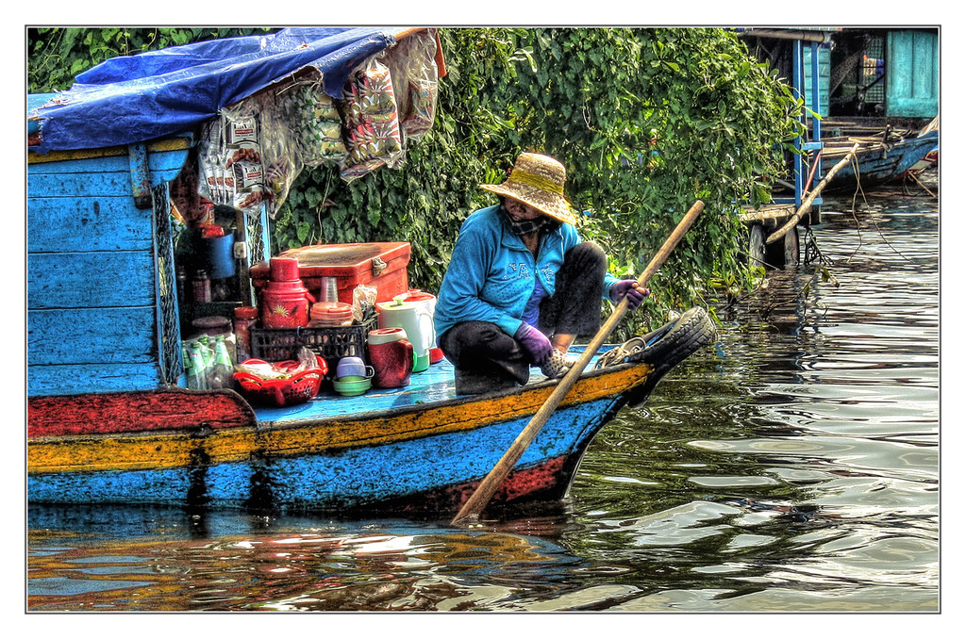
"Tonle Sap Lake K – Chong Kneas the floating village 09" by Daniel Mennerich is licensed under CC BY-NC-ND 2.0.
Extension question:
Compare Tonlé Sap with the Nile River using a T-chart. Then complete an extended response answering the following:
Why have the majority of Australians heard of the Nile, but not Tonle Sap? What does this tell us about how and why cultural perspectives shape history?

Water management
Note: Define water management and briefly explain how we manage water in our daily lives.
Examine Figures 4-7 and describe the Angkor Wat moat. Predict the reasons it may have been built.
Figure 4
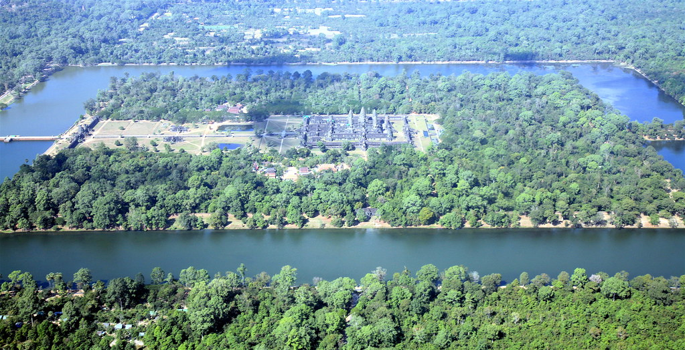
"Angkor Wat" by jurvetson is licensed under CC BY 2.0.
Figure 5
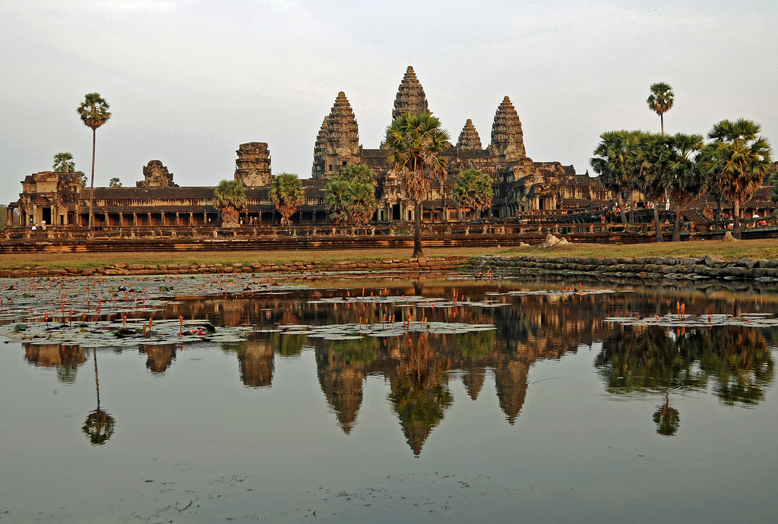
"Cambodia-2638 - Mighty Angkor Wat" by archer10 (Dennis) is licensed under CC BY-SA 2.0.
Figure 6
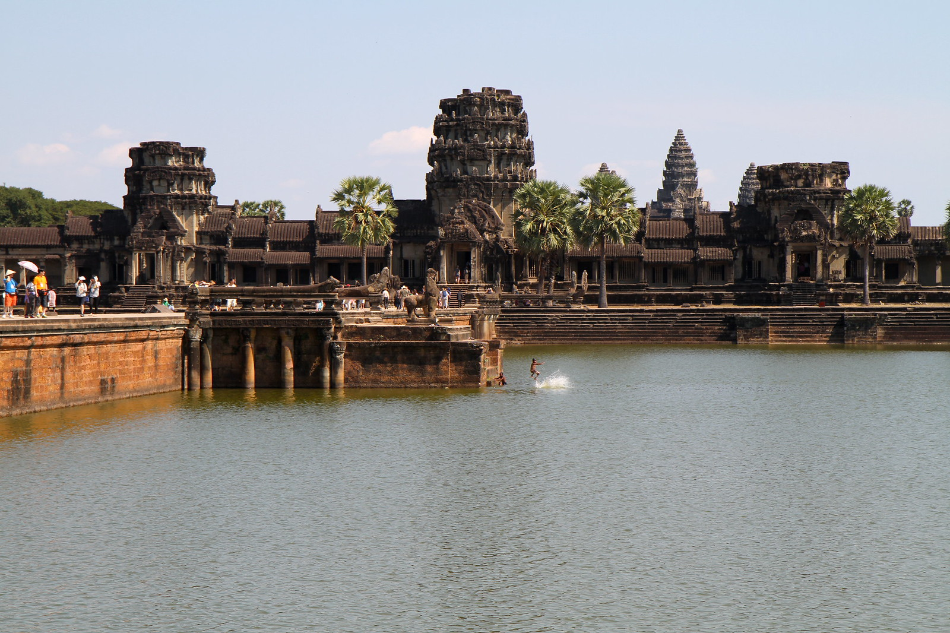
“Kids play in the Angkor Wat moat” by Jason Eppink is licensed under CC BY 2.0.
Figure 7
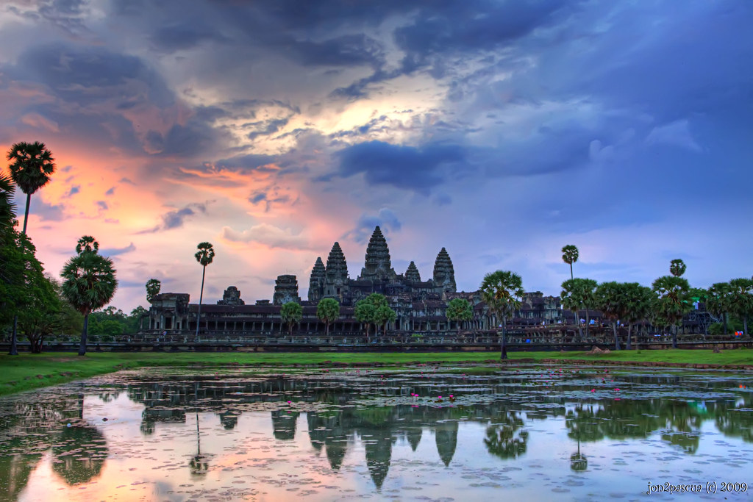
"Angkor Wat Sunrise" by Jon^2 is licensed under CC BY-NC-ND 2.0.
Watch Why the moat was built around Angkor Wat (7:07) and record the 3 reasons for building the moat.
As a class discuss how your predictions align to or differ from those presented in the film.
Figure 8
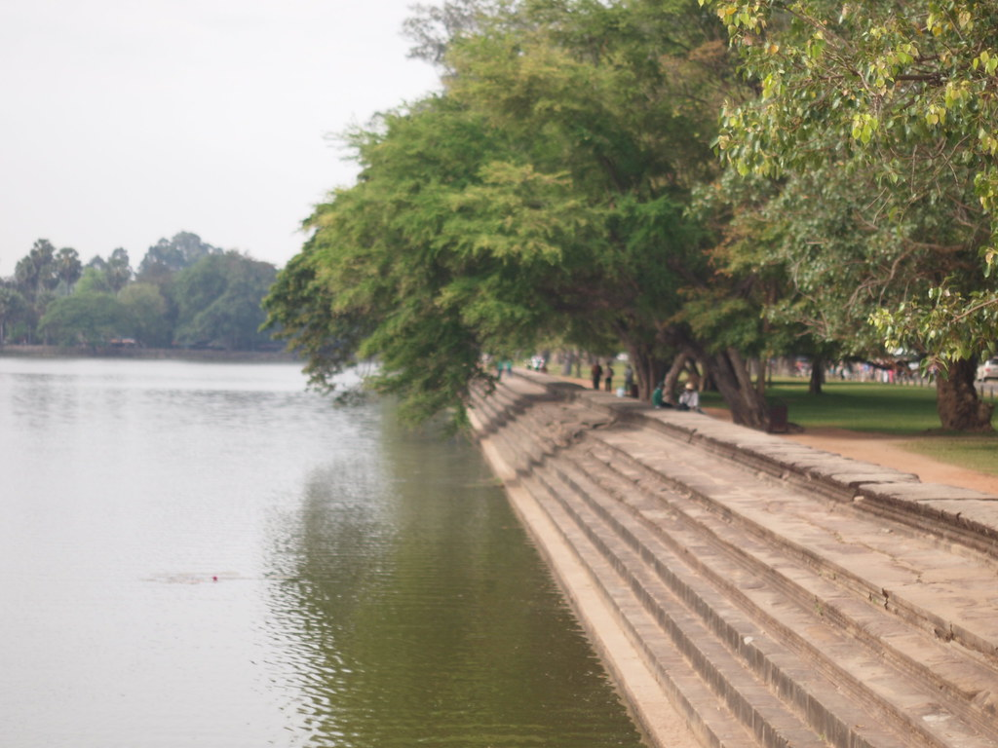
"Steps on the reservoir, Angkor Wat" by HeyItsWilliam is licensed under CC BY-ND 2.0.
Examine Figure 8 above and answer the following questions:
- What is the purpose of the reservoir at Angkor Wat?
- What does it reveal about the way of life in the Khmer empire?

Cultural achievements
Visit Angkor Civilisation and describe why Angkor is described as a ‘hydraulic’ city.
Use Khmer empire to write a short description of the cultural achievements of the Khmer.
Extension question:
The Khmer empire webpage is written by the modern-day Cambodian government. What issues might this raise for historians using it as a source of information about the features of the Khmer Empire?

Learning sequence 4: Site study

Content
The cultural achievements of the Khmer civilisation, including its system of water management and the building of the temples of Angkor (ACDSEH061)
Students:
- using a range of sources and the site of Angkor as an historical source, describe what it reveals about Angkor/Khmer life and culture. This could include:
- the construction of the temples
- religion.

The magnificent Temple of Angkor Wat
Use the following resources to create a concept map that illustrates the key features of Angkor Wat:
- See The Ancient Temple of Angkor Wat Reconstructed in a Stunning 3D Animation! (1:51)
- The Intricate Stories Carved into Angkor Wat’s Walls (3:21)
- How LIDAR Scans Reveal Angkor’s Hidden City (1:09)
Critical and creative thinking activity: Plus, Minus, Interesting (PMI)
Use Mystery of Angkor Wat Temple’s Huge Stones Solved to complete a Plus, Minus, Interesting (PMI) for how Angkor Wat was built.
Use The Empire of Angkor: Religion to write a 100-word response describing the roles of priests in Khmer Empire and how they changed over time.
Watch Amazing Bas-relief Carvings at Bayon Temple Angkor Thom, Siem Reap, Cambodia, Khmer 12th Century (0:48) and view Outer Bas Reliefs in Bayon Temple, Angkor Thom, Cambodia. Use these to answer the following questions:
- What do these sources tell us about technology in the Khmer Empire?
- Why might these carvings have been made?
- What sorts of foods were common in the Khmer Empire?
- What do these sources tell us about the different roles of men and women?
Explain what the sources reveal about the construction of the temples and the role of religion in society.

Learning sequence 5: Theories of decline and legacy

Content
Theories of the decline of Angkor, such as the overuse of water resources, neglect of public works as a result of ongoing war, and the effects of climate change (ACDSEH062)
Students:
- outline theories about the decline of Angkor and assess which factors were most significant
- explain the significance of Angkor today.

Decline of an empire
Note: The following learning activity is closely associated with an assessment task. Details of the assessment task and marking criteria (Table 3) can be found at the end of the learning sequence.
The following resources are quite text dense, and teachers may need to provide some direction.
Working in small groups use the following resources and further research to outline the theories for the decline of Angkor.
Resources:
- How Kings Created Angkor Wat – Then Lost It
- Angkor-Khmer Civilisation and History
- Angkor Wat collapsed after Kings seized land from farmers and became over-reliant on a centralised agricultural system
- Khmer Empire
- Angkor Wat digs yield new clues to its civilization’s decline
Your teacher will assign a theory of decline to your group. In your groups, justify why your theory is the most significant. Present your argument to the class.

The importance and significance of Angkor Wat today
Watch The Fall of Angkor (3:58) and a model to preserve Angkor Wat (4:28) then complete the associated critical and creative thinking activity.
Critical and creative thinking activity: Six thinking hats. Work in groups of 2 or 3 and work through the six thinking hats exercise, answering the following questions:
- white hat – what are the facts, data or information about the decline of Angkor Wat?
- red hat – what feelings and emotions emerge when considering the loss of a great civilisation such as the Khmer Empire?
- black hat – what problems, caution or judgement should we consider regarding conservation today?
- yellow hat – what benefits or positive views can we take from the decline of Angkor Wat and the Khmer Empire?
- green hat – what new ideas or creative thinking emerge from exploring the past?
- blue hat – process or thinking behind why sustainable resource management is important.
Complete an exit ticket to explain the significance of Angkor Wat today.

Assessment task
Note: When using this task, ensure it is placed on the school template and follows all assessment requirements.

Outcomes
- HT4-6 uses evidence from sources to support historical narratives and explanations
- HT4-10 selects and uses appropriate oral, written, visual and digital forms to communicate about the past for different audiences

Syllabus content
Theories of the decline of Angkor, such as the overuse of water resources, neglect of public works as a result of ongoing war, and the effects of climate change (ACDSEH062)
Students:
- outline theories about the decline of Angkor and assess which factors were most significant
- explain the significance of Angkor today.

Task
Your group has been approached by a leading history documentary channel who are creating a series called History Mysteries. You have been asked to develop a resource about the decline of Angkor. This could be a:
- short film
- podcast
- website.
Your resource should:
- outline each of the following theories of decline:
- the overuse of water resources
- neglect of public works because of ongoing war
- the effects of climate change.
- use a variety of primary and secondary sources to make a judgement about which theory your group believes led to the decline of Angkor
- explain why Angkor is significant today.
You may use the following links to help you get started but you should conduct further research to support your ideas:
- the overuse of water resources
- Angkor-Khmer Civilization and History
- The fall of the Khmer Empire – What Caused Angkor’s Collapse?
- neglect of public works because of ongoing war
- Angkor-Khmer Civilization and History
- The Khmer Empire – Fall of the God Kings (1:38:07) (start at 1:14 onwards)
- the effects of climate change
- Climate change and the collapse of Angkor Wat
- Angkor Wat archaeological digs yield new clues to its civilization’s decline
- Drought Led to Demise of Ancient City of Angkor

Marking Criteria
Table 3 – Assessment marking criteria
Grade | Criteria
A | - Demonstrates extensive knowledge of the content by using evidence from sources to support historical narratives and explanations  - Uses evidence from a variety of sources to assess different perspectives and interpretations of the theories of the decline of Angkor  - Effectively communicates complex ideas and information by selecting and using appropriate oral, written, visual and digital forms to communicate effectively about the past for different audiences
B | - Demonstrates thorough knowledge of the content by using evidence from sources to support historical narratives and explanations  - Uses evidence from sources to assess different perspectives and interpretations of the theories of the decline of Angkor  - Clearly communicates complex ideas and information by selecting and using appropriate oral, written, visual and digital forms to communicate effectively about the past for different audiences
C | - Demonstrates sound knowledge of the content by using evidence from sources to support historical narratives and explanations  - Uses sources to explain different perspectives and interpretations of the theories of the decline of Angkor  - Communicates ideas and information in an appropriate way by selecting and using appropriate oral, written, visual and digital forms to communicate effectively about the past for different audiences
D | - Demonstrates basic knowledge of the content by using evidence from sources to support historical narratives and explanations  - Refers to sources to describe different perspectives and interpretations of the theories of the decline of Angkor  - Communicates ideas in a descriptive manner by selecting and using appropriate oral, written, visual and digital forms to communicate effectively about the past for different audiences
E | - Demonstrates elementary knowledge of the content by using evidence from sources to support historical narratives and explanations  - May refer to sources to outline theories of decline of Angkor  - Demonstrates elementary skills in communicating ideas and selecting information

References
Links to third-party material and websites
Please note that the provided (reading/viewing material/list/links/texts) are a suggestion only and implies no endorsement, by the New South Wales Department of Education, of any author, publisher, or book title. School principals and teachers are best placed to assess the suitability of resources that would complement the curriculum and reflect the needs and interests of their students.
If you use the links provided in this document to access a third-party's website, you acknowledge that the terms of use, including licence terms set out on the third-party's website apply to the use which may be made of the materials on that third-party website or where permitted by the Copyright Act 1968 (Cth). The department accepts no responsibility for content on third-party websites.
All material © State of New South Wales (Department of Education), 2021 unless otherwise indicated. All other material used by permission or under licence. Except as otherwise noted, this resource is licensed under the Creative Commons Attribution 4.0 International Licence. To view a copy of this licence, visit http://creativecommons.org/licenses/by/4.0/
History K-10 Syllabus © 2012 NSW Education Standards Authority (NESA) for and on behalf of the Crown in right of the State of New South Wales.
© 2021 NSW Education Standards Authority. This document contains NSW Curriculum and syllabus content. The NSW Curriculum is developed by the NSW Education Standards Authority. This content is prepared by NESA for and on behalf of the Crown in right of the State of New South Wales. The material is protected by Crown copyright.
Please refer to the NESA Copyright Disclaimer for more information.
NESA holds the only official and up-to-date versions of the NSW Curriculum and syllabus documents. Please visit the NSW Education Standards Authority (NESA) website and the NSW Curriculum website.
ABC (Australian Broadcasting Corporation) (25 November 2021) 'Foreign Correspondent: Mysteries of Angkor' [video], ABC Education, ABC website, accessed 15 December 2022.
All Triratna (n.d.) What is Buddhism?, The Buddhist Centre website, accessed 15 December 2022.
Angkor (2022) ‘Khmer empire’, History, Angkor website, accessed 15 December 2022.
Angkor1431 (n.d.) Jayavarman II, Chronology of Cambodian History website, accessed 15 December 2022.
Asienreisender (2013) The Empire of Angkor: Religion, Asienreisender website, accessed 15 December 2022.
BBC (British Broadcasting Corporation) (2009) ‘Hinduism at a glance’, Hinduism, BBC website 15 December 2022.
Carter AK (4 June 2019) ‘Angkor Wat archaeological digs yield new clues to its civilization’s decline’, The Conversation, accessed 15 December 2022.
Carter AK (5 June 2019) ‘Angkor Wat digs yield new clues to its civilization's decline’, University of Oregon: Around the O, accessed 15 December 2022.
Choi CQ (3 January 2012) ‘Drought Led to Demise of Ancient City of Angkor’, Live Science, accessed 15 December 2022.
D-maps.com (n.d.) ‘Cambodia: boundaries and hydrography’ [map], Cambodia, D-maps.com, accessed 15 December 2022.
D-maps.com (n.d.) ‘Cambodia: boundaries’ [map], Cambodia, D-maps.com, accessed 15 December 2022.
Encyclopedia.com (n.d.) Khmer Empire, Encyclopedia.com, accessed 15 December 2022.
Fall of Civilizations (4 May 2020) 'The Khmer Empire – Fall of the God Kings' [video], Fall of Civilizations, YouTube, accessed 15 December 2022.
Ghose,T (1 November 2012) ‘Mystery of Angkor Wat Temple’s huge stones solved’, Live Science, accessed 15 December 2022.
Hays J (2020) ‘Angkor-Khmer Civilisation and History’, Cambodia – History, Facts and Details website, accessed 15 December 2022.
Hirst KK (21 September 2018) ‘The Fall of the Khmer Empire - What Caused Angkor's Collapse?’, ThoughtCo, accessed 15 December 2022.
Hirst KK (5 April 2020) ‘Angkor Civilization’ ThoughtCo, accessed 15 December 2022.
Klassen S and Evans D (12 September 2020) ‘How kings created Angkor Wat—then lost it’, Big Think, accessed 15 December 2022.
Klassen S and Evans D (14 May 2020) ‘How Kings Created Angkor Wat—Then Lost It’, SAPIANS, accessed 15 December 2022.
Lucky Vagabond (22 March 2017) 'Amazing Bas-relief Carvings at Bayon Temple Angkor Thom, Siem Reap, Cambodia, Khmer 12th Century' [video], Lucky Vagabond, YouTube accessed 15 December 2022.
Mays LW (21 May 2015) ‘Water technologies of the Khmer civilisation’, Ancient water technologies blog, accessed 15 December 2022.
Monash University (11 May 2013) 'The Khmer Empire – Cambodia’s Medieval Splendor 2009 Animation' [video], letterzrnumbers, YouTube accessed 15 December 2022.
Monash University (4 September 2019) 'Visualising Angkor: 360 Market (2019)' [video], Sensilab monash, YouTube, accessed 15 December 2022.
Monash University (9 May 2019) 'Simulating 24 Hours at Medieval Angkor Wat' [video], Monash University, YouTube accessed 15 December 2022.
Monash University (SensiLab) (n.d.) ‘Theme Three: Relations with China’, Trade & Diplomacy, Virtual Angkor website, accessed 15 December 2022.
Monash University (SensiLab) (n.d.) ‘Theme Two: Goods and Exchange’, Trade & Diplomacy, Virtual Angkor website, accessed 15 December 2022.
Monash University (SensiLab) (n.d.) Commerce & Trade, Trade & Diplomacy, Virtual Angkor website, accessed 15 December 2022.
National Geographic (7 July 2009) 'The Fall of Angkor | National Geographic' [video], National Geographic, YouTube, accessed 15 December 2022.
NBT World (30 May 2018) 'A model to preserve Angkor Wat' [video], NBT World, YouTube accessed 15 December 2022.
New World Encyclopedia (n.d.) Khmer Empire, New World Encyclopedia website, accessed 15 December 2022.
Paramount (12 December 2014) 'How LIDAR Scans Reveal Angkor's Hidden City' [video], Smithsonian Channel, YouTube, accessed 15 December 2022.
Paramount (24 January 2013) 'The Intricate Stories Carved into Angkor Wat’s Walls' [video], Smithsonian Channel, YouTube, accessed 15 December 2022.
Pinkstone J (16 May 2020) ‘Angkor Wat collapsed after kings seized land from farmers and became over-reliant on a centralised agricultural system’, Daily Mail, accessed 15 December 2022.
Prasad J (14 April 2020) ‘Climate change and the collapse of Angkor Wat’, Phys.org, accessed 15 December 2022.
Selected Technologies LLC (2022) Time.Graphics [website], accessed 15 December 2022.
Sharath L (5 December 2013) ‘Outer Bass Reliefs in Bayon Temple, Angkor Thom, Cambodia,’ Travel with Lakshmi blog, accessed 15 December 2022.
State of Victoria (Department of Education and Training) (2020) ‘Dictogloss’, Literacy Teaching Toolkit, Victoria Department of Education and Training website, accessed 15 December 2022.
Student Handouts (n.d.) ‘Blank Pyramid Charts’, Graphic Organizers for Education, Student Handouts website, accessed 15 December 2022.
The Editors of Encyclopædia Britannica and Tesch N (2017) ‘Suryavarman II’, Kings, Encyclopædia Britannica website, accessed 15 December 2022.
TimeMaps Ltd (2022) ‘South East Asia 1215_{CE}’, World 1215_{CE}, TimeMaps website, accessed 15 December 2022.
UNESCO World Heritage Centre (n.d.) 'Angkor: UNESCO/NHK Videos on Heritage' [video], UNESCO World Heritage Centre, UNESCO World Heritage Convention website, accessed 15 December 2022.
Visit Cambodia (13 June 2020) 'Why the moat was built around Angkor wat?' [video], Visit Cambodia, YouTube, accessed 15 December 2022.
VR Gorilla (19 June 2019) ‘Angkor Wat & Siem Reap Cambodia Guided Tour – 6K 360 VR Video’ [video], VR Gorilla, YouTube, accessed 15 December 2022.
Warner Bros. Discovery (14 June 2017) 'See The Ancient Temple Of Angkor Wat Reconstructed In A Stunning 3D Animation!' [video], Science Channel, YouTube, accessed 15 December 2022.
Wolfarth J (14 May 2020) ‘The Angkor Empire’s National Health Service’, History Today, accessed 15 December 2022.
World Heritage Convention UNESCO (n.d.) ‘The Criteria for Selection’, The List, UNESCO World Heritage Convention website, accessed 15 December 2022.

