# [Language] Stage 2 – [Country] Student workbook

Name:

Class:

## Overview

You will learn about [country] and give a presentation on what you have learnt.

## Resources

**Lesson 1**

* atlas or online map
* source for research – provided text or website
* camera/phone

**Lesson 2**

* phone or an audio recording device
* dictionary – online or paper
* camera/phone

**Lesson 3**

* card

**Lesson 4**

* family member or friend

## Lesson 1

During this lesson you will learn about [country]

### Activity 1

You will draw a map of [country].

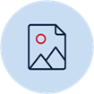Draw

Look at the map of [country] below.

Table 1 Map of [Australia]

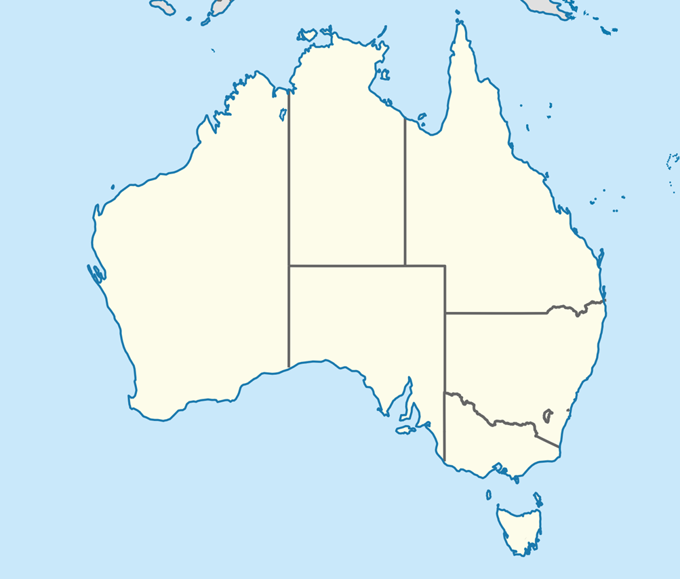

[Australian Antarctic Territory in Australia](https://commons.wikimedia.org/wiki/File:Australian_Antarctic_Territory_in_Australia_(-mini_map).svg) by [TUBS](https://commons.wikimedia.org/wiki/User:TUBS) is licenced under [CC BY-SA 3.0](https://creativecommons.org/licenses/by-sa/3.0/deed.en)

Draw your own map of [country].

### Activity 2

You will label your map of [country].

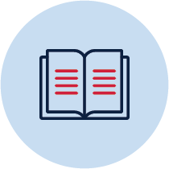Research Label

Use travel books or a website, such as Lonely [Planet](http://www.lonelyplanet.com/), to research [country].

Find the following information and accurately label it on your map in both [Language] and English.

* Capital city
* Another major city
* Famous tourist attraction
* Historical site or natural feature

## Lesson 2

During this lesson you will read and respond to a text about [Country].

### Activity 1

You will read a text in [Language] about Australia.

Listen Read

* Listen to the audio recording of your teacher reading the text.
* After listening, read the text aloud.
* Read the text again. As you read, highlight:
  + the words you know green
  + the words you think you know orange
  + the words you don’t know red
* Read the text aloud one more time.

#### Students with prior learning and/or experience

* Listen to the audio recording of your teacher reading the text.
* After listening, read the text aloud.
* Read the text again. As you read, highlight
  + the words you think you know orange
  + the words you don’t know red
* Underline
  + the verbs green
  + the adjectives purple
  + the nouns blue
* Read the text aloud one more time.

### Australia

[Canberra is the capital city of Australia. Canberra is not the biggest city in Australia. Sydney is the biggest city in Australia. Many people go to Bondi Beach. People also go to Uluru. In Australia, Uluru is an important place for Aboriginal people.]

### Activity 2

You will write a list of the words you highlighted orange.

 Read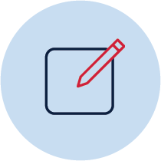 Write

* Write the [Language] words you highlighted orange in the first column of the table below.
* In the second column, write what you think the word might mean.
* Look up the word in a bilingual dictionary. If there is more than one meaning, chose the meaning that makes the most sense to you.
* In the third column, write the dictionary meaning.

|  |  |  |
| --- | --- | --- |
| Word | I think this word means.. | Dictionary definition |
|  |  |  |
|  |  |  |
|  |  |  |
|  |  |  |
|  |  |  |
|  |  |  |
|  |  |  |

* + 1. Activity 3

You will find the meaning of the words you highlighted red.

 Read Write

* Write the [Language] words you highlighted red in the first column of the table below.
* Now that you know the meaning of the words you highlighted green and orange, read the text again.
* Concentrate on the words you highlighted red. What English word would make the most sense?
* In the second column, write your best guess for the meaning of the words you highlighted red.
* Look up the word in a bilingual dictionary. If there is more than one meaning, choose the meaning that makes the most sense to you.
* In the third column, write the dictionary meaning.

|  |  |  |
| --- | --- | --- |
| Word | My best guess of this word’s meaning | Dictionary definition |
|  |  |  |
|  |  |  |
|  |  |  |
|  |  |  |
|  |  |  |
|  |  |  |

* + 1. **Activity** 4

You will answer questions about the text in [Language].

 Read Write

[What is the capital city of Australia?]

________________________________________

[What is the biggest city in Australia?]

________________________________________

[What place is important to Aboriginal people?]

________________________________________

* + 1. Activity 5

You will read the text aloud again.

 ReadSpeak 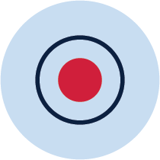 Record

* Listen to the audio recording provided by your teacher again.
* Pay attention to your teacher’s pronunciation.
* Record yourself reading the text aloud

### Activity 6

You will reflect on your language use.

Reflection

Think about your language use in this lesson. Listen to the recording, think about the questions below and complete the table. If you didn’t record the conversation, read and think about the questions below and complete the table

* Do you have a better understanding of the text than when you first read it?
* How many new words did you learn? Are you confident you’ll be able to use them to communicate?
* Did you pronounce all the words correctly when reading aloud?
* Use the two stars and a wish structure to guide your reflection.

|  |  |  |
| --- | --- | --- |
| Star Something that went well! | Star  Something that went well! | Wish A goal for next time… |
|  |  |  |

* 1. Lesson 3

During this lesson you will write sentences in [Language].

* + 1. Activity 1

You will fill in the missing words to complete the text from Lesson 2.

 Write

* Don’t look back at the text about Australia from Lesson 2!
* Read the incomplete text about Australia on the next page.
* Fill in the blanks with words you learnt in Lesson 2 in a coloured pencil.
* If there are some words you weren’t able to remember, go back and look at the text at the start of Lesson 2.
* Add these words to the text on the next page in lead pencil.

#### Students with prior learning and/or experience

* Don’t look back at the text about Australia from lesson 2 or the one on the next page!
* Read the text about Australia on the page after next.
* Fill in the blanks with words you know or learnt in Lesson 2 in a coloured pencil.
* If there are some words you weren’t able to remember, go back and look at the text at the start of Lesson 2.
* Add these words to the text in lead pencil.

### Australia

[Canberra is the _______ ______ of Australia. Canberra is not __ _____ city in Australia.

Sydney __ ____ biggest city in Australia. In Sydney, many ______ go to Bondi Beach. People also ____ ____Uluru. In Australia, Uluru is an _______ place for Aboriginal people.]

#### Students with prior learning and/or experience

### Australia

[Canberra ___ ______ _______ ______ of Australia. Canberra is _____ __ _____ city in Australia.

Sydney __ ____ ______ _____ ____ Australia. In Sydney, _____ ______ ___ ___ Bondi Beach.

People ____ ____ ____Uluru. ___ Australia, Uluru is ___ _______ _____ _____ Aboriginal people.]

### Activity 2

You will write sentences about capital cities in [Language].

 Write

Use the text to help you complete the sets of sentences below.

#### Students with prior learning and/or experience

Complete the sentences without referring to the text.

[Canberra is the __________ _____ of Australia.]

[Beijing ___ ___ ________

______ ___ China.]

[ _________ ___ ___ ________ ____ ___ [Country].]

### Activity 3

You will write sentences about big cities in [Language].

 Write

Use the text to help you complete the sets of sentences below.

#### Students with prior learning and/or experience

Complete the sentences without referring to the text.

[Sydney __ ____ ______ _____ ____ Australia.]

[Auckland __ ____ ______ _____ ____ New Zealand.]

[ _______ __ ____ ______ _____ ____ [Country].]

### Activity 4

You will write sentences about tourist attractions in [Language].

 Write

Use the text to help you complete the sets of sentences below.

Students with prior learning and/or experience

Complete the sentences without referring to the text.

[In Sydney, _____ ______ ___ ___ Bondi Beach.]

[In Paris, _____ ______ ___ ___ Eiffel Tower.]

[___ [City], _____ ______ ___ ___ [tourist attraction].]

### Activity 5

You will write sentences about important places in [Language].

 Write

Use the text to help you complete the sets of sentences below.

#### Students with prior learning and/or experience

Complete the sentences without referring to the text.

[Uluru is ___ _______ _____ _____ Aboriginal people.]

[The Vatican ___ ___ _______ _____ _____ Italian _______.]

[[Place] __ ___ _______ _____ _____ [Nationality]] ________.

## Lesson 4

During this lesson you will write a short report about [Country] in [Language].

### Activity 1

You will write a short report about [Country]

Write

Write a short report about [Country].

* Include information from your research in Lesson 1 about:
  + Capital city
  + Another major city
  + Famous tourist attraction
  + Historical site or natural feature
* Use words from the text in Lesson 2 and the sentences you wrote in Lesson 3.
* Check your finished writing. Underline any words if you think they are spelt incorrectly or are not the correct word. Write any changes in a different coloured pen or pencil.

#### Students with prior learning and/or experience

Follow the steps above. Provide additional information about the cities and places you write about.

### [Country]

__________________________________________________________________________________________________________________________________________________________________________________________________________________________________________________________________________________________________________________________________________________________________________________________________________________________________________________________________________________________________________________________________________________________________________________________________________________

### Activity 2

You will read your text aloud.

 Read Speak  Record

* Listen to your teacher’s recording of the text about Australia again.
* Practise reading your text aloud, think carefully about your pronunciation.
* Record yourself reading the text aloud.

### Activity 3

You will reflect on your language use.

Reflection

Think about your language use in this lesson. Read your report again and listen to the recording. Think about the questions below and complete the table.

* Would you be able to write a report about a different country or topic?
* Did you have to make many changes to your report?
* Do you feel you pronounced all the words correctly when reading aloud?
* Use the two stars and a wish structure to guide your reflection.

|  |  |  |
| --- | --- | --- |
| Star  Something that went well! | Star  Something that went well! | Wish  A goal for next time… |
|  |  |  |

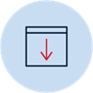 Don’t forget to send your wonderful work to your teacher!

You could:

* Post your workbook to your school.
* Scan or take photos of your workbook and email them to your teacher or upload them to your class digital learning platform.
* Email your recordings to your teacher or upload it to your class digital learning platform.