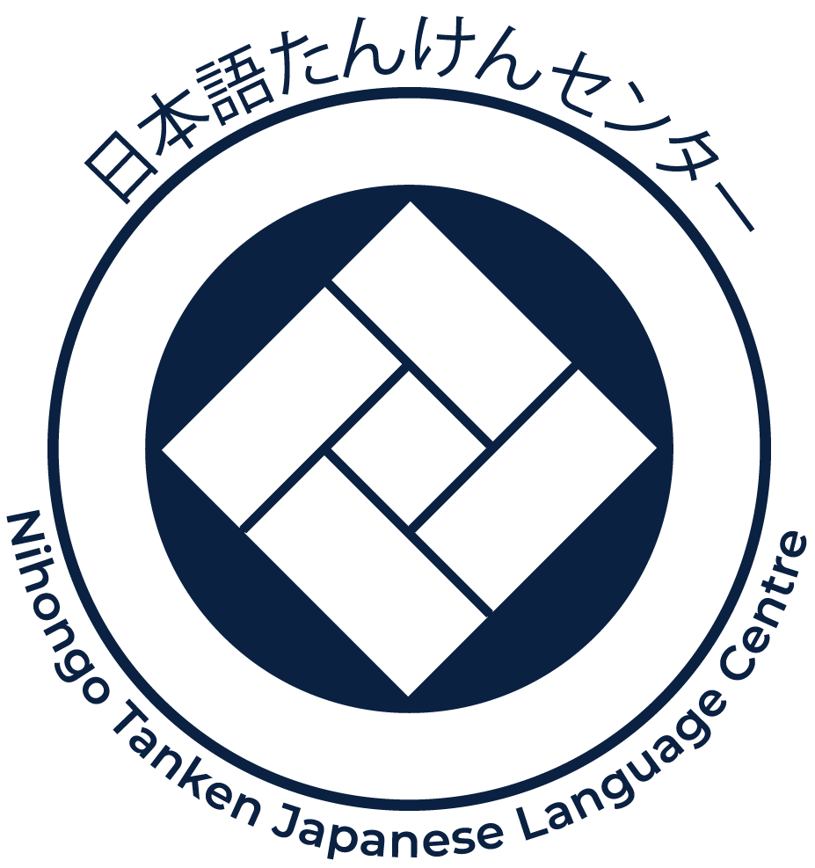

Making onigiri – activity package
This activity package is designed for Stage 4 students. The package can be incorporated into a variety of existing units of work, for example food in Japan. Alternatively, it may be used as a stand-alone activity.

Outcomes
LJA4-2C identifies main ideas in, and obtains information from texts
LJA4-6U demonstrates understanding of key aspects of Japanese writing conventions

Package inclusions
- Video
- Shopping list
- Vocabulary
- Video script
- Wizer activities
If you have trouble opening the video or Wizer links, please open them in Google Chrome.

Related resources
- Irogame – history of onigiri
- Omusubi Kororin – the rolling rice ball (English with Japanese subtitles) (10.29min)
- Japan Foundation – Omusubi Kororin resources (play)
- Uki Uki Japanese lesson 22 – onomatopoeia for food (3.19min)
- Cultural detective blog – Japanese food onomatopoeia
- Nihongo flashcards – Japanese onomatopoeia for eating and drinking

Shopping list
Amounts shown are for 10 people – please multiply the amount to suit your class size.

Ingredients
All ingredients are available at most large supermarkets.
- Rice – short or medium grain, 600g before being cooked
- Tuna in spring water can – 185g, drain water before mixing with mayonnaise
- Mayonnaise – a quarter of a cup, Japanese mayonnaise preferred (see image 1)
- Salt – 1 pinch per person
- Seaweed – 1 sheet (or as required) if seasoned. If using unseasoned whole sheet (21cmx19cm), one sheet can be cut into 8 pieces (see image 2)
- Plastic wrap
- Small plates
- Hand sanitiser
Image 1 | Image 2
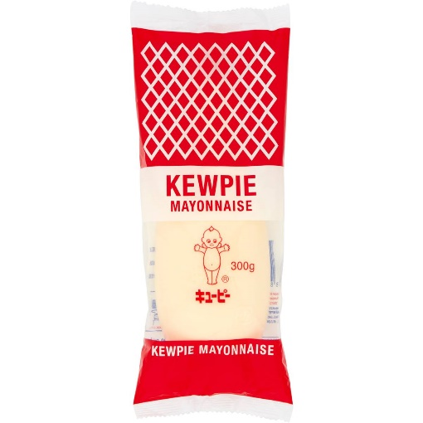 | 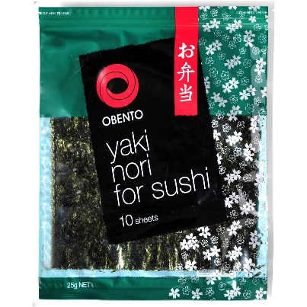
Other suggested fillings:
- pickled plum (umeboshi)
- bonito flakes and soy sauce
- BBQ prawn
- fried chicken
- any meat cooked with teriyaki sauce
- tinned ham with soy sauce
- anything else you think students would enjoy.

Vocabulary
Japanese | English
つくります | to make
ごはん | rice (usually steamed rice)
ツナ（つな） | tuna
マヨネーズ （まよねーず） | mayonnaise
しお | salt
のり | seaweed (nori)
おさら | plate
うえ | on top, above, up
ラップ （らっぷ） | wrap
おきます | to put, to place
まんなか | centre
ぱらぱら | onomatopoeia for small objects falling (in this case salt)
ツナマヨ （つなまよ） | tuna-mayo
あわせます | to put together
さんかく | triangle
たいら | flat
おします | to push
できました | done
はずします | to take off
つけます | to put on
いただきます | greeting that is said before eating in Japanese
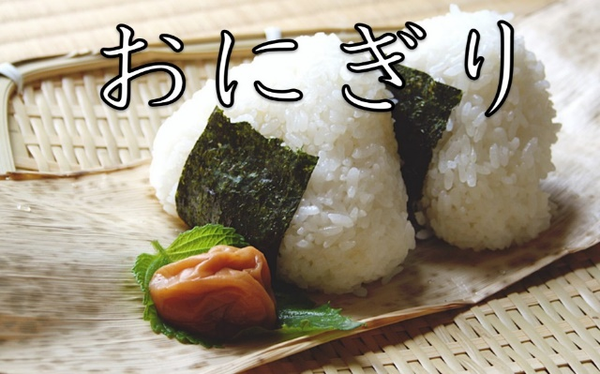
Image source: Nihongo Tanken Centre

Video script
Time | Japanese | English
0.12 | おにぎりをつくります | We are making onigiri
0.17 | ごはん、ツナ、マヨネーズ、しお、のり | Rice, tuna, mayonnaise, salt, seaweed
0.24 | おさらのうえにラップをおきます | Place wrap on the plate
0.30 | ラップのまんなかにおさらをおきます | Place the wrap on the centre of the plate
0.38 | しおをぱらぱらぱらぱら | Sprinkle salt
0.54 | ごはんをおきます | Place rice
1.03 | ごはんのまんなかに | At the centre of rice
1.07 | ツナとマヨネーズ、ツナマヨをおきます | Place tuna-mayo
1.18 | ラップのコーナーをあわせます | Pull the corners of the wrap together
1.27 | さんかくのおにぎりをつくります | Make the onigiri into triangle
1.33 | てをたいらにしてごはんをおきます | Lay your hand out flat and place the rice there
1.39 | てをさんかくにして | Make a triangle with your hand
1.42 | ごはんをぎゅっとおします | Squeeze the rice
1.50 | さんかくのおにぎりができました | Then you have a triangle shaped onigiri
1.57 | ラップをはずします | Take the wrap away
2.00 | のりをつけます | Put the seaweed around it
2.12 | いただきます (itadakimasu) | (Said before eating)

