Stage 6 French Extension – support materials

Introduction to the French Extension course support materials 4
Structure of the French Extension course 4
Prescribed issues 5
Objectives and outcomes 5
Familiarising students with the prescribed issues through related texts 6
Preparing students to present opinions and argue a case 7
Soapbox activity 7
Brainstorming and mind-mapping 8
Class discussions 12
Presenting a point of view 12
Developing skills for monologues and short essays 13
Developing knowledge of specialist vocabulary 14
Recording responses 14
Sample dot points from similar prescribed issues in other languages 15
HSC Standards Packages 15
Proformas for planning monologues and essay writing 16
Sample planning proforma 1 17
Sample planning proforma 2 18
Writing and speaking 19
Producing authentic texts 19
Glossary of key words for the HSC 23
Overview of syllabus text types 24
Suggestions for teaching film 28
The director 28
The cast 28
The screenplay 28
The production design 28
Film techniques 29
Other important elements 35
Film techniques template 36
Activities to develop global understanding of the film 38
Prescribed text 39
Background to the film 40
Summary of the film in English 42
Extract 1 – job interview and the cité 46
Extract 2 – first day on the job 52
Extract 3 – meeting with lawyer 57
Extract 4 – Philippe’s story 59
Extract 5 – Eléonore 62
Extract 6 – opera 66
Extract 7 – Elisa 69
Extract 8 – Driss’ story 72
Extract 9 – Dunkirk 75
Additional cultural references 77
Expressions imagées, argotiques et en verlan 78
Sample analysis of text questions 80
Sample speaking and writing task 80
Related texts 81
Acceptance 81
Resilience 81
Identity 81
More information about the film 82
Additional resources – radio and television 82
Additional resources – general 83

© State of New South Wales (Department of Education) 2019
These support materials were produced by the NSW Department of Education (the department). This publication is copyright to the department, however it may contain material from other sources that is not owned by the department.
Outcomes and other syllabus material referenced in this document are from the French Extension Stage 6 Syllabus © NSW Education Standards Authority (NESA) for and on behalf of the Crown in right of the State of New South Wales, 2009.
Screenshots (or stills) from Intouchables, produced by Arnaud Bertrand, Dominique Boutonnat and Hubert Caillard, directed by Eric Toledano and Olivier Nakache and written by Eric Toledano and Olivier Nakache.

Disclaimer
The interpretation presented in these materials should not be regarded as definitive. Although the notes provide support to the French Extension prescribed text, they are not to be considered authoritative.
Please note that this resource is intended only as an introduction to the study of the prescribed text and issues, and does not attempt to cover all aspects of the French Extension course. It is envisaged that teachers will draw from these materials according to the needs of their students rather than using every item, and that they will supplement these notes with additional material.

Controversial issues in schools
In exploring the issues prescribed for the French Extension course, teachers are to adhere to the department’s policy: Controversial Issues in Schools. The policy provides direction for management of controversial issues in schools, whether by the use of teaching and learning materials or views expressed by teachers or visiting speakers. The policy can be accessed on the department’s policy library.

Third party sites
This resource contains links to third party websites and resources. The department is not responsible for the condition or content of these sites or resources, as they are not under the control of the department.

Introduction to the French Extension course support materials
These materials were prepared for teachers of the French Extension course. They aim to support the teaching of the prescribed text and the prescribed issues, helping students achieve the outcomes of the French Extension Stage 6 Syllabus. They have been designed to be used as introductory material to be further developed by the teacher as part of their lesson planning. In order to deliver lessons that are specifically tailored to the needs and interests of their own students, teachers may wish to use excerpts from these materials, in conjunction with their own related activities and texts.
The French Extension course requires 60 indicative hours to complete, and the French Continuers HSC course is a co-requisite.
Study of the text prescribed for any Year 12 course may not begin before the completion of the Year 11 course. This exclusion applies to study in the Year 11 French Continuers course and to Year 11 courses in other subjects. It also applies to the study of a prescribed text in another medium, such as the film of a novel.

Structure of the French Extension course
The organisational focus of the French Extension course is the theme – the individual and contemporary society.
A number of issues that exemplify aspects of the theme are prescribed for study. Students engage with the issues through the study of a prescribed text and related texts.
Students need to be familiar with the whole prescribed text.
Students may benefit from reading the HSC examinations in Extension languages – advice to students, as they prepare for the HSC.

Exploring the prescribed issues through the prescribed text
The study of the prescribed issues through the prescribed text will involve:
- exploring the relationship between the issues and the prescribed text
- creating original text in response to aspects of the prescribed text
- identifying meaning and how it is conveyed in the prescribed text
- evaluating linguistic and cultural features of the prescribed text
- analysing the sociocultural context of the prescribed text.

The study of the prescribed issues through related texts
Study of the theme and issues through other related texts will allow students to:
- read, view and/or listen to a range of texts
- further develop knowledge of French-speaking communities
- evaluate how the issues are presented in these texts.
You can view the syllabus and the 2020-2024 course prescriptions on the NESA website.

Prescribed issues
Acceptance | Resilience | Identity
For example:  - outcasts  - stereotypes  - dealing with disability | For example:  - friendship  - social mobility  - responsibility and dependence | For example:  - social inequality  - cultural difference  - self-worth
The prescribed issues are mandatory, the sample dot points are not. They are suggestions only and are included to give a sense of the scope of the prescribed issues.

Objectives and outcomes
Objectives | Outcomes
- Present and discuss opinions, ideas and points of view in French | 1.1 discusses attitudes, opinions and ideas in French  1.2 formulates and justifies a written or spoken argument in French
- Evaluate, analyse and respond to the text that is in French and that reflects the culture of French-speaking communities | 2.1 evaluates and responds to text personally, creatively and critically  2.2 analyses how meaning is conveyed  2.3 analyses the social, political, cultural and/or literary contexts of text that is in French

Familiarising students with the prescribed issues through related texts
Before you start the study of the prescribed text, spend some time familiarising students with the prescribed issues through related texts. You will continue to use related texts throughout the course, however it is important that students have a broader understanding of the issues before studying the prescribed text.
Students should engage with a variety of texts on the prescribed issues, discussing their ideas and opinions in class. This will give them an in-depth understanding from a number of perspectives and provide them with the vocabulary and range of ideas to assist in the oral and written sections of the Extension examination.
Reading and listening texts should be chosen which are appropriate to Extension level, but which also provide students with a range of vocabulary and linguistic structures to support them in expressing their own ideas in spoken and written form.
It is important to remember that the 3 prescribed issues can be studied from a number of perspectives, and that the sub-topics provided are suggestions only. There may be other sub-topics that can be explored through related texts and the prescribed text.
The benefit of using a wide range of texts is that students will gain an in-depth background from which to draw ideas, and will develop the tools (including a more sophisticated approach to the issues) to enable them to answer any question in the HSC examination.
The following steps may assist teachers in teaching the issues. Not all steps would need to be included, depending on the length and complexity of the text.
- Find a suitable text (written, aural or visual), which is interesting, accessible and contains relevant vocabulary.
- Brainstorm the topic beforehand, creating a mind-map in French of the students’ thoughts, relevant vocabulary.
- Read, view or listen to the text. Ask questions in French where appropriate, paraphrasing the text where necessary.
- Explore key vocabulary, grammar and sentence structures.
- Discuss the main points of the text, creating a bullet-point summary together.
- Analyse the purpose, context and audience of the text.
- Brainstorm possible side issues, identifying useful expressions.
- Allow students to formulate their own opinions about the issues raised in the text and express their ideas through speaking or writing.
- Compare and contrast between the way the issue(s) is explored in the related text and in the prescribed text.
- Create a task in which students are required to use new vocabulary and expressions in new contexts – for example, class debate, role-play or monologue.
- Ask students to research their own text and present it to the class, focusing on the issues discussed and the perspectives from which these issues are presented.

Preparing students to present opinions and argue a case
To achieve the outcomes of the Extension syllabus, students must be able to use the target language to discuss attitudes, opinions and ideas, and to formulate and justify an argument.
To prepare students to respond capably to a broad range of questions, beyond just the sub-topics of the prescribed issues, teachers need to use strategies that encourage students to think in terms of opinions and arguments.
Emphasis needs to be placed on developing skills that can be applied to any content. Students should not attempt to fit a prepared response to a question, but rather use general structures and prepare a range of phrases that could be used to present any opinion and justify any argument. Students need to be exposed to a variety of topics and trained to quickly develop a logical argument with their own point of view embedded in the response.
Activities and resources that could be used to develop this include:
- soapbox activity
- brainstorming and mind-mapping
- class discussions
- presenting a point of view
- developing skills for monologues and short essays
- developing knowledge of specialist vocabulary
- recording responses
- sample dot points from similar prescribed issues in other languages
- HSC Standards Packages (2002).

Soapbox activity
A soapbox is an impromptu speech on a set topic. To familiarise students with current affairs and to encourage speaking, ask students to discuss something that has occurred in world current affairs that week that is of interest to them.
Consider doing soapbox initially in English, until students are familiar with the format. Once the students are ready to practise the activity in French, limit the scope to the prescribed issues, discussing any relevant current news items, songs or TV programs that raise similar issues. To engage the whole class, have students complete a table, like the one below, while listening to their classmates speak. Review unfamiliar vocabulary before moving on to the next student.
Language structures used | Unfamiliar vocabulary

Brainstorming and mind-mapping
Have students brainstorm the prescribed issues and complete a mind-map to organise their thoughts. Students should think broadly about subjects that would relate to specific issues. Graphic organisers are useful tools to assist students in organising each prescribed issue into topics and sub-topics.
Useful graphic organisers include:
- placemat protocols
- plus/minus/interesting (PMI) charts
- affinity diagrams
- lotus diagrams.

Placemat protocols
These are useful for achieving breadth and depth in monologues and short essays on a topic. They can be used to:
- critically assess texts
- develop a comprehensive range of strategies and skills appropriate to the text being read
- justify a point of view.
Procedure
- Use a marker pen to divide an A3 sheet of paper into the format shown below.
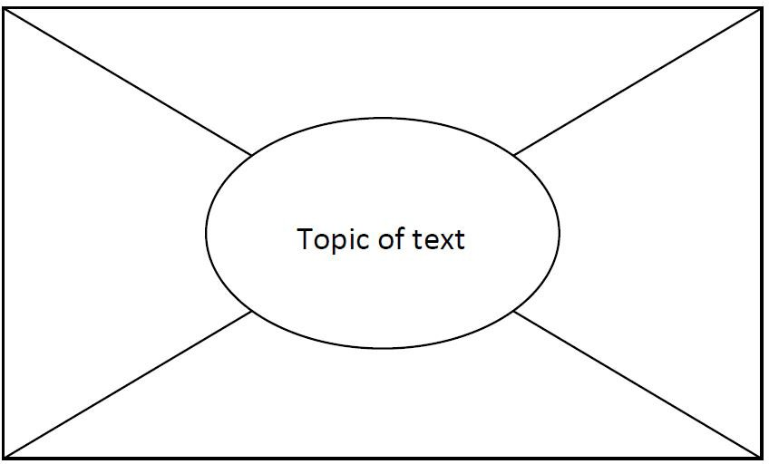
- Divide the class into groups of 4 and give each group 1 ‘placemat’ (A3 sheet).
- Nominate a group leader. The group leader cuts sections of the placemat and gives each student in the group one of the outside sections.
- Give students (including the group leader) a selected text to read individually.
- The group leader writes the topic of the text in the centre section of the placemat.
- After a predetermined period (the length of time will depend on the length and complexity of the text), ask students to summarise the most important points they have read in the text in dot point form on their section of the placemat.
- Reassemble the placemat.
- In the centre of the placemat, the group leader lists common points identified by all four students.
- When this is complete, give each student a specific period of uninterrupted time (for example 3 minutes) to justify orally the inclusion of individual points not listed by others (those that are not listed in the centre of the placemat).
- The group leader presents a summary of findings to the whole class.

Plus/minus/interesting (PMI) charts
These graphic organisers are useful for looking at both sides of an argument, or seeing things from a different perspective. The PMI chart is a creative thinking strategy used in Edward De Bono’s CoRT Thinking Program.
PMI charts help students to:
- see both sides of an argument
- view things from a different point of view
- think broadly about an issue
- suspend judgement
- make informed decisions
- work as individuals, in pairs or as members of a group.
Procedure
The strategy can be used in a range of classroom activities, including analysing texts and exploring issues. Give students a format for recording their ideas such as the table below.

Plus | Minus | Interesting
Individually, in pairs or in small groups, students apply 3 questions to a statement or task provided by the teacher:
- What are the positive ideas about this?
- What are the negative ideas about this?
- What is interesting about this?
Within a specified time limit, students brainstorm their responses, having appointed a recorder and a reporter. At the end of the designated time, the reporter reports back on the group’s most original or creative ideas from each of the categories.
It is useful to model the activity first, using as a topic a statement such as: The lifestyle of all countries is enriched by immigrant cultures or a recently shared text or experience.
PMI-based activities can support the development of a range of skills including:
- understanding and interpreting the topic, question or statement
- using strategies to assist or facilitate brainstorming
- contributing to discussion
- comprehending and explaining opinions and information
- evaluating a range of viewpoints and distinguishing them from their own
- applying the process of PMI to a range of situations.

Affinity diagrams
These are useful for brainstorming issue-related ideas and organising them into topics. The affinity diagram is an interactive data collection method that allows groups of people to identify and sort large quantities of ideas within a short time frame.
Procedure
- Clearly define and write the question or topic for the session at the top of a flip chart.
- All class members individually and without discussion, write their ideas on a separate sticky note and place these in front of them.
- Class members randomly place ideas on the topic flip chart.
- Class members, working as a group, silently place ideas into like categories.
- Label the idea for each category by writing it on the flip chart.

Lotus diagrams
This graphic organiser is useful for issues and sub-topics. The lotus diagram takes its name from the lotus flower, whose petals open in an overlapping way.
You can photocopy the diagram on to A3 paper, use colour-coded sticky notes on a display wall or use an online graphic organiser, for example Miro.
Procedure
- The diagram comprises 9 boxes, each made up of 9 squares. The main topic goes into the centre square of the centre box.
- Around the centre square of the centre box are 8 numbered squares. Students write up to 8 ideas about the central topic in each of the numbered squares.
- Each of the 8 squares then has a box of its own, with the corresponding number in the centre square. Students place the information from the square labelled 1 in the centre box into the centre square of box 1, and so on.
- In the outer squares of each box, students add more ideas to expand on each numbered idea.

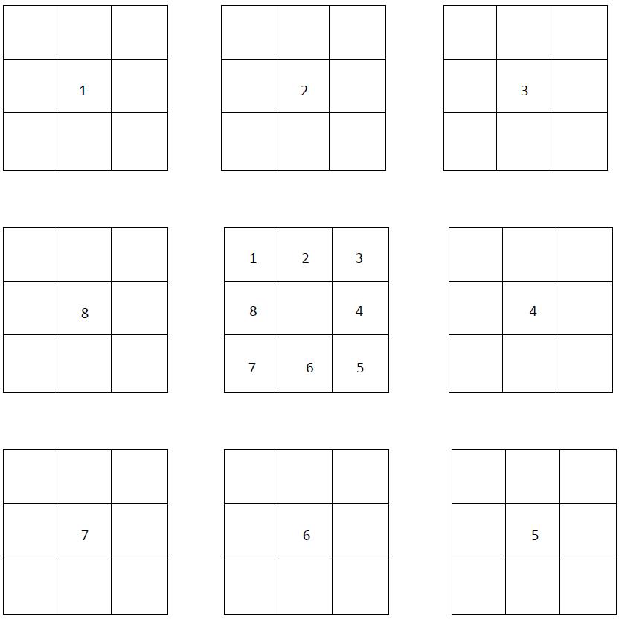

Class discussions
Use class discussions, in English or French (depending on context), to gather ideas and debate pros and cons related to a particular topic or question. The results of the discussions can then be organised and used to formulate responses to particular topics and questions in French.
Use material already published on the topic as a discussion starter – see the list below. Discussion could involve expanding ideas or identifying vocabulary, phrases and structures in the target language that will be useful in any response.
Useful resources include:
- articles in textbooks
- past HSC papers/questions
- a brainstormed list of possible prescribed issue-related topic questions
- news items and internet articles related to the prescribed issues.

Presenting a point of view
Encourage students to think about both sides of the argument for a given stimulus statement or question before deciding which stance they will take – for or against, or a more balanced approach.
Students should take the point of view they feel they are best equipped to argue.

Exercise 1
In order to practise presenting a point of view through classroom discussion, as described above, students formulate a response to a question in French and then present a different point of view on the same topic.

Exercise 2
Students brainstorm HSC-style questions in pairs, based on sub-topics from their mind-maps.
- Give each pair a different topic.
- Ask one student to speak for the affirmative and one for the negative.
- Each pair prepares a 1.5-2 minute speech, initially in English. This is conducted as a debate, where the other students act as adjudicators after hearing each of the arguments. The other students must justify their decision based on the logic of the argument. This exercise can be done in French when students become more confident.

Developing skills for monologues and short essays
Students should develop the skills necessary to prepare monologues and write short essays, as well as the ability to present and support a point of view or develop an argument in French. These skills are necessary for the speaking and writing sections of the HSC examination. However, note that short essay writing is not the only text type specified for productive use in the Extension course.

Exercise
Give students a question/stimulus statement. For example: Self-acceptance is harder than accepting others. What is your opinion? Give reasons for your answer.
- As a class, brainstorm ideas and record them on the board.
- Organise points/ideas into ‘for’ and ‘against’ the argument.
- As a class, decide which side of the argument is easier to present.
- Using the ideas gathered, ask individual students to write their own response.
- Share the sample responses as a class.
- Deconstruct the sample responses and come up with a skeleton structure common to all good responses – introduction, main body and conclusion.
- Go through the sample response structure below.
- Joint construction – students create a group response in French to the same question by fleshing out their argument using the sample structure. Working in pairs or groups of 3, students take an aspect of the structure and write a paragraph on it.
- When all students in the group have finished, put the paragraphs together to make a whole response. The opening statement, brief outline and concluding statements can be written at the same time. There may be some repetition through the argument, but students should gain confidence and the ability to put together a response before writing individual responses.
- Individual construction – students write their own response to the same question using ideas and skills gathered in this exercise.
Sample response structure
- Make an opening statement contextualising the question.
- State your argument/opinion on the question/stimulus – this may be for, or against, or a more balanced view.
- Provide point 1 related to your argument with 2 detailed examples.
- Provide point 2 related to your argument with 2 detailed examples.
- Draw your conclusion. Do not just reiterate the point that you made in your introduction. Provide some future advice/direction/suggestion related to your conclusion.

Developing knowledge of specialist vocabulary
Learning some commonly-used vocabulary and expressions related to the prescribed issues will help students respond to speaking and writing tasks.

Exercise 1
Cut up a mixture of specialist vocabulary or expressions – some in English and some in French – and put them into a hat. Students then take turns drawing one out and translating it into the other language.

Exercise 2
Have students make a domino game where they have to match the French vocabulary or expressions with the English equivalent. You can set up this activity as a group or individual activity (you will need several sets) and make it into a competition by timing students. This is useful as a revision activity.

Exercise 3
In order to develop students’ ability to express complex ideas in simple language rather than relying on a dictionary, put a list of difficult and hard to translate English words into a hat. Have students draw words one at a time and express them in French they are already familiar with. You may need to rephrase some words in English before the students express them in French.
This exercise is particularly relevant practice for the speaking exam where dictionaries are not permitted. However, even in writing tasks, students should try to avoid using unknown words from the dictionary as much as possible. Finding an alternative way of expressing an idea is an excellent skill to develop.

Recording responses
For the oral examination, students respond with a monologue on 1 question from a choice of 2. They are given 7 minutes to prepare their response and may make notes and refer to them during the examination. Students are expected to speak for approximately 3 minutes.
The monologues are recorded, therefore students need to become accustomed to having their speaking responses recorded. They also need to learn how to make effective use of the preparation time and be well-practised in planning and writing dot points for their monologues.

Exercise 1
Students take a question or stimulus statement out of a hat and give themselves 7 minutes preparation time. At the end of the 7 minutes they record their response. They should not stop the recording until they have completed their response. When finished, they play back the recording. This is an excellent exercise to help students become accustomed to forming ideas and developing a response within the time limit of the HSC oral examination.

Exercise 2
Have students record a monologue and bring it to school for peer assessment. This will help them to develop confidence in recording their voice and to become used to speaking clearly and at an even pace. Peer assessment is recommended for this exercise, as other students learn from their peers’ strengths and weaknesses.
The exercise should be used as a stimulus for a constructive discussion aimed at improving the performance of the whole class as well as that of the student whose performance is being assessed.
An explanation of the marking guidelines is necessary at this point so that students are made aware of the criteria examiners will apply.

Sample dot points from similar prescribed issues in other languages
Review the prescribed issues and suggested sub-topics for other languages from the NESA website. If they are similar to those set for French Extension, use them as a source of ideas for practice speaking and writing questions.
Be aware that the sub-topics listed for any one prescribed issue are many and varied. They are not limited to the dot points in the syllabus nor to those that have been examined in previous HSC examinations.

HSC Standards Packages
It is important that students are familiar with the marking rubric and guidelines for each section of the HSC examination. HSC Standards Packages (2002) contain the marking guidelines as well as a sample examination paper, syllabus, answers and sample student responses at band cut-off points. The Standards Packages are a useful teaching and learning tool and are available on each language-specific page of the NESA website.

Exercise 1
Select a number of sample answers from the Standards Package speaking and writing sections and have students award marks to them by applying the marking guidelines. Students can discuss the marking criteria and justify their marks from an examiner’s perspective.

Exercise 2
Students listen to and read a number of speaking and writing samples from across the range of bands. They can use the exemplar samples as a model for their own monologues and writing.

Proformas for planning monologues and essay writing
In both the oral examination and the written examination, students are required to present and support a point of view in French. Teachers will need to support their students in developing these skills. The following proformas have been designed to help students develop a structured approach to responding to monologue and short essay questions.
Depending on context, you may wish to introduce the proformas using English, moving to French as students develop more confidence in planning monologues and essay writing. You can also adapt the proformas to meet the needs of your students.
In order to gain confidence and competence in these skills, students should write as many monologues and short essays as possible. Monologues can be recorded for practice. Please note that short essays are not the only text type prescribed in the Stage 6 Extension syllabus. Students also need to be familiar with the text types for productive use listed in the Stage 6 Continuers syllabus.

Sample planning proforma 1
Task | Answer
Question
(Write in the question with the stimulus statement)
Opening statement
(Make an opening statement contextualising the question; state your argument/opinion on the question/stimulus – this may be for, or against, or a more balanced view)
Introductory statement
(State why you have this argument/opinion and introduce the points you are going to discuss to support your argument)
First point
(Include 2 detailed examples)
Second point
(Include 2 detailed examples)
Concluding statement
(Draw your conclusion, but do not just reiterate the point that you made in your introduction – provide some future advice/direction/suggestion related to your conclusion)

Sample planning proforma 2
Task | Answer
Question
(Write in the question with the stimulus statement)
Opening statement
(Make an opening statement contextualising the question; state your argument/opinion on the question/stimulus – this may be for, or against, or a more balanced view)
Introductory statement
(State why you have this argument/opinion and introduce the points you are going to discuss to support your argument)
First point
(Include 1 detailed example)
Second point
(Include 1 detailed example)
Third point
(Include 1 detailed example)
Concluding statement
(Draw your conclusion, but do not just reiterate the point that you made in your introduction – provide some future advice/direction/suggestion related to your conclusion)

Writing and speaking

Producing authentic texts
Learning authentic phrases and expressions is a good way to build up vocabulary. However these phrases and expressions must be used in context. Students should be encouraged to keep a list of words and expressions they can use to build an argument or use in a discussion. They should write down one or more sentences in which these expressions could be used. Some sample phrases and expressions are set out below and require students and teachers to build meaningful sentences.

How to refer to the title or subject
Cette déclaration/cette proposition/cette affirmation mérite d’être examinée de plus près/en plus de détails...

Starting a paragraph
- En premier lieu/d’abord/cet aspect négatif
- Je cite l’exemple de
- Abordons cette question
- Il y a plusieurs raisons pour que
- Prenons le cas de
- Commençons par examiner
- Pour commencer
- Certains pensent que
- D'autres au contraire estiment que

Presenting an opinion
- Selon certains
- D’après
- À en croire
- On ne peut nier
- À mon avis
- Il se peut que
- Je dirais que
- Je suis d’accord avec
- Il n’y a aucun doute que

Developing an argument
- Si on prenait l’exemple de
- Il faudrait
- Il s’agit de
- De nos jours
- Il suffirait de
- Selon d’autres
- Prenons l’exemple de
- De plus
- Par ailleurs
- Contrairement à
- Bien que
- En outre
- D'une part…d'autre part
- En revanche
- En ce qui concerne
- Au mieux
- Au pire
- Néanmoins
- Toutefois
- Cependant

Expressions to use within a paragraph to add structure
- D’abord
- Quant à, en ce qui concerne
- Ensuite
- À cet égard, après tout
- Enfin
- Par conséquent/en consequence
- D’une part
- D’autre part
- Étant donné que
- Cependant, pourtant, néanmoins, tout de même
- D’une façon ou d’une autre
- Bref, en un mot
- En réalité
- Grâce à la/au/aux
- Malgré tout/toutes

Introducing an impersonal statement
- Il est possible (de manger des champignons hors de saison mais)
- Il est facile (de se rendre au bureau en utilisant)
- Il est important (d’être présent avant la réunion)
- Il est nécessaire que (vous soyez de retour avant 4 heures)
- Il faut, il faudrait
- Il reste peu de temps
- Il manque beaucoup de
- Il s’agit de
- Il suffit de
- Il est question de

Indicating rises, increases or decreases
- Le nombre s’accroît
- Le taux diminue
- Une augmentation de
- Une baisse des prix au marché
- Une hausse des niveaux de la mer
- Le coût des fruits et des légumes sont tombés

Numbers of people and things
- La plupart (des enfants vont en vacances avec leurs parents)
- Beaucoup de (filles ne portent plus de jupes)
- Certains ne sont pas sûrs de (ce que veut dire liberté)

Expressing doubt (inversion is needed when you begin a sentence with peut-être)
- Les tribus d’Afrique sont peut-être mieux au courant de la disparition des
- Peut-être (que les effets de serre se font-ils plus ressentir en Océanie)
- Il se peut que (ce soit la faute aux industriels)

Indicating times and periods
- De nos jours
- Autrefois
- À l’époque actuelle
- Jadis
- À l’avenir
- Du temps de mes grands-parents
- Les générations futures diront
- À l’époque victorienne
- Au début du siècle
- Dans les années 70
- Pendant longtemps
- En moins d’un siècle

Giving examples or quoting an opinion
- Citons en exemple/je cite en exemple
- Prenons l’exemple de
- Selon certain, selon d’autres
- À en croire les scientifiques
- L’exemple le plus frappant est
- D’après le directeur

Comparing ideas
- Certains disent que... d’autres pensent...
- Comparé à notre mode de vie aujourd’hui
- Faisons une comparaison entre
- Si je compare nos activités à celles de
- En contraste/par rapport à
- Celui-ci est mieux rémunéré que

Ending a discussion
- En fin de compte
- Il faut conclure que
- Tout bien considéré
- En conclusion disons que
- C'est pourquoi
- En conséquence
- Donc, pour conclure
- Dans l’ensemble
- Finalement
- En dernier lieu
- Pour finir

Glossary of key words for the HSC
The table below contains key words and their meanings in the context of HSC language courses. The table may help teachers and students understand how to respond to questions and tasks which use these terms.

Term | Description
Account | Account for, state reasons for, report on. Give an account of; narrate a series of events or transactions
Analyse | Identify components and the relationship between them; draw out and relate implications
Compare | Show how things are similar or different
Construct | Make, build; put together items or arguments
Contrast | Show how things are different or opposite
Critically analyse or evaluate | Add a degree or level of accuracy, depth, knowledge and understanding, logic, questioning, reflection and quality to analyse or evaluate
Define | State meaning and identify essential qualities
Demonstrate | Show by example
Describe | Provide characteristics and features
Discuss | Identify issues and provide points for and/or against
Evaluate | Make a judgement based on criteria; determine the value of
Explain | Relate cause and effect; make the relationships between things evident; say why and/or how
Explore | Examine or discuss (a subject, an option, an idea, a possibility)
Express | Put opinions, thoughts or views into words
Identify | Recognise and name
Interpret | Draw meaning from
Justify | Support an argument or conclusion
Outline | Sketch in general terms; indicate the main features of
Propose | Put forward (for example, a point of view, idea, argument, suggestion) for consideration or action
Recommend | Provide reasons in favour
Recount | Retell a series of events
Reflect | Think deeply or carefully about something
Summarise | Express, concisely, the relevant details
Adapted from A glossary of key words – NESA

Overview of syllabus text types
The text types listed in the Continuers Stage 6 syllabus are assumed knowledge for Extension students. Each Extension syllabus lists text types for production in the external examination. Below is an overview of some of the text types with which Extension students should be familiar. Refer to the Continuers and Extension syllabuses for complete lists.

Syllabus text type | Purpose | Structure | Language features
Article | - to sustain an argument  - to describe  - to inform, persuade, amuse or entertain | - titles or headings  - development of ideas or argument  - sequencing and linking of ideas  - statement of conclusion or advice | - range of tenses  - linking words  - language can be descriptive, factual, judgemental, emotive or persuasive, depending on context
Conversation | - to exchange information, opinions and experiences  - to maintain and sustain communication | - exchange of opening salutations  - question or statement followed by response  - 2-way interaction (sustained) | - question forms  - strategies to maintain conversation (fillers)  - interjections  - incomplete sentences  - language level depends on context and relationship between participants
Description | - to inform  - to entertain  - to describe  - to classify | - general statement or classification  - introduction and elaborated description of characteristic features | - specific details  - descriptive words  - range of tenses  - varied vocabulary  - comparative expressions  - literary devices (for example simile, imagery)
Diary or journal entry | - to record personal reflections or experiences | - chronological or stream of consciousness | - first person  - range of tenses  - sequencing (time) words  - abbreviated words or sentences  - subjective or informal language
Discussion | - to give different points of view  - to examine issues from more than one perspective  - to make recommendations based on evidence  - to sustain an argument | - presentation of main idea in introduction  - evidence or data to support main idea  - interaction between participants to clarify understandings  - conclusion or reiteration of main idea  - balanced | - linking words to sequence ideas logically  - qualifying words (for example, usually, probably)  - persuasive, descriptive, discursive or personal language, depending on context  - comparative expressions
Email or fax | - to use technology-based methods of communication  - to inform  - to seek a response | - conventions (for example subject line, email address)  - specific details without elaboration  - salutations and sign-offs | - abbreviated words and sentences  - simple language structures
Essay | - to discuss  - to analyse  - to assess  - to guide or teach | - orientation or introduction  - presentation of argument, judgement or evaluation  - conclusion or reiteration of main argument  - often has embedded description and/or explanation | - range of tenses  - formal, objective language  - linking words to sequence ideas and paragraphs  - qualifying words  - abstract nouns and concepts  - complex sentence structure  - evidence or examples included to support or enhance argument
Formal letter | - to communicate in writing in formal contexts  - to request information  - to lodge a complaint  - to express an opinion | - salutations and sign-offs  - letter conventions (for example layout, address, dates)  - logical and cohesive sequence of ideas | - use of full sentences and paragraphs  - more complex sentence structure  - objective language  - use of formulaic expressions
Informal letter | - to communicate in writing with acquaintances, friends, family  - to inform or amuse | - salutations and sign-offs  - letter conventions (for example layout, address, date) | - frequent colloquial language  - subjective language  - sentence structure often less complex than in formal letters
Interview | - to seek and convey information, views or opinions | - question and response format | - question words  - link words  - strategies to maintain communication
Invitation | - to invite in written form | - layout conventions  - statement of facts  - protocols | - abbreviated language  - formal or informal language  - expressions that tell when, where, with whom
Message or note | - to inform  - to request  - to instruct  - to remind | - general statement, description, procedure  - may be in point form | - succinct  - abbreviated words and sentences  - lack of descriptive detail  - use of colloquial language
Narrative account | - to entertain, amuse or instruct | - series of events presented in logical progression  - resolution or conclusion  - may contain a series of complications | - time words used to connect events  - use of action words  - descriptions of characters and settings
Personal profile | - to describe  - to outline personal details | - may be in point form (appropriate to situation)  - use of headings and subheadings | - factual  - descriptive language  - present tense  - simple phrases or sentences
Postcard | - to provide information  - to retell events | - salutations and sign-offs  - brief description or message | - descriptive language  - incomplete sentences  - abbreviated words  - colloquial expressions  - clichés  - personal impressions
Recount | - to retell what happened  - to tell a series of events | - introduction or orientation  - events sequenced in chronological order | - descriptive language  - past tense  - time words to connect events  - expressions that tell us when, where, with whom and how
Report | - to classify and/or describe  - to organise facts  - to draw conclusions | - general statement or classification  - description  - logical progression | - supporting evidence (for example statistics)  - factual  - usually present tense  - language specific to the topic  - objective language
Review | - to respond to a text or stimulus  - to summarise, analyse or interpret a text and to assess its value | - describe context of text or work  - describe the text or work  - judgement or evaluation of text or work | - descriptive language  - more complex structures with frequent abstract language  - words that express judgement  - possible comparisons  - expressions of aesthetic nature
Speech or talk (script) | - to communicate ideas, opinions and attitudes  - to entertain  - to persuade  - to welcome  - to thank | - introductory statement of purpose  - explanation or sequence of events or presentation of argument  - concluding remarks | - choice of expressions to engage the audience  - descriptive words  - a range of tenses  - subjective language  - consistent use of correct register depending on audience  - address audience throughout

Suggestions for teaching film
The tools of production are the director, the cast, the screenplay, the production design and the film techniques.
The tools of production are important in gaining an understanding of film. There are so many effects and subtle technical changes that add to the mood and meaning of the screenplay, creating a complete and new entity, sometimes even totally different to the original script.
Therefore it is important to go over these tools of production with students at an early stage of their study so that they may use the tools when focusing on the film as a whole, and more specifically within the chosen film extracts.
A film may gain meaning through the use of some or all of these means of production. Sometimes it can particularly gain meaning through leaving out an important tool during the film to create an effect. It is up to the teachers to guide the students to look for these effects and how the tools have been utilised in the film.

The director
The director is responsible for each and every scene shot, every effect and how every word is uttered in a film. He or she has poetic license to change the original screenplay to convey the meaning of the film, and works on the film with appropriate technical staff, from the conception stage to the finished product.

The cast
The cast are the actors chosen to play the various parts in the film and the right choice of cast can make or break a film. There are different styles of acting, and the cast must be able to fulfil the director’s vision for each role.

The screenplay
The screenplay is the script of the film with the addition of directions specifically for film, just as in a play there are directions for the characters on stage. The directions for a film may include information such as lighting, sound effects, music and camera angles.

The production design
Production design includes the exterior and interior location for the shots, the sets and colours used. The colour palette, for example, can reflect the mood, such as depressing, happy or exciting. Wardrobe, hair and make-up are also important in setting the scene, including the era.

Film techniques

Plot development and sequence of events
Film directors may present the plot and the subject matter in a chronological sequence of events.
Alternatively, the use of flashback and out-of-sequence narration may be used. This technique may enhance suspense and maintain a high level of interest and involvement by the audience. Such a structure allows for complication in the plot by offering a multi-layered interpretation of the story.
The plot may include events which foreshadow what is to come. Several plots may also run parallel in a film.

Setting
The setting is where and when the story takes place. It can incorporate location, weather conditions, time of day and the physical environment, for example natural or man-made.

Shot composition and framing
The shot composition consists of all the elements within a shot. It is a selective representation of reality, as seen within the confines of a frame. It is carefully thought through, very rarely the product of chance.
Framing refers to the placement of the subject matter within each shot. The subject may be placed centrally or at the side. A character may be seen in profile, from the back or from the front. The numbers of characters in each frame, how much of the background is included and for what purpose are also elements of framing.
The framing, and the way in which all the elements within it are placed, form the shot composition. By examining shot composition, students will be able to discern certain subtleties used by the director to manipulate the audience.

Type of shot and camera angle
A shot is all that is recorded on film from the time the clapboard has been shut to the time the director calls out ‘Cut!’. A lengthy shot (20 to 30 seconds) may convey a feeling of tranquillity, whereas a succession of short shots (1 to 5 seconds) may hasten the pace and movement. Film shots are taken from different distances to serve different purposes.

Long shot or wide shot
The long shot, also known as the wide shot, shows the entire object or character and places the object or character in its surroundings. With the camera shooting at a distance from the characters or the centre of the setting, long shots are commonly used as an introduction to grab the viewer’s attention and to invite involvement. A long shot is often used to anticipate the events that will follow or transport us to a different environment.
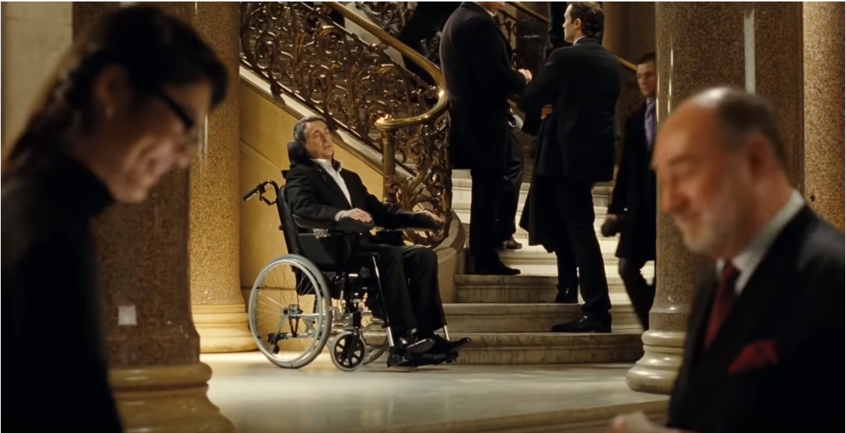
Intouchables – TF1 Films Production
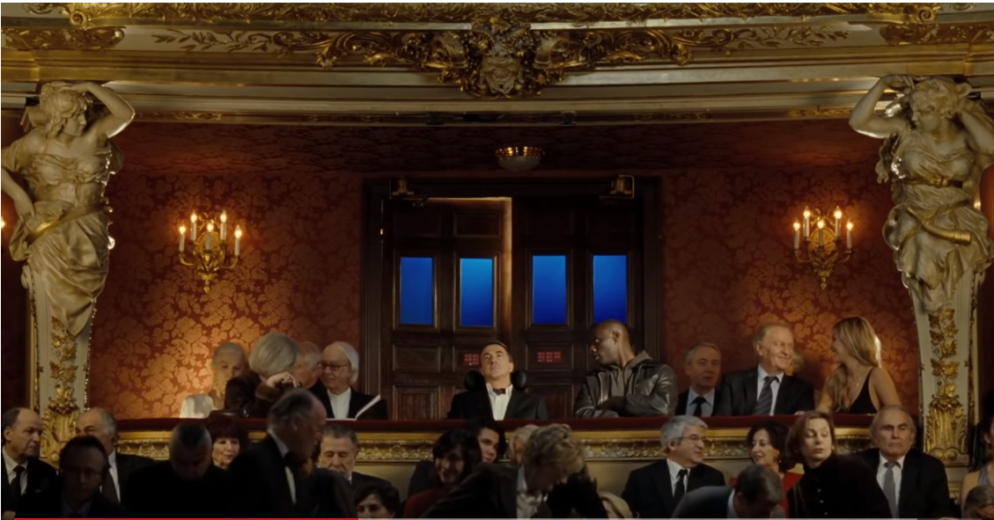
Intouchables – TF1 Films Production
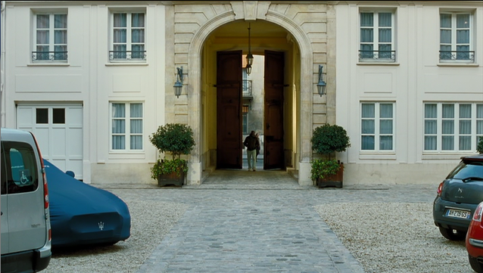
Intouchables – TF1 Films Production

Medium shot
Medium shots are used to focus on the dialogue and the interaction between characters in a group.
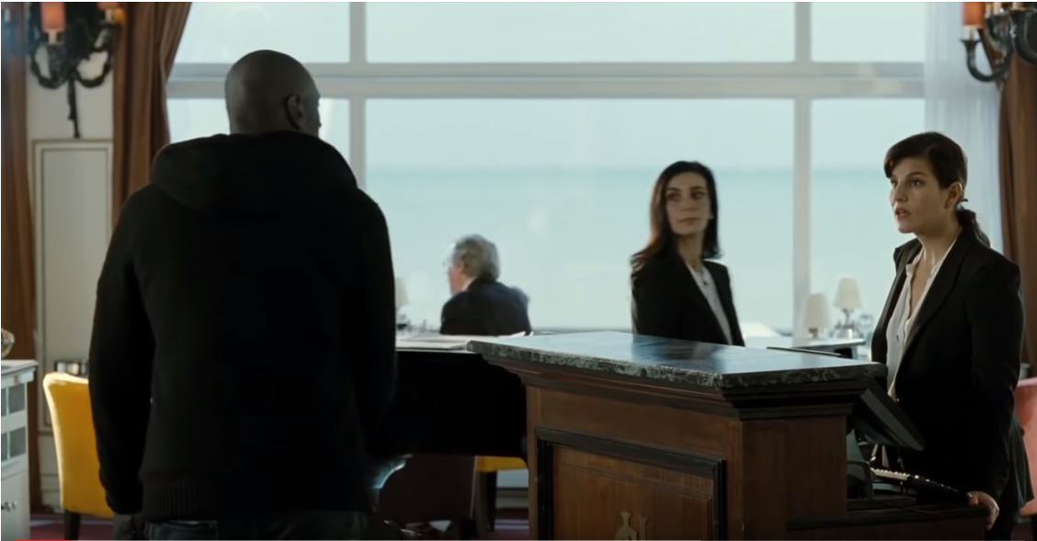
Intouchables – TF1 Films Production

Medium close-up
The medium close-up shot is generally used to reveal the psychological state of the characters rather than their actions.
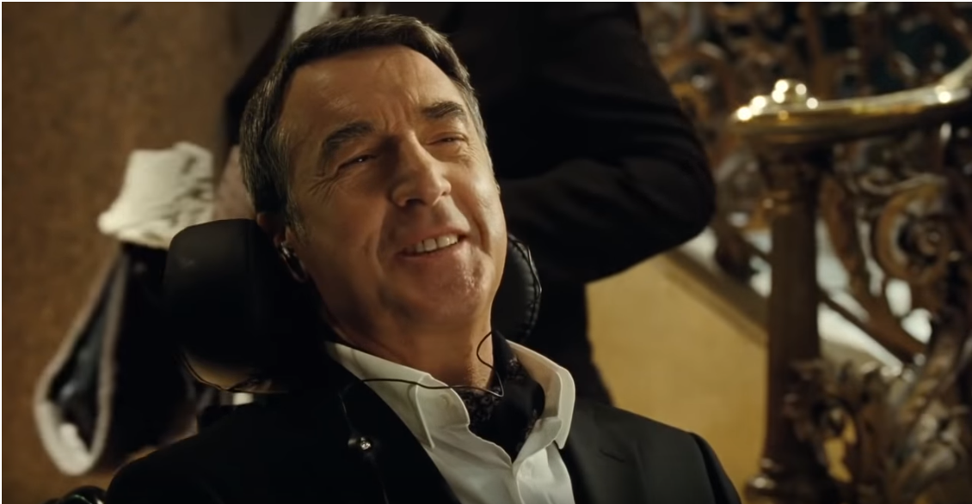
Intouchables – TF1 Films Production
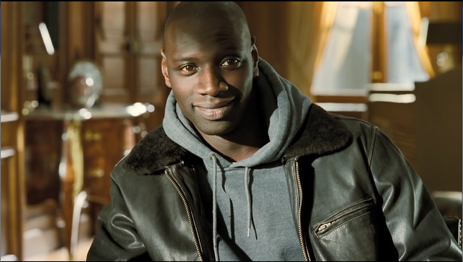
Intouchables – TF1 Films Production

Close-up
Close-ups are often used to display the feelings and emotions of the characters and to gain an insight into their thoughts. Close-ups are dramatic and effective devices used to portray characters and character development.
Close-ups of objects give significance to the object, directing the audience to an important element in the film.
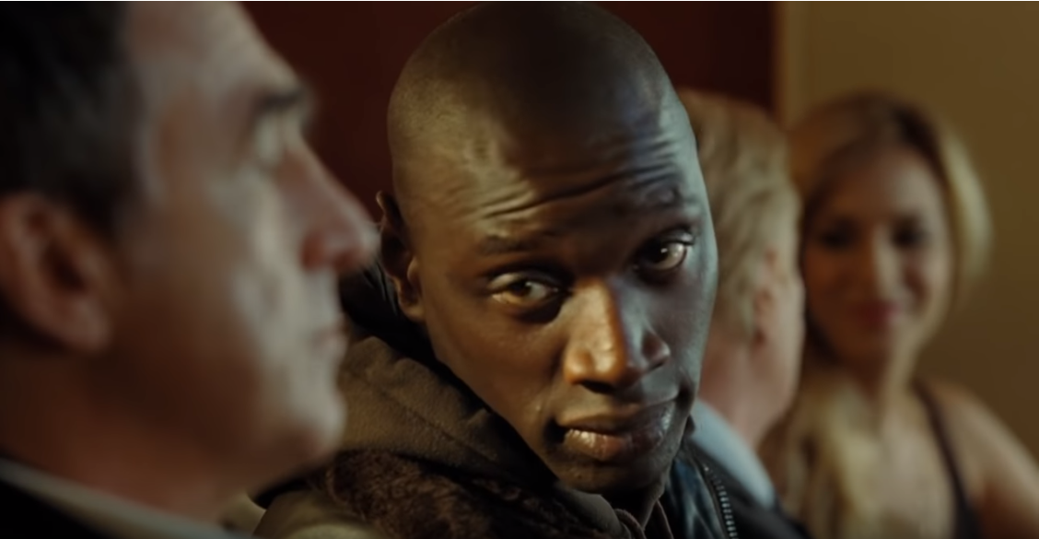
Intouchables – TF1 Films Production
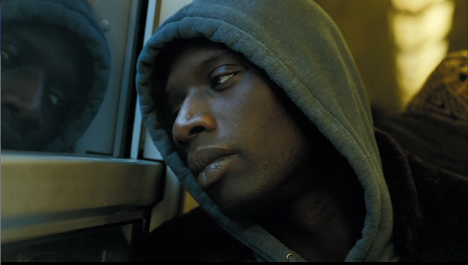
Intouchables – TF1 Films Production

High-angle shot
The high-angle shot reduces the subject to lower proportions in relation to the surroundings. It is often used to indicate a feeling of vulnerability, powerlessness, helplessness, loneliness or isolation.
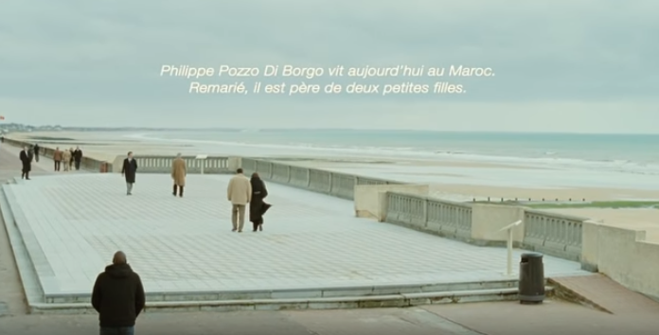
Intouchables – TF1 Films Production
(Please note, this is also a wide/long shot.)
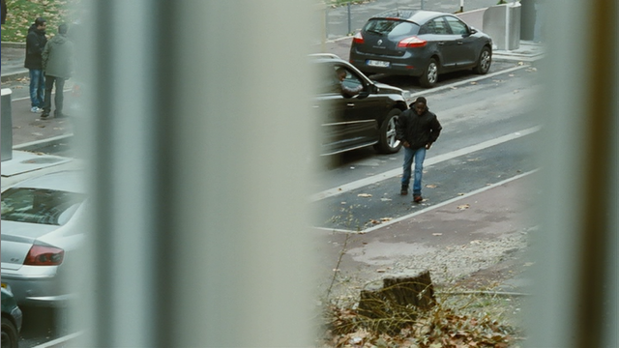
Intouchables – TF1 Films Production

Low-angle shot
A low-angle shot lends more authority, more weight to the subject.
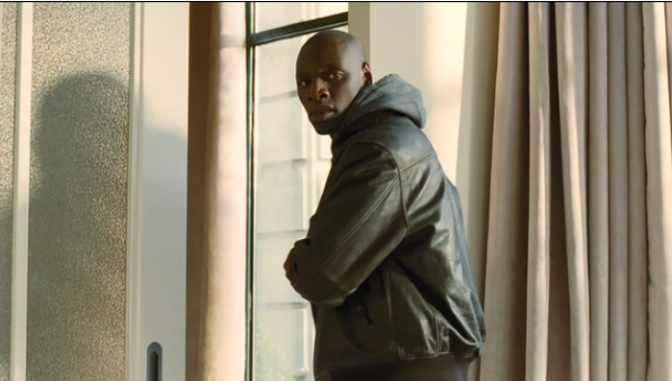
Intouchables – TF1 Films Production

Straight-on angle shot
This is the most common angle used in filmmaking. Unlike the high and low angle shots mentioned above, it conveys objectivity.
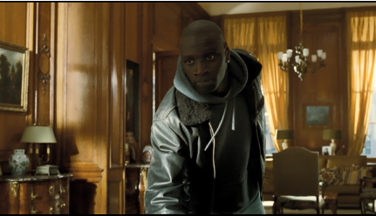
Intouchables – TF1 Films Production

Colour and lighting
Colour and lighting (including the angle of lighting) are essential elements of cinematography. Colour visually stimulates the viewer’s senses and feelings in a most direct and physical manner. On an emotional level, lighting sets a mood, creates an atmosphere and invites an emotional and intellectual response from the viewer. Colour helps to convey meaning by visually expressing the characters’ moods and feelings.
It is important to locate the source of light in a shot composition. Is it natural or artificial lighting? Does it come from the side, the back, the front, the top, or from underneath? Is the light coming from outside the frame or from within it? Is it soft, diffused, strong or harsh?
Colour and lighting are not easily separable, as lighting will change the way an object looks regardless of its colour. Our personal response to a particular shot will often be subconsciously determined by the quality, depth and type of colour used. It is important to ask how the colour complements the theme both in the film as a whole and in particular shots.

Sound
Elements to consider with the soundtrack include:
- verbal exchanges
- sound effects
- music
- silence.
The physical presence or absence, and quality of, the verbal exchanges are important features in the overall effect of any film. Tone, pitch, speed and volume of dialogue all make a significant contribution to our perception of a character and the part he or she plays in a scene.
Scenes without any speaking may communicate their message via the visual elements combined with background music. The type of music used also plays an important part in the creation of the film; however, the director may choose to have no sound at various times throughout the film. This can be a powerful device, as the viewer has to rely on the visual elements only.
Music is added either as a complete soundtrack or as a series of songs played in certain scenes. Feelings of excitement, surprise, fear, love and hatred are evoked through the music.

Costuming and decor
Costuming and decor comprise the way people dress, interior decor and any other personal or collective look. This is done through the use of particular clothes and decorations that help to set the scene on a historical, social, personal and emotional level. Decor and costumes not only set a scene within its geographical and historical context, but they can also reveal the social status or personality of the characters.

Imagery
Imagery conveys meaning without words, and may include recurring symbols (including animals, objects or people), actions or colours.

Editing
Editing is the putting together, in a given order, of the thousands of shots that have been taken and to which the sound track will be added. This very complex task involves the selecting, deleting, clipping, lengthening and rearranging of shots before gaining the final stamp of approval from the director. Editing also involves the choice and order of opening and closing credits, sound effects and voice-overs.

Other important elements

Theme
The theme is the message the director wants the viewer to remember – what is the universal idea which shines through in the film? For example, the resilience of the human spirit. A film may have more than 1 theme.

Characterisation
Characterisation is how the director reveals the personality of each character and may also include the use of stereotypes.
Characterisation can include the way characters speak and interact, their appearance, mannerisms, thoughts and feelings, and their qualities.
Characters may remain static throughout a film, or they may develop.

Film techniques template
Extract: _________________________________

Before this extract | After this extract

Technique | Description
Setting
Camera angles and shots
Colour
Lighting
Sound
Costuming and decor
Imagery
Editing and transitions
Characterisation

Activities to develop global understanding of the film
The following are sample activities that may assist in providing a global understanding of the film. They can be used for the development of written and/or oral skills. Many are suitable for group work.
- Writing a review of the film.
- Creating a cloze test on a prescribed extract.
- Writing a report on an event from the film, for example who was there, what were they doing, why they were doing it, and so on.
- Organising a role-play based on a key scene. This may include improvised dramatisation and paraphrasing of the text.
- Taking key sentences from the film out of order and rearranging them in sequence.
- Summarising the plot in a number of sentences, mixing them up then arranging them in sequence.
- Drawing diagrams to show the structure behind what has happened. For example, timelines and graphic summaries. Students could consider whether the action is chronological or involves flashbacks, and could create diagrams of the relationships between the characters.
- Considering what the characters know about each other. Are the characters stereotypes or individuals?
- Holding a press conference for a character (interviewing a character, adopting the persona of the character and recording the interview).
- Writing a tag line for each of the key characters – one line to sum them up.
- Writing the history of a character. What is known about this person? Why is he/she now in this situation?
- Imagining yourself as a character and writing a letter explaining your actions.
- Writing the diary entry of a character for one day.
- Analysing significant character relationships in the film. Groups could consider specific quotations and show how language illuminates the changes in these relationships.
- Writing a letter to the editor of a newspaper, on behalf of a character, explaining what happened.
- Discussing the issues raised in the film – how do the issues unfold?
- Discussing whether the film offers new perspectives on the issues raised. Can it change perceptions? What does the viewer learn?
- Linking issues raised to students’ personal experiences or other texts studied.
- Discussing how viewing the film has widened the students’ experiences.
- Considering parallels and conflicts.
- Considering the setting. Is it integral to the whole story?
- Questioning whether the director is saying something new. Is it universal to the human condition?
- Considering how the level of language reflects the relationship between the characters.
- Identifying a social comment in the story and discussing the methods used to make the comment.

Prescribed text
Film – Intouchables directed by Olivier Nakache and Eric Toledano (2011)
There are 9 extracts prescribed for study.
- Extract 1 – 7.18 to 16.40 (approximately)
From: « Vous avez des références ? »
To: « Va-t-en ! »
- Extract 2 – 18.39 to 25.00 (approximately)
From: « Oui ? » « Je suis venu chercher mon papier. »
To: « Voilà ça c’est fait ! »
- Extract 3 – 33.12 to 34.55 (approximately)
From: « Salut Philippe ! »
To: « C’est tout ce que tu voulais me dire ? »
- Extract 4 – 43.17 to 46.57 (approximately)
From: « Avec Alice ma femme... »
To: « C’est quoi là que vous avez perdu ? »
- Extract 5 – 48.54 to 52.25 (approximately)
From: « Ses yeux polis sont fait de minéraux charmants... »
To: « Ah, non non non non, non, non, rien. »
- Extract 6 – 52.36 to 54.23 (approximately)
From: « Pardon... excusez-moi. »
To: « ... j’ai compris. »
- Extract 7 – 55.54 to 57.48 (approximately)
From: « Passe-moi une clope… »
To: « Je ne sais pas moi. »
- Extract 8 – 1:22.25 to 1:26.01 (approximately)
From: « Driss, il y a quelqu’un pour vous dans le grand salon. »
To: « Vous savez ce que c’est une allitération ? »
- Extract 9 – 1:41.12 to 1:43.42 (approximately)
From: « Bonjour Monsieur… »
To: « Abdel Sellou est devenu chef d’entreprise, il est marié et père de 3 enfants. »
The prescribed text is available at Abbey’s Bookshop, 131 York Street, Sydney NSW 2000 or
02 9264 3111.

Background to the film

The writers and directors
Olivier Nakache and Eric Toledano wrote and directed the film Intouchables, released in France in November 2011. The film became one of the greatest box office successes in French film history and Nakache and Toledano were nominated for several awards, including three César Awards. They have since established themselves as the leaders of French comic cinema.

From memoir to film
The film is inspired by the true story of Philippe Pozzo di Borgo and his French-Algerian caregiver Abdel Sellou, discovered by Nakache and Toledano in À la vie, à la mort, a documentary film. The film is adapted from Le Second Souffle, a memoir by Philippe Pozzo di Borgo, a rich quadriplegic, about his friendship with his assistant, Abdel Sellou, an Algerian freshly released from prison. “We saw an incredible story between 2 men who never should have met. It was a story you never would have dared invent,” Nakache said.
Watch the Interview with Philippe Pozzo di Borgo in English. View a photograph of Philippe Pozzo di Borgo and Abdel Sellou on the IMDb website.

Synopsis of the film
The story begins with a car ride that triggers a flashback. Intouchables finds Driss (character based on Abdel Sellou, played by Omar Sy) returning to his family's cramped apartment following a mysterious 6-month absence. Kicked out onto the streets by his overburdened mother (later identified as his aunt), the resilient young man finds himself in a job helping a quadriplegic, the aristocratic Philippe (character based on Philippe Pozzo di Borgo, played by François Cluzet). Convinced that he would never actually qualify for the job, Driss does it not out of ambition, but instead out of a desire to get the signature needed to secure his government benefits. However, when a casual conversation between the two men leads to a playful exchange about music, Philippe tricks Driss into returning the following morning and hires him on the spot.
Driss takes up the challenge and moves into the mansion, changing the boring lives of Philippe and his employees. While they have precious little in common on the surface, the more time Philippe and Driss spend together, the stronger their bond grows. For Philippe, the aristocratic and intellectual millionaire, it means finding the courage to let go of his late wife and build the confidence to start dating again; for Driss, it means respectability and facing his responsibilities.

Social context
From the first encounter between the main protagonists of the film, audiences see two seemingly opposite characters that fit society’s expected class stereotypes: Philippe, an intellectually gifted and rich aristocrat, reminiscent of the once-ruling noble families; and Driss, an abrasive, poor immigrant from a big family attempting to take advantage of the French government.
Driss’ life and family identify the social stereotypes associated with the lower class. His aunt is the single mother of an above-average number of children. Driss is an immigrant and poor, which presents the assumption that immigrants and the lower class are one in the same. Driss, initially, appears to embody many of the stigmas associated with these groups – he is involved with drugs, crime and alcohol, and he relies on the French government to sustain him through welfare. His personality is loud and comic, with complete disregard for proper manners. He embodies the disrespectful behaviour (incivilités) associated with the les banlieues (suburbs in larger French cities, often associated with low-income housing). This stereotypical depiction of the lower class is contrasted by Philippe’s lifestyle in his palatial mansion on the opposite side of the social divide. Philippe is introduced as a stereotypical French aristocrat, despite his disability.
There seems to be no possible connection between the lower social classes and the French high society as the latter is often perceived as pretentious and exclusive. In the French media, the upper classes have often been accused for their isolation amidst the dated ideals and practices of high culture. Philippe’s personality and lifestyle in the film thus falls within these social stereotypes. His mansion in Saint Germain des Prés exudes luxury, both in its appearance and with the large household staff. Philippe’s interest in art and poetry is also a key tool used throughout the movie to portray Philippe as a product of high culture.
However, the presentation of these social stereotypes act as fictional comic exaggerations in the eyes of the French public. The social characteristics of both Driss and Philippe are not challenged in the film. The film attempts to demonstrate how their social distinctions are irrelevant in true human terms. Despite the clash of social class, Driss and Philippe gradually learn to live and flourish in the company of one another and eventually discover the codes of both their worlds.
The film presents with humour contemporary social issues such as:
- social integration
- disability
- the problems associated with les banlieues
- the importance of money in our society
- friendship and solidarity in our daily lives.

Humour
Intouchables is a typical French comedy where there is a clash of different cultures and their reconciliation. It uses humour to dampen the underlying harrowing social issues – the clash of social classes, the daily problems of the disabled, social integration and the problems associated with low-income housing in urban areas. It breaks many taboos concerning disability and poverty. It dares to show the tragic situation of a quadriplegic and the need for support from an immigrant from les banlieues. It dares to show with humour the daily care of a disabled French aristocrat and his need for love, and the need for money and belonging of an immigrant. Ultimately, the film is about the healing power of laughter and the transformative nature of friendship. We do not laugh at Driss and Philippe but with them.

Style and language
Nakache and Toledano specifically chose the comedy actor, Omar Sy, to play Driss. In an interview with Huffpost, they clarified “We relied heavily on Omar’s life experience as we shaped the role. Omar was our guarantee of authenticity from the clothing down to the subtle local slang. As an actor, he injected his own winning sensibility into Driss while effortlessly capturing Abdel’s irreverence, his very personal sense of humor and his ineffable vitality”. The directors wanted to convey a way of speaking and walking, and a sense of humour and vitality that belong to Driss’ social type, without resulting in caricature.
Throughout the film, Driss uses slang and an urban youth language register while Philippe consistently uses a high register. For instance, the high register of Philippe’s love letter, evoking the myths common to French neo-classical writing, contrast with the urban youth and slang vocabulary employed by Driss, mostly to express his boredom and shock that Philippe has never met his epistolary friend, nor even spoken to, Eléonore (Quelle tête elle a ? C’est peut-être un thon !).

Summary of the film in English
No | Timing | Duration | Description
1. | 00:00:00  00:06:30 | 06’30” | Opening film credits – the car chase: Two men seem to run away in a Maserati in Paris. The driver is a black man while his front passenger is white and seems disconnected. Speeding, they are chased and stopped by the police. In order to extricate himself, the driver (Driss) tells his disabled passenger (Philippe) to fake a fit. Philippe successfully acts out and they are escorted by the police to the hospital where they wait for the police cars to leave. Without waiting for the hospital emergency team, they drive away (music – Earth, Wind and Fire, “September”).
2 | 00:06:31  00:11:38 | 04’57” | The job interview: Classical music is playing. In a rich and palatial Parisian mansion, numerous candidates are waiting to be interviewed for the job of personal assistant to a very rich quadriplegic. Driss jumps the line. He only wants to obtain the required signature for attending an interview as quickly as possible so that he can receive unemployment benefits.
3 | 00:11:39  00:16:10 | 04’31” | In the suburbs: Driss returns home after a long absence. In the small housing commission flat are numerous brothers and sisters of different ages. His (presumably) mother, furious that he did not contact her for 6 months, throws him out of the family home. (We will learn later that he had been in jail for having robbed a jewellery store.)
4 | 00:16:11  00:17:36 | 01’25” | Night-life on the streets: Driss spends the evening and the night hanging with others around the housing commission blocks. He leaves in the early morning. (Travelling film shot in Driss’ suburb with housing commission flats. He then catches the train to come back to Paris.)
5 | 00:17:37  00:21:09 | 03’42” | Unemployment benefit form: Driss comes back to the rich mansion to collect the form that will allow him to receive unemployment benefits. Yvonne gives him a tour of the mansion as well as his sleeping quarters. Philippe offers to employ him for a trial period (classical music playing).
6 | 00:21:10  00:21:38 | 00’28’’ | Moving in: Driss takes residence in the plush quarters assigned to him.
7 | 00:21:39  00:25:09 | 03’30’’ | The training: Driss begins to learn how to take care of his disabled boss. He lifts him out of his bed to put him in his wheelchair, forgetting to belt him in. He washes him but mixes up the shampoo with the foot-cream. With reticence, he puts on Philippe’s support stockings.
8 | 00:25:10  00:25:51 | 00’41’’ | Reticence: Driss refuses vehemently to undertake one of his tasks which consists in emptying his boss’ bowels à vider le cul. He discusses this with Yvonne in the kitchen.
9 | 00:25:52  00:29:43 | 03’51’’ | Driss’ first steps: Driss treats Philippe’s daughter in a dismissive manner but takes good care of Philippe in his unconventional manner. He continues to take an interest in Magalie, Philippe’s secretary. He orders a massage at home and, while in his bathtub, forgets the time.
10 | 00:29:44  00:31:11 | 01’27’’ | The car: Driss chooses the Maserati instead of the equipped van to drive Philippe around. Aggressively, Driss makes the neighbour understand that he is not allowed to park in front of the mansion’s exit.
11 | 00:31:12  00:33:05 | 01’53’’ | At the art gallery: In the art gallery, Philippe shows his interest in contemporary art as he looks at a painting with red splotches on a white background. Driss does not understand how this could be art. He teases Philippe about his disability.
12 | 00:33:06  00:34:48 | 01’42’’ | Security warning: A close friend of Philippe advises him not to trust Driss as he has a prison record and behaves unconventionally. Philippe refuses to listen to the friendly advice because he appreciates the fact that Driss does not pity him, instead treating him as a normal person.
13 | 00:34:49  00:36:04 | 01’15’’ | Flirting: Driss suggests to Magalie that they both take a bath together in the bathtub in his room. She leads him on, eventually declining.
14 | 00:36:05  00:37:57 | 01’52’’ | Epistolary relationship: Driss discovers that Philippe has a 6-month, letter-writing relationship with a woman named Eléonore.
15 | 00:37:58  00:39:59 | 02’01’’ | The panic attack: Philippe has a panic attack in which he has trouble breathing in the middle of the night. Driss gets up and applies a cold compress while helping him to calm down.
16 | 00:40:00  00:43:00 | 03’00’’ | Paris by night: To alleviate Philippe’s phantom pains and breathing difficulties, Driss dresses Philippe warmly and pushes him along the Seine in the early hours of the morning. Driss and Philippe share a joint and this improves Philippe’s state of mind.
17 | 00:43:01  00:46:43 | 03’42’’ | Employed: While chatting in the café « Les Deux Magots », Philippe and Driss continue to get to know each other. Philippe reveals the life he shared with his deceased wife and the traumatic events that have shaped his life. He employs Driss on a permanent basis.
18 | 00:46:44  00:48:47 | 02’03’’ | At the police station: Driss collects his younger brother Adama from the police station. Adama was in police custody for having been caught with 30 grams of drugs.
19 | 00:48:48  00:52:18 | 03’30’’ | The telephone call: Driss, annoyed by the letters which Philippe sends Eléonore without ever having spoken to her, snatches a letter and telephones her, passing the telephone to Philippe. While he is stressed at the thought of speaking with her and initially nervous, he happily warms to the conversation.
20 | 00:52:19  00:54:48 | 02’29’’ | At the opera: Philippe and Driss attend the opera (Der Freischütz – Carl Maria Von Weber). Driss mocks the singer who looks like a tree. Philippe continues to communicate with Eléonore.
21 | 00:54:49  00:55:29 | 00’40’’ | The photo: Driss chooses the photo which Philippe ought to send Eléonore, a photo which only gives a hint of his wheelchair. Philippe agrees to send the photo but later chooses another in which he is able-bodied, without telling Driss.
22 | 00:55:30  00:57:12 | 01’42’’ | Disciplining Elisa: As Driss paints, Elisa enters his room. He does not approve of Elisa, Philippe's adopted daughter – her behaviour, her make-up, her boyfriend Bastien and her disrespectful way of treating others. He demands that Philippe discipline her.
23 | 00:57:13  01:01:21 | 04’10’’ | The good relationship: Different scenes show Philippe and Driss happy and getting along, influencing each other’s attitudes and tastes.
24 | 01:01:22  01:11:28 | 10’06’’ | The birthday party: In an orchestrated, traditional and formal ambiance Philippe’s soiree takes place with a classical music concert given at home for his whole extended family. After the relatives have left, Philippe requests that the orchestra play Vivaldi’s Four Seasons – Estate as well as other famous pieces to further educate Driss. Contrastingly, Driss, lightens the atmosphere by introducing Philippe and his household personnel to what he considers ‘his’ classics, dancing to Boogie Wonderland by Earth Wind and Fire. Driss manages to create a true party atmosphere and get all the remaining guests to dance which entertains Philippe immensely. He retires to bed happy, especially after Driss hands him his gift – a letter that contains Eléonore’s photo.
25 | 01:11:29  01:12:18 | 00’49’’ | Preparing for the rendez-vous: Yvonne and Driss advise Philippe on what he should wear for his meeting with Eléonore. Philippe feels increasingly stressed.
26 | 01:12:19  01:13:00 | 00’41’’ | The threat: Driss goes to see Bastien at the end of his school day, at Elisa’s request. Driss insists he apologise to Elisa, behave decently towards her and bring her croissants everyday wearing a hair clip.
27 | 01:13:01  01:15:43 | 02’42’’ | The rendez-vous: Philippe arrives with Yvonne well ahead of time for the rendez-vous arranged with Eléonore. Stressed, he drinks a few whiskies and finally decides to leave, not meeting her. They cross each other’s path without realising. At the same time, Driss drives to his aunt’s place of work and watches her from the car. Philippe rings asking him if he wants to fly away. Driss accepts.
28 | 01:15:44  01:18:31 | 02’47’’ | The plane: Driss helps Philippe board a private plane to go for a flight somewhere undisclosed. When aboard, Philippe hands Driss a gift – an envelope containing eleven thousand euros for the sale of his first painting.
29 | 01:18:32  01:21:17 | 02’45’’ | Tandem paragliding: Philippe takes Driss for a tandem paragliding experience. Philippe is dressed in a paragliding suit and flies away. Driss refuses to suit up at first but finally he is convinced to also take off. Both fervently enjoy the experience.
30 | 01:21:18  01:22:42 | 01’24’’ | Back in Paris: Driss and Philippe get on perfectly now as they return to Paris. Driss’s younger brother, Adama, seeks refuge in the Paris mansion, most probably because of an incident with drug dealers.
31 | 01:22:43  01:25:53 | 03’10’’ | Driss’ past life: Driss reveals his complicated personal history to Philippe. Philippe puts an end to their working relationship and decides that Driss should go back to his family to face his responsibilities.
32 | 01:25:54  01:26:17 | 00’23’’ | The croissants: Under Driss’ orders, Bastien brings croissants every morning wearing a hair clip.
33 | 01:26:18  01:30:06 | 03’48’’ | Driss’ departure: Driss takes his leave from the household personnel. Yvonne gives him back his file revealing the photo of Philippe which was never sent. Driss puts the file in a bin and keeps the photo.
34 | 01:30:07  01:31:12 | 01’05’’ | On the station platform: Driss and his brother wait for their aunt’s return from work and they walk home together.
35 | 01:31:13  01:34:02 | 02’49’’ | Philippe’s depression: Since Driss’ departure, Philippe descends into depression. Other personal assistants are unsuccessfully caring for him.
36 | 01:34:03  01:35:29 | 01’26’’ | New job interview: Driss goes for a job interview and impresses the employer by the way he presents himself. He recognises the Salvador Dali painting.
37 | 01:35:30  01:36:47 | 01’17’’ | Driss’ return: Philippe is not able to overcome his panic attacks. Yvonne, Philippe’s house manager, has asked Driss to come back and he agrees to do so.
38 | 01:36:48  01:38:31 | 02’43’’ | The flight: Driss finds that Philippe is depressed as he shows little attention to his appearance. Philippe is happy to see Driss and lets him take charge. Together they embark on a road trip to the seaside. (Echo au flashforward, séquence numéro 1.)
39 | 01:38:32  01:39:36 | 01’04’’ | By the seaside: Driss and Philippe go to a hotel facing the sea in Dunkirk, a change of scenery for Philippe.
40 | 01:39:37  01:41:36 | 01’59’’ | Shaving: While Driss shaves Philippe, he has fun in creating different types of moustaches, for example, Dali and Hitler. His cheekiness finally manages to make Philippe laugh.
41 | 01:41:37  01:43:00 | 01’23’’ | At the grand hotel’s restaurant: Driss takes Philippe to a restaurant facing the immensity of the ocean. Soon after their arrival, Driss tells Philippe that he is not staying for lunch because Philippe has a rendez-vous which he cannot miss this time. Philippe begins to realise that Driss has arranged a meeting with Eléonore.
42 | 01:43:01  01:43:50 | 04’36’’ | Driss’ final departure: Driss waves goodbye through the window as Eléonore arrives. Completely alone, Philippe is distressed but the quick arrival of Eléonore forces him to overcome his distress and react courteously. Philippe appears to be delighted.
43 | 01:43:51  01:44:42 | 00’51’’ | On-screen epilogue: Philippe Pozzo di Borgo lives in Morocco today. Remarried, he has two young daughters. Abdel Sellou is a business manager and he is married with three children.
44 | 01:44:42  01:49:00 | 04’18’’ | End of film credits

(scriptwriter Eric Toledano and Olivier Nakache)

Extract 1 – job interview and the cité

Library
Character | Script
Magalie | Vous avez des références ?
Candidat 1 | Oui, donc, ben moi, je suis titulaire du CAFAD, Certificat d’Aptitude aux Fonctions d’Aide à Domicile...
Candidat 2 | Que j’ai fait valider pendant une formation en alternance, à l’Institut Bayer, dans les Landes en 2001.
Candidat 3 | D’abord j’ai un bac Pro, ça veut dire proximité aide sociale et je l’ai poursuivie avec un BTS, Economie sociale et familiale.
Candidat 4 | Enfin... J’ai pas... Je... Voilà ! J’ai plus fait d’études pour l’instant que travaillé.
Magalie | Quelle est votre principale motivation ?
Candidat 1 | Ben l’argent !
Candidat 2 | L’humain. Moi je suis à fond dans l’humain.
Magalie | Eh bien.
Candidat 3 | C’est d’aider l’autre, je pense. C’est bon ça, comme, euh, enfin, c’est bien ça, comme...
Candidat 4 | J’aime bien le quartier.
Candidat 2 | J’aime beaucoup les gens diminués. Depuis tout petit, hein, tout petit.
Candidat 3 | C’est de favoriser l’autonomie des, des personnes handicapées je dirais. Oh, c’est à dire leur insertion sociale.
Candidat 1 | Le sport, également. Faut bouger... faut, pour l’insertion, euh, dans la vie quoi ! C’est des personnes qui peuvent rien faire euh...
Candidat 4 | J’ai eu ma première vraie expérience professionnelle...
Candidat 2 | C’était Mme Dupond-Moretti.
Candidat 1 | Une très très vieille dame. Très... très vieille.
Candidat 2 | Que j’ai assistée... jusqu’à la fin, au quotidien.
Candidat 1 | Alors je me souviens, en gériatrie, par exemple, y avait quand même des bons moments. On avait fait la galette, on avait fait la...
Candidat 4 | Ah je suis également expert en tout ce qui concerne les démarches administratives.
Candidat 1 | Vous vérifierez, Magalie ? Mais je pense pas...
Philippe | Vous vérifierez, Magalie ? Mais je pense pas...
Magalie | (Magalie rit)

Waiting room
Character | Script
Yvonne | Yvan Laprade.
Candidat 5 | Oui.
Driss | Oh ouais, c’est bon.
Yvonne | Vas-y.
Driss | Non, non. Ça fait deux heures que j’attends. C’est moi.
Magalie | Bonjour.
Driss | Je viens faire signer un papier.
Magalie | Ben je vous en prie. Asseyez-vous. Euh, vous avez des références ?
Driss | Oui des références moi j’en ai.
Magalie | Oui ? On vous écoute.
Driss | Sais pas. Kool and the Gang, Earth, Wind and Fire... C’est des bonnes références non ?
Philippe | Je connais pas. Asseyez-vous.
Driss | Si vous connaissez pas c’est que vous y connaissais rien en musique.
Philippe | Ecoutez j’ai pas l’impression d’être totalement inculte dans le domaine musical, même si je connais pas votre soul... Je ne sais pas quoi...
Driss | Non. Kool and the Gang.
Philippe | Et vous ? Vous connaissez Chopin, Schubert, Berlioz ?
Driss | Moi, si je connais Berlioz ? Vous là, ça m’étonnerait que vous connaissiez Berlioz.
Philippe | Pourtant je suis un spécialiste.
Driss | Ah bon ? Vous connaissez qui là-bas ? Quel bâtiment ?
Philippe | Comment ça, quel bâtiment ? Enfin mon vieux, Berlioz, avant d’être un quartier, c’était un compositeur célèbre, écrivain et critique du 19ième.
Driss | C’est une vanne. Je sais qui c’est Berlioz ! Je vois que l’humour, c’est comme la musique. Vous y connaissez rien en fait !
Philippe | Expliquez-nous un peu votre papier-là.
Driss | Il faut une signature pour dire que je me suis présenté à l’embauche, que malheureusement, malgré les qualités évidentes... enfin bref, vous mettez votre baratin habituel comme quoi vous êtes pas intéressé. Faut trois refus pour que je puisse retoucher mes Assedics.
Philippe | Oui je comprends. Vos Assedics. Vous n’avez pas d’autre motivation dans la vie ?
Driss | Si si, j’en ai d’autres. Y en a une juste là-là. Ça c’est très motivant, ça ! Bon ! C’est pas que je m’ennuie, mais qu’est-ce qu’on fait ? On signe ? On signe pas ?
Philippe | Je ne suis pas en mesure de vous le signer sur-le-champ.
Driss | Ah bon ? Pourquoi ? (Philippe moves towards Driss.) Oui c’est emmerdant ça, parce qu’y a une histoire de délai et comme je suis pas mal en retard.
Philippe | Oui c’est emmerdant, comme vous dites.
Driss | Et la motivation, elle peut pas signer pour vous ?
Philippe | Non, non, non, Magalie n’a pas de procuration.
 | (Magalie looks at Philippe, surprised at what he has said.)
Driss | Ben c’est dommage ! Comme ça elle aurait pu me greffer un petit 06, en même temps !
Philippe | Bon, ben, revenez demain, à 9h. Le papier sera signé. Je veux surtout pas vous priver de vos Assedics. Bon je vous raccompagne pas.
Philippe | Non, c’est bon... Vous vous levez pas. Enfin... je veux dire, restez assis... Je reviens demain.
(Scene changes to Driss entering la cite, greeting his mates.)
(Driss enters his family’s apartment.)

Living room
Character | Script
Driss | Mina ? Elle est là ?
Mina | Non, elle va rentrer tard.

Bathroom
Character | Script
Driss | Non, non, non ! Non, non, eh ! N’allume pas ! N’allume pas ! Coupe l’eau ! Coupe l’eau ! Si non j’ai plus d’eau moi. Coupe l’eau ! D’ailleurs, sortez, sortez ! Sortez ! Je prends ma douche ! Qu’est-ce tu fais là ? Sors !
Petit garçon | Laisse-moi !
Driss | Sortez, sors-le ! Laisse-moi ! Sors-les, toi. Eh Bintou, je rigole pas ! Dégage ! Mina ! Mina ! Sors ! Ton gros ventre, Sors !
Mina | Lâche ! Lâche !
Driss | Ils comprennent pas ou quoi ? Eh !
Driss | Bintou... Bintou... , qu’est-ce tu fais ?
Driss | Toi, assieds-toi ! Tu veux quoi ? Du coca ou ça ?
Enfant | Du Nutella !
 | (Driss looks out the window at a black 4-wheel drive. A person inside talks to young black man.)
Driss | Tu viens d’où là ?
Adama | De l’école.
Driss | C’est celui-là ton verre ?
Enfant | Oui.
Driss | Tu vas où là ?
Adama | Je vais à l’équitation.
Driss | Fais le malin toi...
 | (Driss in kitchen waiting for his mother to return home.)
Driss | Tiens, c’est pour toi. (Looking at the Fabergé egg on the kitchen table.)
Mère | Où c’est que t’es passé ?
Driss | J’étais en vacances.
Mère | En vacances ? Tu penses que les gens ils parlent pas ici ? Que je suis la dernière des connes ? 6 mois qu’on t’a pas vu ! Pas un coup de fil ! Rien ! Et tu te pointes comme une fleur en m’offrant un Kinder ?! Tu penses qu’avec tes magouilles, je vais payer le loyer ? Les courses ? (Senegalese dialogue.) Tu crois que c’est un hôtel ici ? Regarde-moi quand je te parle ! Imbécile !
Driss | On peut pas parler avec toi aussi.
Mère | Ah tu veux parler ? Ok, je t’écoute. Je t’écoute. Tu sais, Driss... j’ai beaucoup prié pour toi. Mais que Dieu me pardonne. J’ai d’autres enfants. J’ai encore de l’espoir, pour eux. Je ne veux plus te voir trainer par ici. Tu prends tes cliques et tes claques et tu fous le camp d’ici ! T’as compris ? Va-t-en ! Va-t-en !
 | (Driss leaves. Eldest daughter holding youngest watches him leave. Mother distressed at what has just happened.)

Vocabulary and expressions
une galette – savoury crepe
inculte – uneducated
être une vanne (fam.) – to be a joke
le baratin – spiel
sur-le-champ – on the spot
greffer un 06 (fam.) – to leave your number (note: most mobiles start with 06 in France)
des magouilles – shenanigans
une conne – fool
se pointer comme une fleur – to turn up unannounced
prendre ses cliques et ses claques – take your stuff
foutre le camp (fam.) – get lost

Cultural references
Institut Bayer – Bayer AG est une société chimique et pharmaceutique allemande fondée en 1863 à Barmen ; elle fait des essais cliniques, des progrès en médecine pour améliorer la qualité de vie des patients
BTS (Brevet de technicien supérieur) – technician certificate, a national diploma of higher education in France
Bac Pro (professionnel) – vocational high school diploma
APL – l'aide personnalisée au logement
Kool and the Gang – 1960s American band
Earth, Wind and Fire – 1970s American band
Assédics (partial acronym of Association pour l'emploi dans l'industrie et le commerce) – dole
Fabergé egg – a jewelled egg (possibly numbering as many as 69, of which 57 survive today) created by the House of Fabergé, in St. Petersburg, Imperial Russia. Virtually all were manufactured under the supervision of Peter Carl Fabergé between 1885 and 1917, the most famous being the 50 “Imperial” eggs, 43 of which survive, made for the Russian Tsars Alexander III and Nicholas II as Easter gifts for their wives and mothers.
Kinder Surprise – a hollow milk chocolate egg, lined with a layer of sweet milk-flavoured cream. Inside each egg is a plastic capsule that contains a small surprise toy, which sometimes requires assembly.
Scenes in Philippe’s house were filmed at L’Hôtel d’Avaray, a hôtel particulier in Paris. In reality, the building is the Dutch Embassy in Paris.

Prescribed issues
Issue | Description
Acceptance | The cutting between different candidates in their interview highlights their seeming acceptance of disability through their qualifications and motivations. However, some candidates state their motivation is the money which suggests a lack of altruism. Furthermore, their body language/voices/personalities are somewhat meek/timid, suggesting passive personalities.  Driss is accepting of his own standing. He does not hide his key motivation, which is to get his social security cheque. Philippe, too, accepts this fact and asks Driss to return the next day so he can claim his social security payments. Driss remains standing for most of this scene. This, combined with his physique, juxtaposes with the reality that Philippe is now living and is symbolic of Driss being the embodiment of Philippe’s ideal physical self.  Driss is not trying to get the job and is unaware of Philippe’s situation. He therefore treats him like he would treat anyone, rather than as a person with a disability. He only realises that Philippe has a disability when it is explained that Philippe cannot sign his paper, and Philippe moves his wheelchair towards Driss. Despite this revelation, Driss does not pity Philippe, suggesting that he is acquainted with personal suffering and is accepting by nature.  Music is a dominant recurring motif in the film and here we see that both value it for different reasons. This suggests that harmony comes from accepting an alternative perspective on something that you value. Also, the music that is played reflects who is in control at that moment. For example, Driss’ music in the car as he is driving compared to Philippe’s music when he is being cared for, where all those around him are wearing earmuffs.
Resilience | Social identity and inequality are explored through the conversation between Philippe and Driss about music. Philippe speaks of the classical composer Berlioz, but Driss interprets this as a cité (social housing block) also called Berlioz. Driss uses humour to cover up his misunderstanding by implying that he was joking.  Philippe jokes about his own disability status by stating that he will not accompany Driss out.  Driss shows his resilience through his comfort in a very different social setting. He is prepared to do whatever it takes to get his social security cheque.
Identity | A panning shot of the candidate’s shoes demonstrates that one is not dressed for the interview, and is instead wearing running shoes. This is ironic considering Philippe’s physical impairment.  A medium shot shows the candidates dressed in suits for the interview. By contrast, Driss is wearing stereotypical casual attire: jeans and a hoodie, common in the suburbs.  The establishing shot of the extract depicts the opulence of the house. We see a rich hôtel particulier parisien (mansion) and Fabergé eggs. This shows Philippe’s rich background and high social class.  Driss succeeds in jumping the queue, demonstrating his disregard for some social conventions. His lack of patience further highlights an apparent unsuitability for this job, reinforcing that he is only there to get a signature so he can prove he attended the interview and receive his social security cheque.  Philippe’s rejection of the candidates and their motivations (money, a love of disabled people) demonstrates that he does not want to be viewed as just a disabled person. This foreshadows his later revelation that he was a risk-taker attracted to extreme sports prior to his injury.  Music is used as a symbol of identity and cultural differences. Driss and Philippe have different tastes; Driss prefers rap and modern music, whereas Philippe prefers classical music. Ironically, music brings a form of escape to both of these characters.  Driss’ behaviour and personality do not change depending on his social setting. He is clearly out of place in Philippe’s house, but still uses familiar language, dresses in his street clothes, and confidently flirts with Magalie. He then returns to his own suburb and cité where his behaviour fits in with stereotypical greetings with people similarly dressed.  When Driss enters his own apartment we see the contrast between his place and Philippe’s house. Philippe’s rich, luxurious, bourgeois, sterile home clashes with the authentic, messy, cramped, poor housing of Driss, exposing their social differences and inequalities. Driss’ home is full of life whereas Philippe’s home is full of possessions and ornaments.

Extract 2 – first day on the job

Philippe’s house
Character | Script
 | (Driss rings doorbell.)
Yvonne | Oui ?
Driss | Je suis venu chercher mon papier.
Yvonne | Oui, oui, je vous attendais.
Driss | Par rapport aux...
Yvonne | Entrez.
Driss | ... aux Assédics.

House interior
Character | Script
Yvonne | Vous pouvez prévenir Philippe que le jeune homme est arrivé ?
Magalie | Oui bien sûr.
 | (Ave Maria by Schubert is playing.)
Yvonne | Alors ?
Jardinier | Les betteraves, c’est pas encore ça. Mais les radis, c’est presque bon.
Yvonne | Bien.
Jardinier | Bonjour.
Yvonne | On y va ?  Je vous préviens qu'il a passé une mauvaise nuit. (Un peu comme vous, apparemment... ) La journée commence impérativement à sept heures du matin avec l’infirmière. Il a besoin de deux à trois heures de soins tous les matins. Je dois vous préciser que beaucoup de candidats jettent l'éponge au bout d’une semaine. Ça défile, ici.
Driss | Bon, j’aime bien la déco, la musique, et tout ça c’est très bien, mais a priori je vais pas acheter. Puis j’ai pas prévu la journée.
Yvonne | Bon écoutez on m’a demandé de vous faire une visite. Moi aussi j’ai d’autres chats à fouetter. De toute façon, c’est bientôt fini. Alors voilà, pour communiquer, vous avez un babyphone, c’est comme un talkie. Vous l’entendez, il vous entend. Selon le contrat, vous disposez également d’une dépendance. Alors là, vous avez les toilettes. Et là, vous avez une salle de bain séparée. Oh, c’est là.  Bon, il vous attend.
Driss | Une minute.

Phillipe’s room
Character | Script
 | (Nurse turns off sound.)
Philippe | Ça y est c’est signé, votre papier. Elle est dans une enveloppe sur la petite table. Autrement, comment vous vivez l’idée d’être un assisté ?
Driss | Quoi ?
Philippe | Bon je veux dire que ça vous gêne pas de vivre sur le dos des autres ? Ça ne vous pose pas un petit problème de conscience ?
Driss | Ça va, merci. Et vous ?
Philippe | Sinon, vous pensez que vous seriez quand même capable de travailler ? Avec des contraintes, des horaires, des responsabilités...
Driss | Je me suis trompé en fait, vous en avez de l’humour !
Philippe | J’en ai tellement que je suis prêt à vous prendre à l’essai pendant un mois. Je vous laisse la journée pour réfléchir ? Je parie que vous tiendrez pas deux semaines.
 | (Driss walking up the interior staircase.)

Driss’ room
Character | Script
Driss | Quoi ? (looking at a portrait)

Phillipe’s room
Character | Script
Infirmière | Aucun os aucun muscle ne doit être oublié. Tout doit bouger. On doit garder la peau et les articulations en bon état. Pour ça, il faudra que tu sois méticuleux. Rigoureux. D’accord ? C’est bien compris ? Oh, debout ! C’est la nuit qu’il faut dormir !
Driss | Je dors pas...
Infirmière | Viens m’aider. On va mettre Philippe dans son fauteuil. Direction la douche. Ben tiens... Essaie tout seul. Montre-moi. N’aie pas peur... vas-y.
Driss | J’ai pas peur.  Voilà, c’est bon, comme ça ?
Infirmière | Attends ! Ne jamais le lâcher tant qu’il est pas sanglé.
Philippe | Et oui, ça fait partie de mes vices...
Driss | Bah elle m’a pas dit ! Je suis en formation !

Bathroom
Character | Script
Philippe | Bien alors, vous voulez des gants blancs ou quoi ? Frottez, nom de Dieu !
Driss | Ah mais ça mousse pas, c’est un shampoing bizarre ça ! Ça mousse pas.
Infirmière | Alors, où vous en êtes ?
Philippe | Je lui lave les cheveux, mais ça mousse pas !
Driss | Ben comment ? Mais c’est pas vrai enfin écoute... Tu lui as mis la crème pour les pieds sur la tête !
Driss | Ouais, mais...
Philippe | Rassurez-moi, Driss. Vous savez lire au moins ?
Infirmière | Mais écoute tu m’as l’air doué, toi dis-donc !
Driss | C’est les mêmes ! Normalement, c’est un pour tout le corps ! Y-en a vingt !
Philippe | Bon, allez, on enchaîne. Je vais pas rester là deux heures.
Driss | Je mets celui-là ?
Philippe | Ben... avec marqué « Shampoing » dessus !
Infirmière | Bon ça va ? Tu vas t’en sortir ?
Philippe | Ben oui, il va s’en sortir vous pensez. Je n’ai jamais eu les pieds aussi bien coiffés ! Allez, allez déjeuner, Marcelle. Tout va bien.

Philippe’s room
Character | Script
Driss | Et la jupe, elle est où là ?
Philippe | Non, ça c’est des bas de contention. Si je les mets pas, le sang circule mal et du coup je risque de m’évanouir.
Driss | Moi, je vais pas vous mettre des bas ! Là y a un petit problème, là. Petit problème parce que comme je veux pas le faire, à un moment donné, c’est... faut que... faut qu’on voit si... Marcelle ! Si Marcelle, elle peut revenir... pour les mettre elle. Parce que, elle... en plus, sait, comment le faire, comme c’est une fille et tout... J’sais pas pourquoi on discute ? Franchement, je... je vais pas le faire. Même pour vous... vaut mieux vous évanouir ! Franchement, a un moment donné, faut... On dit « Non » ! On les met pas ! On reste là... Marcelle, on va pas les mettre !
Philippe | Ben quoi ? Vous m’enfilez mes bas, vous avez une très jolie petite boucle d’oreille... Moi je trouve ça très cohérent.
Driss | On peut arrêter les vannes là ?
Philippe | On a l’impression que vous avez fait ça toute votre vie ? Vous avez jamais pensé à faire... un C-A-P d’esthéticienne ?
Driss | Voilà ça c’est fait.

Vocabulary and expressions
jeter l’éponge – to throw in the towel
à priori – in principal
avoir d’autres chats à fouetter – to have better things to do
un babyphone – baby monitor
une dépendance – own quarters
un assisté – a welfare case (play on words as Driss interprets to be ‘someone who needs assisting’)
être sanglé – to be strapped in
être en formation – to be in training
enchainer – to move on
des bas de contention – compression stockings
un moment donné – at some point
enfiler un bas – put on a stocking
un cul – an arse
un débat chelou – weird

Cultural references
CAP Esthéticienne – le titulaire du CAP Esthétique, cosmétique, parfumerie maîtrise les techniques de soins esthétiques du visage, des mains et des pieds

Prescribed issues
Issue | Description
Acceptance | Driss is partially accepting of Philippe’s disability. There are certain tasks which he is prepared to carry out (such as showering Philippe), however he initially refuses to put on Philippe’s stockings, and then draws the line at assisting him with going to the toilet. His reluctance to carry out any task which involves intimate contact with a man may come down to cultural taboos.
Resilience | Philippe copes with his disability through a strict routine of carers, procedures and music to calm him. His higher social class means that he can afford such treatments.  Driss mixes up the shampoo and the foot cream when showering Philippe. When this is pointed out, he again uses humour to cover up his ignorance (when it is suggested that he is illiterate), stating that “It’s normally one bottle for the whole body!”.
Identity | Philippe’s opulence is reconfirmed in this extract. He is rich enough to have a vegetable garden in Paris while Schubert’s Ave Maria is playing loudly throughout the house.

Extract 3 – meeting with lawyer

Café
Character | Script
Avocat | Salut Philippe, ça va ?
Philippe | Tu m’as convoqué alors maintenant je suis là. Je t’écoute. Qu’est-ce que tu as de si important à me dire ?
Avocat | Mais je t’ai pas ‘convoqué’... ben tu te doutes bien pourquoi je suis là. Non ? Ben c’est qui, ce type ? Autour de toi tout le monde s’inquiète. Yvonne me dit qu’il est inconscient, violent. Il a frappé un voisin ! Philippe, c’est pas à toi que je vais expliquer qu’il faut être vigilant. Tu peux pas laisser rentrer n’importe qui chez toi. Surtout dans ton état. Pour le coup, je suis pas certain que tu saches vraiment à qui tu as affaire.
Philippe | Vas-y, continue.
Avocat | J’ai eu Sivot à la chancellerie. C’est pas Mesrine, mais il a quand même un petit casier bien rempli, ton Driss. Il vient de faire six mois pour le braquage d’une bijouterie. Si au moins il était qualifié, mais il parait qu’en plus, il est nul. Fais attention, les gars des cités n’ont aucune pitié.
Philippe | C’est exactement ça. C’est ce que je veux. Aucune pitié. Souvent, il me tend le téléphone. Tu sais pourquoi ? Parce qu’il oublie. Alors c’est vrai il a pas spécialement de compassion pour moi. Seulement il est grand, costaud, il a deux bras, deux jambes, un cerveau qui fonctionne, il est en bonne santé... Alors tout le reste, maintenant, aujourd’hui « dans mon état », comme tu dis... D’où il vient, ce qu’il a fait avant, je m’en contrefous !
Avocat | Bon, ben, comme tu veux.
Philippe | C’est tout ce que tu voulais me dire ?

Vocabulary and expressions
un casier – record
inconscient – reckless
le braquage – robbery
costaud – built/solid
je m’en contrefous – I couldn’t care less

Cultural references
Laurent Sivot is a production manager and actor, known for Intouchables (2011), Mesrine Part 1: Killer Instinct (2008) and Mesrine Part 2: Public Enemy #1 (2008).
Jacques Mesrine was a French criminal responsible for numerous murders, bank robberies, burglaries, and kidnappings in France, the US, and Canada in the 1960s and 1970s.

Prescribed issues
Issue | Description
Acceptance | Philippe is accepting of Driss. Despite finding out that Driss is a thief and has just come out of prison, he still accepts him in his life. He states that Driss does not treat him with pity and appears to often forget about his disability.
Resilience | Philippe is aware of what he needs to deal with his disability – Driss takes care of his physical wellbeing through his work (showering, massaging and so on) but also his mental wellbeing by treating him like anyone else.
Identity | Philippe’s lawyer stereotypes people from the cité by saying “be careful, guys from the housing commission have no pity”. Coming from an upper class, he has highly prejudicial views of people from the suburbs and lower social classes.

Extract 4 – Philippe’s story

Les Deux Magots
Character | Script
Philippe | Avec Alice ma femme on s’est rencontrés à 20 ans sur les bancs de Sciences Po. Elle était grande, très élégante, des yeux rieurs...
Driss | J’ai vu plein de photos je me souviens. C’est la blonde, là ? Elle est pas mal.
Philippe | On a vécu une histoire incroyable. Je vous souhaite de vivre ça une fois dans votre vie. Putain ce que je l’aimais ! Qu’est-ce que je l’ai aimée... Elle est tombée enceinte une fois, deux fois. Cinq fausses couches successives. Puis le verdict est tombé. C’était une maladie incurable, elle était condamnée. On a décidé d’adopter.
Driss | Monsieur, s’il vous plaît ? S’il vous plaît !
Serveur | Oui ? (Philippe laughs.)
Driss | Je vais prendre une tarte Tatin, s’il vous plaît. Mais cuite, parce qu’il y avait un problème avec le gâteau au chocolat, il était cru, tout mou... , enfin, moelleux... Bizarre.
Serveur | ... c’est un petit peu le principe de mi cuit.
Driss | Ah c’est pour ça ?
Serveur | Oui.
Driss | Bah, je vais quand même prendre une tarte Tatin.
Philippe | J’ai toujours aimé la compétition. Les sports extrêmes, la vitesse, aller plus vite, plus haut. Avec le parapente, j’avais tout. Je prenais de la hauteur, je voyais les choses d’en haut, puis je soufflais. J’ai été élevé dans l’idée qu’on pissait sur le monde ! Je veux bien boire quelque chose parce que j’ai la bouche un peu sèche.
Driss | C’est un des effets du joint ça.
Philippe | C’est quoi les autres ?
Driss | Bah ça donne faim, et ça fait causer un peu. (both laugh)
Philippe | Et puis, une météo difficile, ça en parapente, ça pardonne pas.
Driss | Et vous y avez quand même été ?
Philippe | Peut-être pour rejoindre Alice dans sa souffrance parce que je savais qu’elle s’en sortirait pas. Résultat : cervicales 3 et 4 brisées, et plus que ma tête pour me lever. Quand la douleur me laisse tranquille, ben il me reste l’esprit. Mon vrai handicap, c’est pas d’être en fauteuil, c’est d’être sans elle.
Driss | Et les médecins, ils vous disent quoi ?
Philippe | Avec les progrès de la science, ils vont arriver à me faire tenir jusqu’à 70 ans, à coups de massages et de remontants. Tout ça coûte cher, mais en même temps, je suis un tétraplégique riche !
Driss | Ça m’arrive, je me flingue.
Philippe | Ça aussi c’est difficile, pour un tétra.
Driss | Ah oui, c’est vrai. C’est chaud, putain.
Philippe | On est quelle date aujourd’hui ?
Driss | Je sais pas, le 8 ou 9.
Philippe | Alors, c’est officiel !
Driss | De quoi ?
Philippe | Bah, vous avez gagné le pari ! Votre période d’essai va se terminer.
Driss | Je suis embauché alors ?!
Philippe | Ouais ouais, vous êtes embauché. Je peux compter sur vous maintenant ?
Driss | Oui.
Philippe | Très bien. Alors, commencez par me rendre l’œuf de Fabergé. C’est un cadeau d’Alice, elle m’en a offert un par an, j’en ai 25, comme les années qu’on a vécues ensemble. J’y tiens énormément.
Driss | Oui non, c’est... je sais pas pourquoi vous dites... C’est pas moi. C’est quoi là que vous avez perdu ?

Vocabulary and expressions
une fausse couche – a miscarriage
le parapente – paragliding
causer – to chat
elle (ne) s’en sortirait pas – she would not get better
une cervicale – a vertebra
être en fauteuil – to be in a wheelchair
un remontant – a tonic, pick-me-up
un tétraplégique/un tétra – a quadriplegic
ça m’arrive, je me flingue – if that happened to me, I’d shoot myself
une période d’essai – a trial period
être embouché(e) – to be hired
j’y tiens énormément – I’m very attached to it

Cultural references
Les Deux Magots – a famous café on the Left Bank of Paris which was known for attracting the intellectual elite in the 19th and 20th centuries. The cafe still welcomes customers.
Sciences Po – short for Institut d’Études Politiques de Paris is a prestigious grande école. It is one of the most selective European schools in the social sciences, and the primary institution of higher learning for the French political and administrative elite. Sciences Po has expanded by setting up other campuses around France in Dijon, Le Havre, Menton, Nancy, Poitiers and Reims.
Tarte Tatin – an upside-down fruit pastry, usually made of caramalised apples. It is named after the hotel that originally served it as its signature dish.

Prescribed issues
Issue | Description
Acceptance | Despite coming from completely different social backgrounds, the bond between Philippe and Driss deepens in this extract. Philippe opens up about his personal life, demonstrating his trust of Driss. Even though he is certain that Driss stole his Fabergé egg, he is able to look past this and this does not destroy their bond.  Though originally puzzled by Philippe and unwilling to perform basic tasks for him (putting on stockings, helping him with the toilet), Driss has grown fond of him.
Resilience | Just prior to this scene, Philippe has ‘ghost pains’ and Driss wakes up to look after him. Driss is becoming very caring with Philippe, suggesting that Driss has prior experience with trauma as he is shown to be very natural in his comforting gestures and words.  Philippe accepts his disability and tries to get on with his life. He jokes about how the treatment is expensive, but at least he has the luxury of being rich. When Driss says that if the same thing were to happen to him he would shoot himself, Philippe jokes about how that would be difficult for a paralysed person (how would he hold the gun?). Philippe’s honesty and humour about his disability demonstrate his ability to bounce-back and continue with his life.  Philippe and Driss both rely on each other; Driss needs a job and a place to stay and Philippe needs a carer. However, their relationship is not bound by regular employer/employee conventions. Alhough they continue to speak formally (using vous), their behaviour, for example, sharing a joint, enjoying a meal together, joking around and Philippe’s apparent comfort and trust in Driss, reveal a deeper friendship where each relies on the other’s presence. Philippe’s developing bond with Driss is becoming vital to his everyday life and rehabilitation. Driss’ dishonesty about the Fabergé egg leaves a taint on their relationship, and his guilt and shame about this are explored in the following scene where he attempts to get various family members to recover the egg for him.  Philippe mentions how he copes without his wife. He sees this as his main disability, not his quadriplegia, stating “My handicap is not being in a wheelchair, it is being without her”.
Identity | Social and cultural differences are exposed when Driss requests his tarte Tartin ‘cooked.’ Being unfamiliar with fancy French desserts, he did not understand that the chocolate molten cake was meant to be runny, instead believing it to be undercooked. His abrupt way of summoning the waiter by shouting s’il vous plaît also demonstrates how he is not used to this social setting. The waiter appears slightly taken aback and explains that the cake was meant to be runny. Philippe finds the situation amusing and chuckles. Driss is unashamed (possibly not realising that he had committed some social taboos).  We learn that Philippe’s daughter is adopted in this extract.

Extract 5 – Eléonore

Philippe’s library
Character | Script
Philippe | Ses yeux polis sont faits de minéraux charmants. Et dans cette nature étrange et symbolique...
Magalie | Et dans cette nature... étrange... et symbolique...
Driss | Qu’est-ce que c’est chiant !
Philippe | Où l’ange inviolé se mêle au sphinx antique...
Magalie | Alors ‘sphinx’ j’ai toujours un doute, c’est un « i » ou un « y » ?
Driss | Ça me prend la tête, votre truc.
Philippe | C’est un « i » et c’est au singulier.
Driss | Ça sert à quoi de passer par tout ce merdier-là ? Les sphinx, les pâquerettes, les anges. Ça t’intéresse toi, un mec qui te raconte ça ?
Magalie | C’est sûr qu’il y a plus basique, comme approche. Euh, « se mêle au sphinx antique » ... Ensuite ?
Driss | A quoi ressemble cette Eléonore-là ?
Philippe | Je sais pas. C’est pas ce qui m’importe. Y a d’abord une approche intellectuelle, émotionnelle. Avant de tout centrer sur le physique, moi je cherche d’abord la relation d’esprit à esprit.
Driss | D’esprit à esprit d’accord, mais si c’est un thon ? Ce serait une relation d’esprit, à un thon ?
Philippe | Très élégant... Vraiment... Rien à dire, bravo.
Driss | Bon, ça fait combien de temps que ça dure, ça ?
Philippe | (sighs) Oui, il est pénible.
Magalie | Six mois.
Driss | Six mois ? Six mois et vous l’avez jamais vue ? Mais ça se trouve qu’elle est peut-être moche, grosse ! Ou peut-être même handicapée ! Vous devriez lui mettre à la fin du poème-là :  « Sinon, au niveau poids, t’es comment ? » Note !
Philippe | Bon, merci beaucoup Driss pour vos conseils très pertinents, hein ? On reprend ? Oh j’en sais plus où j’étais...
Driss | Je crois que c’était un sphinx qui mangeait des pâquerettes et il était aux anges, après il courait et j’sais pas, il faisait des trucs bizarres.
Magalie | Alors, euh, « Et dans cette nature étrange et symbolique... »
Philippe | Et dans cette nature étrange et symbolique...
Driss | Faut l’appeler.
Philippe | Où l’ange inviolé se mêle au sphinx antique...
Driss | Faut l’appeler, je vous dis !
Philippe | Bon Driss, je fais passer beaucoup plus de choses par l’écrit, d’accord ? Il est incroyable, non ?
Driss | D’accord, mais moi je vais trouver son numéro de téléphone parce que ça commence à me stresser votre truc. (He picks up the envelope.) OH ! OH ! Elle vient de Dunkerque, c’est pas bon ça...
Philippe | Reposez cette enveloppe.
Driss | J’ai jamais vu de Miss France qui venait de Dunkerque, moi. En général elles sont cheum là-bas.
Philippe | Allez, reposez ça immédiatement.
Driss | Putain, elle a mis son numéro de téléphone. Elle l’a rajouté à la main, c’est un signe ça, c’est sûr ! Elle veut qu’on l’appelle !
Philippe | Allez, reposez ça, s’il vous plaît !
Driss | Mais, qu’est-ce que vous voulez, Philippe ? Elle a mis son numéro de téléphone à la main, ça veut dire quoi ? « Appelle-moi ! Je veux te lécher l’oreille ! ». Ben oui ! Bien sûr Philippe !
Philippe | Qu’est-ce qu’il fait ? Vous ne l’appelez pas, hein !
Driss | Elle s’en fout de la poésie ! Six mois de poésie ! Téléphone-lui !
Philippe | Il est malade, ce mec. Je m’en fous, je lui parle pas.
Driss | Je vais vérifier si elle a pas un accent bizarre. Dunkerque, c’est les ch’tis.
Philippe | Coupez ce téléphone !
Driss | « Je veux mon p’tit Philippe ! » Elle va l’avoir, elle va l’avoir.
Femme | Allô ?
Driss | La voix, ça va déjà... (He holds the telephone to Philippe’s ear.)
Femme | Allô ?
Philippe | Non... non...
Femme | Allô ?
Driss | Improvisez ! Parlez des anges, des pâquerettes, tout ça !
Philippe | Eléonore ? C’est Philippe. Voilà, je... je vous appelle parce que j’avais terriblement envie d’entendre le son de votre voix. Et je dois dire que rien que ce petit ‘allô’, je suis comblé.
Femme | Ne quittez pas, je vous la passe.
Driss | Une phrase de trois kilomètres, faites plus simple.
Eléonore | Allô ?
Philippe | Ouais Eléonore, c’est Philippe.
Eléonore | Philippe ?
Philippe | J’étais en train de vous écrire une lettre, et puis, d’un seul coup comme ça je me suis ben, « pourquoi pas lui téléphoner ? »
Driss | N’oubliez pas de demander pour le poids.
Eléonore | Pardon ?
Philippe | Ah, non, non, non, non, non, non, rien.

Vocabulary and expressions
chiant (adjective) – really annoying
un ange – an angel
inviolé (adjective) – unviolated/undamaged
un merdier – shit
une pâquerette – a daisy
un thon – literally ‘a tuna’, figuratively ‘a troll/dog’ (someone ugly)
passer des choses – to get a message across
cheum – ugly (verlan of ‘moche’)
les ch’tis – people from the north of France (see ‘Dunkirk’ in cultural references)

Cultural references
Dunkirk (Dunkerque) is a port city in the far north of France, near the Belgian border. Many people from this area speak with a distinctive accent, which is why Driss wants to check if Eléonore has un accent bizarre. People from this region of France are often called ch’tis, a reference to Ch’timi (a variant of the Picard dialect). The language and accent was popularised in the 2008 Danny Boon film Bienvenue chez les Ch’tis (English title ‘Welcome to the sticks’), the highest-grossing film of all time at the French box-office. It lies ten kilometres from the Belgian border. Dunkirk's port was used extensively by British forces during the First World War.
Driss uses the verlan expression cheum (moche, ugly) to stereotype northern French women. Verlan is a type of colloquial street language in France made by inverting the syllables in a word. Other common examples include une meuf (une femme), un keuf (un flic), and la té-ci (la cité).
Miss France – a national beauty competition held each year in France.

Prescribed issues
Issue | Description
Acceptance | In this scene, Driss is incapable of thinking that Eléonore may not like Philippe, even though he has a physical disability. He is convinced that she wants him to call her. On the other hand, he is concerned that Eléonore may herself be unattractive or even disabled, given where she comes from (Dunkirk in the north of France). Though he voices his concerns for comedic effect, Driss is stereotyping people from the north, showing how universal acceptance of stereotypes is, across all socio-economic groups.  Driss and Philippe have very different views on women. Driss is primarily concerned with the way women look and sees them as objects of desire, whereas Philippe is more interested in a ‘relationship between two souls’.
Resilience | Philippe has no control over his own body, but he does have control over his life and who he spends his time with. Driss represents Philippe’s relinquishing of this control – smoking a joint together and opening up to Driss. Driss recognises Philippe’s relationship with Eléonore as a positive thing, despite Philippe’s fear of rejection. Driss is the instigator of change for Philippe for his own improvement.
Identity | It is implied that Philippe continues to write to Eléonore rather than phone or meet her, as he is scared of rejection. He does not know how she will react to someone in a wheelchair. This indicates that Philippe has low self-worth caused by his disability.

Extract 6 – opera

Atrium, opera theatre
Character | Script
Driss | Pardon... Excusez-moi, j’étais là avant. Merci.
Philippe | Si, je suis content ! Ah si, je suis content !
Driss | La pipelette ! Gros tchatcheur ! Il arrête plus !
Philippe | Je vous embrasse.
Driss | Tout le monde s’embrasse, tout le monde se lèche l’oreille. Très bien. Bon, alors ?
Philippe | Ben alors, y a du bon et du moins bon.
Driss | C’est quoi, le bon ?
Philippe | 53 kilos.
Driss | 53 kilos, c’est bien ! Sauf si elle fait un mètre...
Philippe | Et le moins bon, elle veut une photo.
Driss | Et alors ?
Philippe | Et alors ? Il est marrant lui...
Femme | Bonsoir messieurs, vos billets, s’il vous plaît.
Driss | Bonsoir !
Femme | Alors, c’est juste là.
Driss | Très bien !
Femme | Bonne soirée.
Driss | Bonne soirée à vous ! Si vous me cherchez, on est là. On bouge pas, ben surtout lui. (They enter into the theater.)

Opera theatre
Character | Script
Driss | Attendez, qu’est-ce qu’elles cherchent les femmes, à votre avis.
Philippe | Je sais pas. La beauté, le charme, l’élégance...
Driss | Mon cul ! Elles cherchent l’oseille, la sécurité. Demandez-lui à lui là. Et là, vous, vous avez des arguments.
Philippe | Je suis peut-être naïf, mais j’espère que je peux séduire encore autrement qu’avec mon compte en banque...
Driss | Attendez, elle passe six mois à lire vos poèmes à la mords-moi-le-nœud. Elle kiffe. C’est une originale, c’est sûr. Elle pourrait très bien s’en foutre du fauteuil.
Philippe | Ça, c’est vrai.
Driss | Puis là-bas, dans le nord, il y a des mecs qui cognent à force de boire. Avec vous, elle verra qu’elle risque rien.
Philippe | Salaud. (both laugh)
Driss | C’est pragmatique, ça, non ?
Philippe | Je sais pas si... ouais.
Driss | Donc, la photo c’est un bon test. Si elle renvoie la sienne, ça veut dire qu’elle est d’accord pour aller plus loin. Après, vous, vous pouvez envoyer une photo avec le fauteuil mais on voit pas trop ! Vous êtes pas obligé de lui envoyer une photo genre Téléthon, avec le filet de bave, avec une sale tête !
Philippe | Ça va, ça va j’ai compris.

Vocabulary and expressions
La pipelette ! – What a gossip!
Gros tchatcheur ! – What a chatterbox!
y a du bon et du moins bon – there’s good and bad news
elle fait un mètre – she’s a metre tall
mon cul ! – literally ‘my arse’ (don’t be ridiculous! English equivalent may be ‘my foot’)
l’oseille (f) (fam.) – money
un compte en banque – a bank account
à la mords-moi-le-nœud – lousy, useless
elle kiffe (kiffer) (fam.) – she likes
cogner – to bash, hit, bang
un téléthon – a televised charity event
un filet de bave – a string of saliva

Cultural references
This scene was filmed at Le Théâtre Nationale de l’Opéra-Comique, a large opera theatre situated in the second arrondissement of Paris.
The opera played at the end of this extract is Der Freischütz (The Marksman) by the Romantic German composer Carl Maria von Weber.

Prescribed issues
Issue | Description
Acceptance | Driss again stereotypes people from the north, stating that there are men up there who get drunk and beat up people.  Philippe is accepting of Driss and his honesty when talking about his disability. In the previous extract, Philippe was very annoyed with Driss and his jokes, whereas in this extract Philippe is always smiling or chuckling. This demonstrates that he is also coming to accept himself and his situation.  Driss’ and Philippe’s different opinions on the role of women again become apparent. Philippe says that women are looking for elegance, beauty and charm with a male partner. Driss thinks that they just want security and money in a relationship.
Resilience | Humour is used to talk about disability again in this extract, as a way for Philippe to deal with his situation and dating life. When Driss jokes that at least Philippe will not beat Eléonore up (as opposed to the men in the north), Philippe chuckles instead of being hurt. Driss’ brutal honesty, and Philippe’s ability to talk to his carer about his dating life, demonstrate the strong friendship between the two.
Identity | Philippe is doubtful of sending a photo to Eléonore, saying that her request is ‘bad news’. This demonstrates that, despite his general resilient nature, he is concerned about his image and how he will be perceived as a person with a physical disability. He is insecure and does not have much self-worth when it comes to his dating life. However, he jokes that he hopes he has other ways of seducing women than with his bank account.

Extract 7 – Elisa

Philippe’s house
Character | Script
Elisa | Oh, passe-moi une clope…
Driss | Eh, on t’a jamais appris à frapper, toi ?
Elisa | Tu peins ?
Driss | Ouais, allez dégage !
Elisa | Non mais c’est une blague ? Toi, tu peins ? Et t’as appris à lire aussi, du coup, euh...
Driss | Eh tu veux quoi, là ? Allez ! Sors ! Dégage !
Elisa | Qu’est-ce que tu vas me faire ? Tu vas me frapper, c’est ça ? C’est comme ça qu’on traite les femmes dans ton pays ?
Driss | Mais t’as chaud ou quoi ? Allez sors là, sors, allez !
Elisa | Je sors si je veux quand je veux, OK ?
Driss | C’est ça ! Allez, dégage !
Elisa | Tu vois là, j’décide, et là je sors.
Driss | Dégage ! Putain !
Philippe | Retirez cette photo et vous la remplacez par l’autre. Soyez gentille de la poster personnellement. Et restez discrète !
Yvonne | Comme vous voudrez.
Philippe | Et maintenant, vous jetez l’autre photo dans la poubelle.
Driss | Péter un plomb. J’vais péter un plomb.
Philippe | Quel est le problème ?
Driss | Le problème c’est votre fille. J’étais en train de peindre, là...
Philippe | Vous étiez en train de peindre ?
Driss | Oui bref, ... faut juste vous dire. Faut la recadrer, parce que sinon, je vais l’encastrer contre un mur.
Philippe | Calmez-vous un peu !
Driss | Non, non je ne me calme pas. On est d’accord qu’on est ici je suis vos bras et vos jambes ?
Philippe | Oui, on est d’accord !
Driss | Oui d’accord. Moi, j’ai envie d’être vos mains pour lui en coller une bonne. Parce que vous, à part lui rouler dessus, vous ne pouvez plus faire grand-chose.
Philippe | Driss, vous ne rajoutez pas un peu, là ? Yvonne ?
Driss | Yvonne ?
Yvonne | C’est vrai qu’elle aurait bien besoin d’un... d’un léger recadrage.
Driss | Léger ! Mais à seize ans, elle s’habille, elle se maquille n’importe comment. Sans compter qu’elle galoche l’autre plumeau partout dans la baraque. Ça à la rigueur je m’en fous. Ça ne me regarde pas. C’est son éducation. Ce qui me dérange, c’est plutôt comment elle prend tout le monde de haut là : comment elle vous parle ; comment elle me parle. Il est où, le respect là ? On est quoi nous ? On est des chiens ? Donnez-moi le top que je lui remette les idées en place.
Philippe | Bon, ça va j’ai compris. Laissez-moi faire. Je lui parlerai.
Driss | Parle-lui alors ! Mais, parle-lui vite. Faites un truc, mets lui à sa place
Philippe | Il peint ? mais qu’est-ce qu’il peint ?
Yvonne | Je ne sais pas moi.

Vocabulary and expressions
une clope – a cigarette
Dégage ! – Go away!
lui coller une bonne – to hit her
galocher – to French kiss/snog
un plumeau – a feather duster (referring to Bastien’s hair)
prendre tout le monde de haut – to look down on
donner le top – to give the go-ahead

Cultural references
C’est comme ça qu’on traite les femmes dans ton pays ? Elisa is referring to Driss’ country of origin – Senegal. She is also referring to the issue of domestic violence.

Prescribed issues
Issue | Description
Acceptance | Elisa is intolerant of Driss’ origins after he tells her to get out of his room. She mocks his painting and asks if he has learnt to read yet. She asks if he is going to hit her, and then asks “Is that how men treat women in ‘your country’?”.
Resilience | In spite of his friendship with Driss, Philippe secretly changes the photo he will send to Eléonore to one of him without the wheelchair. This shows that he is not yet accepting of his situation.
Identity | Driss’ identity and image are changing. Having been exposed to different aspects of culture by Philippe, Driss has now taken up painting as a way to get rich. He may not be comfortable with other people knowing this, getting annoyed at Elisa for interrupting him.  The fact that Philippe hides changing the photo from Driss indicates that he is still uncomfortable with his image and how others will view him.  Driss challenges Philippe’s views on what it means to be well raised, and also his role as a father. He criticises Elisa’s behaviour and appearance openly, and has his own traditional ideas of how a 16 year old girl should look and behave. He wants permission to ‘change her ideas’ and discipline her so that she learns to show respect.

Extract 8 – Driss’ story

Exterior – Philippe’s house
Character | Script
Yvonne | Driss, il y a quelqu’un pour vous dans le grand salon.
 | (Driss enters the house.)
Driss | Qu’est-ce que tu fous là ?
Adama | T’es un cachottier, toi. C’est à toi qu’il faut demander ça !
Driss | Comment t’as eu l’adresse ?
Adama | Les Assédics ont envoyé ça. Y a marqué cette adresse.
Driss | Ça c’est quoi là?
Adama | Ah rien. Laisse tomber.
Driss | Qu’est-ce t’as foutu ?
Adama | Je suis tombé en scooter.
Driss | Tu es tombé en scooter ? T’es tombé en scooter ? Lève-toi, Lève-toi... t’es tombé en scooter... par là.
Adama | (Whistles in admiration when entering Driss’s room.) Putain ! Tu dors ici ?
Driss | Vas-y, raconte ! Qu’est-ce qui s’est passé ?
Adama | Rien ! Il ne s’est rien passé !
Driss | Qu’est-ce qui s’est passé ? Je te dis !
Adama | C’est pas ton problème ! C’est tout ! T’es gonflé !
Driss | Comment ça c’est pas mon problème ? Tu viens te cacher ici, c’est pas mon problème ?
Adama | On était quatre. On s’est fait niquer. C’est tout. Mais t’inquiète, ça va partir en couille.
Driss | Ça va partir en couille ! Tu vas rien faire ! Elle est au courant la daronne ?
Adama | Elle est pas au courant. T’inquiète, je gère...
Driss | Tu gères rien du tout ! Tu viens me casser les couilles là ! En attendant tu touches à rien ! Tu m’attends là ! T’as compris ?
Adama | Je peux m’allonger sur le lit ?
Driss | Tu touches à rien, je te dis. Tu ne t’allonges nulle part.
Adama | Ben ça va J’ai compris !
Driss | ... ta tête là !
Driss | C’est bon. Il est avec moi. Je te dis. Mina, arrête de pleurer. II est pas blessé, c’est une égratignure. Il a rien. C’est n’importe quoi Mina ! Personne ne va tuer personne. C’est des menaces, c’est des mots. Ils vont rien faire. Maintenant moi je peux pas m’en occuper. Je peux pas. Je travaille là. Non, tu dis rien. Tu dis rien. Tu la préviens pas. Tu t’enfermes dans ta chambre si tu as envie de pleurer, tu pleures là-bas mais tu dis rien.
Driss | On va se coucher là non ?
Philippe | Je vais rester encore un petit instant. Asseyez-vous ! Asseyez-vous là ! Qu’est-ce qu’elle évoque cette femme pour vous ?
Driss | J’sais pas. Elle a l’air bonne.
Philippe | À part ça ?
Driss | On y va. On monte là ? Parce que j’ai un truc à régler là-haut.
Philippe | Moi, j’imagine qu’elle se lève, qu’elle se retourne, qu’enfin je découvre son visage... Il vous ressemble, le petit. Adama, c’est ça?
Driss | C’est ça.
Philippe | Je l’ai aperçu tout à l’heure. Je crois que si je l’avais croisé dans la rue, j’aurais tout de suite pu deviner que c’était votre frère.
Driss | C’est drôle !
Philippe | Pourquoi ?
Driss | C’est drôle parce que c’est pas mon frère.
Philippe | Ah, bon ?
Driss | Ben c’est compliqué.
Philippe | Ben, c’est votre frère ou c’est pas votre frère ? Bon, d’accord. J’ai compris. Bon, allez, on y va !
Driss | C’est mes parents. Pas mes parents... En fait c’est mon oncle et ma tante. Ils sont venus me chercher au Sénégal quand j’avais huit ans. Ils arrivaient pas à avoir de gosses. Donc ils sont allés voir un frère qui avait plein de gosses. Ils ont pris l’aîné... moi. En vrai je m’appelle Bakari. C’est ça mon vrai nom. Mais y en avait déjà plein au quartier. Donc, ils m’ont appelé Idriss. Je ne sais pas pourquoi c’est Driss qui est resté.
Philippe | Et après ?
Driss | Après, comme par hasard ma mère... ma tante... elle est tombée enceinte deux fois de suite. Puis mon oncle est mort. Après il y a eu d’autres gars, d’autres gosses. Je vous ai dit ; c’est compliqué.
Philippe | Le petit Adama, il n’aurait pas besoin d’un léger recadrage ? Il est venu vous chercher ? C’est ça ? Driss, je crois qu’on va s’arrêter là. En somme, vous n’alliez pas pousser un handicapé toute votre vie. Puisque vous avez travaillé, vous avez bien mérité vos Assédics. Bon, allez ! Allez ! En route ! Allez.
Driss | Ouais.
Philippe | Bassari, Bakari... Bakari, Bassari... C’est beau hein. On dirait de la poésie. On dirait presqu’une allitération. Vous savez ce que c’est une allitération ?

Vocabulary and expressions
C’est n’importe quoi ! – It’s nonsense!
se faire niquer – to get screwed/nabbed
partir en couille – to hit the fan
tu vas me casser les couilles – you’re going to annoy the hell out of me
la daronne (fam.) – the mother
Ta tête là ! – Don’t move!
les gars – guys
les gosses – kids

Cultural references
Les indemnités de chômage – ‘the dole’

Prescribed issues
Issue | Description
Acceptance | Philippe is accepting of Driss’ family obligations and responsibilities. Driss, too, comes to realise that he needs to look after his family and needs to help them at this point in his life.
Resilience | We learn that both Philippe and Adama rely on Driss but in different ways. Philippe needs him as a friend and carer, and Adama needs him as a father figure. Philippe realises that Driss has family responsibilities and suggests that he should prioritise these rather than look after a disabled person.
Identity | This extract reveals Driss’ true identity. We learn that he was born in Senegal and at the age of 8 he was taken from his parents by his aunt and uncle to live in France. In France he was called Idriss, shortened to Driss. His real name is Bassari Bakari.  Philippe comments on the similarities between Adama and Driss – these could be physical or character similarities. Adama is a reminder of where Driss comes from, and he needs to help with his upbringing to get him back on the right path.

Extract 9 – Dunkirk

Café
Character | Script
Maître d'hôtel | Bonjour Monsieur…
Driss | Bonjour, j’ai réservé au nom de Bassari.
Maître d'hôtel | Oui, Bassari, c’est la huit. Suivez-moi s’il vous plaît. Par ici !
 | (Waiter moves the chair.)
Driss | Merci
Philippe | Merci Monsieur.
Driss | Bon, Philippe... Je vais pas rester déjeuner.
Philippe | Pourquoi ?
Driss | Je ne vous laisse pas seul. C’est juste que je crois que vous avez un petit rendez-vous là.
Philippe | Un petit rendez-vous ? Comment ça ?
Driss | Paniquez pas ! Ça va bien se passer.
Philippe | Non, mais...
Driss | Par contre, cette fois vous ne pouvez pas vous barrer. Ah, en fait... (music – Una mattina) j’ai mis le temps mais je l’ai retrouvée. Embrassez-la bien fort pour moi.
Philippe | Driss, Driss !
Eléonore | Bonjour Philippe !
(On-screen epilogue)
Philippe Pozzo di Borgo vit aujourd’hui au Maroc. Remarié, il est père de deux petites filles.
Abdel Sellou est devenu chef d’entreprise, il est marié et père de trois enfants.

Vocabulary and expressions
se barrer – to leave

Cultural references
Una mattina is a piano piece composed by the Italian pianist Ludovico Einaudi. It has a beautiful melody and it makes use of repetition. It is played using softer and louder tones and the music slows down between the different parts. It supports the emotions happening – both the happiness and sadness of this farewell and new beginning.

Prescribed issues
Issue | Description
Acceptance | Driss forces Philippe to meet Eléonore by arranging a lunch between them. Driss has most likely informed Eléonore of the situation as she arrives and is not surprised by Philippe’s physical disability. After his initial shocked reaction, Philippe looks out of the window at Driss for support. He then looks back at Eléonore and gradually comes to accept the present situation and that Eléonore knows the truth about his disability. This is part of his journey towards self-acceptance.
Resilience | The fact that Driss has organised the lunch and meeting for Philippe is the ultimate sign of their deep friendship. It also demonstrates that Driss has a deep knowledge of what Philippe needs after Philippe hit rock bottom after Driss’ departure. That Philippe has recovered from his depressive episode simply by Driss’ return indicates that he is still reliant on Driss for his emotional wellbeing.  Though Driss is no longer an employee, and despite their friendship, Driss and Philippe continue to use vous to talk to each other.
Identity | We see Driss using his birth name for the first time in the film. He books the table under the name Bassari. This demonstrates an increase in his self-worth and his acceptance of his cultural heritage.  When Driss originally stole the Fabergé egg from Philippe in Extract 1, he was a thief who had just come out of prison. We now see a development in his character with the return of the egg, showing his change into an honest and caring man. All previous stereotypes of Driss are broken in this scene, and he has progressed from a stereotypical youth from the cité into a complex compassionate individual.

Additional cultural references
Term | Definition
les banlieues | Since the 1970s and 1980s, the phrase les banlieues has been increasingly used as a euphemism to describe low-income housing (HLM – Habitation à Loyer – housing commission flats) and low-income housing projects (cités) in which many immigrants reside, especially around Paris, but also in some of the other large cities of France. However, les banlieues may also be rich, middle-class or poor when they simply refer to suburbs.
Goya | Francisco José de Goya y Lucientes was a Spanish romantic painter and printmaker. He is considered the most important Spanish artist of the late18th and early 19th centuries and throughout his long career was a commentator and chronicler of his era.
hôtel particulier | A grand, free-standing townhouse. There are still hôtels particuliers in many large cities in France. Scenes in Philippe’s house were filmed at l’Hôtel d’Avaray, a hôtel particulier in Paris. In reality, the building is the Dutch Embassy.
Bové | Joseph Bové is a French farmer, politician and union spokesperson for global corporation and interaction. He has a drooping moustache like the French cartoon character Astérix.
Marchais | Georges René Louis Marchais was the leader of the French Communist Party from 1972 to 1994, and a candidate in the French presidential elections of 1981.
Pas de bras pas de chocolat ! | The punchline from a well-known French joke. Philippe failed to recognise the joke, thereby demonstrating the stereotypical isolation of the upper classes. Driss, for the most part, actually recognises high culture references, but associates them with more relatable things in his life, whereas Philippe either does not understand or, when he does, embraces the lower class stigmas wholeheartedly.
Raffarin | Jean-Pierre Raffarin is a French politician who served as Prime Minister of France from 6 May 2002 to 31 May 2005. He resigned after France's rejection of the referendum on the European Union draft constitution.
Barry White | Barry Eugene Carter (1944-2003), better known by his stage name Barry White, was an American singer-songwriter, musician, record producer and composer.

Expressions imagées, argotiques et en verlan
Expression | Explanation | From
avoir d’autres chats à fouetter | avoir d’autres choses à faire | français courant
avoir les pieds bien coiffés | avoir de longs bas/chaussettes | expression familière
casser les couilles à quelqu’un | agacer fortement | expression vulgaire
C’est chaud ! | assez risqué/assez sensuel | expression populaire
C’est du baratin ! | un discours abondant destiné à convaincre, à tromper, à séduire | expression familière
C’est n’importe quoi ! | C’est du délire/insensé ! | expression familière
charrier quelqu’un | se moquer de quelqu’un | expression populaire
une clope | une cigarette | expression familière
en coller une bonne | donner une claque | expression populaire
une conne | une idiote | expression populaire
un cul | un derrière | expression familière
la daronne | la mère | argot traditionnel
un débat chelou | un débat étrange | verlan
Dégage ! | Ne reste pas là ! Va-t’en ! | expression familière
donner le top | abréviation de donner le top départ/donner la permission | langage des jeunes des cités
être cheum | être moche, dont le physique est gâché par des défauts dans les formes ou les proportions | argot traditionnel
être réglé comme du papier à musique | être régulier/très organisé | expression familière
faire le malin | se rendre intéressant | expression familière
foutre le camp | partir | expression familière
galocher | embrasser à pleine bouche | langage des jeunes des cités
les gars | les garçons | expression familière
les gosses | les enfants | expression familière
Je m’en contrefous ! | Ça m’est égal ! | expression vulgaire
jeter l’éponge | abandonner la lutte, renoncer à ses projets | expression familière
kiffer grave | adorer | langage des jeunes des cités
larguer quelqu’un | abandonner quelqu’un, quelque chose s’en débarrasser ou laisser quelqu'un loin derrière soi | expression familière
une magouille | une manœuvre | expression familière
un merdier | une situation difficile, un désordre, un embrouillement | expression familière
l’oseille | l’argent | argot traditionnel
partir en couille | se dégrader | expression populaire
Pas de bras, pas de chocolat ! | l'absurdité d'une interdiction, ou se moquer de quelqu'un face à une impossibilité physique | expression populaire
péter un plomb | perdre le contrôle de soi-même | expression familière
la pipelette | le/la concierge ou une personne qui a le goût des commérages et parle sans arrêt | expression populaire
le plumeau | ustensile de ménage fait de plumes pour épousseter  un vendeur d’habits | français courant  argot traditionnel
poissard(e) (adj.) | vulgaire, grossier ou personne malchanceuse | expression familière
prendre tout le monde de haut | mépriser, snober  se comporter de manière hautaine, arrogante | expression populaire
prendre ses cliques et ses claques | prendre ses affaires et s’en aller | expression familière
se barrer | s’en aller, partir | expression familière
se faire niquer | se faire duper | expression vulgaire
se pointer comme une fleur | arriver sans prévenir | expression familière
un taré | un imbécile | argot traditionnel
tenter le coup | risquer, tenter sa chance | expression familière
un thon | une fille laide | argot traditionnel
une vanne | une plaisanterie, une critique méchante | expression populaire

Sample analysis of text questions

Extract 4

Part A
  - What does the audience learn about Philippe’s family in this extract?
  - How does Driss’ behaviour towards the waiter reveal his social differences?
  - « Oui non, c’est... je sais pas pourquoi vous dites... C’est pas moi. C’est quoi là que vous avez perdu ? »
What does Driss’ statement reveal about him?
  - How is the theme of resilience explored through the character of Philippe? Refer to this extract and one other scene in the film.

Part B
Philippe : Très bien. Alors, commencez par me rendre l’œuf de Fabergé. C’est un cadeau d’Alice, elle m’en a offert un par an, j’en ai 25, comme les années qu’on a vécues ensemble. J’y tiens énormément.
Imagine that Driss admits to having taken the Fabergé egg. Write the script of the ensuing alternative conversation. Write approximately 200 words in French.

Sample speaking and writing task
Les gens s’adaptent facilement aux grands changements dans leur vie. Qu’en pensez-vous ?
People adapt easily to big changes in their lives. What do you think?

Related texts
The following related texts are suggestions only and can be used to supplement the study of the prescribed text.

Acceptance

Videos
- Song by Kalash – Après l’automne
- Trailer for the film Girl

Articles
- Petite démonstration d’impuissance acquise
- L'homosexualité est aujourd'hui moins acceptée qu'en 2007 en France
- De l’acceptation du handicap à la passion du voyage

Book
- Tahar Ben Jelloun (1998), Le racisme expliqué à ma fille

Resilience

Videos
- Je suis devenue avocate parce qu’on m’a dit que c’était impossible
- La résilience, le pouvoir de rebondir plus haut après une épreuve
- Les Bracelets Rouges Episode 01

Articles
- Accepter son handicap et le faire oublier est la clef de la réussite (an example of a famous successful business man with a disability)
- Review of the film Green Book
- Ma sœur est différente, et alors ?

Identity

Videos
- Kerry James, Lettre à la République
- Coexister, l’association qui lutte contre les préjugés sur les religions

Articles
- Décathlon, ou l'histoire du hijab de la discorde
- Réflexions sur l’identité culturelle. Un préalable nécessaire à l’enseignement d’une langue
- Aux racines de l’identité nationale

More information about the film
- An Untouchable World? – an article in English in which the directors explain the making of the film
- Film review in Le Monde (28.03.2012) which considers the film as a metaphor for ‘la Vieille France paralysée sur ses privilèges et la force vitale de la jeunesse issue de l’immigration’
- Film review – review in English from SBS
- Film synopsis (in French)
- Soundtrack list

Additional resources – radio and television
To access interviews, podcasts, music, weather reports and a range of other up-to-date information on France, French news and cultural content, as well as the vast world of Francophonie:
- Listenlive.eu
- Live-TV-Radio
- Learn French help
- Société
- Ina.fr
- Nova
- Programmes TV5MONDE
- Apprendre TV5MONDE
- TV France International
- Geoado
- Les Voix Du Monde
- 20 minutes
- Bonjour de France
- Pratique
- Textes De Chansons
Australia and the Pacific:
- SBS Radio broadcasts to the Pacific
- Stream the French news online on SBS On Demand
Outremer 1ère for news, radio programs and podcasts in New Caledonia, Réunion, Polynésie, St Pierre and Miquelon, Wallis and Futuna, Mayotte, Martinique, Guyane and Guadeloupe:
- Outre-mer la 1 ère
- Nouvelle Calédonie

Additional resources – general
- R Hares and G Elliot (1984) Compo ! French Literature Essay Writing, Hodder and Stoughton
- Erving Goffman (1987) Façons de Parler, (Broché) Les éditions de Minuit
- Gérard Vigner (1979) Parler et Convaincre, Hachette
- Tex’s French grammar, an online resource to practise a range of grammatical structures

