Stage 6 German Extension – support materials

Introduction to the German Extension course support materials 5
Structure of the German Extension course 5
Prescribed issues 6
Objectives and outcomes 6
Familiarising students with the prescribed issues through related texts 7
Preparing students to present opinions and argue a case 8
Soapbox activity 8
Brainstorming and mind-mapping 9
Class discussions 13
Presenting a point of view 13
Developing skills for monologues and short essays 14
Developing knowledge of specialist vocabulary 15
Recording responses 15
Sample dot points from similar prescribed issues in other languages 16
HSC Standards Packages 16
Proformas for planning monologues and essay writing 17
Sample planning proforma 1 18
Sample planning proforma 2 19
Writing and speaking 20
Producing authentic texts 20
Glossary of key words for the HSC 23
Overview of syllabus text types 24
Suggestions for teaching a novel 28
The elements of a novel 28
Activities to develop global understanding of the novel 29
Prescribed text 32
Background to the novel 34
Extract 1 – chapter 5 41
Extract 2 – chapter 6 43
Extract 3 – chapter 9 46
Extract 4 – chapter 10 49
Extract 5 – chapter 13 51
Extract 6 – chapter 17 53
Extract 7 – chapter 18 55
Extract 8 – chapters 24-25 57
Extract 9 – chapter 25 60
Extract 10 – chapter 34 63
Extract 11 – chapter 41 65
Extract 12 – chapter 45 68
Additional activities 71
Prescribed issues 71
Scaffold for an evaluative response 73
Sample analysis of text question 74
Extract 4 74
Sample speaking and writing task 74
Related texts 75
Youth issues 75
Identity 78
Relationships 79
Additional resources – books 82

© State of New South Wales (Department of Education) 2019
These support materials were produced by the NSW Department of Education (the department). This publication is copyright to the department, however it may contain material from other sources that is not owned by the department.
Outcomes and other syllabus material referenced in this document are from the German Extension Stage 6 Syllabus © NSW Education Standards Authority (NESA) for and on behalf of the Crown in right of the State of New South Wales, 2009.

Disclaimer
The interpretation presented in these materials should not be regarded as definitive. Although the notes provide support to the German Extension prescribed text, they are not to be considered authoritative.
Please note that this resource is intended only as an introduction to the study of the prescribed text and issues, and does not attempt to cover all aspects of the German Extension course. It is envisaged that teachers will draw from these materials according to the needs of their students rather than using every item, and that they will supplement these notes with additional material.

Controversial issues in schools
In exploring the issues prescribed for the German Extension course, teachers are to adhere to the department’s policy: Controversial Issues in Schools. The policy provides direction for management of controversial issues in schools, whether by the use of teaching and learning materials or views expressed by teachers or visiting speakers. The policy can be accessed on the department’s policy library.

Third party sites
This resource contains links to third party websites and resources. The department is not responsible for the condition or content of these sites or resources, as they are not under the control of the department.

Introduction to the German Extension course support materials
These materials were prepared for teachers of the German Extension course. They aim to support the teaching of the prescribed text and the prescribed issues, helping students achieve the outcomes of the German Extension Stage 6 Syllabus. They have been designed to be used as introductory material to be further developed by the teacher as part of their lesson planning. In order to deliver lessons that are specifically tailored to the needs and interests of their own students, teachers may wish to use excerpts from these materials, in conjunction with their own related activities and texts.
The German Extension course requires 60 indicative hours to complete, and the German Continuers HSC course is a co-requisite.
Study of the text prescribed for any Year 12 course may not begin before the completion of the Year 11 course. This exclusion applies to study in the Year 11 German Continuers course and to Year 11 courses in other subjects. It also applies to the study of a prescribed text in another medium, such as the film of a novel.

Structure of the German Extension course
The organisational focus of the German Extension course is the theme – the individual and contemporary society.
A number of issues that exemplify aspects of the theme are prescribed for study. Students engage with the issues through the study of a prescribed text and related texts.
Students need to be familiar with the whole prescribed text.
Students may benefit from reading the HSC examinations in Extension languages – advice to students, as they prepare for the HSC.

Exploring the prescribed issues through the prescribed text
The study of the prescribed issues through the prescribed text will involve:
- exploring the relationship between the issues and the prescribed text
- creating original text in response to aspects of the prescribed text
- identifying meaning and how it is conveyed in the prescribed text
- evaluating linguistic and cultural features of the prescribed text
- analysing the sociocultural context of the prescribed text.

The study of the prescribed issues through related texts
Study of the theme and issues through other related texts will allow students to:
- read, view and/or listen to a range of texts
- further develop knowledge of German-speaking communities
- evaluate how the issues are presented in these texts.
You can view the syllabus and the 2020-2024 course prescriptions on the NESA website.

Prescribed issues
Youth issues | Relationships | Identity
For example:  - communication  - education  - discrimination | For example:  - family  - friendship  - belonging | For example:  - journey  - self-awareness  - dependency
The prescribed issues are mandatory, the dot points are not. They are suggestions only and are included to give a sense of the scope of the prescribed issues.

Objectives and outcomes
Objectives | Outcomes
- Present and discuss opinions, ideas and points of view in German | 1.1 discusses attitudes, opinions and ideas in German  1.2 formulates and justifies a written or spoken argument in German
- Evaluate, analyse and respond to the text that is in German and that reflects the culture of German-speaking communities | 2.1 evaluates and responds to text personally, creatively and critically  2.2 analyses how meaning is conveyed  2.3 analyses the social, political, cultural and/or literary contexts of text that is in German

Familiarising students with the prescribed issues through related texts
Before you start the study of the prescribed text, spend some time familiarising students with the prescribed issues through related texts. You will continue to use related texts throughout the course, however it is important that students have a broader understanding of the issues before studying the prescribed text.
Students should engage with a variety of texts on the prescribed issues, discussing their ideas and opinions in class. This will give them an in-depth understanding from a number of perspectives and provide them with the vocabulary and range of ideas to assist in the oral and written sections of the Extension examination.
Reading and listening texts should be chosen which are appropriate to Extension level, but which also provide students with a range of vocabulary and linguistic structures to support them in expressing their own ideas in spoken and written form.
It is important to remember that the 3 prescribed issues can be studied from a number of perspectives, and that the sub-topics provided are suggestions only. There may be other sub-topics that can be explored through related texts and the prescribed text.
The benefit of using a wide range of texts is that students will gain an in-depth background from which to draw ideas, and will develop the tools (including a more sophisticated approach to the issues) to enable them to answer any question in the HSC examination.
The following steps may assist teachers in teaching the issues. Not all steps would need to be included, depending on the length and complexity of the text.
- Find a suitable text (written, aural or visual), which is interesting, accessible and contains relevant vocabulary.
- Brainstorm the topic beforehand, creating a mind-map in German of the students’ thoughts, relevant vocabulary.
- Read, view or listen to the text. Ask questions in German where appropriate, paraphrasing the text where necessary.
- Explore key vocabulary, grammar and sentence structures.
- Discuss the main points of the text, creating a bullet-point summary together.
- Analyse the purpose, context and audience of the text.
- Brainstorm possible side issues, identifying useful expressions.
- Allow students to formulate their own opinions about the issues raised in the text and express their ideas through speaking or writing.
- Compare and contrast between the way the issue(s) is explored in the related text and in the prescribed text.
- Create a task in which students are required to use new vocabulary and expressions in new contexts – for example, class debate, role-play or monologue.
- Ask students to research their own text and present it to the class, focusing on the issues discussed and the perspectives from which these issues are presented.

Preparing students to present opinions and argue a case
To achieve the outcomes of the Extension syllabus, students must be able to use German to discuss attitudes, opinions and ideas, and to formulate and justify an argument.
To prepare students to respond capably to a broad range of questions, beyond just the sub-topics of the prescribed issues, teachers need to use strategies that encourage students to think in terms of opinions and arguments.
Emphasis needs to be placed on developing skills that can be applied to any content. Students should not attempt to fit a prepared response to a question, but rather use general structures and prepare a range of phrases that could be used to present any opinion and justify any argument. Students need to be exposed to a variety of topics and trained to quickly develop a logical argument with their own point of view embedded in the response.
Activities and resources that could be used to develop this include:
- soapbox activity
- brainstorming and mind-mapping
- class discussions
- presenting a point of view
- developing skills for monologues and short essays
- developing knowledge of specialist vocabulary
- recording responses
- sample dot points from similar prescribed issues in other languages
- HSC Standards Packages (2002).

Soapbox activity
A soapbox is an impromptu speech on a set topic. To familiarise students with current affairs and to encourage speaking, ask students to discuss something that has occurred in world current affairs that week that is of interest to them.
Consider doing soapbox initially in English, until students are familiar with the format. Once the students are ready to practise the activity in German, limit the scope to the prescribed issues, discussing any relevant current news items, songs or TV programs that raise similar issues. To engage the whole class, have students complete a table, like the one below, while listening to their classmates speak. Review unfamiliar vocabulary before moving on to the next student.
Language structures used | Unfamiliar vocabulary

Brainstorming and mind-mapping
Have students brainstorm the prescribed issues and complete a mind-map to organise their thoughts. Students should think broadly about subjects that would relate to specific issues. Graphic organisers are useful tools to assist students in organising each prescribed issue into topics and sub-topics.
Useful graphic organisers include:
- placemat protocols
- plus/minus/interesting (PMI) charts
- affinity diagrams
- lotus diagrams.

Placemat protocols
These are useful for achieving breadth and depth in monologues and short essays on a topic. They can be used to:
- critically assess texts
- develop a comprehensive range of strategies and skills appropriate to the text being read
- justify a point of view.
Procedure
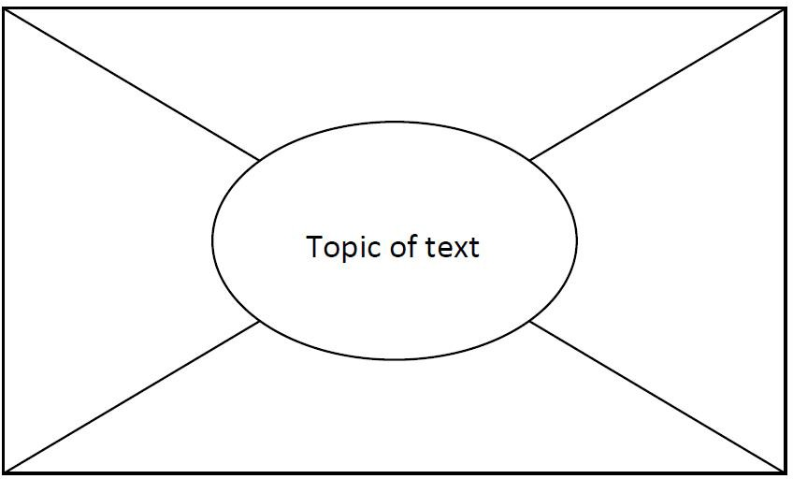
- Use a marker pen to divide an A3 sheet of paper into the format shown above.
- Divide the class into groups of 4 and give each group 1 ‘placemat’ (A3 sheet).
- Nominate a group leader. The group leader cuts sections of the placemat and gives each student in the group one of the outside sections.
- Give students (including the group leader) a selected text to read individually.
- The group leader writes the topic of the text in the centre section of the placemat.
- After a predetermined period (the length of time will depend on the length and complexity of the text), ask students to summarise the most important points they have read in the text in dot point form on their section of the placemat.
- Reassemble the placemat.
- In the centre of the placemat, the group leader lists common points identified by all four students.
- When this is complete, give each student a specific period of uninterrupted time (for example 3 minutes) to justify orally the inclusion of individual points not listed by others (those that are not listed in the centre of the placemat).
- The group leader presents a summary of findings to the whole class.

Plus/minus/interesting (PMI) charts
These graphic organisers are useful for looking at both sides of an argument, or seeing things from a different perspective. The PMI chart is a creative thinking strategy used in Edward De Bono’s CoRT Thinking Program.
PMI charts help students to:
- see both sides of an argument
- view things from a different point of view
- think broadly about an issue
- suspend judgement
- make informed decisions
- work as individuals, in pairs or as members of a group.
Procedure
The strategy can be used in a range of classroom activities, including analysing texts and exploring issues. Give students a format for recording their ideas such as the table below.

Plus | Minus | Interesting
Individually, in pairs or in small groups, students apply 3 questions to a statement or task provided by the teacher:
- What are the positive ideas about this?
- What are the negative ideas about this?
- What is interesting about this?
Within a specified time limit, students brainstorm their responses, having appointed a recorder and a reporter. At the end of the designated time, the reporter reports back on the group’s most original or creative ideas from each of the categories.
It is useful to model the activity first, using as a topic a statement such as: The lifestyle of all countries is enriched by immigrant cultures or a recently shared text or experience.
PMI-based activities can support the development of a range of skills including:
- understanding and interpreting the topic, question or statement
- using strategies to assist or facilitate brainstorming
- contributing to discussion
- comprehending and explaining opinions and information
- evaluating a range of viewpoints and distinguishing them from their own
- applying the process of PMI to a range of situations.

Affinity diagrams
These are useful for brainstorming issue-related ideas and organising them into topics. The affinity diagram is an interactive data collection method that allows groups of people to identify and sort large quantities of ideas within a short time frame.
Procedure
- Clearly define and write the question or topic for the session at the top of a flip chart.
- All class members individually and without discussion, write their ideas on a separate sticky note and place these in front of them.
- Class members randomly place ideas on the topic flip chart.
- Class members, working as a group, silently place ideas into like categories.
- Label the idea for each category by writing it on the flip chart.

Lotus diagrams
This graphic organiser is useful for issues and sub-topics. The lotus diagram takes its name from the lotus flower, whose petals open in an overlapping way.
You can photocopy the diagram on to A3 paper, use colour-coded sticky notes on a display wall or use an online graphic organiser, for example Miro.

Procedure
- The diagram comprises 9 boxes, each made up of 9 squares. The main topic goes into the centre square of the centre box.
- Around the centre square of the centre box are 8 numbered squares. Students write up to 8 ideas about the central topic in each of the numbered squares.
- Each of the 8 squares then has a box of its own, with the corresponding number in the centre square. Students place the information from the square labelled 1 in the centre box into the centre square of box 1, and so on.
- In the outer squares of each box, students add more ideas to expand on each numbered idea.

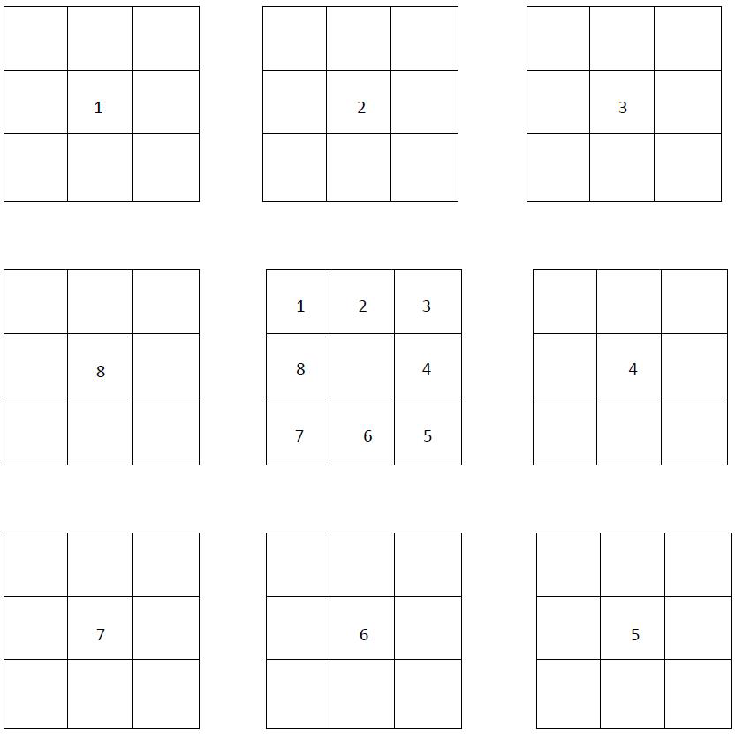

Class discussions
Use class discussions, in English or German (depending on context), to gather ideas and debate pros and cons related to a particular topic or question. The results of the discussions can then be organised and used to formulate responses to particular topics and questions in German.
Use material already published on the topic as a discussion starter – see the list below. Discussion could involve expanding ideas or identifying vocabulary, phrases and structures in German that will be useful in any response.
Useful resources include:
- articles in textbooks
- past HSC papers/questions
- a brainstormed list of possible prescribed issue-related topic questions
- news items and internet articles related to the prescribed issues.

Presenting a point of view
Encourage students to think about both sides of the argument for a given stimulus statement or question before deciding which stance they will take – for or against, or a more balanced approach.
Students should take the point of view they feel they are best equipped to argue.

Exercise 1
In order to practise presenting a point of view through classroom discussion, as described above, students formulate a response to a question in German and then present a different point of view on the same topic.

Exercise 2
Students brainstorm HSC-style questions in pairs, based on sub-topics from their mind-maps.
- Give each pair a different topic.
- Ask one student to speak for the affirmative and one for the negative.
- Each pair prepares a 1.5-2 minute speech, initially in English. This is conducted as a debate, where the other students act as adjudicators after hearing each of the arguments. The other students must justify their decision based on the logic of the argument. This exercise can be done in German when students become more confident.

Developing skills for monologues and short essays
Students should develop the skills necessary to prepare monologues and write short essays, as well as the ability to present and support a point of view or develop an argument in German. These skills are necessary for the speaking and writing sections of the HSC examination. However, note that short essay writing is not the only text type specified for productive use in the Extension course.

Exercise
Give students a question/stimulus statement. For example: Self-acceptance is harder than accepting others. What is your opinion? Give reasons for your answer.
- As a class, brainstorm ideas and record them on the board.
- Organise points/ideas into ‘for’ and ‘against’ the argument.
- As a class, decide which side of the argument is easier to present.
- Using the ideas gathered, ask individual students to write their own response.
- Share the sample responses as a class.
- Deconstruct the sample responses and come up with a skeleton structure common to all good responses – introduction, main body and conclusion.
- Go through the sample response structure below.
- Joint construction – students create a group response in German to the same question by fleshing out their argument using the sample structure. Working in pairs or groups of 3, students take an aspect of the structure and write a paragraph on it.
- When all students in the group have finished, put the paragraphs together to make a whole response. The opening statement, brief outline and concluding statements can be written at the same time. There may be some repetition through the argument, but students should gain confidence and the ability to put together a response before writing individual responses.
- Individual construction – students write their own response to the same question using ideas and skills gathered in this exercise.
Sample response structure
- Make an opening statement contextualising the question.
- State your argument/opinion on the question/stimulus – this may be for, or against, or a more balanced view.
- Provide point 1 related to your argument with 2 detailed examples.
- Provide point 2 related to your argument with 2 detailed examples.
- Draw your conclusion. Do not just reiterate the point that you made in your introduction. Provide some future advice/direction/suggestion related to your conclusion.

Developing knowledge of specialist vocabulary
Learning some commonly-used vocabulary and expressions related to the prescribed issues will help students respond to speaking and writing tasks.

Exercise 1
Cut up a mixture of specialist vocabulary or expressions – some in English and some in German – and put them into a hat. Students then take turns drawing one out and translating it into the other language.

Exercise 2
Have students make a domino game where they have to match the German vocabulary or expressions with the English equivalent. You can set up this activity as a group or individual activity (you will need several sets) and make it into a competition by timing students. This is useful as a revision activity.

Exercise 3
In order to develop students’ ability to express complex ideas in simple language rather than relying on a dictionary, put a list of difficult and hard to translate English words into a hat. Have students draw words one at a time and express them in German they are already familiar with. You may need to rephrase some words in English before the students express them in German.
This exercise is particularly relevant practice for the speaking exam where dictionaries are not permitted. However, even in writing tasks, students should try to avoid using unknown words from the dictionary as much as possible. Finding an alternative way of expressing an idea is an excellent skill to develop.

Recording responses
For the oral examination, students respond with a monologue on 1 question from a choice of 2. They are given 7 minutes to prepare their response and may make notes and refer to them during the examination. Students are expected to speak for approximately 3 minutes.
The monologues are recorded, therefore students need to become accustomed to having their speaking responses recorded. They also need to learn how to make effective use of the preparation time and be well-practised in planning and writing dot points for their monologues.

Exercise 1
Students take a question or stimulus statement out of a hat and give themselves 7 minutes preparation time. At the end of the 7 minutes they record their response. They should not stop the recording until they have completed their response. When finished, they play back the recording. This is an excellent exercise to help students become accustomed to forming ideas and developing a response within the time limit of the HSC oral examination.

Exercise 2
Have students record a monologue and bring it to school for peer assessment. This will help them to develop confidence in recording their voice and to become used to speaking clearly and at an even pace. Peer assessment is recommended for this exercise, as other students learn from their peers’ strengths and weaknesses.
The exercise should be used as a stimulus for a constructive discussion aimed at improving the performance of the whole class as well as that of the student whose performance is being assessed.
An explanation of the marking guidelines is necessary at this point so that students are made aware of the criteria examiners will apply.

Sample dot points from similar prescribed issues in other languages
Review the prescribed issues and suggested sub-topics for other languages from the NESA website. If they are similar to those set for German Extension, use them as a source of ideas for practice speaking and writing questions.
Be aware that the sub-topics listed for any one prescribed issue are many and varied. They are not limited to the dot points in the syllabus nor to those that have been examined in previous HSC examinations.

HSC Standards Packages
It is important that students are familiar with the marking rubric and guidelines for each section of the HSC examination. HSC Standards Packages (2002) contain the marking guidelines as well as a sample examination paper, syllabus, answers and sample student responses at band cut-off points. The Standards Packages are a useful teaching and learning tool and are available on each language-specific page of the NESA website.

Exercise 1
Select a number of sample answers from the Standards Package speaking and writing sections and have students award marks to them by applying the marking guidelines. Students can discuss the marking criteria and justify their marks from an examiner’s perspective.

Exercise 2
Students listen to and read a number of speaking and writing samples from across the range of bands. They can use the exemplar samples as a model for their own monologues and writing.

Proformas for planning monologues and essay writing
In both the oral examination and the written examination, students are required to present and support a point of view in German. Teachers will need to support their students in developing these skills. The following proformas have been designed to help students develop a structured approach to responding to monologue and short essay questions.
Depending on context, you may wish to introduce the proformas using English, moving to German as students develop more confidence in planning monologues and essay writing. You can also adapt the proformas to meet the needs of your students.
In order to gain confidence and competence in these skills, students should write as many monologues and short essays as possible. Monologues can be recorded for practice. Please note that short essays are not the only text type prescribed in the Stage 6 Extension syllabus. Students also need to be familiar with the text types for productive use listed in the Stage 6 Continuers syllabus.

Sample planning proforma 1
Task | Answer
Question
(Write in the question with the stimulus statement)
Opening statement
(Make an opening statement contextualising the question; state your argument/opinion on the question/stimulus – this may be for, or against, or a more balanced view)
Introductory statement
(State why you have this argument/opinion and introduce the points you are going to discuss to support your argument)
First point
(Include 2 detailed examples)
Second point
(Include 2 detailed examples)
Concluding statement
(Draw your conclusion, but do not just reiterate the point that you made in your introduction – provide some future advice/direction/suggestion related to your conclusion)

Sample planning proforma 2
Task | Answer
Question
(Write in the question with the stimulus statement)
Opening statement
(Make an opening statement contextualising the question; state your argument/opinion on the question/stimulus – this may be for, or against, or a more balanced view)
Introductory statement
(State why you have this argument/opinion and introduce the points you are going to discuss to support your argument)
First point
(Include 1 detailed example)
Second point
(Include 1 detailed example)
Third point
(Include 1 detailed example)
Concluding statement
(Draw your conclusion, but do not just reiterate the point that you made in your introduction – provide some future advice/direction/suggestion related to your conclusion)

Writing and speaking

Producing authentic texts
Learning authentic phrases and expressions is a good way to build up vocabulary. However these phrases and expressions must be used in context. Students should be encouraged to keep a list of words and expressions they can use to build an argument or use in a discussion. They should write down one or more sentences in which these expressions could be used. Some sample phrases and expressions are set out below and require students and teachers to build meaningful sentences.

Introductory remarks
- Einleitend möchte ich sagen, dass…
- Zu Anfang möchte ich…
- Zuerst möchte ich erklären, was ich unter…verstehe
- Es ist allgemein bekannt, dass…
- Beinahe täglich…
- Manche sagen…während andere…
- Es gibt Beispiele für…
- Es wird häufig gesagt, dass…
- Es wird oft behauptet, dass…

Presenting an opinion
- Ich bin überzeugt, dass…
- Meiner Meinung/Ansicht nach…
- Mir scheint es, dass…
- Von meinem Standpunkt aus…
- Ich meine, …
- Ich nehme (stark) an, dass…
- Ich kann mir (gut) vorstellen, dass…
- So wie ich die Sache sehe, …
- Ich bin mir sicher, dass…
- Heute werden wir immer wieder mit dem Problem konfrontiert…

Developing an argument:
- Vielleicht könnt ihr euch vorstellen…
- Wir müssen uns darüber klar werden, dass…
- Sowohl…als auch…
- Einerseits…anderseits…
- In diesem Zusammenhang…
- Entweder…oder…
- Was hier am interessantesten ist, …
- Es wird behauptet, dass…
- Es handelt sich um…
- Es steht zu vermuten, dass…
- Es steht fest, dass…
- Sicher ist es aber, dass…
- Es scheint wohl, dass…
- Bis zu einem gewissen Punkt…
- Im Großen und Ganzen…
- Das soll nicht heißen, dass…
- Es ist schwer einzusehen, …
- Das ist völlig grundlos.
- Im Vergleich mit/zu…
- Heutzutage…
- In unserer Zeit…
- In letzter Zeit…
- Es ist gar nicht lange her…
- Wie bereits erwähnt…
- Mir ist auch klar, dass…
- Außerdem finde ich…
- Aus diesem Grund/Aus diesen Gründen…
- Es ist zweifelhaft…
- im falschen/richtigen Licht sehen
- Im Allgemeinen…
- Klar, es gibt immer Vor- und Nachteile bei gewissen Dingen
- Vor allen Dingen…
- Auf der einen/anderen Seite sind…
- Wir müssen uns bemühen (+ Infinitiv mit zu)
- Es ist schwer zu sagen, ob…
- Wäre es wirklich so schlimm, wenn…?
- Das kann man nicht unterschätzen
- Die Folgen sind nicht positiv/leider negativ
- Man muss sich fragen, ob…
- Es gibt nicht den geringsten Zweifel, dass…
- Mir ist auch klar, dass…
- Tatsache ist, dass…
- Man kann mit Sicherheit sagen, dass…
- Das Problem besteht darin, dass…
- Es ist zweifelhaft, ob…
- Es ist unmöglich, dass…
- Auf gar keinen Fall…
- Zurück zu dem Thema, …

Drawing a conclusion
- Alles in allem…
- Jedenfalls…
- Zweifellos…
- Schließlich…
- Es ist offensichtlich…
- Zum Schluss möchte ich sagen…
- Abschließend möchte ich…
- Zusammenfassend kann man sagen, dass…

Glossary of key words for the HSC
The table below contains key words and their meanings in the context of HSC language courses. The table may help teachers and students understand how to respond to questions and tasks which use these terms.

Term | Description
Account | Account for, state reasons for, report on. Give an account of; narrate a series of events or transactions
Analyse | Identify components and the relationship between them; draw out and relate implications
Compare | Show how things are similar or different
Construct | Make, build; put together items or arguments
Contrast | Show how things are different or opposite
Critically analyse or evaluate | Add a degree or level of accuracy, depth, knowledge and understanding, logic, questioning, reflection and quality to analyse or evaluate
Define | State meaning and identify essential qualities
Demonstrate | Show by example
Describe | Provide characteristics and features
Discuss | Identify issues and provide points for and/or against
Evaluate | Make a judgement based on criteria; determine the value of
Explain | Relate cause and effect; make the relationships between things evident; say why and/or how
Explore | Examine or discuss (a subject, an option, an idea, a possibility)
Express | Put opinions, thoughts or views into words
Identify | Recognise and name
Interpret | Draw meaning from
Justify | Support an argument or conclusion
Outline | Sketch in general terms; indicate the main features of
Propose | Put forward (for example, a point of view, idea, argument, suggestion) for consideration or action
Recommend | Provide reasons in favour
Recount | Retell a series of events
Reflect | Think deeply or carefully about something
Summarise | Express, concisely, the relevant details
Adapted from A glossary of key words – NESA

Overview of syllabus text types
The text types listed in the Continuers Stage 6 syllabus are assumed knowledge for Extension students. Each Extension syllabus lists text types for production in the external examination. Below is an overview of some of the text types with which Extension students should be familiar. Refer to the Continuers and Extension syllabuses for complete lists.

Syllabus text type | Purpose | Structure | Language features
Article | - to sustain an argument  - to describe  - to inform, persuade, amuse or entertain | - titles or headings  - development of ideas or argument  - sequencing and linking of ideas  - statement of conclusion or advice | - range of tenses  - linking words  - language can be descriptive, factual, judgemental, emotive or persuasive, depending on context
Conversation | - to exchange information, opinions and experiences  - to maintain and sustain communication | - exchange of opening salutations  - question or statement followed by response  - 2-way interaction (sustained) | - question forms  - strategies to maintain conversation (fillers)  - interjections  - incomplete sentences  - language level depends on context and relationship between participants
Description | - to inform  - to entertain  - to describe  - to classify | - general statement or classification  - introduction and elaborated description of characteristic features | - specific details  - descriptive words  - range of tenses  - varied vocabulary  - comparative expressions  - literary devices (for example simile, imagery)
Diary or journal entry | - to record personal reflections or experiences | - chronological or stream of consciousness | - first person  - range of tenses  - sequencing (time) words  - abbreviated words or sentences  - subjective or informal language
Discussion | - to give different points of view  - to examine issues from more than one perspective  - to make recommendations based on evidence  - to sustain an argument | - presentation of main idea in introduction  - evidence or data to support main idea  - interaction between participants to clarify understandings  - conclusion or reiteration of main idea  - balanced | - linking words to sequence ideas logically  - qualifying words (for example, usually, probably)  - persuasive, descriptive, discursive or personal language, depending on context  - comparative expressions
Email or fax | - to use technology-based methods of communication  - to inform  - to seek a response | - conventions (for example subject line, email address)  - specific details without elaboration  - salutations and sign-offs | - abbreviated words and sentences  - simple language structures
Essay | - to discuss  - to analyse  - to assess  - to guide or teach | - orientation or introduction  - presentation of argument, judgement or evaluation  - conclusion or reiteration of main argument  - often has embedded description and/or explanation | - range of tenses  - formal, objective language  - linking words to sequence ideas and paragraphs  - qualifying words  - abstract nouns and concepts  - complex sentence structure  - evidence or examples included to support or enhance argument
Formal letter | - to communicate in writing in formal contexts  - to request information  - to lodge a complaint  - to express an opinion | - salutations and sign-offs  - letter conventions (for example layout, address, dates)  - logical and cohesive sequence of ideas | - use of full sentences and paragraphs  - more complex sentence structure  - objective language  - use of formulaic expressions
Informal letter | - to communicate in writing with acquaintances, friends, family  - to inform or amuse | - salutations and sign-offs  - letter conventions (for example layout, address, date) | - frequent colloquial language  - subjective language  - sentence structure often less complex than in formal letters
Interview | - to seek and convey information, views or opinions | - question and response format | - question words  - link words  - strategies to maintain communication
Invitation | - to invite in written form | - layout conventions  - statement of facts  - protocols | - abbreviated language  - formal or informal language  - expressions that tell when, where, with whom
Message or note | - to inform  - to request  - to instruct  - to remind | - general statement, description, procedure  - may be in point form | - succinct  - abbreviated words and sentences  - lack of descriptive detail  - use of colloquial language
Narrative account | - to entertain, amuse or instruct | - series of events presented in logical progression  - resolution or conclusion  - may contain a series of complications | - time words used to connect events  - use of action words  - descriptions of characters and settings
Personal profile | - to describe  - to outline personal details | - may be in point form (appropriate to situation)  - use of headings and subheadings | - factual  - descriptive language  - present tense  - simple phrases or sentences
Postcard | - to provide information  - to retell events | - salutations and sign-offs  - brief description or message | - descriptive language  - incomplete sentences  - abbreviated words  - colloquial expressions  - clichés  - personal impressions
Recount | - to retell what happened  - to tell a series of events | - introduction or orientation  - events sequenced in chronological order | - descriptive language  - past tense  - time words to connect events  - expressions that tell us when, where, with whom and how
Report | - to classify and/or describe  - to organise facts  - to draw conclusions | - general statement or classification  - description  - logical progression | - supporting evidence (for example statistics)  - factual  - usually present tense  - language specific to the topic  - objective language
Review | - to respond to a text or stimulus  - to summarise, analyse or interpret a text and to assess its value | - describe context of text or work  - describe the text or work  - judgement or evaluation of text or work | - descriptive language  - more complex structures with frequent abstract language  - words that express judgement  - possible comparisons  - expressions of aesthetic nature
Speech or talk (script) | - to communicate ideas, opinions and attitudes  - to entertain  - to persuade  - to welcome  - to thank | - introductory statement of purpose  - explanation or sequence of events or presentation of argument  - concluding remarks | - choice of expressions to engage the audience  - descriptive words  - a range of tenses  - subjective language  - consistent use of correct register depending on audience  - address audience throughout

Suggestions for teaching a novel

The elements of a novel
There are 5 essential literary elements that make up a novel – plot, setting, character, point of view and theme.

Plot
The plot is the sequence of events in a novel that the author has planned in a logical order. It starts with an exposition or introduction to the story where the characters, setting and background unfold. Essential to a plot is the conflict where there is a change in the character or a situation in the story, which propels the plot. The plot eventually climaxes in the turning point of the story leading into a falling action where the events and complications start to fall into place. The plot ends with the final events in the story culminating into a resolution or conclusion.

Setting
The setting is the location and time where the story unfolds.
To brainstorm the ideas of a setting, you can ask the following questions:
- Place – where is the geographical location of the story?
- Time – when is the action of the story taking place? Consider the historical period, year and time of day.
- Social conditions – does the story unfold in a particular local or cultural setting? What is the daily life of the character?
- Atmosphere or mood – what feeling is created in the novel? What are the ambiance and surroundings like?

Characters
Characters are the people and/or animals in the story. The protagonist is the main central character around whom major events unfold. The antagonist is the ‘enemy’ and is an opposition to the main character.
Characterisation is how the author reveals the personality of each character, and may also include stereotypes.
Characterisation may include:
- speech and mannerisms
- thoughts and feelings
- qualities
- physical appearance
- actions
- how the character interacts with others
- what other characters say and feel about them and how they react to them.
Characters can be:
- rounded – highly developed and affected by the events in the story; these type of characters are life-like as they grow or deteriorate by the conclusion of the story
- dynamic – they undergo a change and evolve during the story
- flat – 1 dimensional characters
- static – they remain the same throughout the whole story.

Point of view
The narrative point of view is the angle from which the story is told. In the genre of film, the point of view is where the camera would be taking the shot.
There are different narrative points of view in a novel. They are:
- first person – the narrator uses ‘I’, ‘me’ or ‘we’. The story is told by the protagonist or a character close to the protagonist. The readers experience the story through this character’s eyes.
- second person – the narrator address the reader and uses ‘you’. This makes the reader more active in the storytelling process.
- third person – the narrator sees all the action, using ‘she’, ‘he’ and/or ‘they’. The story is told from an outsider’s point of view and describes the action the way the narrator sees it.

Theme
The theme is the central message or the fundamental meaning of the story. It is the universal lesson or message explored in the novel. Various language techniques such as symbolism, metaphor, allusion, irony and hyperbole can be used to convey the theme.

Activities to develop global understanding of the novel
The following are sample activities that may assist in providing a global understanding of the novel. They can be used for the development of written and/or oral skills. Many are suitable for group work.
- Stopping the reading at a particular point in class and asking students to predict what will happen next or how the story will end.
- Discussing how the novel engages the reader. Is there conflict, humour, suspense, romance? Does it consistently hold your interest?
- Rewriting the ending of a chapter or extract.
- Writing a newspaper headline to capture the essence of the story.
- Writing a review of the novel.
- Creating a cloze test on a prescribed extract to show the effect of images, words or a particular word.
- Writing a report on an event from the story, for example who was there, what were they doing, why they were doing it, and so on.
- Organising a role-play based on a key passage. This may include improvised dramatisation and a paraphrase of the passage.
- Taking key sentences from the story out of order and rearranging them in sequence.
- Summarising the plot in a number of sentences, mixing them up then arranging them in sequence.
- Drawing diagrams to show the structure behind what has happened. For example, timelines and graphic summaries. Students could consider whether the action is chronological or involves flashbacks, and could create diagrams of the relationships between the characters.
- Considering what the characters know about each other. Are the characters stereotypes or individuals?
- Holding a press conference for a character (interviewing a character, adopting the persona of the character and recording the interview).
- Writing a tag line for each of the key characters – one line to sum them up.
- Writing the history of a character. What is known about this person? Why is he/she now in this situation?
- Imagining yourself as a character and writing a letter explaining your actions.
- Writing the diary entry of a character for one day.
- Analysing significant character relationships in the story. Groups could consider specific passages and show how language illuminates the changes in these relationships.
- Writing a letter to the editor, on behalf of a character, explaining what happened.
- Discussing the issues raised in the novel – how do the issues unfold?
- Discussing whether the novel offers new perspectives on the issues raised. Can it change perceptions? What does the reader learn?
- Linking issues raised in the novel to students’ personal experiences or other texts studied.
- Discussing how reading the novel has widened the students’ experiences.
- Considering parallels and conflicts, for example rich and poor.
- Considering the setting. Is it important? Why? Is it integral to the whole story? Could it take place elsewhere?
- Reflecting on the images and symbols that occur in the story. Do they occur in other stories by the same author? Are they typical of the author’s work? What do they add to the story?
- Considering the possibility of different levels of meaning in the story. Is it just a narrative, or an allegory? Is there parallel symbolism?
- Considering the role of irony, humour or figurative speech in the story.
- Considering the values expressed by the author. Can the personal voice of the author be heard coming through?
- Questioning whether the author is saying something new. Is it universal to the human condition?
- Analysing the vocabulary. Is there repetition? Is regional dialect used? Are colloquialisms used? What is the impact of these vocabulary choices?
- Considering how the level of language reflects the relationship between the characters.
- Noting aspects of the language used. Ideas could be pooled on the board, sifted, sorted and classified. Conclusions about the author’s purpose should emerge. All ideas could be summarised and recorded.
- Identifying a social comment in the story and discussing the methods used to make the comment. How does the language convey the author’s attitude?

Prescribed text
Novel – Tschick by Wolfgang Herrndorf
(Note: The page numbers used in this resource are from the 74. Auflage November 2018 published by Rowohlt Tachenbuch Verlag.)
There are 12 extracts prescribed for study.
- Extract 1 – pages 21-23 (Chapter 5)
From: “Ich hatte nie einen Spitznamen.”
To: “So kann man sich das vorstellen.”
- Extract 2 – pages 27-32 (Chapter 6)
From: “Ich mag meine Mutter.”
To: “…erfunden oder so.”
- Extract 3 – pages 41-47(Chapter 9)
From: “Ich konnte Tschick von Anfang an nicht leiden.”
To: “…oder irgendwas dazwischen.”
- Extract 4 – pages 50-52 (Chapter 10)
From: “Zwei Wochen danach kriegten wir die erste Arbeit in Mathe zurück.”
To: “…hätte man vielleicht sogar vergessen, dass er da war.”
- Extract 5 – pages 68-72 (Chapter 13)
From: “Geh rauf und sag deiner Mutter Bescheid.”
To: “…auf die Fliesen und schluchzte.”
- Extract 6 – pages 91-94 (Chapter 17)
From: “Das Haus war nicht schwer zu finden.”
To: “Erleichterung ist gar kein Ausdruck.”
- Extract 7 – pages 96-100 (Chapter 18)
From: “Wo willst du den überhaupt hin?”
To: “Und dann fing ich wirklich an, mir Gedanken zu machen.”
- Extract 8 – pages 120-125 (part of Chapter 23 to the end of Chapter 24)
From: “Die Sterne über uns wurden immer mehr.”
To: “…und ich Graf Koks.”
- Extract 9 – pages 129-133 (part of Chapter 25)
From: “Die Frau sah uns misstrauisch an…”
To: “…als hätt’s er’s ganz sicher gewusst.”
- Extract 10 – pages 173-176 (Chapter 34)
From: “Stattdessen ging es rauf auf den Berg.”
To: “…fertigmachen würde wie heute.”
- Extract 11 – pages 212-216 (Chapter 41)
From: “Ich muss dir ein Geheimnis verraten…”
To: “…soweit man bei dem Geklimper mitsingen konnte.”
- Extract 12 – pages 227-231 (Chapter 45)
- From: “Er begreift es nicht.”
- To: “…nicht mal Briefe bekam man da.”
The prescribed text is available at Abbey’s Bookshop, 131 York Street, Sydney NSW 2000 or 02 9264 3111.

Background to the novel

The author
Wolfgang Herrndorf was born in Hamburg on 12 June 1965. After high school he studied fine arts (painting) at the Akademie der Künste in Nürnberg. Upon graduation, he moved to Berlin in the early 1990s and worked as an illustrator for a number of German satirical magazines, for example Titanic. He also wrote for an internet forum (Wir höflichen Paparazzi) where contribution was by invitation only. His first published book In Plüschgewittern appeared in 2002. In 2004, he won the audience prize of the Ingeborg-Bachmann Competition for his text Diesseits des Van-Allen-Gürtels.
In March 2010, Wolfgang Herrndorf was diagnosed with brain cancer, when a malignant brain tumour was detected. Following this diagnosis, he started to write a blog detailing his personal state, his medical treatment including chemotherapies, radiation and surgeries, as well as his working projects (Arbeit und Struktur). It was also in 2010 that Tschick was first published to wide acclaim, winning the German Youth Literature Prize and several other prestigious fiction prizes in the following year. In 2012, his second novel Sand won the fiction prize at the Leipzig Book Fair. In July 2013, he was told that any further treatment would be futile after his cancer had returned. Wolfgang Herrndorf wrote his last blog entry on the day he took his own life on 26 August 2013.
Posthumously, his blog Arbeit und Struktur was published later in the year, followed in 2014 by Bilder einer großen Liebe which had remained unfinished.

Discussion question
An author’s experiences, personal life and background often influence their writing. How do you think Herrndorf’s own life experiences influenced the writing of Tschick?

Literary background to Tschick
Tschick is among a group of adolescent novels. In a 2011 interview with Frankfurter Allgemeine, Herrndorf stated that in 2004 he had reread the books that he had read in his youth, including:
- Lord of the Flies (William Golding, 1954)
- The Adventures of Tom Sawyer and The Adventures of Huckleberry Finn (Mark Twain, 1876 and 1884, respectively)
- The Narrative of Arthur Gordon Pym of Nuntucket (Edgar Allen Poe, 1884)
- Pik reist nach Amerika (Franz Werner Schmidt, 1927)
“I wanted to find out if these books were really as good as I remembered them, but also to see what kind of person I was aged 12”. He realised that all these books had 3 common features – early elimination of the adult attachment figure, usually a parent or parents, a long journey and travelling to or on water. He aimed to incorporate these elements in his adolescent novel, but “I only could think of something with a car. Two boys steal a car. The water was missing, but I had figured out the plot in a couple of minutes”. He set the story in the Berlin area and surrounding state of Brandenburg, in contemporary Germany.

The plot

Structure
The novel Tschick is divided into 49 chapters. The sequence of events can be divided into 5 major events. Chapters 1-5 and 45-49 function as a point of reference for the novel, which retrospectively narrates the story.
The first few chapters parachute the reader directly into a scene after the climax of the storyline. Maik, one of the protagonists and the narrator, is in a difficult situation at a police station. This prompts him to tell the reader how he ended up in this predicament.
Chapters 6-44 are also told in retrospective. The reader is introduced to Maik’s life before he meets Tschick. Thereafter Maik describes the friends’ adventures on the road. The story of their journey through the East German countryside is interspersed with self-contained subplots, while the journey itself is presented in chronological order.
The final chapters 45-49 are set after a serious accident which puts an abrupt end to the road trip. They tell us about Maik’s life, his hopes and aspirations for the future.
Chapters | Summary of event
Chapters 1-4 | Immediately after the accident
Chapters 5-9 | Maik’s life before Tschick
Chapters 9-42 | Tschick and the road trip
Chapters 43-44 | The accident
Chapters 45-49 | The court case and life after the trip

The setting
Tschick is set in the outskirts of Berlin and in the countryside of the Brandenburg.
Activity
- Even though the setting is not crucial to the storyline, students may get a better idea of the road trip by learning more about some of the place names and objects mentioned in the story, for example:
- Mietshäuser on the outskirts of Berlin
- the stolen car, a Lada – where and when did it get manufactured?
- the A10 autobahn
- Landstraße
- Feldweg (Kopfsteinpflaster), possibly with a Wegweiser (refer to p 106-107).
- Students recreate a basic map of the road trip. The following places are mentioned in chapter 20: Rahnsdorf/Bad Freienwalde/Burig/Spreenhagen are all in Brandenburg.
- Towards which neighbouring country are the friends heading? (refer to p 140 – street signs in a foreign language).
Image
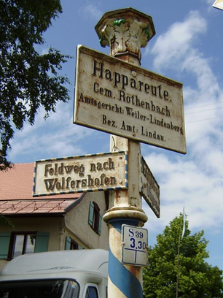 | Wegweiser
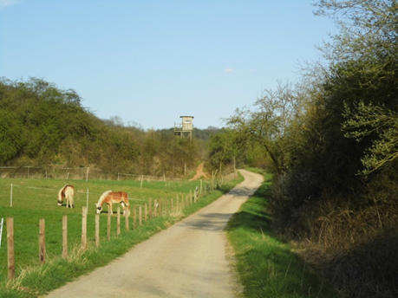 | Feldweg mit Hochsitz (Bildmitte)
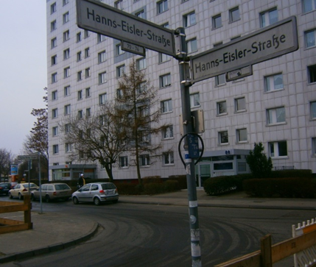 | Mietshäuser
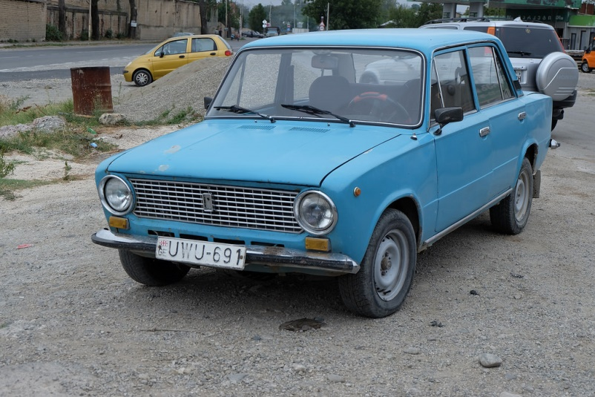 | Lada
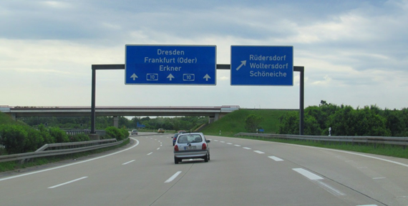 | Autobahn A10
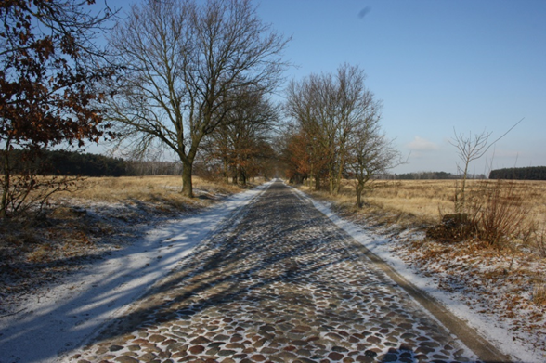 | Kopfsteinpflaster

The characters
There are two main characters in the story, Maik and Tschick. As vastly different characters, they have a great impact on one another.

Maik Klingenberg
Maik Klingenberg is the first-person narrator and the protagonist of the novel. He is a 14-year-old in Year 8 at a Gymnasium in Berlin. His mother is an alcoholic and his father owns a failing real estate firm, but they live in a big house with a swimming pool and servants. His parents’ relationship is in ruins and Maik spends much of his time alone. He has no friends and sees himself as a coward and a bore.

Tschick
Andrej Tschichatschoff, or ‘Tschick’, is the title character. He initiates the road trip through the east of Germany that turns Maik’s life upside-down. Tschick arrives in Maik’s class after the Easter holidays. In the 4 years since he migrated to Germany from Russia, he has moved from a Förderschule, a learning support school, to the Hauptschule, then Realschule and now to a Gymnasium. He is described as an Asi – a social outcast – and soon gains a degree of notoriety at school for turning up to classes drunk and not really caring what anyone thinks of him.
Activity
Students might consider the following questions as they read:
- Describe the relationship between Maik and Tschick.
- What changes in Maik do you notice as you read through the novel?
- What are some of the significant quotes that reveal how each of the characters thinks?
The table below depicts some of the differences between Maik and Tschick.
Maik | Tschick
Well-off, from a privileged family | An ‘Asi’ from a poor, disadvantaged family
Born in Germany | Born in Russia
Feels unremarkable | Looks physically different and ‘foreign’
Naïve and unexperienced | Street-smart
Cares about the opinions of his peers and teachers | Disengaged and disinterested, does not respect rules
Cautious | Adventurous, impulsive, inventive
Activity
In the table below, write as many similarities as you can between the two characters, Maik and Tschick.
Maik | Tschick

Maiks Mutter – Frau Klingenberg
Frau Klingenberg’s most marked characteristic is her alcohol addiction and Maik says she has been drinking alcohol for as long as he can remember. An amateur tennis player, she has often won club competitions even after having drunk a bottle of vodka. Although Frau Klingenberg cannot look after Maik well, Maik genuinely loves her and thinks there are worse things in life than having an alcoholic as a mum. Maik likes that she can be very funny. For example, she calls the rehab clinic she regularly visits the ‘Beautyfarm’. Frau Klingenberg also gives her son good advice in her lucid moments:
„Du kannst nicht viel von deiner Mutter lernen. Aber das kannst du von deiner Mutter lernen. Erstens kann man über alles reden. Und zweitens, was die Leute denken, ist scheißegal.“
At the end of the novel, she throws all their unnecessary luxury goods in the pool, without a thought about what the neighbours might think. She tells Maik the only important thing in life is if one is happy.
„Sie zeigte einmal rundum. ‚Das alles ist egal. Was nicht egal ist: Bist du glücklich damit? Das. Und nur das.‘“

Maiks Vater – Herr Klingenberg
Josef Klingenberg owns a real estate firm and, based on the Klingenberg’s comfortable lifestyle, he was clearly successful in business for a long time. However, he is now facing bankruptcy as a result of a failed real estate investment and bad speculation on the stock market.
Herr Klingenberg is having an affair with his attractive, young assistant Mona and when he goes on a ‘business trip’ with her, Maik has the opportunity for the road trip with Tschick. Herr Klingenberg does not have a very deep emotional bond with his son and he does not seem to think twice about leaving him alone at home for 2 weeks. He also does not shy away from violence and on the day before the trial hearing, he hits Maik repeatedly. Herr Klingenberg advises Maik to lie in court and lay the blame solely on Tschick.
„Ihr habt überhaupt keine Scheiße gebaut, du Vollidiot! Dein asiger Russenfreund hat Scheiße gebaut! Und du bist so dämlich, dich da reinziehen zu lassen.“
It is evident that Herr Klingenberg is only concerned about his reputation:
„Wie soll ich den Leuten Häuser verkaufen, wenn mein Sohn ihre Autos klaut?“

Isa Schmidt and Tatjana Cosic
There are 2 important girls in Maik’s life – Isa and Tatjana. Maik’s opinion of the girls changes throughout the course of the novel as his character develops.
Activity
Compare Isa and Tatjana and how Maik’s opinion of each girl changes over time. What are their main characteristics? What kind of relationship does Maik have with them? Refer to the text in your answer.

Isa | Tatjana
Main characteristics | Main characteristics
Relationship with Maik | Relationship with Maik
Quotes and references | Quotes and references

Style
Tschick’s storyline is conveyed through Maik’s interior monologue and numerous lively dialogues. Throughout much of the novel, the reader sees the world through Maik’s eyes and gets an insight into his emotions. The reader watches events unfold as Maik perceives them, with very little adult reflection. The result is realistic and often funny.
Maik relates his story in a calm, composed voice with the immediate and authentic effect of verbal story telling. The plot features 3 main protagonists, who all use expressions common to young people, colloquialisms and an abundance of coarse language. Maik’s interior monologue and the conversations he has with his friends are characterised by simple sentence structure, many of which are incomplete sentences or even one-word exclamations. For example, ‘Der ist Wahnsinn.’ ‘Aber voll.’ ‘Mann!’
The comedic effect of the novel is established through choice of words, situations and description of characters (‘Flusspferd’). Tschick’s and Maik’s sketchy knowledge of ambiguous concepts (‘die Walachei/Steppenwolf’) and their ensuing banter about these topics adds to the humour of the book. Wolfgang Herrndorf‘s transcription of spoken local dialect ‘Fahrafahra’ subtly draws the reader into the humour of the story.

Extract 1 – chapter 5

Vocabulary and expressions
Page 21
der Spitzname – nickname
nicht der ganz große Bringer – not all that great
endbescheuert – completely crazy
er ist abgedreht – he ‘lost it’/lost touch with the real world
Page 22
versumpfen – to go to seed/go to pot
antreiben – to push somebody
der Spatz – sparrow (very common bird)
der Hochsitz – elevated lookout for hunters
Tierbeobachtungen – animal observations
Buch führen – to keep a log
die Viecher – creatures (colloquial)
der Luchs – lynx
das Wildschwein – feral pig/wild boar
der Bekloppte – the loony/lunatic
Page 23
sie voll auf dem Schirm haben – to have her on the radar
badabim, badabong – blah, blah, blah
rumschwafeln – to waffle on
die Schuluntersuchung – medical check-up at school
sich etwas vorstellen – to imagine something
überflüssig – superfluous

Cultural references
Whilst wild boars are common, lynx and wolves do not exist in the country side around Berlin.
Mietshäuser are tall apartment blocks with rented accommodation.

Prescribed issues
Issue | Description
Youth issues | There is a transition from primary to secondary school which the characters experience and which is common to all adolescents as they try and navigate their way in their new setting and environment.
Relationships | Maik’s friendship with Paul is deteriorating. Maik does not find it easy to make friends – he feels like an outsider. Maik has a crush on Tatjana but finds it hard to approach her.
Identity | Maik is looking for his place among his peers. He thinks having a nickname would be a sign of acknowledgement and acceptance by his peers.

Comprehension questions
- Why is Maik worried about not having a nickname?
- Who is Paul?
- How has the relationship between Paul and Maik changed in recent years?
- Describe Maik’s visit to Paul’s new house.
- How do Paul and Maik differ in their attitude towards girls?
- What do we find out about Tatjana?

Extract 2 – chapter 6

Vocabulary and expressions
Page 27
dazusagen – to add
ein gutes Licht werfen auf – to reflect well/badly on something/somebody
der Crack – the expert/professional
Vereinsmeisterschaften – club championships
intus haben – to have it in your system (alcohol)
die Kronkorken – champagne cork
Page 28
geizig – stingy/mean with money
die Medenspiele – competitive tennis matches in Germany
eine wahnsinnig geistreiche Bemerkung – a terribly clever remark
runterkippen – to down a drink
die Entzugsklinik – detox clinic
egal – all the same
einleuchten – to be clear/make sense
Page 29
wie das ablief – how it worked
ein Wollknäul – ball of wool
das Gesprächsgeflecht – mesh/network of conversation
die Anstalt – clinic/institution – often used for psychiatric care
die Vorsätze – resolutions
sich Vorwürfe machen – to blame oneself

Page 30
die Sehnsüchte – desires
das Irre daran – the crazy think about it
der Alki – colloquial for alcoholic
der Vorschlag – proposition/suggestion
löchern – to drill with questions/pester
die Pappschachtel – cardboard box
Bescheid wissen – here: to fully understand
Page 31
verraten – to give away
im Nachhinein – in retrospect
Rettung – rescue/salvation
in Fahrt sein – to get going
verwechseln – to confuse/mistake somebody or something for something else
ausreichend – sufficient
durchgedreht – crazy with excitement
dabehalten – to keep back
angucken – to look at (colloquial)
der Erfolg – success
zuklappen – to close
anerkennendes Kopfschütteln – approving nod
endgeil – supercool
Page 32
das Pult – teacher’s desk
drüber nachdenken – to think about
peinlich – embarrassing
widerwärtig – repulsive
ekelerregend – disgusting
schamlos – shameless
der Schuldienst – school service
unterkommen – here: to come across
am Boden zerstört – devastated/shattered
der letzte Trottel – biggest idiot
ehrlich gesagt – honestly
kapieren – to get it/understand
erfinden – to make up

Cultural references
Dirk Nowitzki – famous German basketball player
Osiris – Egyptian lord of the underworld and judge of the dead

Prescribed issues
Issue | Description
Youth issues | Generation gap  There is a lack of communication and understanding between Maik and his teacher.
Relationships | Family  Despite all the chaos, Maik has an unusual but close relationship with his mother.
Identity | Self-awareness  Maik writes an essay about his mother and fails to recognise that some of the details he wrote were inappropriate. He does not recognise his dysfunctional family background and sees it as the norm.

Comprehension questions
- Describe Maik’s mum.
- How does Maik feel about his mother?
- What does Maik learn from his mother?
- Describe the activities at the ‘beauty farm’.
- How did the family react to some of mum’s story about the rehab?
- Why is Maik proud of his essay?

Extract 3 – chapter 9

Vocabulary and expressions
Page 41
etwas nicht leiden können – to not be able to stand something
Asi – short for ‘Asoziale(r)’, derogatory term for social outsider usually marginalised and socio-economically disadvantaged
schleppen – to drag
wie festgetackert – as if glued to their chairs (lit. stapled)
auseinandernehmen – to take apart
mucksmäuschenstill – quiet as a mouse
das Gerücht – rumour
zerkloppen – to smash
Page 42
heranschlurren – to shuffle to the front (colloquial)
Schlitzaugen – slanty eyes (derogative)
wie sich dann rausstellte – as it turned out
schmuddelig – grubby
die Narbe – scar
der Schädel – scull
kantig – angular
Page 43
kichern – to giggle
das war schon eine Leistung – that was quite a feat
nuscheln – to mumble
eine Marotte – a tick/habit
Stecknadel zu Boden fallen – pin drop to the ground
die Höflichkeit – politeness
Page 44
das Schweigen – silence
erobern – to conquer
vertreiben – to expel
sich rühren – to move
unterdrückt – supressed
Page 45
beharren – to insist
er ist ein großer Formulierer – he’s very eloquent (ironic)
er verdient unsere Rücksicht in gewissen Bereichen – he deserves our consideration in certain areas
die Förderschule – special needs school
umschulen – to transfer (schools)
Page 46
die Kunstpause – pause for effect
schnäuzen – to blow your nose
umhauen – to knock over
die Alkoholfahne – smell of alcohol on your breath (colloquial)
vermutlich – presumably/supposedly
offensichtlich – obvious
der Auftritt – performance/scene
Page 47
abgewrackt – worn out
sich beteiligen – to participate
aufgerufen warden – to be called on in class
weggetreten – mentally absent
zusammengesunken – slumped
hacke – drunk (slang)
lässig – laid-back/easy going
der Vollrausch – full intoxication/’off your face’ with alcohol
besoffen – drunk (slang)
was Phase war – what phase he was in
verteidigen – to defend
der Redebeitrag – oral contribution

Prescribed issues
Issue | Description
Youth issues | Selective school system, transition between schools.
Relationships | The teacher’s interaction with the students demonstrates the power-play between teacher and student. Tschick gains some status in class by refusing to respond to the teacher’s questions.
Identity | Exclusion and marginalisation  Tschick’s migrant background highlights the cultural and social differences he experiences at school.

Comprehension questions
- What kind of first impression does Tschick make on his fellow students and Herr Wagenbach?
- What do we learn about Tschick’s background?
- How is Herr Wagenbach portrayed in this chapter?
- How does Tschick settle into class in the following weeks?

Extract 4 – chapter 10

Vocabulary and expressions
Page 50
der Klassenspiegel – break down of marks showing how many students got As, Bs, Cs and so on
das Grauen – horror
endgestört – totally weird (slang)
der Jubelschrei – scream of joy
einstellen – to stop doing something
das Klicken eines Gewehrhahns – the trigger of a gun
Page 51
nachholen – to catch up
der Scherz – joke
in Klammern – in brackets
der Stoff – content
zusammenzucken – to flinch
jdm. etwas zutrauen – to think somebody is capable of doing something
die Sensibilität – sensitivity
vollkotzen – to puke all over
der Ruf – reputation
irritierend – confusing
‘alter Finne’ – exclamation of astonishment, such as ‘oh my god’ (slang)
durchdrehen – to go crazy/lose it
Page 52
nicht nachlassen – keep it up
hinter den Kulissen – behind the scenes
ermahnen – to admonish
etwas unternehmen – to do something about a problem
sein Schicksal – his lot/fate
asig – adjective of ‘Asi’ (see Extract 3)
die Lage beruhigte sich – the situation calmed down
mitkommen – to follow/keep up with lessons
einigermaßen – to a certain extent
der Aussetzer – lapse (colloquial)

Cultural references
PISA test – Program for International Student Assessment – worldwide study of students’ educational standards

Prescribed issues
Issue | Description
Youth issues | Education  There is a competitive environment at school, pressuring students to perform.

Comprehension questions
- How did the teacher introduce the maths results to the class?
- How did the teacher give Tschick his paper?
- Describe Tschick’s reaction.
- Why was he sent home?
- Describe Tschick’s performance at school in the following weeks.
- How do Tschick’s fellow students view him?

Extract 5 – chapter 13

Vocabulary and expressions
Page 68
schubsen – to push
sich auftanken – here: to fill up with alcohol (slang)
Page 69
das Dackelgesicht – puppy-dog face
versenken – to drown something/somebody
Dackelfurchen – furrowed brows
die Hiobsbotschaft – bad news
verkraften – to bear/handle something
feindlich – hostile
betrübt – sorrowfully
übertreiben – to exaggerate
die Schale – bowl
Page 70
scheinbesorgt – pretending to care
wuscheln – to ruffle somebody’s hair
Theater abziehen – to put on a show
begreifen – to understand
sich etwas einbilden – to flatter yourself
Page 71
schielen – to squint
das Unsichtbare – the invisible (object)
das Übliche – the usual
grausam – horrible
sich trauen – to dare to
haarscharf (vorbei) – very closely (past)
verantwortungsvoll – responsible
Page 72
die Landschaftsbetrachtung – contemplation of scenery
bedauern – to feel sorry for somebody
die Taille – waist
die Heimlichtuerei veranstalten – to put on pretences
schluchzen – to sob
die Fliesen – tiles

Prescribed issues
Issue | Description
Youth issues | Coming of age and a rite of passage for Maik as he starts to develop sexual emotions/longings.
Relationships | Family  Maik’s relationship with his dad – dysfunctional parental relationship and family breakdown.
Identity | Maik is trying to define his independence and grapples with the adolescent contradictory emotions of wanting to be cared for and at the same time doing his own thing.

Comprehension questions
- Why did Maik have to say goodbye to his mother?
- What did his father announce to Maik soon after?
- Why did Mona come to the house?
- How does Maik feel about Mona?
- What keywords are repeated in these two paragraphs? (pp 70-71 Was ich nicht lange begriff, Deshalb denke ich nicht mehr darüber nach?)
- What do these passages reveal about Maik’s emotional state?
- Why does Maik sob at the end of this extract?

Extract 6 – chapter 17

Vocabulary and expressions
Page 91
der Ortseingang – start of town
in sicherem Abstand – at a safe distance
rot geklinkert – red brick
der Fußraum – leg room/foot well
runterkurbeln – to wind down the window
Unmengen – heaps of people/crowds
aufgedonnert – dolled-up (slang)
die Parallelklasse – another class in the same year group
Page 92
irgendwer – someone
entsetzt – horrified
unbeteiligt – disinterested/detached
der Bürgersteig – footpath
der letzte Russenarsch – the biggest Russian jerk ever
die Beleidigung – insult
eine Ladung Gel – a ton of gel
Page 93
anstoßen (stieß mich an) – to nudge
rammen – to push against
das Armaturenbrett – dashboard
in den 2. Gang schalten – to change into second gear
runterschießen – to shoot down
die Sackgasse – dead-end road
erleichtert – relieved
das Steuer – steering wheel
beschleunigen – to accelerate
aus den Augenwinkeln – out of the corner of my eye
schmieren – here: to skid
Gas geben – to accelerate
der Ausdruck – expression

Cultural references
Die Havel is a river that runs through Berlin and Brandenburg.
‘Gute Zeiten, schlechte Zeiten’ is a long-running German TV soap opera.
KiK is a German discount store.

Prescribed issues
Issue | Description
Youth issues | Maik struggles for acceptance among his peer group.
Relationships | Maik and Tschick are growing closer and becoming friends through common experiences and mutual support. Tatjana notices Maik.
Identity | Maik gains confidence.

Comprehension questions
- How did Tschick and Maik find the house where the party takes place?
- Describe the party and the guests.
- How do Tschick and Maik feel about not having been invited?
- How is Maik’s insecurity portrayed in this passage?
- Describe Tschick’s changed appearance.
- What is the significance of the drawing?
- How does Maik give Tatjana the present?

Extract 7 – chapter 18

Vocabulary and expressions
Page 97
die Verwandtschaft – relatives
Dingenskirchen/Jottwehdeh/Pampa/am Arsch der Welt – out in the sticks (similar to ‘woopwoop’)
Page 98
Wolgadeutsche, Volksdeutsche, Banater Schwaben – ethnic Germans living in the former Eastern block
Page 99
die Kippe (Kippah) – yarmulke which is a skullcap worn by Jewish men
abbügeln – to brush off (colloquial)
die Überzeugungskraft – power of persuasion
die Gesten – gestures
die Wirkung – effect
gerührt – touched
Page 100
sich im Nebel auflösen – to dissolve
das heulende Elend – wailing misery
der Rechner – computer
sich beschweren – to complain
rangehen – to answer the phone
die Ausrede – excuse

Cultural references
Die Walachei refers to the Wallachia region in Romania. It is also common expression for ‘somewhere out there in the middle of nowhere’.
Berber is an ethnic group from North Africa. It is also a type of carpet.

Prescribed issues
Issue | Description
Youth issues | There is a culture of underage drinking at school.
Relationships | Maik and Tschick forge a closer bond.
Identity | Tschick tries to explain his family’s cultural background. Tschick searches for his roots.

Comprehension questions
- Who does Tschick want to visit?
- Explain Maik’s and Tschick’s different understandings of the term ‘in der Walachei’.
- What do we find out about Tschick’s family background?
- Why does Maik become sentimental about a fly?
- Describe Maik’s emotional state after Tschick leaves.

Extract 8 – chapters 24-25

Vocabulary and expressions
Page 120
wegsacken – to drop away/disappear
die Gehirnkäfer – brain beetles
die Riesenschlacht – giant battle
die Vorherrschaft – supremacy
das Weltall – space/universe
Page 121
unwahrscheinlich – improbable/incredible
ausrechnen – to calculate
mich reißt’s voll – it blows my mind
klauen – to nick/steal (colloquial)
sich ekeln vor – to be repulsed by
Page 123
unbegreifliche Unendlichkeit – inconceivable endlessness
die Grillen – cicadas
zirpen – to chirp
Page 123
die Wiese – meadow
keine Spur – no trace
die Aussichtsplatform – lookout
das Sägewerk – saw mill
hochstapfen – to trudge up (the hill)
beratschlagen – to discuss
währenddessen – meanwhile
sich breitmachen – to make oneself at home
merkwürdig – strange/weird
das Behindertenheim – home for the disabled
Page 124
im Gegenteil – on the contrary
der Betreuer – supervisor/coordinator
der Vorgesetzte – superior/boss
das Radl – southern German for Fahrrad
der Adel – aristocracy/nobility
das Gut – country estate
örtlich – local
die Automobilisten – ‘motorists’ (old-fashioned)
Proleten auf Raketen – ‘hoons on rockets’
bemerkenswert – remarkable
Mann, war die drauf! – Man, was she weird!
eine Ladung Koks war ausgekippt worden – a load of cocaine had been tipped out
winken – to wave
der Deckname – code name
der Graf – count

Cultural references
Graf Koks is a common expression for a posh, arrogant person, pretending to be of aristocratic background.

Prescribed issues
Issue | Description
Youth issues | References to pop culture and science fiction movies are made.
Relationships | Maik and Tschick discover a common perspective on life and have a philosophical conversation.
Identity | Maik and Tschick meet a group of young aristocrats. They notice a stark contrast between themselves and the young cyclists. The cyclists display self-assuredness and confidence in their interactions.

Comprehension questions
- Where are Maik and Tschick?
- Why have they decided to stay there?
- Why do they talk about the science fiction movies?
- What leads Tschick to say ‘Mich reißt’s gerade voll’?
- Why is Maik concerned when he wakes up in the morning?
- What language devices does the author use to characterise the group of cyclist? Give examples.
- What does the exchange between the girl and Tschick reveal about Tschick’s resourcefulness? (p 124)
- What is the significance of Maik and Tschick giving each other a code name? Compare with Extract 1.

Extract 9 – chapter 25

Vocabulary and expressions
Page 129
misstrauisch – suspicious
sich erkundigen – to enquire/ask
spähen – to peer (up and down)
weit und breit – far and wide
der Platten – flat tyre
die Haltung – posture
(her)rum reißen – to jerk around
das Rollerfahrrad – scooter
schleudern – to skid
sich vorbeugen – to bend forward
einen Kracher loslassen – to come up with a brilliant line (colloquial)
das zog mir endgültig den Stecker – that finally blew my mind
Deutsch für Aussiedler – German lessons for ethnic German migrants
mit den Armen wedeln – to wag your arms
Page 130
mir war nicht wohl dabei – I did not feel good about it
mit dem Finger an die Stirn tippen – common German hand gesture, indicates that someone is weird/crazy
Reis mit Pampe – rice with mush
die Bröckchen – lumps
die Suppenkelle – ladle
wie auf Kommando – as if by command
schiefgelegt – tilted
was uns beschert wurde – what has been bestowed upon us
bonfortionös – scrumptious
Page 131
ergänzen – to add
sich räuspern – to clear one’s throat
das Tablett – tray
etwas Schaumiges – something frothy
sich täuschen – to be mistaken
anrühren – to touch
bedenken (bedachte) – to grant
den Kopf wiegen – to sway your head
Ich Depp! – I’m such an idiot!/Silly me! (Southern German)
Page 132
das Forschungsschiff – ship for explorers or researchers
Pfingsten – Pentecost holiday in May
verzichten – to go without
runterleiern – to rattle something off
die Spielleitung an sich reißen – to take over the control of the game
der Stundenzeiger – hour hand
der Winkel – angle
zweifelnd – doubtfully

Prescribed issues
Issue | Description
Relationships | Maik and Tschick experience a more conventional family life. They are cared for and safe, nourished both emotionally and physically.

Comprehension questions
- Why do Maik and Tschick talk to Friedemann? (see start of chapter)
- Why does Maik say that their bike has a flat tyre?
- Describe Friedemann’s family.
- How does Tschick adapt to the situation at hand?
- What are they having for lunch and how do they feel about it?
- Why is Maik unwilling to recount the story about the dishing out of the dessert? (p 131)
- How does Tschick turn the situation around to their own benefit? (p 133)

Extract 10 – chapter 34

Vocabulary and expressions
Page 173
kurven – to go for a casual ride (colloquial)
die Abzweigung – turnoff
schlängeln – to wind/meander
kriechen – to crawl
die Passhöhe – top of the pass
der Gipfel – summit/peak
erwischen – here: to end up on
das Gelände – terrain/open country
die Schnitzereien – carvings
Page 174
der Geruch – smell/scent
hochwehen – to drift up/waft up
das Tal – valley
verwüstet – destroyed/war-ravaged
die Kutsche – horse-drawn carriage
ritzen – to slit/carve/prick
Page 175
der Witzbold – prankster
schwören – to pledge/promise
Page 176
mickrige Greise – puny old men and women
im Innern – at heart

Prescribed issues
Issue | Description
Relationships | Maik, Tschick and Isa are now friends and carving their initials together in the wood which symbolises their sense of belonging.
Identity | Maik, Tschick and Isa realise that being at the summit of the mountain marks a milestone in their journey and their lives. It leads them to contemplate what the future holds for them and what they will be like in 50 years’ time.

Comprehension questions
- Who is Isa? (refer to previous chapters)
- Why do they decide to go up the mountain?
- Describe the journey up the mountain.
- What makes Maik contemplate ‘life and death’?
- What does Tschick do?
- Why does the mood amongst the friends become a bit sombre?
- What do they pledge to one another?

Extract 11 – chapter 41

Vocabulary and expressions
Page 212
ein Geheimnis verraten – to tell a secret
der Feigling – coward
der Langweiler – bore
Page 213
nicht alle Tassen im Schrank haben – to have a few screws loose/not right in the head (colloquial)
wie Luft behandeln – to ignore
weichgespült – weakened/softened up
der Penner – bum/jerk
die Eigenschaft – characteristic
eine taube Nuss – nothing between her ears/numbskull
beurteilen – to gauge
als hätte man ihm eine Bleikugel im Hals versenkt – as though someone had shot him in the neck
Page 214
sich keine Gedanken machen – to not worry about something
schwul – gay/homosexual
die Windschutzscheibe – windscreen
eine Proberunde – test drive
auf die Kupplung treten – to step on the clutch
Page 215
die Standspur – emergency lane/shoulder of the road
eine Lücke im Verkehr – a gap in the traffic
klitschnass – soaking wet
meine Aufregung ließ nach – my agitation subsided
vorbeirasen – to speed by
erschrecken – to be startled/scared
bremsen – to brake
das Isolierband – gaffer tape
klimpern – to tinkle in the piano
eingedetscht – dented
die Müllkippe – rubbish dump
die Unzerstörbarkeit – indestructibility
die Behörde – the authorities
Page 216
das physikalische Gesetz – the laws of physics

Cultural references
Ballade pour Adeline is a track from the Richard Clayderman cassette that was in the Lada when Maik and Tschick stole it. Richard Clayderman is a German pianist who was popular in the 1970s and 1980s.

Prescribed issues
Issue | Description
Youth issues | Sexuality  Tschick comes out to Maik. Maik gains confidence through Tschick’s assessment of Tatjana and Isa.
Relationships | Maik and Tschick now trust each other enough to open up and reveal their inner-most secrets. They both feel like outsiders but find true acceptance and support in each other.

Comprehension questions
- Why does Maik feel like a coward at this moment? Why has he been put in this position in the first place?
- Outline the reasons why Tschick thinks that Maik’s self-perception is inaccurate.
- What does Tschick reveal about himself?
- How does Maik react to this revelation?
- How does Maik respond to the challenge of driving on the autobahn?
- Sum up the feeling in the car at the end of the extract.

Extract 12 – chapter 45

Vocabulary and expressions
Page 227
sich vorbeugen – to lean forward
sag gefälligst was – say something for God’s sake.
jdm. eine scheuern – to slap someone hard (colloquial)
Page 228
zittern – to shake
sich die Arme verschränken – to cross one’s arms
die Zerknirschung – remorse/contrition
abkürzen – to cut short
dämlich – stupid/dimwitted
den Rückspiegel verstellen – to adjust the rear vision mirror
die Fresse – gob/mouth (slang)
Page 229
sich aufrappeln – to pick oneself up
mit einem blauen Augen davonkommen – to be let off with a slap on the wrist (colloquial)
ein Auto kurzschließen – to hotwire a car
das Jugendgericht – juvenile court
das Verfahren einstellen – to drop a (court) case
als Zeuge aussagen – to make a witness statement
verlass dich drauf – count on it
der Ladendiebstahl – shoplifting
das Schwarzfahren – fare evasion
der Betrug – fraud
die Hehlerei – handling stolen goods
die Sippschaft – clan
hingehören – to belong
das Heim – youth institution/home
abschieben – to deport
die Schuld geben – to blame
die Jugendgerichtshilfe – social worker (attached to the juvenile court)
Page 230
und allem Pipapo – the whole shebang
linsen – to peer
Capisce? – Do you understand? (Italian)
schniefen – to snuffle/sniff
der Kescher – scoop/net
der Rollo (Rollladen) – roller blind
rumzuppeln – to fiddle around
schaukeln – to flap
der Inder kriegte auch noch was ab – the Indian guy was also getting a serve (colloquial)
welk – withered
Page 231
die Dämmerung – dusk

Prescribed issues
Issue | Description
Youth issues | Juvenile justice system  Maik is concerned about Tschick’s wellbeing as he is in a home for adolescents and is not allowed to have any contact with the outside world.
Relationships | Maik’s dysfunctional family and his divided loyalties continue to be an issue.  He also reasserts his friendship with Tschick.
Identity | Maik’s confidence and sense of self have grown as a result of the trip and he is now prepared to stand up to his father.  Maik shows a strong moral compass – he is honest and has a clear sense of justice.

Comprehension questions
- What does Maik’s father want him to do?
- What opinions does Herr Klingenberg express about Tschick? Give examples.
- Why does Maik resist his father’s advice?
- Why does Maik spend the rest of the day contemplating?
- How does this scene reflect on Maik’s relationship with his parents?

Additional activities

Prescribed issues
The following questions below may be used to brainstorm and or discuss the prescribed issues with your students.

Youth issues
- Many people say that your school days are the best time of your life? Do you agree? Why/why not?
- Does peer group pressure exist?
- Many people still believe that appearances are important. How important is someone’s appearance to you?
- Can you describe a situation where you judged someone by his or her appearance? What made you make these judgements?
- Sometimes people complain about stereotypes made about them. Have you ever made a stereotypical comment about anyone? Be honest!
- What kinds of discrimination do you see in the world around you?
- What issues are most important to you and your friends?
- Can you give examples of young people who are trying to change the world?
- What are your ambitions for the future? Are these ambitions realistic? What do you need to do to fulfil them?

Relationships
- Who are the most important people in your life? Why? How do you feel when you are with them?
- What does family mean to you?
- How do you get along with the other members of your family?
- Do you agree with everything your parents do or say?
- Who do you turn to when you have a problem? Why?
- Who are your friends? How did you meet? Why are you friends?
- What does friendship mean to you?
- Do you find it easy to make friends?
- Do you get along with everyone on your class/year level?
- Have you ever felt alone or excluded?
- Have you ever been in love or had a crush on someone? What did you do to get their attention?

Identity
- Do you have a nickname? Do you like it? Who gave it to you? Who calls you by your nickname? What does your nickname say about you?
- What are some memories that you have from your childhood? Is there a reason these memories are significant?
- What are some factors that have helped shape your personality?
- Consider people who have had an impact on your life. Choose one of these people and explain how they have influenced you.
- Are there any areas in your life that have undergone change recently? What are they? How did you feel when these changes happened?
- How has your opinion or perception of your life changed over time?
- Who makes the final decision about key aspects of your life? What decisions would you make by yourself? What factors do you consider when making a big decision? Do you ask for other people’s opinions when making your own decisions? How important is making decisions for yourself?
- Have you ever been on a trip without your parents? Or a trip that changed the way you see things? Would you like to? What would you do?
- Were you born overseas? If not, talk to someone who was.
  - How did you feel about the decision to come to Australia?
  - When you came to Australia, what were some of the difficulties you faced?
  - What did you do to try to overcome these difficulties?
  - How is your life here different to your life overseas?

Scaffold for an evaluative response
To get a better understanding of the prescribed issues, you should write your thoughts and ideas as they form.
Before reading each extract, write down what you know about the prescribed issues. This might be keywords, concepts related to the themes or reflect a wider understanding of the text.
After reading the extract, compare what you initially thought before reading to what you know after reading the extract.

Questions | Response
Before – what do I know about the prescribed issue?
Before – key words, concept related to themes
After – what I know about the prescribed issue after reading the extract
After – new ideas, vocabulary, further questions to investigate

Sample analysis of text question

Extract 4

Part B-style question
Und dann hat Herr Schürmann das Heft zugeklappt und mich angesehen.
Write a different ending to this chapter.

Sample speaking and writing task
Kommunikation zwischen Menschen kann oft sehr schwer sein, besonders wenn es um sensible Themen geht. Was meinen Sie dazu?
Communication between people can often be very difficult, especially when sensitive issues are at stake. What do you think?

Related texts
The following related texts are suggestions only and can be used to supplement the study of the prescribed text.

Youth issues

Article – Mobbing – Außenseiter in der Klasse
Als Außenseiter bezeichnet man jemanden, der in einer Gruppe nicht akzeptiert und integriert ist. Ein Außenseiter verhält sich nicht so, wie die Gruppe es als angemessen ansieht und erwartet. Ein Kennzeichen von Außenseitern ist, dass sie sich oft in einem oder mehreren Merkmalen von den übrigen Gruppenmitgliedern unterscheiden. Das kann an einer anderen Hautfarbe, einer Behinderung, einer zu hohen oder zu niedrigen Intelligenz liegen, aber auch an Verhaltensauffälligkeiten wie Schüchternheit oder Aggressivität.
In der Klassengemeinschaft macht sich ein Jugendlicher möglicherweise zum Außenseiter, wenn er kein Interesse an der Markenkleidung hat, die zurzeit im Trend ist. Auch die Art, wie man seine Freizeit verbringt, kann eine Schülerin/einen Schüler ausgrenzen. Gehören zum Beispiel Sport und Computerspiele zu den beliebtesten Freizeitbeschäftigungen, so hat eine Leseratte schlechte Karten.
Im Zusammenhang mit den bestimmten Merkmalen, die Außenseiter charakterisieren, kann man zwei Haupttypen von Außenseitern unterscheiden:
die aggressiv-antisozialen Außenseiter (zum Beispiel: Klassenclown oder Raufbold)
die introvertiert-schüchternen Außenseiter (zum Beispiel Leistungsschwache oder Hochbegabte, die häufig als Streber angesehen werden)
Das Gefühl, ein Außenseiter zu sein, führt häufig zu Problemen mit dem Selbstwertgefühl, die natürlich noch schlimmer werden, wenn der Schüler zusätzlich den Hänseleien seiner Klassenkameraden ausgesetzt ist und von ihnen gedemütigt wird. Mobbing konzentriert sich in der Schule auf Mitschüler, die nicht der ‚Norm‘ entsprechen und ausgegrenzt werden.
Außenseiter schämen sich oft für ihre Rolle, weil sie glauben, dass etwas mit ihnen nicht in Ordnung sei. Sie versuchen ihre problematische Situation zu verdecken, so dass die Lehrer nicht darauf aufmerksam werden und das Elternhaus nicht informieren können.
Depressive Zustände können die Folgen sein, in Extremfällen sogar Suizidgefahr. Eine Langzeitstudie (Universität Stockholm), die die Entwicklung von über 14000 Schülern des Jahrgangs 1953 von 1966 bis zum Jahre 2003 verfolgte, ergab, dass sozial isolierte Jugendliche eine erhöhte Anfälligkeit an körperlichen und seelischen Krankheiten sowie Verhaltensauffälligkeiten im späteren Leben zeigen.

Vocabulary
angemessen – reasonable
die Merkmalen – characteristics
die Behinderung – disability
die Verhaltensauffälligkeiten – behavioural issues
die Markenkleidung – brand-name clothing
ausgrenzen – to ostracise
die Leseratte – bookworm
schlechte Karten haben – to be dealt a bad hand
der Raufbold – ruffian/roughneck
die Leistungsschwache – low achievers
die Hochbegabte – gifted people
der Streber – swot (someone who studies a lot)
das Selbstwertgefühl – self-worth
die Hänselei – teasing
ausgesetzt sein – to be exposed to
gedemütigt – humiliated
entsprechen – to correspond
verdecken – to cover up
auf etw. aufmerksam werden – to become aware of something
die Entwicklung – development
verfolgen – to track/follow
die Anfälligkeit – predisposition

Activity
- Richtig oder falsch? Kreuze an.
Außenseiter in der Klasse – Arbeitsblatt | richtig | falsch
Ein Außenseiter ist in einer Gruppe nicht akzeptiert und integriert.
Ein Außenseiter unterscheidet sich immer durch mehrere Merkmale von der Gruppe.
Schüler, die kein Interesse an den Freizeitgestaltungen der Mitschüler haben, können sich dadurch ausgrenzen.
Es gibt Außenseiter, die sich aggressiv verhalten und solche, die introvertiert sind.
Schüler mit einer geringen Intelligenz gehören zwangsläufig zu den Außenseitern.
- Erkläre, warum sehr gute Schüler Außenseiter werden können.
- Welche Schüler sind nicht in Gefahr Außenseiter zu werden? Warum?
- Welche Gedanken und Gefühle könnte ein Außenseiter haben. Schreibe deine Ideen in die Gedankenblase in der ‘ich’-form:

Identity
Video – Ich habe zu Hause kein Deutsch gesprochen – zum Glück!
(video of a bilingual student speaking about growing up in Germany; with German subtitles)
Activity
- Warum denken manche Menschen, dass es ein Problem ist, wenn Kinder zu Hause ihre Muttersprache und nicht Deutsch sprechen?
- Warum glaubt Selma, dass es besser ist, wenn die Eltern mit den Kindern in ihrer Muttersprache reden?
- Warum sind Selmas Eltern nach Deutschland gekommen?
- Wie haben sie Deutsch gelernt?
- Wie gut sprechen ihre Eltern – Selmas Meinung nach – heute Deutsch?
- Warum war es besser, dass ihre Eltern mit ihr immer Bosnisch gesprochen haben?
- Wie haben die Eltern Selma beim Deutschlernen unterstützt?
- Warum glaubt Selma, dass es sogar ein Vorteil ist, bilingual aufzuwachsen?
- Unter welchen Umständen kann es Nachteile bringen, bilingual aufzuwachsen?
- In welchen Situationen kann es problematisch sein, wenn Eltern gar kein oder nur sehr schlecht Deutsch sprechen?
- Warum glaubt Selma, dass es bei der öffentlichen Diskussion um Mehrsprachigkeit um etwas ganz anderes geht? Worum geht es wirklich?
Article – Zwischen Moschee und Minirock
(growing up between two cultures)
Activity
- Why was Melda Akbas on so many TV talk shows?
- Describe Melda's family background.
- Outline some of the conflicting issues in Melda's life (‘Melda fühlt sich hin- und hergerissen’).
- In which areas had Melda been involved before her Abitur?
- How did her family react to the publication of her book?
- What were Melda's plans for the years after her Abitur?
- Imagine you are Melda. It has been some time since the Spiegel article was published. Write a blog for the online magazine of your former school in which you describe your experiences of the last few years (about 250 words in German).
- Write an email to Melda describing your own experience of growing up in multicultural Australia (or any other place) and asking Melda how her life and career have developed over the last few years (about 250 words in German).

Relationships

Article – Freundschaft
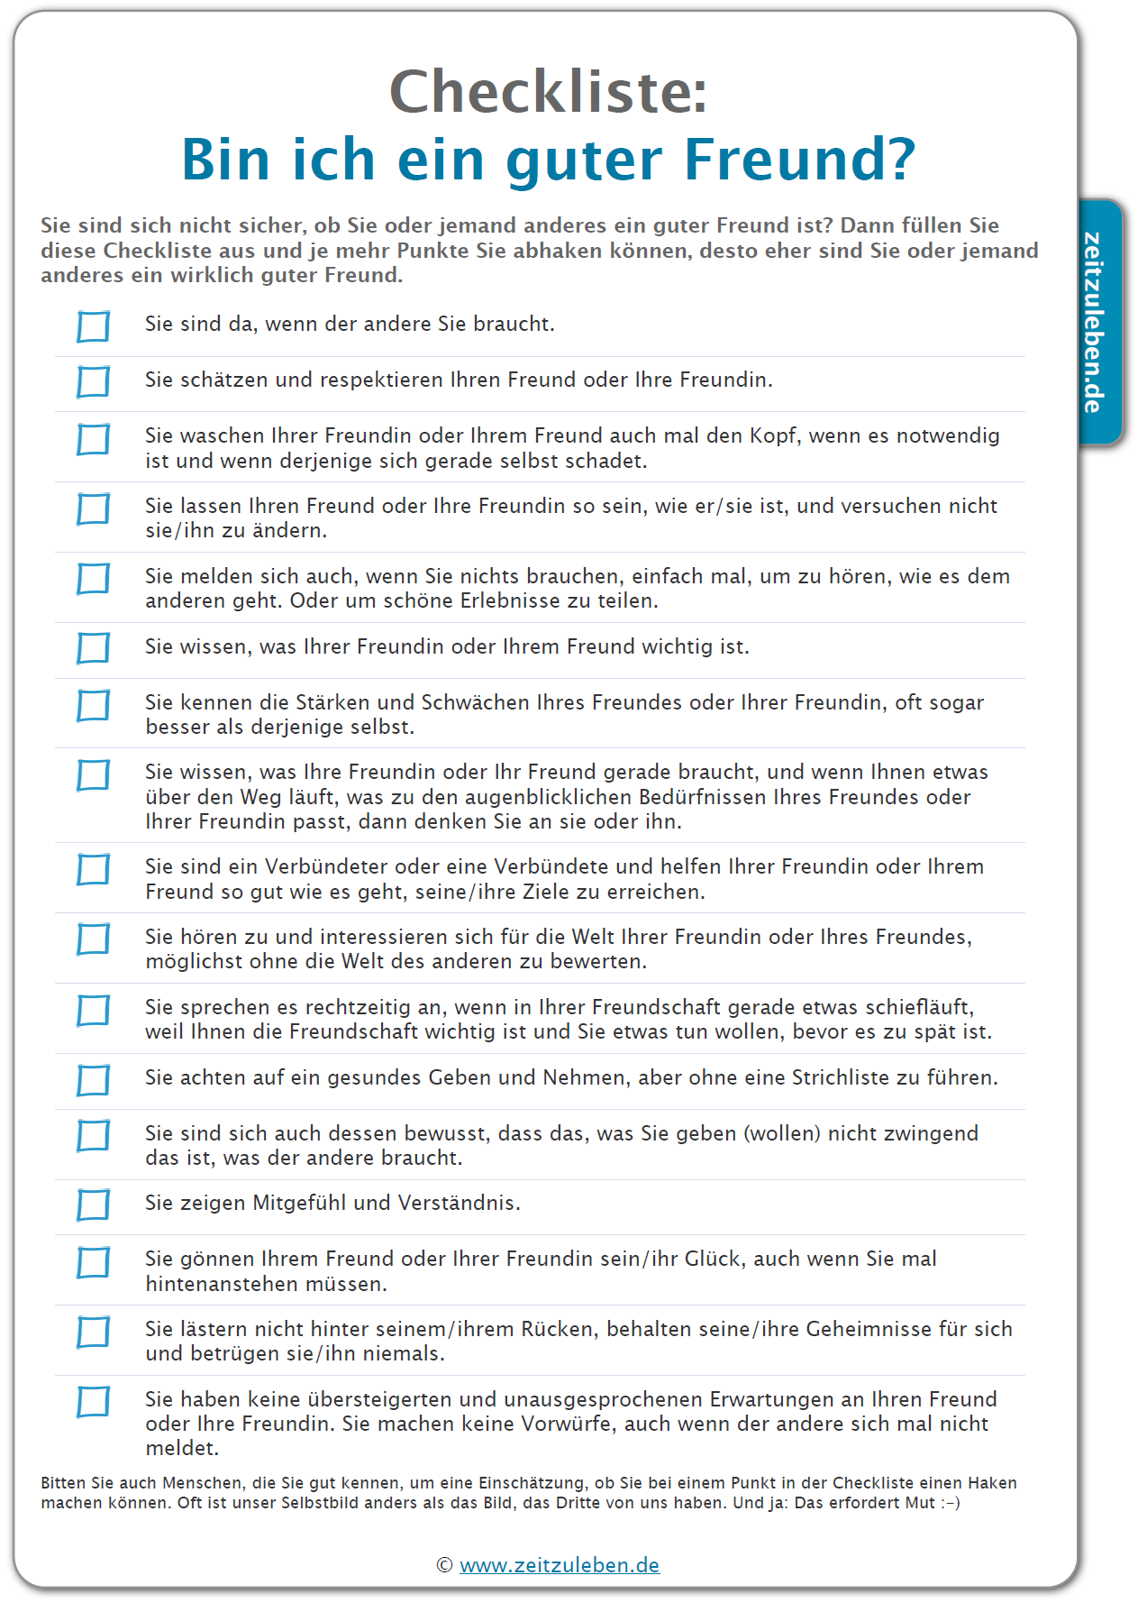

Vocabulary and expressions
abhaken | to tick off
schätzen | to value
jdm. den Kopf waschen | to give somebody a piece of one’s mind
sich selbst schaden | to do damage to oneself
sich melden | to get in touch
die Stärke | strength
die Schwäche | weakness
etw. über den Weg laufen | to run into something/come across something by chance
jdm. über den Weg laufen | to run into somebody
das Bedürfnis, -se | need(s)
augenblicklich | momentary
der Augenblick | moment
Verbündete(r) | ally
passen zu | to fit/suit
bewerten | to judge/assess
etwas ansprechen | to address something
schieflaufen | to go wrong/askew
rechtzeitig | in time
achten auf | to watch out for
eine Strichliste führen | to keep a tally sheet
zwingend | here: necessarily
das Mitgefühl | empathy/compassion
jdm. etwas gönnen | not to begrudge somebody or something
hintenanstehen | to stand back/take a back seat
lästern | to talk badly about somebody
betrügen | to betray/cheat
übersteigert | exaggerated
unausgesprochen | unsaid
der Vorwurf | reproach, blame, criticism

Activity
Welche Bestandteile und Eigenschaften sind deiner Meinung nach am wichtigsten in einer guten Freundschaft? Dein Text sollte mindestens 10 Punkte enthalten, entweder aus der Checkliste oder andere Dinge, die für dich besonders wichtig sind (etwa 200-250 Worte).
In your opinion, which elements and characteristics are the most important in a good friendship? Your text should contain at least 10 points from the checklist or other aspects that you consider particularly important (approximately 200-250 words).
Note: Do not copy the statements from the list! Use ‘man’ phrases or write in first person
For example:
- Es ist wichtig, dass man da ist, wenn der andere einen braucht or wenn der Freund/die Freundin Unterstützung brauch, or
- Es ist wichtig, dass ich da bin, wenn der andere mich braucht or wenn der andere meine Unterstützung braucht.

Additional resources – books
- Matt, Elinor: Tschick, Lehrerheft, Illerbachen/Berkheim: Krapp & Gutknecht 2012
- Möbius, Thomas, Wolfgang Herrndorf Tschick (Königs Erläuterungen), Hollfeld: Bange Verlag 2014
- Scholz, Eva-Maria , Lektüreschlüssel für Schülerinnen und Schüler: Wolfgang Herrndorf Tschick, Ditzingen: Reclam 2014

